**FC_01**

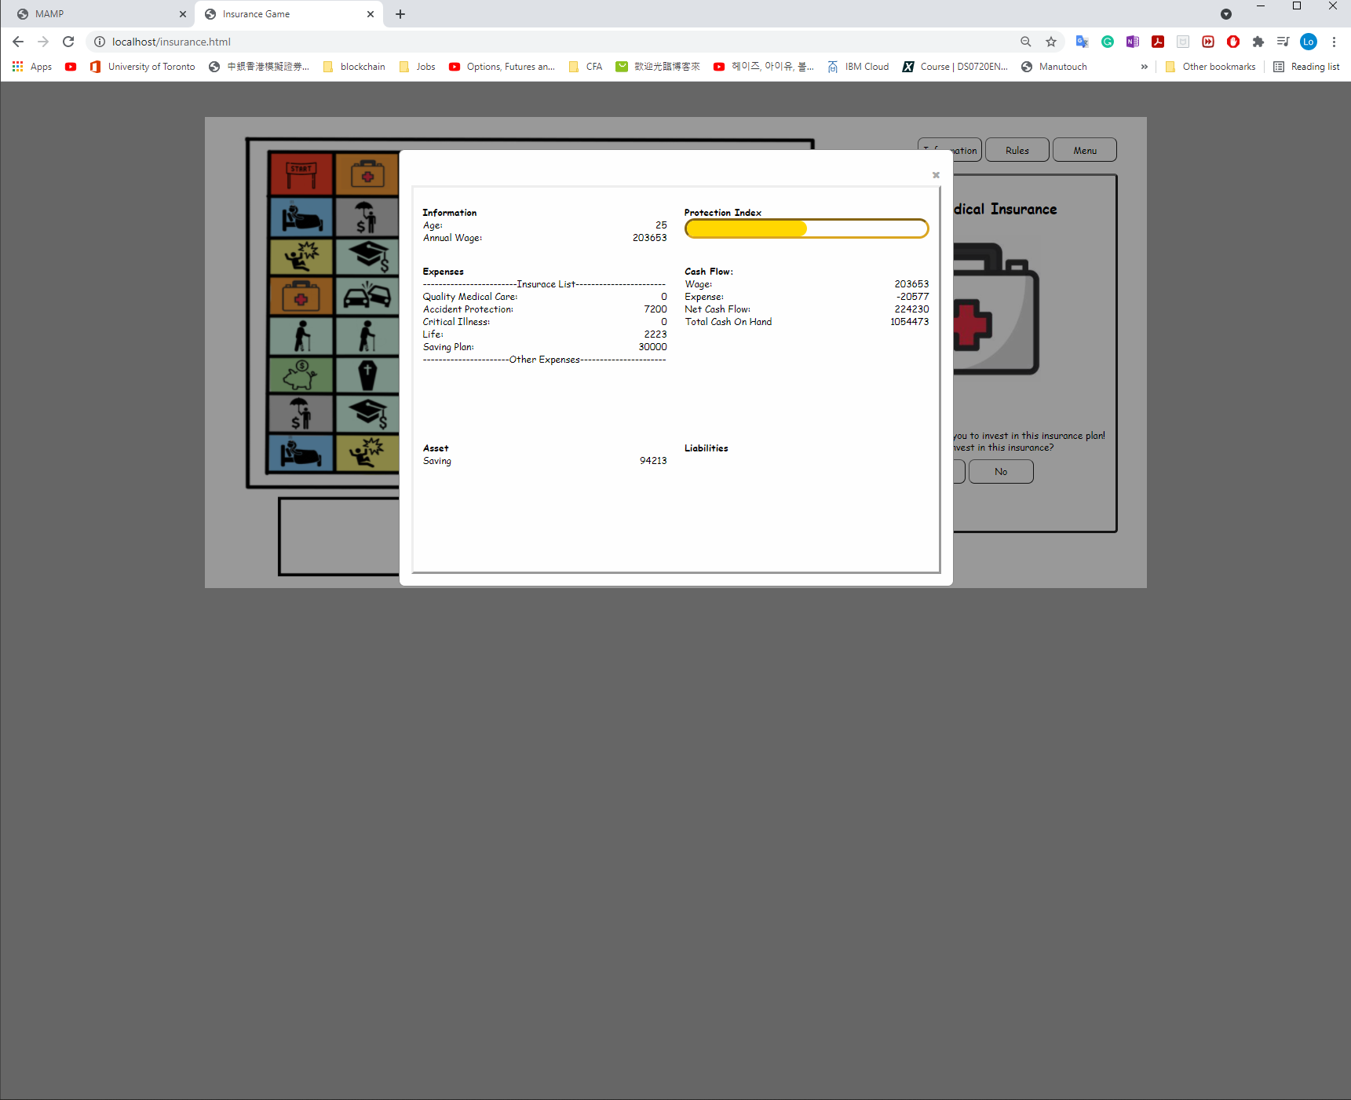

Saving plan in the expense’s calculation is wrong.

1. ~~Check the equation. Saving plan should be sum up with the other insurance plans~~

~~Expense = Quality Medical + Accident Protection + Critical Illness + Life + Saving Plan~~

1. ~~Once the saving plan is paid up,(paid up in 20 steps) the amount in the insurance list should be 0.~~
2. When the plan is paid up, The amount of saving in the Asset column should add to the total cash on hand ONCE.

**~~FC_05~~**

~~Divorce seems do nothing.~~

~~It actually deduct the total cash on hand in half.~~

**FC_07**

New kid’s asset is sometimes zero

when you step on new kid after you stepped on unemployed, the wage is 0 and you are multiplying wage and 0. The new kid exp will result $0.

FC_09

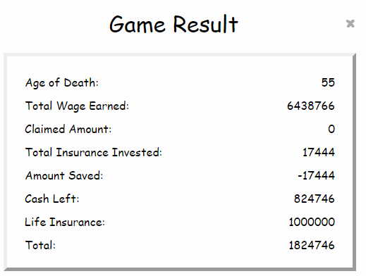

Claimed amount = total claimed by critical illness, accident, medical insurance.

* 1 time event(Car accident, Leg broke),medical treatment claimed amount should be added in this claimed amount calculation.
* Reminder: life insurance isn’t included in this calculation.
  + Life insurance only include in ‘life insurance’

**Fixed**

**~~FC_03~~**

~~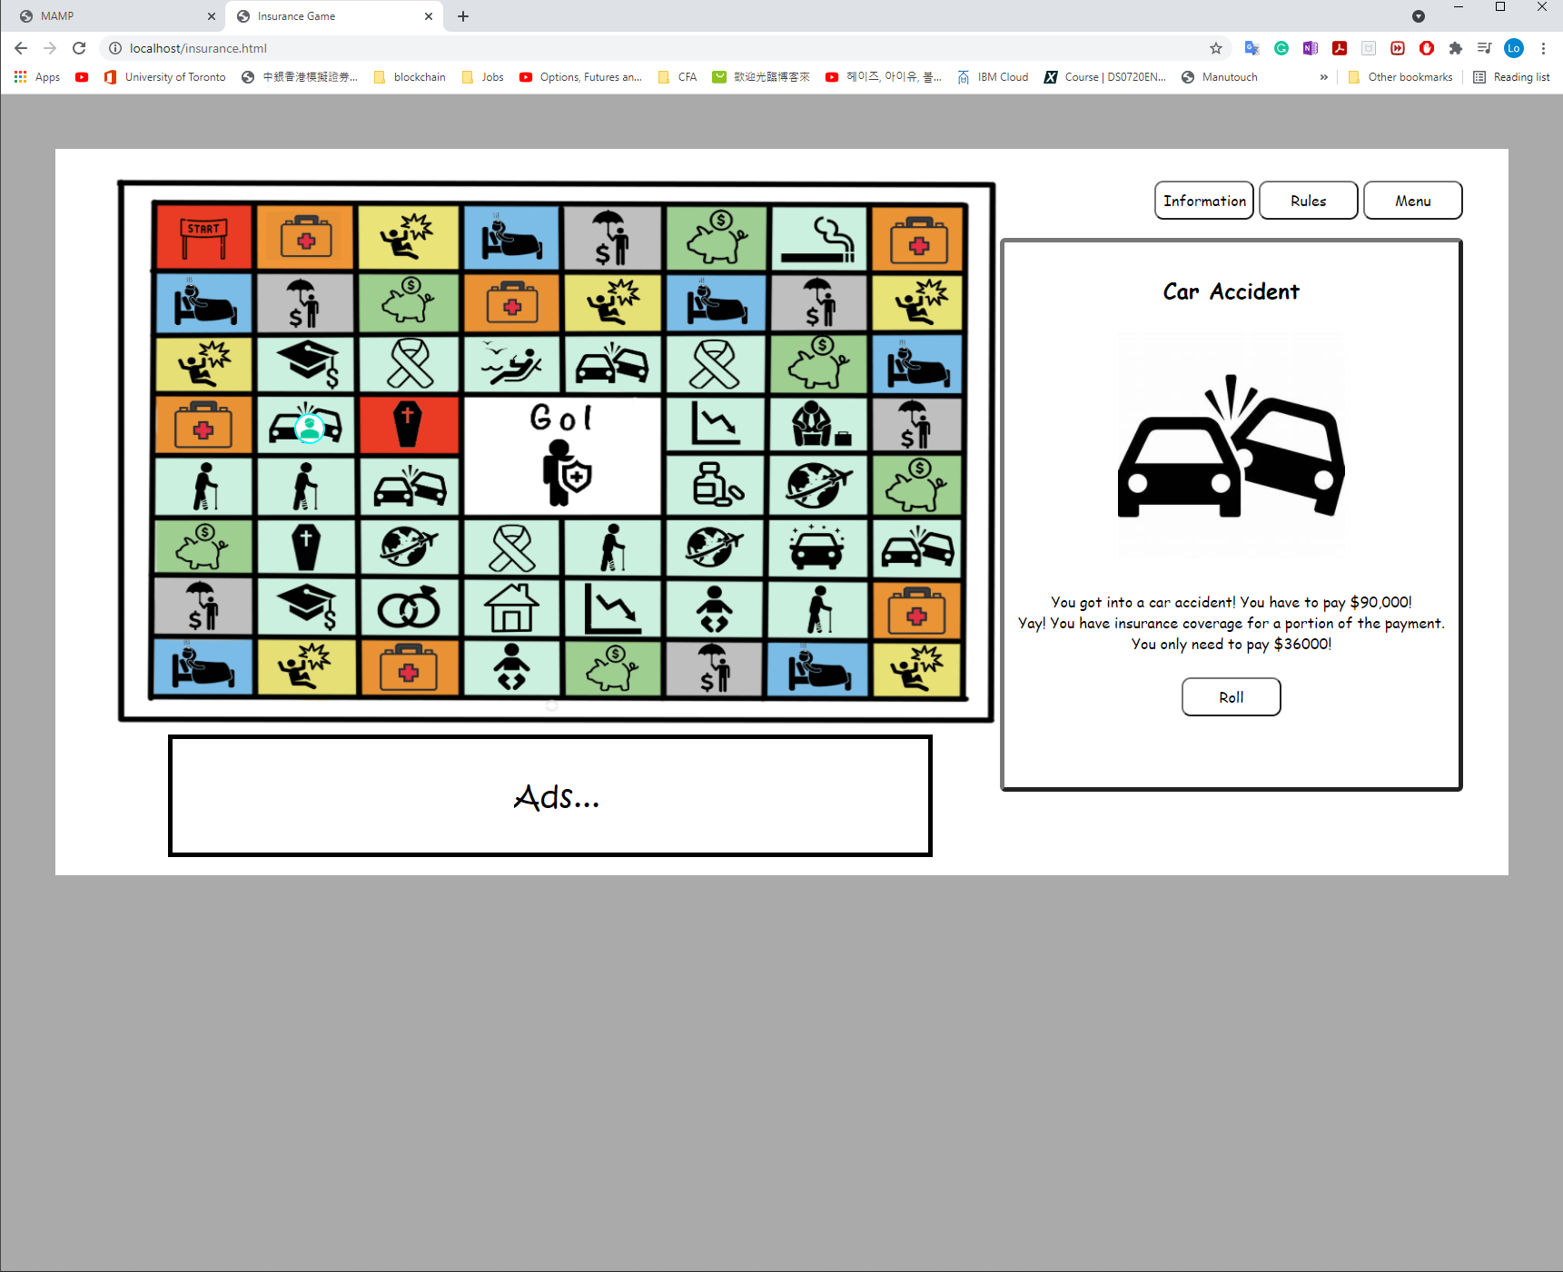~~

~~36,000. Please add comma LOL~~

**~~FC_04~~**

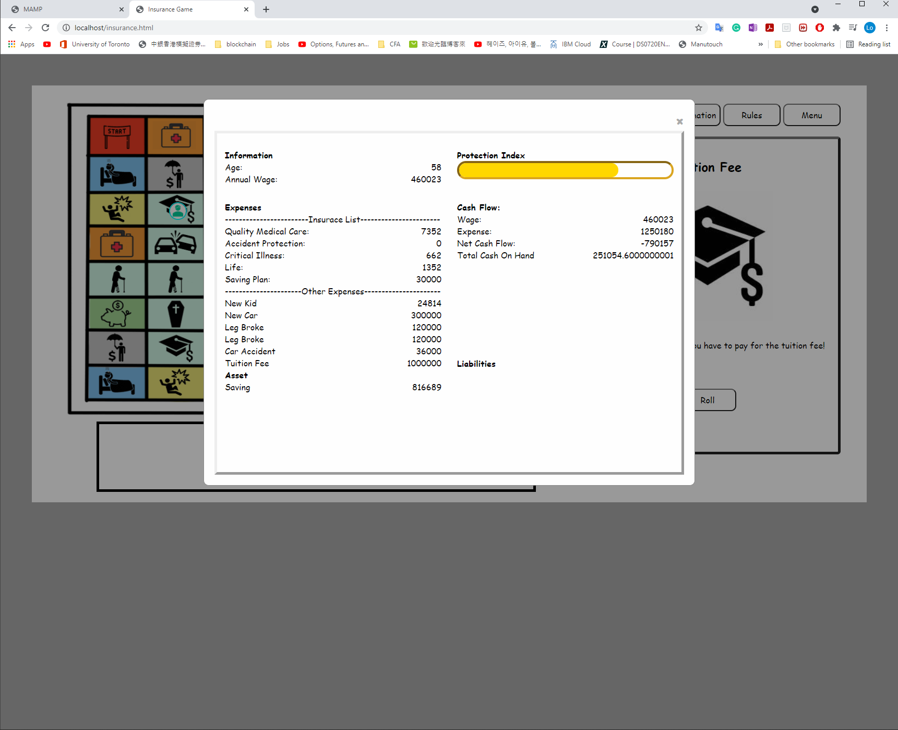

~~Too much decimal on Total Cash On Hand~~

**~~FC_06~~**

~~Remove liabilities~~

**FC_02**

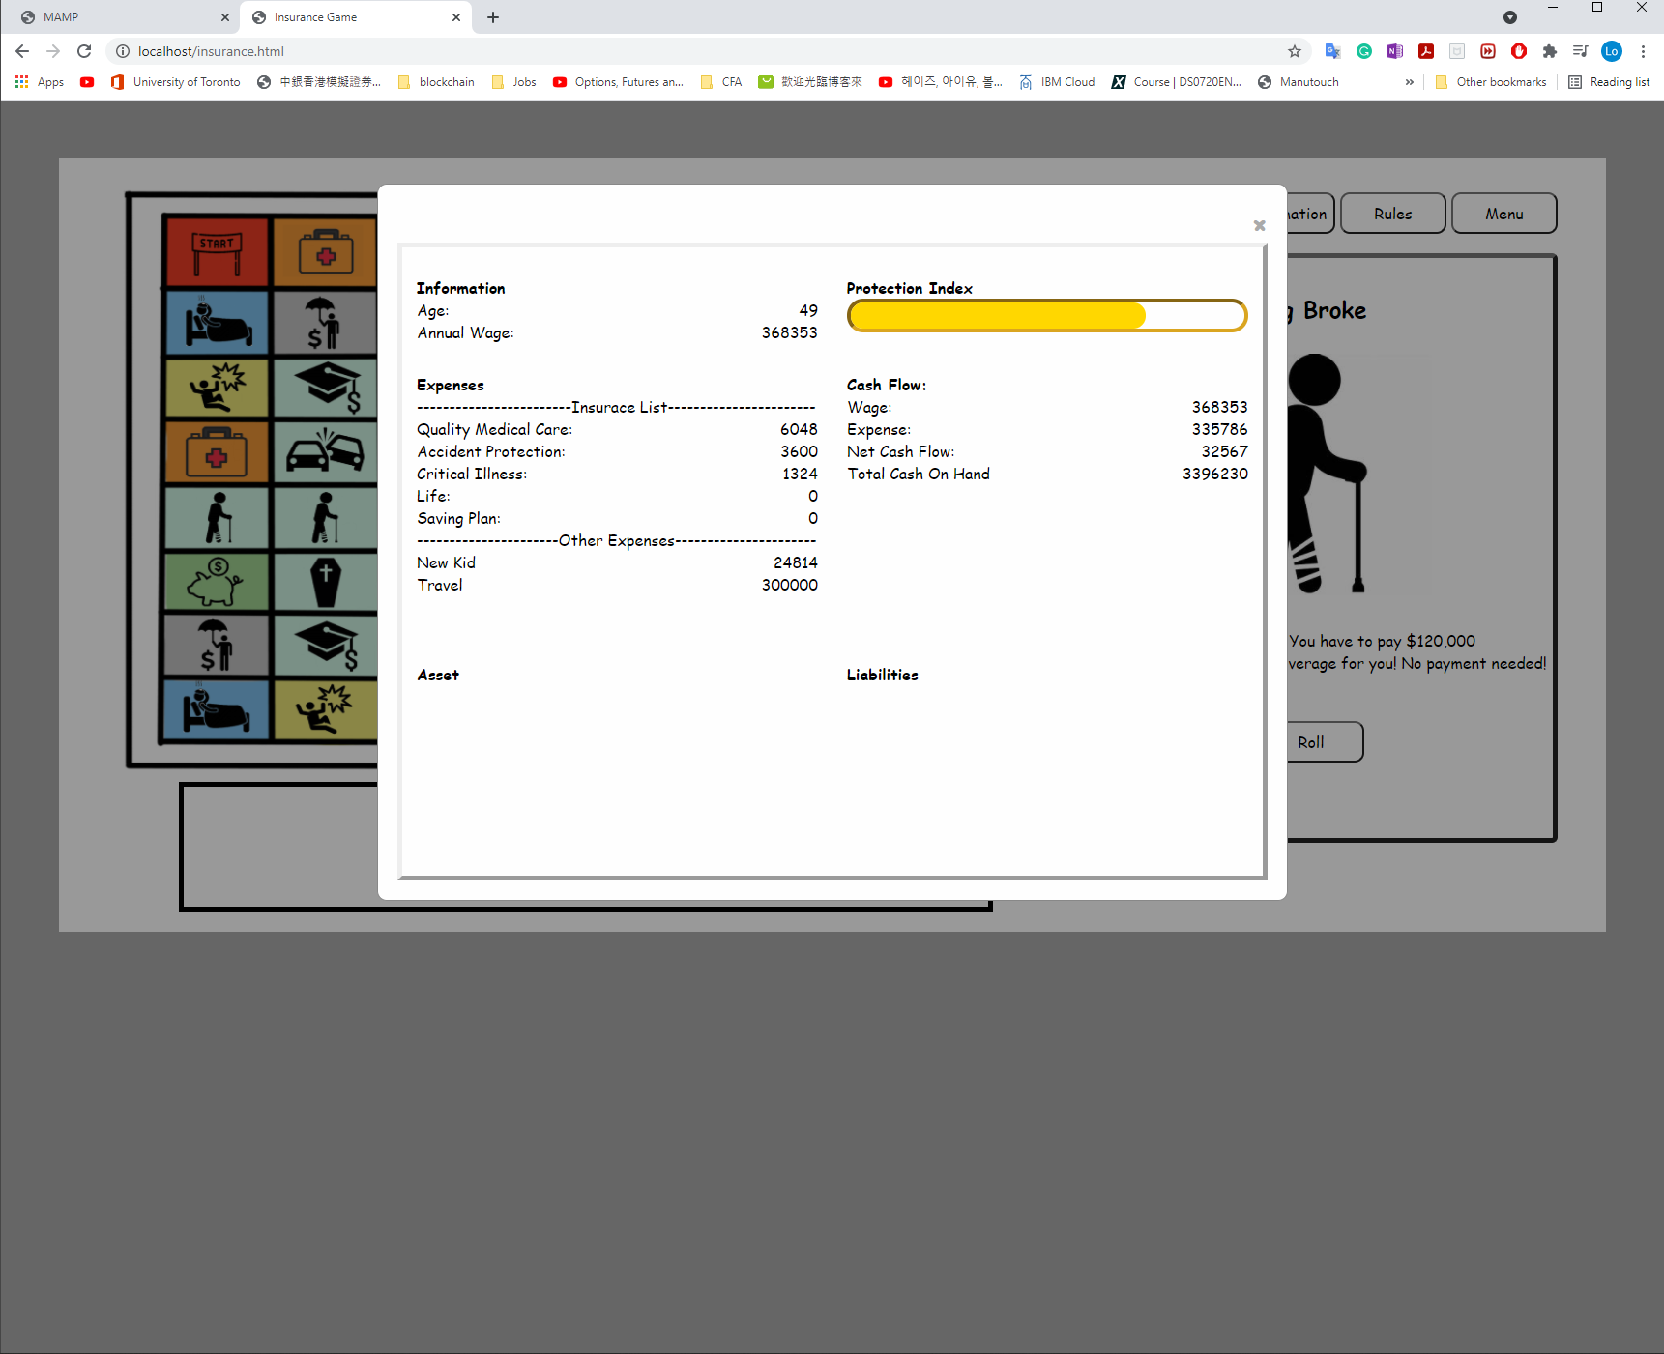

~~Only new kid, medical treatment expense will last forever.~~

~~Other than those(leg broke, travel, car accident) are 1 time event which means it is 1 time deduction. It only appears once. (once when the event occurred and can be seen right away but disappear after rolling the dice?)~~

|  |  |
| --- | --- |
| 1 time event | Continuous event |
| * ~~Car accident~~ * ~~Leg broke~~ * ~~Kid tuition fee~~ * ~~New car~~ * ~~New house~~ * ~~Travel~~ * ~~Stock loss~~ | ~~-new kid born~~  ~~-Medical treatment~~  ~~-unemployed (only 6 steps)~~ |

~~FC_08~~

~~In the asset area, separating the saving plans would be better. As when the first saving plan ended, the second saving plan amount in the asset seems like added to the TCOH too.~~

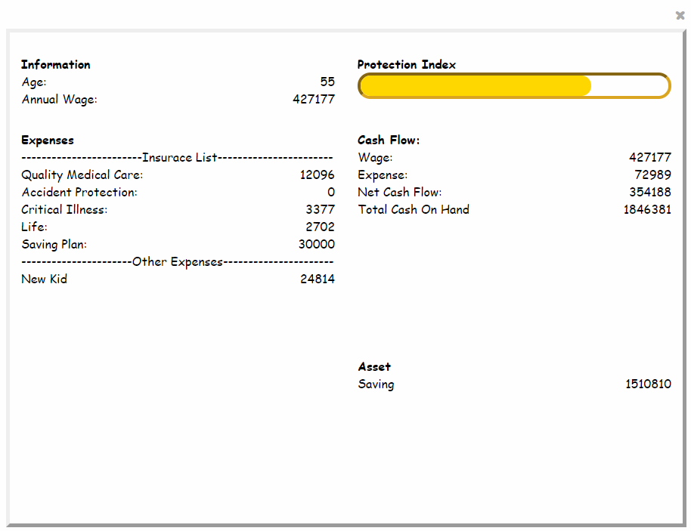

Saving plan 1 xxxx

Saving plan 2 xxxxx