Jurassic Craft

**A Game Makers Union game for ROM Jam 2014**

# What is Jurassic Craft?

This game theme is based the popular game genre of Real Time Strategy games. There are two sides with related Dinosaur ancestries, divided into the two major divisions of Saurishia and Ornithischia. Following typical RTS game mechanics, units (dinosaurs) can be selected, directed to move to target locations, attack each other when in proximity, and have an enemy base (a nest of eggs) that can be destroyed. Another common RTS trait supported is seeing only part of the world, and moving around the world map by having the mouse cursor at the edge of the screen.

# Game Concept:

Two sides battle for dominance by fighting each other, until all enemy units and home base are destroyed. New evolutions of dinosaurs would appear as the game progressed, with superior properties such as better incline climbing, more strength constitution, etc. There would be multiple maps to introduce the player to new evolutions as the gameplay progressed from beginning to end.

# Prototype Completed:

A single map has been completed with one initial set of units. The units flash red when attacking each other, until one wins. There’s one human player and computer player, Brachiosaurus, Herrerasaurus and Pisanosaurus, Triceratops respectively. No additional units appear at their respective nest during gameplay, and no additional maps have been created. There is no visual indicator currently activated to show which units have been selected. If selected to proceed as part of ROM’s showcase, we can create more.

# How to Play:

Dinosaur units are selectable by using the left mouse button to draw a box over them, just like file selection happens on a computer.

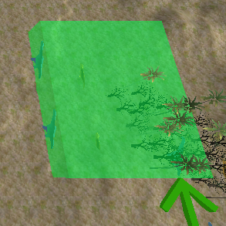

Figure 1

Once selected, direct those units to move to a target location

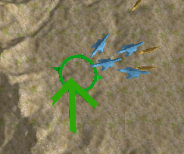

Figure 2

Attacking is automatic once in proximity, Units flash red when being hit.

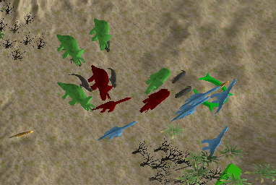

Figure 3

Units have two regions: An attack region, and a collision region. Note the larger dinosaurs have a larger radius of attack, thus giving an advantage.

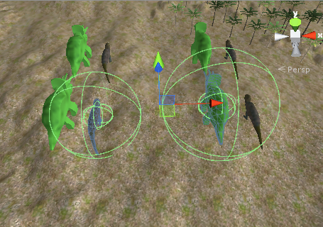

Figure 4

Game Contents:

There are four unit types, two for each side. The first tier units are the Pisanosauru (black) and Herrerasaurus (yellow). Their common properties are a smaller attack range, and can climb 30° slopes. The second tier are the Triceratops (green) and Brachiosaurus (blue). They have a larger attack radius, and can climb steeper slopes up to 45°. The superior angle of climbing is not accurate per Aaron Phillips’ input and can be adjusted.

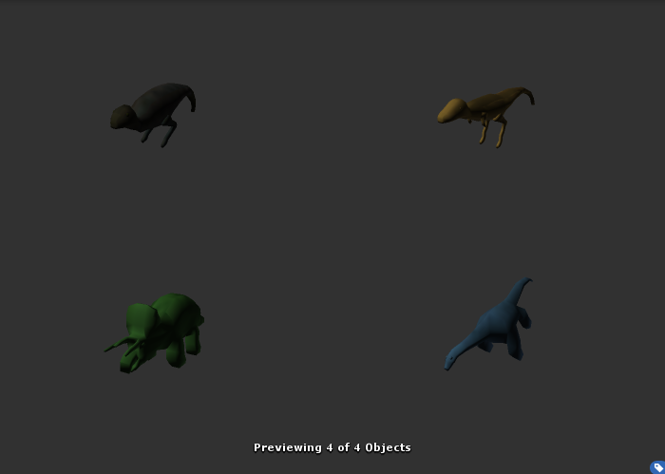

Figure 5

Nest of eggs. Destroy all enemy dinosaurs and this to win.

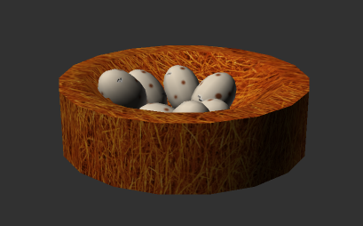

Figure 6

The entire map:

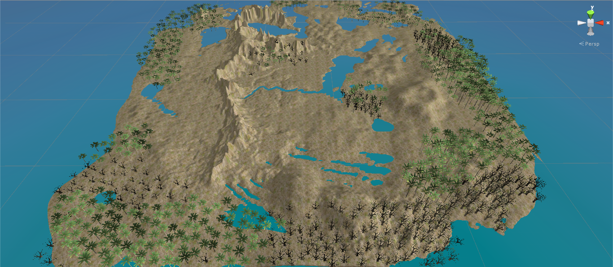

Figure 7

Player and enemy starting positions. These are entirely modifiable, and are just a sample layout.

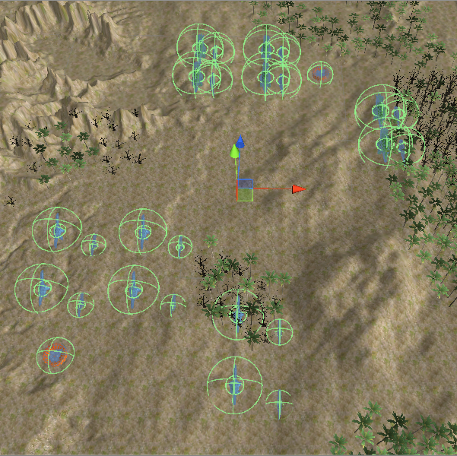

Figure 8

Bug:

There is a bug where the win/lose button needs to be clicked a second time. The first resets the map, the second begins play.

# Spoiler Game Play Strategy:

Only read this if struggling to win. You will deprive yourself of the challenge of winning if you read directly. We play-tested this on the last day of the jam with about 10 people. It is definitely winnable, however inexperienced RTS game players may find it exceptionally challenging, while experienced RTS players will find it easy. The enemy AI is very rudimentary, and this can be taken advantage of. All enemy units simply move towards one unit at a time, picking off yours one-by-one. If you do not move your initial layout of units, you will certain lose. The reason for this is because all the enemies’ attacks collectively outweigh your single unit at a time. The trick to win is to immediately select all your units, and pull them together. As the enemies all herd towards you, you need to move back-and-forth your herd onto their isolated units, in order to overpower them a few at a time. Keep doing this while moving about the map. This is known as “kiting”, as in, imagine pulling a kite behind you, but instead, the enemy group is following you in a trail.

# Credits

**Main contributors:**

* Game Concept, Design, and Coding: Ian Nastajus, David Tenty, Adrian Popescu
* Modelling: George Macharashvili

**Assistant contributions:**

* Additional insights about evolution: ROM’s Aaron Phillips
* Additional code brought into jam: GMU’s Morgan Brandt, Dante Camarena, Zack Harris
* Additional models: Unity assets (trees, terrain textures)