GameModeler SDK
SaveLoadObject module documentation

Introduction

With this module, you can save an object in differents languages on file. And you can load an object from file.

Differents languages/method :
- Json
- Yaml
- Xml
- Binary
- Csv
- Character

Configuration

Differents languages

- WRITE
  - Communal parameter list : path , fileName, T ObjectToWrite, append (optional)
  - Example (Json)
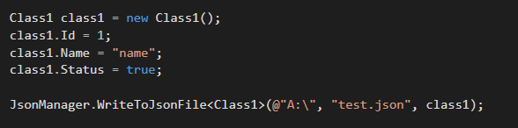
- READ
  - Communal parameter list : path, fileName
  - Example (Json)
MySQL

The MySQL submodules contains six methods :
- 3 methods for write/execute script from object
  - ConvertObjectInScript
    - Parameters :
      - T objectToWrite
      - boolean append
      - string dbName
      - bool execute
      - string user (mysql user)
      - string pwd (mysql password)
    - Return : SQL script (string) for creating database and table and execute or not
    - Example :
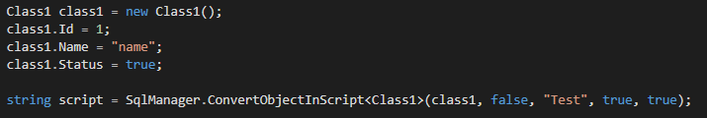
  - ExecuteStringSql
      - Parameters :
        - string script
        - string user (mysql user)
        - string pwd (mysql password)
    - Return : Execute SQL script (string)
  - WriteToSqlFile
    - Parameters :
      - string path
      - string fileName
      - T objectsToWrite
      - boolean append
      - string dbName
      - boolean createDb
      - boolean execute
      - string user (mysql user)
      - string pwd (mysql password)
    - Return : Write SQL script into file and execute or not

- 3 methods for read database and convert into object (IDictionnary)
  - CreateObjectByDatabase
    - Parameters :
      - string user (mysql user)
      - string pwd (mysql password)
      - string database
      - string table
    - Return : IDictionnary object from table of database
    - Example :
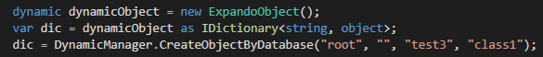
  - CreateMySqlCommandArray
    - Parameters :
      - string query
      - MysqlConnection connection
      - Boolean openclose (for open and close connection in function)
    - Return mysql values (array) of query
  - CreateMySqlCommandDict
    - Parameters :
      - string query
      - MysqlConnection connection
      - Boolean openclose (for open and close connection in function)
    - Return mysql values (dictionnary) of query

