# Yeti Tournament

## Menu

This is the start screen, when you started the Yeti_Tournament.exe:

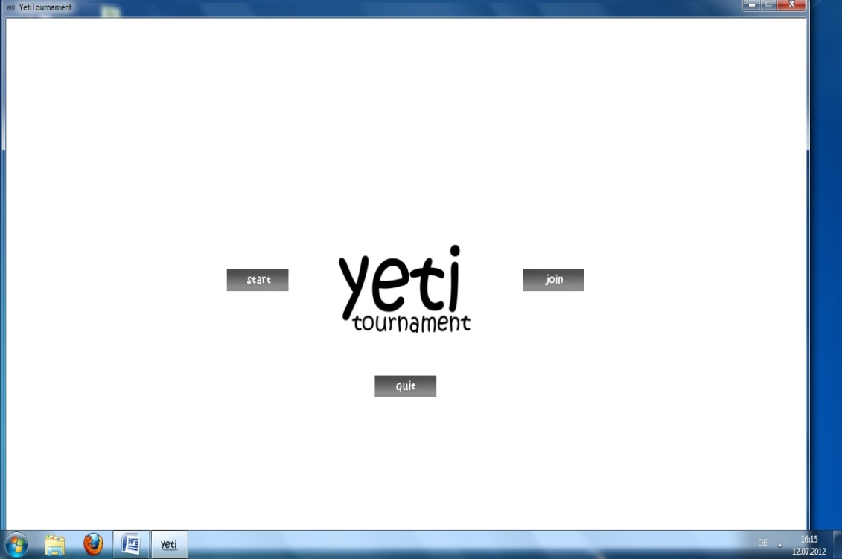

With the *start* button you can create a new game.

With the *join* button you can join an already existing game.

With the *quit* button you can exit the game.

When clicking on the *start* button you will get this screen:

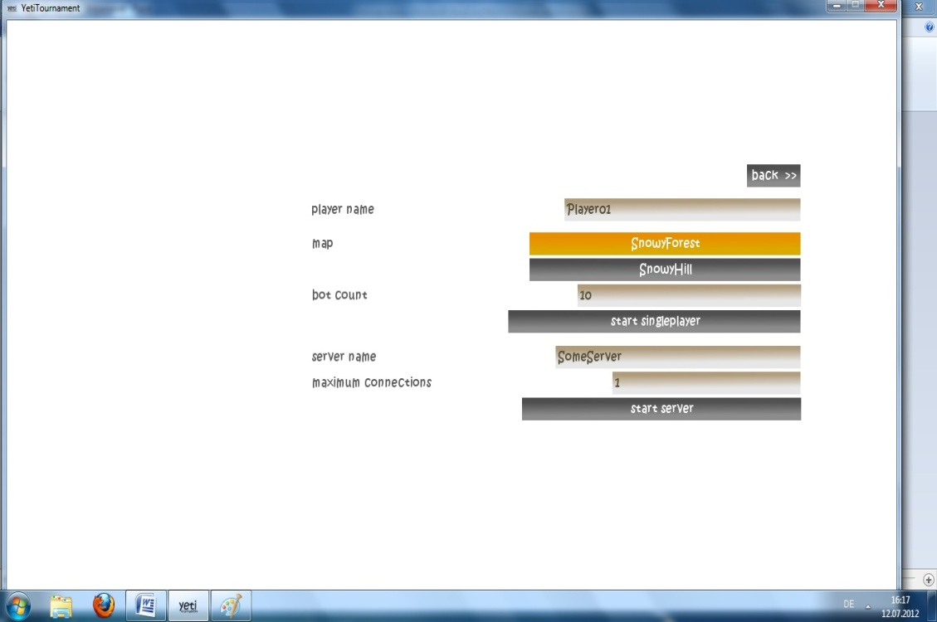

You can enter your *player name* here and choose a map. Furthermore you can say how many bots you want to play with.

If you want to play in *multiplayer* you can enter a server name and you can specify how many people are able to join the server.

With *start singleplayer/ start server* you can finally create the game.

When clicking on the *join* button in the start menu you get this screen:

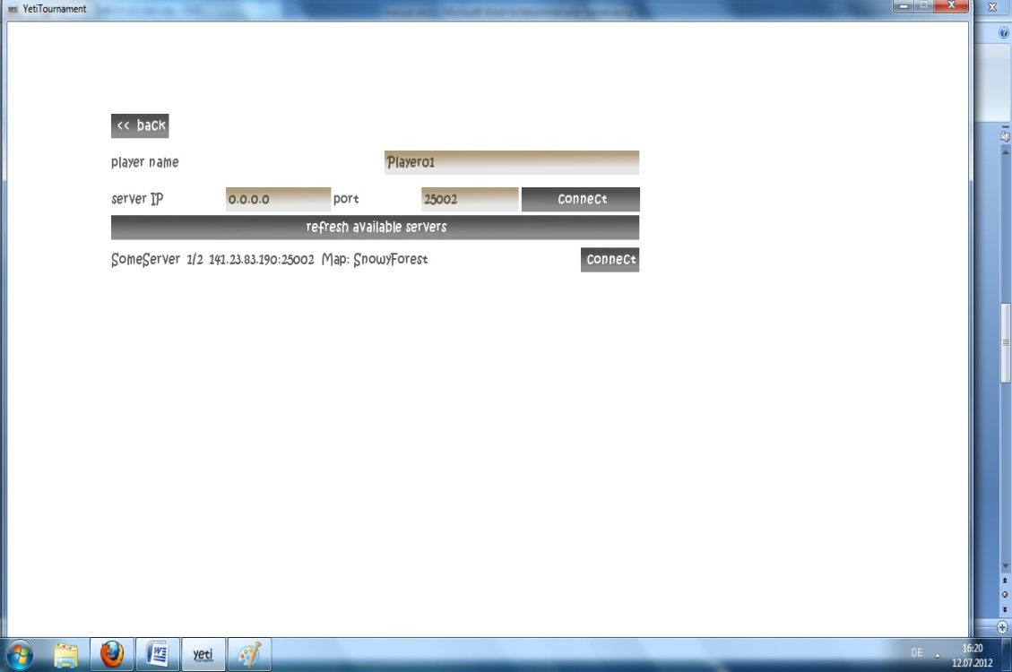

You can also specify a *player name* here.

You can either join directly by typing in a concrete *server ip* (e.g. 141.17.25.36) and the corresponding port (e.g. 25002) and then click the *connect* button.

Furthermore you can see available servers in the server list. You can join this server by clicking on the *connect* button at the corresponding server.

## Map Overview

If you join/start a server you will get such a map overview screen:

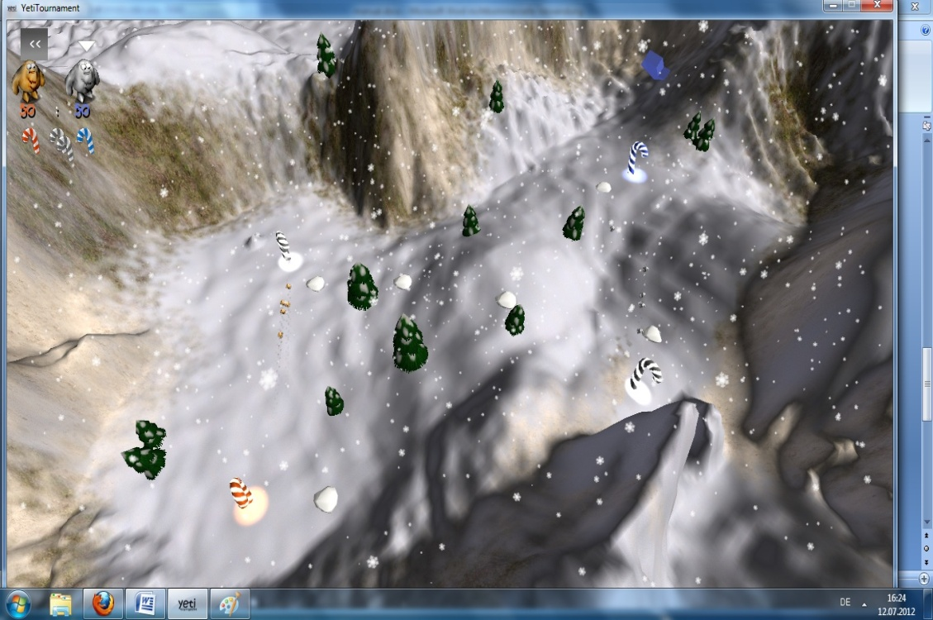

In the upper left corner you can see a summary of the 2 teams, which are fighting against each other. The white triangle says that you are in that team. By clicking on the arrows over the other team you can change the team. The numbers below the yetis indicate the ticket amount of the corresponding team. Every time a Yeti dies, this number decreases by 1. Below this ticket amount you see icons how many bases (the candy canes) you possess. In this case team1 has 1 base, team2 has 1 base and 2 bases (gray) are not possessed by anyone. If you want to join the game, just click on a candy cane with the big arrows over them, which is in your possession. You will spawn next to it.

## Main Screen

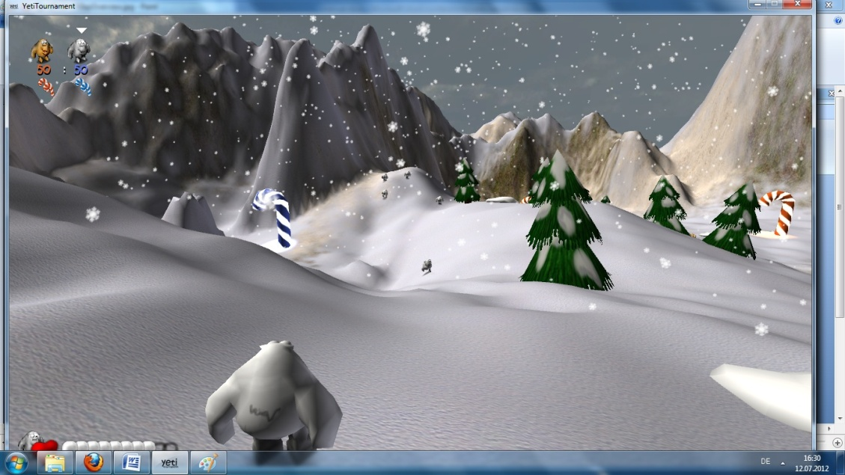

This is the “main” screen while playing. You see in the upper left corner the summary of the teams. In the lower left corner you see your health points (the heart). It will be smaller if you lose hp (when another yeti will hit you with a snowball). Right next to it, you can see the number of snowballs you have (in this case 8 out of 10). If you shoot (left mouse button on default) you will lose one snowball.

With a right click you can burp and if an enemy yeti is near you, he will get hurt. When you press “Tab” you can see a frag overview.

## Snow Resource

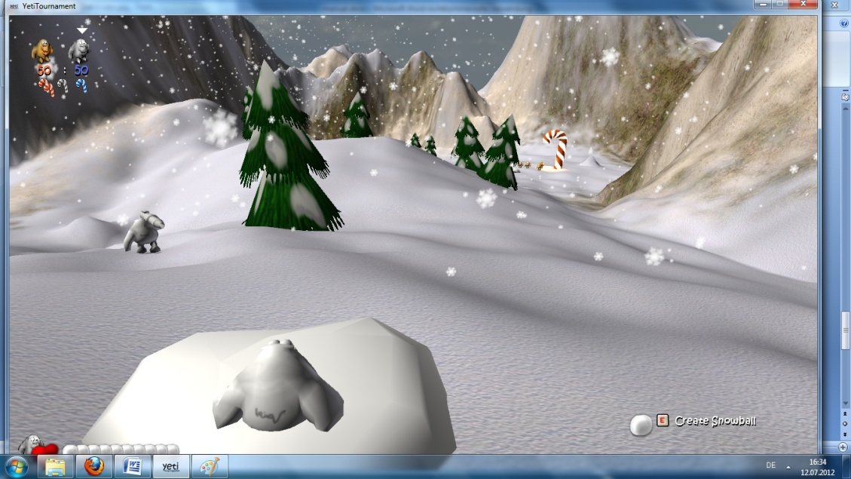

In the picture you are standing inside a snow resource. If you stand inside a snow resource, the snowballs you are carrying are automatically filling. Furthermore you can create a snowball by pressing the “E” button. The snow resource will be smaller the more big snowballs and snowballs you get. But when time goes by, it will refill.

## Big Snowball

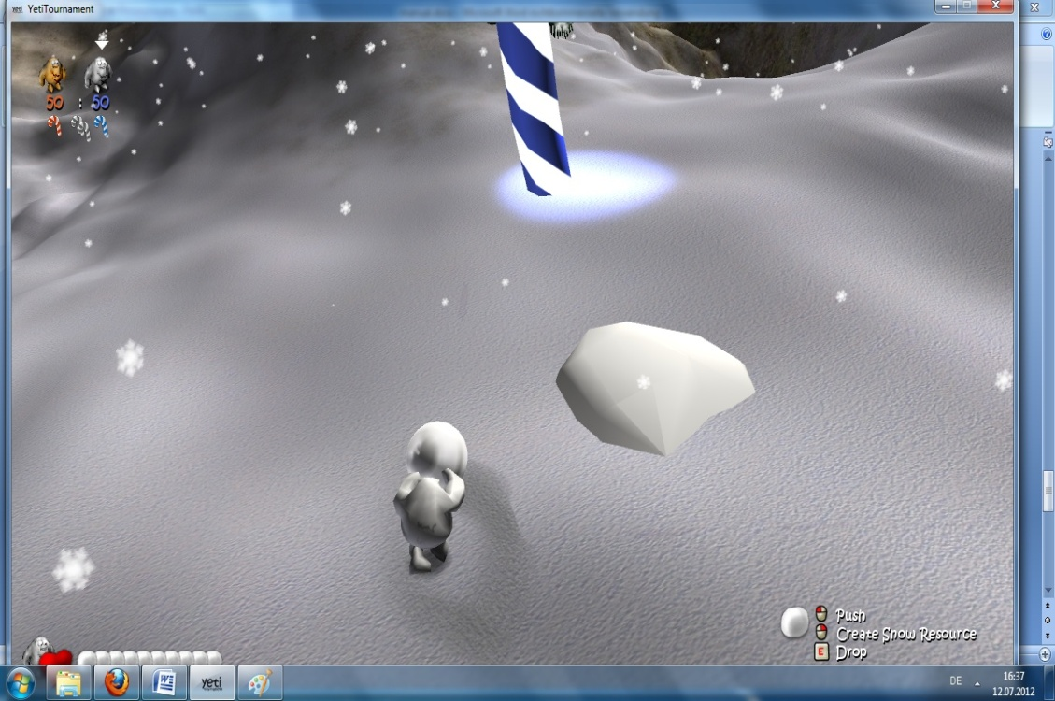

In this picture you have a big snowball. If you move, the big snowball will move with you. You can push this big snowball by clicking the left mouse button or create a new snow resource out of it by clicking the right mouse button. You can drop it by pressing “E”.

If you carry a big snowball to a base (no matter if it belongs to you) you can make a special weapon out of it.

## UFO

If you created the maximum size of a big snowball and gave it back to a base it will turn into an UFO. You can enter it by pressing “E”.

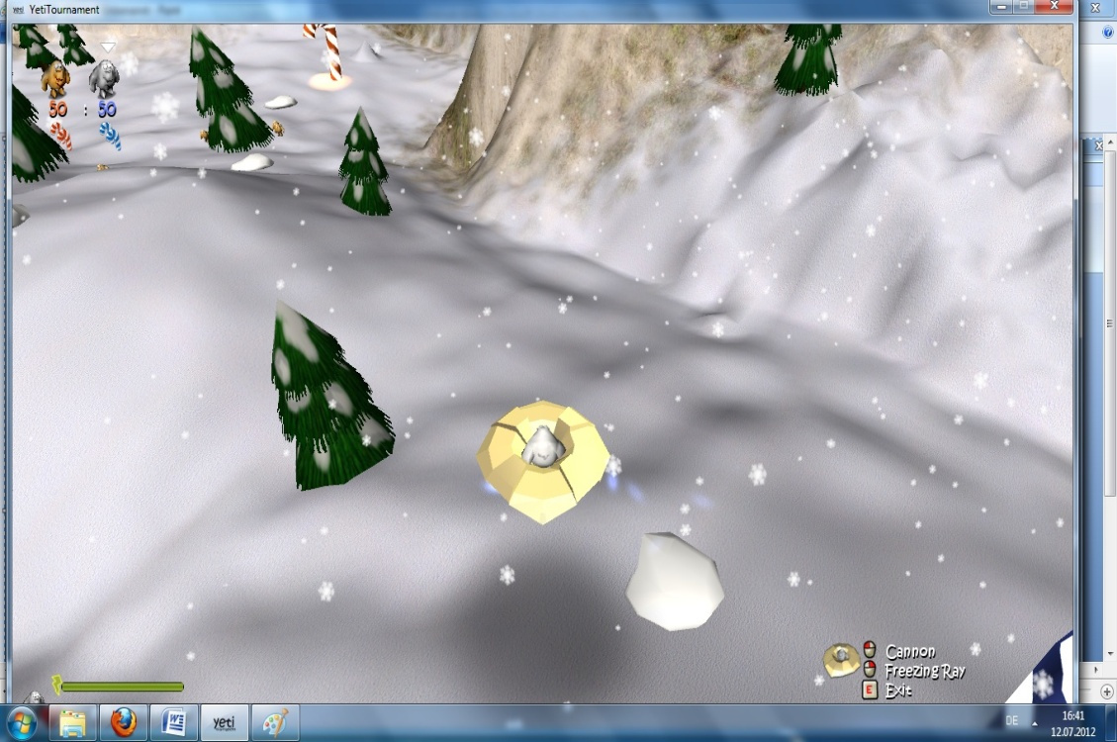

With a click on the left mouse button you can use the cannon and attack other yetis. With a click on the right mouse button you can use the freezing ray and freeze other yetis. When you press “E” you can exit the UFO. In the lower left corner you also see the freezing ray display, which shows you how many freezing ray energy you have left.

## Rocket launcher

When the big snowball has not reached his maximum size and you bring it to a base it will convert into a snow rocket. You can pick it up by pressing “E”.

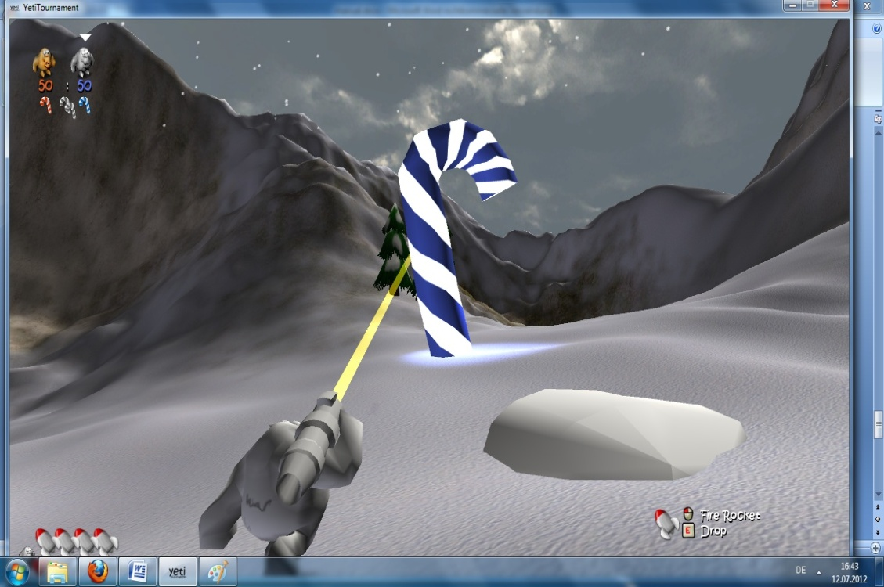

You can see the amount of snow rockets in the lower left corner.

You can shoot by clicking the left mouse button. If you want to shoot UFO’s you have to aim the UFO. Then the UFO will be locked. When the UFO is aimed for a certain time, it will get locked finally. Then you can shoot the UFO by clicking the left mouse button.

## In Game Menu

Here you see the ingame menu:

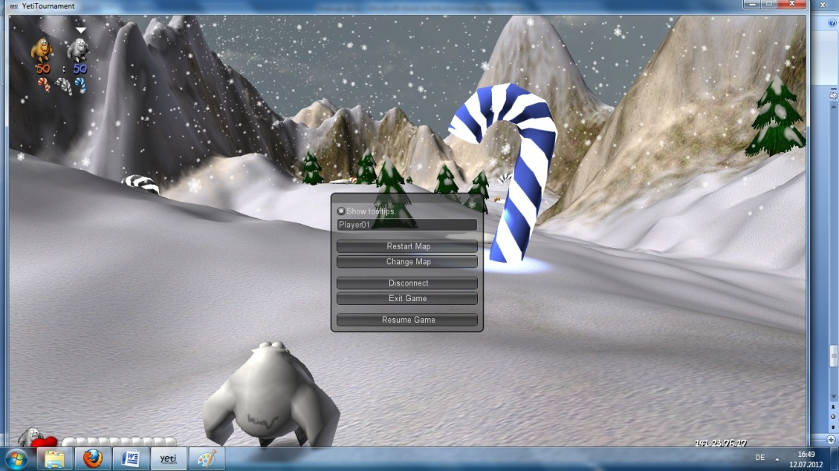

The server can restart the map or change the map.

But anyone can toggle the tooltips. So you wont get the help if you carry a weapon etc. You can change your name within the text field. Furthermore you can disconnect from the server or exit the game.

## Chat

By pressing “Enter” you can use the chat. You can enter messages then:

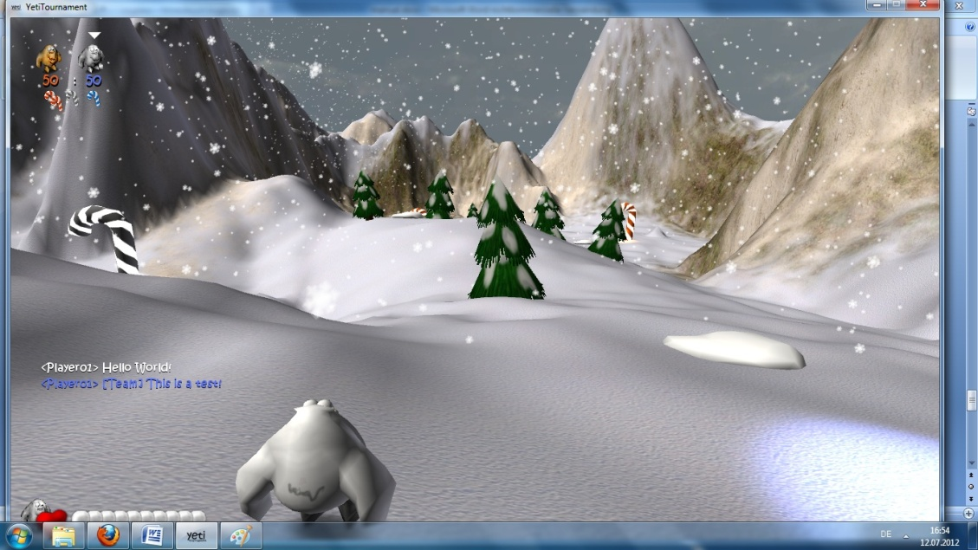

## Credits

Team lead: Benjamin Bisping

Graphics Programmer: Hannes Rammer

Content Design: Tiare Feuchtner

Game Programmer: Andreas Büscher