GRAPHICS, PROJECT 3:

IDO KESSLER xxxxxxxxxx???? & JONATHAN SOMER 307923383

1. [TranformedIm] = ComputeProjective(Im, H)

H=[1 0.2 0; 0.4 1 0; 0.4 0.2 1];

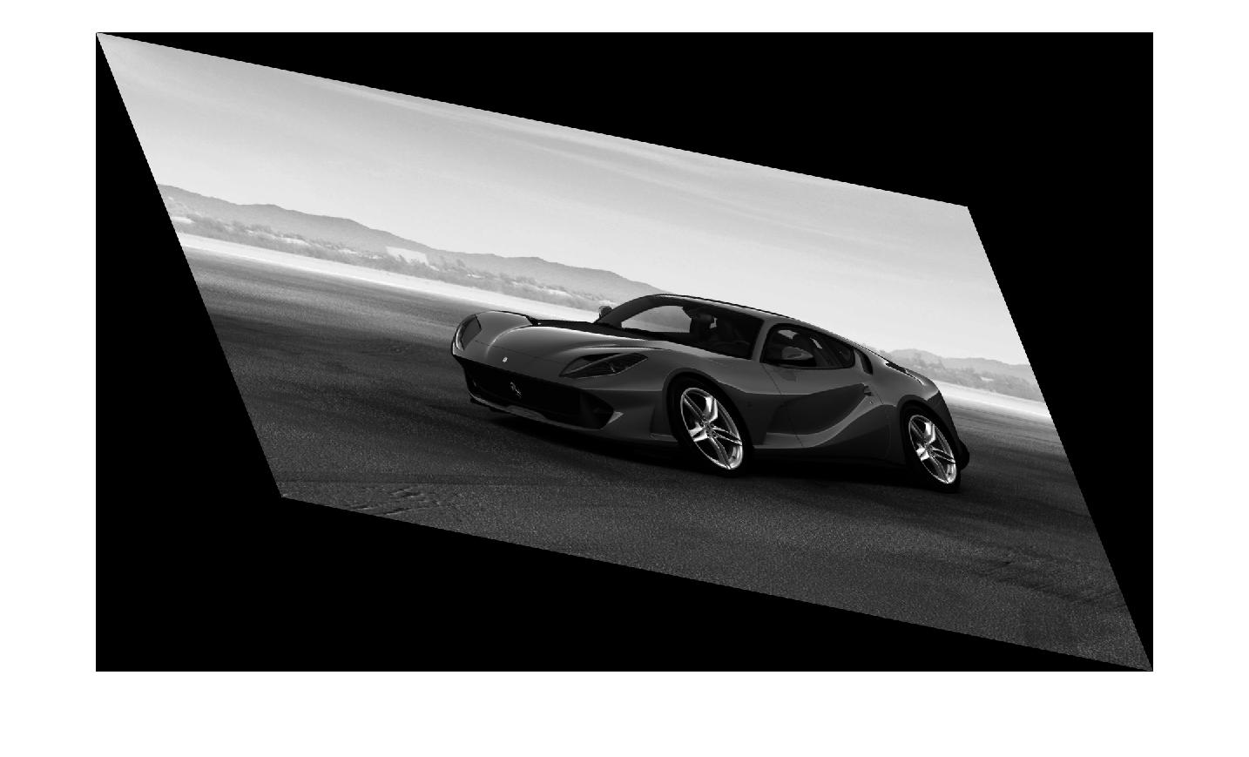

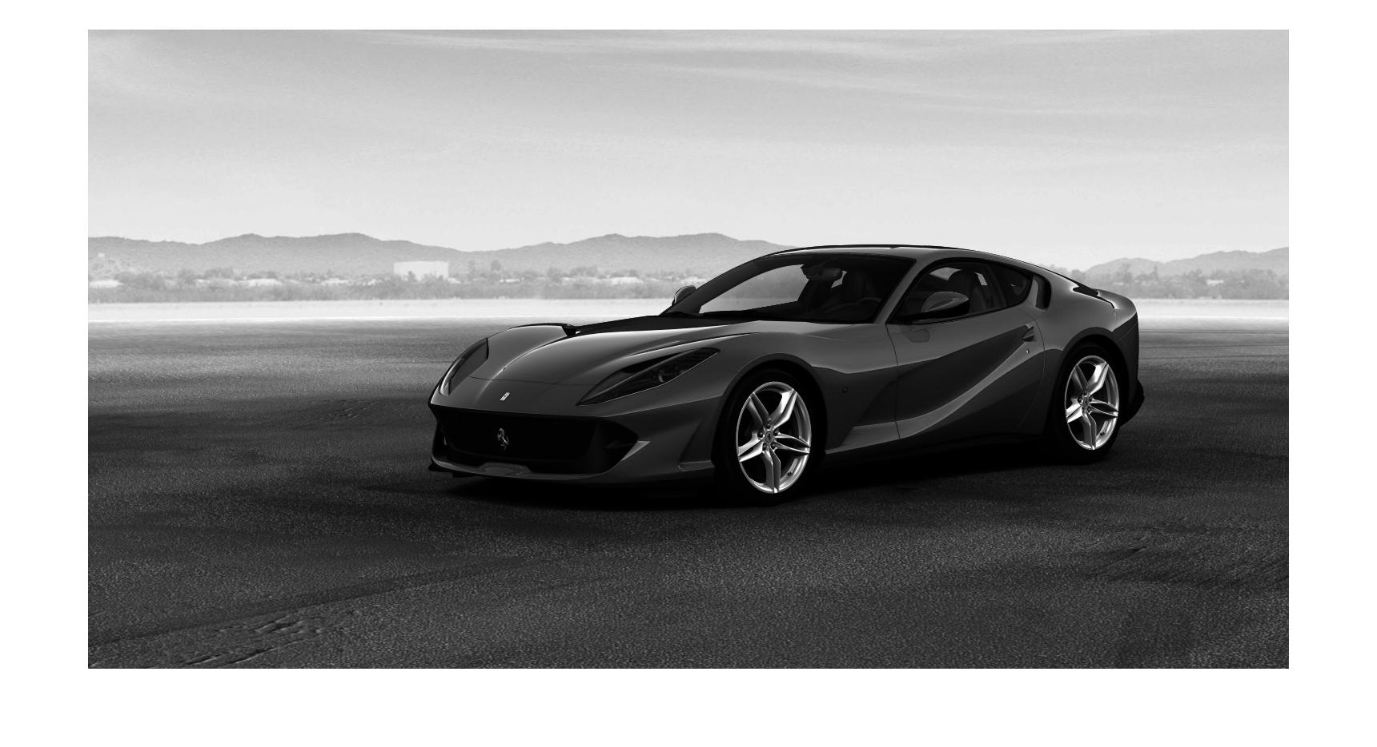

2. [displayedCorr] = DisplayCorr(image1, image2, matches, dist_vals, x)

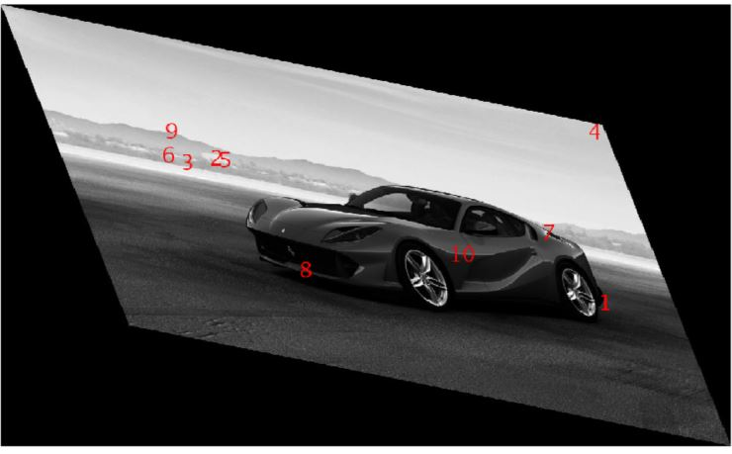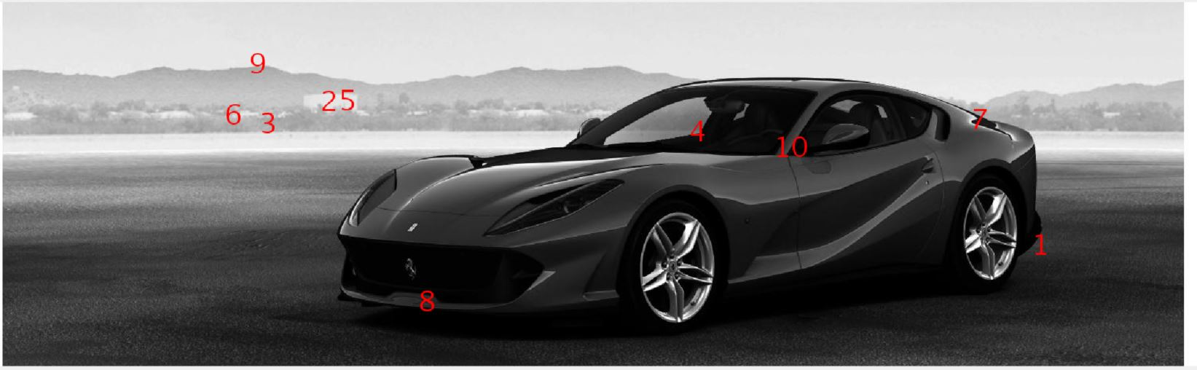

TOP TEN POINTS:

1429.4, 518.5 -> 1115.6, 532.8

525.5300, 336.6300 -> 469.7900, 293.2100

448.2100, 364.5800 -> 420.7900, 300.1200

993.9, 374.8 -> 1099.2, 249.1

549.4600 336.1500 -> 483.9900 295.7300

403.5900 354.4600 -> 389.9400 287.5400

1350.7 360.3 -> 1022.0 417.4

650.1900 590.8400 -> 617.8600 478.6600

434.9000 288.9500 -> 394.7000 248.3600

1.1116 0.3946 -> 0.8784 0.4529

3. Evaluating the resulting homography we notice that when supplying a great amount of points (above 70%+ of all points) the DLT fails!

We need to supply around 1% of the points, with the greatest match in order for DLT to create an adequate transformation.

This is the main parameter to tune in order to get an accurate result. You can tune it by adjusting the threshold for match.

4. The addaptations made to RANSAC in our implementation:

a. As RANSAC counts outliers we implemented an “error” loss function, that returns the number of outliers for a specific homography, and supply this function to the wrapper for RANSACS use.

b. normalizing images size in order to avoid errors on different scale.

c. Transposing matrices in order to comply with our functions standards.

5.

Case where RANSAC is worse:

When there are very little (or no) outliers, (as you can see in the first image displayed by the script) the RANSAC algorithm has no advantage over the DTL. The DTL takes into account all points, which are good predictors for the homography in this case, and minimizes error. The end result is much more accurate than “counting” outliers, which in this case results in an almost random prediction.

Case where RANSAC improves:

We take an image where the matches have significant outliers, the DLT minimizes error in total and due to this the end result is bad overall. The outliers are very far and This affects the prediction profoundly.RANSAC can ignore the distances, due to only counting the number of outliers.

figure 1 shows the outliers, figure 2 shows the bad DLT result, figure 3 shows the good RANSAC result.