ACKNOWLDGEMENT

We would like to thank the CBSE board and the VPS Management, especially our Principal, Mr. Vijai Krishna for giving me an opportunity to develop project using C++.

We would like to express profound gratitude to our Computer Science tutor, Mrs. Veena, for her invaluable support, encouragement, supervision and useful suggestions throughout this project work. Her moral support and continuous guidance enabled me to complete my work successfully.

**SYSTEM REQUIREMENTS**

For efficient and optimum utilization of the program, it is advised that the system be equipped with the following minimum requirements:

**SOFTWARE REQUIREMENTS**

Windows (98, 2000, XP or any higher version),

Compatible Turbo-C software (preferably NOT Borland as it does not support graphics) or, alternatively, Dos Box with C++ mountable.

HARDWARE REQUIREMENTS

P2 & Above Processor

32MB RAM

USB Port/CD Writer

Minimum Hard disk Space 100 Mb

***INTRODUCTION***

**Basic concepts of OOP’s:**

1. **Data Abstraction:** Abstraction refers to the act of representing essential features without including the background details or explanations. Abstraction is implemented through public members of a class, as the outside world is given only the essential and necessary information through public members, rest of the things remain hidden.
2. **Data Encapsulation:** The wrapping up of data and operations/functions (that operate o the data) into a single unit (called class) is known as Encapsulation. Encapsulation is implemented with the help of a class as a class binds together data and its associated function under one unit.

Name of classes are news, dispnews, main, it_news, sport_news.

1. **Modularity:** The act of partitioning a program into individual components is called modularity. C++ implements modularity through separately compiled files. The traditional practice in the C++ community is to place module interface in files named with a .***h*** suffix; these are called header files which can be used through #include directive.Used in user defined functions like

Latest(), password(), display_news(), ent_news(),etc

1. **Inheritance:** Inheritance is the capability of one class of things to inherit capabilities or properties from another class. Inheritance is implemented in C++ by specifying the name of the (base) class from which the class being defined (the derived class) has to inherit from. Base class name-main derived class names-news, sports_news, it_news.
2. **Polymorphism:** Polymorphism is the ability for a message or data to be processed in more than one form. C++ implements polymorphism through virtual functions, overloaded functions and overloaded operators. The function overloading used, i.e latest().

**Files and Folder**

**(FILES NAME AND ITS CONTENT)**

1. **data_it1.dat** - contains information about IT and Technology.
2. **data_it2.dat** - contains information about IT and Technology.
3. **data_HAT.dat -** contains information about History and Technology.
4. **data_WAI.dat** - contains information about Women and IT.
5. **New_ITnews.dat** - It takes information given by the user.
6. **data_GUJ.dat** - contains information about Gujarat’s cricketing History.
7. **data_MSD.dat** - contains information about speech by Dhoni.
8. **data_EVA.dat** - contains information about Evans losing singles final.
9. **data_MUR.dat** - contains information about Andy Murray.
10. **con1.dat** - contains information about controversies in sports.
11. **con2.dat** - contains information about controversies in sport.
12. **con3.dat** - contains information about controversies in sports
13. **New_SPORTSnews.dat** – It takes in information given by the user.
14. **New_news.dat**- It takes in information given by the user.

**SOURCE CODE-**

#include<iostream.h>#include<conio.h>#include<process.h>#include<string.h>#include<graphics.h>#include<stdlib.h>#include<stdio.h>#include<dos.h>#include<fstream.h>#include<ctype.h>

int latest();

int password(); int latest(int ch2);

char c,ch,ch1,ch2,ch3,ch4,ch5,ch6,ch7,ch8,ch9,ch10,ch11,ch12; char str[20],str1[20],pas[20],pas0[20],pas1[20]; int z,v,g,s,r; int left, top, right, bottom; int left1, top1, right1, bottom1;

char flag,m; fstream info,news;

class main { public: char user_news[600]; char str5[100];

void display_news() { cout<<"\n\n\n\t\t"; cout.write(str5,100); cout<<"\n\n\n"; cout.write(user_news,600); } };

class news:public main { public: void ent_news() { cout<<"\n Enter news (headline) - "; gets(str5); cout<<"\n NEWS : \n\n" ; gets(user_news); } }n; class sports_news:public main { public: void ent_news() { cout<<"\n Enter Sports news (headline) - "; gets(str5); cout<<"\n NEWS : \n\n" ; gets(user_news); } }n2;

class it_news:public main { public: void ent_news() { cout<<"\n Enter IT news (headline) - "; gets(str5);

cout<<"\n NEWS : \n\n" ; gets(user_news); } }n1;

class dispnews { public: char b; dispnews() { b=0; } void display(); }j;

void dispnews::display() { { while(info) { info.get(b); cout<<b; delay(1); } getch(); } }

typedef int space;

void main() { clrscr(); randomize();

void ellipse(); void fpage(); void time();

ellipse();

space gdriver = DETECT, gmode;

initgraph(&gdriver, &gmode, "");

int flag3;

setbkcolor(BLUE);

do { flag3=0; cout<<"\n\n\n\n\n Enter the user name - "; cin>>str; s=strlen(str); char t; for(int r=0;r<s;r++) { t=str[r]; if(isalpha(t)==0) { cout<<"\n\n Please enter only alphabhets in username!!!!"; flag3=1; int end; goto end; } else { str[r]=t; } } for(g=0;g<20;g++) { pas[g]='\0'; pas0[g]='\0'; }

cout<<"\n\n Enter the password - "; z=0; pas[0]=getch(); while(pas[z]!=13) { z++; cout<<"*"; pas[z]=getch(); }

r=strlen(pas); cout<<"\n\n Confirm password - "; v=0; pas0[0]=getch(); while(pas0[v]!=13) { v++; cout<<"*"; pas0[v]=getch(); }

if(strcmp(pas,pas0)!=0) { cout<<"\n\n Passwords do not coincide!!!!"; flag3=1; } if(str[0]=='\0'||pas[0]=='\0') { cout<<"\n\n\n PLEASE ENTER A CHARACTER!!!!!!"; flag3=1; }

else if(str[0]!='\0'||pas[0]!='\0') { continue;

} end: }while(flag3==1); do { clrscr(); fpage();

setbkcolor(BLUE); cout<<"\n\n\n\n\n\n\n\n 1) IT"; cout<<"\n\n\n 2) SPORTS"; cout<<"\n\n\n 3) Enter the news"; cout<<"\n\n\n 4) News update"; cout<<"\n\n\n 5) Exit"; cout<<"\n\n\n\n Enter your choice : "; cin>>c;

if(c=='1') { do { clrscr(); cleardevice(); setbkcolor(GREEN);

moveto(75,30); settextstyle(TRIPLEX_FONT, HORIZ_DIR, 5); outtext("Information Technology"); cout<<"\n\n\n\n\n\n\n\n 1) IT and technology"; cout<<"\n\n 2) History and technology"; cout<<"\n\n 3) Latest technology"; cout<<"\n\n 4) Women and IT"; cout<<"\n\n 5) Enter IT news"; cout<<"\n\n 6) IT News update";

cout<<"\n\n\n\n Enter your choice : "; cin>>ch;

switch(ch) { case '1': clrscr(); cleardevice();

moveto(125,40); settextstyle(TRIPLEX_FONT, HORIZ_DIR, 5); outtext("IT AND TECHNOLOGY");

info.open("data_it1.dat",ios::in); j.display(); info.close(); clrscr(); cleardevice();

setbkcolor(GREEN);

moveto(125,40); settextstyle(TRIPLEX_FONT, HORIZ_DIR, 5); outtext("IT AND TECHNOLOGY");

info.open("data_it2.dat",ios::in); j.display(); info.close();

break;

case '2': clrscr(); cleardevice();

moveto(50,28); settextstyle(TRIPLEX_FONT, HORIZ_DIR, 5); outtext("HISTORY AND TECHNOLOGY"); info.open("data_HAT.dat",ios::in); j.display(); info.close();

clrscr(); cleardevice();

break;

case '3': clrscr(); cleardevice(); setbkcolor(CYAN);

do { latest(); } while(ch3=='y'||ch3=='Y');

break;

case '4': clrscr(); cleardevice();

moveto(170,25); settextstyle(TRIPLEX_FONT, HORIZ_DIR, 5); outtext("WOMEN AND IT");

info.open("data_WAI.dat",ios::in); j.display(); info.close(); clrscr(); cleardevice();

break;

case '5': password(); if(flag==1) { cout<<"\n\n\n WRONG USERNAME OR PASSWORD"; }

else { clrscr(); cleardevice();

news.open("New_ITnews.dat",ios::app); news.seekg(EOF);

moveto(150,40); settextstyle(TRIPLEX_FONT, HORIZ_DIR, 5); outtext("ENTER THE NEWS"); cout<<"\n\n\n\n\n\n\n\n ";

n1.ent_news(); news.write((char*)&n1,sizeof(n1)); news.close(); }

break;

case '6': clrscr(); cleardevice(); setbkcolor(GREEN);

ifstream fin; fin.open("New_ITnews.dat",ios::in); if(fin) { fin.seekg(0);

while(!fin.eof()) { for(int o=0;;o++) { clrscr(); cleardevice(); moveto(165,40); settextstyle(TRIPLEX_FONT, HORIZ_DIR, 5); outtext("NEWS UPDATE");

cout<<"\n\n\n\n\n\n\n\n"; fin.read((char*)&n1,sizeof(n1)); if(fin.eof()) break; n1.display_news(); cout<<"\n Press any button to continue!!!! ";

getch(); } } fin.close(); }

else { moveto(165,200); settextstyle(TRIPLEX_FONT, HORIZ_DIR, 5); outtext("NO NEWS UPDATE"); }

break;

default: clrscr(); cleardevice(); setbkcolor(RED);

moveto(165,200); settextstyle(TRIPLEX_FONT, HORIZ_DIR, 5); outtext("WRONG CHOICE!!!");

break; } cout<<"\n\n Want to search for more IT news!!!! (y/n) : "; cin>>ch1; } while(ch1=='y'||ch1=='Y');}

else if(c=='2') { do { clrscr(); cleardevice(); setbkcolor(BROWN);

moveto(225,30); settextstyle(TRIPLEX_FONT, HORIZ_DIR, 5); outtext("Sports News");

cout<<"\n\n\n\n\n\n\n\n 1) Football"; cout<<"\n\n 2) Criket"; cout<<"\n\n 3) Tennis"; cout<<"\n\n 4) Controversies that rocked the sports world"; cout<<"\n\n 5) Enter Sports news"; cout<<"\n\n 6) Sports News update"; cout<<"\n\n\n Enter your choice : "; cin>>ch4;

if (ch4=='1') { do { clrscr(); cleardevice(); setbkcolor(BROWN); moveto(245,40); settextstyle(TRIPLEX_FONT, HORIZ_DIR, 5); outtext("FOOTBALL");

cout<<"\n\n\n\n\n1) Cristiano Ronaldo wins FIFA best player award "; cout<<"\n\n 2) Real Madrid scripts history"; cout<<"\n\n 3) Football World Cup 2026 to have 48 teams"; cout<<"\n\n\n Enter your choice : "; cin>>ch5;

if(ch5=='1') { clrscr(); cleardevice(); setbkcolor(BROWN);

moveto(70,45); settextstyle(TRIPLEX_FONT, HORIZ_DIR, 2); outtext("Cristiano Ronaldo wins FIFA best player award ");

info.open("data_CR7.dat",ios::in); j.display(); info.close(); }

else if(ch5=='2') { clrscr(); cleardevice(); setbkcolor(BROWN);

moveto(160,45); settextstyle(TRIPLEX_FONT, HORIZ_DIR, 3); outtext("Real Madrid scripts history");

info.open("data_RM.dat",ios::in); j.display(); info.close(); }

else if(ch5=='3') { clrscr(); cleardevice(); setbkcolor(BROWN);

moveto(95,45); settextstyle(TRIPLEX_FONT, HORIZ_DIR, 2); outtext("Football World Cup 2026 to have 48 teams");

info.open("data_FWC.dat",ios::in); j.display(); info.close(); }

else { clrscr(); cleardevice(); setbkcolor(RED);

moveto(165,200); settextstyle(TRIPLEX_FONT, HORIZ_DIR, 5); outtext("WRONG CHOICE!!!"); }

cout<<"\n\n\n Want to search for more Football news!!!! (y/n) : "; cin>>ch6; } while(ch6=='y'||ch6=='Y'); } else if(ch4=='2') { do { clrscr(); cleardevice(); setbkcolor(BROWN);

moveto(255,40); settextstyle(TRIPLEX_FONT, HORIZ_DIR, 5); outtext("CRICKET");

cout<<"\n\n\n\n\n\n\n1) A new day in Gujarat's cricketing history"; cout<<"\n\n 2) Split captaincy doesn't really work: Dhoni"; cout<<"\n\n\n Enter your choice : "; cin>>ch7;

switch(ch7) { case '1' : clrscr(); cleardevice(); setbkcolor(BROWN);

moveto(80,45); settextstyle(TRIPLEX_FONT, HORIZ_DIR, 3); outtext("A new day in Gujarat's cricketing history"); info.open("data_GUJ.dat",ios::in);

j.display(); info.close(); break;

case'2' : clrscr(); cleardevice(); setbkcolor(BROWN); moveto(80,45); settextstyle(TRIPLEX_FONT, HORIZ_DIR, 3); outtext("Split captaincy doesn't really work: Dhoni");

info.open("data_MSD.dat",ios::in); j.display(); info.close();

break;

default: clrscr(); cleardevice(); setbkcolor(RED);

moveto(165,200); settextstyle(TRIPLEX_FONT, HORIZ_DIR, 5); outtext("WRONG CHOICE!!!");

break; } cout<<"\n\n\n Want to search for more Criket news!!!! (y/n) : "; cin>>ch8; } while(ch8=='y'||ch8=='Y'); } else if(ch4=='3') { do { clrscr(); cleardevice(); setbkcolor(BROWN);

moveto(265,40); settextstyle(TRIPLEX_FONT, HORIZ_DIR, 5); outtext("TENNIS");

cout<<"\n\n\n\n\n\n\n\n\n 1) Evans loses singles final & Jamie beaten in doubles";cout<<"\n\n2) Andy Murray spurred on by world number one status"; cout<<"\n\n Enter your choice : "; cin>>ch9;

switch(ch9) { case '1' :clrscr(); cleardevice(); setbkcolor(BROWN);

moveto(55,45); settextstyle(TRIPLEX_FONT, HORIZ_DIR, 2); outtext("Evans loses singles final & Jamie beaten in doubles");

info.open("data_EVA.dat",ios::in); j.display(); info.close();

break;

case '2' : clrscr(); cleardevice(); setbkcolor(BROWN); moveto(40,50); settextstyle(TRIPLEX_FONT, HORIZ_DIR, 2); outtext("Andy Murray spurred on by world number one status");

info.open("data_MUR.dat",ios::in); j.display(); info.close(); break;

default: clrscr(); cleardevice(); setbkcolor(RED);

moveto(165,200); settextstyle(TRIPLEX_FONT, HORIZ_DIR, 5); outtext("WRONG CHOICE!!!");

break; } cout<<"\n\n\n Want to search for more Tennis news!!!! (y/n) : "; cin>>ch10;

} while(ch10=='y'||ch10=='Y'); }

else if(ch4=='4') { clrscr(); cleardevice(); setbkcolor(BROWN);

moveto(70,50); settextstyle(TRIPLEX_FONT, HORIZ_DIR, 3); outtext("Controversies that rocked the sports world");

info.open("con1.dat",ios::in); j.display(); info.close();

clrscr(); cleardevice();

moveto(70,50); settextstyle(TRIPLEX_FONT, HORIZ_DIR, 3); outtext("Controversies that rocked the sports world");

info.open("con2.dat",ios::in); j.display(); info.close();

clrscr(); cleardevice();

moveto(70,50); settextstyle(TRIPLEX_FONT, HORIZ_DIR, 3); outtext("Controversies that rocked the sports world"); info.open("con3.dat",ios::in); j.display(); info.close(); } else if(ch4=='5') { password(); if(flag==1) { cout<<"\n\n\n WRONG USERNAME OR PASSWORD"; }

else { clrscr(); cleardevice();

news.open("New_SPORTSnews.dat",ios::app); news.seekg(EOF);

moveto(150,40); settextstyle(TRIPLEX_FONT, HORIZ_DIR, 5); outtext("ENTER THE NEWS"); cout<<"\n\n\n\n\n\n\n\n "; n2.ent_news(); news.write((char*)&n2,sizeof(n2)); news.close(); } }

else if(ch4=='6') { clrscr(); cleardevice(); setbkcolor(BROWN);

ifstream fin; fin.open("New_SPORTSnews.dat",ios::in);

if(fin) { fin.seekg(0); while(!fin.eof()) { for(int o=0;;o++) { clrscr(); cleardevice();

moveto(165,40); settextstyle(TRIPLEX_FONT, HORIZ_DIR, 5); outtext("NEWS UPDATE"); cout<<"\n\n\n\n\n\n\n\n";

fin.read((char*)&n2,sizeof(n2)); if(fin.eof()) break; n2.display_news(); cout<<"\n Press any button to continue!!!! "; getch(); } } fin.close(); } else { moveto(165,200); settextstyle(TRIPLEX_FONT, HORIZ_DIR, 5); outtext("NO NEWS UPDATE"); } }

else { clrscr(); cleardevice(); setbkcolor(RED);

moveto(165,200); settextstyle(TRIPLEX_FONT, HORIZ_DIR, 5); outtext("WRONG CHOICE!!!"); }

cout<<"\n\n\n Want to search for more Sports news!!!! (y/n) : "; cin>>ch11; } while(ch11=='y'||ch11=='Y'); }

else if(c=='3') { password(); if(flag==1) { cout<<"\n\n\n WRONG USERNAME OR PASSWORD"; }

else { clrscr(); cleardevice();

news.open("New_news.dat",ios::app); news.seekg(EOF);

moveto(150,40); settextstyle(TRIPLEX_FONT, HORIZ_DIR, 5); outtext("ENTER THE NEWS");

cout<<"\n\n\n\n\n\n\n\n "; n.ent_news(); news.write((char*)&n,sizeof(n)); news.close(); } }

else if(c=='4') { clrscr(); cleardevice(); setbkcolor(BLUE);

ifstream fin; fin.open("New_news.dat",ios::in);

if(fin) { fin.seekg(0); while(!fin.eof()) { for(int o=0;;o++) { clrscr(); cleardevice();

moveto(165,40); settextstyle(TRIPLEX_FONT, HORIZ_DIR, 5); outtext("NEWS UPDATE"); cout<<"\n\n\n\n\n\n\n\n";

fin.read((char*)&n,sizeof(n)); if(fin.eof()) break; n.display_news();

cout<<"\n Press any button to continue!!!! "; getch(); } } fin.close(); }

else { moveto(165,200); settextstyle(TRIPLEX_FONT, HORIZ_DIR, 5); outtext("NO NEWS UPDATE"); } }

else if(c=='5') { exit(0); }

else { clrscr(); cleardevice(); setbkcolor(RED);

moveto(165,200); settextstyle(TRIPLEX_FONT, HORIZ_DIR, 5); outtext("WRONG CHOICE!!!"); } cout<<"\n\n Want to search for more news!!!! (y/n) : "; cin>>ch12; }while(ch12=='y'||ch12=='Y'); getch();}

void ellipse() { clrscr();

space gdriver = DETECT, gmode; initgraph(&gdriver, &gmode, "");

setbkcolor(CYAN);

left = getmaxx() / 2 - 310; top = getmaxy() / 2 - 210; right = getmaxx() / 2 + 310; bottom = getmaxy() / 2 + 210; left1 = getmaxx() / 2 - 312; top1 = getmaxy() / 2 - 212; right1 = getmaxx() / 2 + 312; bottom1 = getmaxy() / 2 + 212; rectangle(left,top,right,bottom); rectangle(left1,top1,right1,bottom1); settextstyle(0,0,0); setcolor(14); outtextxy(390,310,"Developed By :: AKHIL.K.JAMES"); outtextxy(510,325,"& RAMANATH.B.L"); setcolor(14); outtextxy(390,350,"CLASS :: 12"); setcolor(14); outtextxy(390,380,"2017-2018"); settextstyle(TRIPLEX_FONT, HORIZ_DIR, 4); setcolor(12); outtextxy(100,140,"VIDYANIKETAN PUBLIC SCHOOL"); getch();

clrscr(); cleardevice();

space midx, midy; space stangle = 0, endangle = 360; space xradius = 250, yradius = 200; midx = getmaxx() / 2; midy = getmaxy() / 2; setcolor(getmaxcolor());

ellipse(midx, midy, stangle, endangle,xradius, yradius);

moveto(240,200); highvideo(); setcolor(6);

settextstyle(TRIPLEX_FONT, HORIZ_DIR, 7); outtext("NEWS"); settextstyle(2, HORIZ_DIR, 4); moveto(265,280);

for(space p=0;p<20;p++) { setbkcolor(random(5)); delay(150); } outtext("(PRESS ANY BUTTON)"); getch(); closegraph(); }

void fpage() { clrscr(); cleardevice(); setbkcolor(BLACK);

moveto(220,20); settextstyle(TRIPLEX_FONT, HORIZ_DIR, 5); outtext("THE NEWS"); getch(); }

int latest() { clrscr(); cleardevice(); setbkcolor(CYAN);

moveto(125,30); settextstyle(TRIPLEX_FONT, HORIZ_DIR, 5); outtext("LATEST TECHNOLOGY");

cout<<"\n\n\n\n\n\n\n Inventions - " <<"\n\n 1) Cloud Computing" <<"\n\n 2) Car Gps Tracking" <<"\n\n 3) Air Into Water" <<"\n\n 4) Vein Identification" <<"\n\n 5) World's Fastest Motor" <<"\n\n 6) A House that Walks"; cout<<"\n\n\n Enter your choice : "; cin>>ch2;

latest(ch2); return 0; }int latest(int ch2){ switch(ch2) { case '1': clrscr(); cleardevice(); setbkcolor(CYAN);

moveto(220,35); settextstyle(TRIPLEX_FONT, HORIZ_DIR, 3); outtext("Cloud Computing");

cout<<"\n\n\n\n\n\n Analysts predict that the latest technology inventions in cloud computing willsignificantly influence how we use our computers and mobile devices."

<<"The advantages of cloud computing is that it eliminates the difficulty and expense of maintaining, upgrading and scaling your own computer hardware and software while increasing efficiency, speed and resources."

<<"Your computer's processing speed, memory capacity, software applications and maintenance requirements are minimized."

<<"You could store and access any size or type of file, play games, use or develop applications, render videos, word process, make scientific calculations, or anything you want, by simply using a smart phone."

<<"As a comparison, let's say you had to generate your own electricity. You would need to maintain, upgrade and scale these resources as required to meet your demands.This would be expensive and time consuming."

<<"Cloud computing could be compared to how a utility provides electricity. It has the architecture, infrastructure, applications, expertise and resources to generate this service for you. You justconnect to their grid."

<<"Microsoft, IBM and Google are some of the companies that are investing heavily into the research and development of cloud technology. ";

break;

case '2': clrscr(); cleardevice(); setbkcolor(CYAN);

moveto(215,35); settextstyle(TRIPLEX_FONT, HORIZ_DIR, 3); outtext("Car GPS Tracking");

cout<<"\n\n\n\n\n\n Car Gps Tracking is fairly common in new vehicles, providing drivers with tracking and navigation."

<<"However, latest technology inventions have made car gps tracking systems more sophisticated, allowing for a wide range of additional uses."

<<"Smartbox technology is one example of how car gps tracking systems are being used to lower car insurance."

<<"A comprehensive recording of a driver's habitsallows insurance companies to provide pay-as-you-drive car insurance."

<<"City officials in New York City are considering how car gps tracking could be used asDrive Smart technology."

<<"Most large cities have a limited capability to change theinfrastructure of their roadways."

<<"A car gps tracking system that integrates with traffic information would give drivers the ability to select routes in real timethat were more fuel efficient, less congested, faster or shorter."

<<"A driver's recorded routing selection could then be used to penalize or reward drivers by lowering or increasing their related licensing fees or by calculating mileage based road-use fees."

<<"Eventually, such a system would replace gasoline tax since these revenues will decline as more vehicles become less dependent on fossil fuels.";

break;

case '3' : clrscr(); cleardevice(); setbkcolor(CYAN);

moveto(235,35); settextstyle(TRIPLEX_FONT, HORIZ_DIR, 3); outtext("Air Into Water");

cout<<"\n\n\n\n\n\n Johathan Ritchey has invented the Watermill, which is an atmospheric water generator. It converts air into fresh water."

<<"This latest technology invention produces fresh water at a cost of about 3 cents a liter (1 quart). Originally designed for areas that do not have clean drinking water, the Watermill is for households that prefer an eco-friendly, cost effective alternative to bottled water. "

<<"Atmospheric water generators convert air into water when the temperature of the air becomes saturated with enough water vapor that it begins to condense (dew point)."

<<"'What is unique about the Watermill is that it has intelligence', says Ritche. This makes the appliance more efficient. It samples the air every 3 minutes to determine the most efficient time to convert the air into water."

<<"It will also tell you when to change the carbon filter and will shut itself off if it cannot make pure clean water.";

break;

case '4' : clrscr(); cleardevice(); setbkcolor(CYAN);

moveto(215,35); settextstyle(TRIPLEX_FONT, HORIZ_DIR, 3); outtext("Vein Identification");

cout<<"\n\n\n\n\n\n Another technology innovation is the biometric identification and security device known as PalmSecure."

<<"It works by identifying the vein pattern in the palmsof our hands."

<<"Similar to our fingerprints, vein patterns are unique to each individual. The purported advantages of this technology is that it is less expensive, easier to manage, and is more reliable than traditional methods of identification.";

break;

case '5' : clrscr(); cleardevice(); setbkcolor(CYAN);

moveto(205,35); settextstyle(TRIPLEX_FONT, HORIZ_DIR, 3); outtext("World's Fastest Motor");

cout<<"\n\n\n\n\n\n A new motor developed by researchers at ETH Zurich's Department of Power Electronics and marketed by the Swiss company, Celeroton, can spin in excess of 1 million revolutions per minute."

<<"As a comparison, collapsed stars spin at 60,000rpms, a blender at about 30,000 and high performance engines at around 10,000 rpms."

<<"The matchbook-sized motor has a titatnium shell, ultra-thin wiring and a trade secret iron formulated cylinder. The need for smaller electronic devices requires smaller holes, which means smaller, faster, more efficient drills.";

break;

case '6' : clrscr(); cleardevice(); setbkcolor(CYAN);

moveto(205,35); settextstyle(TRIPLEX_FONT, HORIZ_DIR, 3); outtext("A House that Walks");

cout<<"\n\n\n\n\n\n A new prototype house walked around the campus of the Wysing Arts Centre in Cambridgeshire, England."

<<"The eco-friendly house is powered by solar cells and minature windmills, and comes with a kitchen, a composting toilet, a system for collecting rain water, one bed, a wood stove for CO2 neutral heating, a rear opening that forms a stairway entrance, and six legs."

<<"A collaborative effort between MIT and the Danish design collective N55, the house walks about five kilometers an hour similar to the walking speed of a human."

<<"The legs reguire a software algorithm to calculate the movement and position of the legs to providestability over varying terrain."

<<"The house can turn, move forward or backwards, orchange height as required and can be programmed with GPS waypoints for travelingto destinations.";

break;

default : clrscr(); cleardevice(); setbkcolor(RED);

moveto(165,200); settextstyle(TRIPLEX_FONT, HORIZ_DIR, 5); outtext("WRONG CHOICE!!!");

break; } cout<<"\n\nWant to find out more new inventions ? (y/n) : "; cin>>ch3; return(ch3);}

int password(){

clrscr(); cleardevice(); setbkcolor(BLUE);

for(g=0;g<20;g++) { str1[g]='\0'; pas1[g]='\0'; } flag=0; cout<<"\n\n\n\n Enter the user name to proceed - "; gets(str1); cout<<"\n\n Enter the password to proceed - ";

z=0; pas1[0]=getch();

while(pas1[z]!=13) { z++; cout<<"*"; pas1[z]=getch(); }for(space i=0;pas[i]!='\0';i++)for(space k=0;str[k]!='\0';k++){ for(space j=0;pas1[j]!='\0';j++) for(space w=0;str1[w]!='\0';w++) { if(pas1[i]!=pas[i]||str1[k]!=str[k]) { flag=1; } }}return flag;}

SCREENSHOTS:





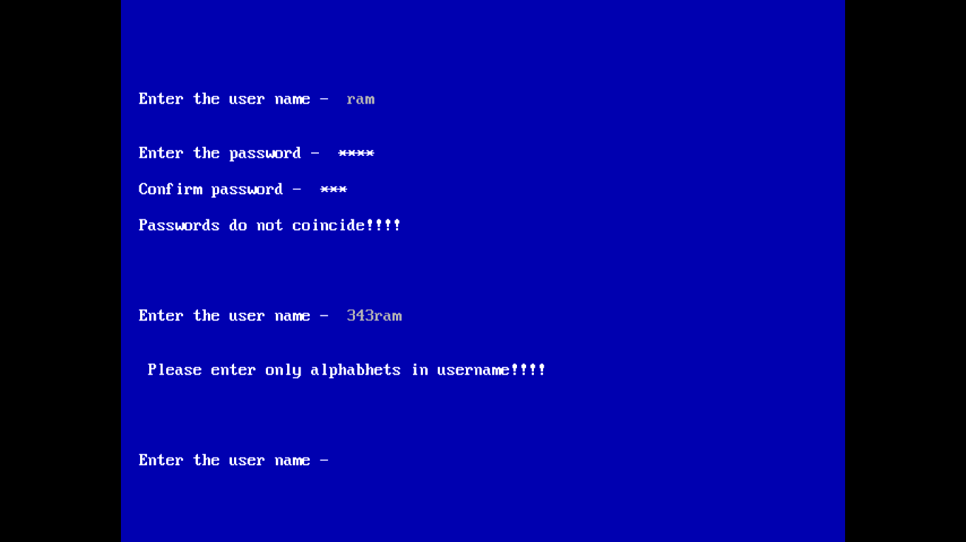

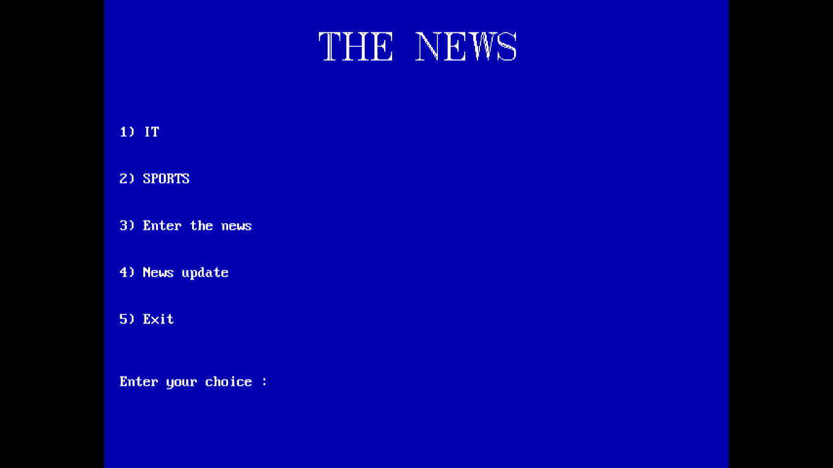

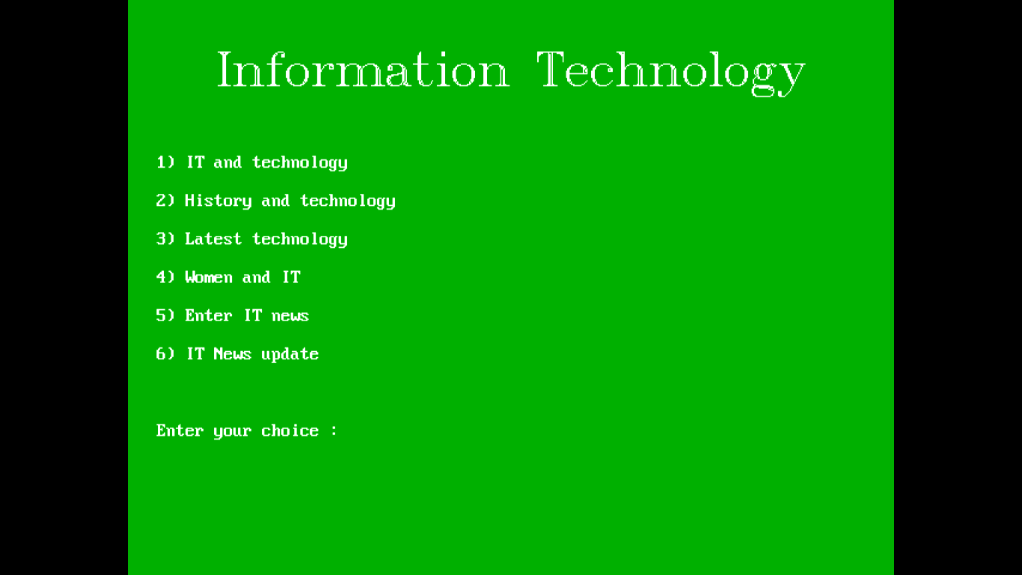

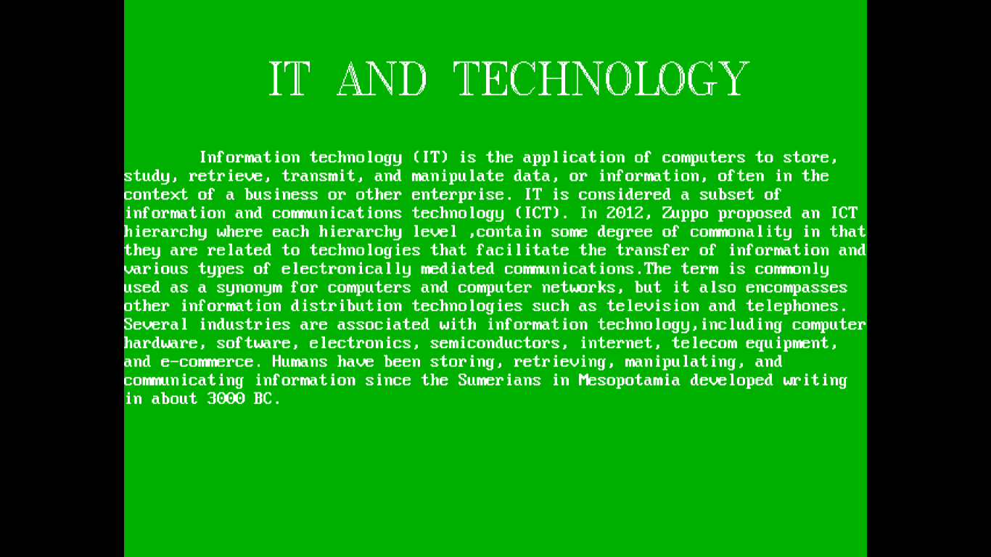

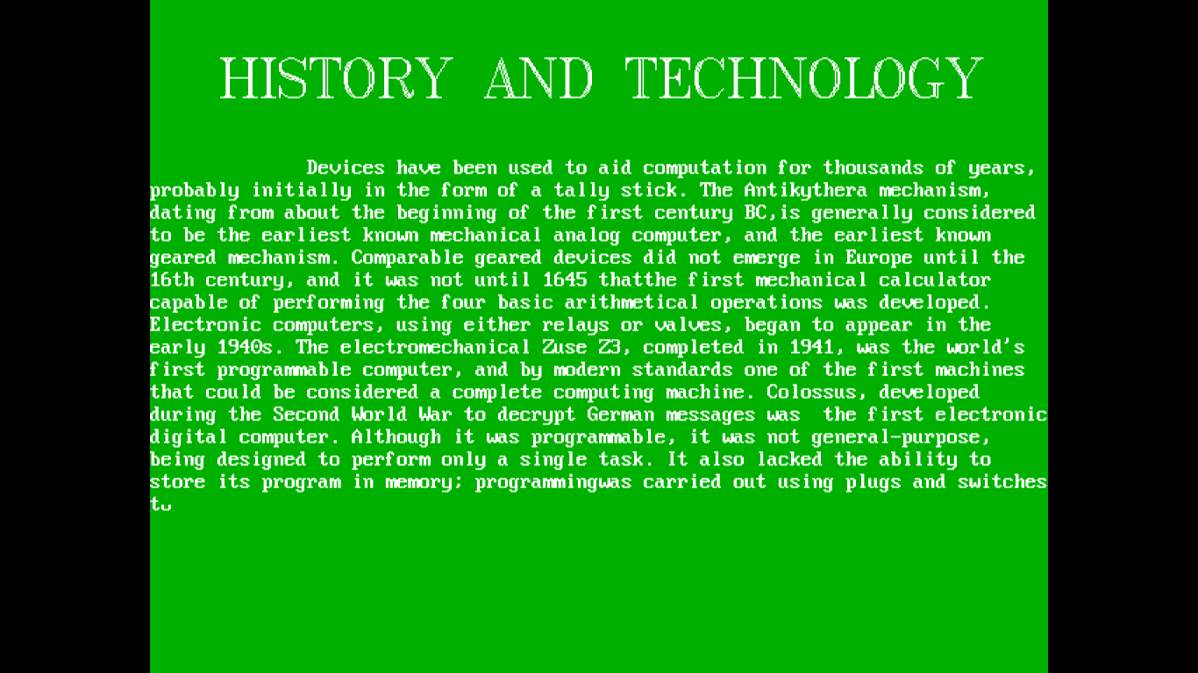



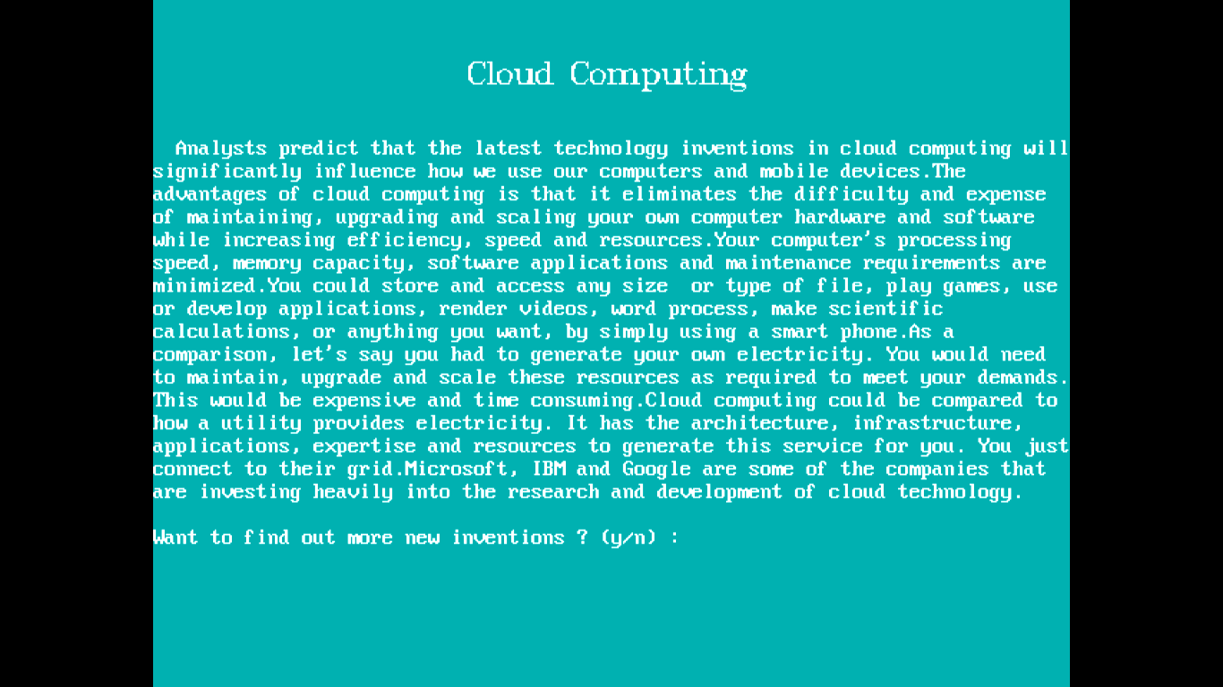

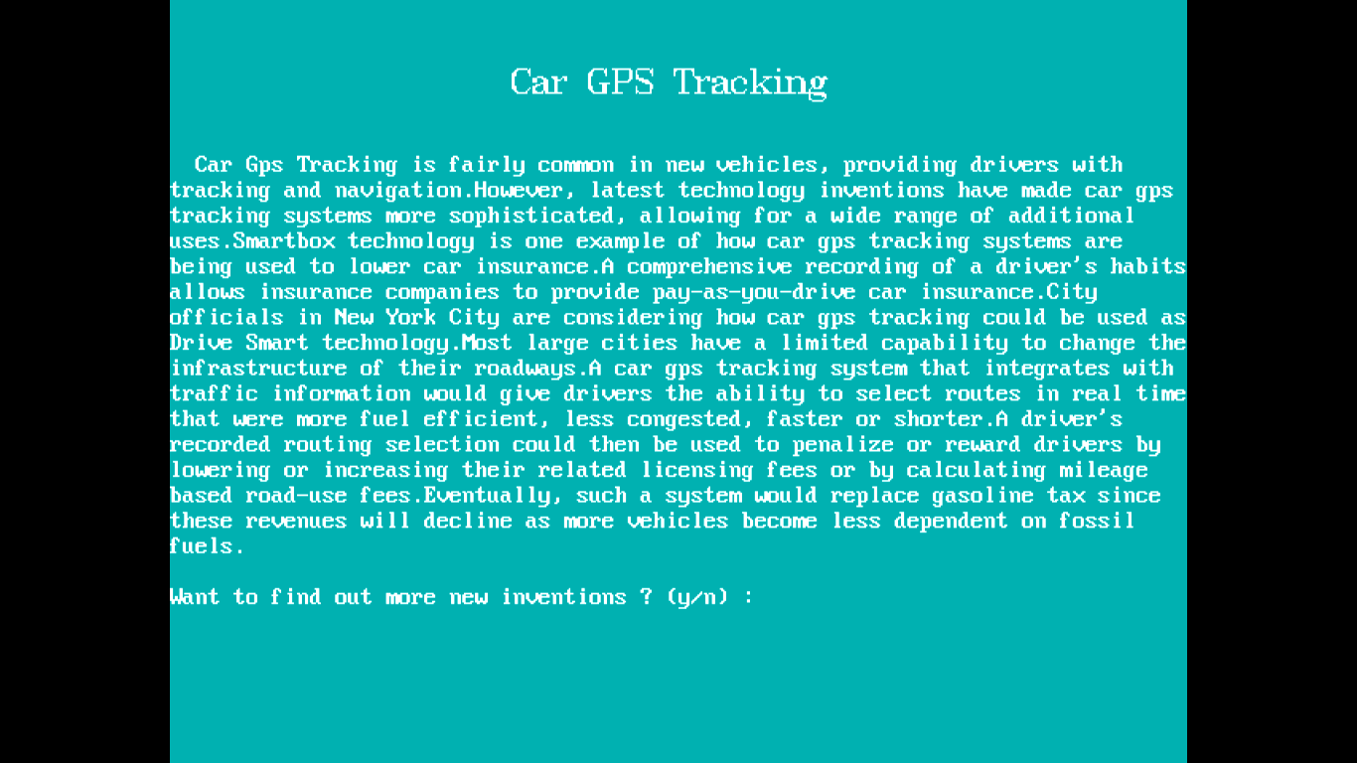

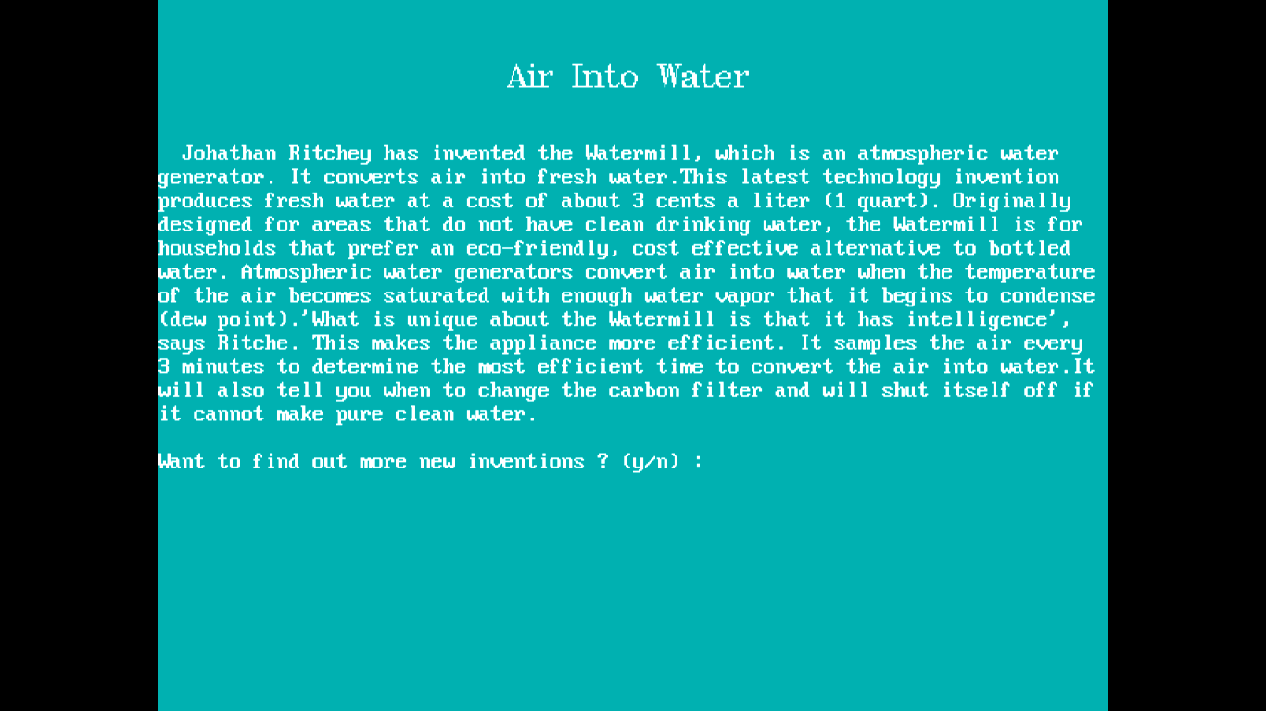

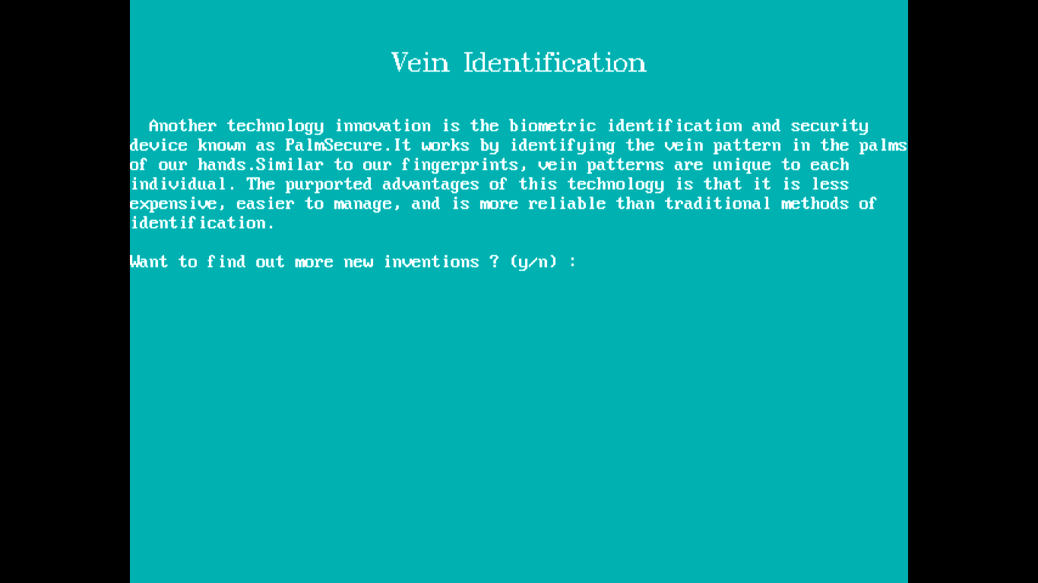

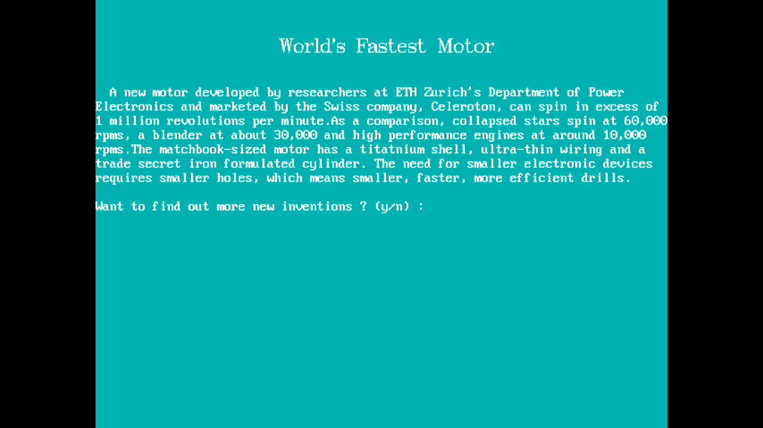

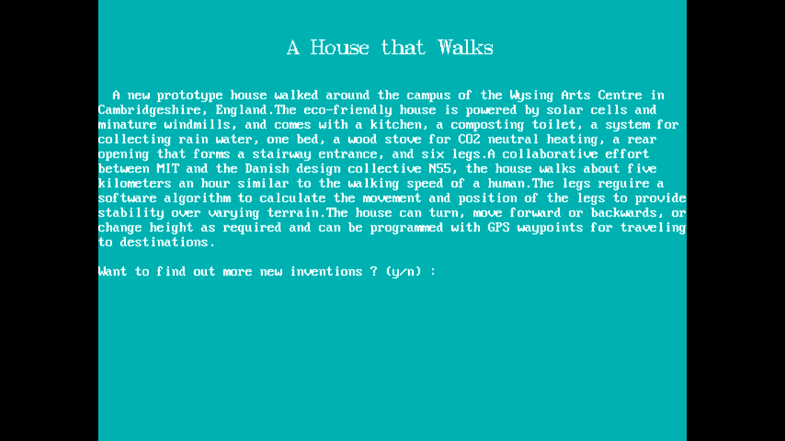



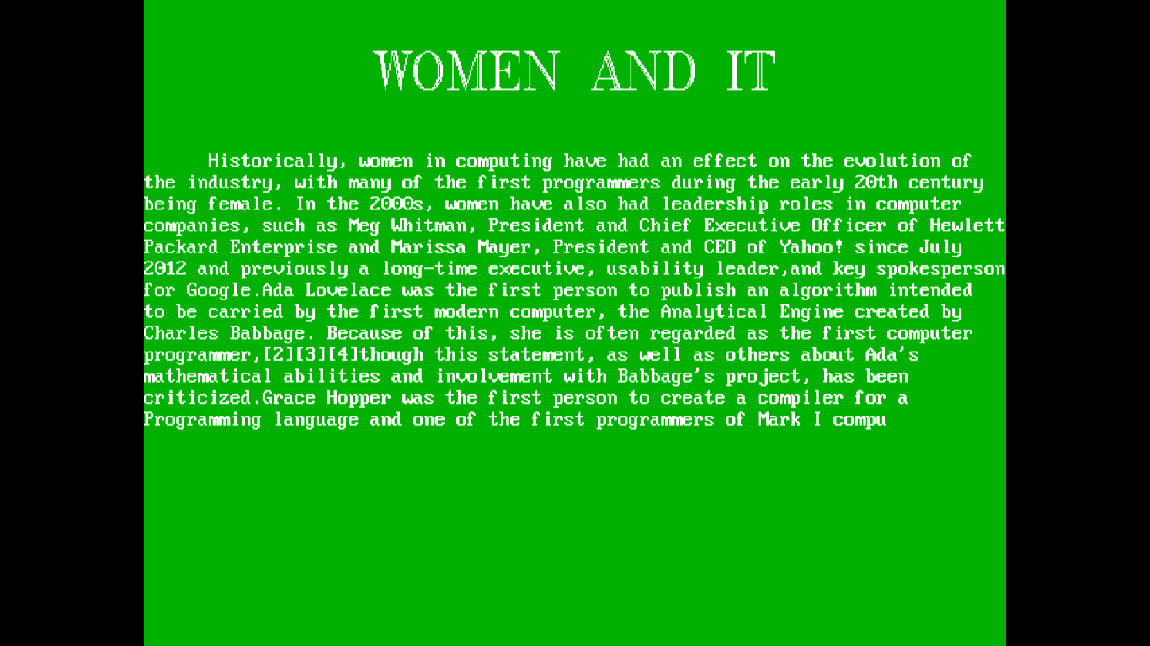

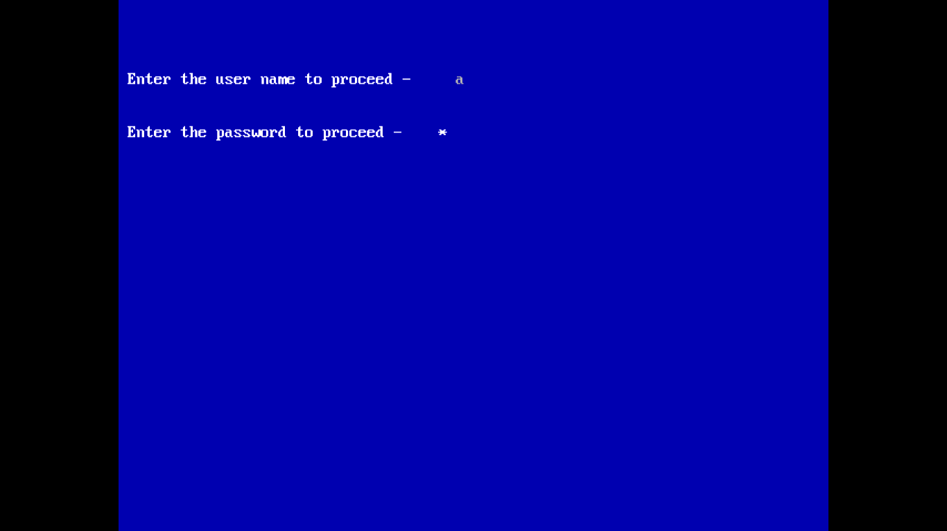

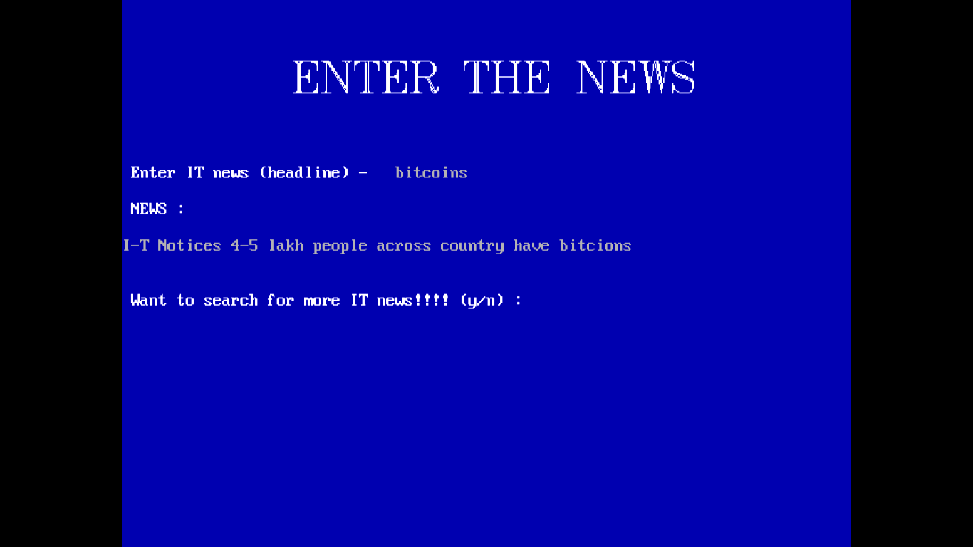

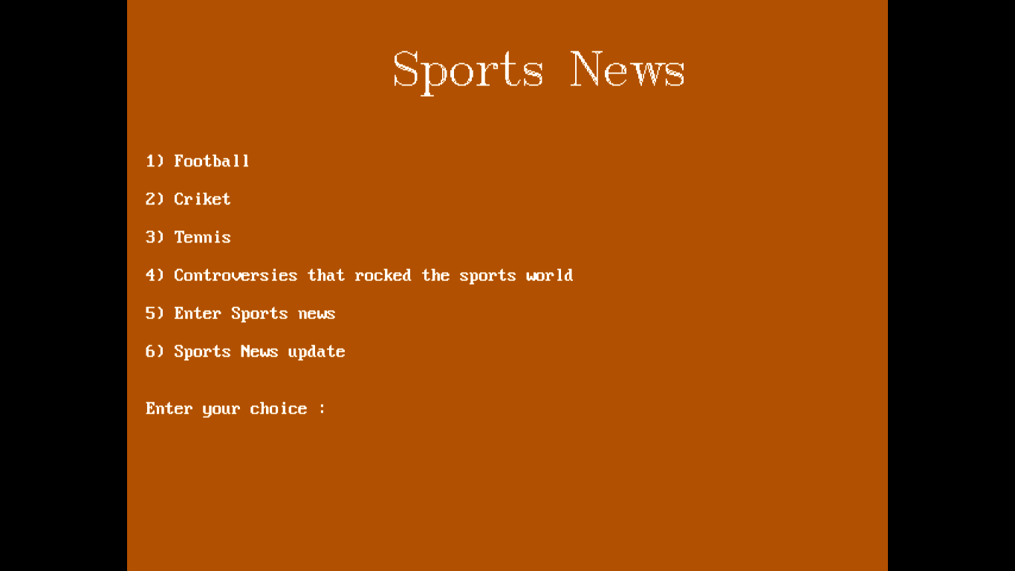

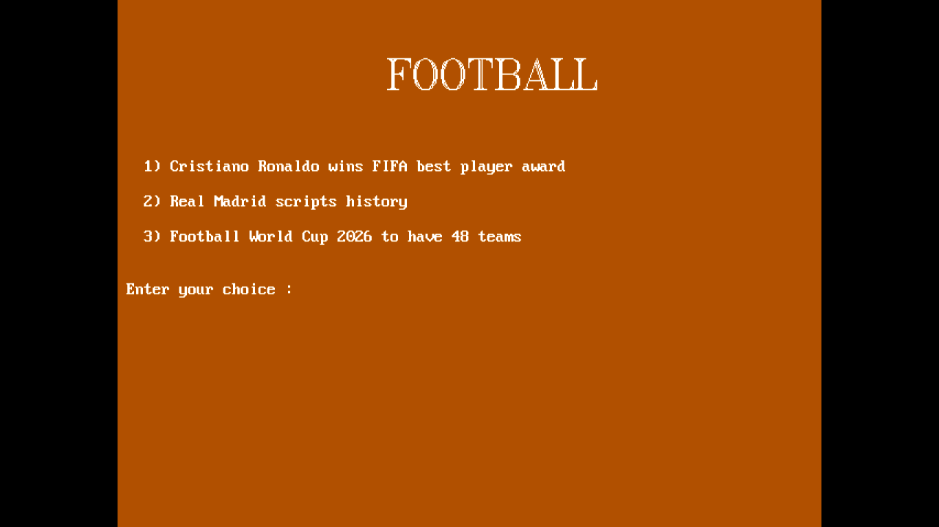

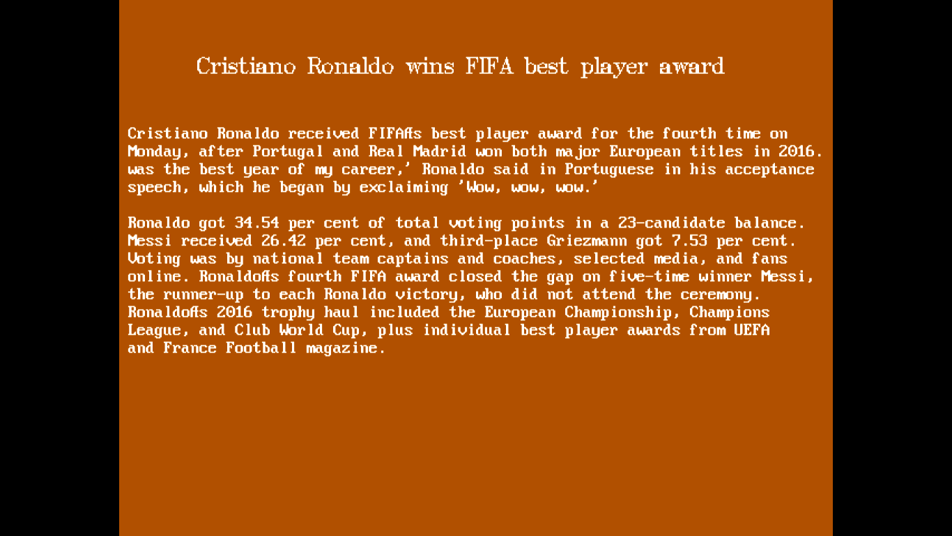

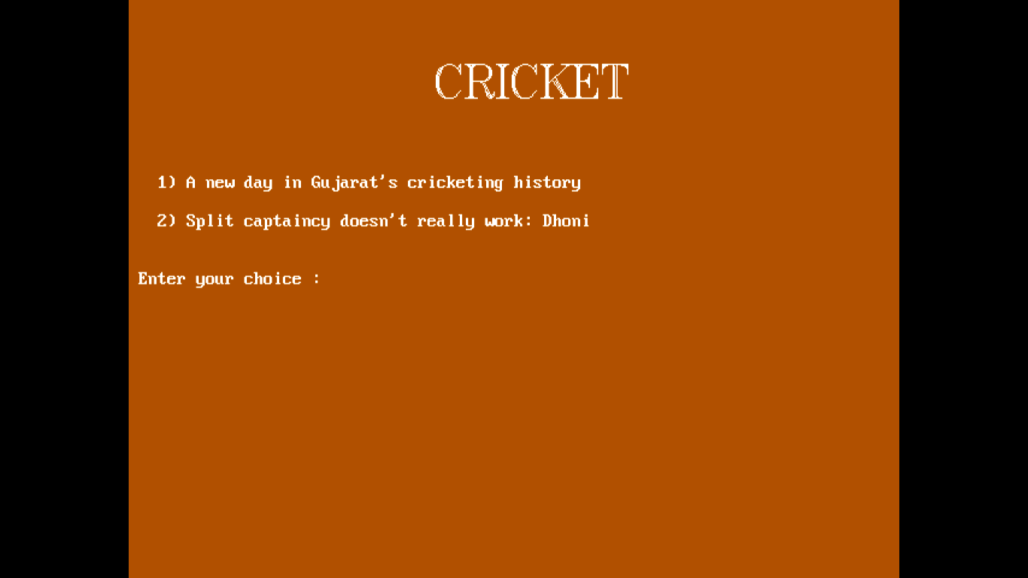

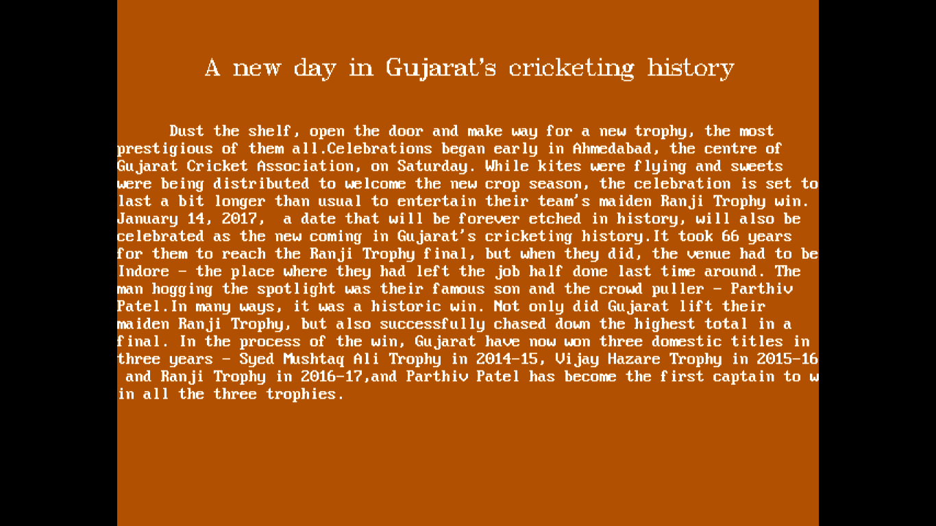

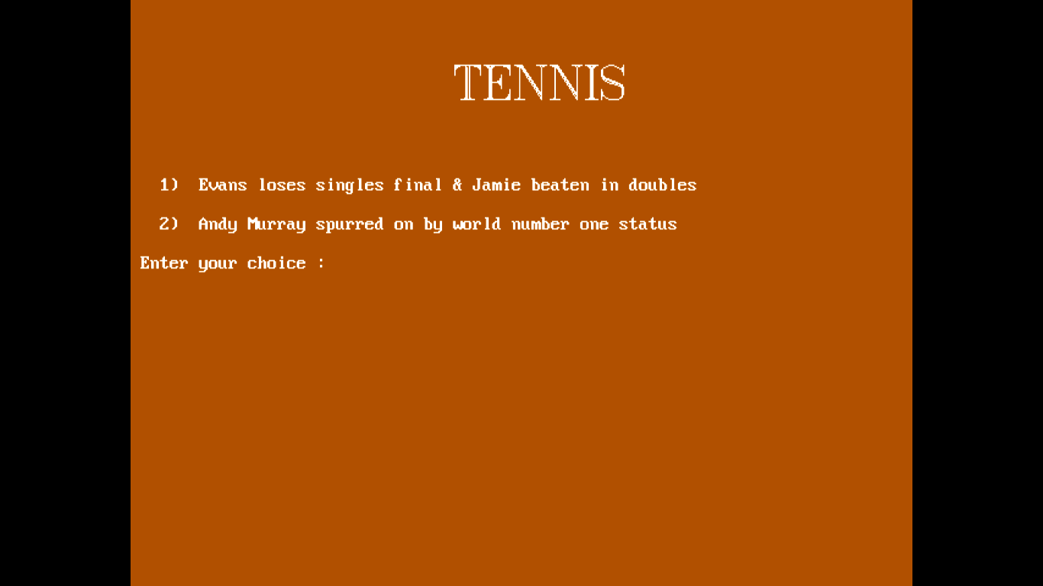

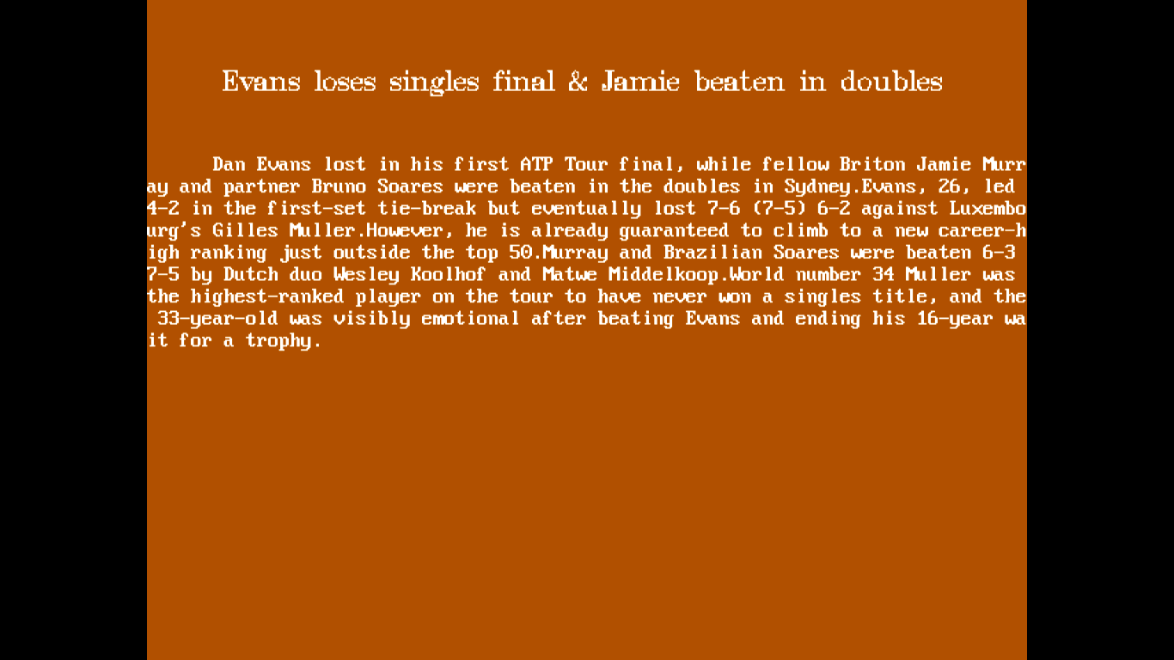

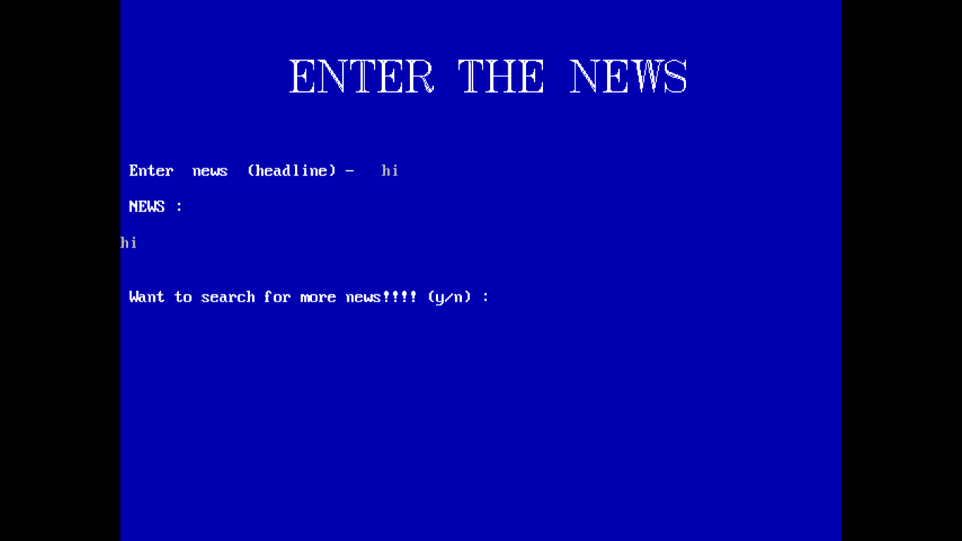



Future enhancement:

(HOW WE CAN IMPROVE)

* Allow user to edit the news.
* Adding more entertainment like games and other activities.

**BIBILIOGRAPHY-**

Class 12th Computer science textbook

www.google.co.in

www.wikipedia.com