Gameio product and implementation proposal
  - Add ons local games personalization community and support
Prepared for the Gameio owner • 14 September 2026
Keep Gameio’s existing catalog at the center of the app. Let users import their own add-on and keep using local games alongside it. Look up download sources when a game is opened, using the current server links for the first test. Add a normal comment thread inside game details so players can joke, react and talk about the game.

The recommended product direction
Gameio’s catalog is intended to cover every game, independently of installed add-ons. Users browse that catalog immediately. An add-on answers one narrower question: where can this selected game be obtained? A local file answers whether it can be launched now. Importing an add-on must never create a separate catalog or hide local games.
Priority | Recommendation | User outcome
1 | Import one JSON add-on and look up sources on demand | Use the current server links as the test dataset.
2 | Simple local folders and favorite games | Use existing files and get a useful first Home.
3 | Voluntary support | Help fund the project through a website checkout.
4 | Game comments and replies | Talk, joke and react inside game details.

What stays
Keep the current landscape handheld composition, large hero covers, vertically scrolling genre sections, platform tabs that scroll with the hero, and the R3 button-guide toggle. Keep installed games playable offline and retain existing download, emulator and save flows while replacing how sources are obtained. Empty Recommendations and Favorites sections remain hidden.

What changes
Add a Sources area in Settings, an import option during setup, and an optional favorite-game selection. Put Comments inside game details and Support Gameio in Settings and the website footer. Avoid adding a separate Picks page or a donation banner to the game carousel.

Setup with a simple import option
Version one has no add-on store, discovery page or publisher browser. The add-on option opens a JSON file picker. Users bring the file themselves. Importing an add-on and loading local games are compatible actions, not separate account or library modes.
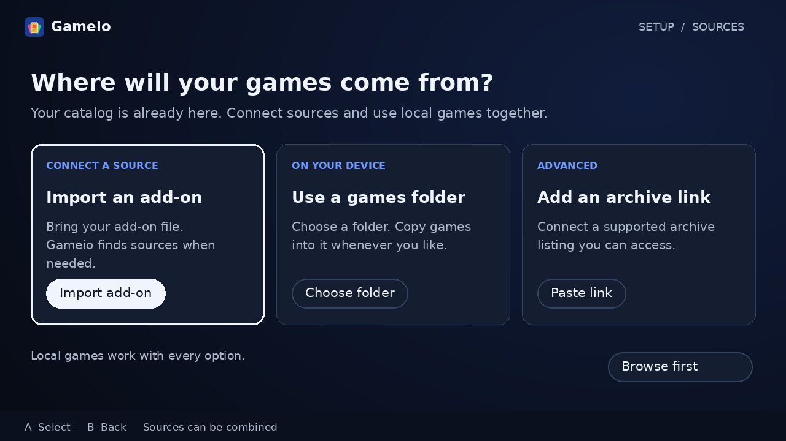
Concept 1 Import your own add-on while keeping a games folder available with every setup choice

Proposed first run
Welcome → account → sources → games folder → systems and emulator setup → optional favorites → Home. Reuse the existing setup steps. Skip remains available for sources and favorites, and source setup can be revisited in Settings.
- Import add-on opens the system file picker. Validate the JSON, show its name and requested connections, then let the user confirm. Save a private copy so moving the original file does not break the installation.
- A local games folder is available regardless of the chosen source option. Choose it once and then copy files with a file manager or PC. No per-game import wizard is needed.
- A manual archive-link option may use the same adapter later. It is not required to prove the first add-on implementation, and unsupported URLs should not trigger a generic web scraper.

Reach Home without indexing a collection
After importing, show “Add-on connected” and continue immediately. Do not scan every linked archive. The existing catalog provides the games, descriptions and artwork; source discovery waits until the user opens a game. With no add-on, the full catalog and the user’s local games remain accessible.

Import once and find sources when needed
An add-on contains instructions for finding sources. It does not supply the game catalog. Keep the entire first release to Import, Reimport, Enable or Disable, and Remove. Reimport is the simple version-one update mechanism.
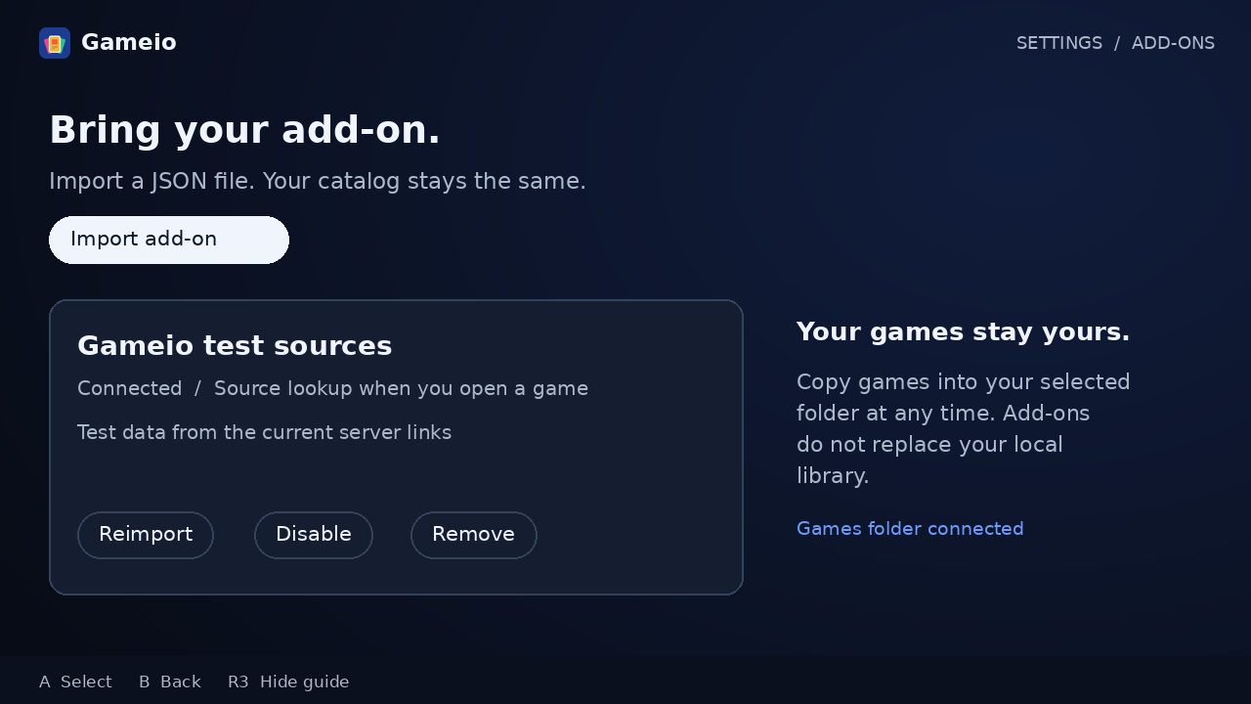
Concept 2 Import-only add-on management using the current server link set as an illustrative test source

What happens when a game is opened
Render its existing details immediately. If it has a usable local file, offer Play. Otherwise ask the enabled add-on for sources using the catalog game ID and platform, then region or revision when available. Show “Checking sources…” beside the download action, without blocking details, comments or Back.
When a match arrives, show Download. If several editions match, remember the chosen edition and expose Change source. If the lookup completes with no match, show “No source found.” A timeout or an unavailable archive gets Retry, not a false “No source” result. With no add-on, offer Import add-on.

Local games always remain available
A downloaded or manually copied file appears under the same catalog game. The source lookup is unnecessary for launching it. Removing or disabling an add-on does not remove games from the catalog, delete local files, or alter favorites and saves. The app only clears that add-on’s cached source results.

Lookup on demand instead of indexing everything
Searching when the user opens a game is the recommended design. The important distinction is between a small manifest and the data it points to. Fetching one enormous JSON file and then searching it on every click would move the same indexing problem into game details.
Layer | Proposed responsibility
Gameio catalog | Supply game IDs, platforms, descriptions and artwork before an add-on is installed.
Small imported manifest | Name the adapter and source locations. Contain a small amount of configuration, not every file in every archive.
Client source lookup | Fetch the relevant game mapping or a small index chunk. Match the selected game and cache the result.
Source host | Serve the referenced index chunk, archive listing or game file directly to the device.

Recommended first lookup strategy
Prepare the existing server mappings into small static index chunks keyed by catalog ID and platform. The imported manifest describes how to select a chunk. Opening a game fetches only its chunk, matches the exact ID and platform, and returns candidates. This works without downloading the full mapping to the handheld and without requiring a new live search service.
If the current links point only to archive collections, route by platform first, then inspect a relevant listing and cache it. This fallback can still be slow for a huge collection. Prefer the existing matched mappings where present; measure chunk sizes on the actual dataset before choosing how many chunks to generate.

Keep the interface fast and honest
Cache positive results and briefly cache confirmed misses. Deduplicate simultaneous requests and limit concurrency. Cancel screen-bound lookups when focus changes, while allowing explicit downloads to continue. Cached results can appear immediately, with stale URLs refreshed on download failure. An initial network failure is not a confirmed miss.
Keep All games and On device filters. Do not promise a complete Available filter in version one: source availability is unknown until checked. Never hide an unchecked game from Home or start thousands of lookups while scrolling.

Server scope and rights
Use the current server links as a controlled test fixture, as requested. That tests behavior, not permission to distribute every file. Moving lookups does not itself establish a legal exemption. Production source distribution and metadata licensing still need their own review; source 6 gives general rights guidance.

Local games and a personal first Home
Ask which games the user loves after source and system setup. Make this optional, searchable and controller friendly. Let users pick 3 to 5 games across their chosen systems, with a visible selection count and Skip.
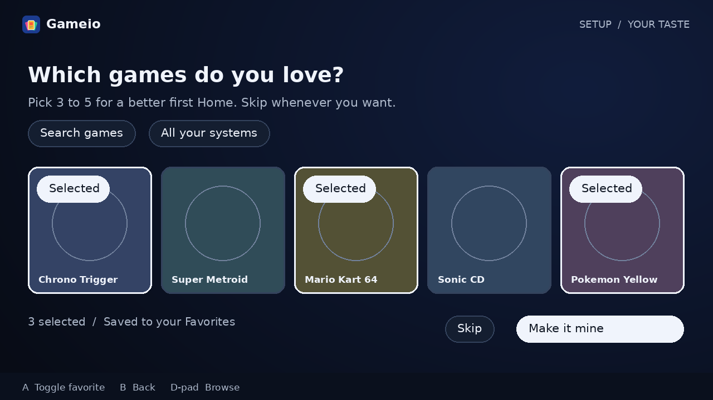
Concept 3 Optional favorites selection with illustrative cover placeholders and a clear skip action

Turn choices into useful discovery
Save selections as actual Favorites, with the copy saying so. Use genres, themes and systems from those games to seed recommendations, then blend in variety and later play history. Explain rows with labels such as “Because you like Chrono Trigger.” A selection never triggers a download. Users can edit their favorites or reset personalization in Settings.

Keep local import as a folder workflow
Choose one root folder, with optional system subfolders such as Games/SNES and Games/Wii. Scan on returning to the app when content may have changed, using a debounced background task and a manual Rescan fallback. Do not rely on a file watcher working for every Android document provider.
Match copied files to the existing catalog by system and title or file identity. A failed match is a matching problem, not proof the game is absent from the catalog: keep the file visible and offer Correct match. The inspected RomScanner skips unmatched files and leaves URI scanning unimplemented. Fix those gaps, preserve folder access and group multi-disc files without duplicating catalog games.

Comments that feel like a real community
Use a familiar YouTube-style comment thread inside each game’s details. The purpose is to hang out around the game: jokes, memories, reactions, questions and arguments about the final boss. Do not turn it into a review form or require players to write useful tips.
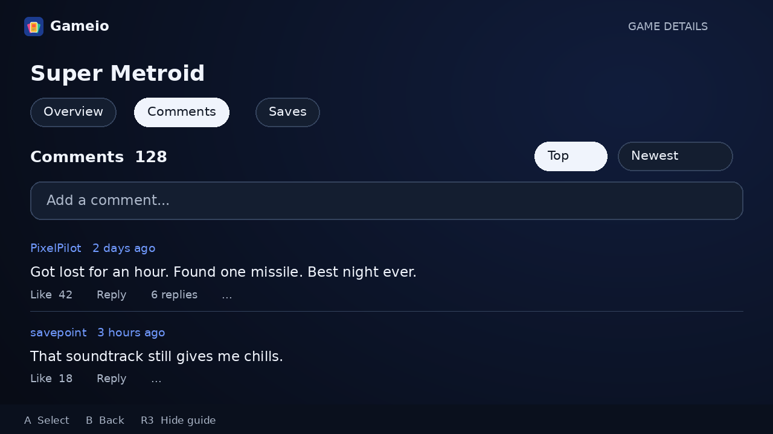
Concept 4 A normal game comment thread with a composer, likes, replies and Top or Newest sorting

The first comment experience
Show Comments with a count, an “Add a comment…” composer, and Top or Newest sorting. Each comment has an avatar, display name, timestamp, text, Like and Reply. Collapse replies behind “View replies” so long conversations do not dominate the screen. Players can leave multiple comments and edit or delete their own.
Allow emoji and natural conversation. Keep text entry on the existing virtual keyboard. Remember the user’s position when opening replies or returning from another screen. The primary game information and Play action should remain quick to reach; comments are a section or tab within details, not a new top-level feed.

Keep controls out of the conversation
Put Report, Block and moderation actions in the overflow menu. Provide optional spoiler hiding. Rate limiting, plain-text rendering and a moderator queue run behind the scenes; the UI should not lecture people before they post. Keep download-source sharing out of comments through a concise policy and moderation rather than large warning panels.

Build on real activity later
Begin with comments, likes and replies. Later, add opt-in reply notifications, pinned comments and mentions if people actually use the discussions. Avoid a separate social network, direct messages or automated conversation prompts in the first release.

Donations that fit the product
Use the label Support Gameio. Place it in Settings and the landing-page footer, with a dedicated website page explaining what contributions support. Keep the Home game rows focused on games.
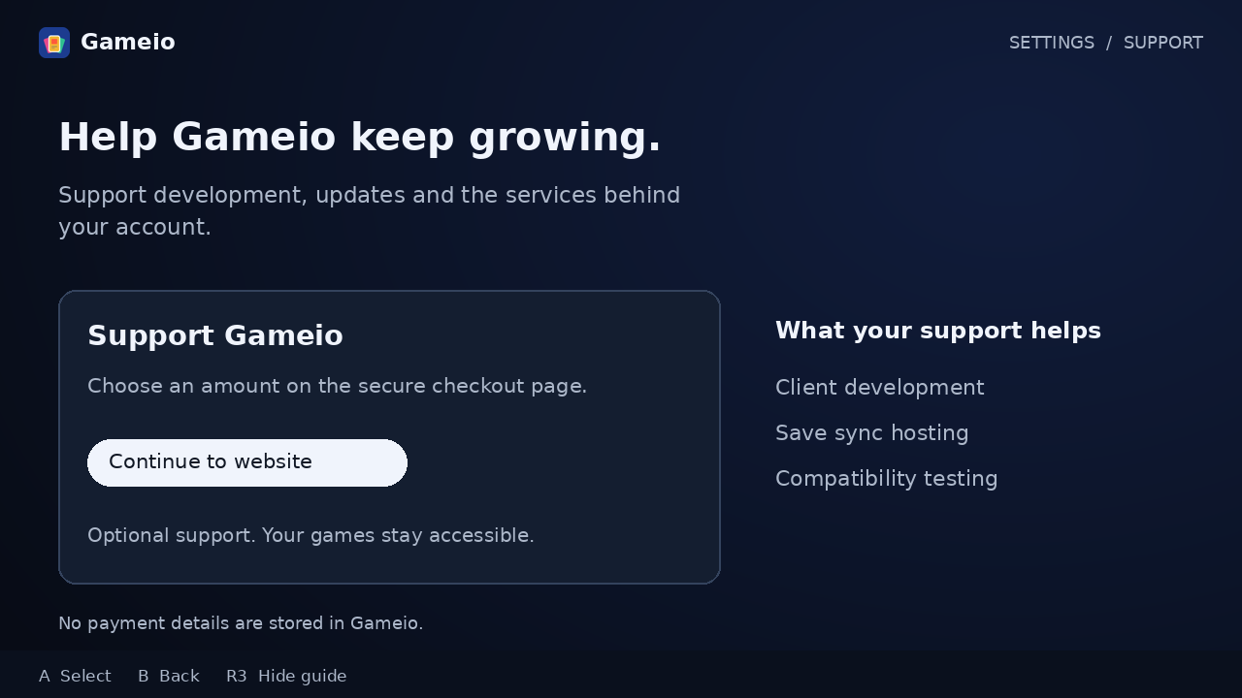
Concept 5 An optional support screen opens a website checkout and keeps payment details outside the client

Start with a simple checkout
Offer one-time contributions first through a hosted payment page. Add recurring support only when there is a clear budget and a provider available for the project’s business location. Show the currency, final amount and payment terms at checkout. Do not treat a return URL as proof of payment; use verified, idempotent provider events if supporter status is introduced.

Make support credible
Explain the actual costs: client development, save hosting and device testing. Publish occasional development updates and real cost figures when available. An optional supporter badge can be considered later, but it must be hidden by default on public profiles and should not unlock game access or change recommendations.
Do not ask for a donation during setup, before a download, or after every session. A user who never contributes should retain the same browsing and local-play experience. Avoid describing contributions as charitable or tax-deductible without establishing that status.

A small implementation boundary
The first release needs a website page and an app link. It does not need an in-app wallet, stored payment cards or custom billing infrastructure. Provider selection and final copy remain decisions for the owner before publishing payments.

Deliver in phases with clear exit checks
First prove an imported add-on can find a selected game using the current source dataset. Then connect that lookup to downloads and setup. Donations can ship independently once a payment destination is configured. Comment implementation follows as a distinct feature with its own server data and moderation controls.
Phase | Deliverable | Exit check
1 | Import-only JSON add-on, on-demand lookup and current server links as the test fixture. | Opening one game retrieves only its relevant mapping and returns the expected source.
2 | Source setup, simple folder import, unmatched local entries and favorite seeding. | A new user reaches Home through each source route, including offline local import and skipped favorites.
3 | Transition existing users and remove production server source dependencies. | Existing installed games and saves remain usable; new clients require no legacy source endpoint.
4 | Support page and hosted checkout. | Payment success is verified only when needed; canceling returns cleanly with no access changes.
5 | Game comments, likes, replies and Top or Newest sorting. | Players can post and reply; report, block, delete and moderation actions work.

Migrate without changing game identity
Use a feature flag and a small client pilot before making add-ons the default. Keep catalog identifiers stable and identify a playable edition by platform, region, revision and file information. Sources are replaceable ways to obtain that edition. Changing or removing a provider must not create a new save identity or combine incompatible saves.
Generate the first test add-on from the current server link set, preserving the existing mappings. Keep private credentials and signed or expiring URLs out of a distributable manifest. Use an explicit test import, not a silent installation. Once lookup and downloads pass, transition clients deliberately and then retire production source resolution, indexing and proxy dependencies. Preserve installed files and keep account and save APIs compatible.

Measure outcomes without source secrets
Measure setup completion, time to first usable Home, add-on installation failures, successful downloads, unidentified local files and scrolling performance. Use aggregate diagnostics that omit credentials, full private URLs and personal folder names. Do not make full telemetry a condition for local play.

The first test add on contract
Use the current server source set to test the provider boundary rather than inventing a different library. Snapshot the non-secret source mappings for a controlled test. Keep the old flow available during the pilot so results can be compared without changing users’ files.

Illustrative manifest
{
"schemaVersion": 1,
"id": "gameio.test.sources",
"name": "Gameio test sources",
"adapter": "catalog-shards-v1",
"lookup": {
"key": "catalogId:platformSlug",
"partition": "sha256-prefix-2",
"urlTemplate": "https://example.org/test/{shard}.json"
},
"allowedHosts": ["example.org"]
}
This is a proposed schema, with a placeholder URL. SHA-256 prefix partitioning is an example, not a fixed decision: the generator and client must use the same UTF-8 key and lower-case hex rule. Measure the actual dataset; use smaller or per-game files if a chunk is too large. Add file hosts explicitly to the approved host list.

How to build the fixture
Export existing matched game and platform mappings into static chunks with source ID, filename, region or revision when known, checksum when available, and either a stable file URL or an adapter locator. Keep test artifacts separate from credentials. For archives that need resolution, port the required resolver into the client and store its input locator instead of a short-lived resolved URL.
The client imports the manifest, constructs the selected game’s lookup key, fetches one chunk and filters exact matches. Cache by add-on version, game, platform and edition. Reimport invalidates changed source results; it never changes catalog identity. JSON supplies data to built-in adapters and cannot execute arbitrary code.

What this test must demonstrate
A fresh install imports the file without browsing a store. Opening a known game produces the same candidates as the current server. Opening a missing mapping gives a confirmed miss; an unreachable host gives an error. Reopening a cached game avoids a redundant lookup. A local copy launches without any source request. Large catalogs do not trigger a full scan.
Validate file sizes, schema and allowed hosts, including redirects. Keep credentials in protected device storage. After the fixture proves the flow, choose how users obtain production add-on files separately from the Gameio catalog service.

Engineering map and acceptance checks

Where the current code informs this proposal
The following files were inspected on 14 September 2026. They identify integration points and observed limitations; they are not evidence that the proposed features are already implemented.
Source | Relevant finding
1 Client FirstRunViewModel.kt | Existing account, permissions, ROM folder, image cache, platform and core setup steps can be reused.
2 Client RomScanner.kt | The inspected file scanner updates matching catalog rows, skips unmatched files and has a URI-scanning stub.
3 Server endpoints/catalog.py | Catalog responses include sources. Download redirects and a streaming proxy currently resolve sources on the server.
4 Server handler/sources/indexer.py | Matches host file listings to catalog entries and records sources. Use these existing mappings to generate the first lookup fixture; source discovery moves to a client adapter.
5 Client docs/discovery-home.md and server docs/SAVE_SYNC.md | Discovery uses scoped, paged rows. Keep catalog browsing independent from on-demand source lookups and preserve save identity.

Acceptance scenarios before release
- Import the test add-on and open known game IDs on several systems. Compare returned candidates with the current server mappings; verify that each lookup fetches only the relevant chunk.
- Cancel setup, skip favorites, revoke folder access and lose network connectivity. Every case has a usable next action and no silent loss of files.
- Copy a game into the selected folder while an add-on is enabled. It appears under its catalog entry, and Play works without resolving a source. Failed filename matches remain visible for correction.
- Import malformed JSON, reimport changed host access, and simulate lookup timeouts. Preserve the previous valid configuration and distinguish a network error from a confirmed missing source.
- Exercise touch, D-pad, Back and R3 across the new screens. Verify restored focus, bounded loading and scrolling on a real handheld, not only an emulator.

Reference paths and rights guidance
Client sources 1 and 2 are under app/src/main/kotlin/com/nendo/argosy/ui/screens/firstrun/ and data/scanner/. Server sources 3 and 4 are under backend/. Source 5 uses the docs folders in the respective repositories.
6 U.S. Copyright Office, Copyright and Digital Files: https://www.copyright.gov/help/faq/faq-digital.html. General reference accessed 14 September 2026. The guidance distinguishes permitted backup copying from distributing backup copies; it does not authorize any particular Gameio source.

