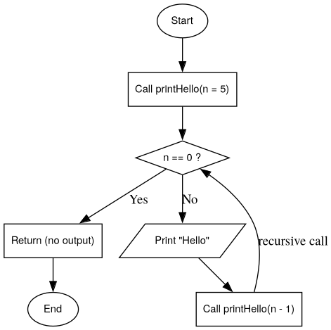
Phase 1:
- void print_hello(int n) {
// recur pritns hello
if (n == 0) {
return ;
}
cout << "Hello World!" << endl;
print_hello(n-1);
}

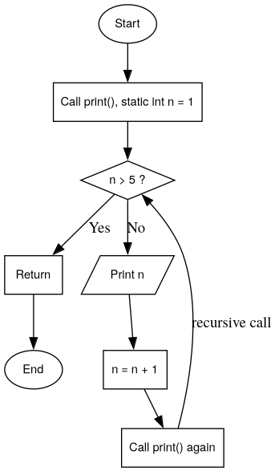

- void print_1_to_5() {
static int c = 1;
if (c > 5) {
return;
}
cout << c << endl;
c++;
print_1_to_5();
}

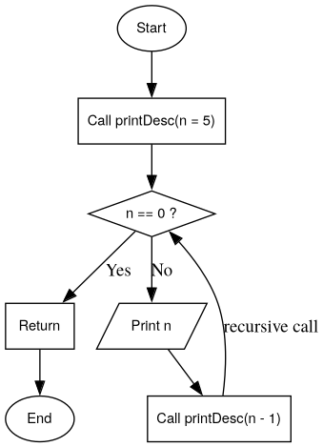
- void print_5_to_1(int n) {
if (n < 1) {
return;
}
cout << n << endl;
print_5_to_1(n - 1);
}

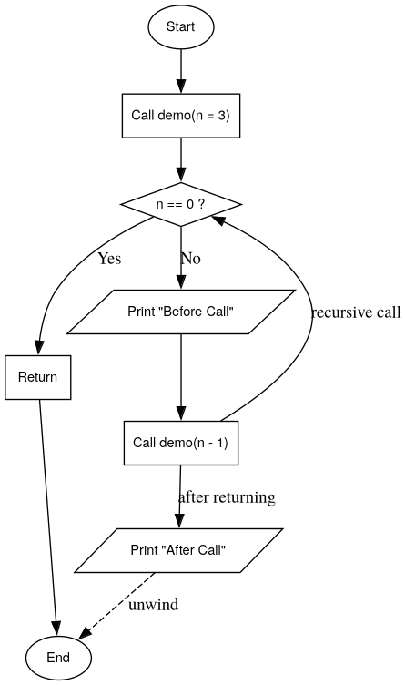
- void obeserving_order(int n) {
if (n < 1) {
return ;
}
cout << "Before call: " << n << endl;
obeserving_order(n-1);
cout << "After call: " << n << endl;
}

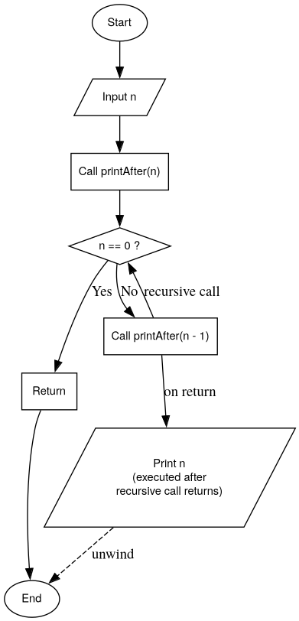
- voidprint_1_to_n_after(int n) {
if (n < 1) return ;
print_1_to_n_after(n-1);
cout << n << endl;

}

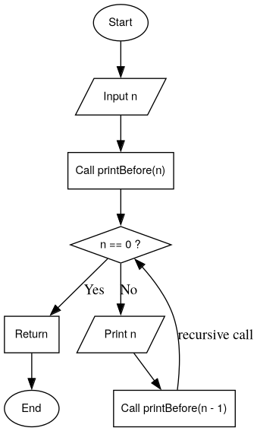
- void print_1_to_n_before(int n, int curr) {
if (curr > n) return ;
cout << curr << endl;
print_1_to_n_before(n, curr+1);
}

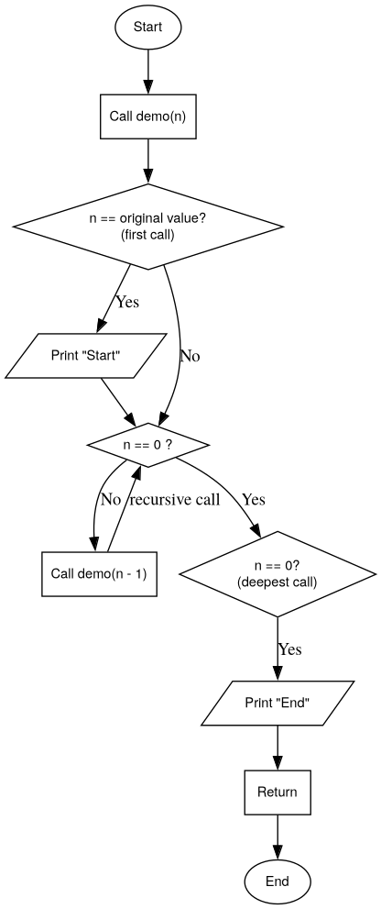
- void print_start_2_end(int n) {
static bool is_first = true;
if (is_first) {
cout << "First" << endl;
is_first = false;
}
if (n==0) {
cout << "End" << endl;
return;
}
print_start_2_end(n-1);
}

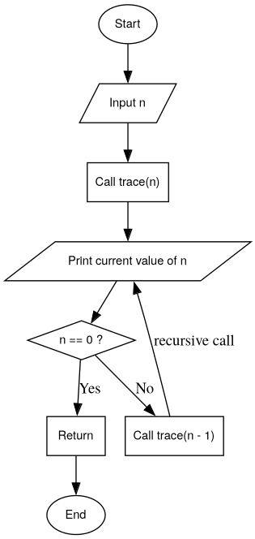
- void print_current_n(int n) {
if(n==0) return ;
cout << "Current n: " << n << endl;
print_current_n(n-1);
}

- void stop_at_zero(int n) {
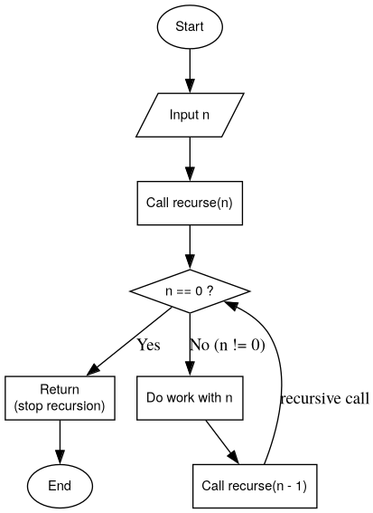
if (n == 0) return ;
stop_at_zero(n-1);
}

