CODE:-

s = input("Enter your string:")

l =[]

l = s.split()

print('Choices of actions that cah be performed:-')

print('\t1]Find the longest length in the string\n\t2]Occurance of a particular charcter is string')

print('\t3]Check if palindrome\n\t4]Index of substring\n\t5]Count of each word')

chi = int(input("Please enter the choice number:"))

def longlen(l):

w =[]

for i in l:

if len(w)<len(i):

w = i

print(w,'is the longest word in the string')

def occurance(l):

o = input("Enter the word to be seacrched:")

c = 0

for i in l:

if i == o:

c = c+1

print(o,"repeats",c,"times")

def palindrome(s):

p = s[::-1]

if p == s:

print("Entered string is a palindrome")

else:

print("Entered string is not a palindrone")

def substr(s):

sub = input("Enter your substring:")

print('Index of ',sub,'is',s.index(sub))

def count(l):

k = list(dict.fromkeys(l))

for i in range(len(k)):

print(F"'{l[i]}' repeats",l.count(l[i]))

if chi==1:

longlen(l)

elif chi ==2:

occurance(l)

elif chi==3:

palindrome(s)

elif chi==4:

substr(s)

elif chi==5:

count(l)

else:

print('Entered choice number is invalid')

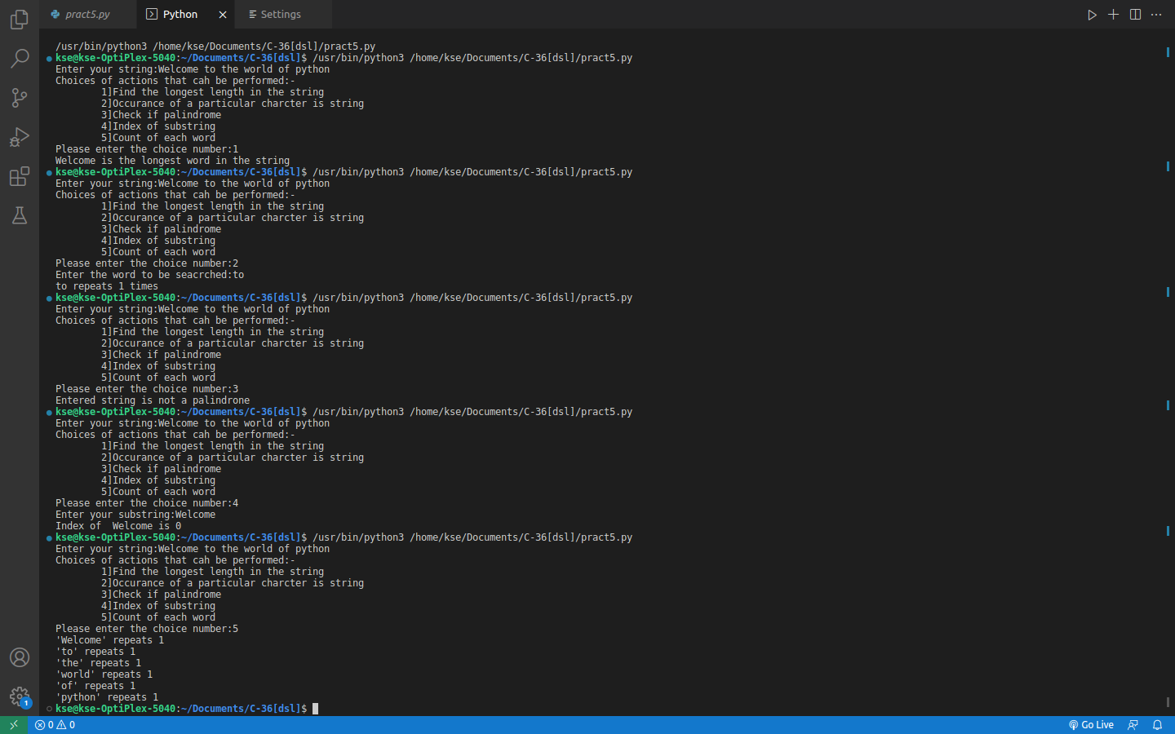

OUTPUT:-