Cambio

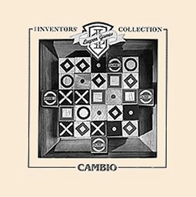

Kwei-you (Simon) Tao
Gamescrafters

Last Update: January 25, 2007

2
Table of Content

1. Rules................................................................................................... 3
1.1. Board and Pieces......................................................................... 3
1.2. Objective....................................................................................... 3
1.3. Game Setup.................................................................................. 3
1.4. Game Play.................................................................................... 4

2. Design Decisions................................................................................ 5
2.1. Hash............................................................................................. 5
2.2. Tier Numbering............................................................................. 5
2.3. Hash Context................................................................................ 5

3. Variants............................................................................................... 6
3.1. Board Size.................................................................................... 6
3.2. Initial Placement........................................................................... 6
3.3. Misère........................................................................................... 6

3
1. Rules

1.1. Board and Pieces
Cambio is played on a 5 by 5 square board.

Cambio has 25 pieces. For two-player, non-chance combinatorial games, the pieces can only take the value: neutral, X, or O.

1.2. Objective

The objective of Cambio is to make a line composed of 3, 4, or 5 (depending on the board size) of your own symbol – horizontally, vertically, or diagonally.

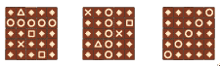

1.3. Game Setup

To start the game, the players each select a symbol to be their own, and decide who will begin the game. In the following diagrams the first player (Player A) has chosen circles, and the second player (Player B) has chosen triangles.

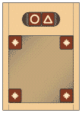

Remove the cubes from the board, leaving with only 4 neutral symbols – one in each corner of the tray.

Alternatively, starting with player A, each player will place one of his/her opponent's piece on the board. Each player should avoid placing his/her opponent's pieces in consecutive orders.

After each player has finished placing the pieces (3, 4, or 5 according to the board size) on the board, fill in the rest of the positions with neutral symbols.

4
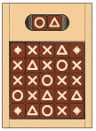

1.4. Game Play

Each player in turn places a cube of his/her symbol, at the beginning of any row or column; frees the end cube by lifting it from the board; then pushes all the pieces in that line along one place. Note: A player MAY NOT push cubes with his/her opponent's symbol showing OFF the board. (e.g. player A may not push along a line that has a triangle at the far end.)

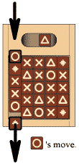

A player may only push off neutral cubes, or cubes of his/her own symbol. As the game progresses, each player should have more and more of his/her own cubes in play.

The first player to make a line of 3, 4, or 5 (depending on the board size) of his/her own symbol wins. A draw occurs when a move makes a row of 3, 4, or 5 for both of the players simultaneously

5
2. Design Decisions

2.1. Hash

Generic hash is used in both regular gamesman and tier gamesman.

2.2. Tier Numbering

In tier gamesman, tier numbers are labeled as follow:
- a total sum is used to represent the tier number
- for each X on the board, we add 1 to the sum
- for each O on the board we add # of O's (times) boardsize^2
e.g. a 3x3 board with 2 X's and 3 O's would have a tier number of
2 + 3*9 = 29

2.3. Hash Context

Since we are solving each tier using a different hash, the hash context scheme is as follow:
- the original gamesman hash is numbered as boardsize^3 to avoid conflict with tier hashes
- the tier gamesman hashes are numbered using their tier numbers or
# of X's + # of O's*boardsize^2

6
3. Variants

3.1. Board Size

Cambio currently supports 3x3, 4x4, or 5x5 board size using tier gamesman. 4x4 and 5x5 boards take considerable amount of time to solve.

3.2. Initial Placement

Players can also choose how many pieces to be placed in the initial placement phase.

3.3. Misère

The misère mode is also supported.

7

