Handout Highrise

Statistics of efforts:

Overall usecase diagram:

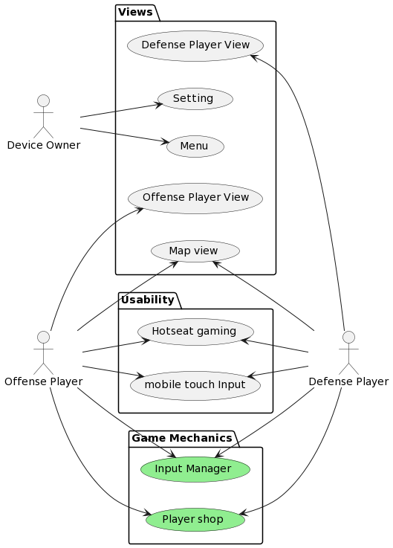
Architecture style and decisions:
We chose Godot as our Game Engine for Highrise. This was for multiple Reasons. The two main reasons were, that multiple team members had already experience working with Godot, and Godot’s Architecture enables our team to work in a familiar Object Oriented environment.
For the Game itself, we chose to use an Event-Driven approach. This was especially easy to implement, as Godot already has first-class support for signals which are Godot’s interpretation of events. Other than the ease of implementation, the Event-Driven architecture enables us to treat the game as a simulation itself. If for example, an attacking character enters the vision of a defending character, the defending character can send an event to all other defending characters and notify them of the intruder. The event in this example would simulate a shout from the first defending character.
Furthermore, we decided to treat inputs which interact with screen space items such as menus differently that inputs which interact with the 3D World of the Game itself. This was done as the screen space inputs can be easily handled by Godot’s control nodes, while world space inputs need a custom implementation which we provided in the “InputManager”.
Because Godot completely separates graphics and visuals from physics and from audio, we had an easy time enforcing the separation of responsibility design pattern. A non-custom Node always provides either visuals, behaviour/physics or sound. As sound can be added later and isn’t necessary for a first working prototype, we are going to postpone sound design and implementation for now.

Software used for development:

