Handout Highrise

Statistics of efforts:
Work Type | Spent time
Analysis & Design | 12h
Implementation | 30h
Projectmanagement | 30h
Requirements | 15,5h

Member | Time
Bence | 4h
Benedikt | 30,1h
Lars | 29,5h
Lukas | 8,5h
Cesar | 21,5h

Overall usecase diagram:

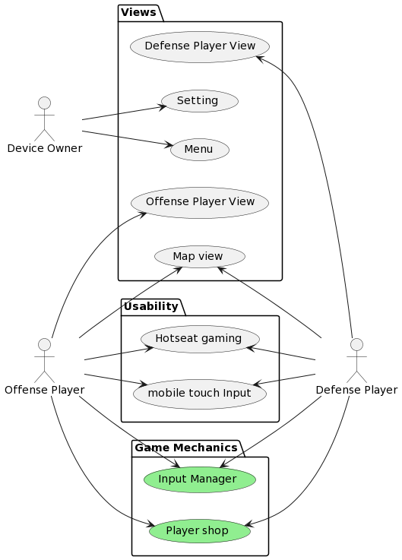
Architecture style and decisions:
We chose Godot as our Game Engine for Highrise. This was for multiple Reasons. The two main reasons were, that multiple team members had already experience working with Godot, and Godot’s Architecture enables our team to work in a familiar Object Oriented environment.
For the Game itself, we chose to use an Event-Driven approach. This was especially easy to implement, as Godot already has first-class support for signals which are Godot’s interpretation of events. Other than the ease of implementation, the Event-Driven architecture enables us to treat the game as a simulation itself. If for example, an attacking character enters the vision of a defending character, the defending character can send an event to all other defending characters and notify them of the intruder. The event in this example would simulate a shout from the first defending character.
Furthermore, we decided to treat inputs which interact with screen space items such as menus differently that inputs which interact with the 3D World of the Game itself. This was done as the screen space inputs can be easily handled by Godot’s control nodes, while world space inputs need a custom implementation which we provided in the “InputManager”.
Because Godot completely separates graphics and visuals from physics and from audio, we had an easy time enforcing the separation of responsibility design pattern. A non-custom Node always provides either visuals, behaviour/physics or sound. As sound can be added later and isn’t necessary for a first working prototype, we are going to postpone sound design and implementation for now.

Software used for development:
As mentioned in the previous paragraph, we made the decision to use Godot. Godot is a free and open-source game engine used for creating 2D and 3D games. The engine itself is written in C++ and uses a built-in scripting language called GDScript which is based on Python. In addition, the game engine comes with its own IDE which we use as the main platform for creating and implementing the game.
Additionally, we use Blender which is an open-source program used for 3D modelling, animation and post-production. A common use for Blender is the creation of 3D models for video games. While most of the models that will be used for the game are free ones form the Internet, we need Blender for altering existing models and creating simple new ones.
Since Project Management is also important in order to keep a project on track, we decided to use YouTrack which is a web-based project management and issue tracking tool by JetBrains. It. Provides us with the possibility of creating agile boards, issues and sprints and helps us structuring and managing our project, as well as the time spent working on it.
Lastly, even though it ins’t part of the project itself, we chose Medium as the platform for our blog which we use to update readers on our progress on a weekly basis becauses it is a free and easy to use tool for creating blogs and writing articles.

