Cosmetic attacment system for Toaster Arena weapons

Attachments are skeletal meshes that share the same rig as the base weapon
There will be 2 types of attachments
- Additions
-Replacements
Replacements Replace a part of a weapon, Ex. Triggers, handles, Mags and other parts that are animated
Additions are attachments that can be added to a weapon and are not animated
Like supresors, sights
If it's rigged then it can most likely be changed
(Changed parts might not have custom skin support)
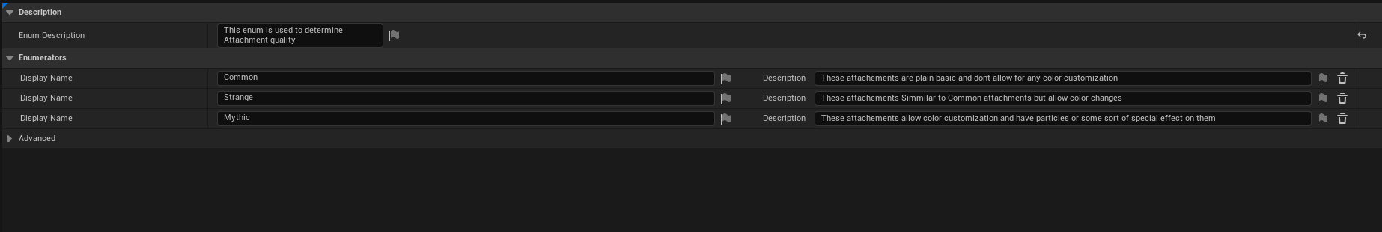
Best that can be done is some sort of color mask to allow for player custommmisation simmilar to armor colors
Replacement attachments need to share the same rig as the weapon
Addition attachments don't need it
Setup in engine is diferent too
Attachment quality
Common(These attachements are plain basic and dont allow for any color customization)
Strange(These attachements Simmilar to Common attachments but allow color change)
Mythic(These attachements allow color customization and have particles or some sort of special effect on them)

Replacement attachments are more technically complex to setup
They require a couple of things to qoek propperly
The source weapon model must be stripped away from any part that will work as a replacement
and these parts must be made attachments instead
Example. If I wanted to have a pistol with a replacable trigger then I would need to remove it from the source model and then export it as it's own attachment that shares the same bone hyearchy as the weapon
In engine wepons can have default attachments that will be chosen automatically if a player has none selected

Guide to adding attachments to weapons

Adding replacement Attachments
Weapons must be modified a specific way to support replacement attachments
weapon model must be stripped from any parts that can be replaced
and these models must be exported separetley with the same rig as base weapon
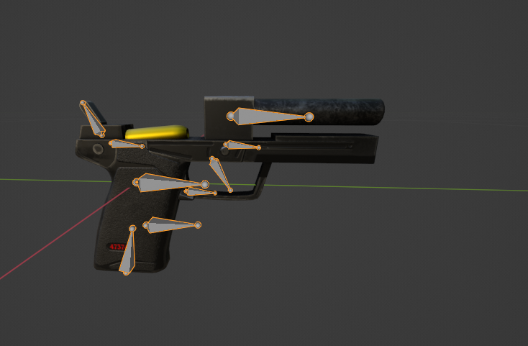
Example of HK pistol striped down
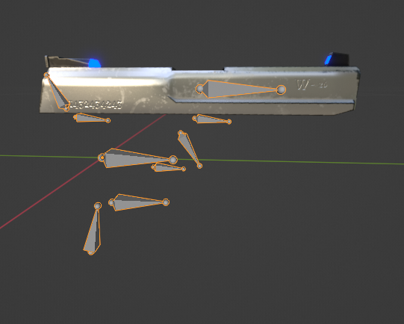
Replacable parts are exported as separate models (must inlcude rig)

Engine setup
Make sure the attachments have propper sockets in unreal
are properly scaled
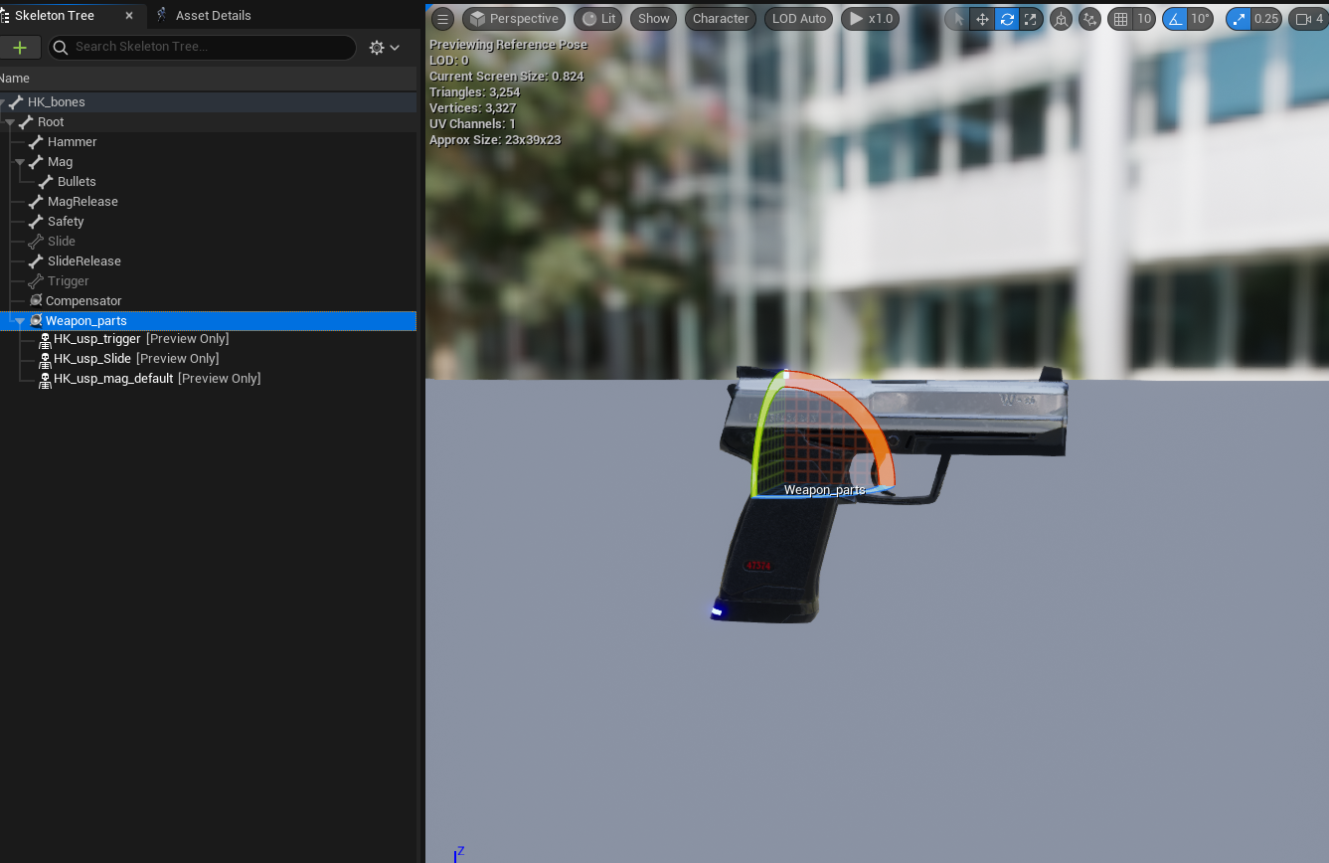
Here we can see that all the replacement parts will use the same socket called “Weapon_parts”
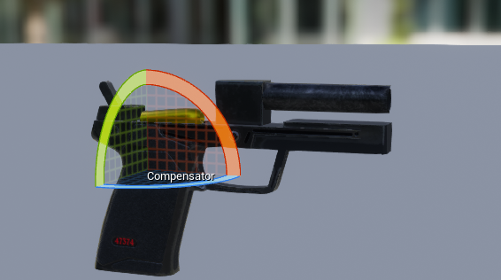
Here we can see how the weapon model looks without any of the replacement parts

Adding the attachments to work in game
Right now we only have the model setup for attachments but they cant be selected in game yet, to do that we need to make a Data Asset
Normally the weapon wont automatically load any parts unless they are specified

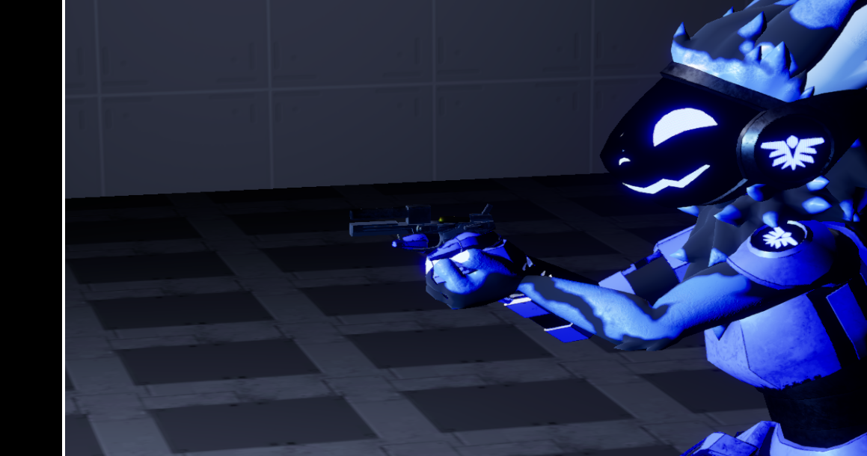
so it will look like this in game
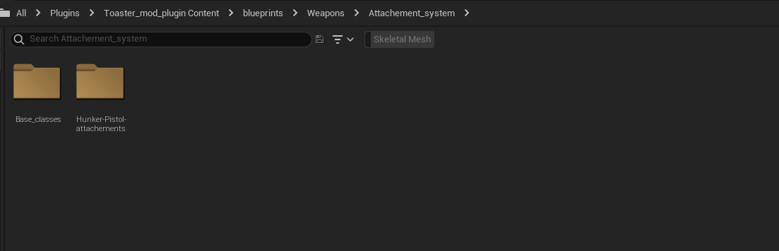
This is because we havent added any attachments data assets and havent specified the weapon's default parts
To make a attachment asset Navigate to this folder
Make a folder here if the weapon you are adding the attachment for does not exist
Create a new Data Asset
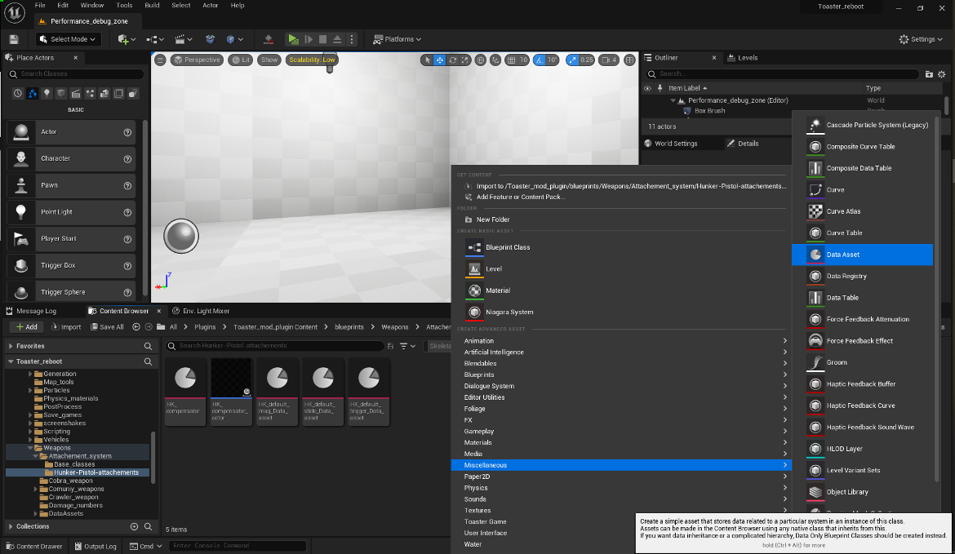

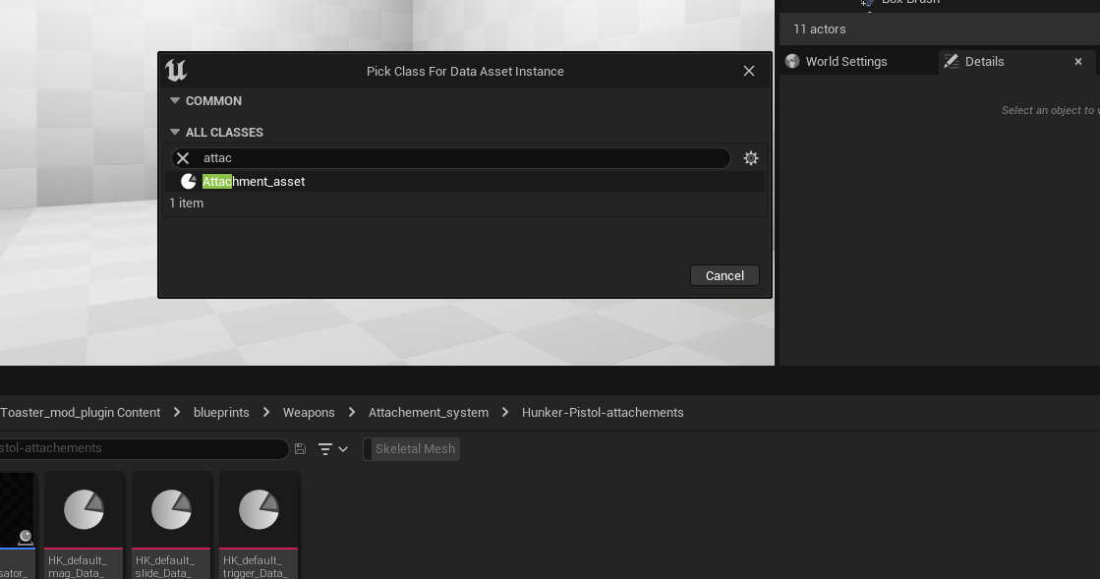
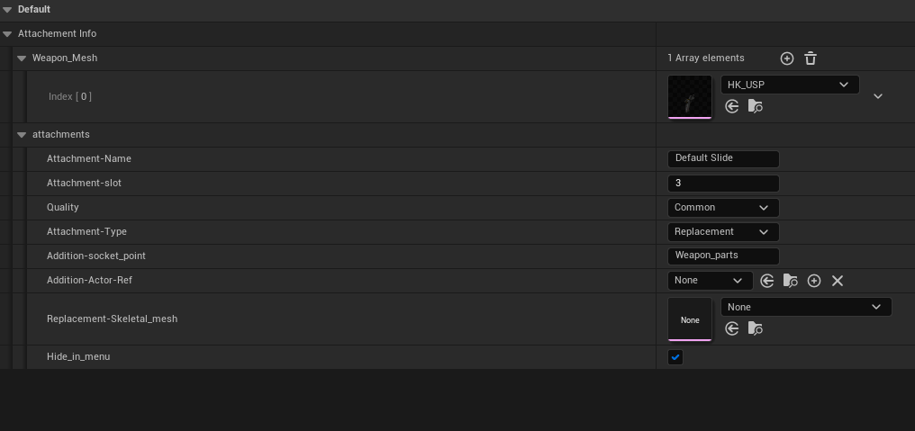
Select Attachment_asset
this will create a Data Asset for your attachment
A few things need to be specified
such as the compatible modles that this attachment will use
The Name
Slot (Slot makes it so that there are not repeats of the same attachment For example. It makes it so that I cant select to supressors to be used on the weapon at the same time)
Attachment-Type (Is this attachment a part replacment or an addition)
Example. Part replacements could be a diferent trigger model
and Additions can be something like a supressor on the weapon
Addition-socket_point (The weapon socket that the attachment will be attached to)
Addition-Actor-Ref (Bluepprint object that will be used for additive attachments)
Replacement-Skeletal_mesh(Skeletal mesh that will be used for weapon part replacement)
Hide_in_menu (Makes this attachment not show in the customization menu, used for weapon default replacement parts)
Default replacement parts are the parts that will be chosen if the player has not selected any
speaking of default attachments
we have to fix that
so far we have added attachment to our weapon but if none are selected, the weapon will just look like this
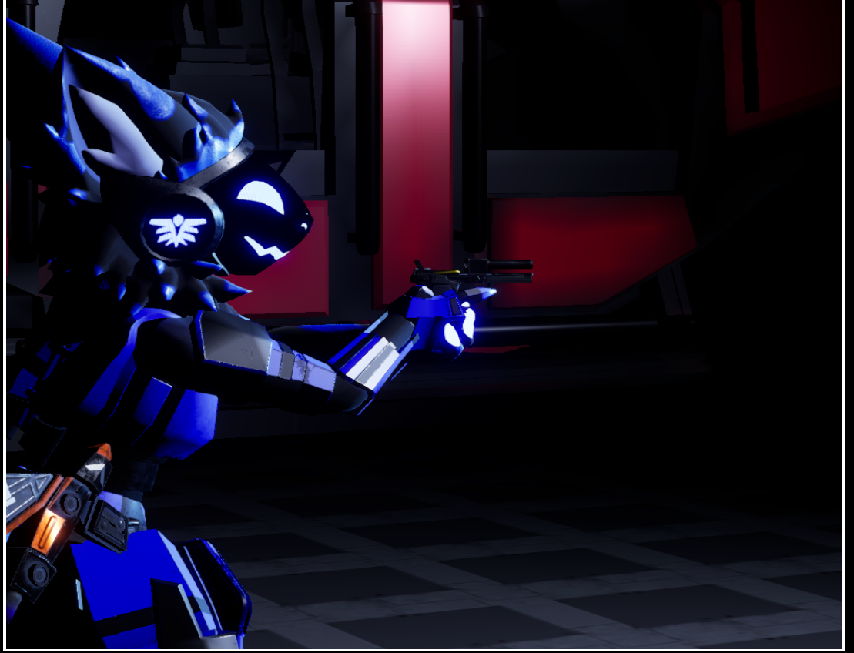
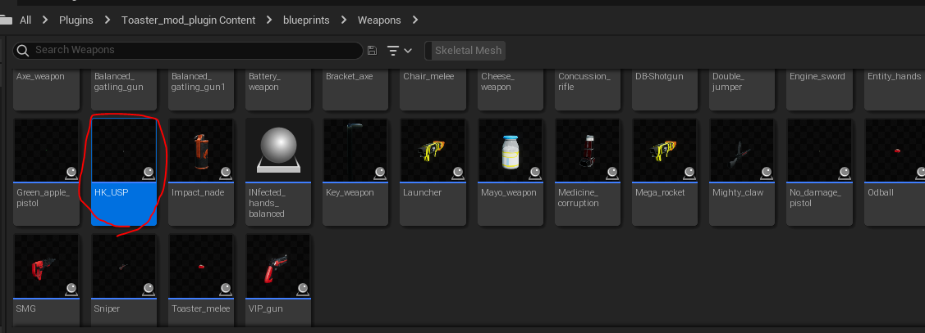
Navigate to the weapon blueprint and open it, in my case the hunker pistol is located here
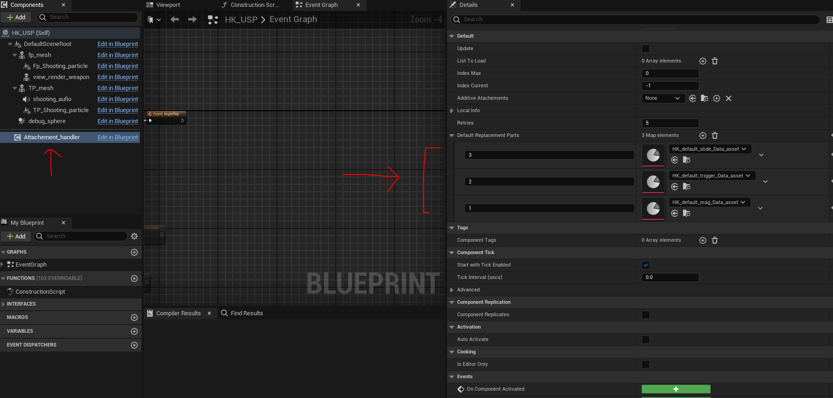
Open it and navigate here
The options here will specify what attachments the weapon will select by default when none take their place
The numbers specify the attachment slot and the Data asset specifies what attachment to use
there is no limit on how many you can add

If everything is setup propperly you should have something like this
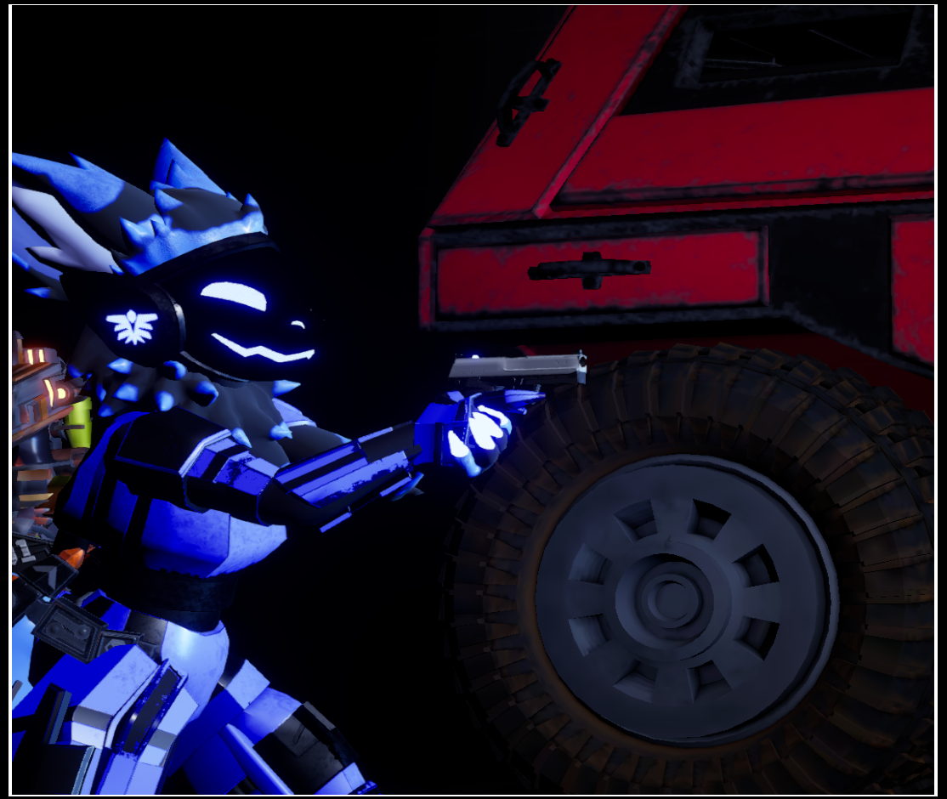

For additive attachments use this setup instead

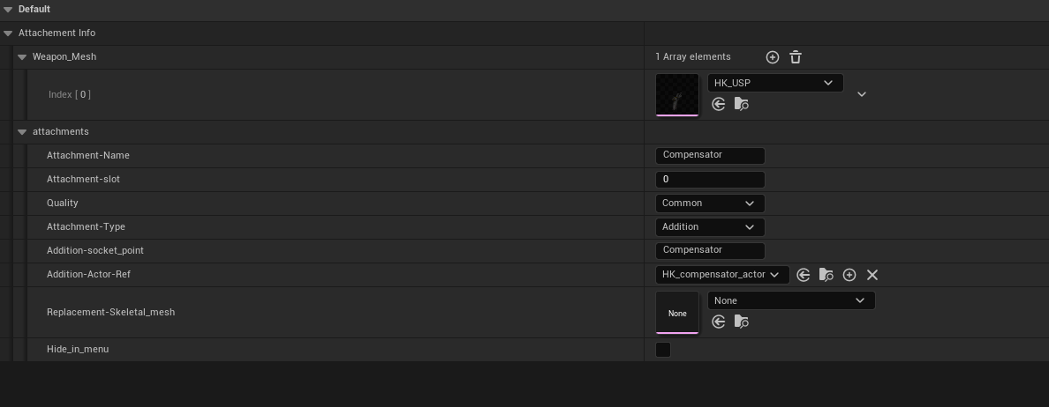
Notice how on this one
a Blueprint reference is used instead of a skeletal reference
the reason for this is that for the future aditive attachments will have some sort of logic related to them

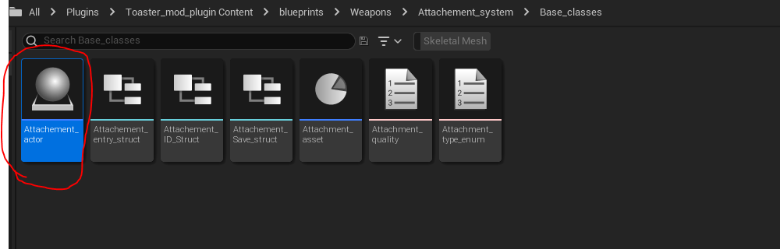
Additive attachments must be a child of this class or else they wont work

