Experiment No 03

BECS 32461

Paper C

**VERIFICATION OF SAMPLING THEOREM IN TIME DOMAIN**

Student Name: W. K. G. K. Jayawardana

Student No: EC/2021/006

Date Performed: 2025/10/03

Date Submitted: 2025/10/03

**PROCEDURE**

F01.

% Amplitude and Frequency

A = 1; F = 2;

%Time vector for continuous signal

t = 0:0.001:1;

% Continuous-time sine wave

x_a = A*sin(2*pi*F*t);

figure;

subplot(3,1,1)

plot(t,x_a,'-b')

title('Analogue (Continuous) Input Signal')

ylabel('x_a','Interpreter','tex')

xlabel('time(sec)')

% Sampling at Nyquist rate

F_s = 2*F;

% Sampling points

n = 0:1/F_s:1;

% Discrete-time signal

x_s = A*sin(2*pi*F*n);

subplot(3,1,2)

stem(n,x_s,'-b')

title('Discreete Time Signal ( F_s = 2*F)','Interpreter','tex')

xlabel('samples(n)')

ylabel('x_s','Interpreter','tex')

% Time vector for reconstruction

t_r = linspace(0, 1, 1000);

% Reconstruct signal using linear interpolation

x_linear = interp1(n, x_s, t_r, 'linear');

% Reconstruct signal using spline interpolation

x_spline = interp1(n, x_s, t_r, 'spline');

subplot(3,1,3)

hold on

plot(t_r,x_spline,'-b')

title('Reconstructed Signal ( F_s = 2*F)','Interpreter','tex')

xlabel('time(sec)')

ylabel('x_r','Interpreter','tex')

F02.

% Amplitude and Frequency

A = 1; F = 2;

%Time vector for continuous signal

t = 0:0.001:1;

% Continuous-time sine wave

x_a = A*sin(2*pi*F*t);

figure;

subplot(3,1,1)

plot(t,x_a,'-b','LineWidth',1.5)

title('Analogue (Continuous) Input Signal')

ylabel('x_a','Interpreter','tex')

xlabel('time(sec)')

% Sampling at Nyquist rate

F_s = 10*F;

% Sampling points

n = 0:1/F_s:1;

% Discrete-time signal

x_s = A*sin(2*pi*F*n);

subplot(3,1,2)

stem(n,x_s,'-b','LineWidth',1.5)

title('Discreete Time Signal ( F_s > 2*F)','Interpreter','tex')

xlabel('samples(n)')

ylabel('x_s','Interpreter','tex')

% Time vector for reconstruction

t_r = linspace(0, 1, 1000);

% Reconstruct signal using linear interpolation

x_linear = interp1(n, x_s, t_r, 'linear');

% Reconstruct signal using spline interpolation

x_spline = interp1(n, x_s, t_r, 'spline');

subplot(3,1,3)

hold on

plot(t_r,x_spline,'-b','LineWidth',1.5)

title('Reconstructed Signal ( F_s > 2*F)','Interpreter','tex')

xlabel('time(sec)')

ylabel('x_r','Interpreter','tex')

F03.

% Amplitude and Frequency

A = 1; F = 2;

%Time vector for continuous signal

t = 0:0.001:1;

% Continuous-time sine wave

x_a = A*sin(2*pi*F*t);

figure;

subplot(3,1,1)

plot(t,x_a,'-b','LineWidth',1.5)

title('Analogue (Continuous) Input Signal')

ylabel('x_a','Interpreter','tex')

xlabel('time(sec)')

% Sampling at Nyquist rate

F_s = 1.5*F;

% Sampling points

n = 0:1/F_s:1;

% Discrete-time signal

x_s = A*sin(2*pi*F*n);

subplot(3,1,2)

stem(n,x_s,'-b','LineWidth',1.5)

title('Discreete Time Signal ( F_s < 2*F)','Interpreter','tex')

xlabel('samples(n)')

ylabel('x_s','Interpreter','tex')

% Time vector for reconstruction

t_r = linspace(0, 1, 1000);

% Reconstruct signal using linear interpolation

x_linear = interp1(n, x_s, t_r, 'linear');

% Reconstruct signal using spline interpolation

x_spline = interp1(n, x_s, t_r, 'spline');

subplot(3,1,3)

hold on

plot(t_r,x_spline,'-b','LineWidth',1.5)

title('Reconstructed Signal ( F_s < 2*F)','Interpreter','tex')

xlabel('time(sec)')

ylabel('x_r','Interpreter','tex')

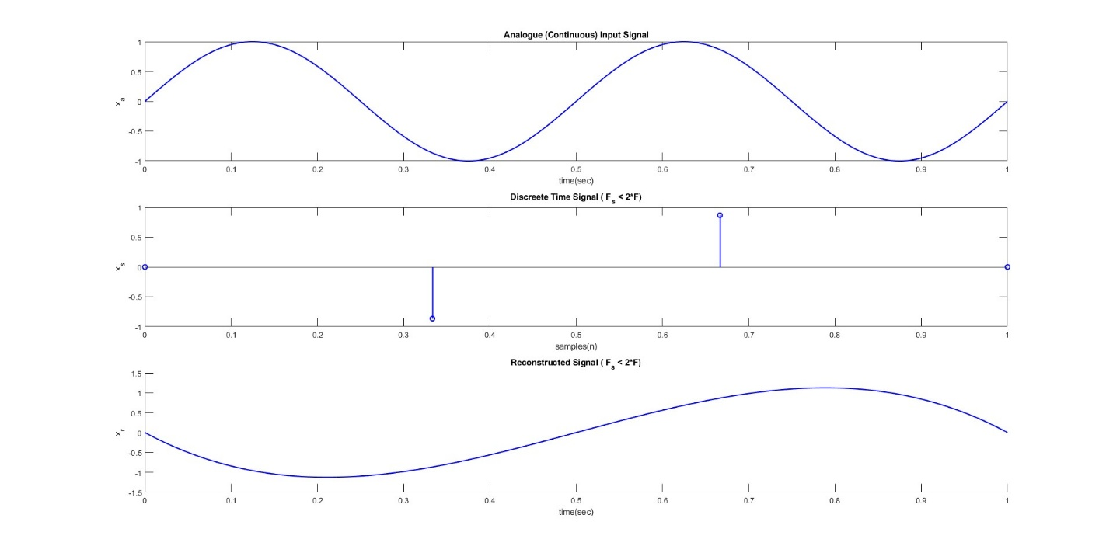

**EXERCISE**

E01.

E02.

E03.

E04.

E05.