Experiment No 01

BECS 32461

**FUNDAMENTALS OF MATLAB FOR DIGITAL SIGNAL PROCESSING**

Student Name: W. K. G. K. Jayawardana

Student No: EC/2021/006

Date Performed: 2025/09/21

Date Submitted: 2025/09/21

01.

x = -10:1:10;

y = 2*x.^2-2*x+1;

z = x.^3+3*x.^2-6*x-18;

plot(x,y,'-b','LineWidth',1.5)

hold on

plot(x,z,'--r','LineWidth',1.5)

legend('y=2x^2-2x+1','y=x^3+3x^2-6x-18')

title('Polynomial Plot')

xlabel('x')

ylabel('y')

axis([-10 10 -200 200])

grid on

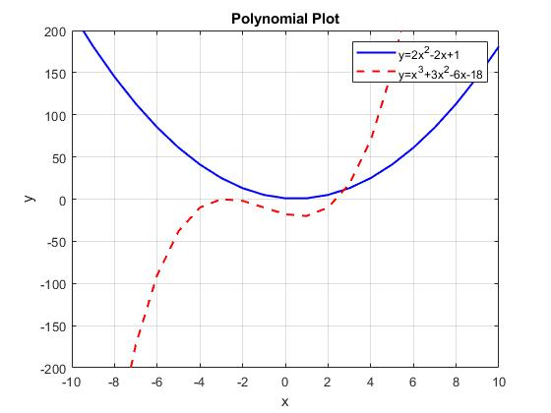

02.

subplot(2,1,1);

x = linspace(-5,5);

y1 = x.^2+1i*x;

plot(x,real(y1),'-c')

xlabel('x')

ylabel('Real Part')

title('Real Part of w=x^2+ix')

grid on

subplot(2,1,2);

y2 = x.^2+1i*x;

plot(x,imag(y2),'-m')

xlabel('x')

ylabel('Imaginary Part')

title('Imaginary Part of w=x^2+ix')

grid on

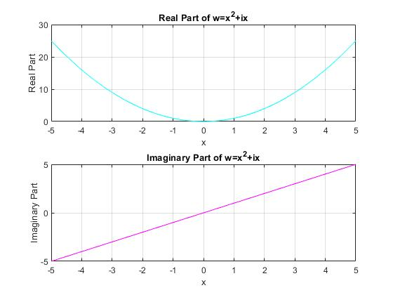

03.

subplot(2,1,1);

x = -5:0.5:5;

y1 = exp(-x)+1i*log(x.^2+2);

stem(x,real(y1),'-b','filled','LineWidth',1.5)

xlabel('x')

ylabel('Real Part')

title('Real Part of w=exp(-x)+ilog(x^2+2)')

grid on

subplot(2,1,2);

y2 = exp(-x)+1i*log(x.^2+2);

stem(x,imag(y2),'-r','filled','LineWidth',1.5)

xlabel('x')

ylabel('Imaginary Part')

title('Imaginary Part of w=exp(-x)+ilog(x^2+2)')

grid on

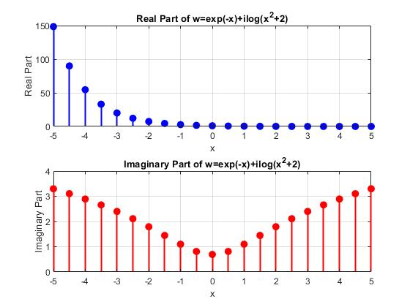

04.

x = 0:0.5:10;

y1 = exp(-x);

subplot(2,2,1);

plot(x,y1,'-b','LineWidth',1.5)

xlabel('x')

ylabel('y')

title('Normal Plot:y=e^-^x')

grid on

subplot(2,2,2);

semilogy(x,y1,'-g','LineWidth',1.5)

xlabel('x')

ylabel('y(log Scale)')

title('Semilog y Plot:y=e^-^x')

grid on

subplot(2,2,3);

semilogx(x,y1,'-r','LineWidth',1.5)

xlabel('x(log Scale)')

ylabel('y')

title('Semilog x Plot:y=e^-^x')

grid on

subplot(2,2,4);

loglog(x,y1,'-k','LineWidth',1.5)

xlabel('x(log Scale)')

ylabel('y(log Scale)')

title('Loglog Plot:y=e^-^x')

grid on

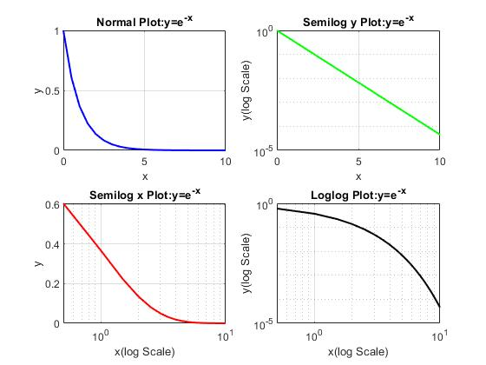

05.

x = linspace(-5, 5, 100);

y = linspace(-5, 5, 100);

[X, Y] = meshgrid(x, y);

Z = exp(-(X.^2/4 + Y.^2/4));

figure;

surf(X, Y, Z);

xlabel('X-axis');

ylabel('Y-axis');

zlabel('Z-axix(Gaussian Function');

title('3D Surface Plot of Gaussian Function');

grid on;

xlim([-5 5]);

ylim([-5 5]);

zlim([0 1]);

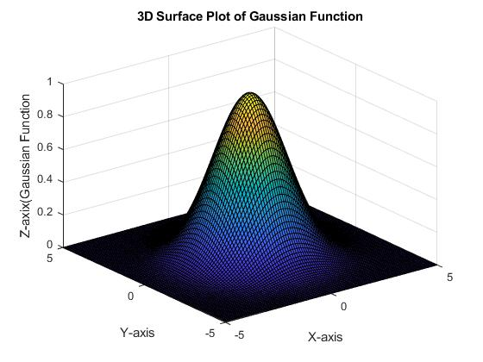

06.

x = -10:0.1:10;

x1 = x(x < -3);

y1 = x1 + 6;

x2 = x(x >= -3 & x <= 3);

y2 = 3 * ones(size(x2));

x3 = x(x > 3);

y3 = x3;

figure;

plot(x1, y1, '-b', 'LineWidth', 1.5); hold on;

plot(x2, y2, '--g', 'LineWidth', 1.5);

plot(x3, y3, '-r', 'LineWidth', 1.5);

grid on;

xlabel('x');

ylabel('y');

title('Piecewise Function');

legend('y = x + 6 ', 'y = 3 ', 'y = x ');

