Experiment No 02

BECS 32461

Paper C

**SIGNAL GENERATION AND OPERATIONS IN MATLAB**

Student Name: W. K. G. K. Jayawardana

Student No: EC/2021/006

Date Performed: 2025/09/26

Date Submitted: 2025/09/26

**PROCEDURE**

01.

subplot(3,2,1);

t_impulse = -5:0.01:5;

impulse_signal = (t_impulse == 0);

plot(t_impulse,impulse_signal,'-b','LineWidth',1.2)

xlabel('Time')

ylabel('Amplitude')

title('CT Unit Impulse Signal')

grid on

subplot(3,2,2);

t_step = -5:0.01:5;

step_sequence = (t_step >= 0);

plot(t_step,step_sequence,'-b','LineWidth',1.2)

xlabel('Time')

ylabel('Amplitude')

title('CT Unit Step Signal')

grid on

subplot(3,2,3);

t_ramp = 0:0.01:10;

ramp_sequence = max (t_ramp,0);

plot(t_ramp,ramp_sequence,'-b','LineWidth',1.2)

xlabel('Time')

ylabel('Amplitude')

title('CT Ramp Signal')

grid on

subplot(3,2,4);

t_exp = 0:30;

a=1.5;

exp_sequence = a.^t_exp;

plot(t_exp,exp_sequence,'-b','LineWidth',1.2)

xlabel('Time')

ylabel('Amplitude')

title('CT Exponential Signal')

grid on

subplot(3,2,5);

t = -2*pi:0.1:2*pi;

sine_wave = sin(t);

plot(t,sine_wave,'-b','LineWidth',1.2)

xlabel('-2/pi<x<2/pi')

ylabel('sin(x)')

title('CT Sine wave')

grid on

subplot(3,2,6);

cosine_wave = cos(t);

plot(t,cosine_wave,'-b','LineWidth',1.2)

xlabel('-2/pi<x<2/pi')

ylabel('cos(x)')

title('CT Cosine Wave')

grid on

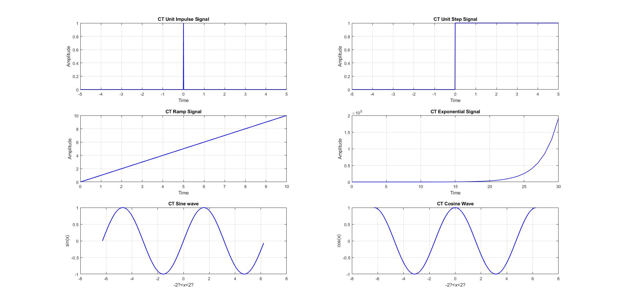

02.

subplot(3,2,1);

t_impulse = -5:1:5;

impulse_signal = (t_impulse == 0);

stem(t_impulse,impulse_signal,'-b','filled','LineWidth',1.2)

xlabel('Time')

ylabel('Amplitude')

title('DT Unit Impulse Signal')

grid on

subplot(3,2,2);

t_step = -5:1:5;

step_sequence = (t_step >= 0);

stem(t_step,step_sequence,'-b','filled','LineWidth',1.2)

xlabel('Time')

ylabel('Amplitude')

title('DT Unit Step Signal')

grid on

subplot(3,2,3);

t_ramp = 0:1:10;

ramp_sequence = max (t_ramp,0);

stem(t_ramp,ramp_sequence,'-b','filled','LineWidth',1.2)

xlabel('Time')

ylabel('Amplitude')

title('DT Ramp Signal')

grid on

subplot(3,2,4);

t_exp = 0:1:30;

a=1.5;

exp_sequence = a.^t_exp;

stem(t_exp,exp_sequence,'-b','filled','LineWidth',1.2)

xlabel('Time')

ylabel('Amplitude')

title('DT Exponential Signal')

grid on

subplot(3,2,5);

t = -2*pi:0.2:2*pi;

sine_wave = sin(t);

stem(t,sine_wave,'-b','filled','LineWidth',1.2)

xlabel('-2?<x<2?')

ylabel('sin(x)')

title('DT Sine wave')

grid on

subplot(3,2,6);

cosine_wave = cos(t);

stem(t,cosine_wave,'-b','filled','LineWidth',1.2)

xlabel('-2?<x<2?')

ylabel('cos(x)')

title('DT Cosine Wave')

grid on

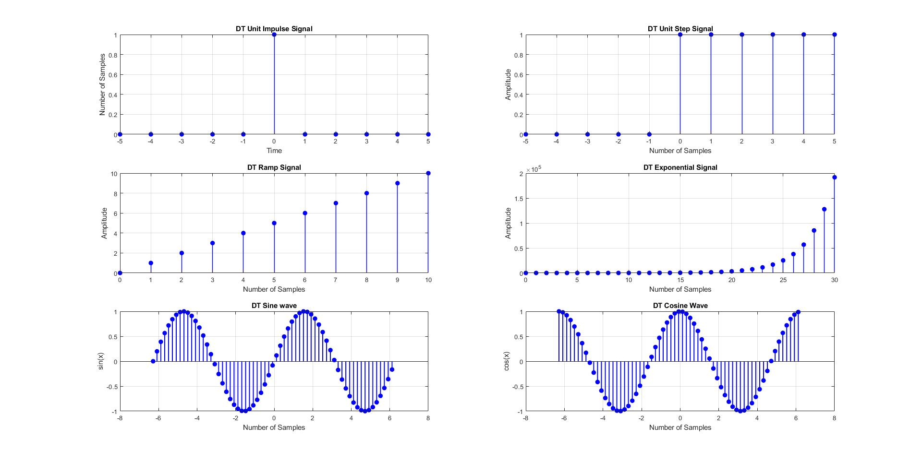

**EXERCISE**

01.

n_step=0:15;

step_sequence=(n_step>=0);

a=3;

x=a.^n_step.*step_sequence;

subplot(2,1,1)

stem(n_step,x,'-b','filled','LineWidth',1.2)

xlabel('n')

ylabel('x[n]')

title('DT Eeponential Growth')

subplot(2,1,2)

a=2;

stem(-n_step,x,'-g','filled','LineWidth',1.2)

xlabel('n')

ylabel('x[n]')

title('DT Eeponential Decay')

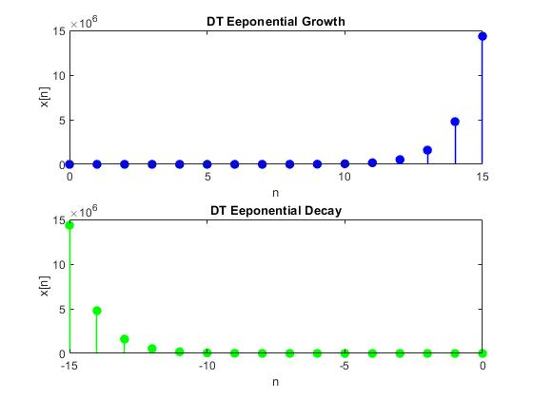

02.

t = -2*pi:0.1:2*pi;

theta = pi/4;

unshipted_sine_wave = sin(t);

plot(t,unshipted_sine_wave,'-b','LineWidth',1.5)

xlabel('Time')

ylabel('Amplitude')

title('Sine wave')

grid on

hold on

shipted_sine_wave = sin(t + theta);

plot(t,shipted_sine_wave,'--y','LineWidth',1.5)

xlabel('Time')

ylabel('Amplitude')

legend('Unshipted Sine Wave','Shifted Sine Wave')

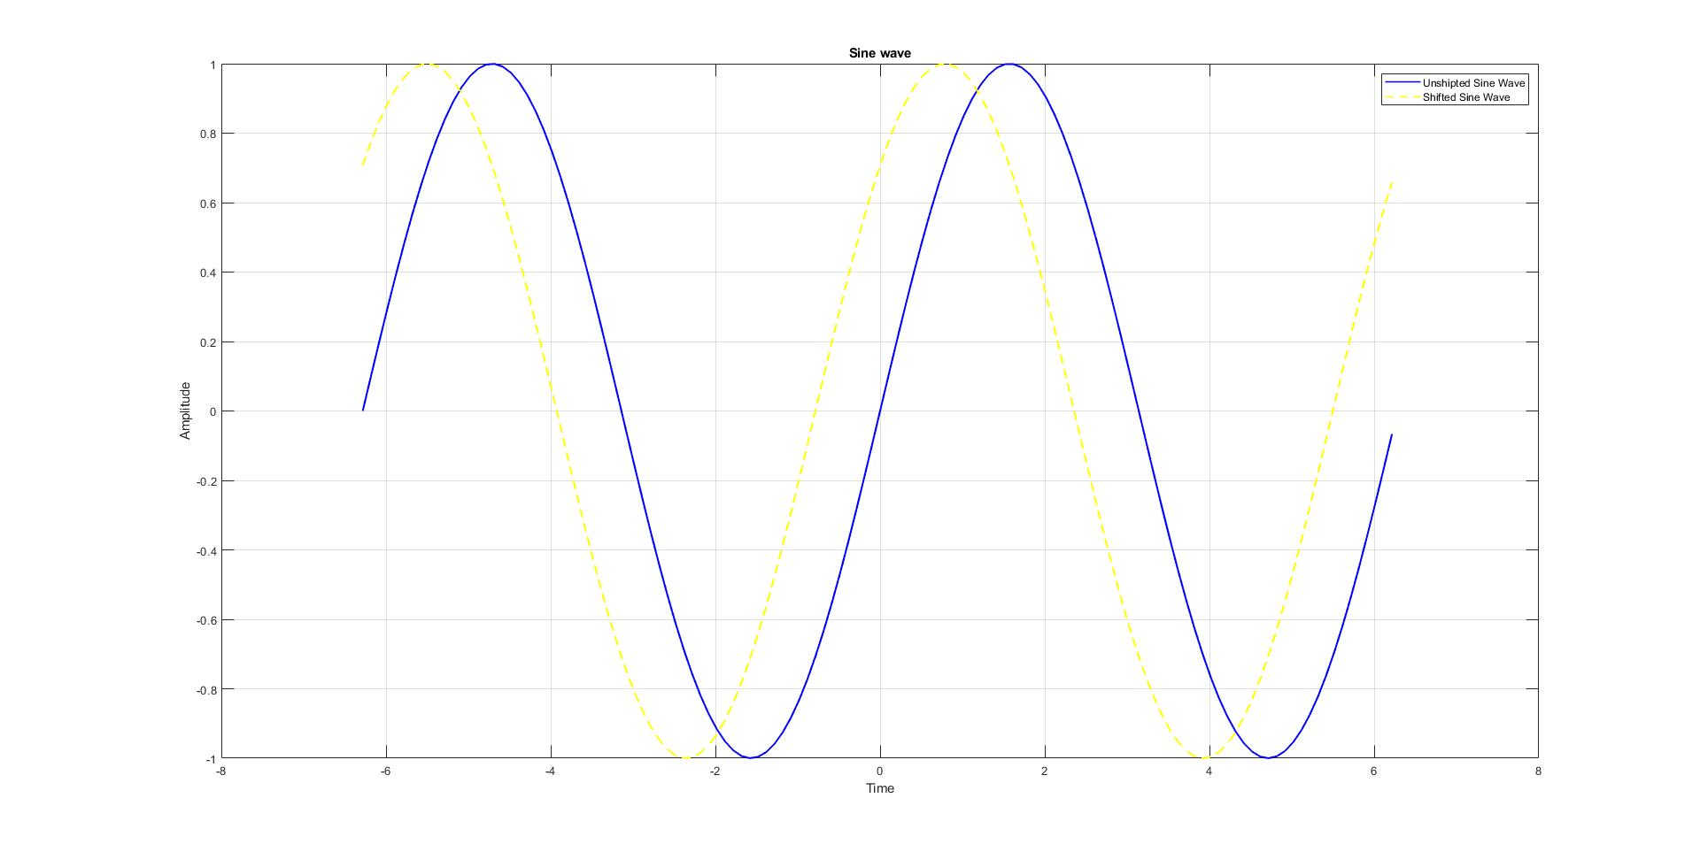

03.

t = -5:0.01:10;

step_sequence = (t >= 0);

del_step_sequence = (t >= 0);

ramp_sequence = max (t,0);

z = ramp_sequence - 2*del_step_sequence;

subplot(3,1,1);

plot(t,step_sequence,'-m','LineWidth',1.5)

xlabel('t')

ylabel('u(t)')

grid on

subplot(3,1,2);

plot(t,ramp_sequence,'-b','LineWidth',1.5)

xlabel('t')

ylabel('r(t)')

grid on

subplot(3,1,3);

plot(t,z,':g','LineWidth',1.5)

xlabel('t')

ylabel('Z(t)')

grid on

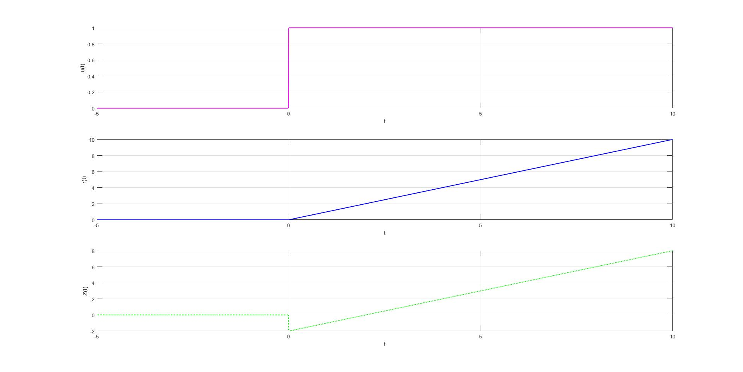

04.

A = 1;

M = 0.5;

fc = 50;

fm = 5;

t = 0: 0.001: 0.5;

carrier = A*cos(2*pi*fc*t);

modulating = M*sin(2*pi*fm*t);

Xam = A*cos(2*pi*fc*t) .*(2 + M*sin(2*pi*fm*t));

subplot(3,1,1);

plot(t, carrier, 'k', 'LineWidth', 1.5);

xlabel('t');

ylabel('Amplitude)');

title('The Carrier Signal');

grid on;

subplot(3,1,2);

plot(t, modulating, 'k', 'LineWidth', 1.5);

xlabel('t');

ylabel('Amplitude)');

title('The Modulating Signal');

grid on;

subplot(3,1,3);

plot(t, Xam, 'k', 'LineWidth', 1.5);

xlabel('t');

ylabel('Amplitude)');

title('The AM Signal');

grid on;

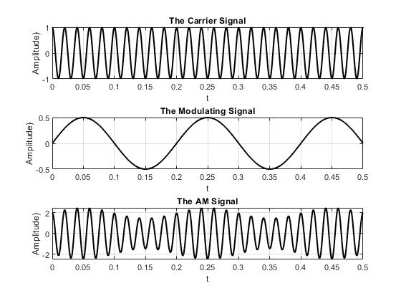

05.

t = 0:0.001:6;

v = 5*sin(2*pi*1*t);

n = v + 1.5*sin(2*pi*60*t) + 0.8*sin(2*pi*70*t) + 0.6*sin(2*pi*120*t) + 0.2*randn(size(t));

ts = 0:0.1:6;

v_sampled = 5*sin(2*pi*1*ts);

n_sampled = v_sampled + 1.5*sin(2*pi*60*ts) + 0.8*sin(2*pi*70*ts) + 0.6*sin(2*pi*120*ts) + 0.2*randn(size(ts));

subplot(3,1,1);

plot(t,v,'r','LineWidth',1.2);

title('Original Signal v(t)');

xlabel('t');

ylabel('v(t)');

grid on;

subplot(3,1,2);

plot(t,n,'r','LineWidth',1.2);

title('Noisy Signal n(t)');

xlabel('t');

ylabel('n(t)');

grid on;

subplot(3,1,3);

stem(ts,n_sampled,'r','filled');

title('Discrete-Time Noisy Signal n(t)');

xlabel('t');

ylabel('n(t)');

grid on;

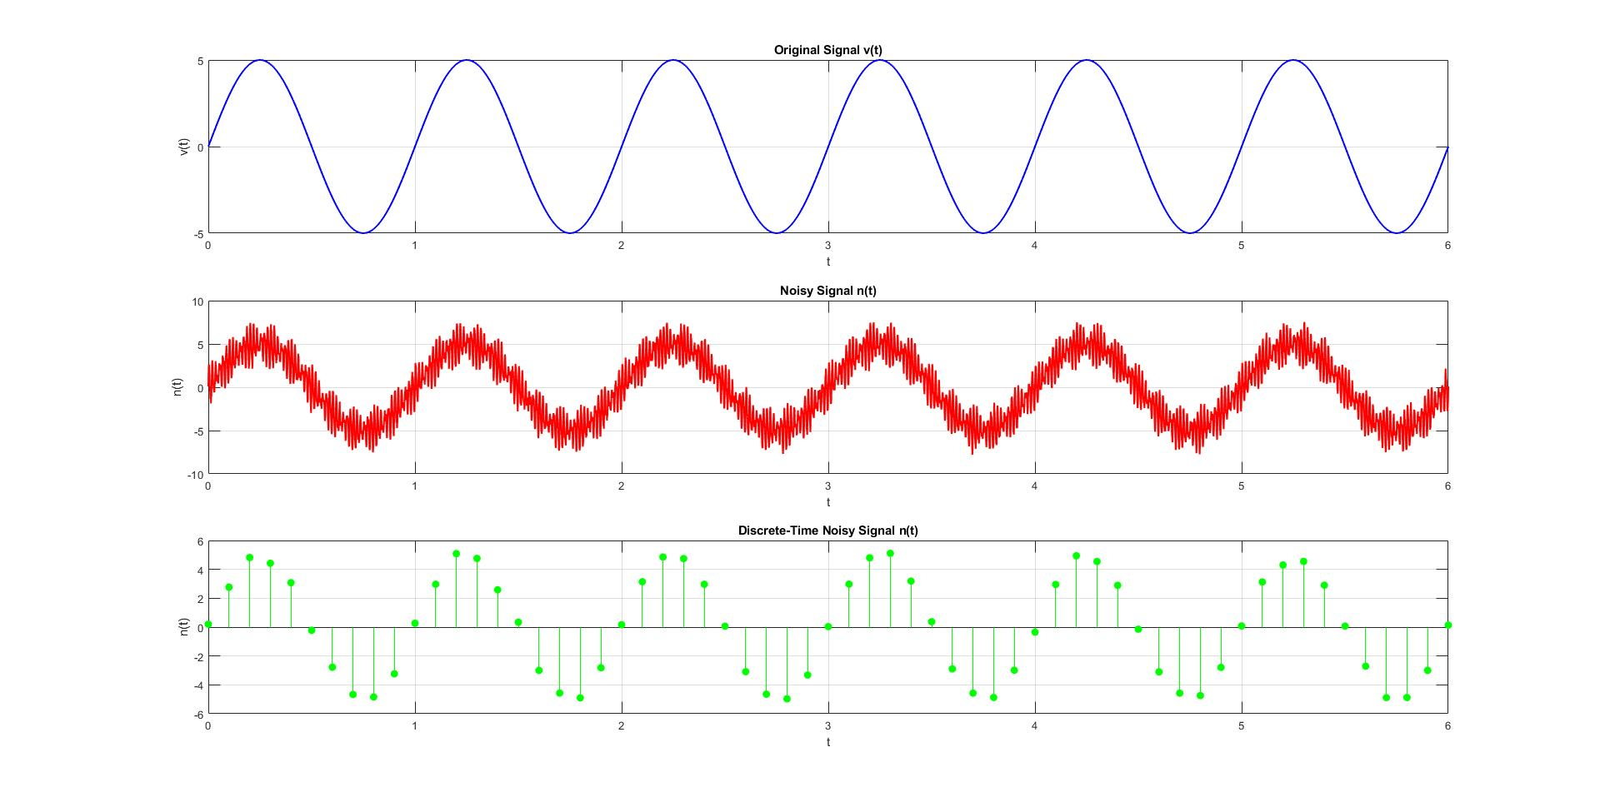

06.

t = 0:0.01:60;

x = 2*sin(0.1*pi*t);

y = x;

y(x > 1) = 1;

y(x < -1) = -1;

figure;

subplot(3,1,1);

plot(t,x,'b','LineWidth',1.2);

title('Original Signal x(t)');

xlabel('t');

ylabel('x(t)');

grid on;

subplot(3,1,2);

plot(t,y,'--g','LineWidth',1.2);

title('Clipped Signal y(t)');

xlabel('t'); ylabel('y(t)');

grid on;

subplot(3,1,3);

plot(t,x,'b','LineWidth',1.2); hold on;

plot(t,y,'g--','LineWidth',1.2);

title('Comparison of x(t) and y(t)');

xlabel('t');

ylabel('Amplitude');

legend('x(t)','y(t)');

grid on;

