Experiment No 03

BECS 32461

Paper D

**VERIFICATION OF SAMPLING THEOREM IN TIME DOMAIN**

Student Name: W. K. G. K. Jayawardana

Student No: EC/2021/006

Date Performed: 2025/10/03

Date Submitted: 2025/10/03

**PROCEDURE**

F01.

% Amplitude and Frequency

A = 1; F = 2;

%Time vector for continuous signal

t = 0:0.001:1;

% Continuous-time sine wave

x_a = A*sin(2*pi*F*t);

figure;

subplot(3,1,1)

plot(t,x_a,'-b')

title('Analogue (Continuous) Input Signal')

ylabel('x_a','Interpreter','tex')

xlabel('time(sec)')

% Sampling at Nyquist rate

F_s = 2*F;

% Sampling points

n = 0:1/F_s:1;

% Discrete-time signal

x_s = A*sin(2*pi*F*n);

subplot(3,1,2)

stem(n,x_s,'-b')

title('Discreete Time Signal ( F_s = 2*F)','Interpreter','tex')

xlabel('samples(n)')

ylabel('x_s','Interpreter','tex')

% Time vector for reconstruction

t_r = linspace(0, 1, 1000);

% Reconstruct signal using linear interpolation

x_linear = interp1(n, x_s, t_r, 'linear');

% Reconstruct signal using spline interpolation

x_spline = interp1(n, x_s, t_r, 'spline');

subplot(3,1,3)

hold on

plot(t_r,x_spline,'-b')

title('Reconstructed Signal ( F_s = 2*F)','Interpreter','tex')

xlabel('time(sec)')

ylabel('x_r','Interpreter','tex')

F02.

% Amplitude and Frequency

A = 1; F = 2;

%Time vector for continuous signal

t = 0:0.001:1;

% Continuous-time sine wave

x_a = A*sin(2*pi*F*t);

figure;

subplot(3,1,1)

plot(t,x_a,'-b','LineWidth',1.5)

title('Analogue (Continuous) Input Signal')

ylabel('x_a','Interpreter','tex')

xlabel('time(sec)')

% Sampling at Nyquist rate

F_s = 10*F;

% Sampling points

n = 0:1/F_s:1;

% Discrete-time signal

x_s = A*sin(2*pi*F*n);

subplot(3,1,2)

stem(n,x_s,'-b','LineWidth',1.5)

title('Discreete Time Signal ( F_s > 2*F)','Interpreter','tex')

xlabel('samples(n)')

ylabel('x_s','Interpreter','tex')

% Time vector for reconstruction

t_r = linspace(0, 1, 1000);

% Reconstruct signal using linear interpolation

x_linear = interp1(n, x_s, t_r, 'linear');

% Reconstruct signal using spline interpolation

x_spline = interp1(n, x_s, t_r, 'spline');

subplot(3,1,3)

hold on

plot(t_r,x_spline,'-b','LineWidth',1.5)

title('Reconstructed Signal ( F_s > 2*F)','Interpreter','tex')

xlabel('time(sec)')

ylabel('x_r','Interpreter','tex')

F03.

% Amplitude and Frequency

A = 1; F = 2;

%Time vector for continuous signal

t = 0:0.001:1;

% Continuous-time sine wave

x_a = A*sin(2*pi*F*t);

figure;

subplot(3,1,1)

plot(t,x_a,'-b','LineWidth',1.5)

title('Analogue (Continuous) Input Signal')

ylabel('x_a','Interpreter','tex')

xlabel('time(sec)')

% Sampling at Nyquist rate

F_s = 1.5*F;

% Sampling points

n = 0:1/F_s:1;

% Discrete-time signal

x_s = A*sin(2*pi*F*n);

subplot(3,1,2)

stem(n,x_s,'-b','LineWidth',1.5)

title('Discreete Time Signal ( F_s < 2*F)','Interpreter','tex')

xlabel('samples(n)')

ylabel('x_s','Interpreter','tex')

% Time vector for reconstruction

t_r = linspace(0, 1, 1000);

% Reconstruct signal using linear interpolation

x_linear = interp1(n, x_s, t_r, 'linear');

% Reconstruct signal using spline interpolation

x_spline = interp1(n, x_s, t_r, 'spline');

subplot(3,1,3)

hold on

plot(t_r,x_spline,'-b','LineWidth',1.5)

title('Reconstructed Signal ( F_s < 2*F)','Interpreter','tex')

xlabel('time(sec)')

ylabel('x_r','Interpreter','tex')

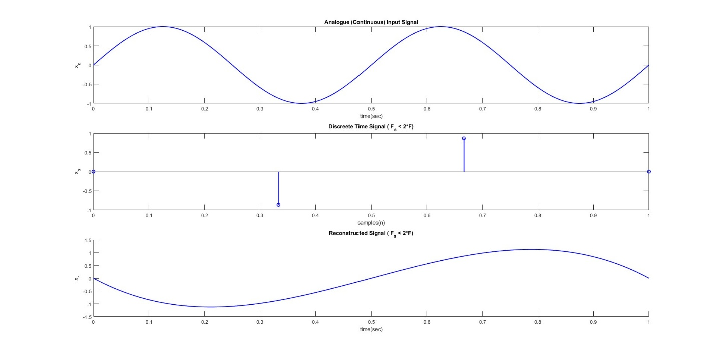

**EXERCISE**

E01.

%Time vector for continuous signal

t = 0:0.001:1;

% Continuous-time sine waves

x1 =sin(25*pi*t);

x2 =sin(25*pi*(t-0.2));

figure;

subplot(3,1,1)

plot(t,x1,'-m','LineWidth',1.5)

hold on

plot(t,x2,'--g','LineWidth',1.5)

hold off

title('Analogue (Continuous) Input Signal')

ylabel('x(t)','Interpreter','tex')

xlabel('time(sec)')

% Sampling at Nyquist rate

F_s = 20;

% Sampling points

n = 0:1/F_s:1;

% Discrete-time signals

x1_s =sin(25*pi*n);

x2_s =sin(25*pi*(n-0.2));

subplot(3,1,2)

stem(n,x1_s,'b','filled','MarkerFaceColor','yellow','LineWidth',1.5)

title('Discreete Time Signal for x1(t)','Interpreter','tex')

xlabel('samples(n)')

ylabel('x_s','Interpreter','tex')

subplot(3,1,3)

stem(n,x2_s,'r','filled','MarkerFaceColor','blue','LineWidth',1.5)

title('Discreete Time Signal for x2(t)','Interpreter','tex')

xlabel('samples(n)')

ylabel('x_s','Interpreter','tex')

* x1(t) and x2(t) time shifting is clearly visible but it is obscured by aliasing.
* To avoid aliasing Fs should be increase to at least 2×12.5=25 Hz or higher, as per the Nyquist criterion.

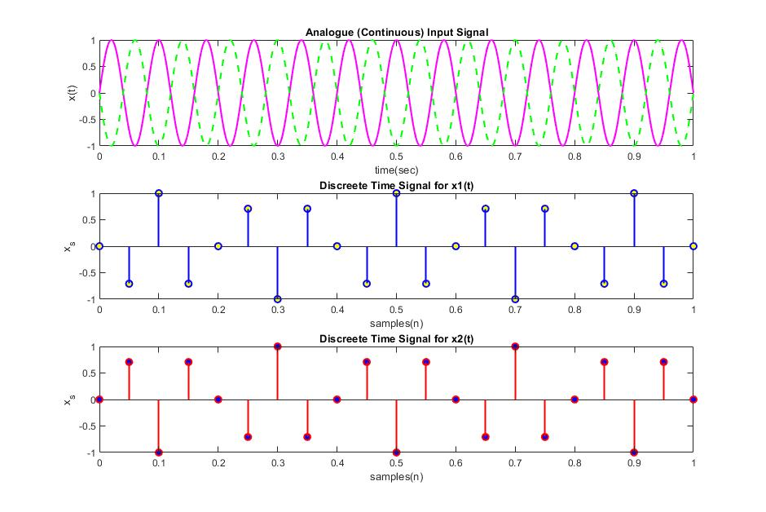

E02.

%Time vector for continuous signal

t = 0:0.001:1;

% Continuous-time sine waves

x1 =sin(45*pi*t);

x2 =sin(5*pi*(t));

% Sampling at Nyquist rate

F_s = 20;

% Sampling points

n = 0:1/F_s:1;

% Discrete-time signals

x1_s =sin(45*pi*n);

x2_s =sin(5*pi*n);

figure;

subplot(3,1,1)

plot(t,x1,'-g','LineWidth',1.5)

hold on

stem(n,x1_s,'m','filled','LineWidth',1.5)

hold off

title('Analogue (Continuous) Input Signal')

ylabel('x(t)','Interpreter','tex')

xlabel('time(sec)')

subplot(3,1,2)

plot(t,x2,'-g','LineWidth',1.5)

hold on

stem(n,x2_s,'m','filled','LineWidth',1.5)

title('Analogue (Continuous) Input Signal')

ylabel('x(t)','Interpreter','tex')

xlabel('time(sec)')

subplot(3,1,3)

stem(n,x1_s,'g','filled','LineWidth',1.5)

hold on

stem(n,x2_s,'r','LineWidth',1.5)

hold off

title('Reconstructed Signal ( F_s = 2*F)','Interpreter','tex')

xlabel('time(sec)')

ylabel('x_r','Interpreter','tex')

* The sampled version of x1(t) x1​(t) appears identical to x2(t) x2​(t) due to aliasing. This happens because the sampling frequency Fs=20 Hz is insufficient to distinguish between the two signals.
* The aliasing phenomenon occurs because the frequency of x1(t) x1​(t) exceeds the Nyquist frequency (Fs/2=10 Hz).

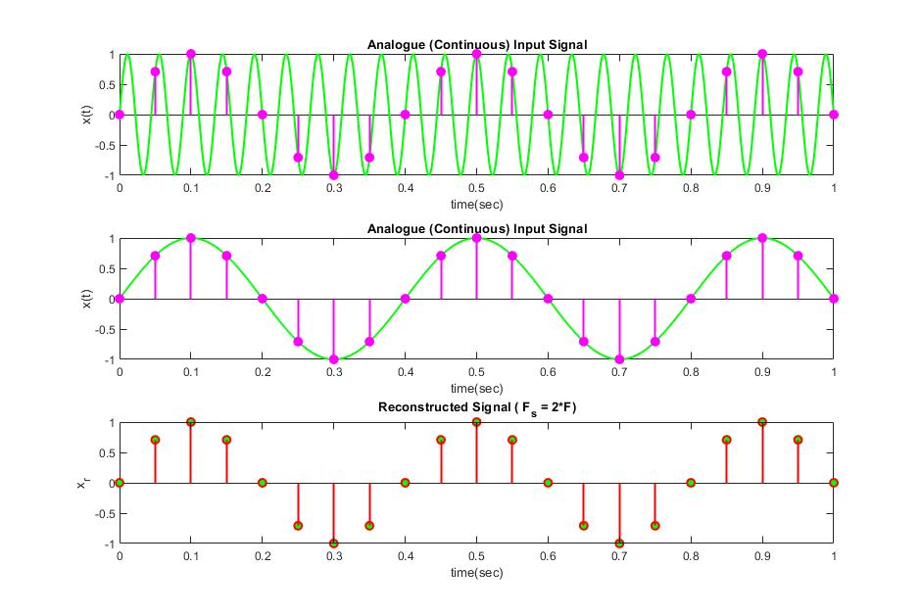

E03.

%Time vector for continuous signal

t = 0:0.001:1;

% Continuous-time sine waves

x =sin(10*pi*t) + sin(50*pi*t);

figure;

subplot(4,1,1)

plot(t,x,'-m','LineWidth',1.5)

title('Analogue (Continuous) Input Signal')

ylabel('x(t)','Interpreter','tex')

xlabel('time(sec)')

% Sampling at Nyquist rate

F_s = 120;

% Sampling points

n = 0:1/F_s:1;

% Discrete-time signals

x_s =sin(10*pi*n) + sin(50*pi*n);

subplot(4,1,2)

stem(n,x_s,'-b','MarkerFaceColor','yellow','LineWidth',1.5)

title('Discreete Time Signal','Interpreter','tex')

xlabel('samples(n)')

ylabel('x_s','Interpreter','tex')

% Time vector for reconstruction

t_r = linspace(0, 1, 1000);

% Reconstruct signal using linear interpolation

x_linear = interp1(n, x_s, t_r, 'linear');

% Reconstruct signal using spline interpolation

x_spline = interp1(n, x_s, t_r, 'spline');

subplot(4,1,3)

plot(t,x,'-g','LineWidth',1.5)

hold on

plot(t_r,x_linear,'--b','LineWidth',1.5)

title('Reconstructed Signal Liner','Interpreter','tex')

xlabel('time(sec)')

ylabel('x_r','Interpreter','tex')

subplot(4,1,4)

plot(t,x,'-m','LineWidth',1.5)

hold on

plot(t_r,x_spline,'--y','LineWidth',1.5)

title('Reconstructed Signal Spline','Interpreter','tex')

xlabel('time(sec)')

ylabel('x_r','Interpreter','tex')

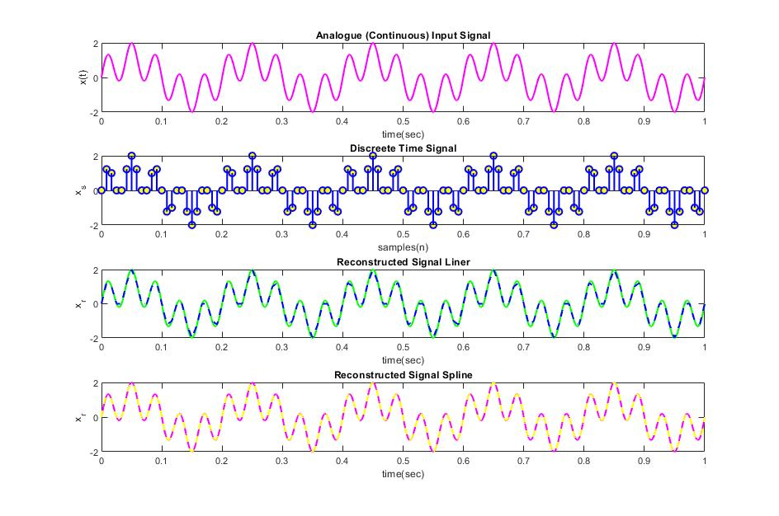

E04.

%Time vector for continuous signal

t = 0:0.001:1;

% Continuous-time sine waves

x =sin(50*pi*t) + sin(90*pi*t);

figure;

subplot(3,1,1)

plot(t,x,'-g','LineWidth',1.5)

title('Analogue (Continuous) Input Signal')

ylabel('x(t)','Interpreter','tex')

xlabel('time(sec)')

% Sampling at Nyquist rate

F_s = 190;

% Sampling points

n = 0:1/F_s:1;

% Discrete-time signals

x_s =sin(50*pi*n) + sin(90*pi*n);

subplot(3,1,2)

plot(t,x,'-g','LineWidth',1.5)

hold on

stem(n,x_s,'-b','MarkerFaceColor','yellow','LineWidth',1.5)

hold off

title('Discreete Time Signal','Interpreter','tex')

xlabel('samples(n)')

ylabel('x_s','Interpreter','tex')

% Time vector for reconstruction

t_r = linspace(0, 1, 1000);

% Reconstruct signal using spline interpolation

x_spline = interp1(n, x_s, t_r, 'spline');

subplot(3,1,3)

plot(t,x,'-g','LineWidth',1.5)

hold on

plot(t_r,x_spline,'--m','LineWidth',1.5)

title('Reconstructed Signal Spline','Interpreter','tex')

xlabel('time(sec)')

ylabel('x_r','Interpreter','tex')

