Experiment No 04

BECS 32461

Paper D

**IMPLEMENTATION OF Z-TRANSFORM AND INVERSE Z-TRANSFORM**

Student Name: W. K. G. K. Jayawardana

Student No: EC/2021/006

Date Performed: 2025/10/24

Date Submitted: 2025/10/24

**PROCEDURE**

F01.

b = 0.2;

a = [1, -0.52, 0.68];

H = tf(b, a, -1);

disp('Transfer Function H(z):'); H

figure;

zplane(b, a);

title('Pole-Zero Plot of H(z)');

grid on;

F02.

b = 0.2;

a = [1, -0.52, 0.68];

H = tf(b, a, -1);

disp('Transfer Function H(z):'); H

figure;

stepz(b, a);

F03.

b = 0.2;

a = [1, -0.52, 0.68]; s

H = tf(b, a, -1);

disp('Transfer Function H(z):'); H

impz(b, a);

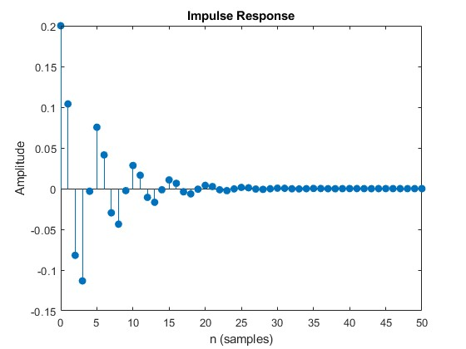

F04.

b = 0.2;

a = [1, -0.52, 0.68];

w = linspace(0, pi, 500);

[h, w] = freqz(b, a, w);

magH = abs(h);

phaH = angle(h) * 180/pi;

poles = roots(a);

disp('Poles of H(z):');

disp(poles);

subplot(2,1,1);

plot(w/pi,magH, 'r-', 'LineWidth', 1.5)

xlabel("|H|")

ylabel("Frequency (in pi units)")

title('Magnitude Response of H(z)');

subplot(2,1,2);

plot(w/pi,phaH, 'm-', 'LineWidth', 1.5)

xlabel("Degrees")

ylabel("Frequency (in pi units)")

**EXERCISE**

E01.

a.

b = [1, -0.6,0];

a = [1, -0.5, 0.2];

figure;

zplane(b, a);

title('Pole-Zero Plot');

xlabel('Real(z)'); ylabel('Imag(z)');

grid on;

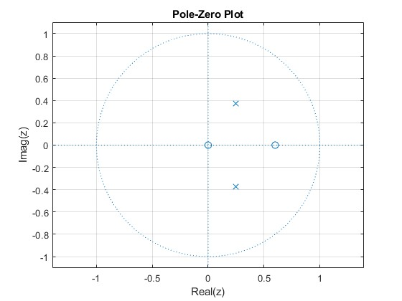

b.

b = [1, -0.6 ,0];

a = [1, -0.5, 0.2];

w = linspace(0, pi, 500);

[h, w] = freqz(b, a, w);

magH = abs(h);

phaH = angle(h) * 180/pi;

subplot(2,1,1);

plot(w/pi,magH, 'm--', 'LineWidth', 1.5)

xlabel("|H|")

ylabel("Frequency (in pi units)")

title('Magnitude Response of H(z)');

subplot(2,1,2);

plot(w/pi,phaH, 'b-', 'LineWidth', 1.5)

xlabel("Degrees")

ylabel("Frequency (in pi units)")

title('Phase Response of H(z)');

c.

b = [1, -0.6 ,0];

a = [1, -0.5, 0.2];

n = 0:49;

x = sin(0.1*pi*n);

y = filter(b, a, x);

figure;

plot(n, y, 'g-', 'LineWidth', 1.2); hold on;

plot(n, x, 'b--', 'LineWidth', 1.0);

title('Input and Output');

xlabel('n');

ylabel('Amplitude');

legend('output','input');

grid on;

E02.

a.

b = [4, 3, 2, 0.5, 1.5];

a = [1, 6, 8, 2, 0.6];

[R, P, K] = residuez(b, a);

fprintf('Residues (R):\n'); disp(R);

fprintf('Poles (P):\n'); disp(P);

fprintf('Direct terms (K):\n'); disp(K);

b.

b = [4, 3, 2, 0.5, 1.5];

a = [1, 6, 8, 2, 0.6];

figure;

zplane(b, a);

title('Pole-Zero Plot of G(z)');

xlabel('Real(z)'); ylabel('Imag(z)');

grid on;

c.

b = [4, 3, 2, 0.5, 1.5];

a = [1, 6, 8, 2, 0.6];

p = roots(a);

mag_p = abs(p);

fprintf('Poles:\n'); disp(p);

fprintf('Magnitudes:\n'); disp(mag_p);

if all(mag_p < 1)

fprintf('\nResult: System is STABLE (all |p| < 1).\n');

elseif any(mag_p > 1)

fprintf('\nResult: System is UNSTABLE (some |p| > 1).\n');

else

fprintf('\nResult: MARGINAL (some pole(s) lie on the unit circle: |p| == 1).\n');

end

d.

b = [4, 3, 2, 0.5, 1.5];

a = [1, 6, 8, 2, 0.6];

n = 0:20;

[h, nout] = impz(b, a, n);

figure;

stem(nout, h, 'filled');

title('Impulse Response of G(z)');

xlabel('n');

ylabel('h[n]');

grid on;

E03.

a.

syms z n

Hz = (1 + 2*z^-1 + 3*z^-2) / (1 - 1.2*z^-1 + 0.8*z^-2);

x_n = iztrans(Hz, z, n);

x_n_simpl = simplify(x_n);

fprintf('Symbolic inverse Z-transform x[n] = \n');

disp(x_n_simpl);

Symbolic inverse Z-transform x[n] =

(15*kroneckerDelta(n, 0))/4 + (16*(-1)^n*4^n*cos(n*(pi - acos((3*5^(1/2))/10))))/(3*(2*5^(1/2))^n) + ((-1)^n*5^(1 - n)*11^(1/2)*(- 3 - 11^(1/2)*1i)^(n - 1)*97i)/66 - ((-1)^n*5^(1 - n)*11^(1/2)*(- 3 + 11^(1/2)*1i)^(n - 1)*97i)/66

b.

b = [1, 2, 3];

a = [1, -1.2, 0.8];

figure;

zplane(b, a);

title('Pole-Zero Plot of H(z)');

xlabel('Real(z)'); ylabel('Imag(z)');grid on;

c.

b = [1, 2, 3];

a = [1, -1.2, 0.8];

[R, P, K] = residuez(b, a);

fprintf('Residues (R):\n'); disp(R);

fprintf('Poles (P):\n'); disp(P);

fprintf('Direct terms (K):\n'); disp(K);

[num, den] = residuez(R, P, K);

fprintf('Reconstructed numerator (z^-1 coeffs):\n'); disp(num);

fprintf('Reconstructed denominator (z^-1 coeffs):\n'); disp(den);

d.

System is STABLE (all |p| < 1)

E04.

r_outer = 2.0;

x_inner = r_inner * cos(theta); y_inner = r_inner * sin(theta);

x_outer = r_outer * cos(theta); y_outer = r_outer * sin(theta);

ux = cos(theta); uy = sin(theta);

figure;

hold on;

axis equal;

fill([x_inner, fliplr(x_outer)], [y_inner, fliplr(y_outer)], 'y','FaceAlpha', 0.35, 'EdgeColor', 'none');

plot(ux, uy, 'm--', 'LineWidth', 1.5);

xlabel('Real(z)');

ylabel('Imag(z)');

title('Unit circle and ROC for x[n] = - (0.3)^n, 0 \le n \le 20');

legend('ROC','Unit circle |z|=1');

grid on;

xlim([-r_outer r_outer]); ylim([-r_outer r_outer]);

The Region of Convergence (ROC) is the set of complex $z$-values where the Z-transform sum converges to a finite value. Its shape (outside a radius, inside, or an annulus) depends on whether the sequence is finite, right-sided, or left-sided, and the ROC never includes poles where the transform blows up. ROC matters for stability because an LTI system is BIBO-stable only if its ROC includes the unit circle $(∣z∣=1)$, which guarantees the frequency response exists and bounded inputs produce bounded outputs.