Experiment No 10
BECS 32461

Digital Signal Processing Exercise

Student Name: W. K. G. K. Jayawardana
Student No: EC/2021/006
Date Performed: 2025/12/12
Date Submitted: 2025/12/12

Q01.a
fs = 500;
t = 0:1/fs:2;
noise = 2.5*randn(size(t));
x = sin(16*pi*t) + 0.7*sin(100*pi*t) + 0.5*sin(200*pi*t) + noise;

plot(t, x);
title('Sampled Signal x(t)');
xlabel('Time (s)');
ylabel('Amplitude');
grid on;

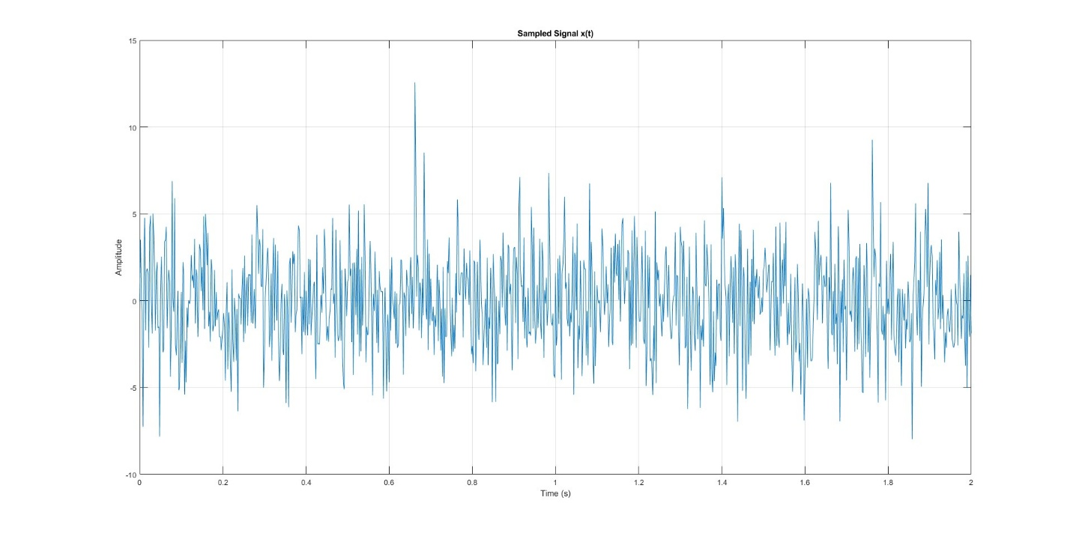
Q01.b
Yes. Choosen sampling frequency is satisfying Nyquist criteria for 𝑥(𝑡) = sin(16𝜋𝑡) + 0.7 sin(100𝜋𝑡) + 0.5 sin(200𝜋𝑡) + 𝑛(𝑡) because Nyquist rate of this signal is 200Hz and 500Hz(fs) is greater than that.

Q02.a
fs = 500;
t = 0:1/fs:2;
noise = 2.5*randn(size(t));
x = sin(16*pi*t) + 0.7*sin(100*pi*t) + 0.5*sin(200*pi*t) + noise;

N = length(x);
Y = fft(x);

f = (0:N-1)*(fs/N);

plot(f,abs(Y));
title('Magnitude Spectrum of x[n]');
xlabel('Frequency (Hz)');
ylabel('|fft(x)|');
xlim([0 250]);
grid on;

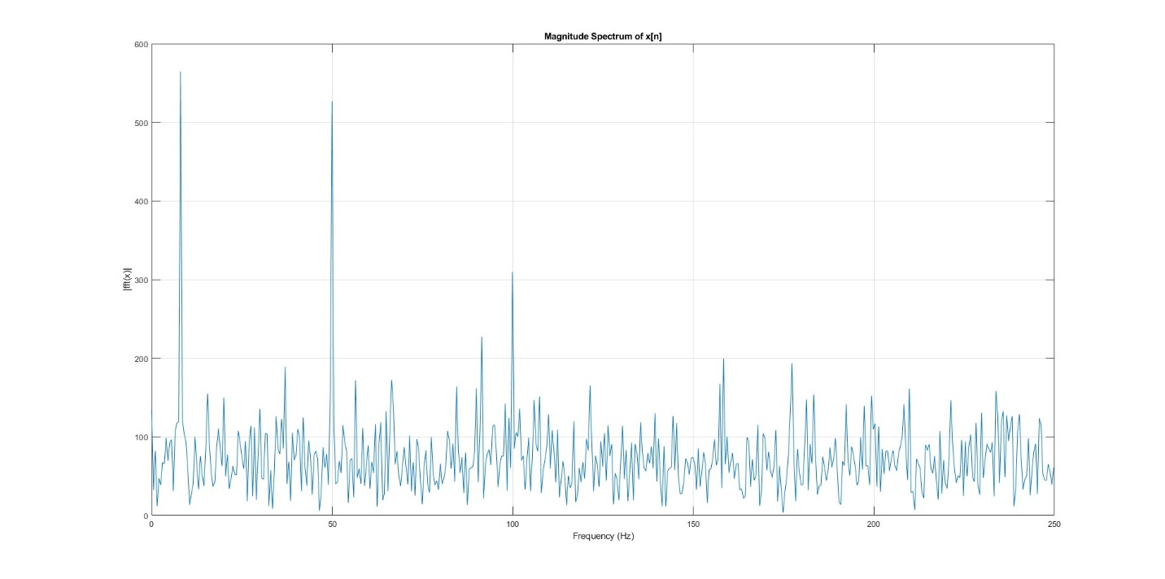
Q02.b
8Hz, 50Hz, 100Hz likely belongs to the true cosmic wave.

Q03.
N = 80;
fp = [0.008 0.08];
fs = 500;

x_fir = fir1(N, fp, 'bandpass', hamming(N+1));

figure;
[h_ham, w_ham] = freqz(x_fir, 1, 1024, fs);
plot(w_ham*fs/(2*pi), 20*log10(abs(h_ham)), 'r-'); hold on;
xlabel('Frequency(Hz)');
ylabel('Magnitude');
title('Magnitude Response');
grid on;

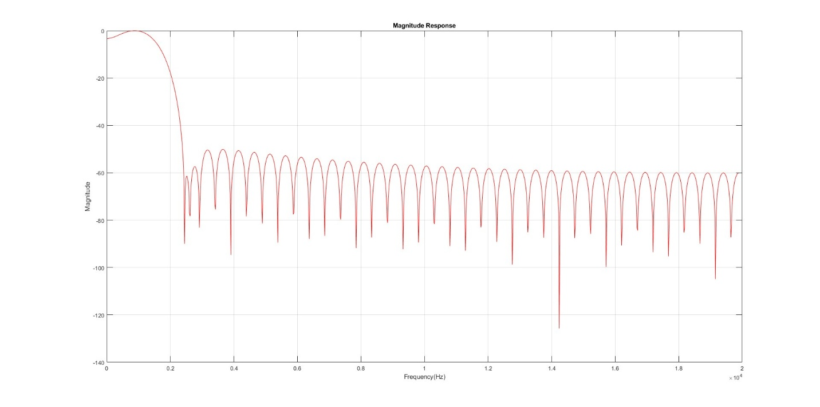
Hamming gives low ripple and good side-lobe suppression.

Q04.
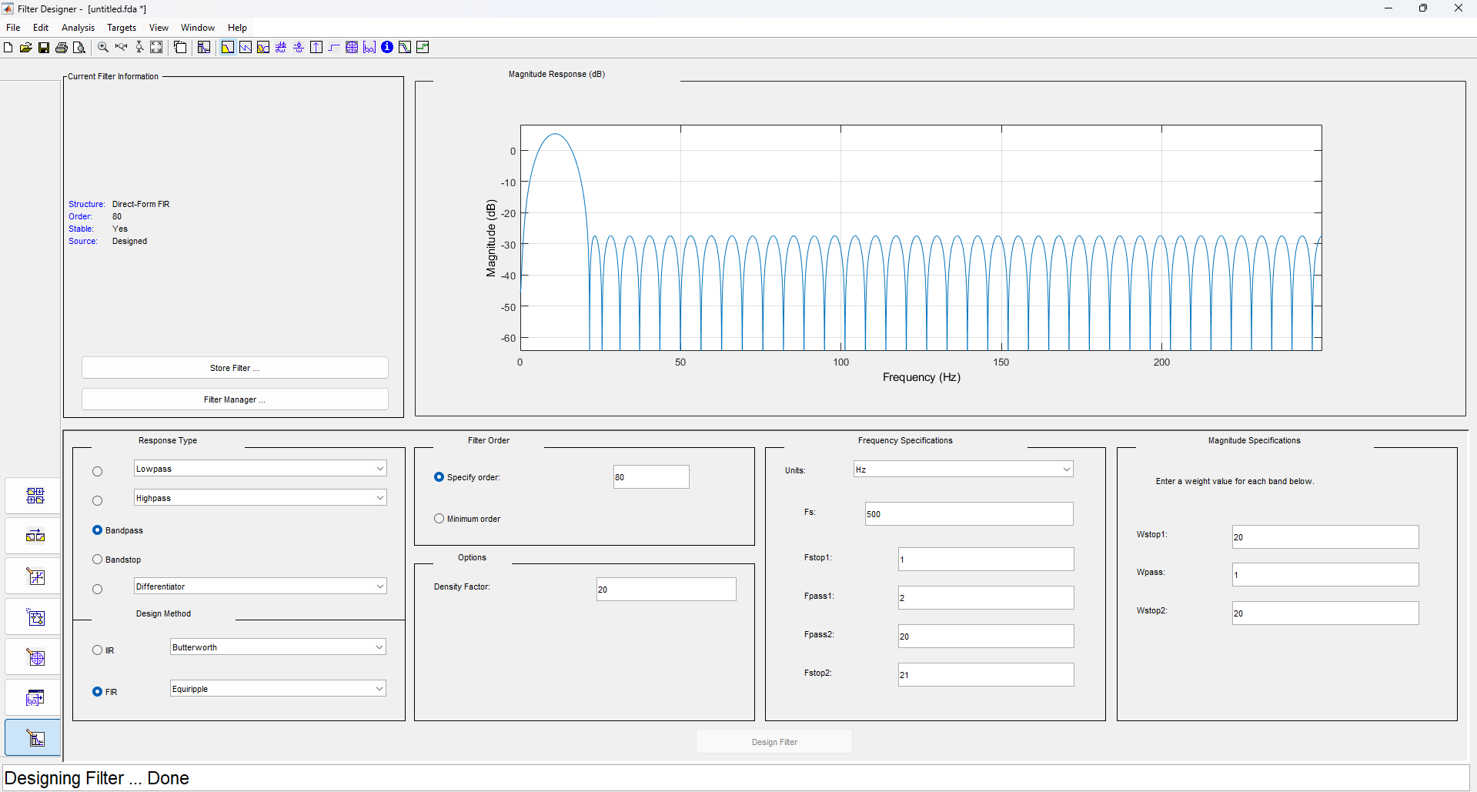
Q04.a
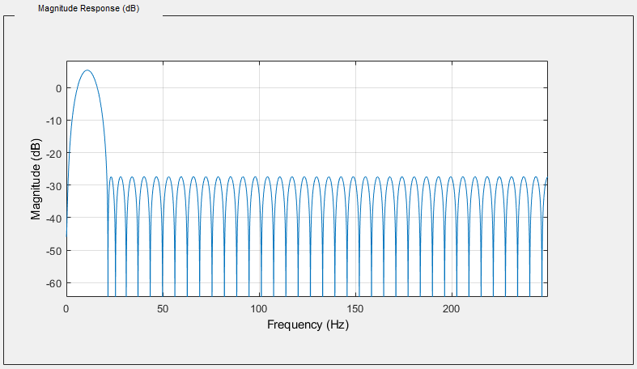
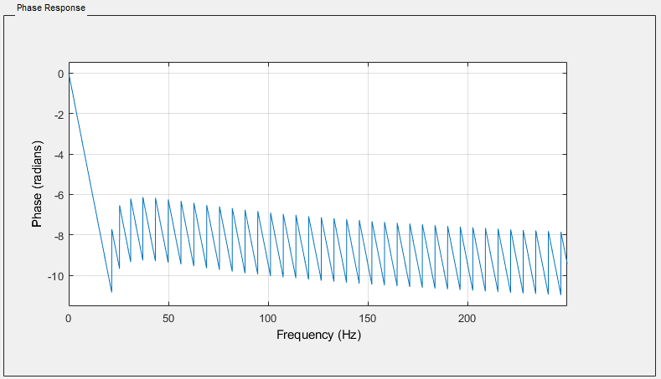
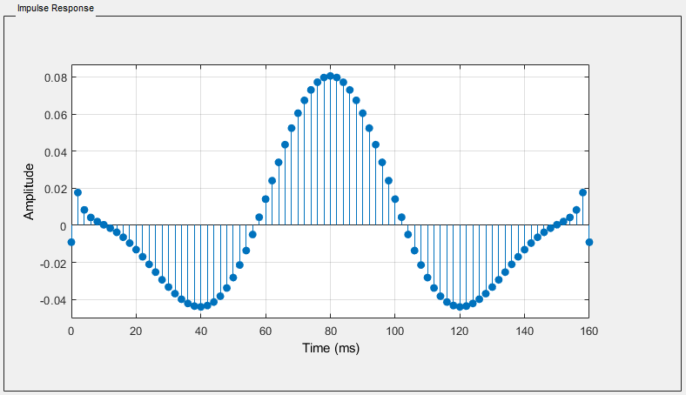

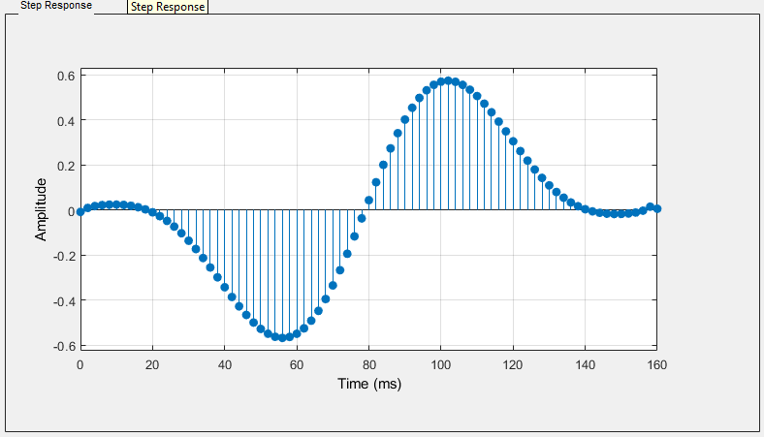
Q04.b
N = 80;
fp = [0.008 0.08];
fs = 500;
a = 1;

x_fir = fir1(N, fp, 'bandpass', hamming(N+1));

figure;
[h_ham, w_ham] = freqz(x_fir, 1, 1024, fs);
[h_fda, w_fda] = freqz(b, a, 1024, fs);

plot(w_ham*fs/(2*pi), 20*log10(abs(h_ham)), 'r-'); hold on;
plot(w_fda*fs/(2*pi), 20*log10(abs(h_fda)), 'b-');
xlabel('Frequency(Hz)');
ylabel('Magnitude(db)');
title('Magnitude Response');
grid on;

legend('Hamming FIR','FDA Tool');

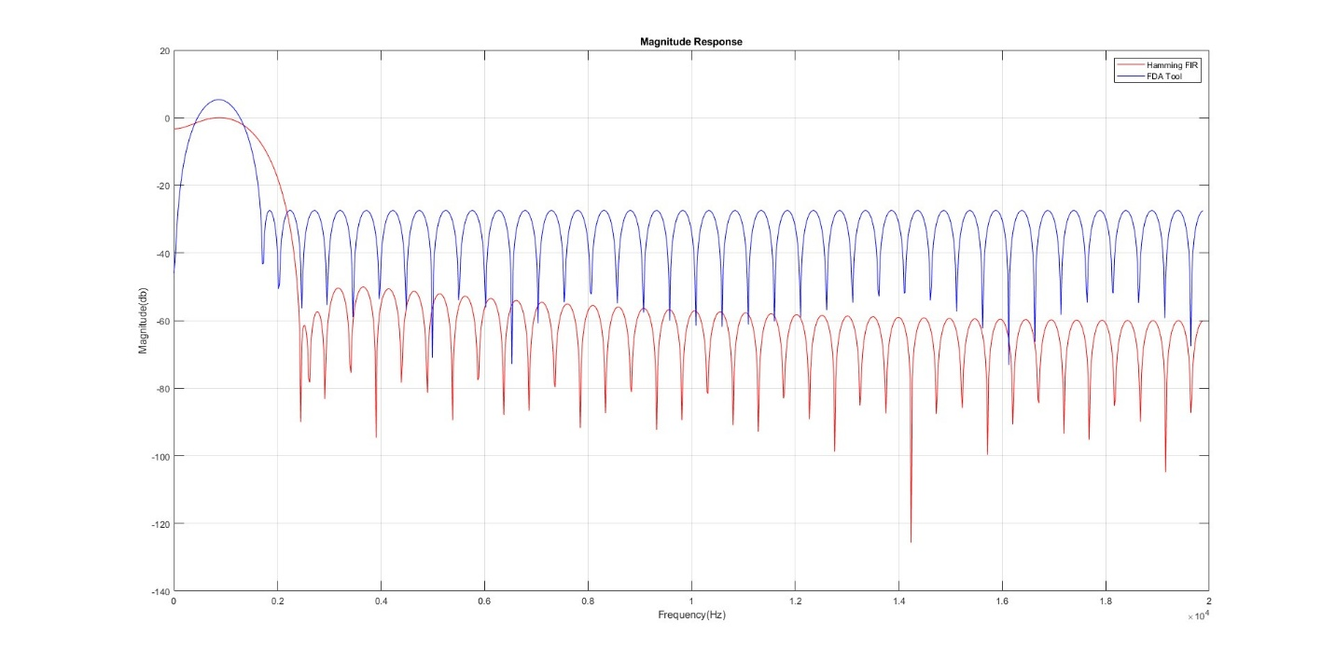
Q04.c
- FDA tool signal sharper than previously designed filter.
- So FDA tool is more suitable for preserving the cosmic message ehile removing interference.

Q05.
fs = 500;
t = 0:1/fs:2;
a = 1;

figure;
subplot(2,1,1);
plot(t, x);
title('Sampled Signal x(t)');
xlabel('Time (s)');
ylabel('Amplitude');
grid on;

subplot(2,1,2);
y_fda = filter(b, a, x);
plot(t, y_fda);
title('Filtered Signal y[n] (FDA Tool FIR)');
xlabel('Time(s)');
ylabel('Amplitude');

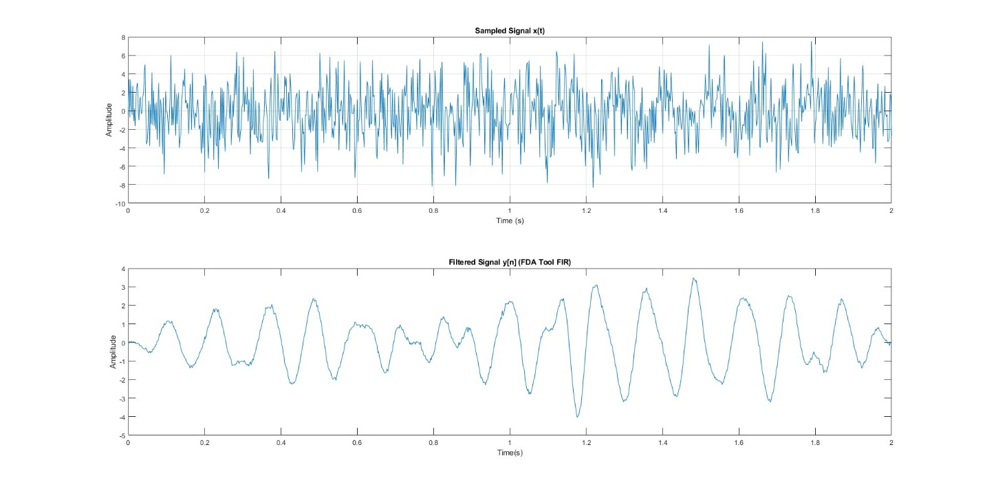

Q06.
fs = 500;
t = 0:1/fs:2;

X = fft(x);
mask = zeros(size(X));

for k = 1:length(f)
if (f(k) >= 2 && f(k) <= 20)
mask(k) = 1;
mask(end-k+1) = 1;
end
end

X_masked = X .* mask;
x_rec = real(ifft(X_masked));

figure;
plot(t, x_rec, 'LineWidth', 1.2); hold on;
plot(t, y_fda, 'LineWidth', 1.2);
legend('IFFT Reconstructed','FDA Tool FIR Output');
title('Time-domain Comparison');
xlabel('Time (s)');

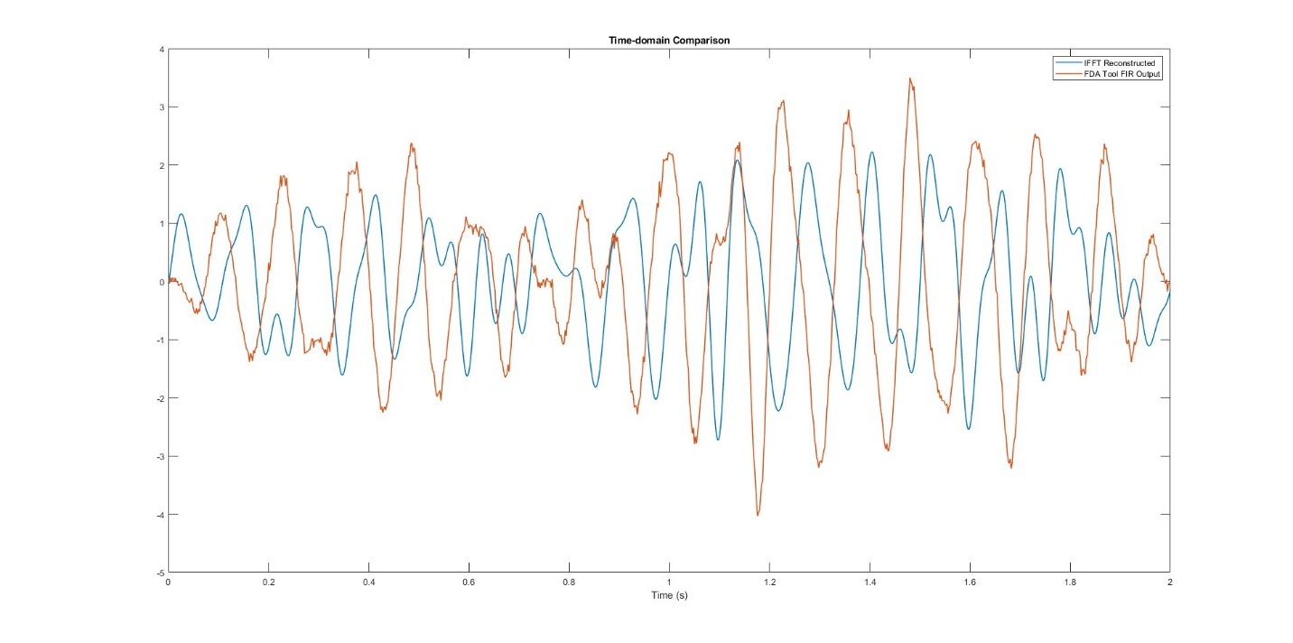

Q07.a
I choose Elliptic because it is more stable one.
Fs = 500;
Wp = [2 20] / (Fs/2);
Ws = [1 25] / (Fs/2);
Rp = 1;
Rs = 40;

[biir, aiir] = ellip(4, Rp, Rs, Wp, 'bandpass');

figure;
freqz(biir, aiir, 1024, Fs);
title('IIR Elliptic Bandpass Filter Response');

y_iir = filter(biir, aiir, x);

figure;
plot(t(1:500), x(1:500), 'LineWidth', 1); hold on;
plot(t(1:500), y_iir(1:500), 'LineWidth', 1.2);
legend('Original x[n]','IIR Filtered');
title('IIR vs Noisy');
xlabel('Time (s)');

figure;
zplane(biir, aiir);
title(' Pole-Zero Plot of Elliptic IIR Filter');

Q07.d

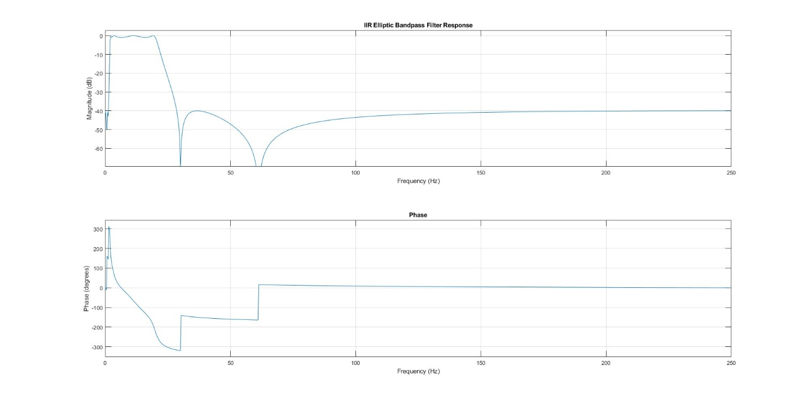
Q07.e
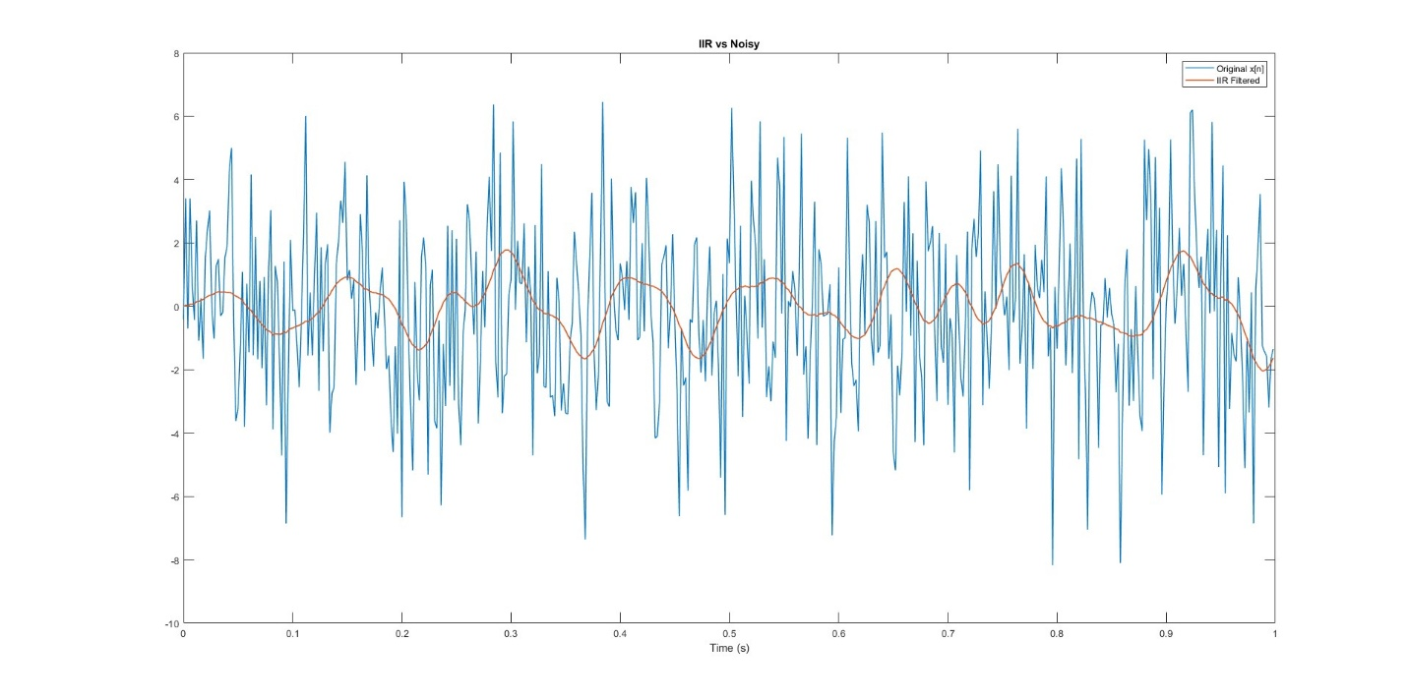
Q07.f
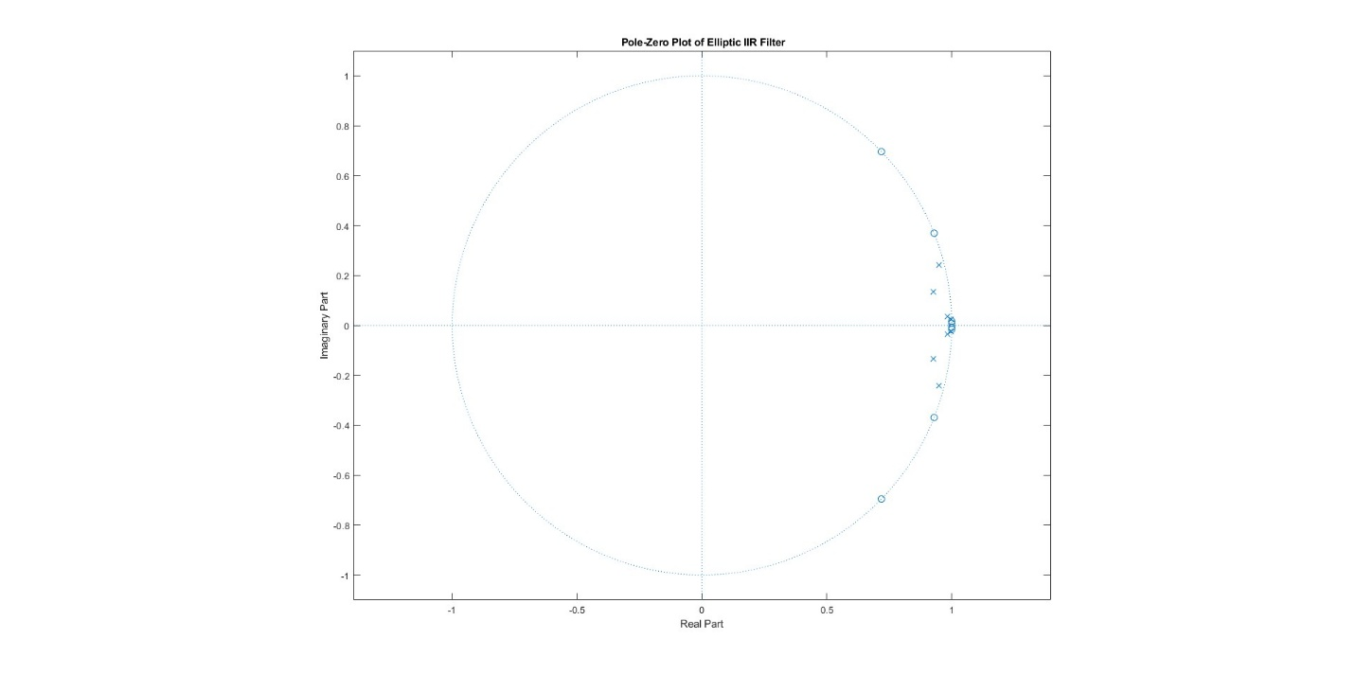
Q07.g
- IIR has sharper transition but FIR is more stable (all poles at 0).
- FIR FDA Tool filter better for distortion-free cosmic signal recovery.

