Experiment No 09
BECS 32461
Paper A

FILTER DESIGN AND ANALYSIS WITH (FDA) TOOL

Student Name: W. K. G. K. Jayawardana
Student No: EC/2021/006
Date Performed: 2025/11/21
Date Submitted: 2025/11/21

PROCEDURE
F01.
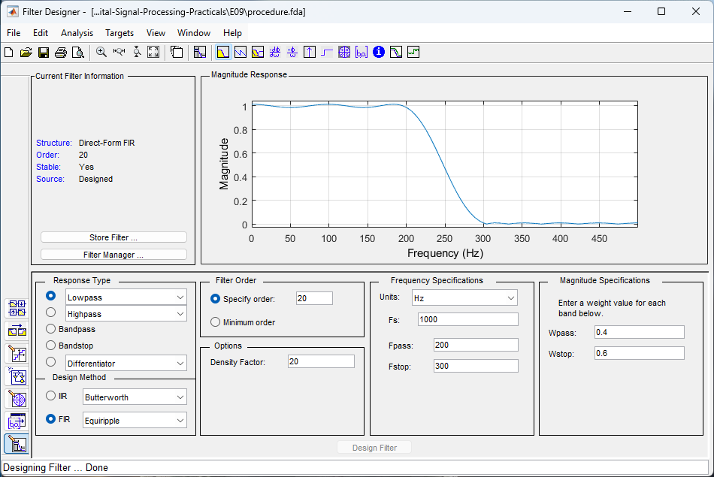

F02.
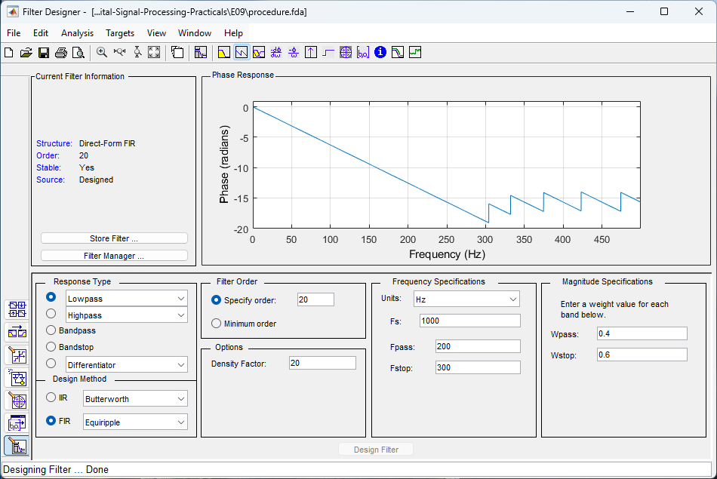
F03.
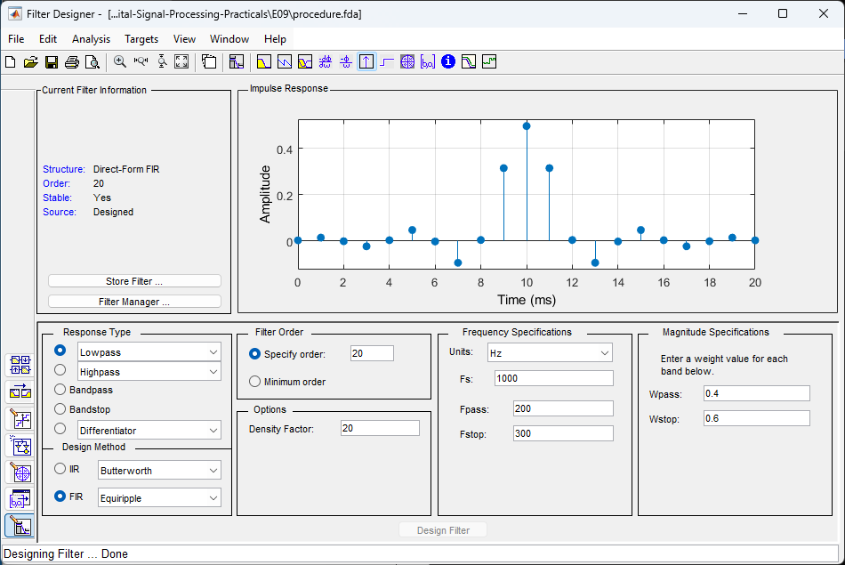
F04.
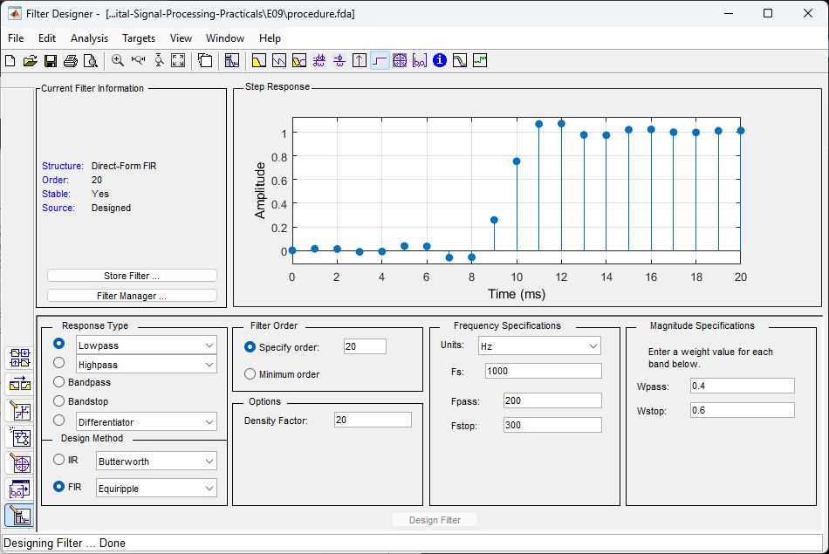

P09.
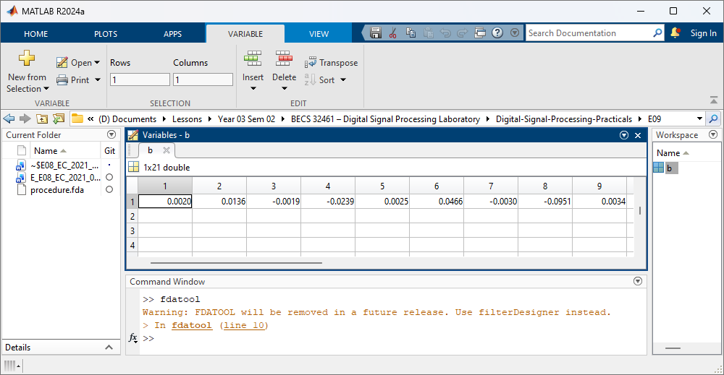
F05.
Fs = 1000;
t = 0:1/Fs:1;

x1 = sin(2*pi*125*t);
x2 = sin(2*pi*350*t);

x = x1 + x2;

figure;
plot(t, x,'LineWidth',1.5);
xlabel('Time (s)');
ylabel('Amplitude');
title('Composite Signal in Time Domain');

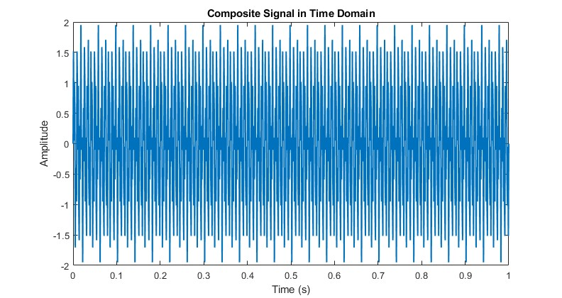
F06.
Fs = 1000;
t = 0:1/Fs:1;
x1 = sin(2*pi*125*t);
x2 = sin(2*pi*350*t);
x = x1 + x2;

y = filter(b, 1, x);

N = length(x);
X = abs(fft(x));
Y = abs(fft(y));

f = (0:N-1)*(Fs/N);

figure;
subplot(2,1,1);
plot(f, X,'g-');
title('FFT of Original Signal');
xlabel('Frequency (Hz)');
ylabel('Magnitude');
xlim([0 500]);
grid on;

subplot(2,1,2);
plot(f, Y,'r-');
title('FFT of Filtered Signal');
xlabel('Frequency (Hz)');
ylabel('Magnitude');
xlim([0 500]);
grid on;

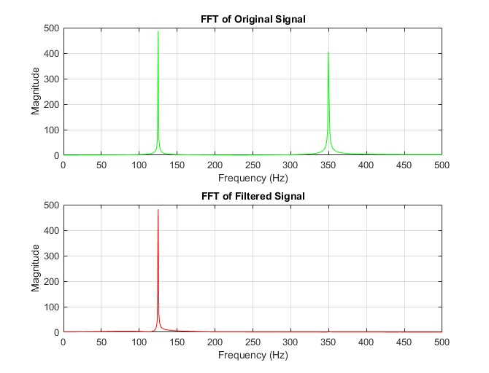

EXERCISE
E01.
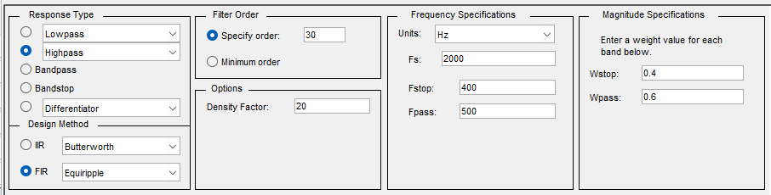
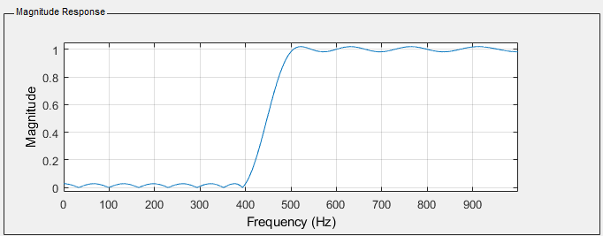
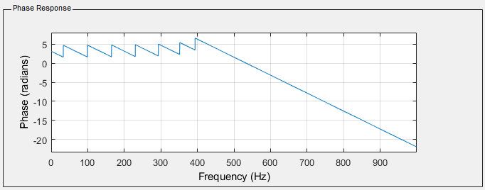
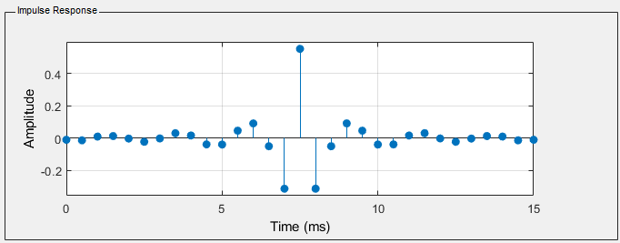
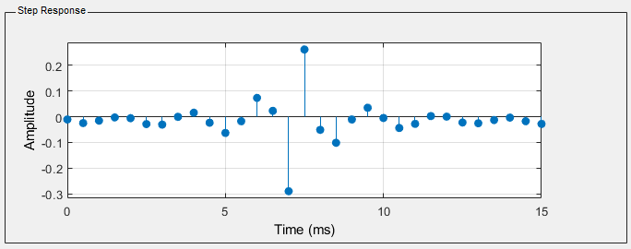
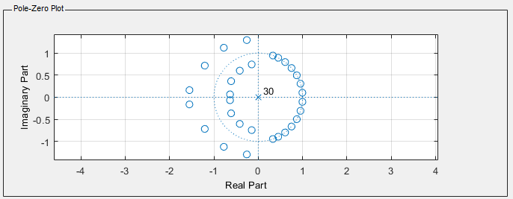

c.
Fs = 2000;
Fstop = 400;
Fpass = 500;
N = 30;

nyq = Fs/2;
f = [0 Fstop Fpass nyq] / nyq;
a = [0 0 1 1];

nfft = 2048;
[H, w] = freqz(b_hp, 1, nfft, Fs);

figure;
subplot(2,1,1);
plot(w, abs(H));
grid on;
xlabel('Frequency (Hz)');
ylabel('Magnitude (dB)');
title('Magnitude Response (freqz)');

subplot(2,1,2);
plot(w, unwrap(angle(H)));
grid on;
xlabel('Frequency (Hz)');
ylabel('Phase (rad)');
title('Phase Response (freqz)');

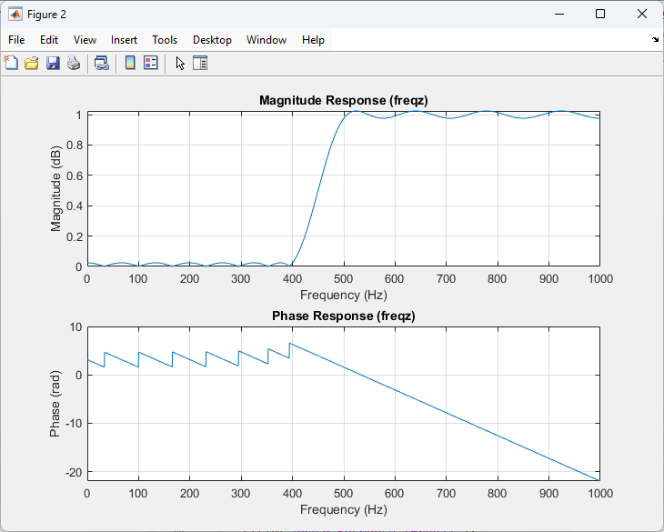
d.
Ts = 1/Fs;
Hd_tf = tf(b_hp, 1, Ts);
disp('Transfer function (discrete-time):');
Hd_tf
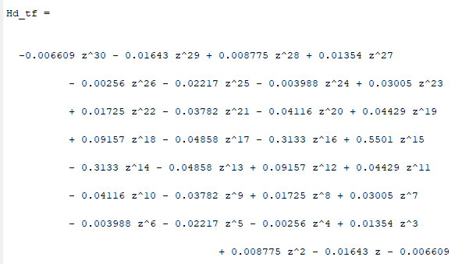
e.
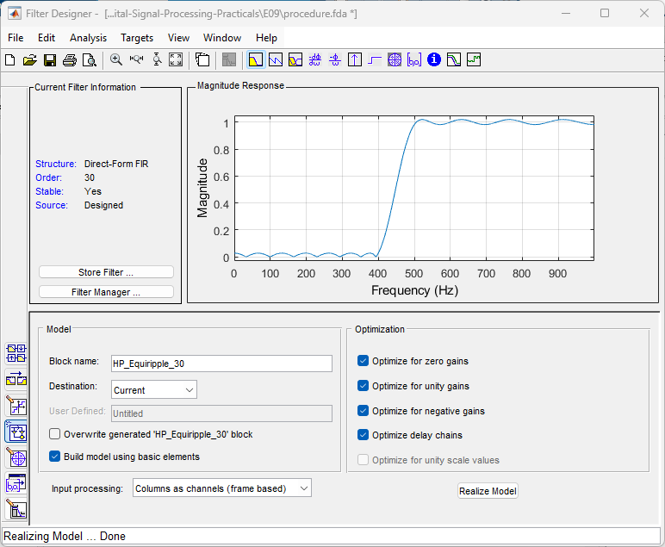
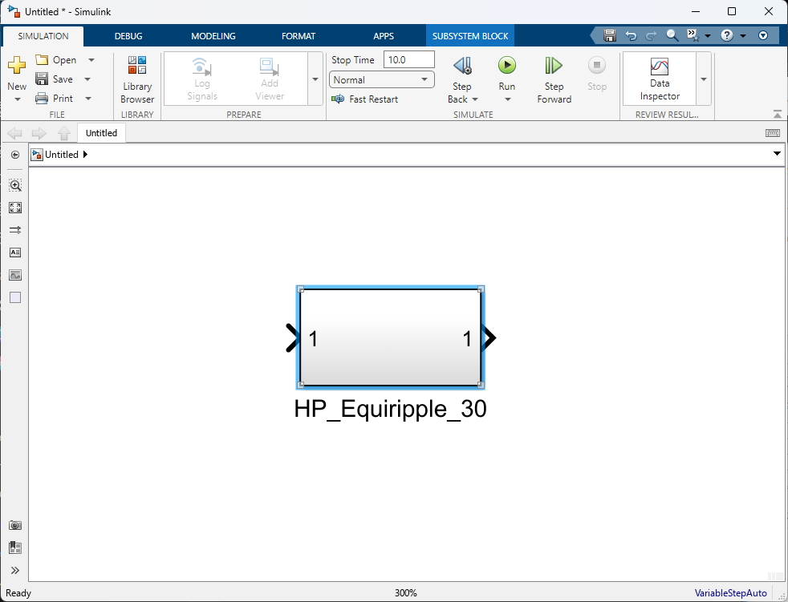

E02.
c.
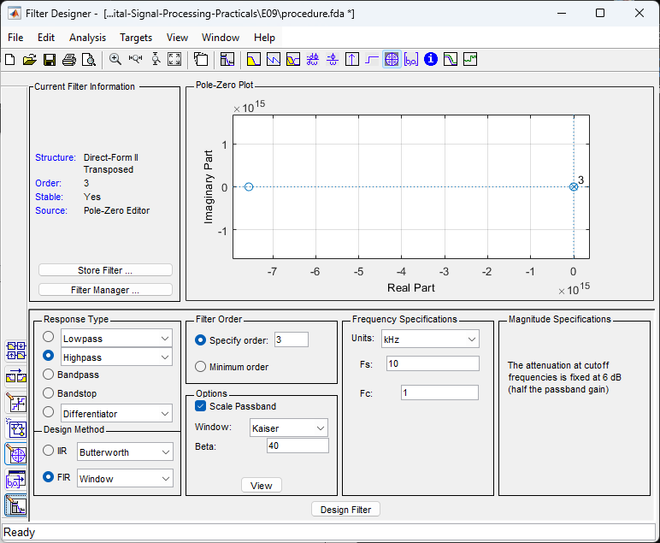
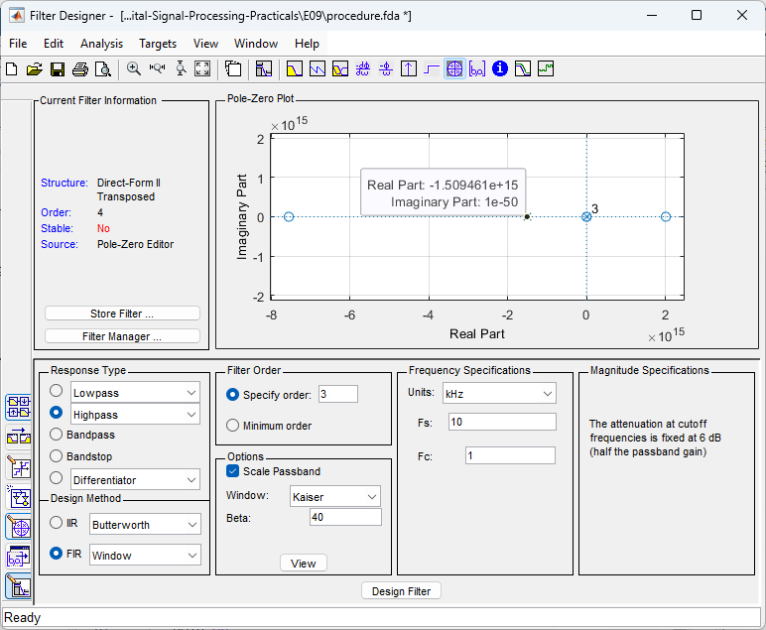
After adding a zero at z = 2 and a pole at z = –1.5, the modified system becomes an IIR filter. The impulse response plot shows that the output does not decay with time; instead, it grows in magnitude, indicating an unstable behavior. This occurs because the added pole is located at |–1.5| = 1.5, which is outside the unit circle. For a discrete-time system to be stable, all poles must lie inside the unit circle (|p| < 1). Since this condition is violated, the modified filter is unstable, and its impulse response clearly reflects this instability through unbounded oscillations.
d.
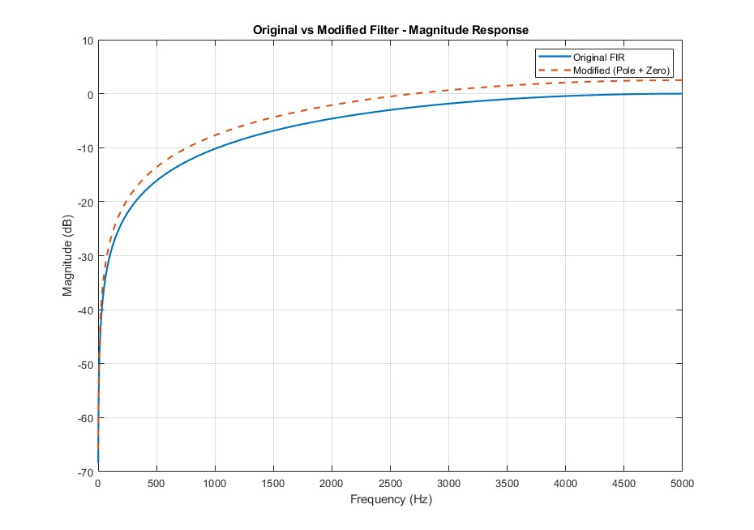

E03.
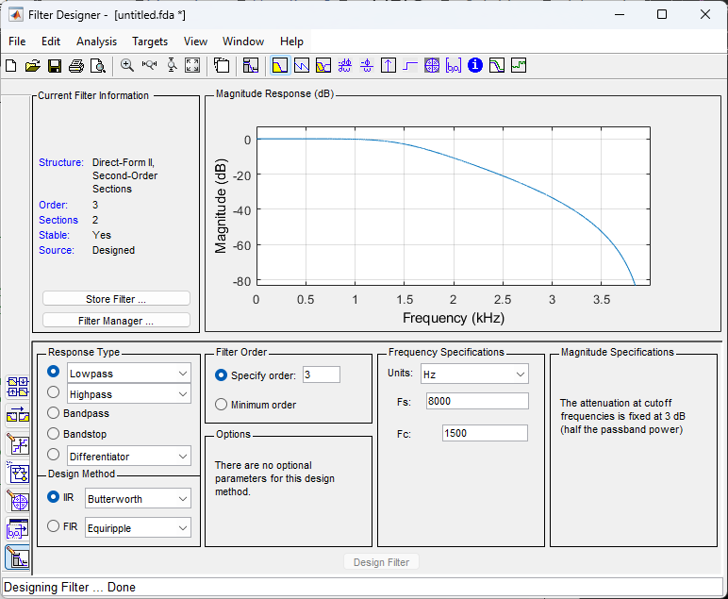
function Hd = butter_lp3
%BUTTER_LP3 Returns a discrete-time filter object.

% MATLAB Code
% Generated by MATLAB(R) 24.1 and DSP System Toolbox 24.1.
% Generated on: 21-Nov-2025 15:27:40

% Butterworth Lowpass filter designed using FDESIGN.LOWPASS.

% All frequency values are in Hz.
Fs = 8000; % Sampling Frequency

N = 3; % Order
Fc = 1500; % Cutoff Frequency

% Construct an FDESIGN object and call its BUTTER method.
h = fdesign.lowpass('N,F3dB', N, Fc, Fs);
Hd = design(h, 'butter');

% [EOF]

fvtool(Hd);

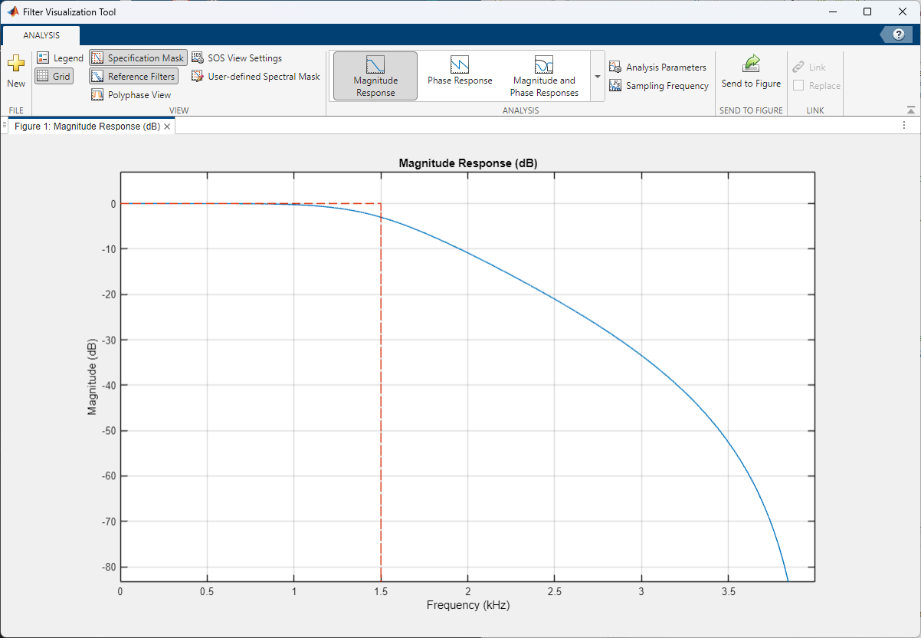
C.
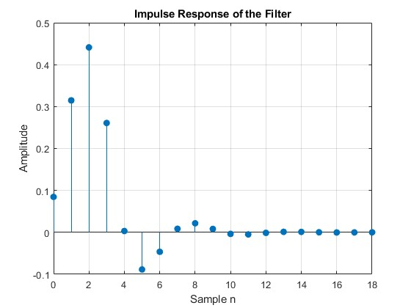
d.
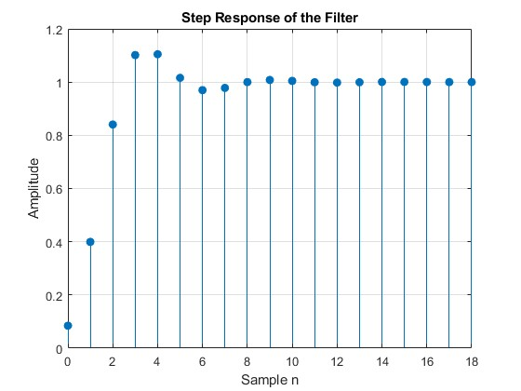
function Hd = butter_lp3
%BUTTER_LP3 Returns a discrete-time filter object.

% MATLAB Code
% Generated by MATLAB(R) 24.1 and DSP System Toolbox 24.1.
% Generated on: 21-Nov-2025 15:27:40

% Butterworth Lowpass filter designed using FDESIGN.LOWPASS.

% All frequency values are in Hz.
Fs = 8000; % Sampling Frequency

N = 3; % Order
Fc = 1500; % Cutoff Frequency

% Construct an FDESIGN object and call its BUTTER method.
h = fdesign.lowpass('N,F3dB', N, Fc, Fs);
Hd = design(h, 'butter');

% [EOF]

fvtool(Hd);

figure;
[impResp, n] = impz(Hd); % Compute impulse response
stem(n, impResp, 'filled'); % Stem plot
title('Impulse Response of the Filter');
xlabel('Sample n');
ylabel('Amplitude');
grid on;

figure;
[stepResp, n] = stepz(Hd); % Compute step response
stem(n, stepResp, 'filled'); % Stem plot
title('Step Response of the Filter');
xlabel('Sample n');
ylabel('Amplitude');
grid on;

