Experiment No 07
BECS 32461
Paper D

FINITE IMPULSE RESPONSE (FIR) FILTER DESIGN

Student Name: W. K. G. K. Jayawardana
Student No: EC/2021/006
Date Performed: 2025/11/07
Date Submitted: 2025/11/07

PROCEDURE
F01.
clc; close all; clear;

f = input('Enter cut off frequency (normalized,0<f<1): ');
N = input('Enter filter order (N > 1): ');

w0 = 0:0.1:pi;

b_rectangle = fir1(N, f/pi, 'low', rectwin(N+1));
b_blackman = fir1(N, f/pi, 'low', blackman(N+1));
b_hamming = fir1(N, f/pi, 'low', hamming(N+1));
b_hanning = fir1(N, f/pi, 'low', hann(N+1));
b_triangular = fir1(N, f/pi, 'low', triang(N+1));

h_rectangle = freqz(b_rectangle, 1, w0);
h_blackman = freqz(b_blackman, 1, w0);
h_hamming = freqz(b_hamming, 1, w0);
h_hanning = freqz(b_hanning , 1, w0);
h_triangular = freqz(b_triangular, 1, w0);

sgtitle('Low-Pass Filters using Different Windows');

subplot(2,3,1);
plot(w0/pi, abs(h_rectangle),'LineWidth',1.6); grid on;
title('Rectangular Window');
xlabel('Normalized frequency');
ylabel('Magnitude in dB');
xlim([0 1]);

subplot(2,3,2);
plot(w0/pi, abs(h_blackman),'LineWidth',1.6); grid on;
title('Blackman Window');
xlabel('Normalized frequency');
ylabel('Magnitude in dB');
xlim([0 1]);

subplot(2,3,3);
plot(w0/pi,abs(h_hamming),'LineWidth',1.6); grid on;
title('Hamming Window');
xlabel('Normalized frequency');
ylabel('Magnitude in dB');
xlim([0 1]);

subplot(2,3,4);
plot(w0/pi, abs(h_hanning),'LineWidth',1.6); grid on;
title('Hann Window');
xlabel('Normalized frequency');
ylabel('Magnitude in dB');
xlim([0 1]);

subplot(2,3,5);
plot(w0/pi, abs(h_triangular),'LineWidth',1.6); grid on;
title('Triangular Window');
xlabel('Normalized frequency');
ylabel('Magnitude in dB');
xlim([0 1]);

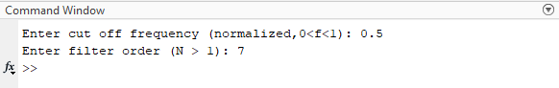
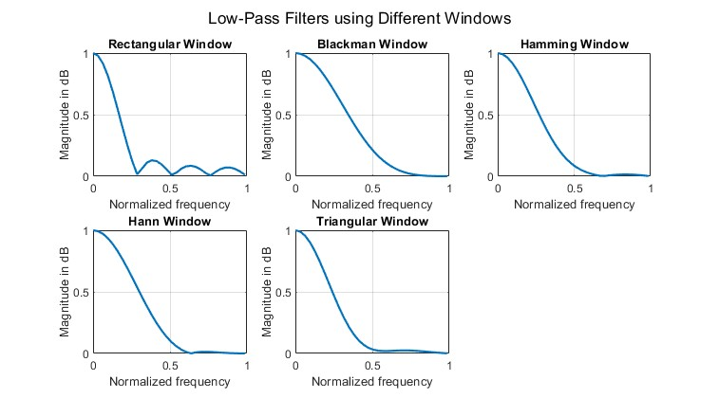

F02.
clc; close all; clear;

f = input('Enter cut off frequency (normalized,0<f<1): ');
N = input('Enter filter order (N > 1): ');

w0 = 0:0.1:pi;

b_rectangle = fir1(N, f/pi, 'high', rectwin(N+1));
b_blackman = fir1(N, f/pi, 'high', blackman(N+1));
b_hamming = fir1(N, f/pi, 'high', hamming(N+1));
b_hanning = fir1(N, f/pi, 'high', hann(N+1));
b_triangular = fir1(N, f/pi, 'high', triang(N+1));

h_rectangle = freqz(b_rectangle, 1, w0);
h_blackman = freqz(b_blackman, 1, w0);
h_hamming = freqz(b_hamming, 1, w0);
h_hanning = freqz(b_hanning , 1, w0);
h_triangular = freqz(b_triangular, 1, w0);

sgtitle('High-Pass Filters using Different Windows');

subplot(2,3,1);
plot(w0/pi, abs(h_rectangle),'LineWidth',1.6); grid on;
title('Rectangular Window');
xlabel('Normalized frequency');
ylabel('Magnitude in dB');
xlim([0 1]);

subplot(2,3,2);
plot(w0/pi, abs(h_blackman),'LineWidth',1.6); grid on;
title('Blackman Window');
xlabel('Normalized frequency');
ylabel('Magnitude in dB');
xlim([0 1]);

subplot(2,3,3);
plot(w0/pi,abs(h_hamming),'LineWidth',1.6); grid on;
title('Hamming Window');
xlabel('Normalized frequency');
ylabel('Magnitude in dB');
xlim([0 1]);

subplot(2,3,4);
plot(w0/pi, abs(h_hanning),'LineWidth',1.6); grid on;
title('Hann Window');
xlabel('Normalized frequency');
ylabel('Magnitude in dB');
xlim([0 1]);

subplot(2,3,5);
plot(w0/pi, abs(h_triangular),'LineWidth',1.6); grid on;
title('Triangular Window');
xlabel('Normalized frequency');
ylabel('Magnitude in dB');
xlim([0 1]);

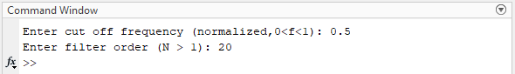
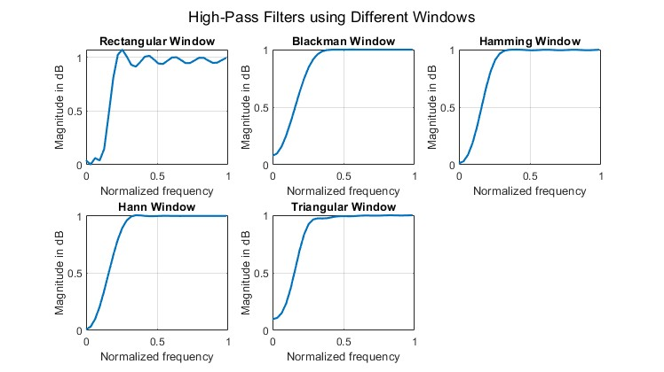

EXERCISE

E01.
clc; close all; clear;

n = 0:199;
x = cos(0.3*pi*n) + cos(0.6*pi*n) + cos(0.9*pi*n);

%--(a)--
figure;
plot(n, x, 'g', 'LineWidth',1.3); grid on;
title('Input Multi-tone Signal x[n]');
xlabel('n'); ylabel('Amplitude');

fs1 = 0.5; fs2 = 0.7;
N = 40;
b = fir1(N, [fs1 fs2], 'stop', hamming(N+1));

w0 = 0:0.01:pi;
h = freqz(b, 1, w0);

%--(b)--
figure;
plot(w0/pi, 20*log10(abs(h)+eps), 'b', 'LineWidth',1.6); grid on;
title('Hamming Window Band-Stop Filter Response');
xlabel('Normalized Frequency (\times\pi rad/sample)');
ylabel('Magnitude (dB)');
xlim([0 1]);

y = filter(b, 1, x);

%--(c)--
figure;

subplot(2,1,1);
plot(abs(fftshift(fft(x))), 'm', 'LineWidth',1.4); grid on;
title('Magnitude Spectrum of Input Signal');
xlabel('Frequency Index'); ylabel('|X(f)|');

subplot(2,1,2);
plot(abs(fftshift(fft(y))), 'm', 'LineWidth',1.4); grid on;
title('Magnitude Spectrum of Filtered Signal');
xlabel('Frequency Index'); ylabel('|Y(f)|');

sgtitle('Effect of Hamming Window Band-Stop Filter on Multi-tone Signal');

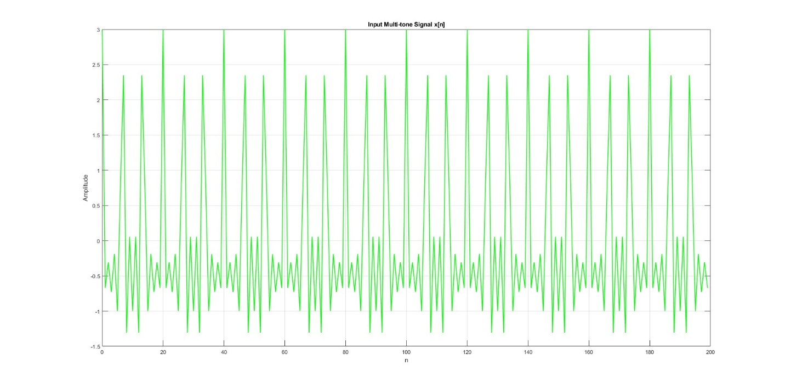
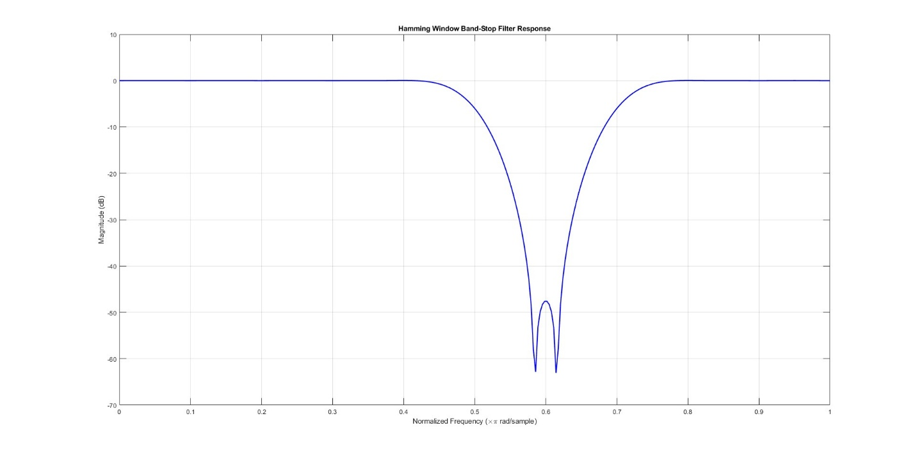
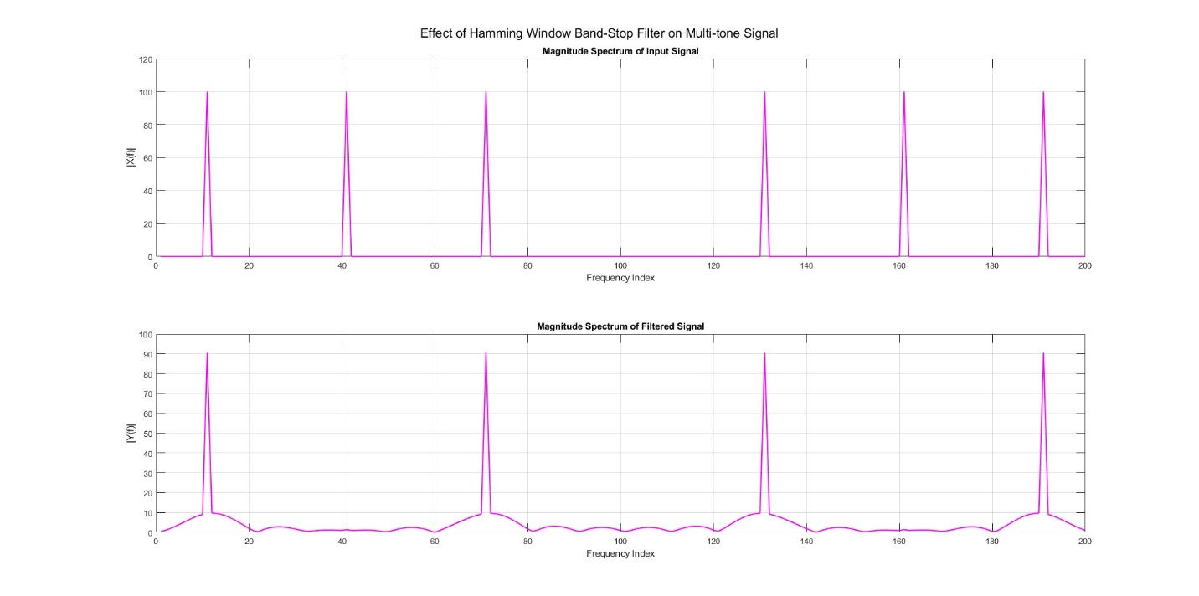

E02.
clc; close all; clear;

fp = [0.15 0.45];
N = 30;

w0 = 0:0.01:pi;

b_rect = fir1(N, fp, 'bandpass', rectwin(N+1));
b_black = fir1(N, fp, 'bandpass', blackman(N+1));
b_ham = fir1(N, fp, 'bandpass', hamming(N+1));
b_hann = fir1(N, fp, 'bandpass', hann(N+1));
b_tri = fir1(N, fp, 'bandpass', triang(N+1));

H_rect = freqz(b_rect,1,w0);
H_black = freqz(b_black,1,w0);
H_ham = freqz(b_ham,1,w0);
H_hann = freqz(b_hann,1,w0);
H_tri = freqz(b_tri,1,w0);

%--(a)--
figure;
sgtitle('Band-Pass FIR Filters');

subplot(2,3,1);
plot(w0/pi, 20*log10(abs(H_rect)),'LineWidth',1.4); grid on;
title('Rectangular Window'); ylabel('Magnitude (dB)');
xlabel('Normalized Frequency ');
xlim([0 1]);

subplot(2,3,2);
plot(w0/pi, 20*log10(abs(H_black)),'LineWidth',1.4); grid on;
title('Blackman Window'); ylabel('Magnitude (dB)');
xlabel('Normalized Frequency ');
xlim([0 1]);

subplot(2,3,3);
plot(w0/pi, 20*log10(abs(H_ham)),'LineWidth',1.4); grid on;
title('Hamming Window'); ylabel('Magnitude (dB)');
xlabel('Normalized Frequency ');
xlim([0 1]);

subplot(2,3,4);
plot(w0/pi, 20*log10(abs(H_hann)),'LineWidth',1.4); grid on;
title('Hann Window'); ylabel('Magnitude (dB)');
xlabel('Normalized Frequency ');
xlim([0 1]);

subplot(2,3,5);
plot(w0/pi, 20*log10(abs(H_tri)),'LineWidth',1.4); grid on;
title('Triangular Window'); ylabel('Magnitude (dB)');
xlabel('Normalized Frequency ');
xlim([0 1]);

%--(b)--
figure;
N1=13; N2=14; N3=15;

b1 = fir1(N1, fp, 'bandpass', hamming(N1+1));
b2 = fir1(N2, fp, 'bandpass', hamming(N2+1));
b3 = fir1(N3, fp, 'bandpass', hamming(N3+1));

H1 = freqz(b1,1,w0);
H2 = freqz(b2,1,w0);
H3 = freqz(b3,1,w0);

plot(w0/pi,20*log10(abs(H1)),'r','LineWidth',1.4);
hold on;
plot(w0/pi,20*log10(abs(H2)),'g','LineWidth',1.4);
plot(w0/pi,20*log10(abs(H3)),'b','LineWidth',1.4);
grid on;
title('Effect of Filter Order (Hamming Window)');
xlabel('Normalized Frequency');
ylabel('Magnitude (dB)');
legend('N=13','N=14','N=15');

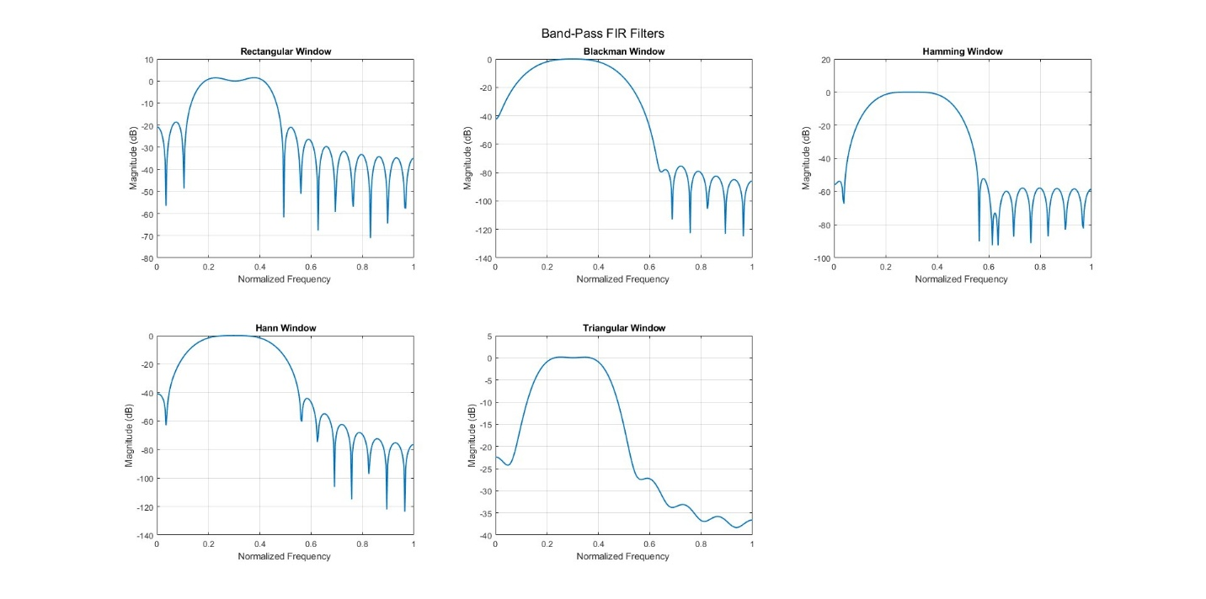
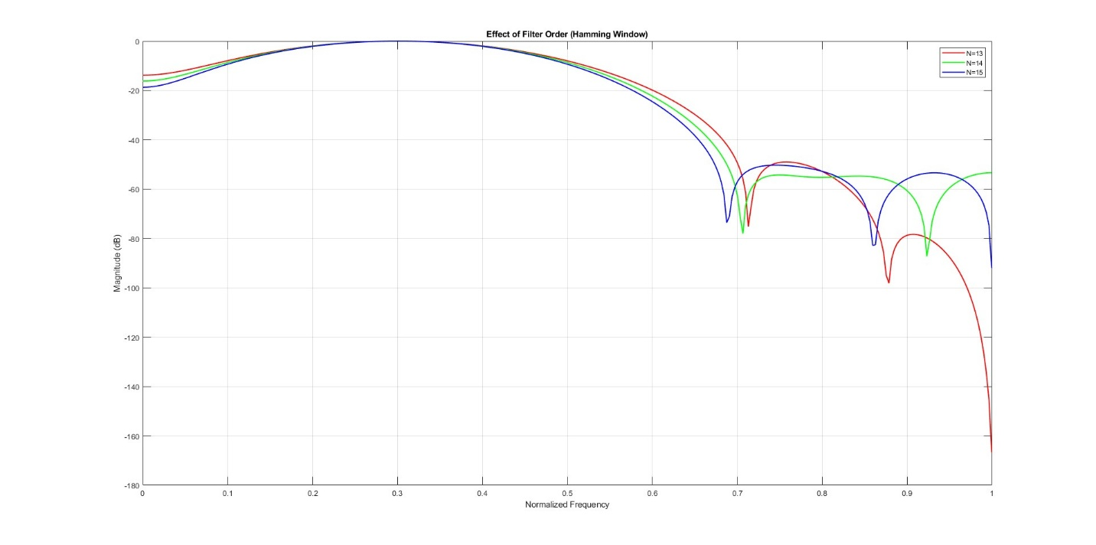

E03.
clc; close all; clear;

fs1 = 0.1; fs2 = 0.8;
N = 20;

w0 = linspace(0, pi, 512);

b_rect = fir1(N, [fs1 fs2], 'stop', rectwin(N+1));
b_black = fir1(N, [fs1 fs2], 'stop', blackman(N+1));
b_ham = fir1(N, [fs1 fs2], 'stop', hamming(N+1));
b_hann = fir1(N, [fs1 fs2], 'stop', hann(N+1));
b_tri = fir1(N, [fs1 fs2], 'stop', triang(N+1));

H_rect = freqz(b_rect, 1, w0);
H_black = freqz(b_black, 1, w0);
H_ham = freqz(b_ham, 1, w0);
H_hann = freqz(b_hann, 1, w0);
H_tri = freqz(b_tri, 1, w0);

figure;

subplot(2,1,1);
plot(w0/pi, 20*log10(abs(H_rect)), 'r', 'LineWidth', 1.2); hold on;
plot(w0/pi, 20*log10(abs(H_black)), 'b', 'LineWidth', 1.2);
plot(w0/pi, 20*log10(abs(H_ham)), 'g', 'LineWidth', 1.2);
plot(w0/pi, 20*log10(abs(H_hann)), 'm', 'LineWidth', 1.2);
plot(w0/pi, 20*log10(abs(H_tri)), 'k', 'LineWidth', 1.2);
xlabel('Normalized Frequency');
ylabel('Magnitude (dB)');
title('Magnitude Responses of Band-Stop FIR Filters');
legend('Rectangular','Blackman','Hamming','Hann','Triangular');
grid on;
xlim([0 1]);

subplot(2,1,2);
plot(w0/pi, angle(H_rect), 'r', 'LineWidth', 1.2); hold on;
plot(w0/pi, angle(H_black), 'b', 'LineWidth', 1.2);
plot(w0/pi, angle(H_ham), 'g', 'LineWidth', 1.2);
plot(w0/pi, angle(H_hann), 'm', 'LineWidth', 1.2);
plot(w0/pi, angle(H_tri), 'k', 'LineWidth', 1.2);
xlabel('Normalized Frequency');
ylabel('Phase (radians)');
title('Phase Responses of Band-Stop FIR Filters');
legend('Rectangular','Blackman','Hamming','Hann','Triangular');
grid on;
xlim([0 1]);

sgtitle('Band-Stop FIR Filters using Different Windows');

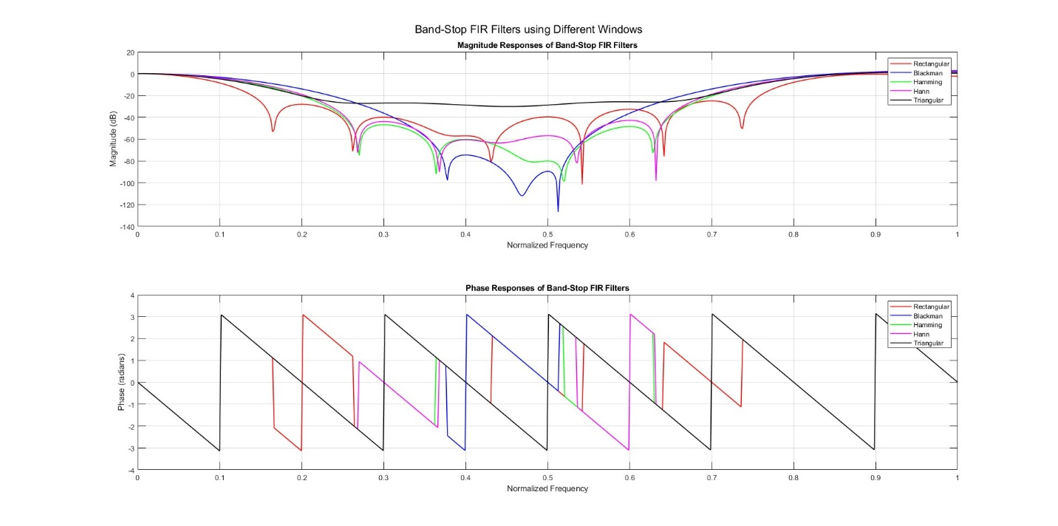
The Rectangular window gives the sharpest transition (narrowest main lobe) but has high side lobes, causing more leakage.
The Blackman window provides the best side-lobe suppression but has a wide main lobe (slow transition).
Hamming and Hann windows offer a good balance between transition sharpness and side-lobe attenuation, while Triangular lies in between Rectangular and Hamming.
- All filters have similar computational complexity for the same order.
Trade-off: sharper transitions
- higher side lobes; lower side lobes
- wider transition.
Recommendation:
- Use Rectangular when sharp transitions are required.
- Use Blackman when low side lobes (better stopband attenuation) are more important.
- Hamming is the best general compromise.

E04.
clc; close all; clear;

fc_low = 0.2;
fc_high = 0.8;
N = 40;

b_low = fir1(N, fc_low, 'low', triang(N+1));
b_high = fir1(N, fc_high, 'high', triang(N+1));

b_band = conv(b_low, b_high);

w0 = 0:0.01:pi;
H_band = freqz(b_band,1,w0);

plot(w0/pi, 20*log10(abs(H_band)+eps), 'r', 'LineWidth',1.5); grid on;
title('Band-Pass FIR Filter from LPF + HPF (Triangular Window)');
xlabel('Normalized Frequency ');
ylabel('Magnitude (dB)'); xlim([0 1]);

