01.

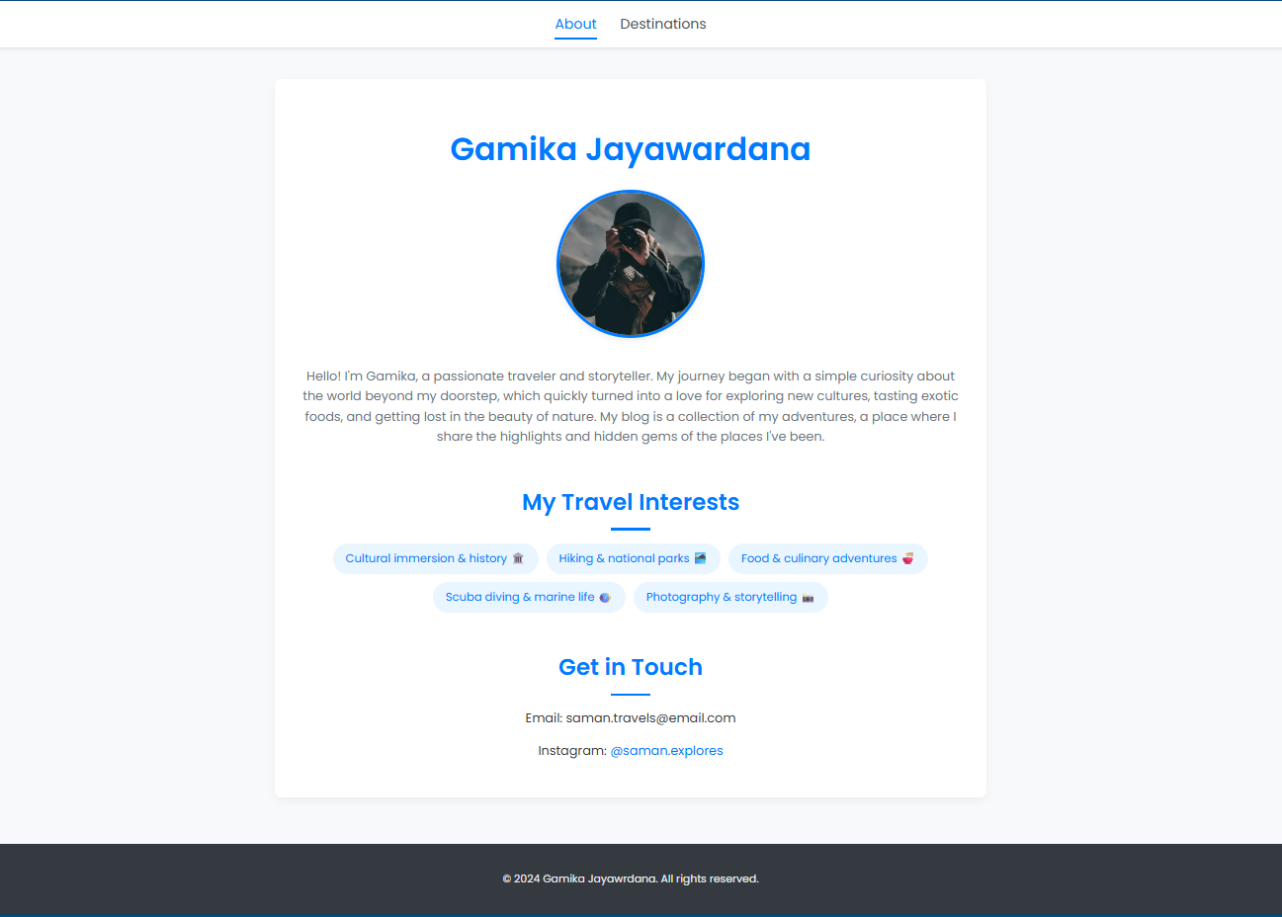

02.

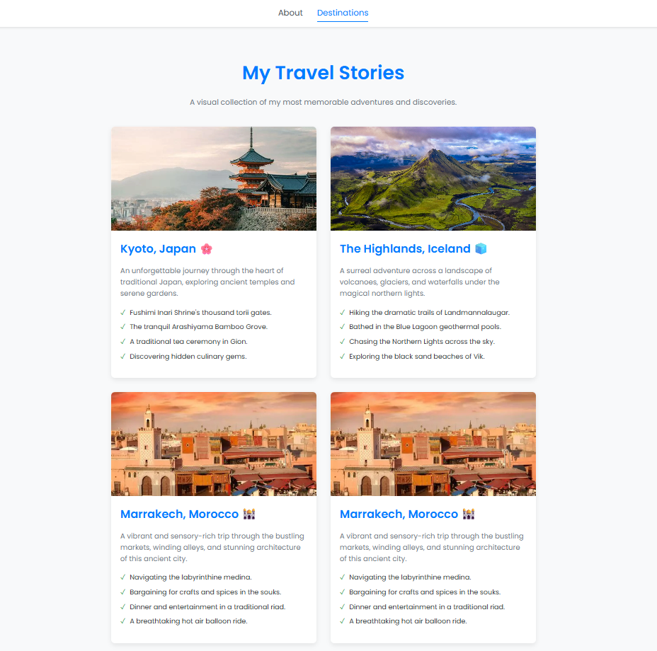

03.

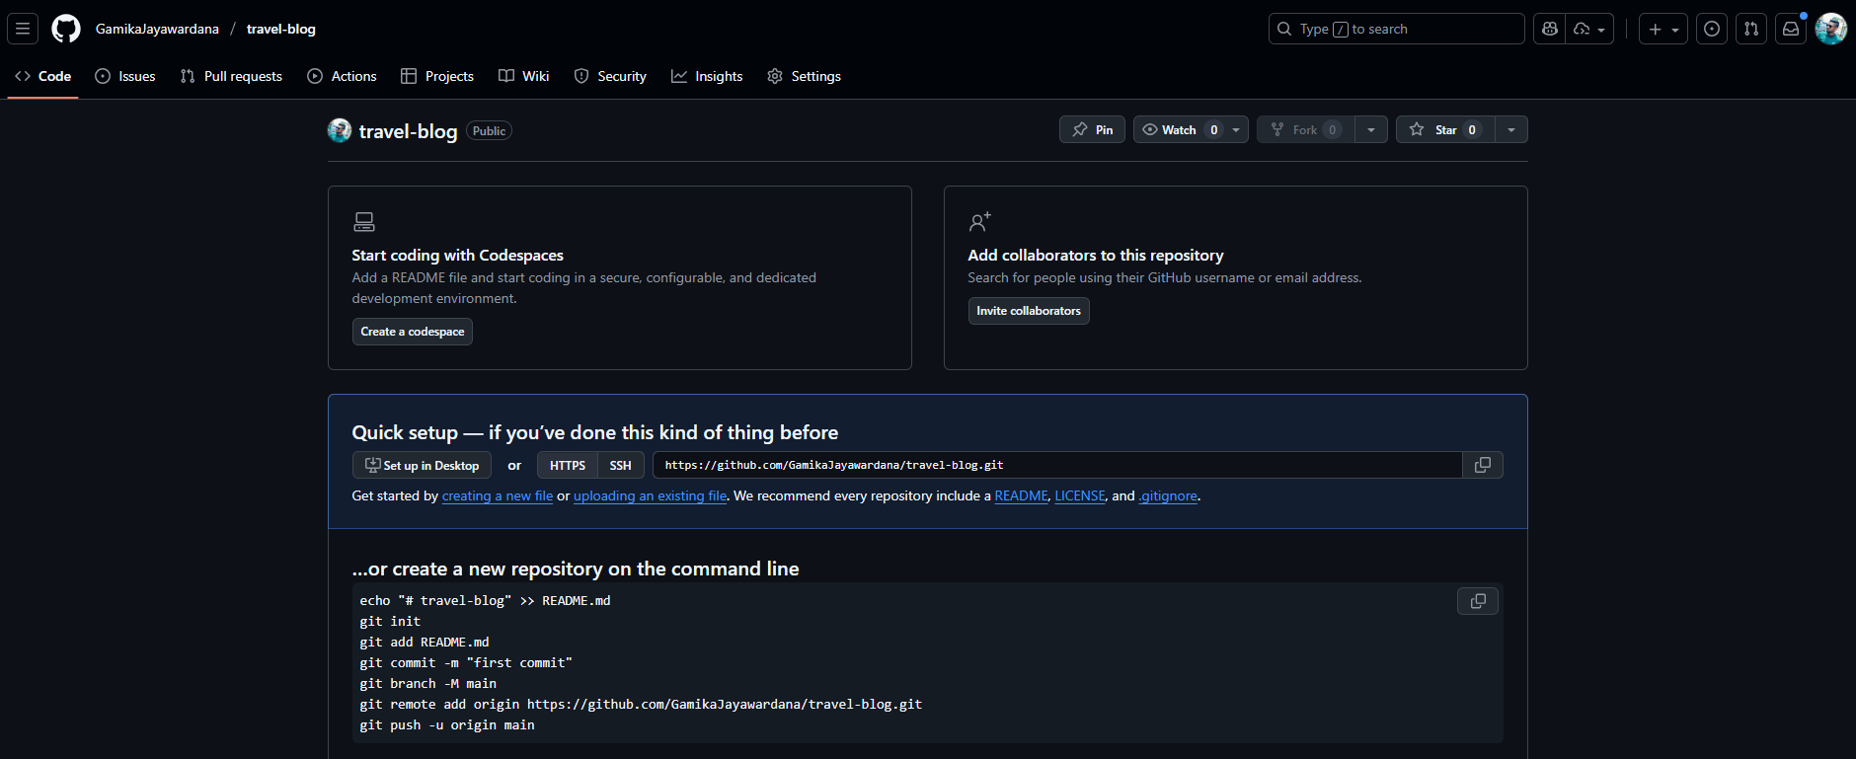

04.

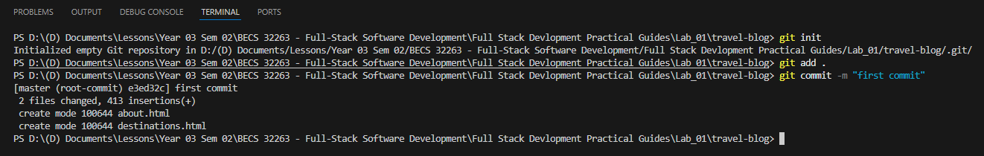

05.

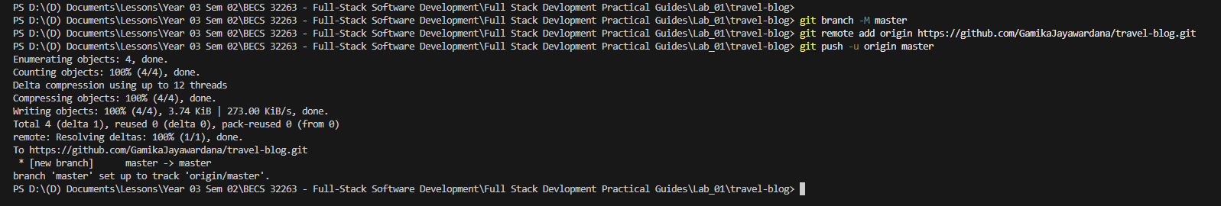

06.

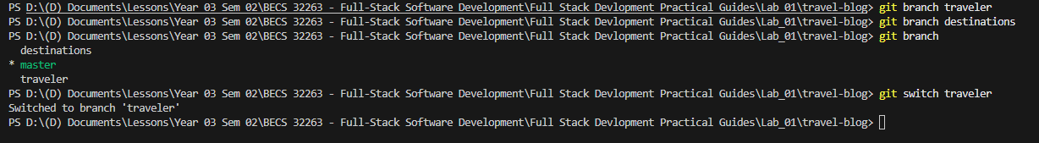

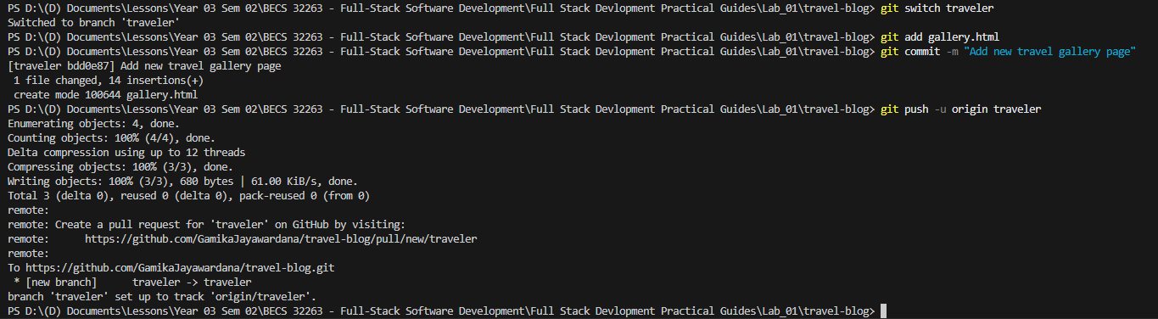

07.

08.

