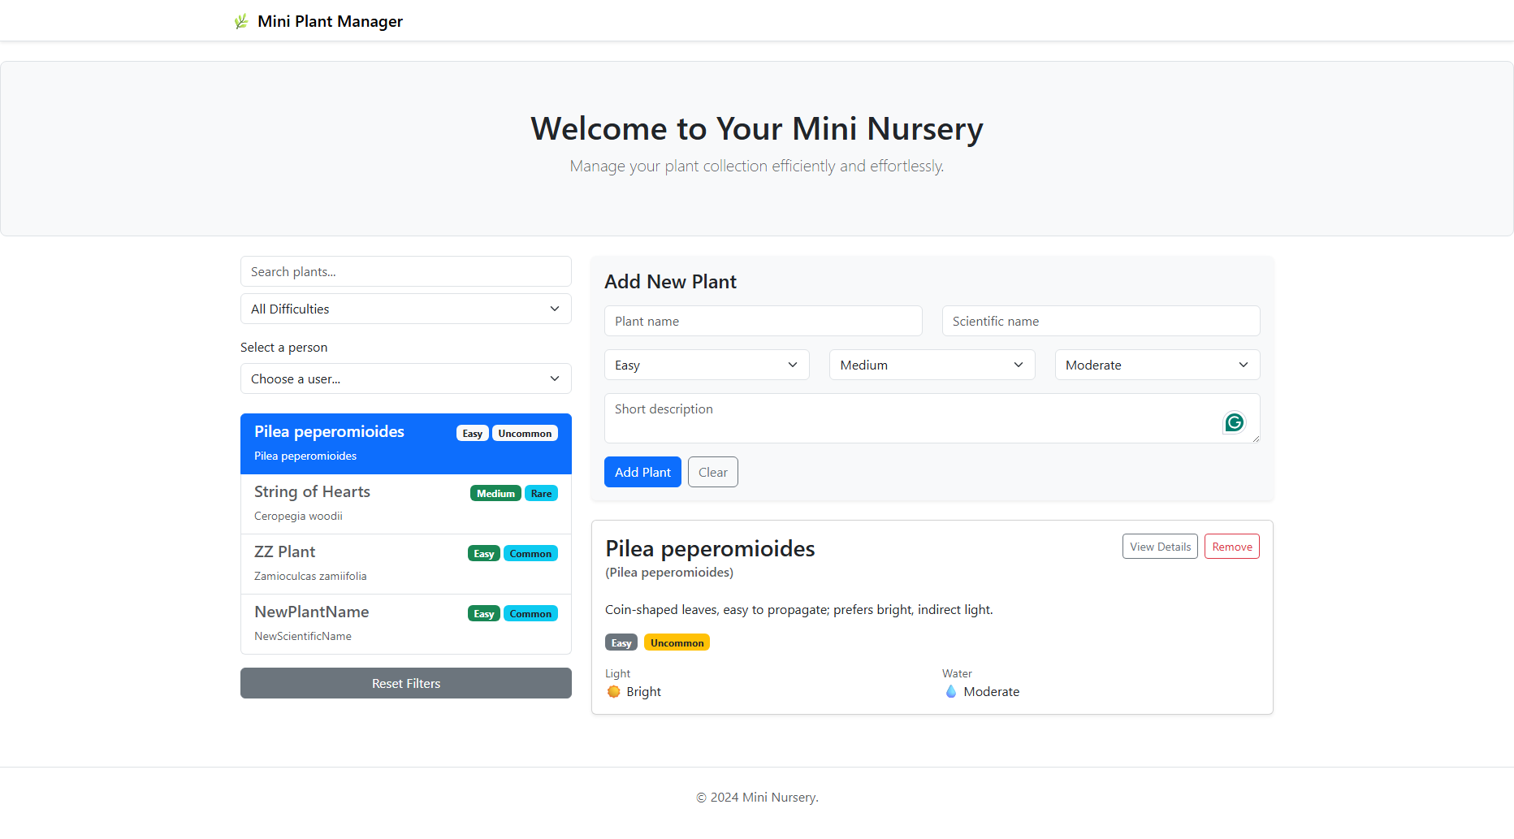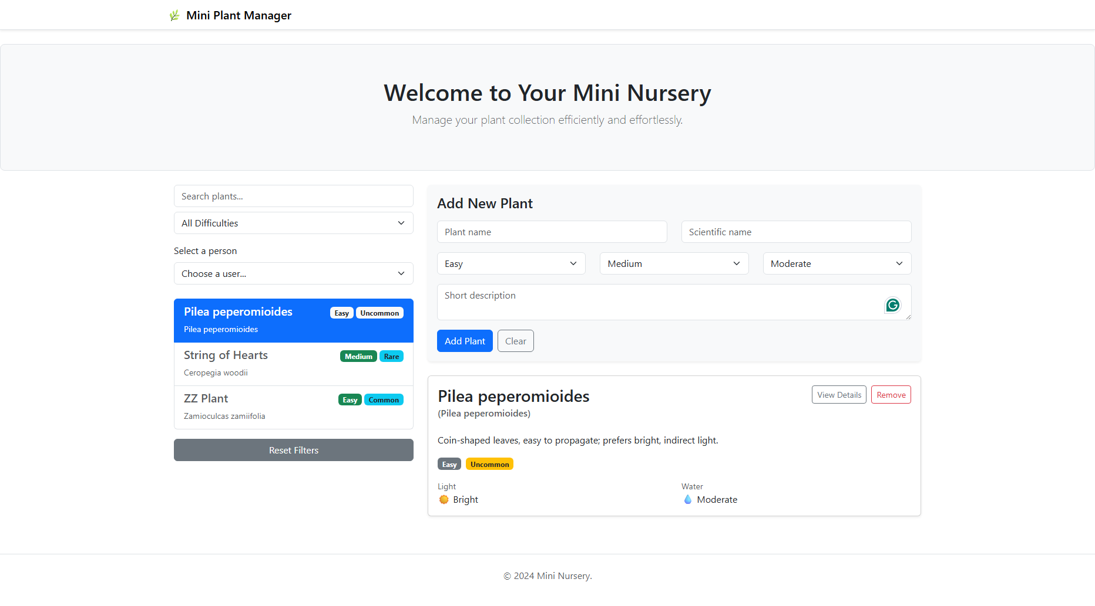

Banner.tsx
import React from "react";

interface BannerProps {
children: React.ReactNode;
}

const Banner: React.FC<BannerProps> = ({ children }) => {
return (
<div className="container-fluid p-5 mb-4 bg-light rounded-3 border">
<div className="container py-2 text-center">
{children}
<p className="lead text-muted">
Manage your plant collection efficiently and effortlessly.
</p>
</div>
</div>
);
};

export default Banner;

Footer.tsx
import React from "react";

const Footer: React.FC = () => {
return (
<footer className="text-center py-4 mt-5 border-top text-muted">
<p>&copy; 2024 Mini Nursery.</p>
</footer>
);
};

export default Footer;

Header.tsx
import React from "react";

const Header: React.FC = () => {
return (
<nav className="navbar navbar-light bg-white border-bottom shadow-sm mb-4">
<div className="container">
<span className="navbar-brand mb-0 h1">🌿 Mini Plant Manager</span>
</div>
</nav>
);
};

export default Header;

PeapleDropdown.tsx
import React, { useEffect, useState } from "react";
import { getUsers, type User } from "../services/UserService";

interface PeopleDropdownProps {
onSelect: (user: User) => void;
}

const PeopleDropdown: React.FC<PeopleDropdownProps> = ({ onSelect }) => {
const [users, setUsers] = useState<User[]>([]);
const [selectedUser, setSelectedUser] = useState<User | null>(null);
const [loading, setLoading] = useState(true);
const [error, setError] = useState<string | null>(null);

useEffect(() => {
getUsers()
.then((data) => {
setUsers(data);
setLoading(false);
})
.catch(() => {
setError("Failed to load users.");
setLoading(false);
});
}, []);

const handleChange = (e: React.ChangeEvent<HTMLSelectElement>) => {
const user = users.find((u) => u.id === parseInt(e.target.value));
if (user) {
setSelectedUser(user);
onSelect(user);
}
};

if (loading)
return <div className="spinner-border text-primary" role="status"></div>;
if (error) return <div className="alert alert-danger">{error}</div>;

return (
<div className="mb-4">
<label className="form-label">Select a person</label>
<select className="form-select mb-3" onChange={handleChange}>
<option value="">Choose a user...</option>
{users.map((user) => (
<option key={user.id} value={user.id}>
{user.name} ({user.email})
</option>
))}
</select>

{selectedUser && (
<div className="card bg-light border-0 shadow-sm p-3">
<h5>{selectedUser.name}</h5>
<p className="small mb-1">
<strong>Email:</strong> {selectedUser.email}
</p>
<p className="small mb-1">
<strong>Phone:</strong> {selectedUser.phone}
</p>
<p className="small mb-0">
<strong>Company:</strong> {selectedUser.company?.name}
</p>
</div>
)}
</div>
);
};

export default PeopleDropdown;

PlantCard.tsx
import React from "react";
import type { Plant } from "./types";

interface PlantCardProps {
plant: Plant;
onDelete: (id: number) => void;
}

const PlantCard: React.FC<PlantCardProps> = ({ plant, onDelete }) => {
return (
<div className="card mb-3 shadow-sm">
<div className="card-body">
<div className="d-flex justify-content-between align-items-start">
<div>
<h3 className="card-title">{plant.name}</h3>
<h6 className="card-subtitle mb-2 text-muted">
({plant.scientific})
</h6>
</div>
<div>
<button
className="btn btn-outline-secondary btn-sm me-2"
onClick={() => alert(`Plant: ${plant.name}`)}
>
View Details
</button>
<button
className="btn btn-outline-danger btn-sm"
onClick={() => onDelete(plant.id)}
>
Remove
</button>
</div>
</div>

<p className="card-text mt-3">{plant.description}</p>

<div className="mb-3">
<span className="badge bg-secondary me-2">{plant.difficulty}</span>
<span className="badge bg-warning text-dark">{plant.rarity}</span>
</div>

<div className="row">
<div className="col-sm-6">
<small className="text-muted d-block">Light</small>
<span>☀️ {plant.light}</span>
</div>
<div className="col-sm-6">
<small className="text-muted d-block">Water</small>
<span>💧 {plant.water}</span>
</div>
</div>
</div>
</div>
);
};

export default PlantCard;

PlantForm.tsx
import React, { useState } from "react";
import type { Plant } from "./types";

interface PlantFormProps {
onAdd: (plant: Omit<Plant, "id">) => void;
}

export const PlantForm: React.FC<PlantFormProps> = ({ onAdd }) => {
const initialState = {
name: "",
scientific: "",
difficulty: "Easy" as const,
light: "Medium" as const,
water: "Moderate" as const,
rarity: "Common" as const,
description: "",
};

const [form, setForm] = useState(initialState);

const handleSubmit = (e: React.FormEvent) => {
e.preventDefault();
if (!form.name) return alert("Plant name is required");
onAdd(form);
setForm(initialState);
};

return (
<div className="card p-3 bg-light border-0 shadow-sm mb-4">
<h4 className="mb-3">Add New Plant</h4>
<form onSubmit={handleSubmit}>
<div className="row mb-3">
<div className="col">
<input
type="text"
className="form-control"
placeholder="Plant name"
value={form.name}
onChange={(e) => setForm({ ...form, name: e.target.value })}
/>
</div>
<div className="col">
<input
type="text"
className="form-control"
placeholder="Scientific name"
value={form.scientific}
onChange={(e) => setForm({ ...form, scientific: e.target.value })}
/>
</div>
</div>
<div className="row mb-3">
<div className="col">
<select
className="form-select"
value={form.difficulty}
onChange={(e) =>
setForm({ ...form, difficulty: e.target.value as any })
}
>
<option value="Easy">Easy</option>
<option value="Medium">Medium</option>
<option value="Hard">Hard</option>
</select>
</div>
<div className="col">
<select
className="form-select"
value={form.light}
onChange={(e) =>
setForm({ ...form, light: e.target.value as any })
}
>
<option value="Low">Low</option>
<option value="Medium">Medium</option>
<option value="Bright">Bright</option>
</select>
</div>
<div className="col">
<select
className="form-select"
value={form.water}
onChange={(e) =>
setForm({ ...form, water: e.target.value as any })
}
>
<option value="Low">Low</option>
<option value="Moderate">Moderate</option>
<option value="Frequent">Frequent</option>
</select>
</div>
</div>
<div className="mb-3">
<textarea
className="form-control"
placeholder="Short description"
rows={2}
value={form.description}
onChange={(e) => setForm({ ...form, description: e.target.value })}
/>
</div>
<button type="submit" className="btn btn-primary me-2">
Add Plant
</button>
<button
type="button"
className="btn btn-outline-secondary"
onClick={() => setForm(initialState)}
>
Clear
</button>
</form>
</div>
);
};

PlantList.tsx
import React from 'react';
import type { Plant } from './types';

interface PlantListProps {
plants: Plant[];
selectedId: number;
onSelect: (id: number) => void;
}

const PlantList: React.FC<PlantListProps> = ({ plants, selectedId, onSelect }) => {
return (
<div className="list-group">
{plants.map((plant) => (
<button
key={plant.id}
type="button"
className={`list-group-item list-group-item-action ${plant.id === selectedId ? 'active' : ''}`}
onClick={() => onSelect(plant.id)}
style={{ cursor: 'pointer' }}
>
<div className="d-flex w-100 justify-content-between align-items-center mb-1">
<h5 className="mb-1">{plant.name}</h5>
<div>

<span className={`badge ${plant.id === selectedId ? 'bg-light text-dark' : 'bg-success'} me-1`}>
{plant.difficulty}
</span>
<span className={`badge ${plant.id === selectedId ? 'bg-light text-dark' : 'bg-info text-dark'}`}>
{plant.rarity}
</span>
</div>
</div>
<p className="mb-1 small">{plant.scientific}</p>
</button>
))}
</div>
);
};

export default PlantList;

App.tsx
import React, { useState, useMemo } from "react";
import type { Plant } from "./types";
import PlantList from "./PlantList";
import PlantCard from "./PlantCard";
import { PlantForm } from "./PlantForm";
import Header from "./components/Header";
import Footer from "./components/Footer";
import Banner from "./components/Banner";
import PeopleDropdown from "./components/PeopleDropdown";

interface AppProps {
plants: Plant[];
}

const App: React.FC<AppProps> = ({ plants: initialPlants }) => {
const [plants, setPlants] = useState<Plant[]>(initialPlants);
const [selectedId, setSelectedId] = useState<number>(initialPlants[0]?.id);
const [search, setSearch] = useState("");
const [difficultyFilter, setDifficultyFilter] = useState("All");

const filteredPlants = useMemo(() => {
return plants.filter(
(p) =>
p.name.toLowerCase().includes(search.toLowerCase()) &&
(difficultyFilter === "All" || p.difficulty === difficultyFilter)
);
}, [plants, search, difficultyFilter]);

const selectedPlant = plants.find((p) => p.id === selectedId);

const handleAdd = (newPlant: Omit<Plant, "id">) => {
const plantWithId = { ...newPlant, id: Date.now() };
setPlants([...plants, plantWithId]);
};

const handleDelete = (id: number) => {
setPlants(plants.filter((p) => p.id !== id));
if (selectedId === id) setSelectedId(plants[0]?.id);
};

return (
<>
<Header />
<Banner>
<h1>Welcome to Your Mini Nursery</h1>
</Banner>
<div className="container px-4">
<div className="row">
<div className="col-md-4">
<input
type="text"
className="form-control mb-2"
placeholder="Search plants..."
value={search}
onChange={(e) => setSearch(e.target.value)}
/>
<select
className="form-select mb-3"
value={difficultyFilter}
onChange={(e) => setDifficultyFilter(e.target.value)}
>
<option value="All">All Difficulties</option>
<option value="Easy">Easy</option>
<option value="Medium">Medium</option>
<option value="Hard">Hard</option>
</select>
<PeopleDropdown onSelect={(u) => console.log(u)} />
<PlantList
plants={filteredPlants}
selectedId={selectedId}
onSelect={setSelectedId}
/>
<button
className="btn btn-secondary w-100 mt-3"
onClick={() => {
setSearch("");
setDifficultyFilter("All");
}}
>
Reset Filters
</button>
</div>
<div className="col-md-8">
<PlantForm onAdd={handleAdd} />
{selectedPlant && (
<PlantCard plant={selectedPlant} onDelete={handleDelete} />
)}
</div>
</div>
</div>
<Footer />
</>
);
};

export default App;

Main.tsx
import { StrictMode } from 'react'
import { createRoot } from 'react-dom/client'
import './index.css'
import App from './App.tsx'
import type { Plant } from './types';
import 'bootstrap/dist/css/bootstrap.min.css';
import "bootstrap/dist/js/bootstrap.bundle.min";

const plants: Plant[] = [
{
id: 1,
name: "Pilea peperomioides",
scientific: "Pilea peperomioides",
difficulty: "Easy",
light: "Bright",
water: "Moderate",
rarity: "Uncommon",
description: "Coin-shaped leaves, easy to propagate; prefers bright, indirect light."
},
{
id: 2,
name: "String of Hearts",
scientific: "Ceropegia woodii",
difficulty: "Medium",
light: "Bright",
water: "Low",
rarity: "Rare",
description: "Trailing succulent-like vine with heart-shaped leaves."
},
{
id: 3,
name: "ZZ Plant",
scientific: "Zamioculcas zamiifolia",
difficulty: "Easy",
light: "Low",
water: "Low",
rarity: "Common",
description: "Extremely hardy plant that tolerates low light and neglect."
}
];

createRoot(document.getElementById('root')!).render(
<StrictMode>
<App plants={plants} />
</StrictMode>,
)

