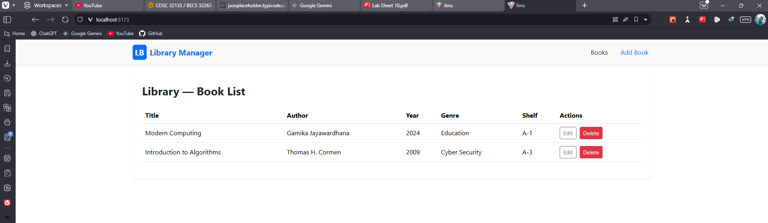
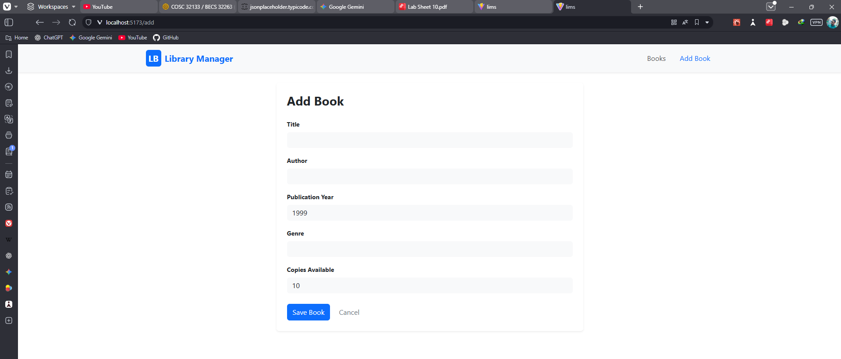
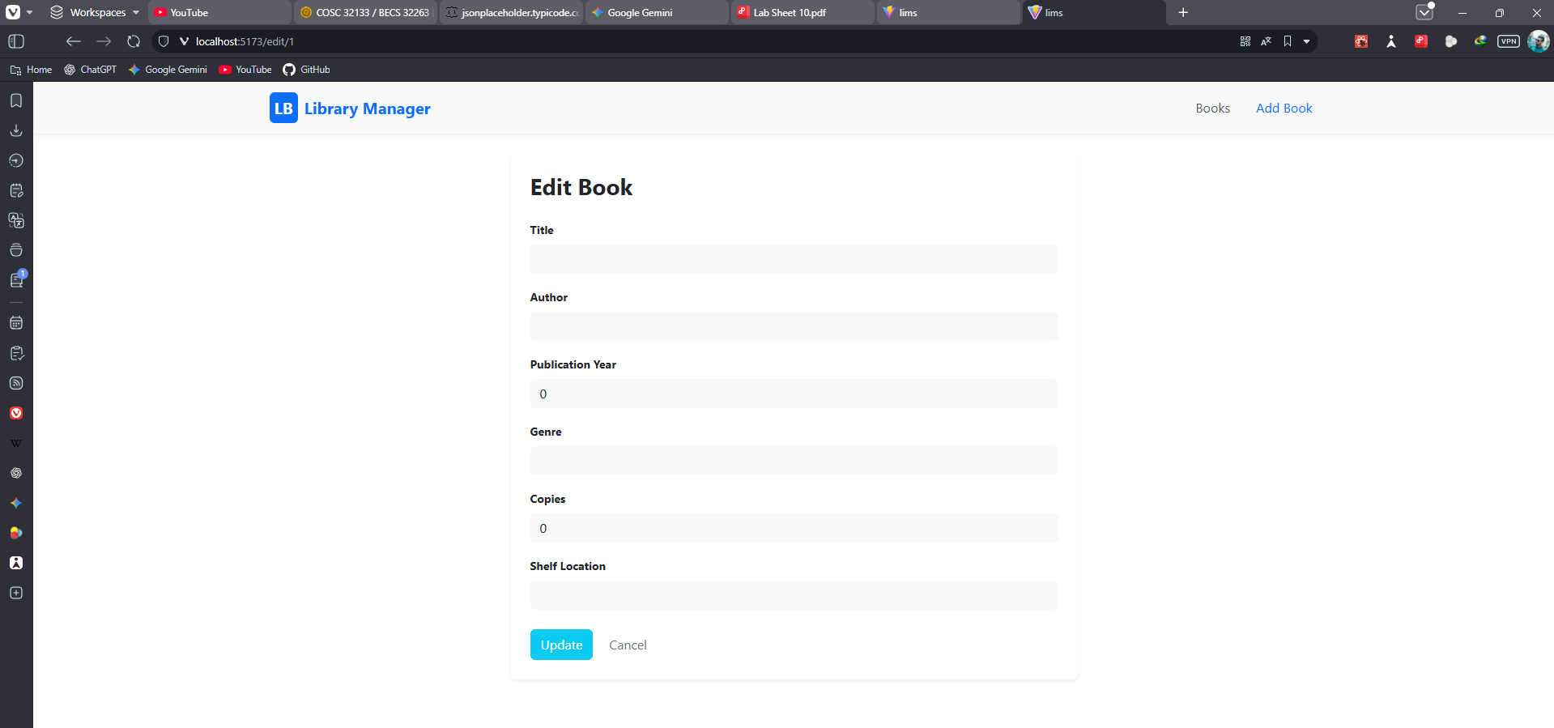

AddBook.tsx
import { useState } from "react";
import { useNavigate } from "react-router-dom";
import api, { type Book } from "../api";

return (
<div
className="card shadow-sm border-0 p-4 mx-auto"
style={{ maxWidth: "700px" }}
>
<h3 className="mb-4 fw-bold">Add Book</h3>
<form onSubmit={handleSubmit}>
<div className="mb-3">
<label className="form-label small fw-bold">Title</label>
<input
className="form-control bg-light border-0"
value={book.title}
onChange={(e) => setBook({ ...book, title: e.target.value })}
/>
</div>
<div className="mb-3">
<label className="form-label small fw-bold">Author</label>
<input
className="form-control bg-light border-0"
value={book.author}
onChange={(e) => setBook({ ...book, author: e.target.value })}
/>
</div>
<div className="mb-3">
<label className="form-label small fw-bold">Publication Year</label>
<input
type="number"
className="form-control bg-light border-0"
value={book.publicationYear}
onChange={(e) =>
setBook({ ...book, publicationYear: parseInt(e.target.value) })
}
/>
</div>
<div className="mb-3">
<label className="form-label small fw-bold">Genre</label>
<input
className="form-control bg-light border-0"
value={book.genre}
onChange={(e) => setBook({ ...book, genre: e.target.value })}
/>
</div>
<div className="mb-4">
<label className="form-label small fw-bold">Copies Available</label>
<input
type="number"
className="form-control bg-light border-0"
value={book.copiesAvailable}
onChange={(e) =>
setBook({ ...book, copiesAvailable: parseInt(e.target.value) })
}
/>
</div>
<button type="submit" className="btn btn-primary me-2">
Save Book
</button>
<button
type="button"
onClick={() => navigate("/")}
className="btn btn-outline-secondary border-0"
>
Cancel
</button>
</form>
</div>
);
};

export default AddBook;

BookList.tsx
import { useEffect, useState } from "react";
import { Link } from "react-router-dom";
import api, { type Book } from "../api";

const BookList = () => {
const [books, setBooks] = useState<Book[]>([
{
id: "1",
title: "Modern Computing",
author: "Gamika Jayawardhana",
publicationYear: 2024,
genre: "Education",
copiesAvailable: 5,
shelfLocation: "A-1",
},
{
id: "2",
title: "Introduction to Algorithms",
author: "Thomas H. Cormen",
publicationYear: 2009,
genre: "Cyber Security",
copiesAvailable: 1,
shelfLocation: "A-3",
},
]);

useEffect(() => {
const fetchBooks = async () => {
try {
const response = await api.get("/books");
setBooks(response.data);
} catch (err) {
console.error(err);
}
};
fetchBooks();
}, []);

const deleteBook = async (id: string) => {
try {
await api.delete(`/books/${id}`);
setBooks(books.filter((book) => book.id !== id));
} catch (err) {
console.error(err);
}
};

return (
<div className="card shadow-sm border-0 p-4">
<h3 className="mb-4 fw-bold">Library — Book List</h3>
<table className="table align-middle">
<thead>
<tr>
<th>Title</th>
<th>Author</th>
<th>Year</th>
<th>Genre</th>
<th>Shelf</th>
<th>Actions</th>
</tr>
</thead>
<tbody>
{books.map((book) => (
<tr key={book.id}>
<td>{book.title}</td>
<td>{book.author}</td>
<td>{book.publicationYear}</td>
<td>{book.genre}</td>
<td>{book.shelfLocation || "-"}</td>
<td>
<Link
to={`/edit/${book.id}`}
className="btn btn-outline-secondary btn-sm me-2"
>
Edit
</Link>
<button
onClick={() => deleteBook(book.id!)}
className="btn btn-danger btn-sm text-white"
>
Delete
</button>
</td>
</tr>
))}
</tbody>
</table>
</div>
);
};

export default BookList;

EditBook.tsx
import { useEffect, useState } from "react";
import { useParams, useNavigate } from "react-router-dom";
import api, { type Book } from "../api";

const EditBook = () => {
const { id } = useParams();
const navigate = useNavigate();
const [book, setBook] = useState<Book>({
title: "",
author: "",
publicationYear: 0,
genre: "",
copiesAvailable: 0,
shelfLocation: "",
});

useEffect(() => {
const fetchBook = async () => {
try {
const response = await api.get(`/books/${id}`);
setBook(response.data);
} catch (err) {
console.error(err);
}
};
fetchBook();
}, [id]);

const handleUpdate = async (e: React.FormEvent) => {
e.preventDefault();
try {
await api.put(`/books/${id}`, book);
navigate("/");
} catch (err) {
console.error(err);
}
};

return (
<div
className="card shadow-sm border-0 p-4 mx-auto"
style={{ maxWidth: "700px" }}
>
<h3 className="mb-4 fw-bold">Edit Book</h3>
<form onSubmit={handleUpdate}>
<div className="mb-3">
<label className="form-label small fw-bold">Title</label>
<input
className="form-control bg-light border-0"
value={book.title}
onChange={(e) => setBook({ ...book, title: e.target.value })}
/>
</div>
<div className="mb-3">
<label className="form-label small fw-bold">Author</label>
<input
className="form-control bg-light border-0"
value={book.author}
onChange={(e) => setBook({ ...book, author: e.target.value })}
/>
</div>
<div className="mb-3">
<label className="form-label small fw-bold">Publication Year</label>
<input
type="number"
className="form-control bg-light border-0"
value={book.publicationYear}
onChange={(e) =>
setBook({ ...book, publicationYear: parseInt(e.target.value) })
}
/>
</div>
<div className="mb-3">
<label className="form-label small fw-bold">Genre</label>
<input
className="form-control bg-light border-0"
value={book.genre}
onChange={(e) => setBook({ ...book, genre: e.target.value })}
/>
</div>
<div className="mb-3">
<label className="form-label small fw-bold">Copies</label>
<input
type="number"
className="form-control bg-light border-0"
value={book.copiesAvailable}
onChange={(e) =>
setBook({ ...book, copiesAvailable: parseInt(e.target.value) })
}
/>
</div>
<div className="mb-4">
<label className="form-label small fw-bold">Shelf Location</label>
<input
className="form-control bg-light border-0"
value={book.shelfLocation || ""}
onChange={(e) =>
setBook({ ...book, shelfLocation: e.target.value })
}
/>
</div>
<button type="submit" className="btn btn-info text-white me-2">
Update
</button>
<button
type="button"
onClick={() => navigate("/")}
className="btn btn-outline-secondary border-0"
>
Cancel
</button>
</form>
</div>
);
};

export default EditBook;

Api.ts
import axios from 'axios';

export interface Book {
id?: string;
title: string;
author: string;
publicationYear: number;
genre: string;
copiesAvailable: number;
shelfLocation?: string;
}

const api = axios.create({
baseURL: 'http://localhost:5000/api'
});

export default api;

App.tsx
import { BrowserRouter as Router, Routes, Route, Link } from "react-router-dom";
import BookList from "./components/BookList";
import AddBook from "./components/AddBook";
import EditBook from "./components/EditBook";
import "bootstrap/dist/css/bootstrap.min.css";

function App() {
return (
<Router>
<nav className="navbar navbar-expand-lg navbar-light bg-light shadow-sm mb-4">
<div className="container">
<Link
className="navbar-brand fw-bold text-primary d-flex align-items-center"
to="/"
>
<div
className="bg-primary text-white rounded p-1 me-2"
style={{ width: "35px", textAlign: "center" }}
>
LB
</div>
Library Manager
</Link>
<div className="navbar-nav ms-auto">
<Link className="nav-link" to="/">
Books
</Link>
<Link className="nav-link text-primary ms-3" to="/add">
Add Book
</Link>
</div>
</div>
</nav>
<div className="container">
<Routes>
<Route path="/" element={<BookList />} />
<Route path="/add" element={<AddBook />} />
<Route path="/edit/:id" element={<EditBook />} />
</Routes>
</div>
</Router>
);
}

export default App;

Main.tsx
import { StrictMode } from 'react'
import { createRoot } from 'react-dom/client'
import './index.css'
import App from './App.tsx'
import "bootstrap/dist/css/bootstrap.min.css";
import "bootstrap-icons/font/bootstrap-icons.css";

createRoot(document.getElementById('root')!).render(
<StrictMode>
<App />
</StrictMode>,
)

