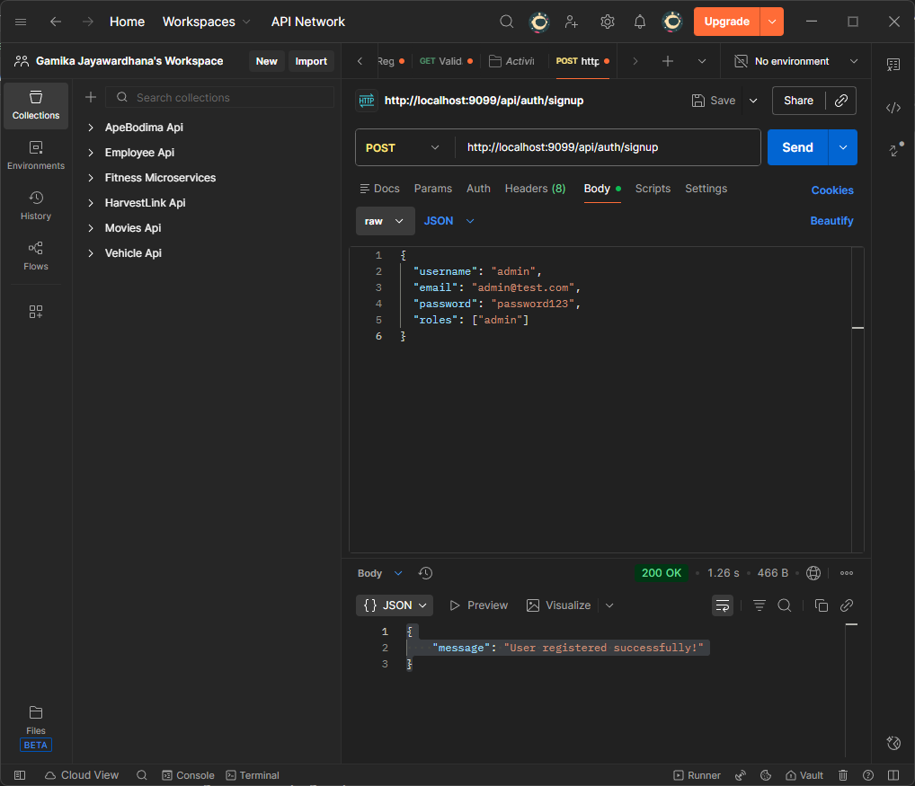
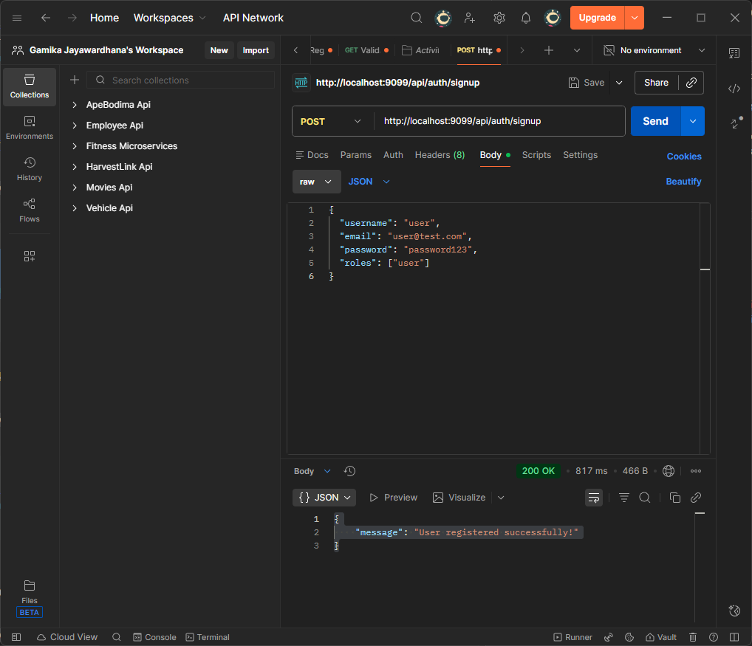
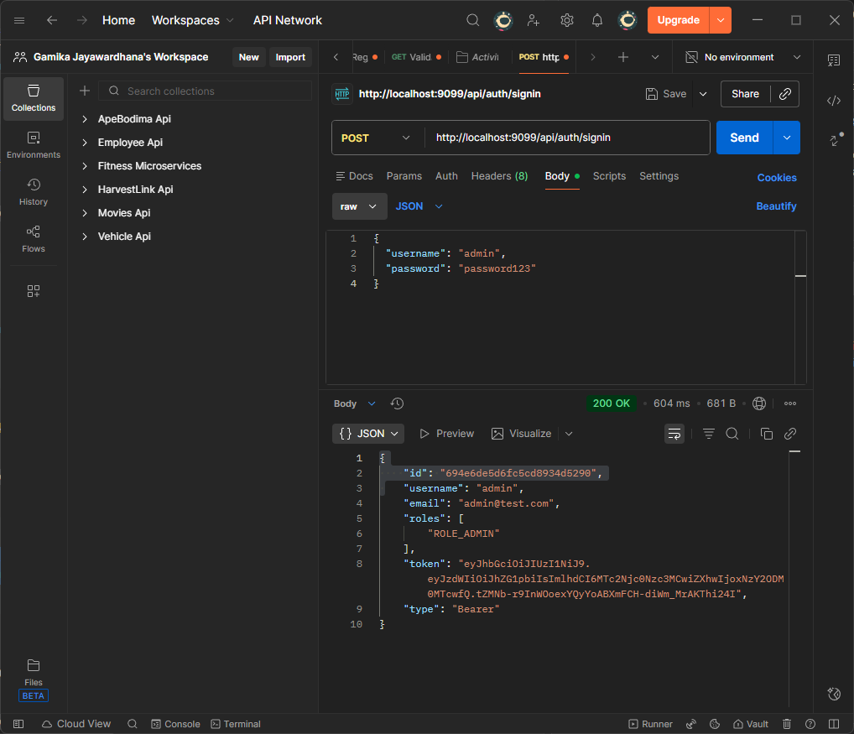
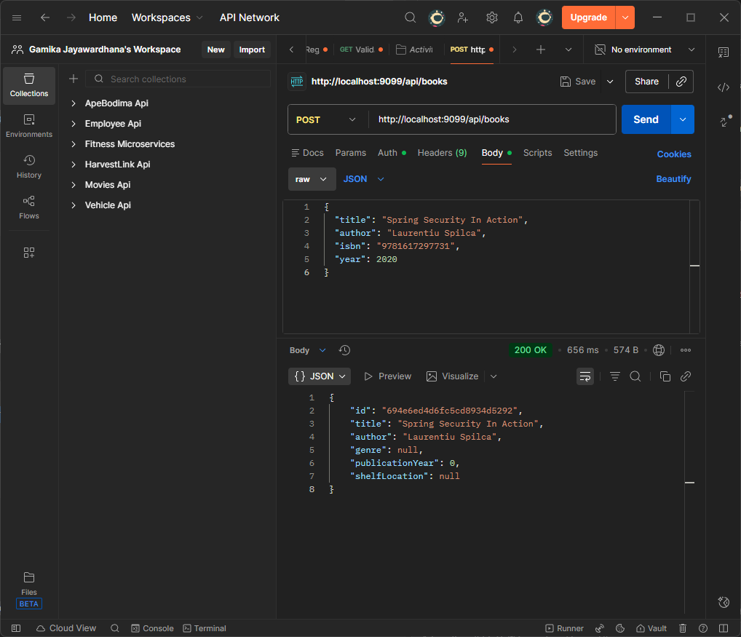
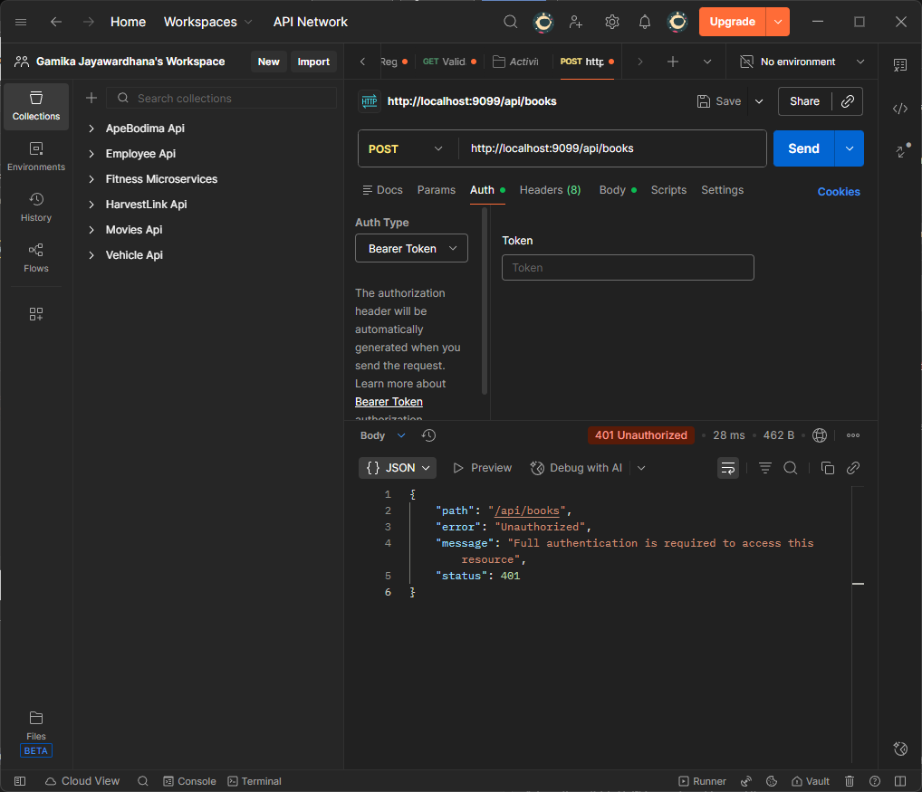
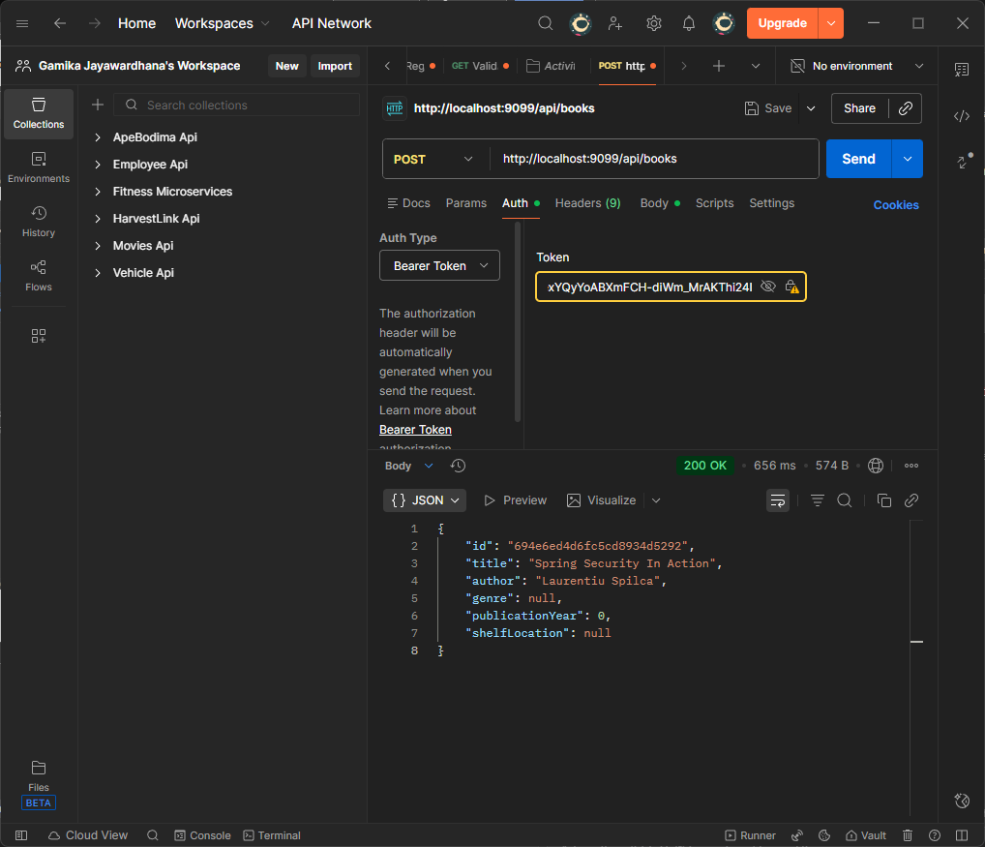
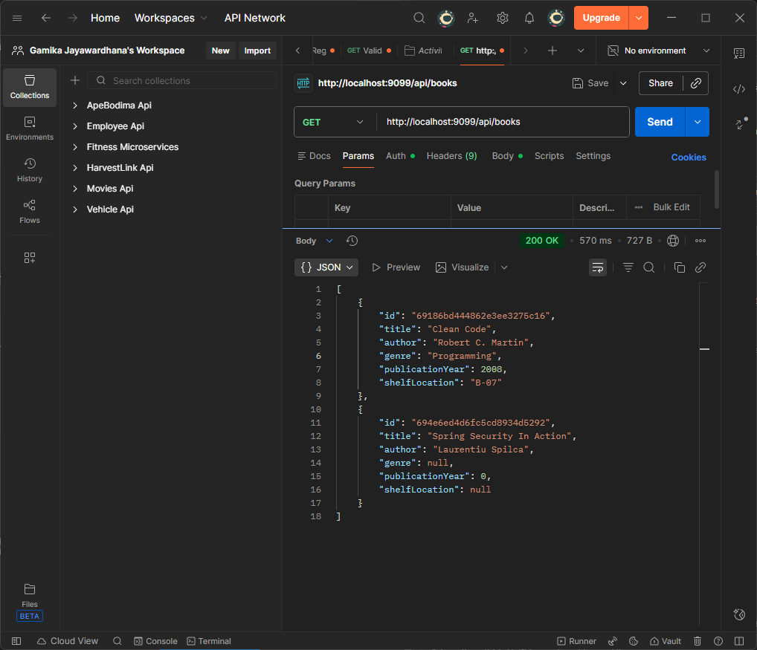

AuthController.java
package com.lib.LiMS.controller;

import com.lib.LiMS.model.ERole;
import com.lib.LiMS.model.Role;
import com.lib.LiMS.model.User;
import com.lib.LiMS.payload.request.LoginRequest;
import com.lib.LiMS.payload.request.SignupRequest;
import com.lib.LiMS.payload.response.JwtResponse;
import com.lib.LiMS.payload.response.MessageResponse;
import com.lib.LiMS.repository.RoleRepository;
import com.lib.LiMS.repository.UserRepository;
import com.lib.LiMS.security.jwt.JwtUtils;
import com.lib.LiMS.security.services.UserDetailsImpl;
import jakarta.validation.Valid;
import org.springframework.beans.factory.annotation.Autowired;
import org.springframework.http.ResponseEntity;
import org.springframework.security.authentication.AuthenticationManager;
import org.springframework.security.authentication.UsernamePasswordAuthenticationToken;
import org.springframework.security.core.Authentication;
import org.springframework.security.core.context.SecurityContextHolder;
import org.springframework.security.crypto.password.PasswordEncoder;
import org.springframework.web.bind.annotation.*;

import java.util.HashSet;
import java.util.List;
import java.util.Set;
import java.util.stream.Collectors;

@CrossOrigin(origins = "*", maxAge = 3600)
@RestController
@RequestMapping("/api/auth")
public class AuthController {
@Autowired
AuthenticationManager authenticationManager;

@Autowired
UserRepository userRepository;

@Autowired
RoleRepository roleRepository;

@Autowired
PasswordEncoder encoder;

@Autowired
JwtUtils jwtUtils;

@PostMapping("/signin")
public ResponseEntity<?> authenticateUser(@Valid @RequestBody LoginRequest loginRequest) {

Authentication authentication = authenticationManager.authenticate(
new UsernamePasswordAuthenticationToken(loginRequest.getUsername(), loginRequest.getPassword()));

SecurityContextHolder.getContext().setAuthentication(authentication);
String jwt = jwtUtils.generateJwtToken(authentication);

UserDetailsImpl userDetails = (UserDetailsImpl) authentication.getPrincipal();
List<String> roles = userDetails.getAuthorities().stream()
.map(item -> item.getAuthority())
.collect(Collectors.toList());

return ResponseEntity.ok(new JwtResponse(jwt,
userDetails.getId(),
userDetails.getUsername(),
userDetails.getEmail(),
roles));
}

@PostMapping("/signup")
public ResponseEntity<?> registerUser(@Valid @RequestBody SignupRequest signUpRequest) {
if (userRepository.existsByUsername(signUpRequest.getUsername())) {
return ResponseEntity
.badRequest()
.body(new MessageResponse("Error: Username is already taken!"));
}

if (userRepository.existsByEmail(signUpRequest.getEmail())) {
return ResponseEntity
.badRequest()
.body(new MessageResponse("Error: Email is already in use!"));
}

// Create new user's account
User user = new User(signUpRequest.getUsername(),
signUpRequest.getEmail(),
encoder.encode(signUpRequest.getPassword()));

Set<String> strRoles = signUpRequest.getRoles();
Set<Role> roles = new HashSet<>();

if (strRoles == null) {
Role userRole = roleRepository.findByName(ERole.ROLE_USER)
.orElseThrow(() -> new RuntimeException("Error: Role is not found."));
roles.add(userRole);
} else {
strRoles.forEach(role -> {
switch (role) {
case "admin":
Role adminRole = roleRepository.findByName(ERole.ROLE_ADMIN)
.orElseThrow(() -> new RuntimeException("Error: Role is not found."));
roles.add(adminRole);

break;
default:
Role userRole = roleRepository.findByName(ERole.ROLE_USER)
.orElseThrow(() -> new RuntimeException("Error: Role is not found."));
roles.add(userRole);
}
});
}

user.setRoles(roles);
userRepository.save(user);

return ResponseEntity.ok(new MessageResponse("User registered successfully!"));
}
}

BookController.java
package com.lib.LiMS.controller;

import com.lib.LiMS.model.Book;
import com.lib.LiMS.service.BookService;
import org.springframework.beans.factory.annotation.Autowired;
import org.springframework.http.ResponseEntity;
import org.springframework.security.access.prepost.PreAuthorize;
import org.springframework.web.bind.annotation.*;

import java.util.List;
import java.util.Optional;

@RestController
@CrossOrigin(origins = "*")
@RequestMapping("api/books")
public class BookController {

@Autowired
private BookService bookService;

@PostMapping
@PreAuthorize("hasRole('ADMIN')")
public ResponseEntity<Book> createBook(@RequestBody Book book) {
Book newBook = bookService.createBook(book);
return ResponseEntity.ok(newBook);
}

@GetMapping
@PreAuthorize("hasRole('USER') or hasRole('ADMIN')")
public ResponseEntity<List<Book>> getAllBooks() {
List<Book> books = bookService.getAllBooks();
return ResponseEntity.ok(books);
}

@GetMapping("/{id}")
@PreAuthorize("hasRole('USER') or hasRole('ADMIN')")
public ResponseEntity<Book> getBookByID(@PathVariable String id) {
Book book = bookService.getBookById(id);
return book != null ? ResponseEntity.ok(book) : ResponseEntity.notFound().build();
}

@PutMapping("/{id}")
@PreAuthorize("hasRole('ADMIN')")
public ResponseEntity<Book> updateBook(@PathVariable String id, @RequestBody Book book) {
Book updatedBook = bookService.updateBook(id, book);
return updatedBook != null ? ResponseEntity.ok(updatedBook) : ResponseEntity.notFound().build();
}

@DeleteMapping("/{id}")
@PreAuthorize("hasRole('ADMIN')")
public ResponseEntity<Book> deleteBook(@PathVariable String id) {
bookService.deleteBookById(id);
return ResponseEntity.noContent().build();
}

@GetMapping("/year/{year}")
@PreAuthorize("hasRole('USER') or hasRole('ADMIN')")
public ResponseEntity<List<Book>> getBooksByYear(@PathVariable int year) {
List<Book> books = bookService.getBooksByYear(year);
return ResponseEntity.ok(books);
}

@GetMapping("/{id}/genre")
@PreAuthorize("hasRole('USER') or hasRole('ADMIN')")
public ResponseEntity<String> getGenre(@PathVariable String id) {
Optional<String> genre = bookService.getGenreById(id);
return genre.map(ResponseEntity::ok).orElseGet(() -> ResponseEntity.notFound().build());
}

@DeleteMapping("/year/{year}")
@PreAuthorize("hasRole('ADMIN')")
public ResponseEntity<String> deleteBookByYear(@PathVariable int year) {
bookService.deleteByYear(year);
return ResponseEntity.ok("Successfully deleted all service record for the year: " + year);
}

}

BookService.java
package com.lib.LiMS.service;

import com.lib.LiMS.model.Book;
import org.springframework.stereotype.Service;

import java.util.List;
import java.util.Optional;

@Service
public interface BookService {
Book createBook(Book book);
List<Book> getAllBooks();
Book getBookById(String id);
Book updateBook(String id, Book book);
void deleteBookById(String id);
List<Book> getBooksByYear(int year);
Optional<String> getGenreById(String id);
void deleteByYear(int publicationYear);

}

BookServiceImpl.java
package com.lib.LiMS.service.impl;

import com.lib.LiMS.model.Book;
import com.lib.LiMS.repository.BookRepository;
import com.lib.LiMS.service.BookService;
import org.springframework.beans.factory.annotation.Autowired;
import org.springframework.stereotype.Service;

import java.util.List;
import java.util.Optional;

@Service
public class BookServiceImpl implements BookService {

@Autowired
private BookRepository bookRepository;

@Override
public Book createBook(Book book) {
return bookRepository.save(book);
}

@Override
public List<Book> getAllBooks() {
return bookRepository.findAll();
}

@Override
public Book getBookById(String id) {
Optional<Book> book = bookRepository.findById(id);
return book.orElse(null);
//return null or throw an exception
}

@Override
public Book updateBook(String id,Book book) {
if(bookRepository.existsById(id)){
book.setId(id);
return bookRepository.save(book);
}
return null;
}

@Override
public void deleteBookById(String id) {
bookRepository.deleteById(id);

}

@Override
public List<Book> getBooksByYear(int year) {
return bookRepository.findByPublicationYear(year);

}

@Override
public Optional<String> getGenreById(String id) {
Optional<Book> book = bookRepository.findGenreById(id);
return book.map(Book::getGenre);
}

@Override
public void deleteByYear(int publicationYear) {
bookRepository.deleteByPublicationYear(publicationYear);

}

}

UserDetailsService.java
package com.lib.LiMS.security.services;

import com.lib.LiMS.model.User;
import com.lib.LiMS.repository.UserRepository;
import org.springframework.beans.factory.annotation.Autowired;
import org.springframework.security.core.userdetails.UserDetails;
import org.springframework.security.core.userdetails.UserDetailsService;
import org.springframework.security.core.userdetails.UsernameNotFoundException;
import org.springframework.stereotype.Service;
import org.springframework.transaction.annotation.Transactional;

@Service
public class UserDetailsServiceImpl implements UserDetailsService {
@Autowired
UserRepository userRepository;

@Override
@Transactional
public UserDetails loadUserByUsername(String username) throws UsernameNotFoundException {
User user = userRepository.findByUsername(username)
.orElseThrow(() -> new UsernameNotFoundException("User Not Found with username: " + username));

return UserDetailsImpl.build(user);
}
}

UserDetailsServiceImpl.java
package com.lib.LiMS.security.services;

import com.fasterxml.jackson.annotation.JsonIgnore;
import com.lib.LiMS.model.User;
import org.springframework.security.core.GrantedAuthority;
import org.springframework.security.core.authority.SimpleGrantedAuthority;
import org.springframework.security.core.userdetails.UserDetails;

import java.util.Collection;
import java.util.List;
import java.util.Objects;
import java.util.stream.Collectors;

public class UserDetailsImpl implements UserDetails {
private static final long serialVersionUID = 1L;

private String id;

private String username;

private String email;

@JsonIgnore
private String password;

private Collection<? extends GrantedAuthority> authorities;

public UserDetailsImpl(String id, String username, String email, String password,
Collection<? extends GrantedAuthority> authorities) {
this.id = id;
this.username = username;
this.email = email;
this.password = password;
this.authorities = authorities;
}

public static UserDetailsImpl build(User user) {
List<GrantedAuthority> authorities = user.getRoles().stream()
.map(role -> new SimpleGrantedAuthority(role.getName().name()))
.collect(Collectors.toList());

return new UserDetailsImpl(
user.getId(),
user.getUsername(),
user.getEmail(),
user.getPassword(),
authorities);
}

@Override
public Collection<? extends GrantedAuthority> getAuthorities() {
return authorities;
}

public String getId() {
return id;
}

public String getEmail() {
return email;
}

@Override
public String getPassword() {
return password;
}

@Override
public String getUsername() {
return username;
}

@Override
public boolean isAccountNonExpired() {
return true;
}

@Override
public boolean isAccountNonLocked() {
return true;
}

@Override
public boolean isCredentialsNonExpired() {
return true;
}

@Override
public boolean isEnabled() {
return true;
}

@Override
public boolean equals(Object o) {
if (this == o)
return true;
if (o == null || getClass() != o.getClass())
return false;
UserDetailsImpl user = (UserDetailsImpl) o;
return Objects.equals(id, user.id);
}
}

BookRepository.java
package com.lib.LiMS.repository;

import com.lib.LiMS.model.Book;
import org.springframework.data.mongodb.repository.MongoRepository;
import org.springframework.transaction.annotation.Transactional;

import java.util.List;
import java.util.Optional;

public interface BookRepository extends MongoRepository<Book, String> {

List<Book> findByPublicationYear(int publicationYear);

Optional<Book> findGenreById(String id);

@Transactional
void deleteByPublicationYear(int publicationYear);
}

UserRepository.java
package com.lib.LiMS.repository;

import com.lib.LiMS.model.User;
import org.springframework.data.mongodb.repository.MongoRepository;

import java.util.Optional;

public interface UserRepository extends MongoRepository<User, String> {
Optional<User> findByUsername(String username);

Boolean existsByUsername(String username);

Boolean existsByEmail(String email);
}

LoginRequest.java
package com.lib.LiMS.payload.request;

import jakarta.validation.constraints.NotBlank;
import lombok.Data;

@Data
public class LoginRequest {
@NotBlank
private String username;

@NotBlank
private String password;
}

SignupRequest.java
package com.lib.LiMS.payload.request;

import jakarta.validation.constraints.Email;
import jakarta.validation.constraints.NotBlank;
import jakarta.validation.constraints.Size;
import lombok.Data;

import java.util.Set;

@Data
public class SignupRequest {
@NotBlank
@Size(min = 3, max = 20)
private String username;

@NotBlank
@Size(max = 50)
@Email
private String email;

private Set<String> roles;

@NotBlank
@Size(min = 6, max = 40)
private String password;
}

jwtResponse.java
package com.lib.LiMS.payload.response;

import lombok.Data;

import java.util.List;

@Data
public class JwtResponse {
private String token;
private String type = "Bearer";
private String id;
private String username;
private String email;
private List<String> roles;

public JwtResponse(String accessToken, String id, String username, String email, List<String> roles) {
this.token = accessToken;
this.id = id;
this.username = username;
this.email = email;
this.roles = roles;
}
}

Book.java
package com.lib.LiMS.model;

import lombok.AllArgsConstructor;
import lombok.Data;
import lombok.NoArgsConstructor;
import org.springframework.data.annotation.Id;
import org.springframework.data.mongodb.core.mapping.Document;

@Document(collection = "books")
@Data
@AllArgsConstructor
@NoArgsConstructor
public class Book {
@Id
private String id;

private String title;
private String author;
private String genre;
private int publicationYear;
private String shelfLocation;
}

User.java
package com.lib.LiMS.model;

import lombok.Data;
import lombok.NoArgsConstructor;
import org.springframework.data.annotation.Id;
import org.springframework.data.mongodb.core.mapping.DBRef;
import org.springframework.data.mongodb.core.mapping.Document;

import java.util.HashSet;
import java.util.Set;

@Document(collection = "users")
@Data
@NoArgsConstructor
public class User {
@Id
private String id;

private String username;

private String email;

private String password;

@DBRef
private Set<Role> roles = new HashSet<>();

public User(String username, String email, String password) {
this.username = username;
this.email = email;
this.password = password;
}
}

WebSecurityConfig.java
package com.lib.LiMS.security;

import com.lib.LiMS.security.jwt.AuthEntryPointJwt;
import com.lib.LiMS.security.jwt.AuthTokenFilter;
import com.lib.LiMS.security.services.UserDetailsServiceImpl;
import org.springframework.beans.factory.annotation.Autowired;
import org.springframework.context.annotation.Bean;
import org.springframework.context.annotation.Configuration;
import org.springframework.security.authentication.AuthenticationManager;
import org.springframework.security.authentication.dao.DaoAuthenticationProvider;
import org.springframework.security.config.annotation.authentication.configuration.AuthenticationConfiguration;
import org.springframework.security.config.annotation.method.configuration.EnableMethodSecurity;
import org.springframework.security.config.annotation.web.builders.HttpSecurity;
import org.springframework.security.config.http.SessionCreationPolicy;
import org.springframework.security.crypto.bcrypt.BCryptPasswordEncoder;
import org.springframework.security.crypto.password.PasswordEncoder;
import org.springframework.security.web.SecurityFilterChain;
import org.springframework.security.web.authentication.UsernamePasswordAuthenticationFilter;

@Configuration
@EnableMethodSecurity
public class WebSecurityConfig {
@Autowired
UserDetailsServiceImpl userDetailsService;

@Autowired
private AuthEntryPointJwt unauthorizedHandler;

@Bean
public AuthTokenFilter authenticationJwtTokenFilter() {
return new AuthTokenFilter();
}

@Bean
public DaoAuthenticationProvider authenticationProvider() {
DaoAuthenticationProvider authProvider = new DaoAuthenticationProvider();

authProvider.setUserDetailsService(userDetailsService);
authProvider.setPasswordEncoder(passwordEncoder());

return authProvider;
}

@Bean
public AuthenticationManager authenticationManager(AuthenticationConfiguration authConfig) throws Exception {
return authConfig.getAuthenticationManager();
}

@Bean
public PasswordEncoder passwordEncoder() {
return new BCryptPasswordEncoder();
}

@Bean
public SecurityFilterChain filterChain(HttpSecurity http) throws Exception {
http.csrf(csrf -> csrf.disable())
.exceptionHandling(exception -> exception.authenticationEntryPoint(unauthorizedHandler))
.sessionManagement(session -> session.sessionCreationPolicy(SessionCreationPolicy.STATELESS))
.authorizeHttpRequests(auth -> auth.requestMatchers("/api/auth/**").permitAll()
.requestMatchers("/api/test/**").permitAll()
.requestMatchers("/error").permitAll()
.anyRequest().authenticated());

http.authenticationProvider(authenticationProvider());

http.addFilterBefore(authenticationJwtTokenFilter(), UsernamePasswordAuthenticationFilter.class);

return http.build();
}
}

