Task 01

Project 01
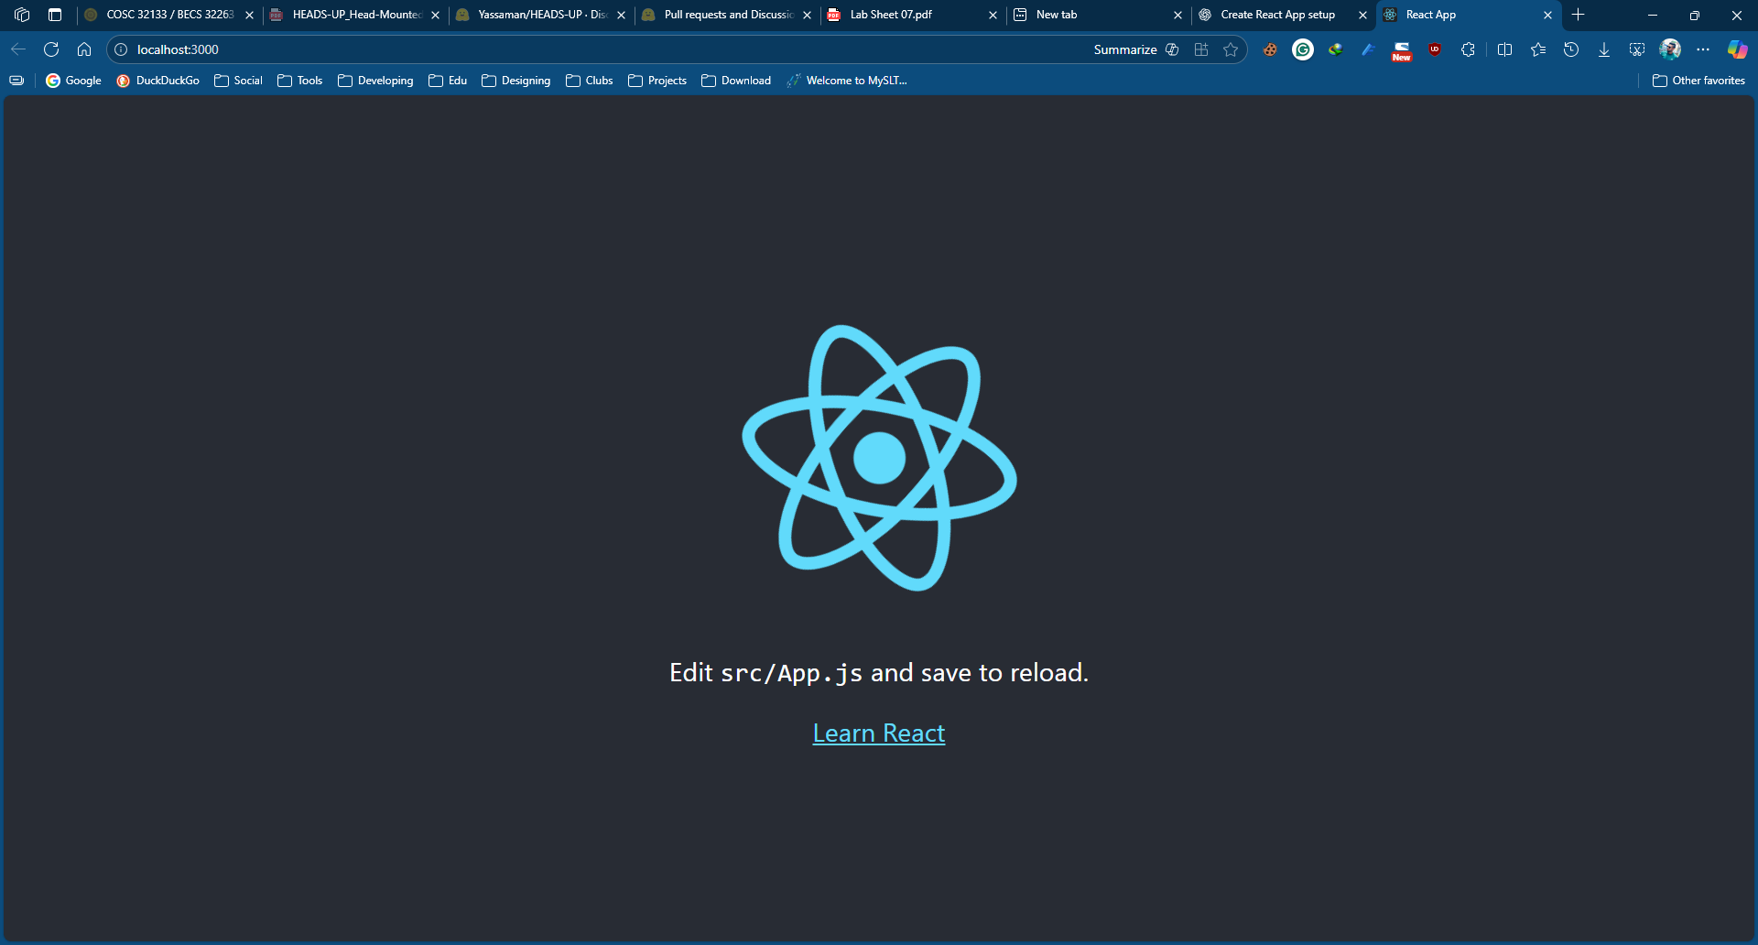
import React from 'react'

const Welcome = () => {
return (
<h2>Hello from NPX React App!</h2>
)
}

export default Welcome

import logo from './logo.svg';
import './App.css';
import Welcome from './Welcome';

function App() {
return (
<div className="App">
<h1>Project 1: NPX Demo</h1>
<Welcome />
</div>
);
}

export default App;

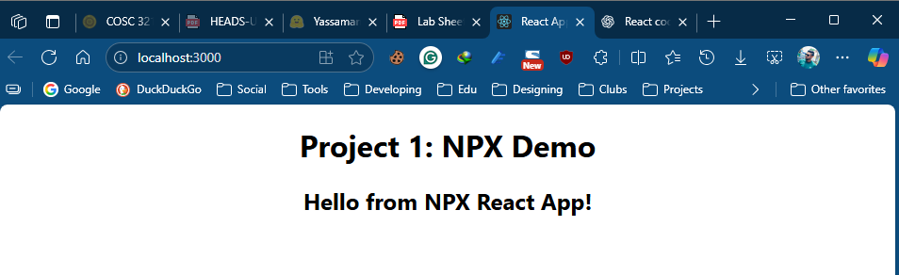

Project 02
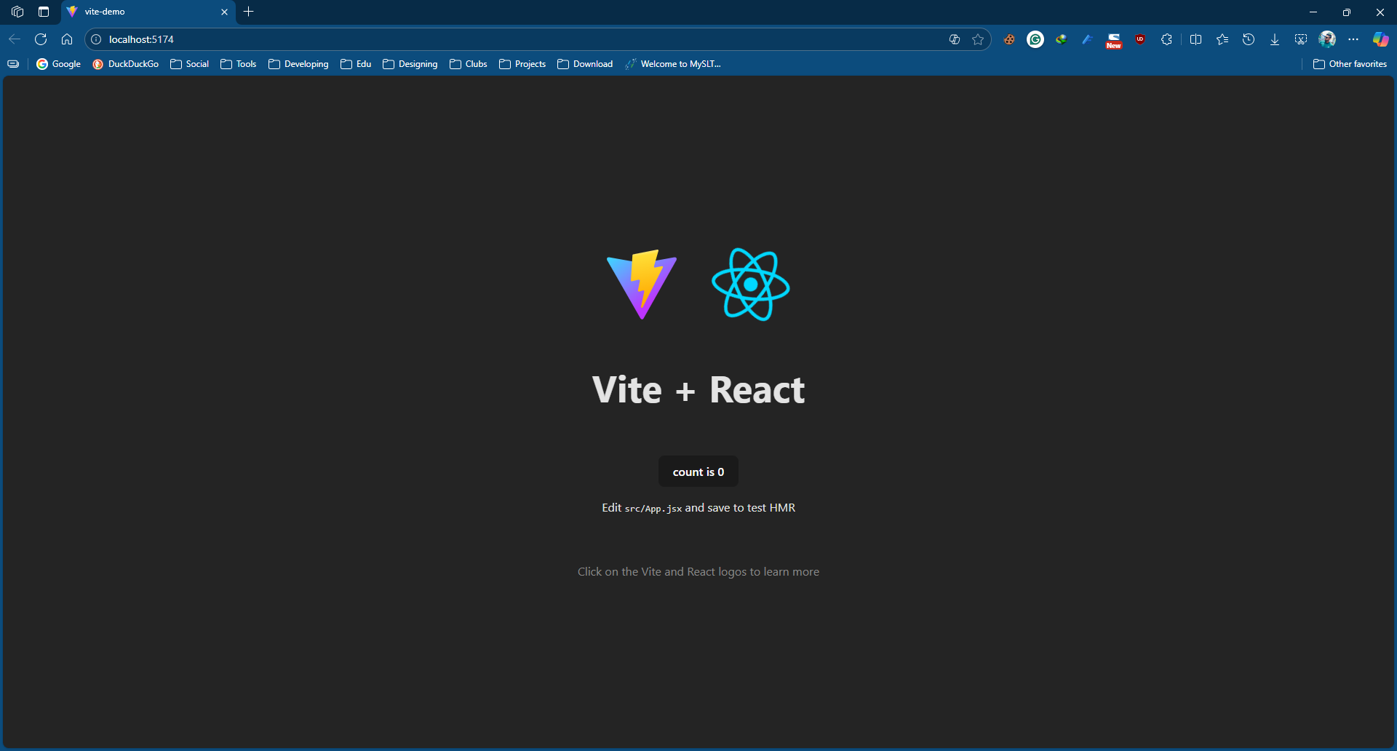
import React from 'react'

const Box = () => {
return (
<div style={{background: 'lightblue', padding: '10px'}}>
Hello from Vite + JSX!
</div>
)
}

export default Box

import { useState } from 'react'
import reactLogo from './assets/react.svg'
import viteLogo from '/vite.svg'
import './App.css'
import Box from './Box.Jsx'

function App() {
const [count, setCount] = useState(0)

return (

<div>
<h1>Project 4: Vite JSX Demo</h1>
<Box />
</div>

)
}

export default App

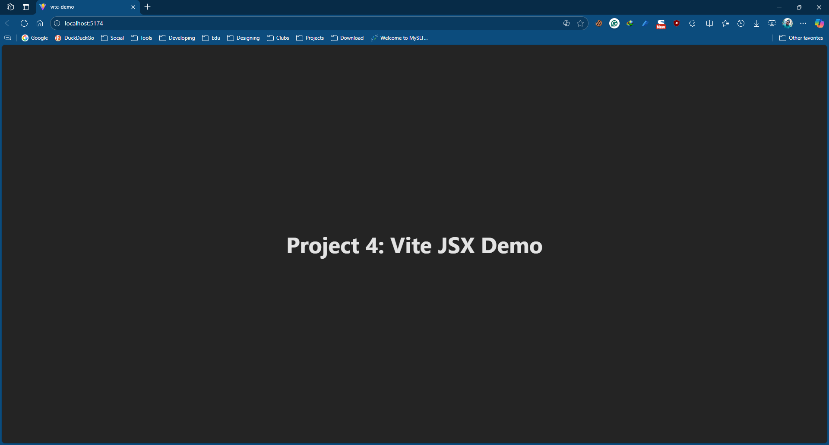

Project 03
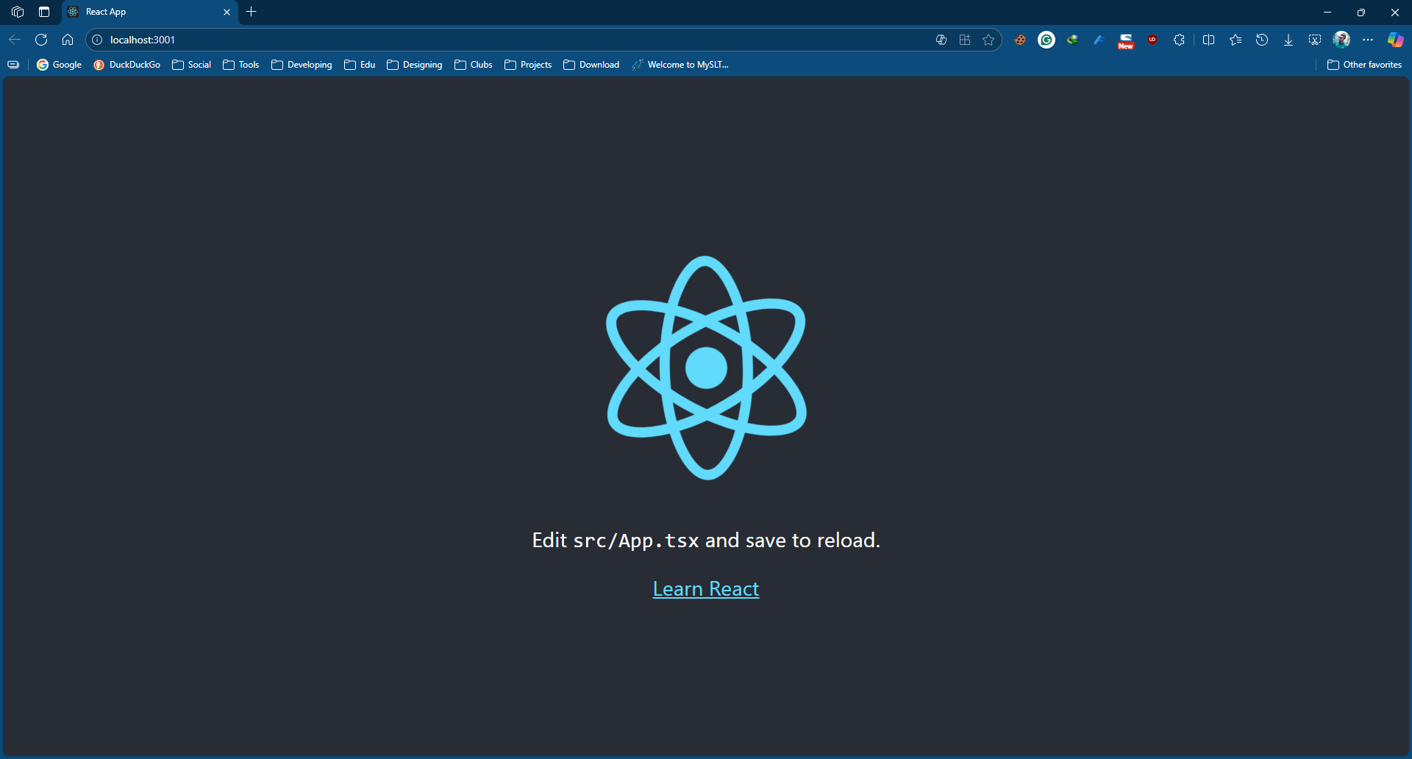
import React from 'react'

const Message : React.FC = () => {
return <h2>Hello from TypeScript + React!</h2>;

};

export default Message

import React from 'react';
import logo from './logo.svg';
import './App.css';
import Message from './Message';

function App() {
return (
<div>
<h1>Project 3: NPX TS Demo</h1>
<Message />
</div>
);
}

export default App;

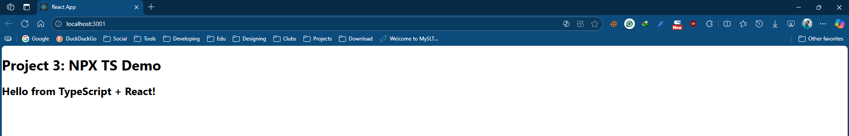

Project 04
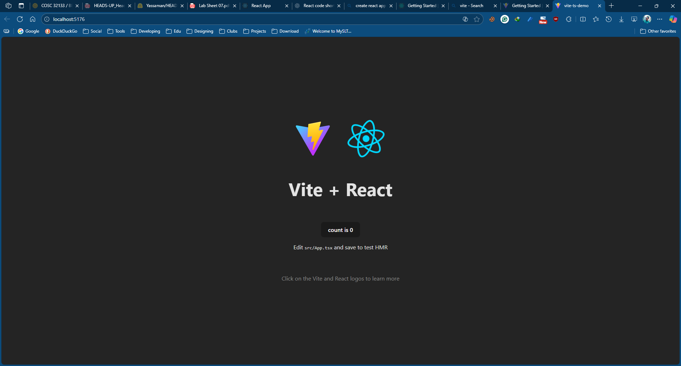
import React from 'react'

const Greeting = () => {
return (
<h2>Welcome to Vite React!</h2>
)
}

export default Greeting

import React from 'react'

const App = () => {
return (
<h1>Project 4: Vite TSX Demo</h1>
)
}

export default App

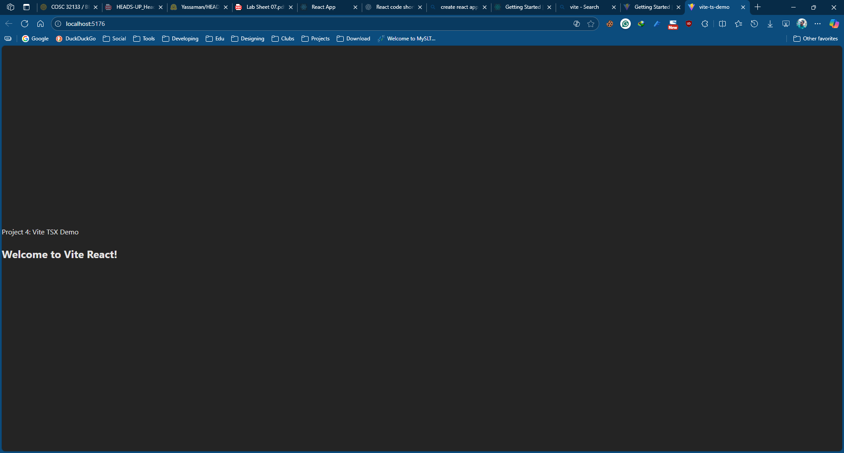

Task 2
Task 02
1. List two different ways to create a React app.
- Using Create React App (CRA) → npx create-react-app my-app
- Using Vite → npm create vite@latest my-app --template react
2. Explain the difference between. jsx and .tsx files.
- jsx: React + JavaScript
- tsx: React + TypeScript (supports type checking)
3. What is the purpose of the node_modules/ folder in a React project?
- Stores all installed dependencies and libraries needed for the React project.
4. List two important files found inside the public/ folder and explain their roles.
- index.html → Main HTML file where the React app is injected.
- favicon.ico → Icon shown in the browser tab.

5. What is the function of the index.html file in a React app?
- It contains a root <div> where the entire React application is rendered.
6. What is the purpose of the src/ folder?
- Contains all the React components, CSS, and main application logic.

