01.

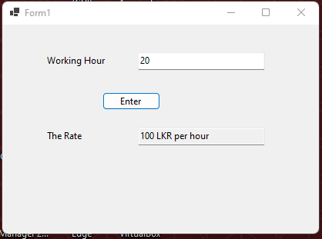

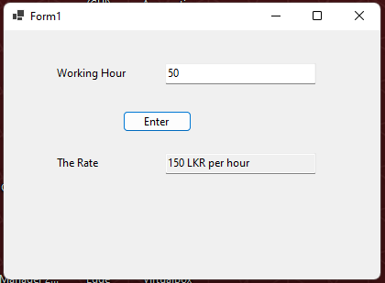

private void button1_Click(object sender, EventArgs e)

{

if (float.Parse(hours.Text) <= 40)

{

rate.Text = "100 LKR per hour";

}

else

{

rate.Text = "150 LKR per hour";

}

}

02.

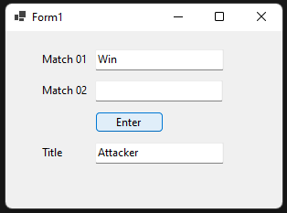 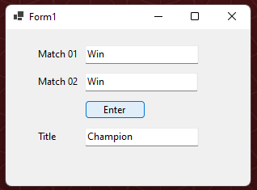 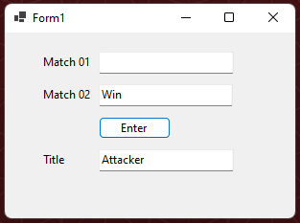 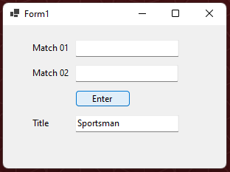

private void button1_Click(object sender, EventArgs e)

{

if (m01.Text == "Win")

{

if (m02.Text == "Win")

{

title.Text = "Champion";

}

else

{

title.Text = "Attacker";

}

}

else

{

if (m02.Text == "Win")

{

title.Text = "Attacker";

}

else

{

title.Text = "Sportsman";

}

}

}

03.

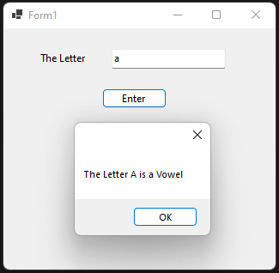 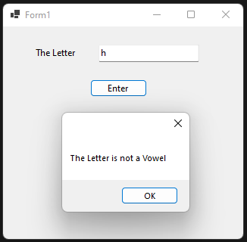

private void button1_Click(object sender, EventArgs e)

{

String letter = lettertxt.Text;

switch (letter)

{

case "A":

MessageBox.Show("The Letter A is a Vowel");

break;

case "E":

MessageBox.Show("The Letter E is a Vowel");

break;

case "I":

MessageBox.Show("The Letter I is a Vowel");

break;

case "O":

MessageBox.Show("The Letter O is a Vowel");

break;

case "U":

MessageBox.Show("The Letter U is a Vowel");

break;

case "a":

MessageBox.Show("The Letter A is a Vowel");

break;

case "e":

MessageBox.Show("The Letter E is a Vowel");

break;

case "i":

MessageBox.Show("The Letter I is a Vowel");

break;

case "o":

MessageBox.Show("The Letter O is a Vowel");

break;

case "u":

MessageBox.Show("The Letter U is a Vowel");

break;

default:

MessageBox.Show("The Letter is not a Vowel");

break;

}

}

04.

private void button1_Click(object sender, EventArgs e)

{

string result1;

string result2;

result1 = match1.Text;

result2 = match2.Text;

switch (result1)

{

case "win":

switch (result2)

{

case "win":

title.Text = "Champion";

break;

case "lose":

title.Text = "Attacker";

break;

}

break;

case "lose":

switch (result2)

{

case "win":

title.Text = "Attacker";

break;

case "lose":

title.Text = "Sportsman";

break;

}

break;

}

}

05.

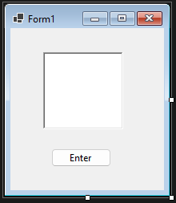

**With While loop –**

private void button1_Click(object sender, EventArgs e)

{

int i = 0;

while (i < 10)

{

richTextBox1.Text = richTextBox1.Text + "\n" + i;

i++;

}

}

**With for loop –**

private void button1_Click(object sender, EventArgs e)

{

int i;

for (i = 0; i < 10; i++)

{

richTextBox1.Text = richTextBox1.Text + "\n" + i;

}

}

**With do-while loop –**

private void button1_Click(object sender, EventArgs e)

{

int i = 0;

do

{

richTextBox1.Text = richTextBox1.Text + "\n" + i;

i++;}

while (i < 10)

}

06.

private void button1_Click(object sender, EventArgs e)

{

int i = 0;

do

{

richTextBox1.Text = richTextBox1.Text + "\n" + i;

i++;

if (i > 5)

{

break;

}

}

while (i < 10);

}

07.

private void button1_Click(object sender, EventArgs e)

{

int i = 0;

do

{

if (i == 5)

{

i++;

continue;

}

richTextBox1.Text = richTextBox1.Text + "\n" + i;

i++;

}

while (i < 10);

}