**Exercise 01**

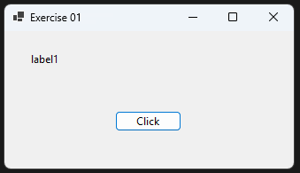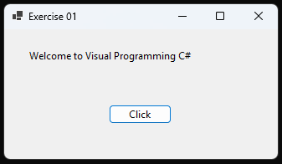

namespace PracticalLesson01

{

public partial class Form1 : Form

{

public Form1()

{

InitializeComponent();

}

private void btnClick_Click(object sender, EventArgs e)

{

lblDisplay.Text = "Welcome to Visual Programming C#";

}

}

}

**Exercise 02**

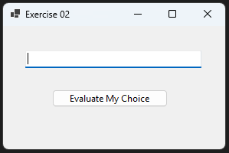 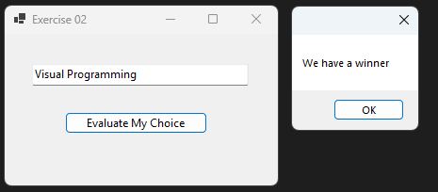

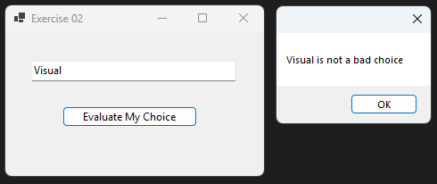

namespace PracticalLesson01

{

public partial class Form2 : Form

{

public Form2()

{

InitializeComponent();

}

private void btnEvaluate_Click(object sender, EventArgs e)

{

string language1;

language1 = txtInput.Text;

if (language1 == "Visual Programming" || language1 == "VISUAL PROGRAMMING")

{

MessageBox.Show("We have a winner");

}

else

{

MessageBox.Show(language1 + " is not a bad choice");

}

}

}

}

**Exercise 03**

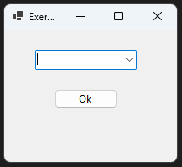 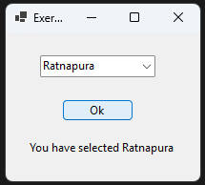

namespace PracticalLesson01

{

public partial class Form3 : Form

{

public Form3()

{

InitializeComponent();

}

private void btnEvaluate_Click(object sender, EventArgs e)

{

lblDisplay.Text = "You have selected " + cmbCity.SelectedItem;

}

private void Form3_Load(object sender, EventArgs e)

{

}

}

}

**Exercise 04**

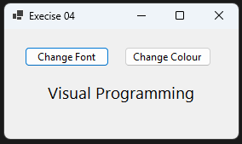**

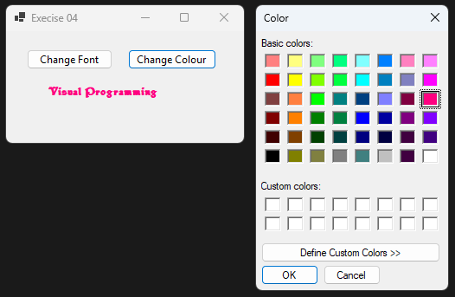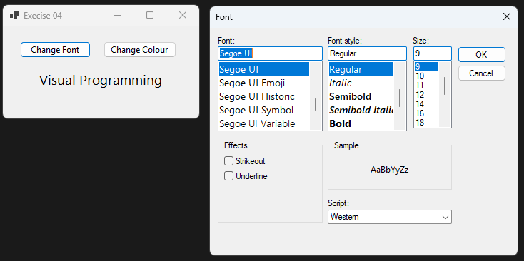

namespace PracticalLesson01

{

public partial class Form4 : Form

{

public Form4()

{

InitializeComponent();

}

private void btnFont_Click(object sender, EventArgs e)

{

fontDialog1.ShowDialog();

lblShow.Font = fontDialog1.Font;

}

private void btnColor_Click(object sender, EventArgs e)

{

colorDialog1.ShowDialog();

lblShow.ForeColor = colorDialog1.Color;

}

}

}

**Exercise 05**

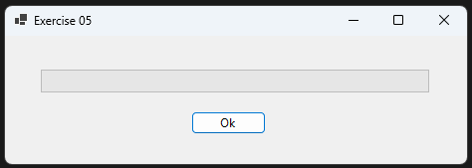

namespace PracticalLesson01

{

public partial class Form5 : Form

{

public Form5()

{

InitializeComponent();

}

private void btnOk_Click(object sender, EventArgs e)

{

int intvalue = 0;

progressBar1.Maximum = 10000;

do

{

progressBar1.Value = intvalue;

intvalue = intvalue + 1;

} while (intvalue != 10000);

}

private void Form5_Load(object sender, EventArgs e)

{

}

}

}

**Exercise 06**

namespace PracticalLesson01

{

public partial class Form6 : Form

{

public Form6()

{

InitializeComponent();

}

private void Form6_Load(object sender, EventArgs e)

{

lstMaster.Items.Add("Germany");

lstMaster.Items.Add("France");

lstMaster.Items.Add("United Kingdom");

lstMaster.Items.Add("Italy");

lstMaster.Items.Add("Spain");

lstMaster.Items.Add("Switzerland");

lstMaster.Items.Add("Netherlands");

lstMaster.Items.Add("Greece");

lstMaster.Items.Add("Poland");

lstMaster.Items.Add("Austria");

}

private void btnOk_Click(object sender, EventArgs e)

{

int x, y;

y = 0;

x = lstMaster.CheckedItems.Count - 1;

do

{

MessageBox.Show(lstMaster.CheckedItems[y].ToString());

y = y + 1;

} while (y <= x);

}

}

}

**Exercise 07**

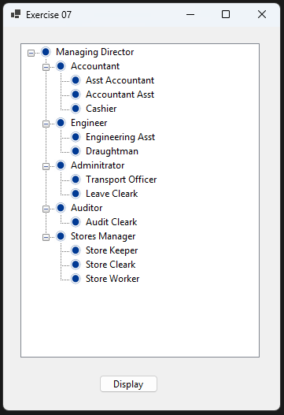

namespace PracticalLesson01

{

public partial class Form7 : Form

{

public Form7()

{

InitializeComponent();

}

private void btnDisplay_Click(object sender, EventArgs e)

{

TreeNode cnode, cnode1;

treeView1.Nodes.Clear();

cnode = treeView1.Nodes.Add("Managing Director");

cnode.Nodes.Add("Accountant");

cnode.Nodes.Add("Engineer");

cnode.Nodes.Add("Adminitrator");

cnode.Nodes.Add("Auditor");

cnode.Nodes.Add("Stores Manager");

cnode1 = cnode.Nodes[0];

cnode1.Nodes.Add("Asst Accountant");

cnode1.Nodes.Add("Accountant Asst");

cnode1.Nodes.Add("Cashier");

cnode1 = cnode.Nodes[1];

cnode1.Nodes.Add("Engineering Asst");

cnode1.Nodes.Add("Draughtman");

cnode1 = cnode.Nodes[2];

cnode1.Nodes.Add("Transport Officer");

cnode1.Nodes.Add("Leave Cleark");

cnode1 = cnode.Nodes[3];

cnode1.Nodes.Add("Audit Cleark");

cnode1 = cnode.Nodes[4];

cnode1.Nodes.Add("Store Keeper");

cnode1.Nodes.Add("Store Cleark");

cnode1.Nodes.Add("Store Worker");

cnode.Expand();

}

private void Form7_Load(object sender, EventArgs e)

{

imageList1.Images.Add(Image.FromFile("C:\\Users\\gamik\\Downloads\\OIP.jpeg"));

treeView1.ImageList = imageList1;

}

}

}

**Exercise 08**

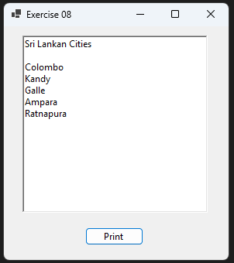

namespace PracticalLesson01

{

public partial class Form8 : Form

{

public Form8()

{

InitializeComponent();

}

private void btnPrint_Click(object sender, EventArgs e)

{

richTextBox1.Clear();

richTextBox1.SelectedText = "Sri Lankan Cities" + Environment.NewLine +Environment.NewLine;

richTextBox1.SelectedText = "Colombo" + Environment.NewLine;

richTextBox1.SelectedText = "Kandy" + Environment.NewLine;

richTextBox1.SelectedText = "Galle" + Environment.NewLine;

richTextBox1.SelectedText = "Ampara" + Environment.NewLine;

richTextBox1.SelectedText = "Ratnapura" + Environment.NewLine;

}

}

}