**How to add another form to the project?**

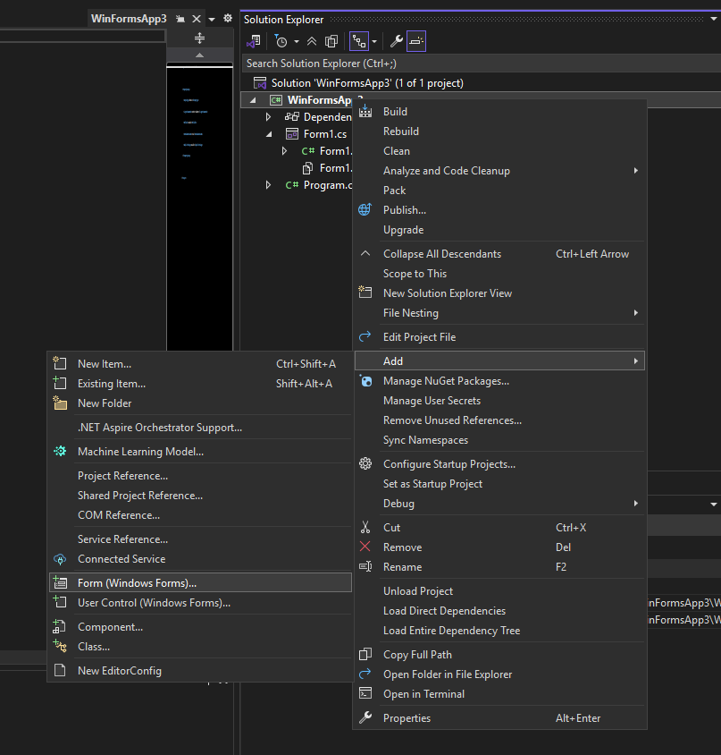

**Display Output in a Message Box in C#**

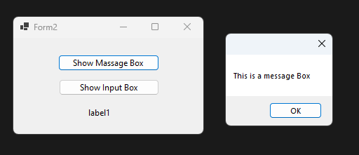

private void button1_Click(object sender, EventArgs e)

{

MessageBox.Show("This is a message Box");

}

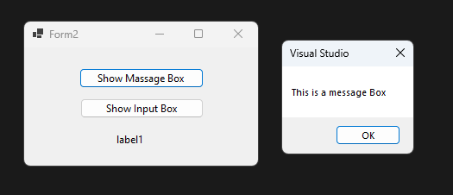

private void button1_Click(object sender, EventArgs e)

{

MessageBox.Show("This is a message Box", "Visual Studio");

}

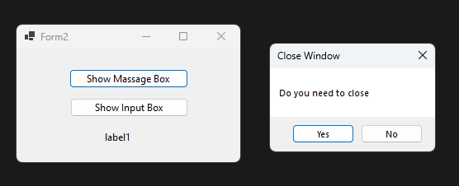

private void button1_Click(object sender, EventArgs e)

{

String message = "Do you need to close";

String title = "Close Window";

DialogResult result = MessageBox.Show(message, title,

MessageBoxButtons.YesNo);

if (result == DialogResult.Yes)

{

this.Close();

}

}

private void button1_Click(object sender, EventArgs e)

{

String message = "Do you need to close";

String title = "Close Window";

DialogResult result = MessageBox.Show(message, title,

MessageBoxButtons.YesNo, MessageBoxIcon.Warning);

if (result == DialogResult.Yes)

{

this.Close();

}

}

**Get Input Using an Input Box in C#**

private void button2_Click(object sender, EventArgs e)

{

string input1;

input1 = Interaction.InputBox("This is an input box", "Title");

label1.Text = input1;

}