**Exercise 01**

01.

03.

namespace Lab_04

{

public partial class Form1 : Form

{

public Form1()

{

InitializeComponent();

}

private void button1_Click(object sender, EventArgs e)

{

int n, first = 0, second = 1, next = 0, c;

if (textBox1.Text == "")

{

MessageBox.Show("Please enter a number to proceed", "Warning",

MessageBoxButtons.OKCancel, MessageBoxIcon.Warning);

}

else

{

n = int.Parse(textBox1.Text);

for (c = 0; c < second; c++)

{

if (c <= 1)

{

next = c;

}

else

{

next = first + second;

first = second;

second = next;

}

}

lblDisplay.Text = n + " fibonacci number is: " + next;

}

}

}

}

04.

05.

06.

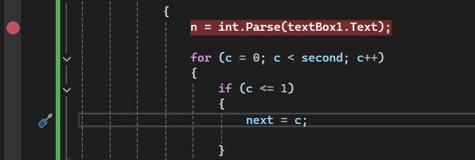

07.

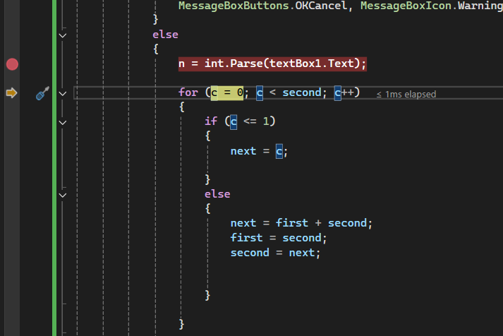

10. only one time

12.

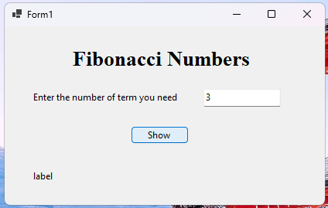

14.

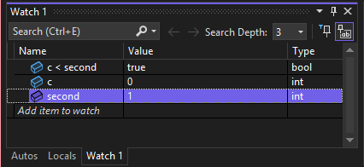

16.

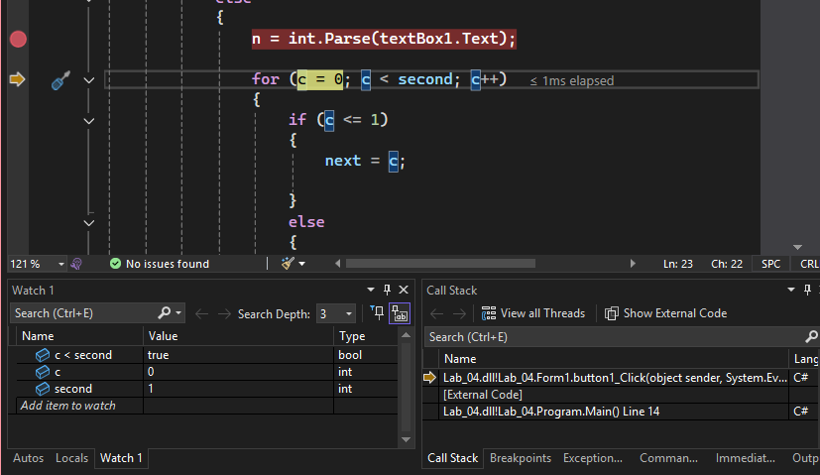

17.

18.

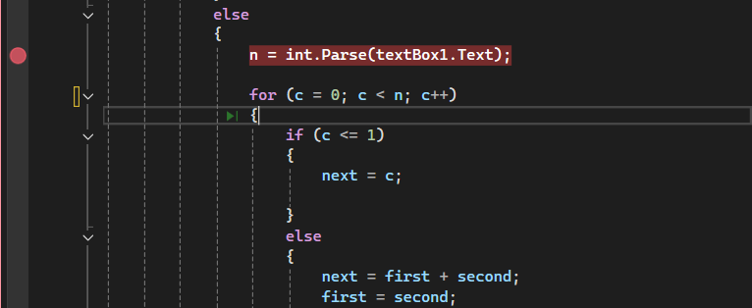

22.

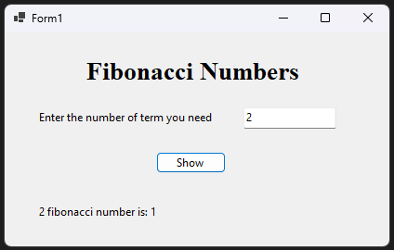

**Exercise 02**

01.

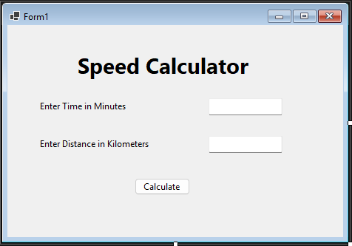

05.

namespace SpeedCalculator

{

public partial class Form1 : Form

{

public Form1()

{

InitializeComponent();

}

private void btnCal_Click(object sender, EventArgs e)

{

double minutes = double.Parse(txtTime.Text);

double distance = double.Parse(txtDistance.Text);

double hours = 0, speed;

hours = minutes / 60;

speed = getSpeed(distance, hours);

MessageBox.Show("Your speed is " + speed + " Kilometers per hour", "Speed", MessageBoxButtons.OKCancel, MessageBoxIcon.Information);

}

public double getSpeed(double hours, double distance)

{

double speed = distance / hours;

return speed;

}

}

}

06.

08.

09.

11.

16.

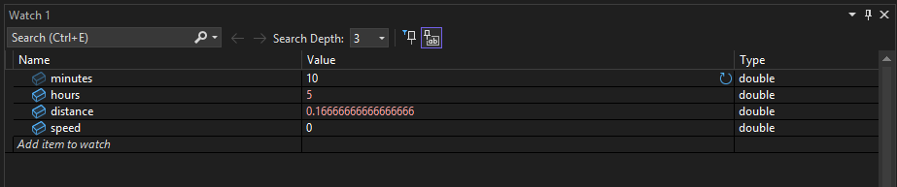

18.

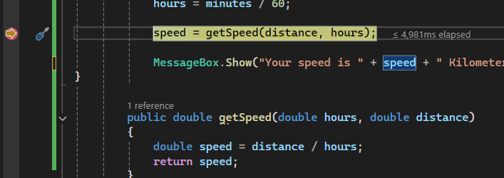

19.

