**Exceptions Handling I**

**Exercise 01**

**01.**

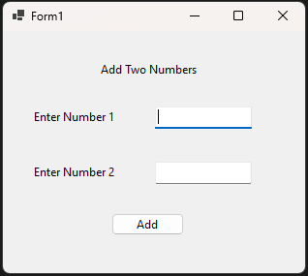

03.

namespace Lab_05

{

public partial class Form1 : Form

{

public Form1()

{

InitializeComponent();

}

private void button1_Click(object sender, EventArgs e)

{

try

{

int num1 = int.Parse(txtnum1.Text);

int num2 = int.Parse(txtnum2.Text);

int num3 = num1 + num2;

MessageBox.Show(num3.ToString());

}

catch (Exception e1)

{

MessageBox.Show(e1.ToString());

}

}

}

}

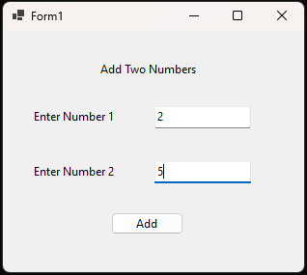

05.



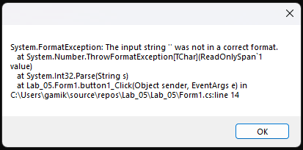

**Exercise 02**

**01.**

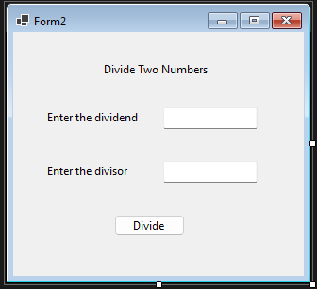

**05.**

using System;

using System.Collections.Generic;

using System.ComponentModel;

using System.Data;

using System.Drawing;

using System.Linq;

using System.Text;

using System.Threading.Tasks;

using System.Windows.Forms;

namespace Lab_05

{

public partial class Form2 : Form

{

public Form2()

{

InitializeComponent();

}

private void button1_Click(object sender, EventArgs e)

{

try

{

int num1 = int.Parse(txtDividend.Text);

int num2 = int.Parse(txtDivisor.Text);

int num3 = num1 / num2;

MessageBox.Show(num3.ToString());

}

catch (FormatException e1)

{

MessageBox.Show("Enter Numbers to both text boxes"+ Environment.NewLine+ e1.ToString());

}

catch (DivideByZeroException e2)

{

MessageBox.Show("Numbers can't be divide by zero" + Environment.NewLine + e2.ToString());

}

}

}

}

**06.a**

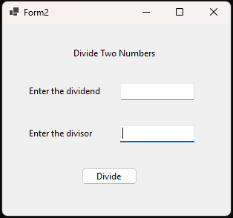

**06.b**

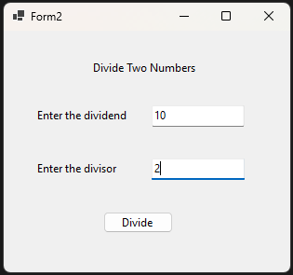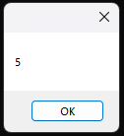

**06.c**

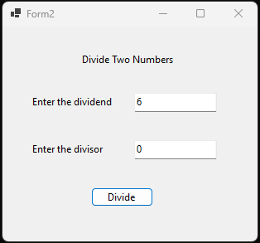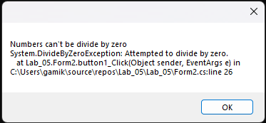

**Exercise 03**

**01.**

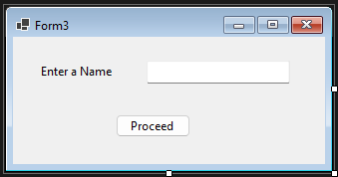

**03.**

namespace Lab_05

{

internal static class Program

{

/// <summary>

/// The main entry point for the application.

/// </summary>

[STAThread]

static void Main()

{

// To customize application configuration such as set high DPI settings or default font,

// see https://aka.ms/applicationconfiguration.

ApplicationConfiguration.Initialize();

Application.Run(new Form3());

}

}

}

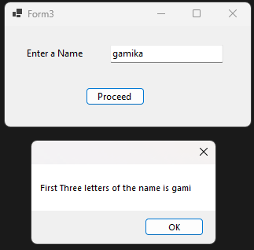

**Exceptions Handling II**

**Exercise 01**

**01.**

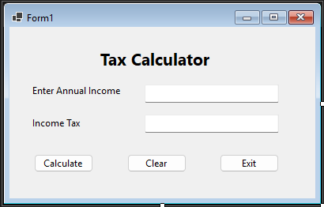

**07.**

namespace Lab_05_02

{

public partial class Form1 : Form

{

public Form1()

{

InitializeComponent();

}

private void button1_Click(object sender, EventArgs e)

{

try

{

int noTaxThreshold = 11000;

int band1 = 11000;

int band2 = 43000;

int band3 = 150000;

decimal tax = 0;

string msg = "Income need to be greater than 11000 to calcilate a tax";

int salary = int.Parse(txtIncome.Text);

if (salary < noTaxThreshold) throw new

InvalidIncomeException(msg);

if (salary >= band3)

{

tax = (salary - noTaxThreshold) * (decimal)0.45;

}

if (salary > band2)

{

tax = (salary - noTaxThreshold) * (decimal)0.40;

}

if (salary > band1)

{

tax = (salary - noTaxThreshold) * (decimal)0.20;

}

txtTax.Text = tax.ToString();

}

catch (InvalidIncomeException e1)

{

MessageBox.Show(e1.ToString(), " Invalid Annual Income");

}

catch (FormatException e1)

{

MessageBox.Show(e1.ToString(), "Enter Numeric Value as Annual Income");

}

catch (System.OverflowException e1)

{

MessageBox.Show(e1.ToString(), "Too Large number to handle");

}

}

private void btnClear_Click(object sender, EventArgs e)

{

txtIncome.Clear();

txtTax.Clear();

}

private void btnExit_Click(object sender, EventArgs e)

{

this.Close();

}

}

public class InvalidIncomeException : Exception

{

public InvalidIncomeException(String message)

: base(message)

{

}

}

}

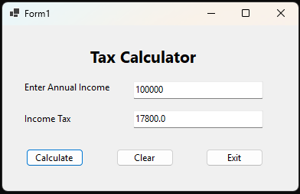

**08.**

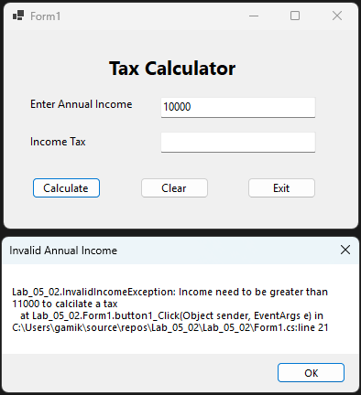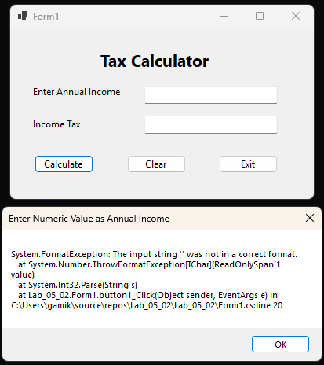

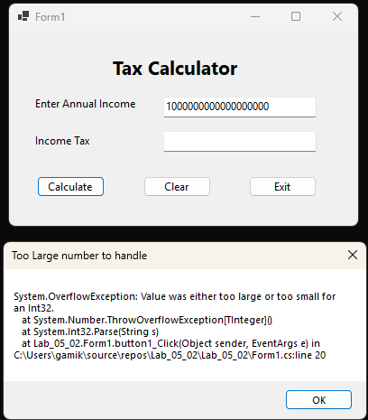

**Exercise 02**

**01.**

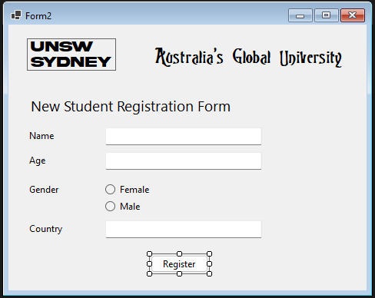

**02.**

using System;

using System.Collections.Generic;

using System.ComponentModel;

using System.Data;

using System.Diagnostics.Metrics;

using System.Drawing;

using System.Linq;

using System.Text;

using System.Threading.Tasks;

using System.Windows.Forms;

using Microsoft.VisualBasic.Devices;

using Microsoft.Win32;

using static System.Windows.Forms.VisualStyles.VisualStyleElement;

namespace Lab_05_02

{

public partial class Form2 : Form

{

public Form2()

{

InitializeComponent();

}

private void radioButton2_CheckedChanged(object sender, EventArgs e)

{

}

private void label3_Click(object sender, EventArgs e)

{

}

private void button1_Click(object sender, EventArgs e)

{

try

{

string name = txtName.Text;

int age = int.Parse(txtAge.Text);

string country = txtCountry.Text;

string gender;

if (age < 17 && age > 70)

{

throw new InvalidAgeRangeException("Sorry, You should be older than 15 and younger than 70 to register our university");

}

if (Female.Checked == true)

{

gender = "Female";

}

else if (Male.Checked == true)

{

gender = "Male";

}

else

{

throw new GenderException("Should Select a gender from the radio buttons");

}

Form3 frm3 = new Form3();

frm3.Show();

}

catch (InvalidAgeRangeException e1)

{

MessageBox.Show(e1.ToString(), "Can't Register!");

}

catch (GenderException e1)

{

MessageBox.Show(e1.ToString(), "Warning!");

}

catch (FormatException e1)

{

MessageBox.Show(e1.ToString(), "Enter a Numerical Value to the Age");

}

}

}

public class InvalidAgeRangeException : Exception

{

public InvalidAgeRangeException(string message)

: base(message)

{

}

}

public class GenderException : Exception

{

public GenderException(string message)

: base(message)

{

}

}

}

**05.**

using System;

using System.Collections.Generic;

using System.ComponentModel;

using System.Data;

using System.Drawing;

using System.Linq;

using System.Text;

using System.Threading.Tasks;

using System.Windows.Forms;

namespace Lab_05_02

{

public partial class Form3 : Form

{

public Form3()

{

InitializeComponent();

}

private void Form3_Load(object sender, EventArgs e)

{

progressBar1.Visible = false;

}

private void btnOk_Click(object sender, EventArgs e)

{

label2.Visible = false;

btnOk.Visible = false;

int value = 0;

progressBar1.Visible = true;

do

{

progressBar1.Value = value;

value = value + 1;

}

while (value < progressBar1.Maximum);

MessageBox.Show("Registration Completed", "Congradulations!");

}

}

}

**09.**

