**Exercise 01**

**Step 01: Create a new database**

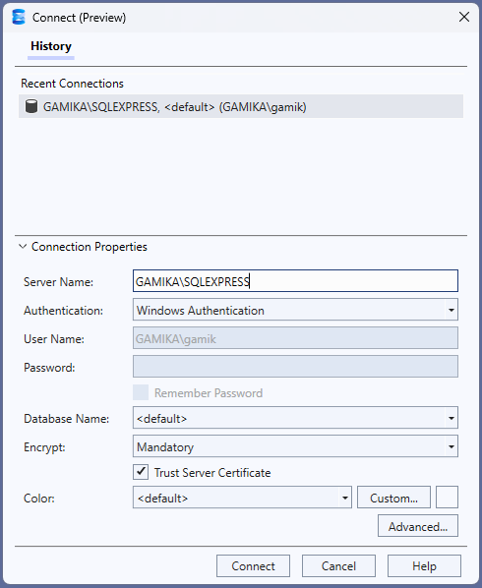

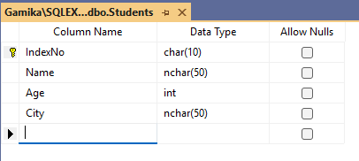

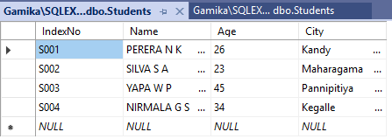

**Step 02: Install Required Package (NuGet)**

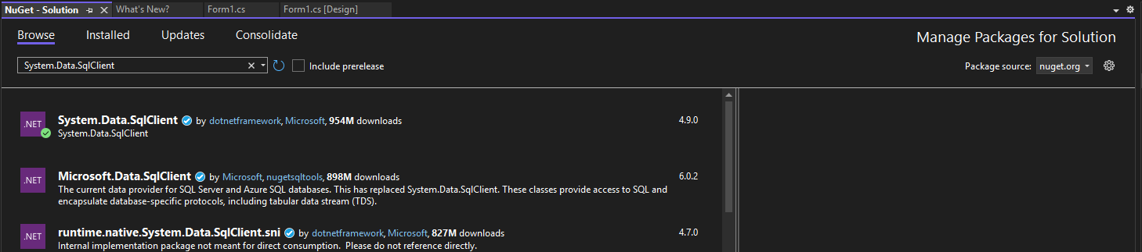

**Step 03: Create the Windows Forms App**

**Step 04: Add These Using Directives at the Top of the Code File**

using System.Data.SqlClient;

using System.Data;

**Step 05: Add Controls to the Form**

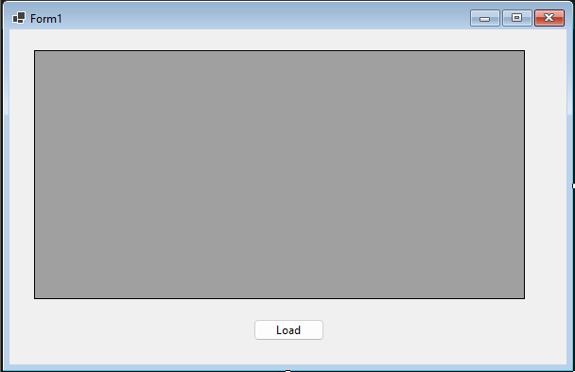

using System.Data.SqlClient;

using System.Data;

namespace DatabaseTest

{

public partial class Form1 : Form

{

public Form1()

{

InitializeComponent();

}

private void Form1_Load(object sender, EventArgs e)

{

}

private void button1_Click(object sender, EventArgs e)

{

string connectionString = "Data Source=GAMIKA\\SQLEXPRESS;Initial Catalog=StudentDB;Integrated Security=True";

string sql = "SELECT * FROM Students";

SqlConnection connection = new SqlConnection(connectionString);

SqlDataAdapter adapter = new SqlDataAdapter(sql, connection);

DataSet ds = new DataSet();

try

{

connection.Open();

adapter.Fill(ds);

}

catch (SqlException ex)

{

MessageBox.Show("SQL Error: " + ex.Message);

}

finally

{

connection.Close();

}

dataGridView1.DataSource = ds.Tables[0];

}

}

}

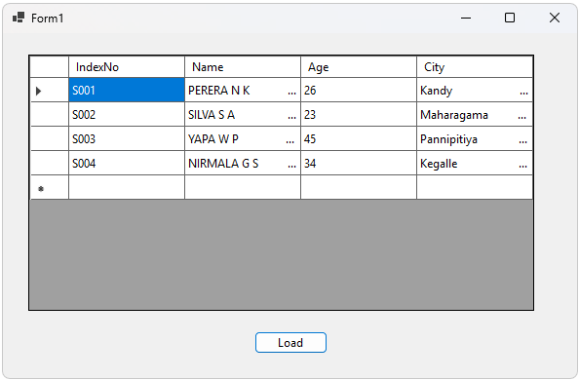

**Exercise 02**

**Step 01: Design Your Form**

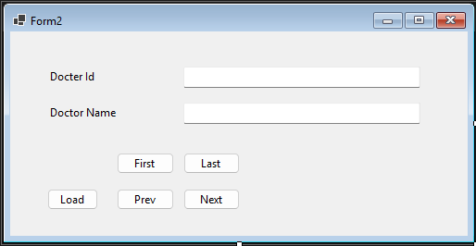

**Step 02: Add Required Namespaces**

using System.Data;

using System.Data.SqlClient;

**Step 03: Create a new database**

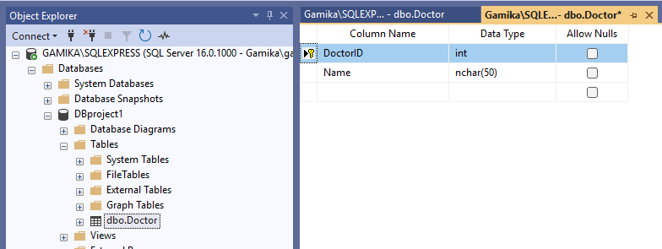

**Step 04:**

private void btnLoad_Click(object sender, EventArgs e)

{

connection = new SqlConnection("Data Source=GAMIKA\\SQLEXPRESS;Initial Catalog=StudentDB;Integrated Security=True");

adapter = new SqlDataAdapter("SELECT * Doctor", connection);

dataTable = new DataTable();

adapter.Fill(dataTable);

BindingSource.DataSource = dataTable;

txtIndexNo.DataBindings.clear();

txtName.DataBindings.Clear();

txtIndexNo.DataBindings.Add("Text", BindingSource, "DoctorID");

txtName.DataBindings.Add("Text", BindingSource, "Name");

}

**Step 05: Add Navigation Button Functionalities**

private void btnFirst_Click(object sender, EventArgs e)

{

BindingSource.MoveFirst();

}

private void btnLast_Click(object sender, EventArgs e)

{

BindingSource.MoveLast();

}

private void btnPrev_Click(object sender, EventArgs e)

{

BindingSource.MovePrevious();

}

private void btnNext_Click(object sender, EventArgs e)

{

BindingSource.MoveNext();

}

**Step 05: Step Run the application by pressing F5**



