**Exercise 01**

**Step 01: Create a new database**

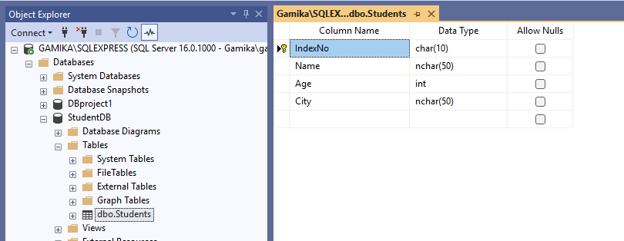

**Step 02: Create the Windows Forms App**

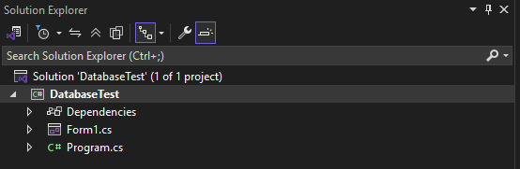

**Step 03: Add These Using Directives at the Top of the Code File**

using System.Data;

using System.Data.SqlClient;

**Step 04: Add Controls to the Form**

using System.Data;

using System.Data.SqlClient;

namespace DatabaseTest

{

public partial class Form1 : Form

{

string connectionString = "Data Source=GAMIKA\\SQLEXPRESS;Initial Catalog=StudentDB;Integrated Security=True";

private void LoadData()

{

using SqlConnection conn = new SqlConnection(connectionString);

SqlDataAdapter adapter = new SqlDataAdapter("SELECT * FROM Students", conn);

DataTable dt = new DataTable();

adapter.Fill(dt);

dataGridView1.DataSource = dt;

}

private void ClearFields()

{

txtIndexNo.Clear();

txtName.Clear();

txtAge.Clear();

txtCity.Clear();

}

public Form1()

{

InitializeComponent();

}

private void Form1_Load(object sender, EventArgs e)

{

}

private void btnLoad_Click(object sender, EventArgs e)

{

LoadData();

}

private void btnAdd_Click(object sender, EventArgs e)

{

using SqlConnection conn = new SqlConnection(connectionString);

string sql = "INSERT INTO Students (IndexNO, Name, Age, City) VALUES (@IndexNo, @Name, @Age, @City)";

SqlCommand cmd = new SqlCommand(sql, conn);

cmd.Parameters.AddWithValue("@IndexNo", txtIndexNo.Text);

cmd.Parameters.AddWithValue("@Name", txtName.Text);

cmd.Parameters.AddWithValue("@Age", int.Parse(txtAge.Text));

cmd.Parameters.AddWithValue("@City", txtCity.Text);

conn.Open();

LoadData();

ClearFields();

}

private void btnUpadate_Click(object sender, EventArgs e)

{

using SqlConnection conn = new SqlConnection(connectionString);

string sql = "UPDATE Students SET Name=@Name, Age=@Age City=@City WHERE IndexNo=@IndexNo"; ;

SqlCommand cmd = new SqlCommand(sql, conn);

cmd.Parameters.AddWithValue("@IndexNo", txtIndexNo.Text);

cmd.Parameters.AddWithValue("@Name", txtName.Text);

cmd.Parameters.AddWithValue("@Age", int.Parse(txtAge.Text));

cmd.Parameters.AddWithValue("@City", txtCity.Text);

conn.Open();

cmd.ExecuteNonQuery();

LoadData();

ClearFields();

}

private void btnDelete_Click(object sender, EventArgs e)

{

using SqlConnection conn = new SqlConnection(connectionString);

string sql = "DELETE FROM Students WHERE IndexNo=@IndexNo";

SqlCommand cmd = new SqlCommand(sql, conn);

cmd.Parameters.AddWithValue("@IndexNo", txtIndexNo.Text);

conn.Open();

cmd.ExecuteNonQuery();

LoadData();

ClearFields();

}

private void dataGridView1_CellContentClick(object sender, DataGridViewCellEventArgs e)

{

if (e.RowIndex >= 0)

{

txtIndexNo.Text = dataGridView1.Rows[e.RowIndex].Cells["IndexNO"].Value.ToString();

txtName.Text = dataGridView1.Rows[e.RowIndex].Cells["Name"].Value.ToString();

txtAge.Text = dataGridView1.Rows[e.RowIndex].Cells["Age"].Value.ToString();

txtCity.Text = dataGridView1.Rows[e.RowIndex].Cells["City"].Value.ToString();

}

}

}

}

**Step 05: Run the application by pressing F5**

