**Exercise 1: Create a data grid object**

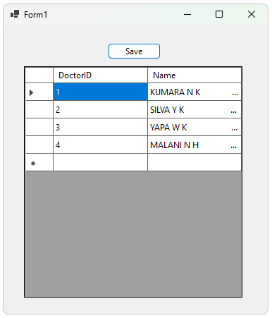

**Exercise 2: Formatting DataGrid View**

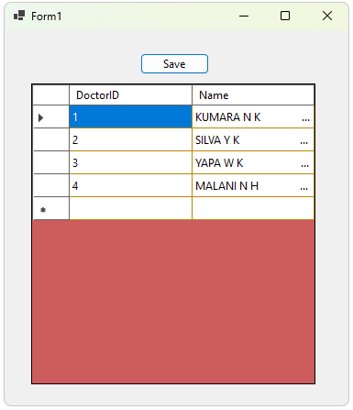

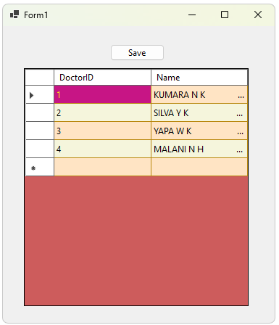

**Exercise 3: Formatting DataGrid Cells**

**Exercise 4: Notes on Editability**

**Exercise 5: Enable Updating and Deleting Records in the DataGridView**

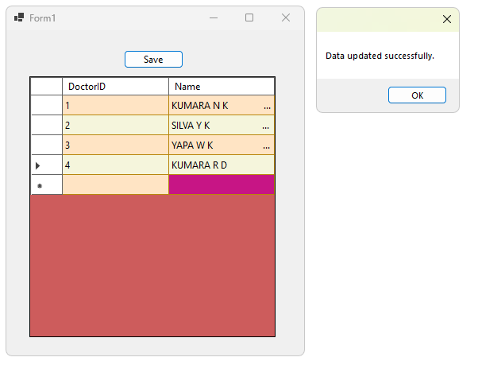

using System.Data;

using System.Data.SqlClient;

namespace DatabaseTest

{

public partial class Form1 : Form

{

private SqlConnection connection;

private SqlDataAdapter adapter;

private DataTable dataTable;

string connectionString = "Data Source = GAMIKA\\SQLEXPRESS; Initial Catalog = DBproject1; Integrated Security = True;";

private void loadData()

{

try

{

connection = new SqlConnection(connectionString);

adapter = new SqlDataAdapter("SELECT * FROM Doctor", connection);

dataTable = new DataTable();

SqlCommandBuilder builder = new SqlCommandBuilder(adapter);

adapter.Fill(dataTable);

dataGridView1.DataSource = dataTable;

dataGridView1.AllowUserToDeleteRows = true;

}

catch (Exception ex)

{

MessageBox.Show("An error occurred while loading data: " + ex.Message);

}

}

public Form1()

{

InitializeComponent();

}

private void button1_Click(object sender, EventArgs e)

{

try

{

adapter.Update(dataTable);

MessageBox.Show("Data updated successfully.");

}

catch (Exception ex)

{

MessageBox.Show("An error occurred: " + ex.Message);

}

}

private void Form1_Load(object sender, EventArgs e)

{

loadData();

dataGridView1.RowsDefaultCellStyle.BackColor = Color.Bisque;

dataGridView1.AlternatingRowsDefaultCellStyle.BackColor = Color.Beige;

dataGridView1.DefaultCellStyle.SelectionBackColor =

Color.MediumVioletRed;

dataGridView1.DefaultCellStyle.SelectionForeColor = Color.Yellow;

}

}

}