**01,02,03,04**

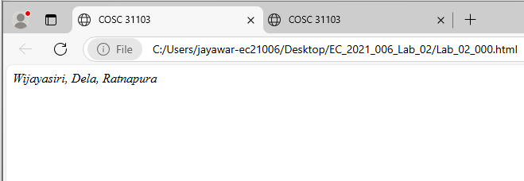

<html>

<head>

<title>COSC 31103</title>

<!--W.K.G.K JAYAWARDANA-->

<!--EC/2021/006-->

<!--BECS 31223-->

</head>

<body>

<address>

Wijayasiri,

Dela,

Ratnapura

</address>

</body>

</html**>**

**05,06**

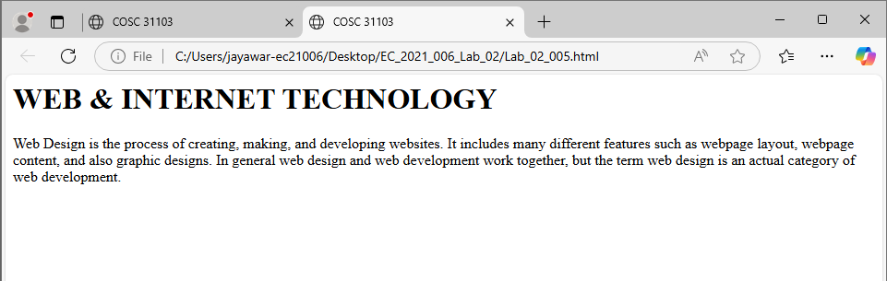

<html>

<head>

<title>COSC 31103</title>

<!--W.K.G.K JAYAWARDANA-->

<!--EC/2021/006-->

<!--BECS 31223-->

</head>

<body>

<h1>WEB & INTERNET TECHNOLOGY</h1>

<p>

Web Design is the process of creating, making, and developing websites. It includes many

different features such as webpage layout, webpage content, and also graphic designs. In

general web design and web development work together, but the term web design is an actual

category of web development.

</p>

</body>

</html>

**07**

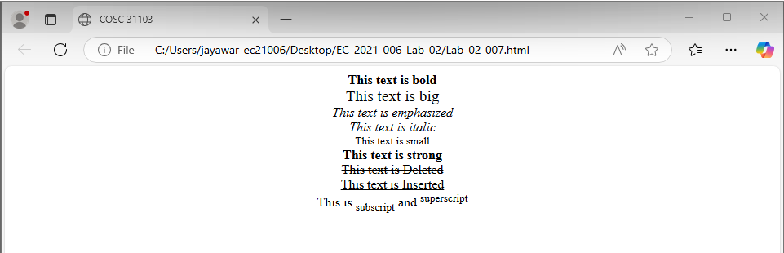

<html>

<head>

<title>COSC 31103</title>

<!--W.K.G.K JAYAWARDANA-->

<!--EC/2021/006-->

<!--BECS 31223-->

</head>

<body>

<center>

<b>This text is bold</b><br>

<big> This text is big </big><br>

<em> This text is emphasized </em><br>

<i>This text is italic </i><br>

<small> This text is small </small><br>

<strong> This text is strong </strong><br>

<del>This text is Deleted</del><br>

<ins>This text is Inserted</ins><br>

This is <sub>subscript</sub> and <sup> superscript

</sup><br>

<center>

</body>

</html>

**08**

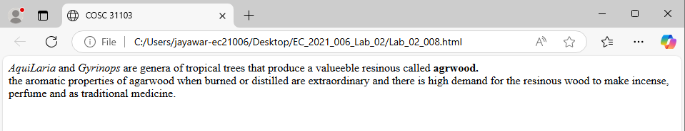

<html>

<head>

<title>COSC 31103</title>

<!--W.K.G.K JAYAWARDANA-->

<!--EC/2021/006-->

<!--BECS 31223-->

</head>

<body>

<p>

<i>AquiLaria</i> and <i>Gyrinops</i> are genera of tropical trees that produce a valuable resinous called <b>agarwood.</b><br>

the aromatic properties of agarwood when burned or distilled are extraordinary and there is high demand for the resinous wood to make incense, perfume and as traditional medicine.

</p>

</body>

</html>

**09**

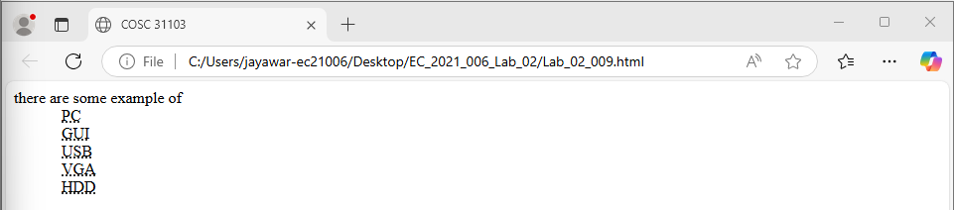

<html>

<head>

<title>COSC 31103</title>

<!--W.K.G.K JAYAWARDANA-->

<!--EC/2021/006-->

<!--BECS 31223-->

</head>

<body>

<p>

there are some example of <br>

&emsp;&emsp;&emsp;

<abbr title="Personal Computer">PC</abbr><br>

&emsp;&emsp;&emsp;

<abbr title="Graphical User interface">GUI</abbr><br>

&emsp;&emsp;&emsp;

<abbr title="Universal Serial Bus">USB</abbr><br>

&emsp;&emsp;&emsp;

<abbr title="Visual Graphic Adaptor">VGA</abbr><br>

&emsp;&emsp;&emsp;

<abbr title="Hard Disk Drive">HDD</abbr>

</p>

</body>

</html>

**10.**

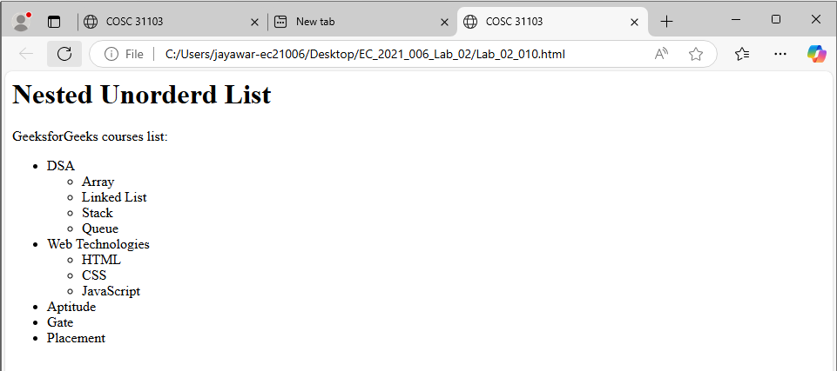

<html>

<head>

<title>COSC 31103</title>

<!--W.K.G.K JAYAWARDANA-->

<!--EC/2021/006-->

<!--BECS 31223-->

</head>

<body>

<h1>Nested Unorderd List</h1>

<P>GeeksforGeeks courses list:</P>

<ul>

<li>DSA</li>

<ul>

<li>Array</li>

<li>Linked List </li>

<li>Stack</li>

<li>Queue</li>

</ul>

<li>Web Technologies </li>

<ul>

<li>HTML</li>

<li>CSS </li>

<li>JavaScript</li>

</ul>

<li>Aptitude</li>

<li>Gate</li>

<li>Placement</li>

</ul>

</body>

</html>

<html>

<head>

<title>Learning Web Development</title>

</head>

<body>

<h2>Learning Web Development</h2>

<ol type="I">

<li>Introduction to HTML

<ol type="A">

<li>HTML Tags

<ol type="a">

<li>HTML Tag Attributes</li>

</ol>

</li>

<li>HTML Elements</li>

</ol>

</li>

<li>HTML Text Formatting</li>

<li>HTML Links

<ol type="A">

<li>Create Hyperlinks

<ol type="a">

<li>Use of target attribute</li>

<li>Use of name attribute</li>

</ol>

</li>

<li>An image as link</li>

<li>Create a mailto link</li>

</ol>

</li>

<li>HTML Tables

<ol type="A">

<li>Table Borders</li>

<li>Table Headings

<ol type="a">

<li>Vertical Headers</li>

<li>Horizontal Headers</li>

</ol>

</li>

<li>Table With A Caption</li>

<li>Table Cell Span

<ol type="a">

<li>Use of rowspan attribute</li>

<li>Use of colspan attribute</li>

</ol>

</li>

<li>Tags Inside A Table

<ol type="a">

<li>Cellspacing</li>

<li>cellpadding</li>

<li>frame</li>

</ol>

</li>

<li>Add Background Image To Table</li>

<li>Align The Content In The Table</li>

</ol>

</li>

<li>HTML Lists

<ol type="a">

<li>Ordered List</li>

<li>Unordered List</li>

<li>Definition List</li>

</ol>

</li>

<li>HTML Forms

<ol type="a">

<li>Text Fields</li>

</ol>

</li>

</ol>

</body>

</html>

**11.**

