**FirstPage.html**

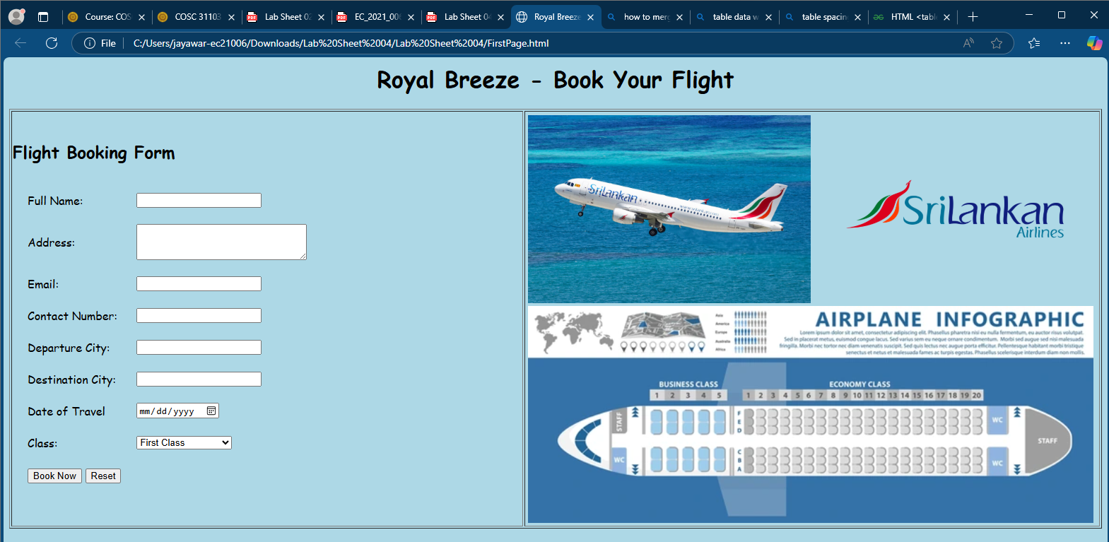

<html>

<head>

<title>Royal Breeze</title>

</head>

<body bgcolor="lightblue">

<font face="Comic Sans MS">

<center><h1>Royal Breeze - Book Your Flight</h1></center>

<table border="1" width="100%">

<tr>

<td>

<h2>Flight Booking Form</h2>

<table cellspacing="20px">

<tr>

<td>Full Name:</td>

<td> <input type="text" name="fname"></td>

</tr>

<tr>

<td>Address:</td>

<td> <textarea name="address" rows="3" cols="30"></textarea></td>

</tr>

<tr>

<td>Email:</td>

<td> <input type="email" name="email"></td>

</tr>

<tr>

<td>Contact Number:</td>

<td> <input type="text" name="cNumber"></td>

</tr>

<tr>

<td>Departure City:</td>

<td> <input type="text" name="fname"></td>

</tr>

<tr>

<td>Destination City:</td>

<td> <input type="text" name="fname"></td>

</tr>

<tr>

<td>Date of Travel</td>

<td> <input type="date" name="fname"></td>

</tr>

<tr>

<td>Class:</td>

<td>

<select name="class">

<option value="first">First Class</option>

<option value="bussiness">Bussiness Class</option>

<option value="pEconomy">Premium Economy</option>

<option value="economy">Economy</option>

</select>

</td>

</tr>

<tr>

<td><input type="submit" value="Book Now"> <input type="reset" value="Reset"></td>

</tr>

</table>

</td>

<td style="width:800px">

<table>

<tr >

<td><img src="plane.jpg" width="400px"></td>

<td><img src="logo.png" width="400px"></td>

</tr>

<tr>

<td colspan = "2"><img src="https://www.shutterstock.com/image-vector/airplane-flight-infographics-flat-aircraft-600nw-2139529143.jpg" width="800px"></td>

</tr>

</table>

</td>

</tr>

</table>

</body>

</html>

**SecondPage.html**

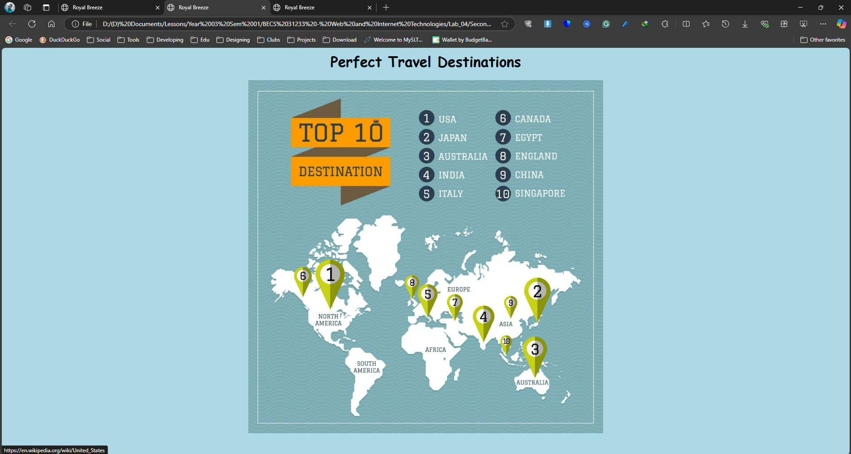

<html>

<head>

<title>Royal Breeze</title>

</head>

<body bgcolor="lightblue">

<font face="Comic Sans MS">

<center>

<h1>Perfect Travel Destinations</h1>

<img src="map.jpg" width="800px" usemap="#workmap">

</center>

<map name="workmap">

<area shape="circle" coords="400,75,20" alt="1" title="USA" href="https://en.wikipedia.org/wiki/United_States">

<area shape="circle" coords="570,75,20" alt="6" title="Canada" href="https://en.wikipedia.org/wiki/Canada">

<area shape="circle" coords="400,120,20" alt="2" title="Japan" href="https://en.wikipedia.org/wiki/Japan">

<area shape="circle" coords="570,120,20" alt="7" title="Egypt" href="https://en.wikipedia.org/wiki/Egypt">

<area shape="circle" coords="400,165,20" alt="3" title="Australia" href="https://en.wikipedia.org/wiki/Australia">

<area shape="circle" coords="570,165,20" alt="8" title="England" href="https://en.wikipedia.org/wiki/England">

<area shape="circle" coords="400,210,20" alt="4" title="India" href="https://en.wikipedia.org/wiki/India">

<area shape="circle" coords="570,210,20" alt="9" title="China" href="https://en.wikipedia.org/wiki/China">

<area shape="circle" coords="400,255,20" alt="5" title="Italy" href="https://en.wikipedia.org/wiki/Italy">

<area shape="circle" coords="570,255,20" alt="10" title="Singapore" href="https://en.wikipedia.org/wiki/Singapore">

</map>

</body>

</html>

**ThirdPage.html**

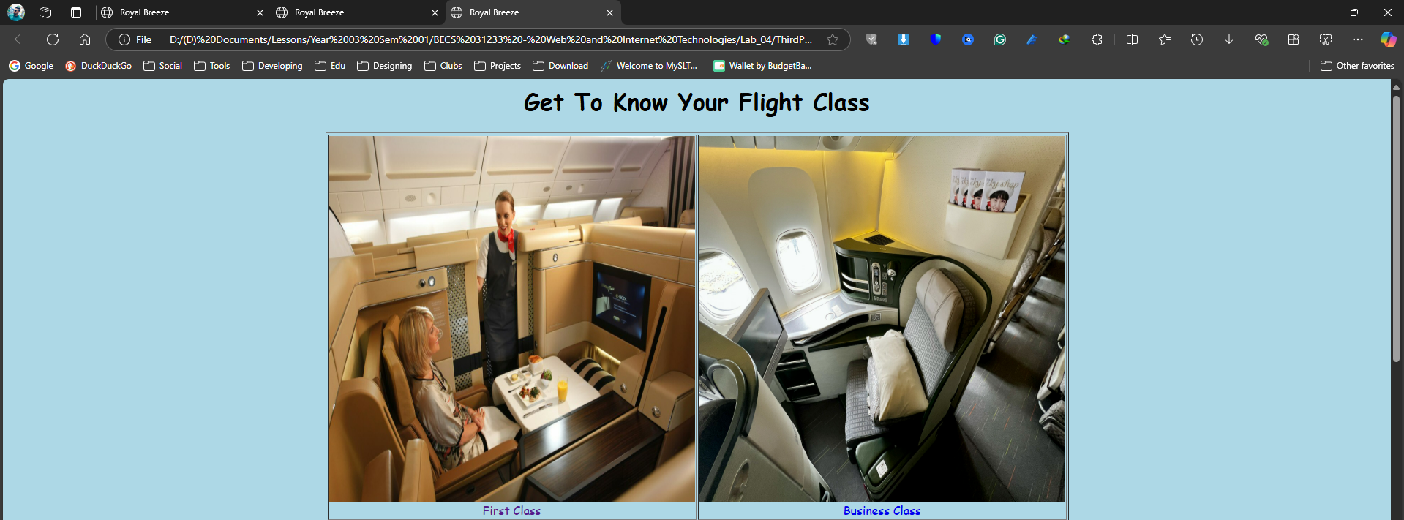

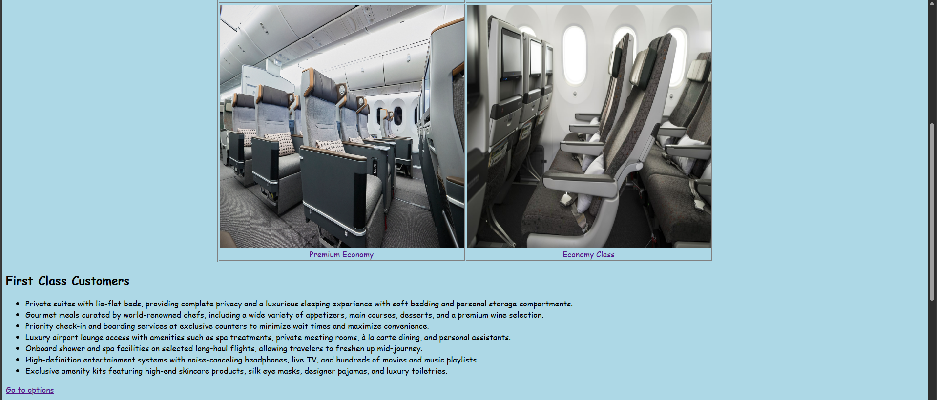

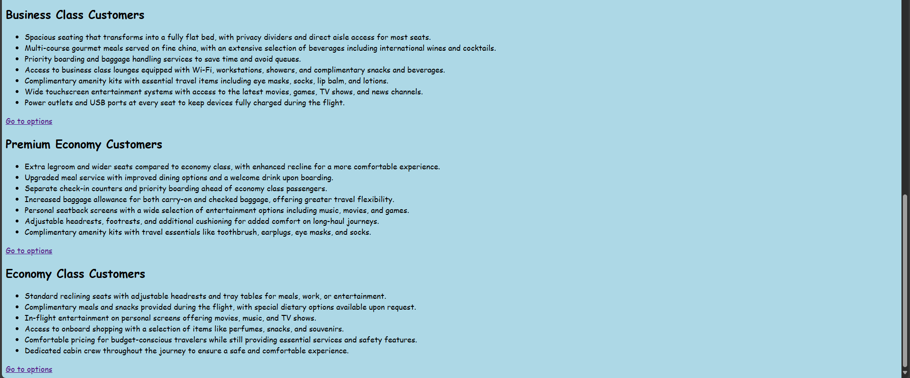

<html>

<head>

<title>Royal Breeze</title>

</head>

<body>

<body bgcolor="lightblue">

<font face="Comic Sans MS">

<center>

<h1 id="top">Get To Know Your Flight Class</h1>

</center>

<table border="1" align="center">

<tr >

<td><img src="firstclass.jpg" width="500px" height="500px"><br><center><a href="#first-class">First Class</a></center></td>

<td><img src="business.jpg" width="500px" height="500px"><br><center><a href="#business-class">Business Class</a></center></td>

</tr>

<tr >

<td><img src="premium economy.png" width="500px" height="500px"><br><center><a href="#premium-economy">Premium Economy</a></center></td>

<td><img src="economy.jpg" width="500px" height="500px"><br><center><a href="#economy-class">Economy Class</a></center></td>

</tr>

<table>

<h2 id="first-class">First Class Customers</h2>

<ul>

<li>Private suites with lie-flat beds, providing complete privacy and a luxurious sleeping experience with soft bedding and personal storage compartments.</li>

<li>Gourmet meals curated by world-renowned chefs, including a wide variety of appetizers, main courses, desserts, and a premium wine selection.</li>

<li>Priority check-in and boarding services at exclusive counters to minimize wait times and maximize convenience.</li>

<li>Luxury airport lounge access with amenities such as spa treatments, private meeting rooms, à la carte dining, and personal assistants.</li>

<li>Onboard shower and spa facilities on selected long-haul flights, allowing travelers to freshen up mid-journey.</li>

<li>High-definition entertainment systems with noise-canceling headphones, live TV, and hundreds of movies and music playlists.</li>

<li>Exclusive amenity kits featuring high-end skincare products, silk eye masks, designer pajamas, and luxury toiletries.</li>

</ul>

<a href="#top">Go to options</a>

<h2 id="business-class">Business Class Customers</h2>

<ul>

<li>Spacious seating that transforms into a fully flat bed, with privacy dividers and direct aisle access for most seats.</li>

<li>Multi-course gourmet meals served on fine china, with an extensive selection of beverages including international wines and cocktails.</li>

<li>Priority boarding and baggage handling services to save time and avoid queues.</li>

<li>Access to business class lounges equipped with Wi-Fi, workstations, showers, and complimentary snacks and beverages.</li>

<li>Complimentary amenity kits with essential travel items including eye masks, socks, lip balm, and lotions.</li>

<li>Wide touchscreen entertainment systems with access to the latest movies, games, TV shows, and news channels.</li>

<li>Power outlets and USB ports at every seat to keep devices fully charged during the flight.</li>

</ul>

<a href="#top">Go to options</a>

<h2 id="premium-economy">Premium Economy Customers</h2>

<ul>

<li>Extra legroom and wider seats compared to economy class, with enhanced recline for a more comfortable experience.</li>

<li>Upgraded meal service with improved dining options and a welcome drink upon boarding.</li>

<li>Separate check-in counters and priority boarding ahead of economy class passengers.</li>

<li>Increased baggage allowance for both carry-on and checked baggage, offering greater travel flexibility.</li>

<li>Personal seatback screens with a wide selection of entertainment options including music, movies, and games.</li>

<li>Adjustable headrests, footrests, and additional cushioning for added comfort on long-haul journeys.</li>

<li>Complimentary amenity kits with travel essentials like toothbrush, earplugs, eye masks, and socks.</li>

</ul>

<a href="#top">Go to options</a>

<h2 id="economy-class">Economy Class Customers</h2>

<ul>

<li>Standard reclining seats with adjustable headrests and tray tables for meals, work, or entertainment.</li>

<li>Complimentary meals and snacks provided during the flight, with special dietary options available upon request.</li>

<li>In-flight entertainment on personal screens offering movies, music, and TV shows.</li>

<li>Access to onboard shopping with a selection of items like perfumes, snacks, and souvenirs.</li>

<li>Comfortable pricing for budget-conscious travelers while still providing essential services and safety features.</li>

<li>Dedicated cabin crew throughout the journey to ensure a safe and comfortable experience.</li>

</ul>

<a href="#top">Go to options</a>

</body>

</html>