01.

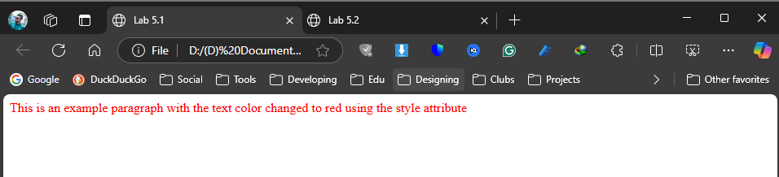

<html>

<head>

<title>Lab 5.1</title>

</head>

<body>

<p style="color: red;">This is an example paragraph with the text color changed to red using the style attribute </p>

</body>

</html>

02.

<html>

<head>

<title>Lab 5.2</title>

<style>

h1 {

color:blue;

text-align:center;

font-size:24px;

}

</style>

</head>

<body>

<h1>This is a Heading</h1>

</body>

</html>

03.

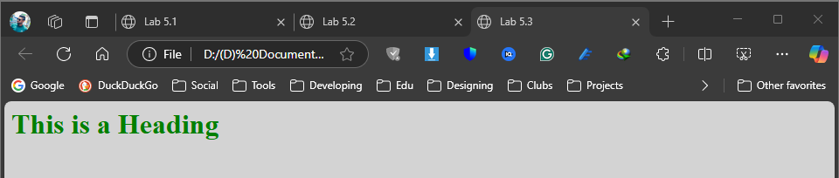

**Style.css**

Body {

background-color:lightgray;

}

h1 {

color:green;

}

**Lab_05_03.html**

html>

<head>

<title>Lab 5.3</title>

<link rel="stylesheet" type="text/css" href="style.css">

</head>

<body>

<h1>This is a Heading</h1>

</body>

</html>

04.

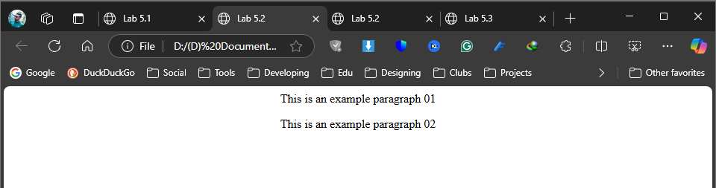

<html>

<head>

<title>Lab 5.4</title>

<style>

.center {

text-align:center;

}

</style>

</head>

<body>

<p class="center">This is an example paragraph 01</p>

<p class="center">This is an example paragraph 02</p>

</body>

</html>

05.

<html>

<head>

<title>Lab 5.5</title>

<style>

#special {

background-color:blue;

font-weight:bold;

}

</style>

</head>

<body>

<p id="special">This is an example paragraph</p>

</body>

</html>

06.

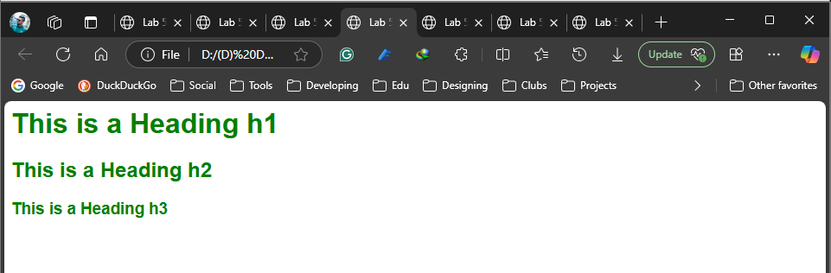

**Style_06.css**

h1,h2,h3 {

color:green;

font-family:Arial;

}

**Lab_05_006.html**

<html>

<head>

<title>Lab 5.6</title>

<link rel="stylesheet" type="text/css" href="Style_06.css">

</head>

<body>

<h1>This is a Heading h1</h1>

<h2>This is a Heading h2</h2>

<h3>This is a Heading h3</h3>

</body>

</html>

07.

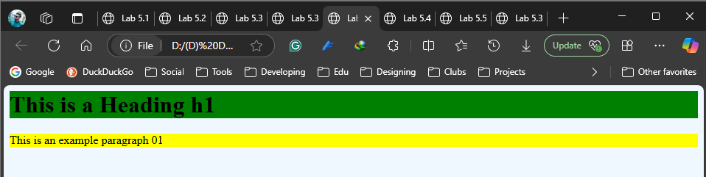

<html>

<head>

<title>Lab 5.7</title>

<style>

body {

background-color: #f0f8ff;

}

h1 {

background-color: green;

}

p {

background-color: yellow;

}

</style>

</head>

<body>

<h1>This is a Heading h1</h1>

<p>This is an example paragraph 01</p>

</body>

</html>

08.

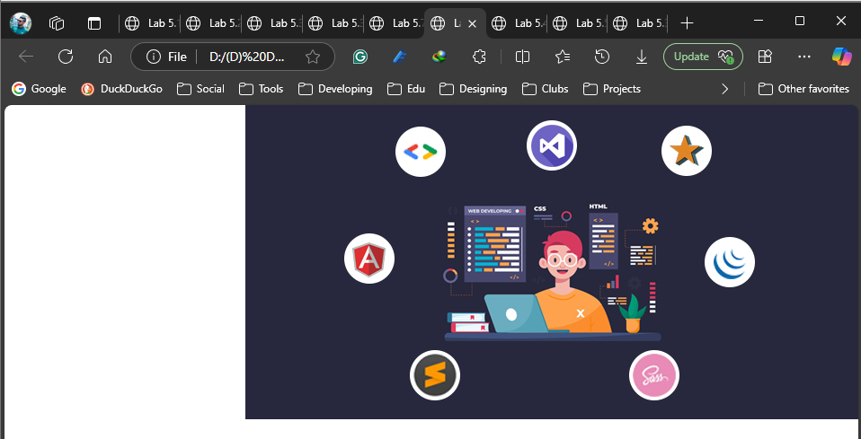

<html>

<head>

<title>Lab 5.7</title>

<style>

body {

background-image:url('image1.jpg');

background-repeat:no-repeat;

background-position:right top;

}

</style>

</head>

<body>

</body>

</html>

09.

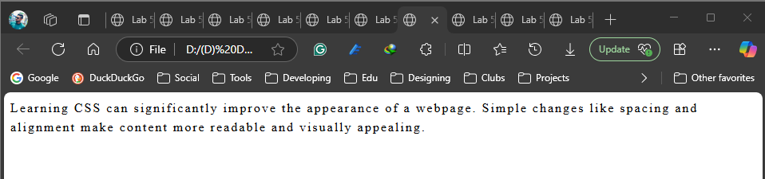

<html>

<head>

<title>Lab 5.9</title>

<style>

p {

line-height:1.5;

letter-spacing:2;

}

</style>

</head>

<body>

<p>Learning CSS can significantly improve the appearance of a webpage. Simple

changes like spacing and alignment make content more readable and visually

appealing. </p>

</body>

</html>

10.

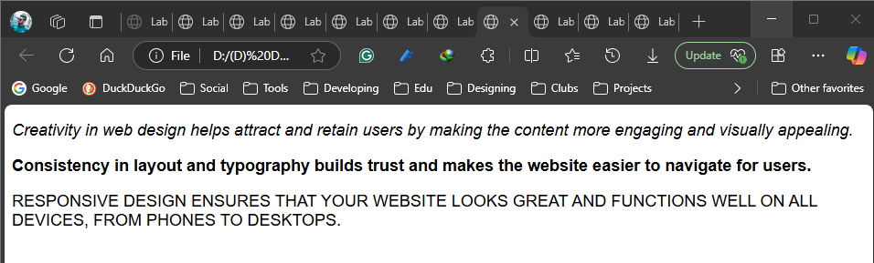

<html>

<head>

<title>Paragraph Styles</title>

<style>

.italic {

font-style: italic;

font-family: Arial, sans-serif;

font-size: 18px;

}

.bold {

font-weight: bold;

font-family: Arial, sans-serif;

font-size: 18px;

}

.uppercase {

text-transform: uppercase;

font-family: Arial, sans-serif;

font-size: 18px;

}

</style>

</head>

<body>

<p class="italic">

Creativity in web design helps attract and retain users by making the content more

engaging and visually appealing.

</p>

<p class="bold">

Consistency in layout and typography builds trust and makes the website easier to

navigate for users.

</p>

<p class="uppercase">

Responsive design ensures that your website looks great and functions well on all

devices, from phones to desktops.

</p>

</body>

</html>

11.

<html>

<head>

<title>Lab 5.11</title>

<style>

.para1 {

text-decoration:underline line-through;

}

.para2 {

text-shadow:2px 2px 3px red;

}

</style>

</head>

<body>

<p class="para1">This is the first paragraph with both an underline and a line-through decoration.</p>

<p class="para2">This is the second paragraph with a red text shadow.<p>

</body>

</html>

12.

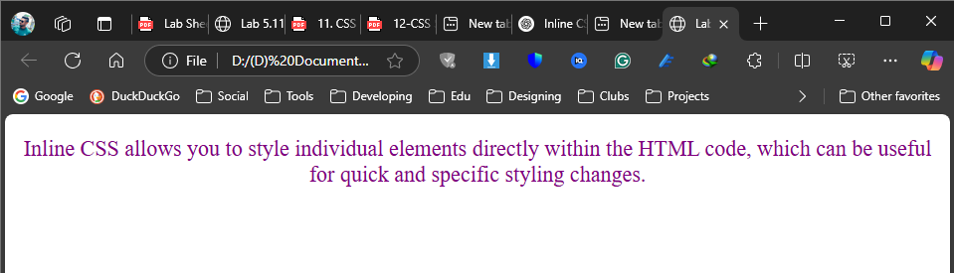

<html>

<head>

<title>Lab 5.12</title>

</head>

<body>

<p style="color: purple; font-size: 22px; text-align: center;">

Inline CSS allows you to style individual elements directly within the HTML

code, which can be useful for quick and specific styling changes.

</p>

</body>

</html>

13.

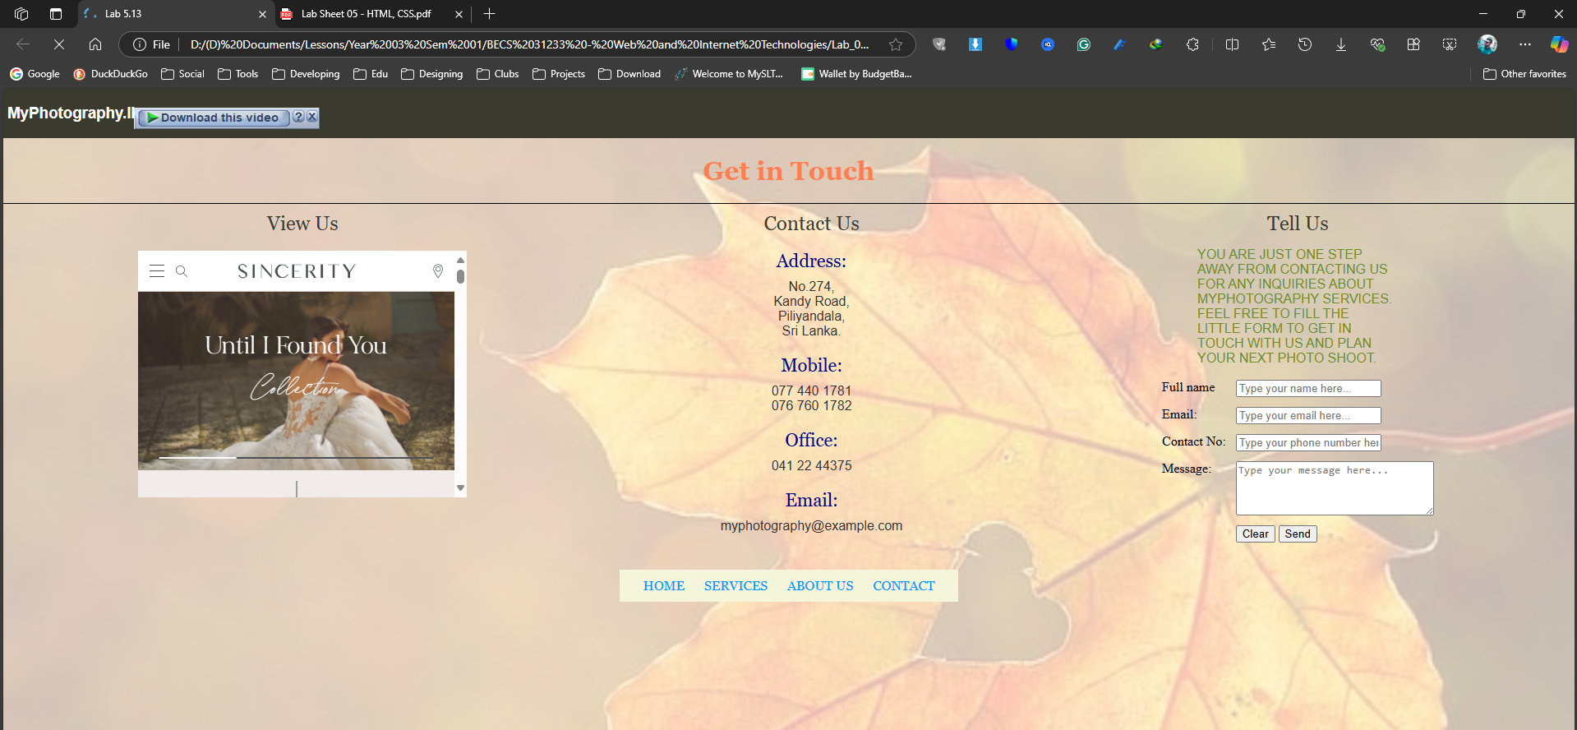

<html>

<head>

<title>Lab 5.13</title>

<style>

body {

margin:0;

background-image:url('image2.png');

background-size: cover;

background-repeat: no-repeat;

}

.top-bar {

background-color:#3b3a2f;

color:white;

font-family:Arial,sans-serif;

padding:0.5px 5px;

}

.main-heading {

font-family:Georgia,serif;

color:#ff7f50;

text-align:center;

border-bottom:1px solid black;

}

.container {

display:flex;

justify-content: space-around;;

margin:10px;

}

iframe {

width: 400px;

height: 300px;

border: none;

margin-top: 20px;

}

.contact-us {

text-align:center;

}

.section-title {

font-family:Georgia,serif;

font-size:24px;

color:#3b3a2f;

text-align:center;

}

.contact-label {

font-family:Georgia,serif;

font-size:22px;

color:darkblue;

margin-bottom: 10px;

margin-top: 20px;

}

.contact-info {

font-family:sans-serif;

font-size:16px;

color:#333333;

}

.form-text {

font-family: sans-serif;

font-size: 16px;

color: #6b8e23;

text-transform: uppercase;

margin-bottom: 10px;

width:240px;

align:center;

margin-left:50px

}

form table {

width: 100%;

}

form td {

padding: 5px;

vertical-align: top;

}

.footer {

background-color: beige;

text-align: center;

padding: 10px;

align:center;

margin-left:750px;

margin-right:750px;

}

.footer a {

font-family: Georgia, serif;

color: #0096FF;

margin: 0 10px;

text-decoration: none;

}

</style>

</head>

<body>

<div class="top-bar">

<h3>MyPhotography.lk</h3>

</div>

<div class="main-heading">

<h1>Get in Touch</h1>

</div>

<div class="container">

<div class="view-us">

<div class="section-title">View Us</div>

<iframe src="https://www.justinalexander.com/sincerity-bridal/" allowfullscreen></iframe>

</div>

<div class="contact-us">

<div class="section-title">Contact Us</div>

<div class="contact-label">Address:</div>

<div class="contact-info">No.274,<br> Kandy Road,<br> Piliyandala,<br> Sri Lanka.</div>

<div class="contact-label">Mobile:</div>

<div class="contact-info">077 440 1781<br>076 760 1782</div>

<div class="contact-label">Office:</div>

<div class="contact-info">041 22 44375</div>

<div class="contact-label">Email:</div>

<div class="contact-info">myphotography@example.com</div>

</div>

<div class="tell-us">

<div class="section-title">Tell Us</div>

<p class="form-text">

YOU ARE JUST ONE STEP AWAY FROM CONTACTING US FOR ANY INQUIRIES ABOUT MYPHOTOGRAPHY SERVICES. FEEL FREE TO FILL THE LITTLE FORM TO GET IN TOUCH WITH US AND PLAN YOUR NEXT PHOTO SHOOT.

</p>

<form>

<table>

<tr>

<td><p class="tell-label">Full name<p></td>

<td><input type="text" id="name" placeholder="Type your name here..."></td>

</tr>

<tr>

<td><p class="tell-label">Email:<p></td>

<td><input type="text" id="email" placeholder="Type your email here..."></td>

</tr>

<tr>

<td><p class="tell-label">Contact No:<p></td>

<td><input type="text" id="contact" placeholder="Type your phone number here..."></td>

</tr>

<tr>

<td><p class="tell-label">Message:<p></td>

<td><textarea id="message" rows="4" cols="30" placeholder="Type your message here..."></textarea></td>

</tr>

<tr>

<td></td>

<td>

<input type="reset" value="Clear">

<input type="submit" value="Send">

</td>

</tr>

</table>

</form>

</div>

</div>

<div class="footer">

<a href="#">HOME</a>

<a href="#">SERVICES</a>

<a href="#">ABOUT US</a>

<a href="#">CONTACT</a>

</div>

</body>

</html>