**Home.html**

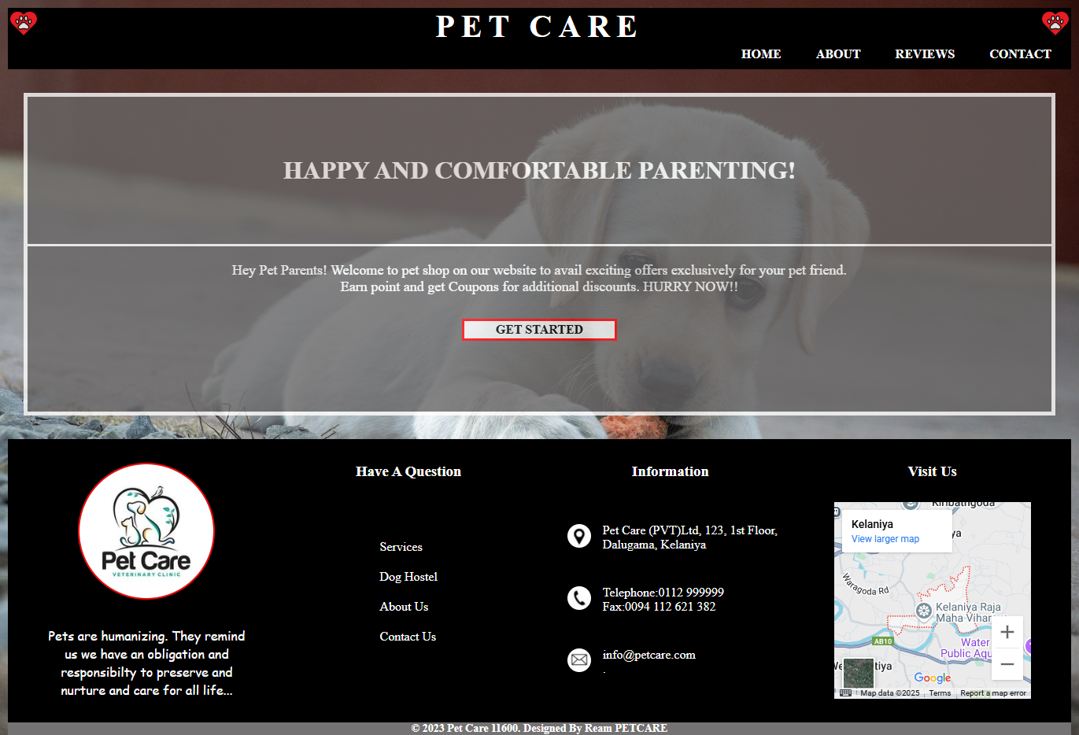

<!DOCTYPE html>

<html>

<head>

    <meta charset="UTF-8" />

    <title>Home</title>

    <link rel="stylesheet" href="styles.css" />

    <style>

        body{

            background-image: url('image04.jpg');

            background-repeat: no-repeat;

            background-size: cover;

            margin:0;

            padding:0;

        }

    </style>

</head>

<body>

    <div class = "title-bar">

        <div class="logo">

            <img src="image05.jpg" alt="Logo" width="40px" />

        </div>

        <div class="title">

            <h1>PET CARE</h1>

        </div>

        <div class="logo">

            <img src="image05.jpg" alt="Logo" width="40px" />

        </div>

    </div>

    <nav class="navbar">

        <ul>

            <li><a href="Home.html">HOME</a></li>

            <li><a href="About.html">ABOUT</a></li>

            <li><a href="Reviews.html">REVIEWS</a></li>

            <li><a href="Contact.html">CONTACT</a></li>

        </ul>

    </nav>

    <div class="home-content">

        <div class="home-welcome">

            <h1>HAPPY AND COMFORTABLE PARENTING!</h1>

        </div>

        <div class="home-description">

           <p>Hey Pet Parents! Welcome to pet shop on our website to avail exciting offers exclusively for your pet friend. Earn point and get Coupons for additional discounts. HURRY NOW!!</p>

           <button class="get-started" onclick="location.href='About.html'">GET STARTED</button>

        </div>

    </div>

    <footer>

    <div class="top-footer">

        <div id="pet-care" class="section">

            <img class="petcare-img" src="image06.jpg" width="170px">

            <p>Pets are humanizing. They remind us we have an obligation and responsibilty to preserve and nurture and care for all life... </p>

        </div>

        <div id="HAQ" class="section">

            <h3>Have A Question</h3>

            <div class="footer-navbar">

                <ul>

                    <li><a href="#">Services</a></li>

                    <li><a href="#">Dog Hostel</a></li>

                    <li><a href="#">About Us</a></li>

                    <li><a href="#">Contact Us</a></li>

                </ul>

            </div>

        </div>

        <div id="info" class="section">

            <h3>Information</h3>

            <div class="info-list">

                <div class="info-item">

                    <div class="info-icon">

                        <img src="location.jpg" alt="location" width="30px">

                    </div>

                    <div class="info-text">

                        <p>Pet Care (PVT)Ltd, 123, 1st Floor,</p>

                        <p>Dalugama, Kelaniya</p>

                    </div>

                </div>

                <div class="info-item">

                    <div class="info-icon">

                        <img src="call.jpg" alt="phone" width="30px">

                    </div>

                    <div class="info-text">

                        <p>Telephone:0112 999999</p>

                        <p>Fax:0094 112 621 382</p>

                    </div>

                </div>

                <div class="info-item">

                    <div class="info-icon">

                        <img src="mail.jpg" alt="email" width="30px">

                    </div>

                    <div class="info-text">

                        <p>info@petcare.com</p>

                        <p> .</p>

                    </div>

                </div>

            </div>

        </div>

        <div id="visit-us" class="section">

            <h3>Visit Us</h3>

            <iframe src="https://www.google.com/maps/embed?pb=!1m14!1m8!1m3!1d15732.143920620876!2d79.90906563559693!3d6.962924621777432!3m2!1i1024!2i768!4f13.1!3m3!1m2!1s0x3ae25789f736ff2f%3A0x7b61e230dd11e6ec!2sKelaniya%2C%20Peliyagoda!5e0!3m2!1sen!2slk!4v1748521603876!5m2!1sen!2slk" width="250" height="250" style="border:0;" allowfullscreen="" loading="lazy" referrerpolicy="no-referrer-when-downgrade"></iframe>

        </div>

    </div>

    <div class="bottom-footer">

        <p>&copy; 2023 Pet Care 11600. Designed By Ream PETCARE</p>

    </div>

    </footer>

</body>

</html>

**About.html**

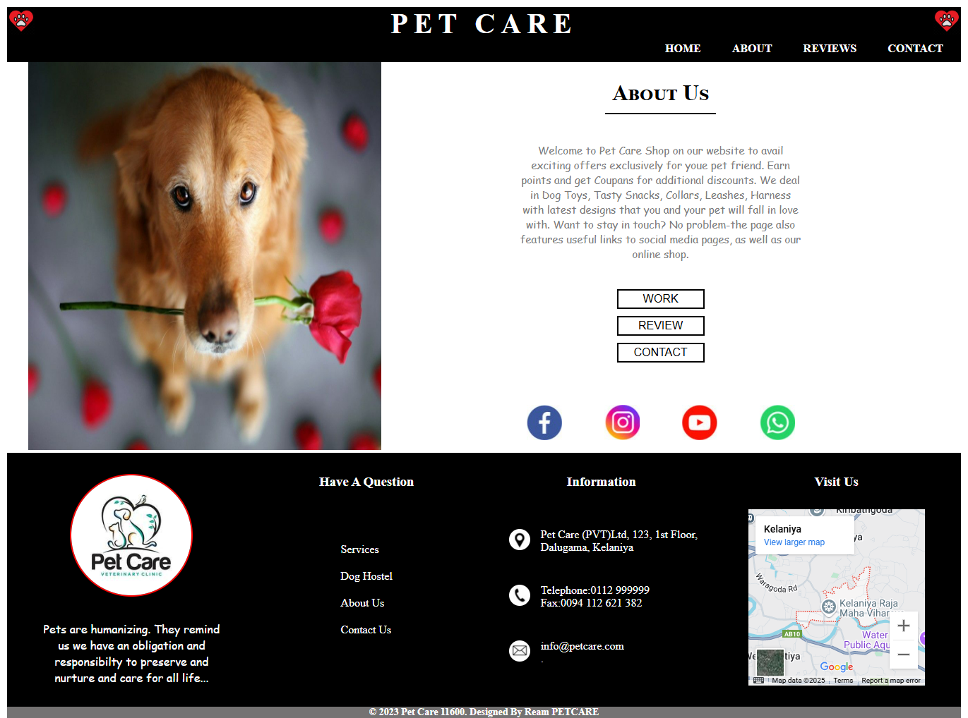

<!DOCTYPE html>

<html>

<head>

    <meta charset="UTF-8" />

    <title>About</title>

    <link rel="stylesheet" href="styles.css" />

    <style>

    </style>

</head>

<body>

    <div class = "title-bar">

        <div class="logo">

            <img src="image05.jpg" alt="Logo" width="40px" />

        </div>

        <div class="title">

            <h1>PET CARE</h1>

        </div>

        <div class="logo">

            <img src="image05.jpg" alt="Logo" width="40px" />

        </div>

    </div>

    <nav class="navbar">

        <ul>

            <li><a href="Home.html">HOME</a></li>

            <li><a href="About.html">ABOUT</a></li>

            <li><a href="Reviews.html">REVIEWS</a></li>

            <li><a href="Contact.html">CONTACT</a></li>

        </ul>

    </nav>

    <div class="about-content">

        <div class="about-img">

            <img src="image01.jpg" alt="About Us" width="500px" height="550px">

        </div>

        <div class="about-description">

            <div class="about-title">

                <h1>About Us</h1>

            </div>

            <div class="about-details">

                <p>Welcome to Pet Care Shop on our website to avail exciting offers exclusively for youe pet friend. Earn points and get Coupans for additional discounts. We deal in Dog Toys, Tasty Snacks, Collars, Leashes, Harness with latest designs that you and your pet will fall in love with. Want to stay in touch? No problem-the page also features useful links to social media pages, as well as our online shop.</p>

            </div>

            <div class="button-container">

                <a href="Home.html" class="nav-button">WORK</a>

                <a href="Reviews.html" class="nav-button">REVIEW</a>

                <a href="Contact.html" class="nav-button">CONTACT</a>

            </div>

            <div class="social-icons">

                <a href="https://www.facebook.com" target="_blank"><img src="facebook.jpg" alt="Facebook" width="50px"></a>

                <a href="https://www.instagram.com" target="_blank"><img src="instergram.jpg" alt="Instagram" width="50px"></a>

                <a href="https://www.twitter.com" target="_blank"><img src="youtube.jpg" alt="Twitter" width="50px"></a>

                <a href="https://www.twitter.com" target="_blank"><img src="whatsapp.jpg" alt="Twitter" width="50px"></a>

            </div>

        </div>

    </div>

    <footer>

    <div class="top-footer">

        <div id="pet-care" class="section">

            <img class="petcare-img" src="image06.jpg" width="170px">

            <p>Pets are humanizing. They remind us we have an obligation and responsibilty to preserve and nurture and care for all life... </p>

        </div>

        <div id="HAQ" class="section">

            <h3>Have A Question</h3>

            <div class="footer-navbar">

                <ul>

                    <li><a href="#">Services</a></li>

                    <li><a href="#">Dog Hostel</a></li>

                    <li><a href="#">About Us</a></li>

                    <li><a href="#">Contact Us</a></li>

                </ul>

            </div>

        </div>

        <div id="info" class="section">

            <h3>Information</h3>

            <div class="info-list">

                <div class="info-item">

                    <div class="info-icon">

                        <img src="location.jpg" alt="location" width="30px">

                    </div>

                    <div class="info-text">

                        <p>Pet Care (PVT)Ltd, 123, 1st Floor,</p>

                        <p>Dalugama, Kelaniya</p>

                    </div>

                </div>

                <div class="info-item">

                    <div class="info-icon">

                        <img src="call.jpg" alt="phone" width="30px">

                    </div>

                    <div class="info-text">

                        <p>Telephone:0112 999999</p>

                        <p>Fax:0094 112 621 382</p>

                    </div>

                </div>

                <div class="info-item">

                    <div class="info-icon">

                        <img src="mail.jpg" alt="email" width="30px">

                    </div>

                    <div class="info-text">

                        <p>info@petcare.com</p>

                        <p> .</p>

                    </div>

                </div>

            </div>

        </div>

        <div id="visit-us" class="section">

            <h3>Visit Us</h3>

            <iframe src="https://www.google.com/maps/embed?pb=!1m14!1m8!1m3!1d15732.143920620876!2d79.90906563559693!3d6.962924621777432!3m2!1i1024!2i768!4f13.1!3m3!1m2!1s0x3ae25789f736ff2f%3A0x7b61e230dd11e6ec!2sKelaniya%2C%20Peliyagoda!5e0!3m2!1sen!2slk!4v1748521603876!5m2!1sen!2slk" width="250" height="250" style="border:0;" allowfullscreen="" loading="lazy" referrerpolicy="no-referrer-when-downgrade"></iframe>

        </div>

    </div>

    <div class="bottom-footer">

        <p>&copy; 2023 Pet Care 11600. Designed By Ream PETCARE</p>

    </div>

    </footer>

</body>

</html>

**Reviews.html**

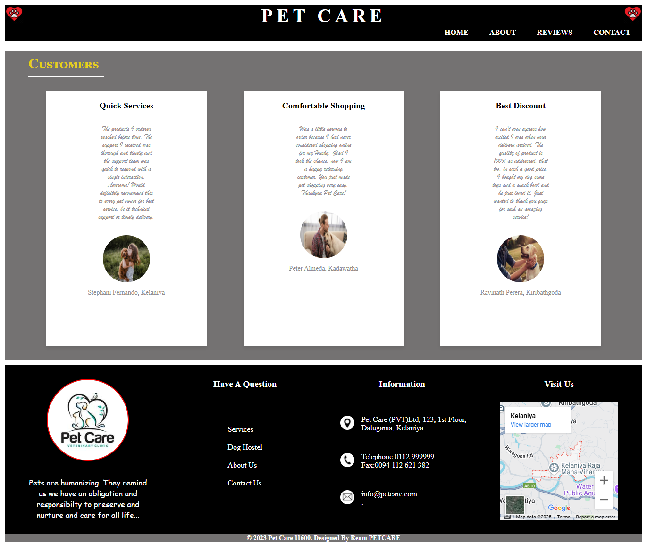

<!DOCTYPE html>

<html>

<head>

    <meta charset="UTF-8" />

    <title>Reviews</title>

    <link rel="stylesheet" href="styles.css" />

    <style>

    </style>

</head>

<body>

    <div class = "title-bar">

        <div class="logo">

            <img src="image05.jpg" alt="Logo" width="40px" />

        </div>

        <div class="title">

            <h1>PET CARE</h1>

        </div>

        <div class="logo">

            <img src="image05.jpg" alt="Logo" width="40px" />

        </div>

    </div>

    <nav class="navbar">

        <ul>

            <li><a href="Home.html">HOME</a></li>

            <li><a href="About.html">ABOUT</a></li>

            <li><a href="Reviews.html">REVIEWS</a></li>

            <li><a href="Contact.html">CONTACT</a></li>

        </ul>

    </nav>

    <div class="review-content">

        <div class="review-header">

            <h2>Customers</h2>

        </div>

        <div class ="review-list">

            <div class="review-item">

                <h3>Quick Services</h3>

                <p class="review-text">The products I ordered reached before time. The support I received was

                thorough and timely and the support team was quick to respond with a single

                interaction. Awesome! Would definitely recommend this to every pet owner

                for best service, be it technical support or timely delivery.</p>

                <img src="image12.jpg" alt="John's Dog" width="100px" height="100px">

                <p>Stephani Fernando, Kelaniya</p>

            </div>

            <div class="review-item">

                <h3>Comfortable Shopping</h3>

                <p class="review-text" >Was a little nervous to order because I had never considered shopping online

                for my Husky. Glad I took the chance, now I am a happy returning customer.

                You just made pet shopping very easy. Thankyou Pet Care! </p>

                <img src="image13.jpg" alt="Jane's Cat" width="100px" height="100px">

                <p>Peter Almeda, Kadawatha</p>

            </div>

            <div class="review-item">

                <h3>Best Discount</h3>

                <p class="review-text">I can't even express how excited I was when your delivery arrived. The quality

                of product is 100% as addressed, that too, in such a good price. I bought my

                dog some toys and a snack bowl and he just loved it. Just wanted to thank you

                guys for such an amazing service!</p>

                <img src="image14.jpg" alt="Emily's Dog" width="100px" height="100px">

                <p>Ravinath Perera, Kiribathgoda</p>

            </div>

        </div>

    </div>

    <footer>

    <div class="top-footer">

        <div id="pet-care" class="section">

            <img class="petcare-img" src="image06.jpg" width="170px">

            <p>Pets are humanizing. They remind us we have an obligation and responsibilty to preserve and nurture and care for all life... </p>

        </div>

        <div id="HAQ" class="section">

            <h3>Have A Question</h3>

            <div class="footer-navbar">

                <ul>

                    <li><a href="#">Services</a></li>

                    <li><a href="#">Dog Hostel</a></li>

                    <li><a href="#">About Us</a></li>

                    <li><a href="#">Contact Us</a></li>

                </ul>

            </div>

        </div>

        <div id="info" class="section">

            <h3>Information</h3>

            <div class="info-list">

                <div class="info-item">

                    <div class="info-icon">

                        <img src="location.jpg" alt="location" width="30px">

                    </div>

                    <div class="info-text">

                        <p>Pet Care (PVT)Ltd, 123, 1st Floor,</p>

                        <p>Dalugama, Kelaniya</p>

                    </div>

                </div>

                <div class="info-item">

                    <div class="info-icon">

                        <img src="call.jpg" alt="phone" width="30px">

                    </div>

                    <div class="info-text">

                        <p>Telephone:0112 999999</p>

                        <p>Fax:0094 112 621 382</p>

                    </div>

                </div>

                <div class="info-item">

                    <div class="info-icon">

                        <img src="mail.jpg" alt="email" width="30px">

                    </div>

                    <div class="info-text">

                        <p>info@petcare.com</p>

                        <p> .</p>

                    </div>

                </div>

            </div>

        </div>

        <div id="visit-us" class="section">

            <h3>Visit Us</h3>

            <iframe src="https://www.google.com/maps/embed?pb=!1m14!1m8!1m3!1d15732.143920620876!2d79.90906563559693!3d6.962924621777432!3m2!1i1024!2i768!4f13.1!3m3!1m2!1s0x3ae25789f736ff2f%3A0x7b61e230dd11e6ec!2sKelaniya%2C%20Peliyagoda!5e0!3m2!1sen!2slk!4v1748521603876!5m2!1sen!2slk" width="250" height="250" style="border:0;" allowfullscreen="" loading="lazy" referrerpolicy="no-referrer-when-downgrade"></iframe>

        </div>

    </div>

    <div class="bottom-footer">

        <p>&copy; 2023 Pet Care 11600. Designed By Ream PETCARE</p>

    </div>

    </footer>

</body>

</html>

**Contact.html**

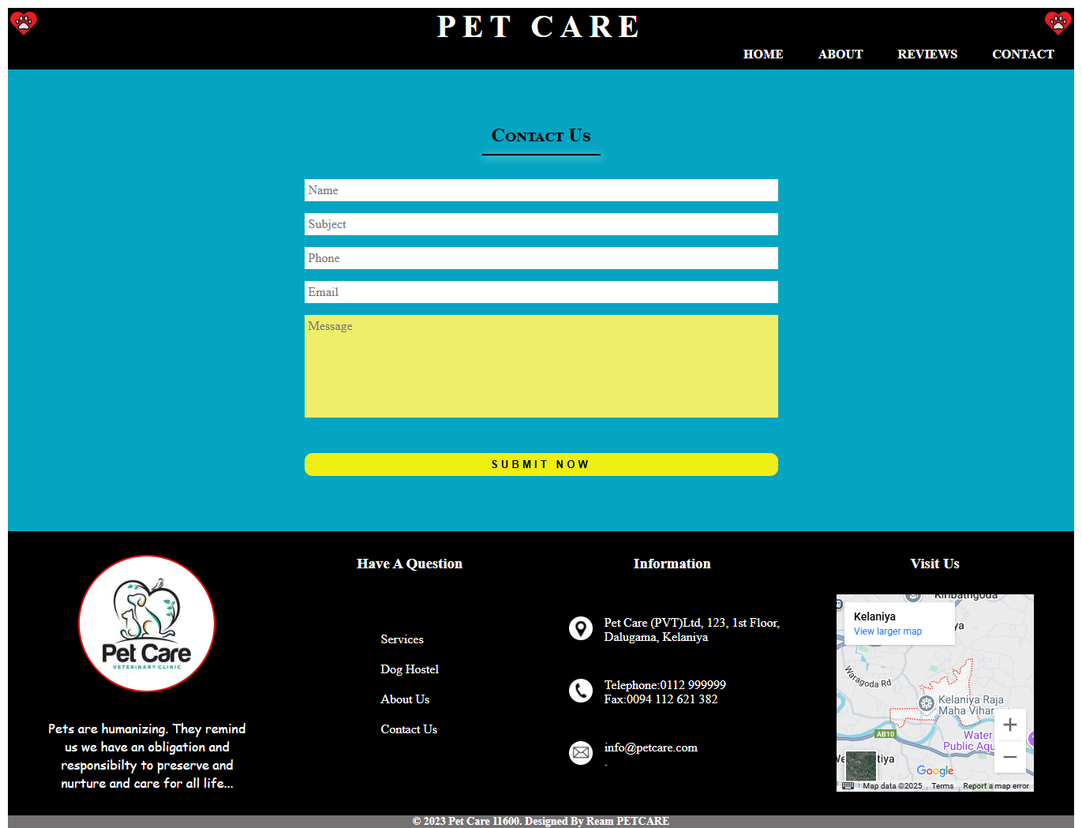

<!DOCTYPE html>

<html>

<head>

    <meta charset="UTF-8" />

    <title>Contact</title>

    <link rel="stylesheet" href="styles.css" />

    <style>

    </style>

</head>

<body>

    <div class = "title-bar">

        <div class="logo">

            <img src="image05.jpg" alt="Logo" width="40px" />

        </div>

        <div class="title">

            <h1>PET CARE</h1>

        </div>

        <div class="logo">

            <img src="image05.jpg" alt="Logo" width="40px" />

        </div>

    </div>

    <nav class="navbar">

        <ul>

            <li><a href="Home.html">HOME</a></li>

            <li><a href="About.html">ABOUT</a></li>

            <li><a href="Reviews.html">REVIEWS</a></li>

            <li><a href="Contact.html">CONTACT</a></li>

        </ul>

    </nav>

 <div class="contact-details">

        <div class="contact-container">

            <h2>Contact Us</h2>

    <div class="underline"></div>

        <form>

            <input type="text" placeholder="Name" required>

            <input type="text" placeholder="Subject" required>

            <input type="tel" placeholder="Phone" required>

            <input type="email" placeholder="Email" required>

            <textarea placeholder="Message" required></textarea>

            <button type="submit">SUBMIT NOW</button>

        </form>

    </div>

  </div>

    <footer>

    <div class="top-footer">

        <div id="pet-care" class="section">

            <img class="petcare-img" src="image06.jpg" width="170px">

            <p>Pets are humanizing. They remind us we have an obligation and responsibilty to preserve and nurture and care for all life... </p>

        </div>

        <div id="HAQ" class="section">

            <h3>Have A Question</h3>

            <div class="footer-navbar">

                <ul>

                    <li><a href="#">Services</a></li>

                    <li><a href="#">Dog Hostel</a></li>

                    <li><a href="#">About Us</a></li>

                    <li><a href="#">Contact Us</a></li>

                </ul>

            </div>

        </div>

        <div id="info" class="section">

            <h3>Information</h3>

            <div class="info-list">

                <div class="info-item">

                    <div class="info-icon">

                        <img src="location.jpg" alt="location" width="30px">

                    </div>

                    <div class="info-text">

                        <p>Pet Care (PVT)Ltd, 123, 1st Floor,</p>

                        <p>Dalugama, Kelaniya</p>

                    </div>

                </div>

                <div class="info-item">

                    <div class="info-icon">

                        <img src="call.jpg" alt="phone" width="30px">

                    </div>

                    <div class="info-text">

                        <p>Telephone:0112 999999</p>

                        <p>Fax:0094 112 621 382</p>

                    </div>

                </div>

                <div class="info-item">

                    <div class="info-icon">

                        <img src="mail.jpg" alt="email" width="30px">

                    </div>

                    <div class="info-text">

                        <p>info@petcare.com</p>

                        <p> .</p>

                    </div>

                </div>

            </div>

        </div>

        <div id="visit-us" class="section">

            <h3>Visit Us</h3>

            <iframe src="https://www.google.com/maps/embed?pb=!1m14!1m8!1m3!1d15732.143920620876!2d79.90906563559693!3d6.962924621777432!3m2!1i1024!2i768!4f13.1!3m3!1m2!1s0x3ae25789f736ff2f%3A0x7b61e230dd11e6ec!2sKelaniya%2C%20Peliyagoda!5e0!3m2!1sen!2slk!4v1748521603876!5m2!1sen!2slk" width="250" height="250" style="border:0;" allowfullscreen="" loading="lazy" referrerpolicy="no-referrer-when-downgrade"></iframe>

        </div>

    </div>

    <div class="bottom-footer">

        <p>&copy; 2023 Pet Care 11600. Designed By Ream PETCARE</p>

    </div>

    </footer>

</body>

</html>

**styles.css**

*{

    font-family: 'Times New Roman', serif;

    margin:0;

    padding:0;

}

.title h1{

    color: white;

    text-align: center;

    margin-top: 0;

    letter-spacing: 8px;

    font-size: 40px;

}

.title-bar{

    background-color: black;

    display: flex;

    justify-content: space-between;

    margin: 10px 10px 0px 10px;

    height: 40px;

}

.title{

    margin-bottom: 20px;

}

nav{

    background-color: black;

    display: flex;

    justify-content: end;

    padding: 10px;

    margin: 0px 10px;

}

nav ul{

    list-style: none;

    margin: 0;

    padding: 0;

}

nav li{

    display: inline;

    margin-right: 10px;

    margin-left: 20px;

}

nav a{

    color: white;

    text-decoration: none;

    font-weight: 600;

    padding: 5px;

}

nav a:hover{

    background-color: red;

}

footer{

    width: 100%;

}

.top-footer{

    background-color: black;

    color: white;

    padding: 10px;

    margin: 0px 10px 0px 10px;

    display:flex;

    justify-content:space-between;

    height:340px;

}

.petcare-img{

    border-radius:50%;

    border: 2px solid red;

    display: block;

    margin-left:auto;

    margin-right:auto;

    margin-top:0px;

}

.section{

    display:flex;

    flex-direction: column;

    justify-content: space-between;

    width:300px;

    padding:20px;

    align-items: center;

}

#pet-care p{

    text-align: center;

    font-family: 'Comic Sans MS', cursive, sans-serif;

    font-size: 16px;

    font-weight: 300;

    width: 250px;

    display: block;

    margin-left:auto;

    margin-right:auto;

}

.info-item{

    display: flex;

    justify-content: start;

    padding: 10px;

    align-items: center;

    margin-bottom: 15px;

}

.info-icon img{

    border-radius: 50%;

    padding: 5px;

}

.info-text{

    margin-left: 10px;

}

.footer-navbar{

    display: flex;

    justify-content: space-between;

    margin: 0px 10px 0px 10px;

    margin-bottom: 50px;

}

.footer-navbar ul{

    list-style: none;

    margin: 0;

    padding: 0;

}

.footer-navbar a{

    color: white;

    text-decoration: none;

    font-weight: 300;

}

.footer-navbar li{

    margin-top: 10px;

    margin-bottom: 20px;

}

.bottom-footer{

    background-color: #747272;

    color: white;

    font-size: 14px;

    font-weight: 600;

    text-align: center;

    margin: 0px 10px 0px 10px;

}

.home-content{

    display: flex;

    flex-direction: column;

    justify-content: center;

    align-items: center;

    height: 400px;

    background-color: #696666;

    color: white;

    margin: 30px;

    border: 5px solid rgb(255, 255, 255);

    opacity: 0.8;

}

.home-welcome{

    display: block;

    margin: auto;

}

.home-description{

    text-align: center;

    width: 100%;

    border-top: 3px solid white;

    margin-bottom: 90px;

}

.home-description button{

    border: 3px solid red;

    padding: 2px 40px;

    font-size: medium;

    font-weight: 600;

}

home-description a{

    text-decoration: none;

    color: black;

}

.home-description p{

    display: block;

    margin: 0px auto 10px auto;

    padding: 20px;

    font-weight: 400;

    font-size: 18px;

    max-width: 800px;

    text-align: center;

}

.about-content{

    display: flex;

    justify-content: space-between;

    align-items: center;

    margin: 0px 40px 0px 40px;

}

.about-description{

    display: flex;

    flex-direction: column;

    justify-content: space-between;

    align-items: center;

    width: 1500px;

}

.about-description p{

    font-size: 15px;

    font-family: 'Comic Sans MS', cursive, sans-serif;

    text-align: center;

    margin: 20px auto;

    max-width: 800px;

    color: rgb(124, 124, 124);

}

.about-title{

    display: block;

    margin-left: auto;

    margin-right: auto;

    text-align: center;

    border-bottom: 2px solid black;

    max-width: 220px;

    font-variant: small-caps;

    padding: 10px;

}

.about-details{

    display: block;

    margin: 20px auto;

    text-align: center;

    max-width: 400px;

}

.button-container {

  display: flex;

  flex-direction: column;

  gap: 10px;

  margin-bottom: 20px;

}

.nav-button {

  display: inline-block;

  width: 120px;

  text-align: center;

  padding: 3px 0;

  border: 2px solid black;

  text-decoration: none;

  color: black;

  font-family: Arial, sans-serif;

  font-weight: 200;

}

.nav-button:hover {

  border: 2px solid green;

}

.social-icons {

  display: flex;

  justify-content: center;

  gap: 60px;

  margin-top: 40px;

}

.review-content {

   background-color: #747272;

    margin: 10px;

}

.review-header {

    text-align: left;

    color: rgb(230, 209, 22);

    font-size: 20px;

    margin-top: 20px;

    margin-left: 50px;

    border-bottom: 2px solid white;

    max-width: 150px;

    padding: 10px 10px 10px 0px;

    font-variant: small-caps;

}

.review-list{

    display: flex;

    justify-content: space-evenly;

    align-items: center;

    padding: 20px;

}

.review-item{

    background-color: white;

    padding: 20px;

    margin: 10px;

    width: 300px;

    height: 500px;

    box-shadow: 0 4px 8px rgba(0,0,0,0.1);

    text-align: center;

}

.review-item img{

    border-radius: 50%;

    margin-bottom: 10px;

}

.review-item p{

    font-size: 14px;

    color: #918e8e;

}

.review-item h3{

    font-size: 18px;

    margin-bottom: 10px;

}

.review-text{

    font-size: 16px;

    display: block;

    margin: 30px auto;

    color: #666565;

    max-width: 120px;

    font-family: 'Brush Script MT', cursive;

    font-weight: 500;

    text-align: center;

}

.contact-container {

  width: 60%;

  max-width: 600px;

  margin: 50px auto;

  text-align: center;

  color: black;

}

.contact-details {

  background-color: rgb(4, 165, 194);

    padding: 20px;

    margin: 0 10px;

}

.contact-container h2 {

  font-weight: bold;

  margin-bottom: 5px;

  font-variant: small-caps;

}

.underline {

  width: 150px;

  height: 2px;

  background-color: black;

  margin: 10px auto 30px;

  box-shadow: white 2px 2px 10px;

}

form {

  display: flex;

  flex-direction: column;

  gap: 15px;

}

input, textarea {

  padding: 5px;

  border: none;

  outline: none;

  font-size: 16px;

}

input {

  background-color: white;

}

textarea {

  background-color: #eeee6b;

  height: 120px;

  resize: none;

}

.contact-details button {

  background-color: #eeee11;

  color: black;

  font-weight: bold;

  letter-spacing: 4px;

  padding: 7px;

  border: none;

  cursor: pointer;

  border-radius: 10px;

  font-family: Arial, Helvetica, sans-serif;

  margin-top: 30px;

}

button:hover {

  background-color: #e0d822;

}