01.

<html>

<head>

<title>My first Javasript Code!!</title>

</head>

<body>

<script type="text/javaScript">

document.write("Hello World!");

</script>

</body>

</html>

02.

<html>

<head>

<title>My first Javasript Practical </title>

</head>

<body>

<script type="text/javaScript">

document.write("Welcome to the First JavaScript Practical Session!!!");

</script>

</body>

</html>

03.

<html>

<head>

<title>My first Javasript Practical</title>

</head>

<body>

<script type="text/javaScript">

document.write("EC/2021/006 W.K.G.K JAYAWARDANA BECS31233");

</script>

</body>

</html>

04.

<html>

<head> <title>My first Javasript Practical!!</title> </head>

<body>

<script type="text/javaScript">

document.write("EC/2021/006 <br>W.K.G.K JAYAWARDANA <br>BECS31233");

</script>

</body>

</html>

05.

function message(){

alert("Warning!!");

}

<html>

<head>

<title>JavaScript Code!!</title>

<script type="text/javaScript" src="firstjs.js"></script>

</head>

<body onload="message()">

</body>

</html>

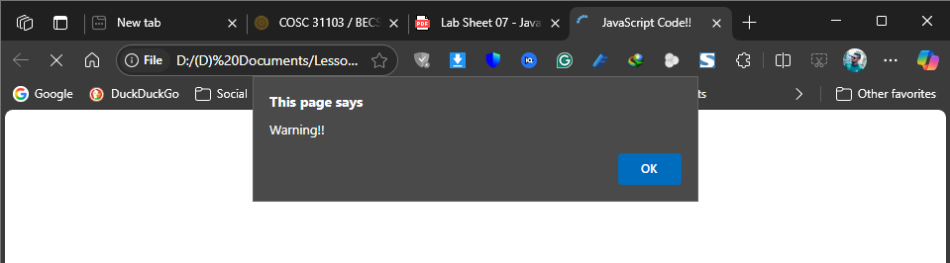

06.

<html>

<head>

<title>My first Javasript Code!!</title>

<script type="text/javaScript">

function message(){

alert("Warning!!");

}

</script>

</head>

<body onload="message()">

</body>

</html>

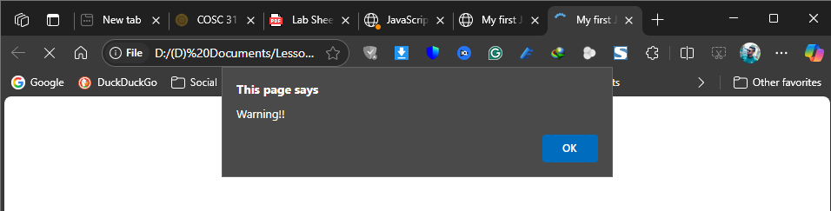

07.

<html>

<head>

<title>My first Javasript Code!!</title>

</head>

<body>

<script type="text/javaScript">

//This is a single line comment

document.write("Welcome to the first JavaScript Practical Session");

/*This is a

multi-line

comment*/

</script>

</body>

</html>

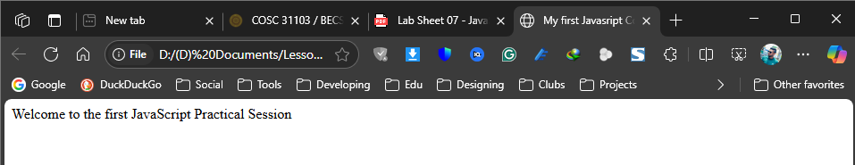

08.

<html>

<head>

<title>My first Javasript Code!!</title>

</head>

<body>

<script type="text/javaScript">

var author;

var bookname;

var country;

author="Leo";

document.write(author);

author="Tolstoy";

document.write(author);

document.write("<br/>");

bookname="Anna Karenina";

document.write(bookname);

document.write("<br/>");

country="Russia";

document.write(country);

document.write("<br/>")

</script>

</body>

</html>

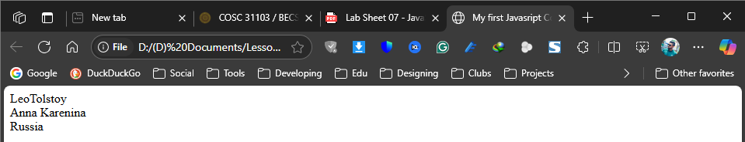

09.

<html>

<head>

<title>My first Javasript Code!!</title>

<script type="text/javaScript">

var d=new Date();

var hour=d.getHours();

var minute=d.getMinutes();

var second=d.getSeconds();

document.write("Now the time is = " + hour + " : " + minute + " " + second);

</script>

</head>

<body>

</body>

</html>

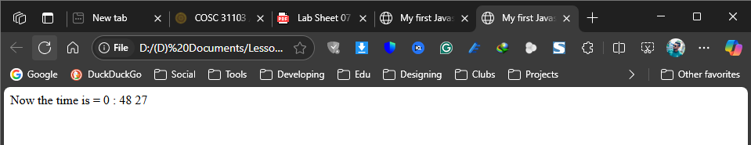

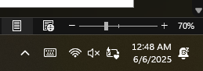

10.

<html>

<head>

<title>My first Javasript Code!!</title>

<script type="text/javaScript">

var d=new Date();

var time=d.getHours();

if(time<12) {

document.write("<b>Good Morning</b>");

}

else {

document.write("<b>Good Bye</b>");

}

</script>

</head>

<body>

</body>

</html>

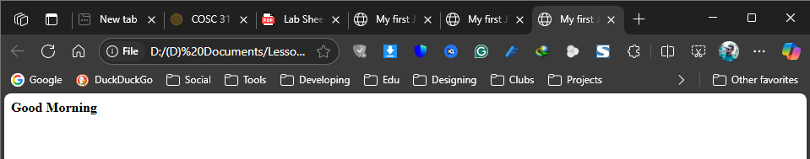

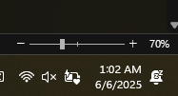

11.

<html>

<head>

<title>My first Javasript Code!!</title>

<script type="text/javaScript">

var d=new Date();

var hour=d.getHours();

if (hour >= 6 && hour < 12) {

document.write("<i>Good Morning!</i>");

}

else if (hour >= 12 && hour < 17) {

document.write("<i>Good Afternoon!</i>");

}

else if (hour >= 17 && hour < 21) {

document.write("<i>Good Evening!</i>");

}

else {

document.write("<i>Good Night!</i>");

}

</script>

</head>

<body>

</body>

</html>

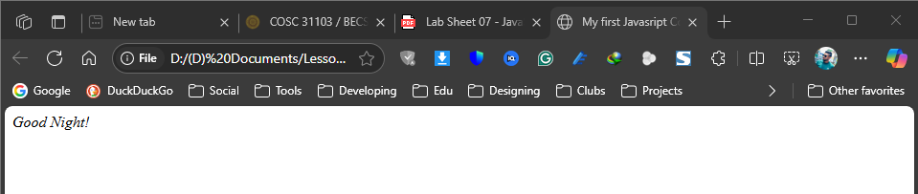

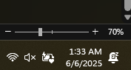

12.

<html>

<head>

<script type="text/javascript">

var favoriteColor = "green";

switch(favoriteColor.toLowerCase()) {

case "red":

document.write("<b>You like red.</b>");

break;

case "blue":

document.write("<b>You like blue.</b>");

break;

case "green":

document.write("<b>You like green.</b>");

break;

case "yellow":

document.write("<b>You like yellow.</b>");

break;

default:

document.write("<b>You like another color.</b>");

}

</script>

</head>

<body>

</body>

</html>

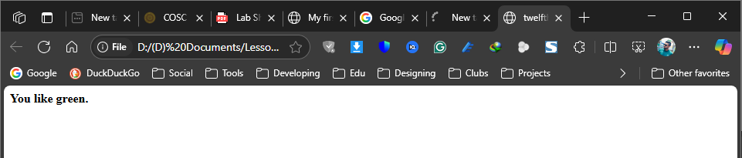

13.

<html>

<head>

<script type="text/javascript">

function alertbox()

{

alert("Hello COSC 31103/ BECS 31233!!!");

}

</script>

</head>

<body onload="alertbox()">

</body>

</html>

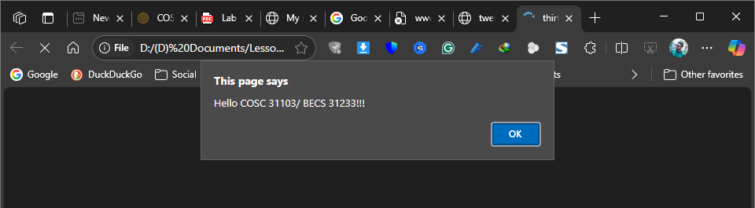

14.

<html>

<head>

<script type="text/javascript">

function confirmation() {

var answer = confirm("Leave the website?");

if (answer) {

alert("Bye bye!");

window.location = "http://www.google.com/";

}

else {

alert("Thanks for sticking around!");

}

}

</script>

</head>

<body>

<form>

<input type="button" onclick="confirmation()" value="Leave">

</form>

</body>

</html>

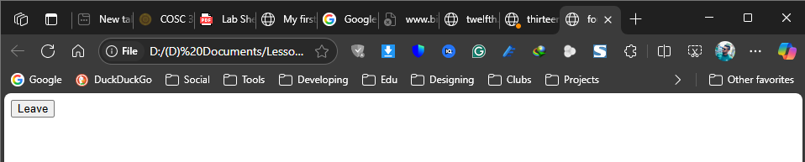

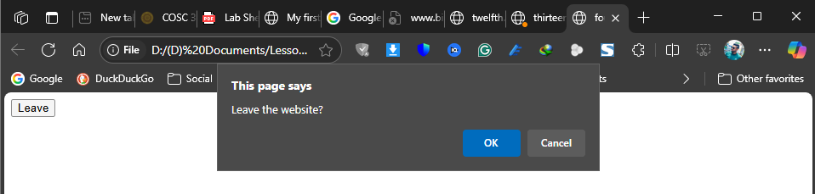

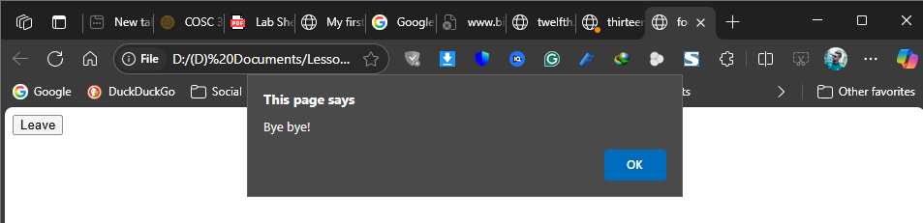

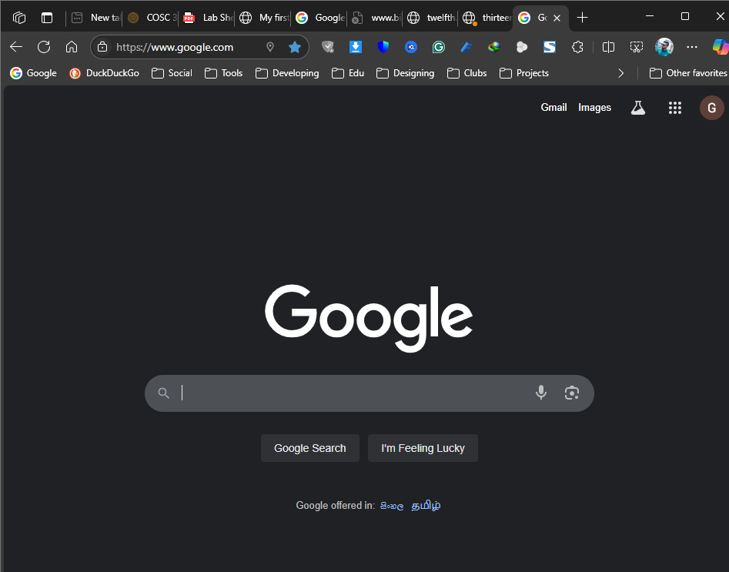

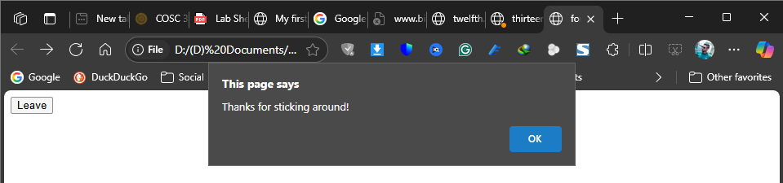

15.

<html>

<head>

<script type="text/javascript">

function show_prompt() {

var name = prompt("Please enter your name","");

if (name!=null && name!="") {

document.write("Hello" + name + "! How are you today?");

}

}

</script>

</head>

<body>

<input type="button" onclick="show_prompt()" value="Show prompt box">

</body>

</html>

