Dimensionality Reduction for Two Biomedical Classification Tables
  - Measured pilot comparison of nine dimensionality reduction methods
Research report | 21 October 2026 | Reproducible code and raw run tables accompany this document

Abstract
This preliminary study compares nine two-dimensional representations on a lesion image table and a blood-cell feature table. Across three shared splits, Isomap had the highest mean ROC AUC on HAM10000 (0.649), while PCA had the highest mean ROC AUC on the blood-cell table (0.630). Performance varied across splits and parameter settings. The data and validation design do not support clinical or journal-level generalization claims. FROC AUC is unavailable because the files contain no candidate lesion locations.

Introduction
Dimensionality reduction is often used to inspect high-dimensional biomedical data. A visually separated map does not automatically retain information needed for a new patient or image. This benchmark therefore compares embeddings through a fixed downstream classifier on held-out samples, while measuring runtime and parameter sensitivity. It treats the methods as representation procedures, not standalone classifiers.
PCA is linear and maximizes retained variance. Kernel PCA applies a radial basis function kernel. Gaussian SNE matches neighbor probabilities with a Gaussian low-dimensional affinity. t-SNE uses a heavy-tailed affinity. The hybrid applies PCA before t-SNE. UMAP builds a fuzzy neighborhood graph. Metric MDS preserves pairwise distances, PCoA decomposes a centered distance matrix, and Isomap approximates geodesic distances. All methods output two coordinates for a common comparison.

Dataset description
Dataset | Records | Input features | Positive class | Split unit
HAM10000 | 10,015 | 192 values from 8 × 8 RGB pixels | Melanoma: 1,113 | Lesion ID
Blood cell anomaly | 5,880 | 22 morphology, color, and blood-count values | Anomaly: 1,880 | Row; patient ID absent

HAM10000 pixel rows were checked against diagnosis metadata, with exact agreement for all 10,015 labels. Lesions are separated between train and test. The 8 × 8 representation reduces compute but discards clinically important detail. The blood-cell table excludes cell type, disease category, anomaly score, classification confidence, and labeller confidence because these fields can directly reveal the target. Its origin and patient independence remain unverified.

Preprocessing and evaluation
For each of three seeds, the study draws 750 training records and 300 held-out records after a group split for HAM10000 or a stratified row split for the blood-cell table. Subsampling retains approximate class proportions. Standardization fits on the training data only. Each embedding fits on training data only. A balanced logistic regression is trained in two dimensions and evaluated at a fixed 0.5 probability threshold. This design avoids fitting an embedding on the test observations.
PCA, kernel PCA, UMAP, and Isomap transform held-out records directly. PCoA uses a Gower distance extension. The SNE, t-SNE, and MDS implementations lack an inductive transform; a distance-weighted five-neighbor regression approximates test coordinates from the training embedding. This changes what is being evaluated, so rankings should be read as end-to-end pipeline rankings.
Method | Setting A | Setting B
PCA | No whitening | Whitening
Kernel PCA | RBF gamma = 0.5 / p | RBF gamma = 2 / p
SNE | Perplexity 15 | Perplexity 30
t-SNE | Perplexity 15 | Perplexity 30
PCA + t-SNE | PCA to ≤30 then perplexity 15 | PCA to ≤30 then perplexity 30
UMAP | 15 neighbors | 30 neighbors
Metric MDS | 80 iterations | 150 iterations
PCoA | Cosine distance | Manhattan distance
Isomap | 10 neighbors | 25 neighbors

Metric definitions
From true positives TP, true negatives TN, false positives FP, and false negatives FN: accuracy = (TP+TN)/N; error = 1−accuracy; sensitivity or recall = TP/(TP+FN); specificity = TN/(TN+FP); precision = TP/(TP+FP); F1 = 2·precision·recall/(precision+recall). ROC AUC integrates sensitivity against false-positive rate across thresholds. Kappa is chance-corrected agreement. Informedness = sensitivity+specificity−1. Markedness = precision+negative predictive value−1. Log loss evaluates probability calibration and discrimination together.
PCoA is defined by its distance matrix. Here cosine distance is primary and Manhattan distance is the sensitivity setting; Euclidean PCoA would largely duplicate PCA. MDS and Isomap use Euclidean input distances. Isomap's neighbor count controls its graph connectivity.

Results and discussion

HAM10000 measured performance
Method | Accuracy | Sensitivity / recall | Specificity | Precision | F1 | ROC AUC
PCA | 0.609 | 0.583 | 0.611 | 0.144 | 0.231 | 0.602
Kernel PCA | 0.603 | 0.535 | 0.610 | 0.133 | 0.212 | 0.638
SNE | 0.593 | 0.505 | 0.602 | 0.124 | 0.199 | 0.616
t-SNE | 0.600 | 0.515 | 0.608 | 0.128 | 0.205 | 0.638
PCA + t-SNE | 0.591 | 0.492 | 0.601 | 0.121 | 0.194 | 0.632
UMAP | 0.609 | 0.588 | 0.610 | 0.143 | 0.230 | 0.645
MDS | 0.599 | 0.556 | 0.602 | 0.134 | 0.216 | 0.620
PCoA | 0.606 | 0.546 | 0.611 | 0.135 | 0.217 | 0.633
Isomap | 0.590 | 0.571 | 0.591 | 0.134 | 0.218 | 0.649

Method | Error | Kappa | Informedness | Markedness | Log loss | CPU s
PCA | 0.391 | 0.084 | 0.194 | 0.075 | 0.679 | 0.08
Kernel PCA | 0.397 | 0.062 | 0.144 | 0.056 | 0.655 | 0.05
SNE | 0.407 | 0.047 | 0.107 | 0.042 | 0.665 | 1.81
t-SNE | 0.400 | 0.054 | 0.123 | 0.048 | 0.647 | 1.74
PCA + t-SNE | 0.409 | 0.040 | 0.093 | 0.037 | 0.654 | 1.73
UMAP | 0.391 | 0.083 | 0.198 | 0.076 | 0.655 | 2.24
MDS | 0.401 | 0.066 | 0.158 | 0.061 | 0.657 | 1.16
PCoA | 0.394 | 0.068 | 0.157 | 0.061 | 0.659 | 0.09
Isomap | 0.410 | 0.067 | 0.162 | 0.061 | 0.646 | 0.10

Values are means across three held-out splits for prespecified setting A. Recall equals sensitivity. CPU time includes embedding, held-out transform, classifier fit, and prediction, after the separately reported UMAP compilation warmup.
In HAM10000, Isomap has the highest mean ROC AUC for setting A (0.649). Kernel PCA uses the least mean CPU time (0.05 s). These are descriptive rankings across only three overlapping splits. Accuracy should be read together with sensitivity and specificity because the positive class is less frequent.
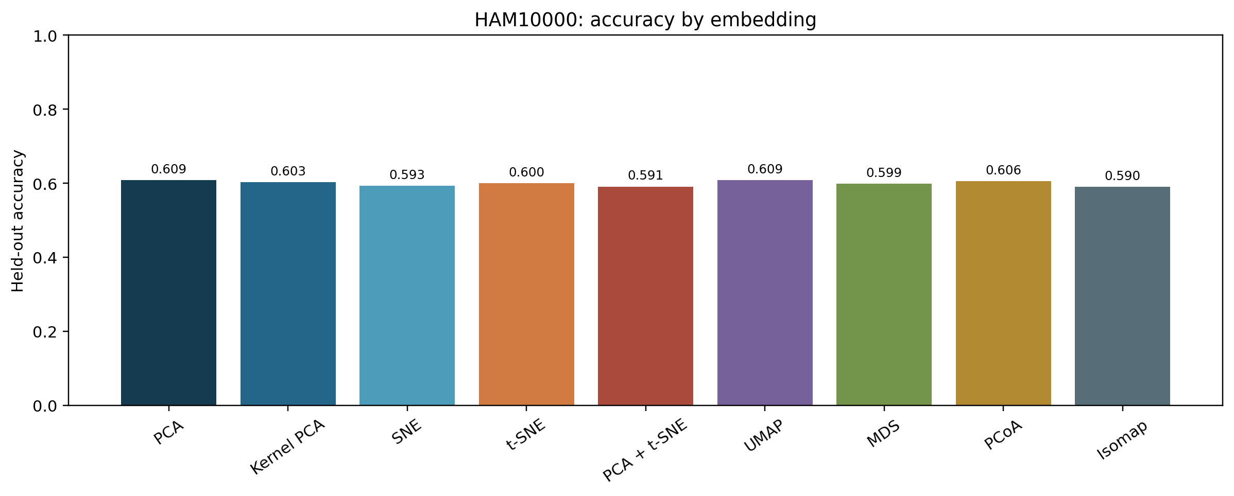
Figure. Held-out accuracy by method on HAM10000.
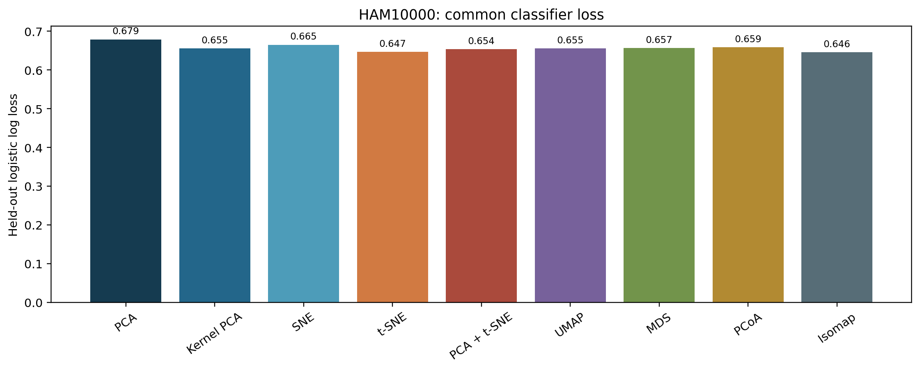
Figure. Common held-out classifier log loss on HAM10000.
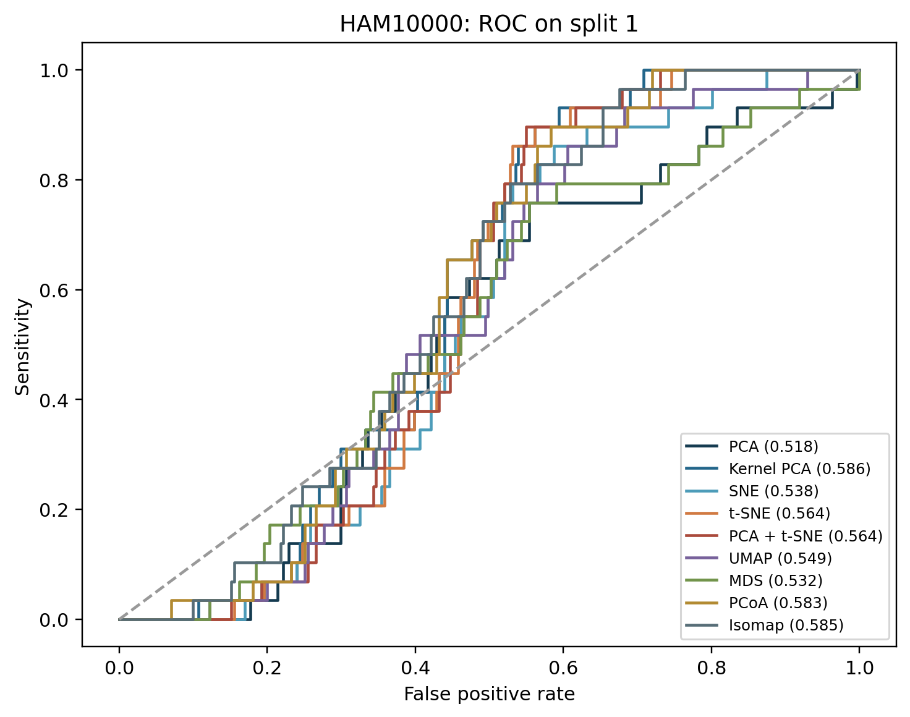
Figure. ROC curves for the first shared split on HAM10000; legend gives split-specific AUC.
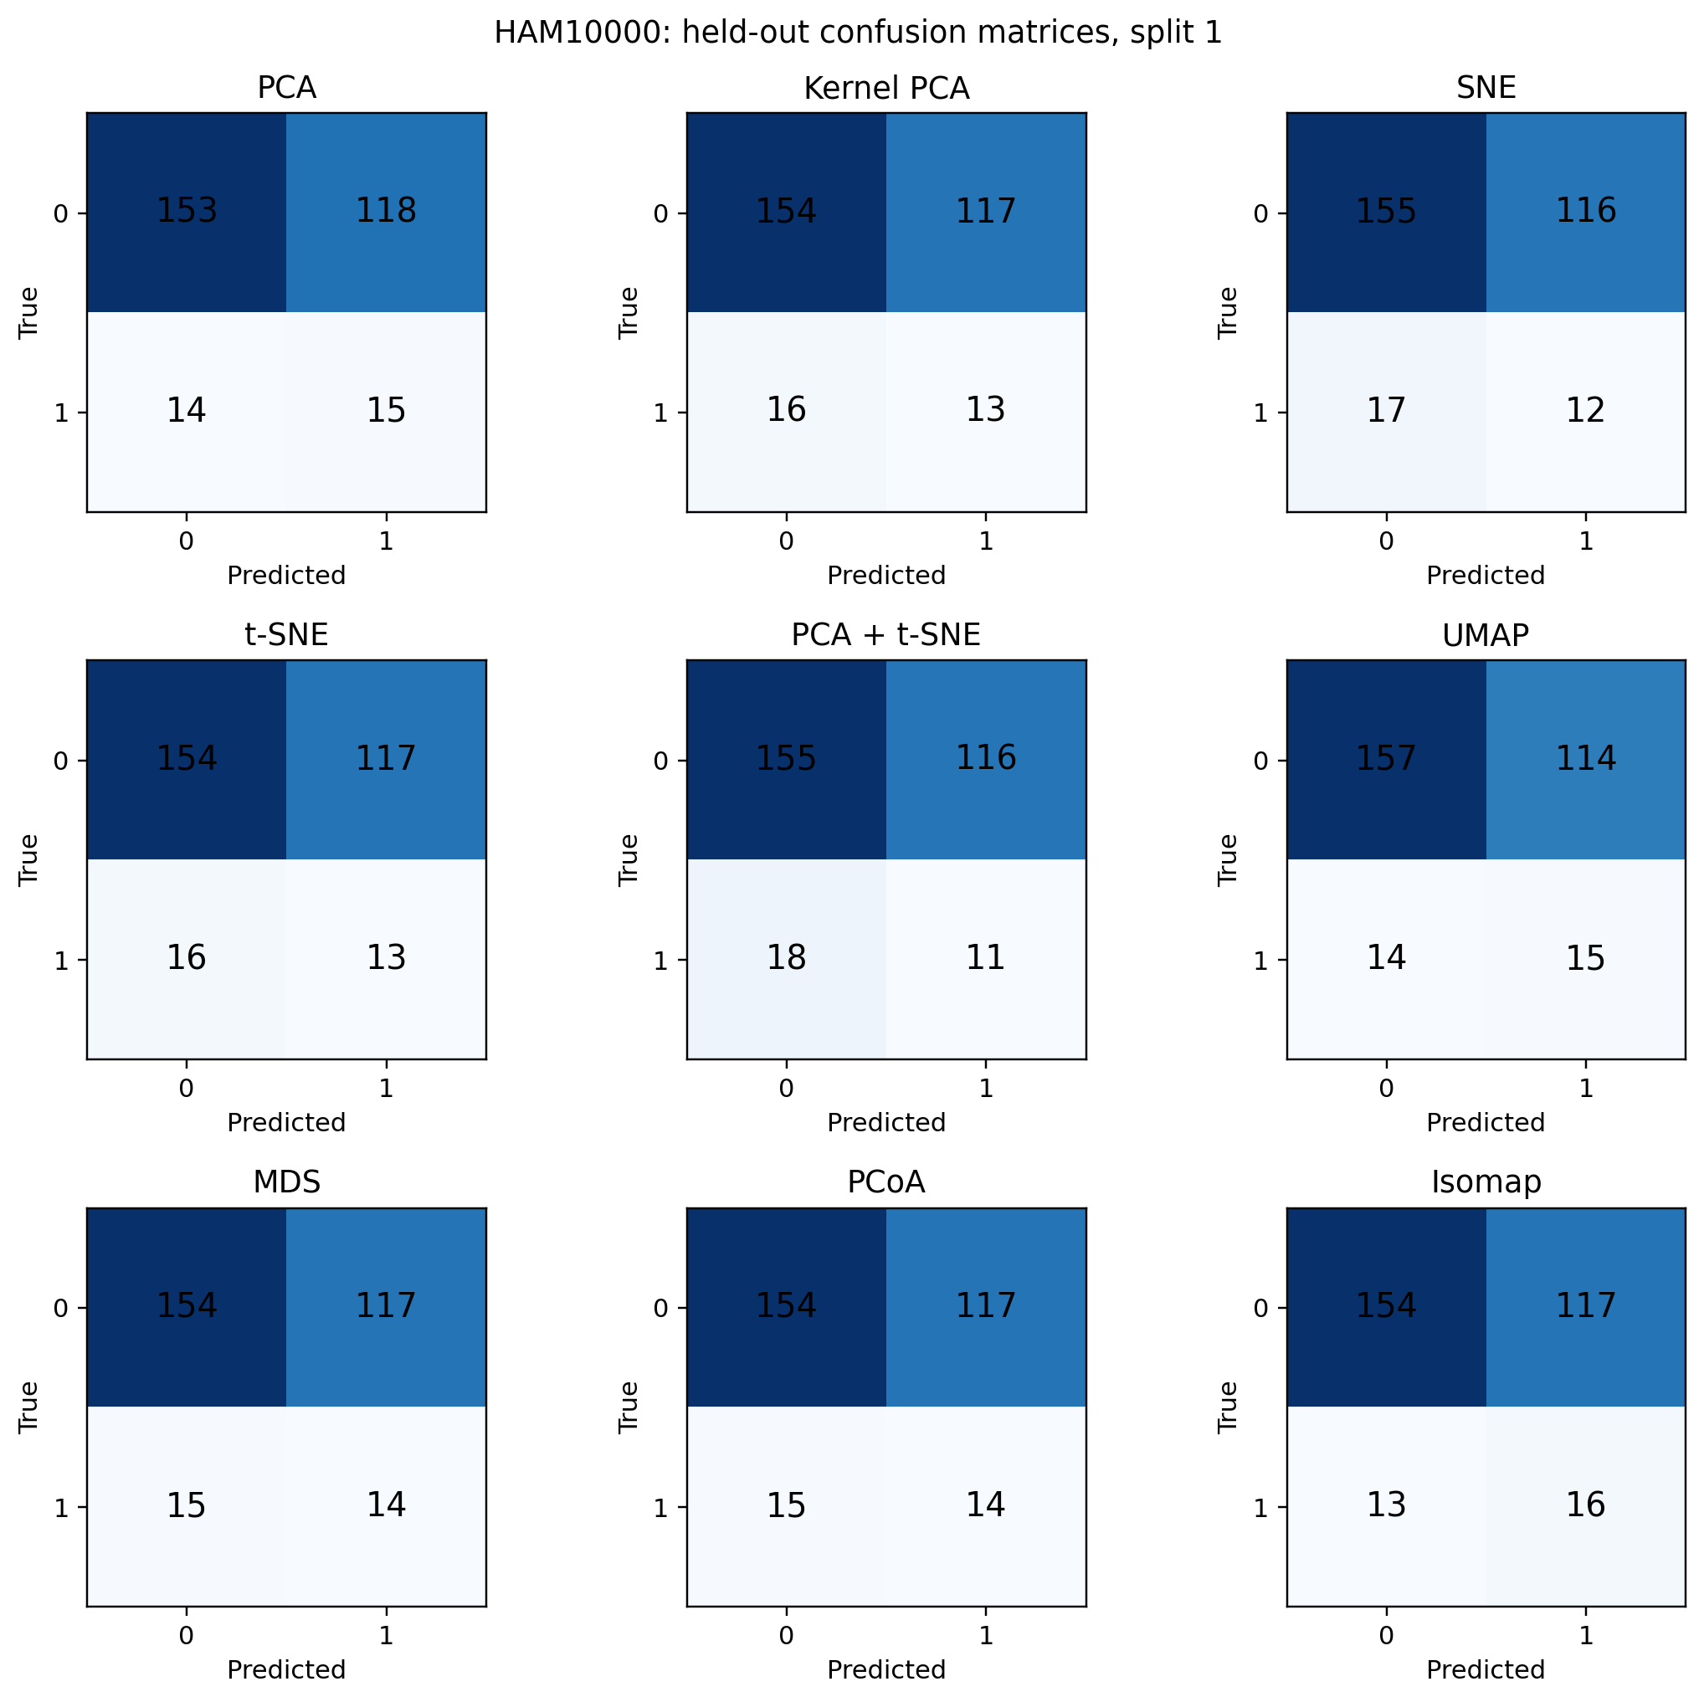
Figure. Held-out confusion matrices for the first shared split on HAM10000.
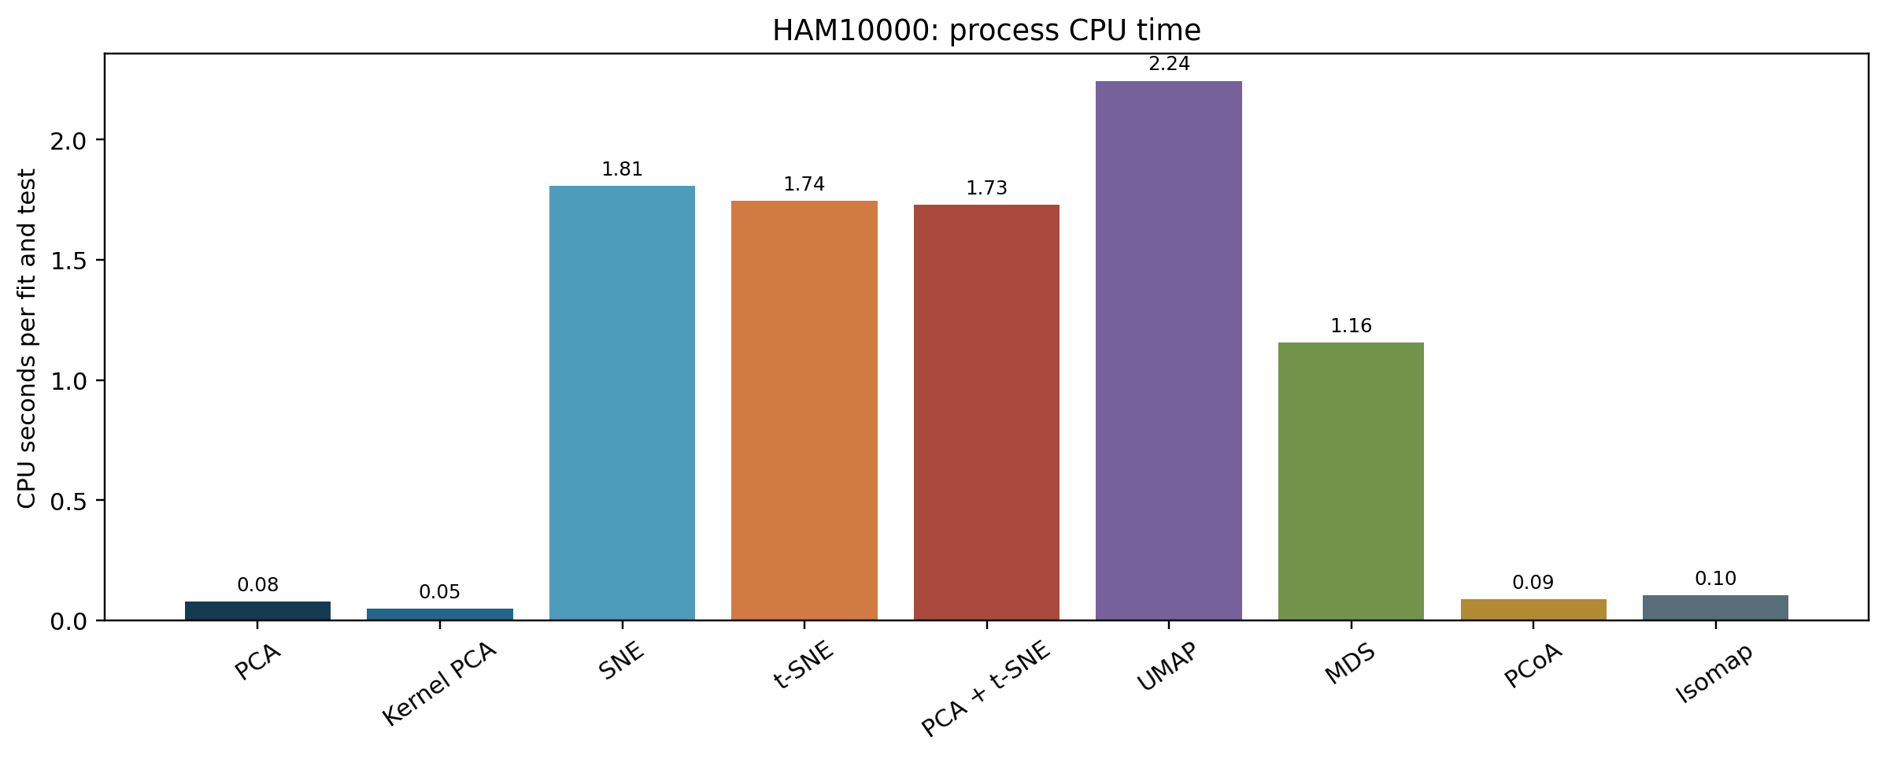
Figure. Mean process CPU time per run on HAM10000, excluding UMAP compilation warmup.
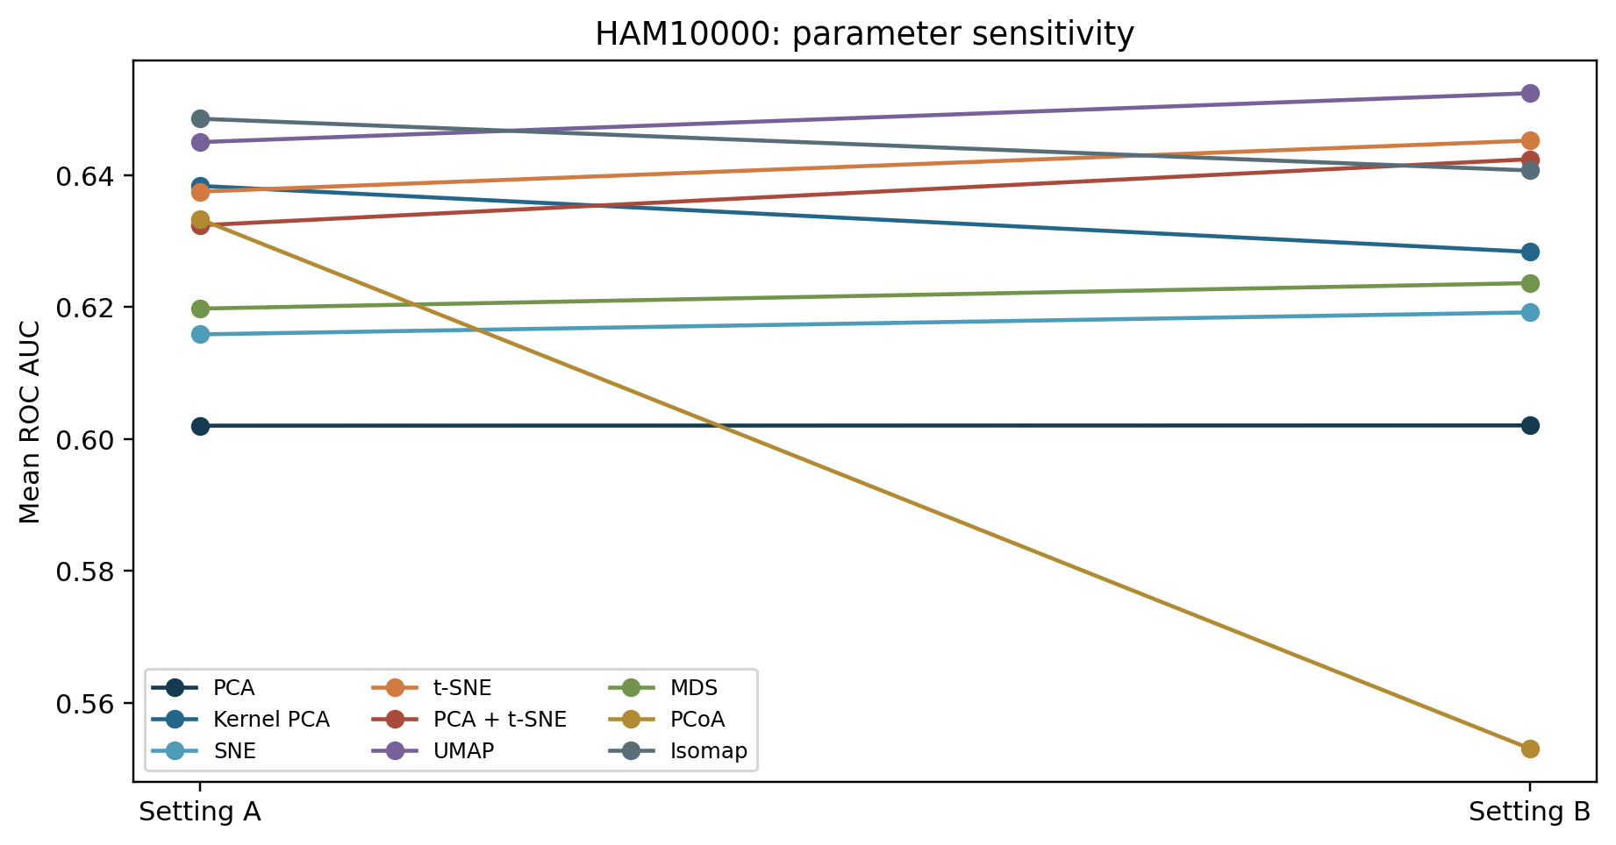
Figure. Mean ROC AUC for two prespecified parameter settings on HAM10000.

Blood cell measured performance
Method | Accuracy | Sensitivity / recall | Specificity | Precision | F1 | ROC AUC
PCA | 0.567 | 0.528 | 0.585 | 0.378 | 0.439 | 0.630
Kernel PCA | 0.552 | 0.545 | 0.556 | 0.369 | 0.438 | 0.624
SNE | 0.614 | 0.500 | 0.668 | 0.428 | 0.458 | 0.581
t-SNE | 0.512 | 0.562 | 0.489 | 0.341 | 0.423 | 0.622
PCA + t-SNE | 0.504 | 0.552 | 0.482 | 0.336 | 0.416 | 0.616
UMAP | 0.566 | 0.476 | 0.608 | 0.364 | 0.410 | 0.600
MDS | 0.474 | 0.465 | 0.479 | 0.313 | 0.368 | 0.562
PCoA | 0.518 | 0.545 | 0.505 | 0.351 | 0.424 | 0.616
Isomap | 0.596 | 0.420 | 0.678 | 0.382 | 0.396 | 0.582

Method | Error | Kappa | Informedness | Markedness | Log loss | CPU s
PCA | 0.433 | 0.104 | 0.113 | 0.101 | 0.645 | 0.02
Kernel PCA | 0.448 | 0.091 | 0.101 | 0.090 | 0.648 | 0.04
SNE | 0.386 | 0.165 | 0.168 | 0.165 | 0.642 | 6.10
t-SNE | 0.488 | 0.044 | 0.051 | 0.046 | 0.663 | 1.92
PCA + t-SNE | 0.496 | 0.030 | 0.034 | 0.030 | 0.665 | 1.92
UMAP | 0.434 | 0.077 | 0.084 | 0.076 | 0.654 | 2.26
MDS | 0.526 | -0.036 | -0.056 | -0.056 | 0.681 | 1.06
PCoA | 0.482 | 0.050 | 0.050 | 0.044 | 0.663 | 0.08
Isomap | 0.404 | 0.096 | 0.098 | 0.096 | 0.640 | 0.09

Values are means across three held-out splits for prespecified setting A. Recall equals sensitivity. CPU time includes embedding, held-out transform, classifier fit, and prediction, after the separately reported UMAP compilation warmup.
In Blood cell, PCA has the highest mean ROC AUC for setting A (0.630). PCA uses the least mean CPU time (0.02 s). These are descriptive rankings across only three overlapping splits. Accuracy should be read together with sensitivity and specificity because the positive class is less frequent.
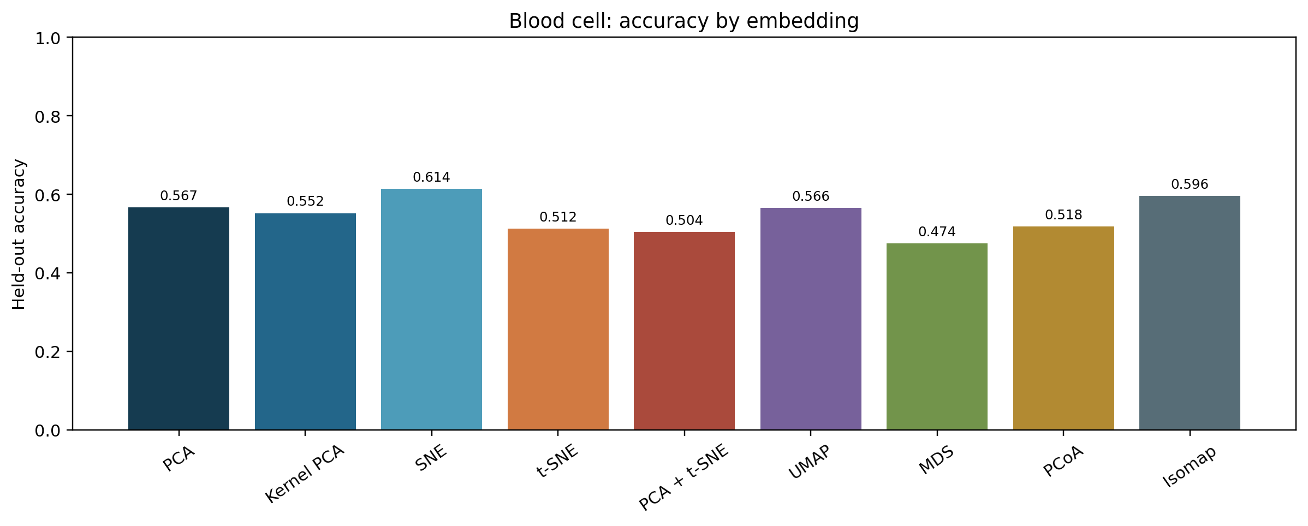
Figure. Held-out accuracy by method on Blood cell.
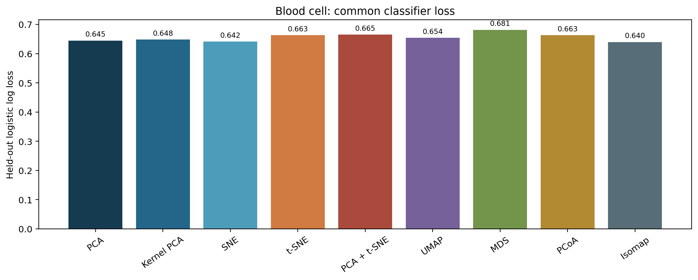
Figure. Common held-out classifier log loss on Blood cell.
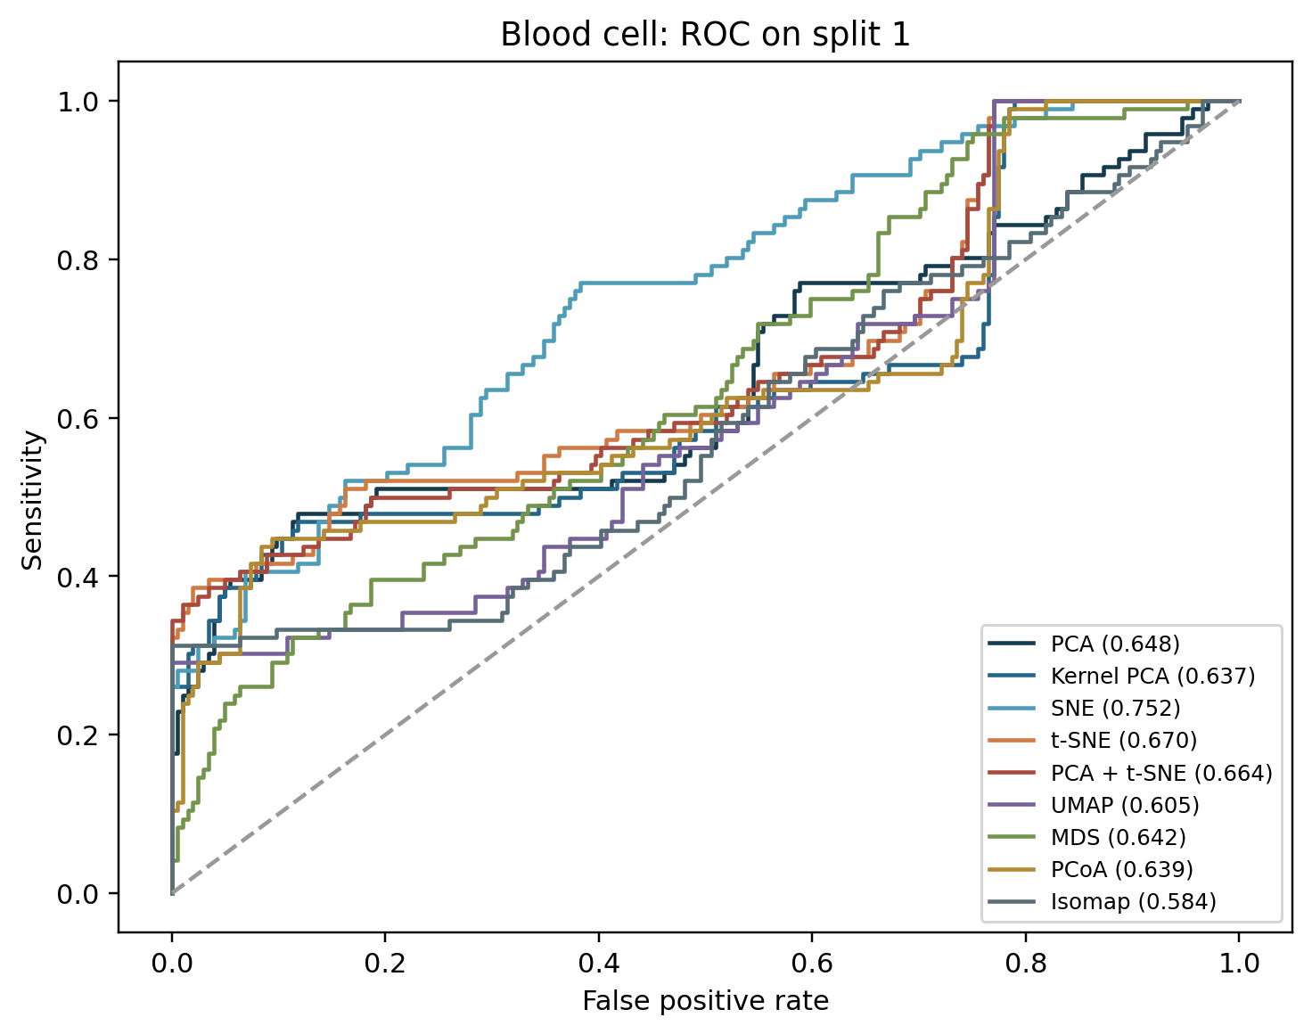
Figure. ROC curves for the first shared split on Blood cell; legend gives split-specific AUC.
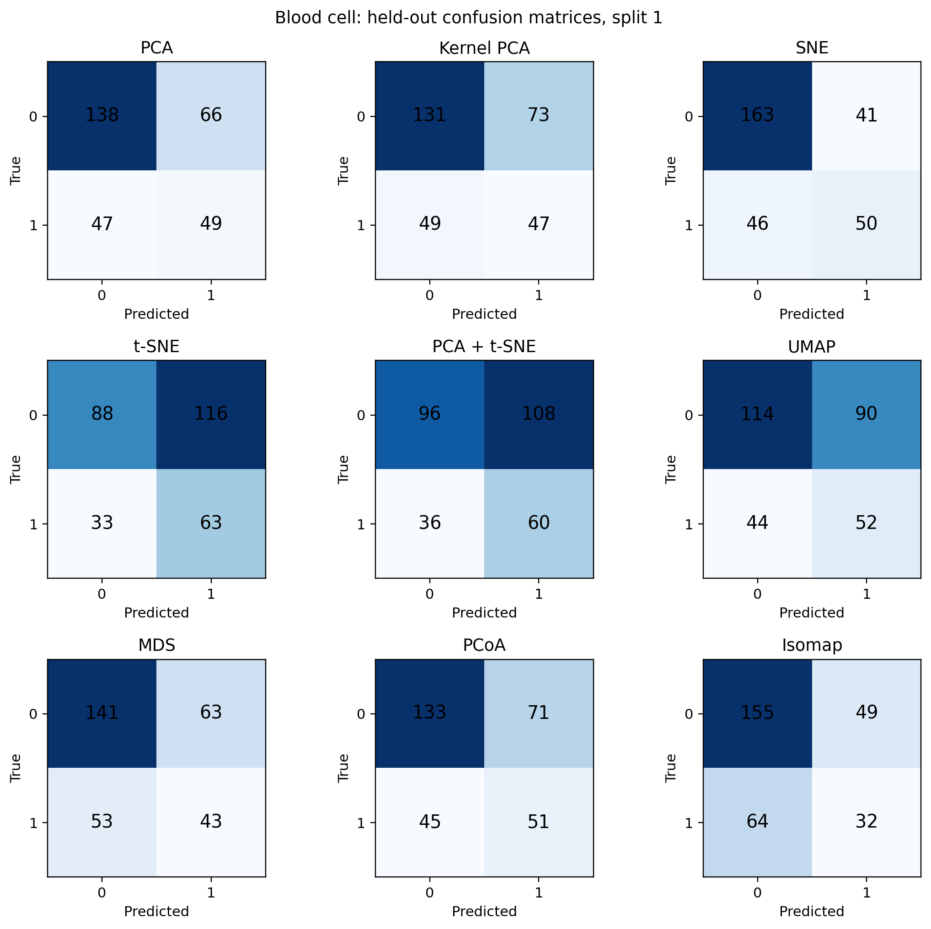
Figure. Held-out confusion matrices for the first shared split on Blood cell.
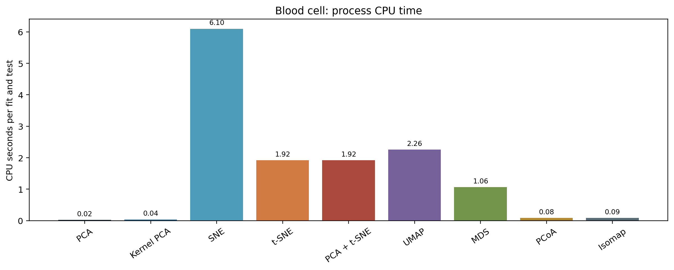
Figure. Mean process CPU time per run on Blood cell, excluding UMAP compilation warmup.
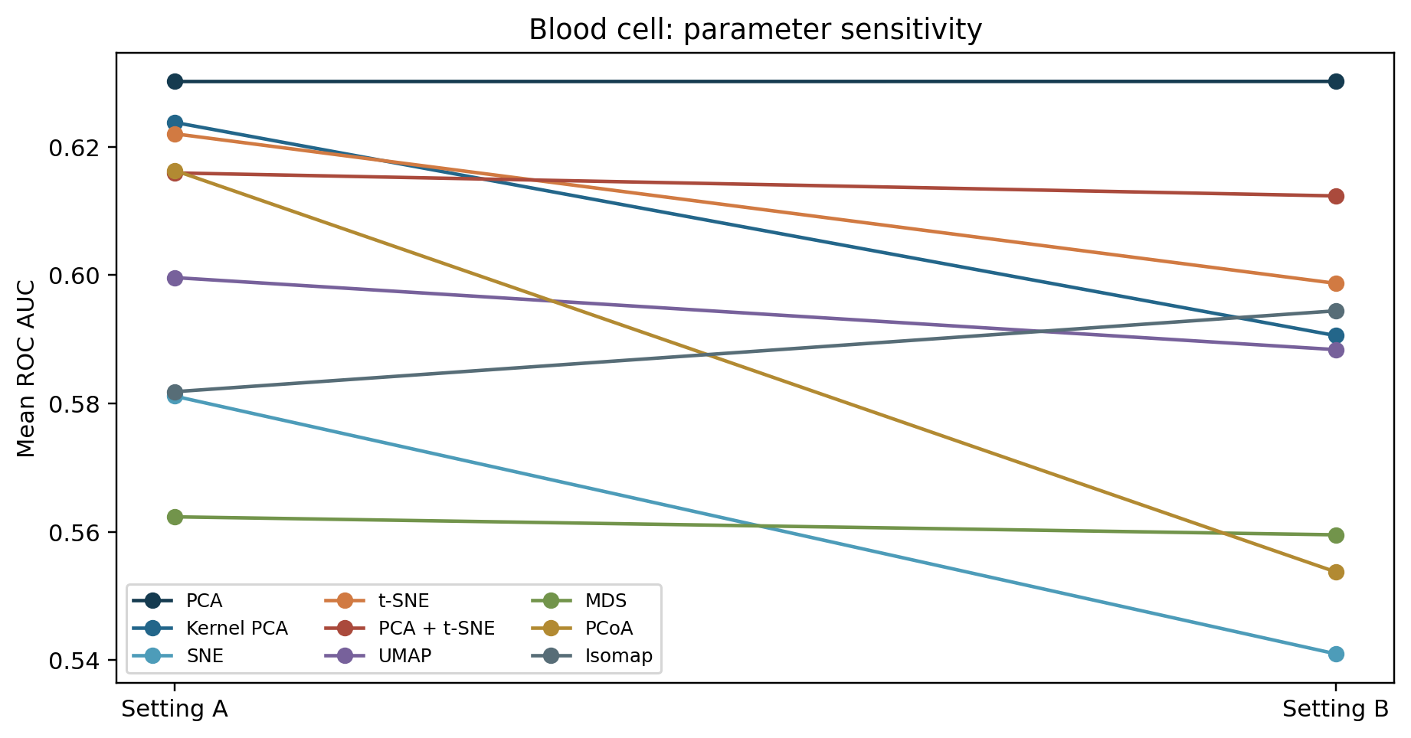
Figure. Mean ROC AUC for two prespecified parameter settings on Blood cell.

Optimization loss and FROC
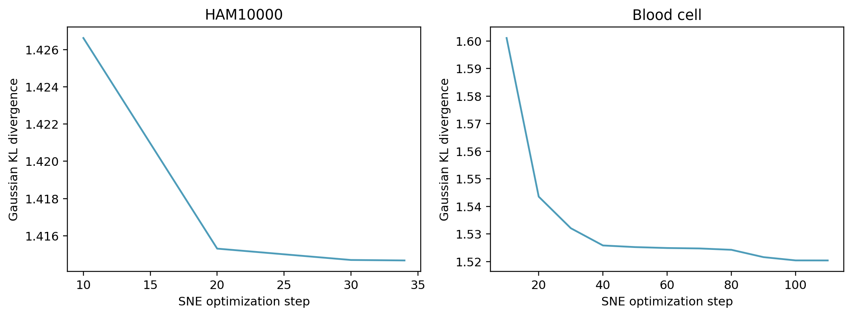
Figure. Gaussian SNE optimization objective for the first split and setting A. This loss is not directly comparable with the common classifier log loss.
The UMAP and PCA objectives have different units and meanings, so their native optimization losses are not plotted on one axis. The common held-out logistic log loss above is the meaningful cross-method loss comparison.
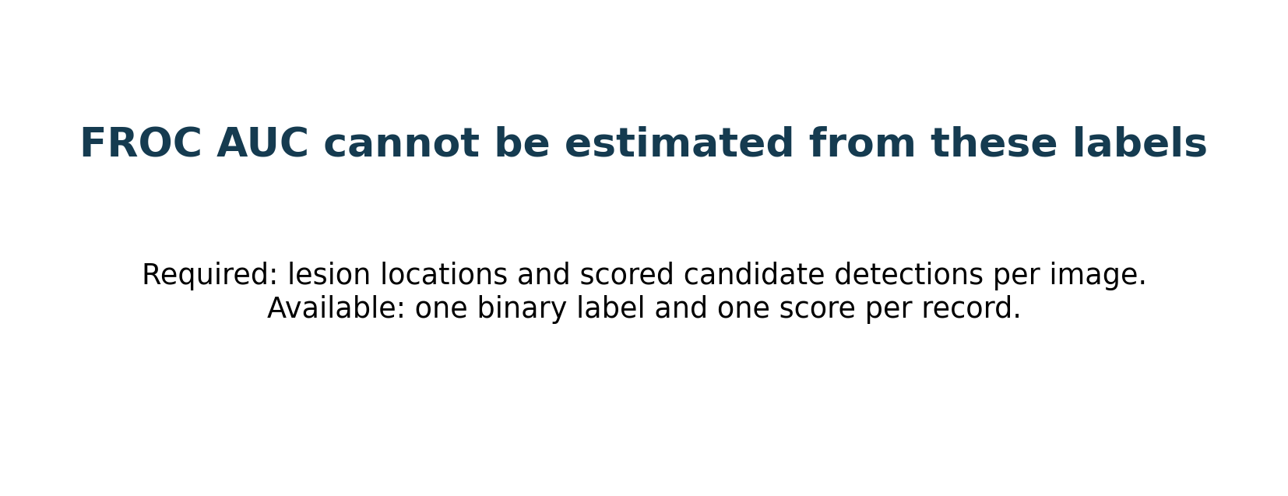
Figure. Why a valid FROC AUC cannot be calculated from the supplied tables.
A free-response operating characteristic requires lesion locations and scored candidate detections per image. The available files provide one class label and one classifier score per record. Counting each positive classification as a detection would simply relabel ROC and falsely imply localization performance. FROC AUC is therefore reported as not estimable.

Statistical comparisons
The repository applies paired t and Wilcoxon signed-rank comparisons of AUC against PCA across three shared splits, Holm correction for paired t tests, repeated-measures ANOVA across methods, a requested descriptive MANOVA of AUC and log loss, and McNemar's discordance z statistic on the first split. The paired analyses respect split matching. The repeated splits overlap in training observations and provide weak inferential power; p values are exploratory. MANOVA's independence assumption is violated by repeated splits, so its output is retained as a diagnostic only.
Dataset | AUC comparison | Mean Δ | Paired t Holm p | Wilcoxon p
HAM10000 | Kernel PCA vs PCA | +0.036 | 1.000 | 0.500
HAM10000 | SNE vs PCA | +0.014 | 1.000 | 0.500
HAM10000 | t-SNE vs PCA | +0.035 | 1.000 | 0.500
HAM10000 | PCA + t-SNE vs PCA | +0.030 | 1.000 | 0.500
HAM10000 | UMAP vs PCA | +0.043 | 1.000 | 0.500
HAM10000 | MDS vs PCA | +0.018 | 1.000 | 0.750
HAM10000 | PCoA vs PCA | +0.031 | 1.000 | 0.250
HAM10000 | Isomap vs PCA | +0.047 | 0.860 | 0.250
Blood cell | Kernel PCA vs PCA | -0.006 | 1.000 | 0.500
Blood cell | SNE vs PCA | -0.049 | 1.000 | 0.750
Blood cell | t-SNE vs PCA | -0.008 | 1.000 | 0.750
Blood cell | PCA + t-SNE vs PCA | -0.014 | 1.000 | 0.500
Blood cell | UMAP vs PCA | -0.031 | 1.000 | 0.500
Blood cell | MDS vs PCA | -0.068 | 1.000 | 0.250
Blood cell | PCoA vs PCA | -0.014 | 0.210 | 0.250
Blood cell | Isomap vs PCA | -0.048 | 1.000 | 0.500

The repeated-measures ANOVA of ROC AUC gives F(8,40)=0.673 and p=0.712. The descriptive MANOVA method term gives Wilks' lambda=0.840 and p=0.945, but its independence assumption is violated. On the first split, McNemar z for UMAP versus PCA is 0.667 (p=0.505) on HAM10000 and −2.201 (uncorrected p=0.028) on blood cells; the latter is one of eight exploratory contrasts and does not survive Bonferroni correction. Full outputs are in the results directory. These tests do not substitute for nested cross-validation, independent patient cohorts, confidence intervals, and a prospective analysis plan.

Limitations and next study
The study compresses lesion images to 8 × 8 pixels and forces every representation to two dimensions. It has three repeated splits, a small subsample, an approximate t-SNE/SNE test transform, and no independent blood-cell patient identifier. The blood-cell source's clinical provenance is not verified. No external cohort, fairness assessment, or uncertainty interval is available. These limits prevent a clinical diagnostic claim or any promise of Q1 journal acceptance. A publication study should use original images or validated embeddings, prespecified nested validation, external cohorts, and lesion detection annotations if FROC is a target.

References and data sources
- HAM10000 dataset: https://www.kaggle.com/datasets/kmader/skin-cancer-mnist-ham10000
- HAM10000 source paper: https://arxiv.org/abs/1803.10417
- Blood-cell data: https://www.kaggle.com/datasets/alitaqishah/blood-cell-anomaly-detection-2025
- Kernel PCA: https://is.mpg.de/de/publications/730
- SNE: https://papers.nips.cc/paper/2276-stochastic-neighbor-embedding
- t-SNE: https://www.jmlr.org/papers/v9/vandermaaten08a.html
- UMAP: https://arxiv.org/abs/1802.03426
- Metric MDS implementation: https://scikit-learn.org/stable/modules/generated/sklearn.manifold.MDS.html
- Principal coordinates analysis: https://doi.org/10.1093/biomet/53.3-4.325
- Isomap: https://doi.org/10.1126/science.290.5500.2319

