# Usage of Patterns

This document describes the implementation of Façade Pattern in our server-side logic.

At first (Abb. 1) the data from the database was accessed by a *Database* class and sent back to the client in a *CommunicationPackage*. Depending on what type of *CommunicationPackage* was sent by the client, the *CommunicationPackageHandler* called the corresponding method from *Database.*

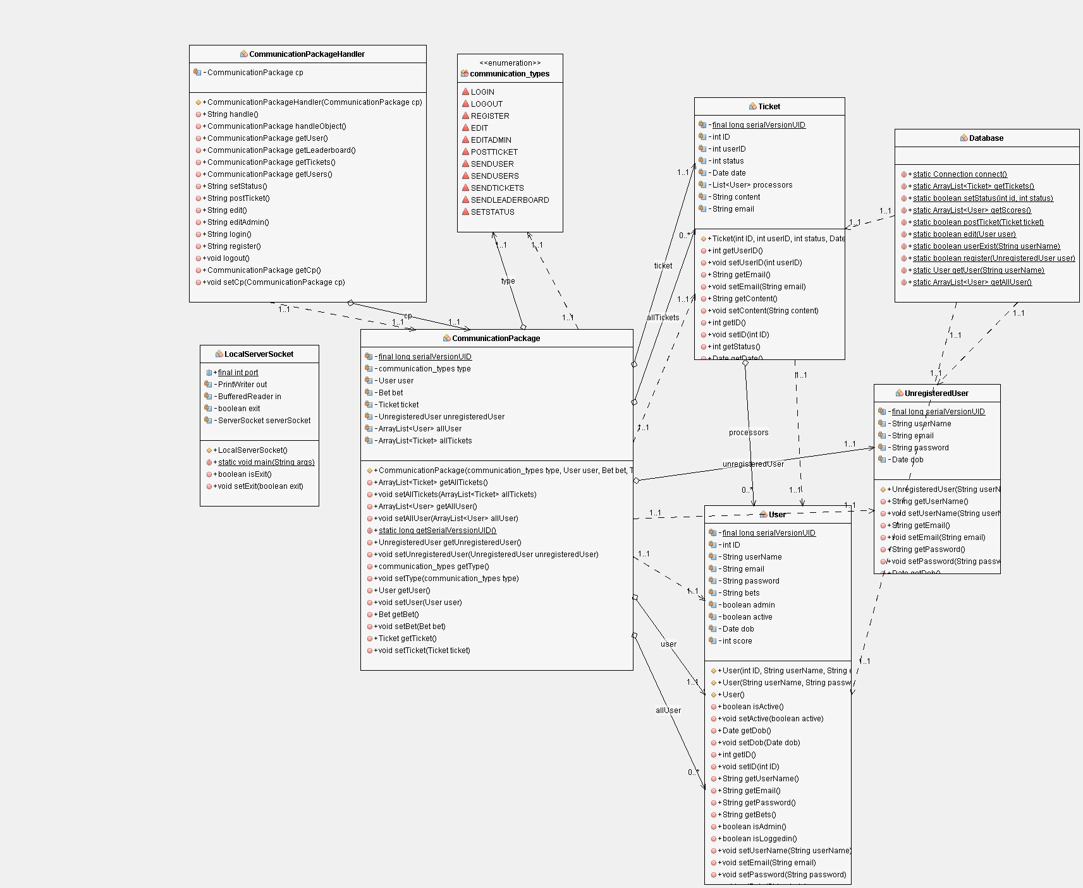

Abbildung

In order to simplify requests to the database, a façade class for each database table was created. These manage the access to the database, their methods can be called via simple Http-Requests by a client and return JSON objects with the results. (Abb.2)

