Sci-fi Objects Pack 1:

Shelves
Shelves are placed in to the map empty, But by clicking on the Fill All Shelves Button will populate all the shelves
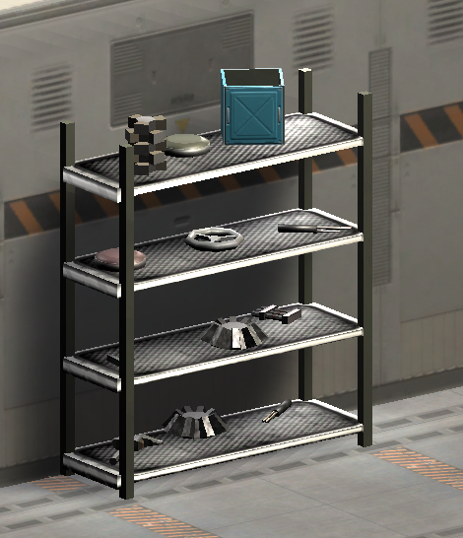
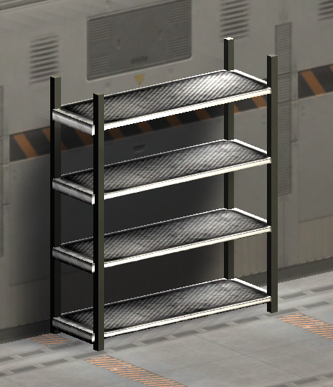

Inspector
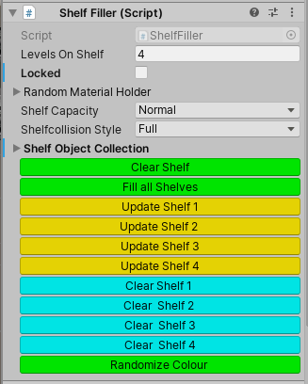
Clear Shelf: Remove all objects from the shelf
Fill all Shelves: Replace objects to all shelf
Update Shelf 1: Replace objects just to level 1
Update Shelf 2: Replace objects just to level 2
Update Shelf 3: Replace objects just to level 3
Update Shelf 4: Replace objects just to level 4
Clear Shelf 1: Clear objects just to level 1
Clear Shelf 2: Clear objects just to level 2
Clear Shelf 3: Clear objects just to level 3
Clear Shelf 4: Clear objects just to level 4
Randomize Colour: Randomize the colour only

The selection of objects in the shelf can be changed by using the Shelf Object Collection Options
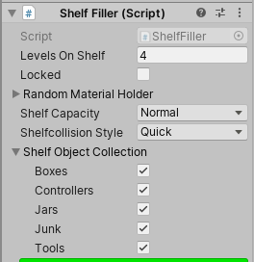

The collections, has Boxes, Controllers, Jars, Junk and Tools The tick boxes allow you to have any arrangement of objects.
And by using the Update Shelf 1-4 options you can select an object type per level of the shelf.

Other Options
Levels On Shelf How many levels to use for this shelf. Some Shelves have less levels
Locked When you are happy with the objects on the shelf, you can lock it so it will never get replaced.
Random Material Holder Holders the selection of materials to use when randomizing the objects and colour.
Shelf Capacity How full to make the shelf
Shelf Collision Style 'Quick' for just a simple box collision, 'Full' for more details collision

Floor Objects
The prefab ObjectsOnFloor_pf will let you place lots of random objects on the floor quickly.
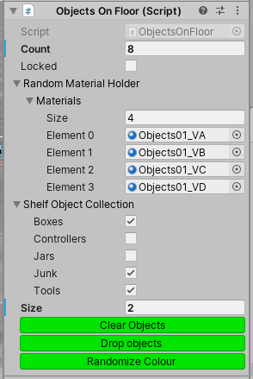
Count The number of object to try and place in the zone
Locked When you are happy with the objects on the floor, you can lock it so it will never get replaced.
Random Material Holder Holders the selection of materials to use when randomizing the objects and colour.
The collections has Boxes, Controllers, Jars, Junk and Tools The tick boxes allow you to have any arrangement of objects.
Size The Size of the zone to place the objects in.

Randomize Scene
The prefab Controller_pf from the common folder, will let you randomize all the objects in the scene with just one button.
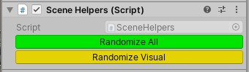
Randomize All Randomize all the object in the scene, unless they have been locked
Randomize Visual Randomize the colour or look of all the objects in the scene,unless they have been locked

Other Objects
22 Other sci-fi objects can be placed in the scene. Most object also have the random colour option, By using the Controller_pf to randomize all, or use the Randomize colour option on each object.

