What is Android

Before learning all topics of android, it is required to know what is android.
Android is a software package and linux based operating system for mobile devices such as tablet computers and smartphones.
It is developed by Google and later the OHA (Open Handset Alliance). Java language is mainly used to write the android code even though other languages can be used.
The goal of android project is to create a successful real-world product that improves the mobile experience for end users.

Android Activity Lifecycle
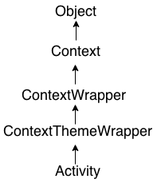
Android Activity Lifecycle is controlled by 7 methods of android.app.Activity class. The android Activity is the subclass of ContextThemeWrapper class.
An activity is the single screen in android. It is like window or frame of Java.
By the help of activity, you can place all your UI components or widgets in a single screen.
The 7 lifecycle method of Activity describes how activity will behave at different states.

Android Activity Lifecycle methods
Let's see the 7 lifecycle methods of android activity.
Method | Description
onCreate | called when activity is first created.
onStart | called when activity is becoming visible to the user.
onResume | called when activity will start interacting with the user.
onPause | called when activity is not visible to the user.
onStop | called when activity is no longer visible to the user.
onRestart | called after your activity is stopped, prior to start.
onDestroy | called before the activity is destroyed.
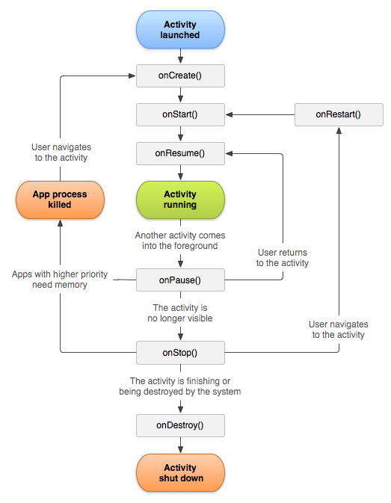
Activity class is one of the very important parts of the Android Component. Any app, don’t matter how small it is (in terms of code and scalability), has at least one Activity class. Unlike most programming languages, in which the main() method is the entry point for that program or application to start its execution, the android operating system initiates the code in an Activity instance by invoking specific callback methods that correspond to specific stages of its Lifecycle. So it can be said that An activity is the entry point for interacting with the user. Every activity contains the layout, which has a user interface to interact with the user. As we know that every activity contains a layout associated with it, so it can be said that the activity class is the gateway, through which a user can interact programmatically with the UI. Layout for a particular activity is set with the help of setContentView(). setContentView() is a function that takes View as a parameter. The view parameter basically contains the layout file for that activity. The code has been given in both Java and Kotlin Programming Language for Android.

Android Intent is the message that is passed between components such as activities, content providers, broadcast receivers, services etc.
It is generally used with startActivity() method to invoke activity, broadcast receivers etc.
The dictionary meaning of intent is intention or purpose. So, it can be described as the intention to do action.
The LabeledIntent is the subclass of android.content.Intent class.

Events are the actions performed by the user in order to interact with the application, for e.g. pressing a button or touching the screen. The events are managed by the android framework in the FIFO manner i.e. First In – First Out. Handling such actions or events by performing the desired task is called Event Handling.

Overview of the input event management
- Event Listeners: It is an interface in the View class. It contains a single callback method. Once the view to which the listener is associated is triggered due to user interaction, the callback methods are called.
- Event Handlers: It is responsible for dealing with the event that the event listeners registered for and performing the desired action for that respective event.
- Event Listeners Registration: Event Registration is the process in which an Event Handler gets associated with an Event Listener so that this handler is called when the respective Event Listener fires the event.
- Touch Mode: When using an app with physical keys it becomes necessary to give focus to buttons on which the user wants to perform the action but if the device is touch-enabled and the user interacts with the interface by touching it, then it is no longer necessary to highlight items or give focus to particular View. In such cases, the device enters touch mode and in such scenarios, only those views for which the isFocusableInTouchMode() is true will be focusable, e.g. plain text widget.

Event Listeners and their respective event handlers
- OnClickListener() – This method is called when the user clicks, touches, or focuses on any view (widget) like Button, ImageButton, Image, etc. Event handler used for this is onClick().
- OnLongClickListener() – This method is called when the user presses and holds a particular widget for one or more seconds. Event handler used for this is onLongClick().
- OnMenuItemClickListener() – This method is called when the user selects a menu item. Event handler used for this is onMenuItemClick().
- OnTouch() – This method is called either for a movement gesture on the screen or a press and release of an on-screen key. Event handler used for this is onTouch().

Android RSS Feed Reader
The RSS stands for Rich Site Summary. It is used to read the latest update made on the content of a blog or website. RSS feed is mostly used for reading the summary of a blog (newsletter). The content for RSS feed is provided in XML format.
RSS stands for Really Simple Syndication. RSS is an easy way to share your website updates and content with your users so that users might not have to visit your site daily for any kind of updates.

SQLite is a opensource SQL database that stores data to a text file on a device. Android comes in with built in SQLite database implementation.
SQLite supports all the relational database features. In order to access this database, you don't need to establish any kind of connections for it like JDBC,ODBC e.t.c

Database - Package
The main package is android.database.sqlite that contains the classes to manage your own databases

Database - Creation
In order to create a database you just need to call this method openOrCreateDatabase with your database name and mode as a parameter. It returns an instance of SQLite database which you have to receive in your own object.Its syntax is given below
SQLiteDatabase mydatabase = openOrCreateDatabase("your database name",MODE_PRIVATE,null);
Apart from this , there are other functions available in the database package , that does this job. They are listed below
Sr.No | Method & Description
1 | openDatabase(String path, SQLiteDatabase.CursorFactory factory, int flags, DatabaseErrorHandler errorHandler)  This method only opens the existing database with the appropriate flag mode. The common flags mode could be OPEN_READWRITE OPEN_READONLY
2 | openDatabase(String path, SQLiteDatabase.CursorFactory factory, int flags)  It is similar to the above method as it also opens the existing database but it does not define any handler to handle the errors of databases
3 | openOrCreateDatabase(String path, SQLiteDatabase.CursorFactory factory)  It not only opens but create the database if it not exists. This method is equivalent to openDatabase method.
4 | openOrCreateDatabase(File file, SQLiteDatabase.CursorFactory factory)  This method is similar to above method but it takes the File object as a path rather then a string. It is equivalent to file.getPath()

Database - Insertion
we can create table or insert data into table using execSQL method defined in SQLiteDatabase class. Its syntax is given below
mydatabase.execSQL("CREATE TABLE IF NOT EXISTS TutorialsPoint(Username VARCHAR,Password VARCHAR);");
mydatabase.execSQL("INSERT INTO TutorialsPoint VALUES('admin','admin');");
This will insert some values into our table in our database. Another method that also does the same job but take some additional parameter is given below
Sr.No | Method & Description
1 | execSQL(String sql, Object[] bindArgs)  This method not only insert data , but also used to update or modify already existing data in database using bind arguments

Database - Fetching
We can retrieve anything from database using an object of the Cursor class. We will call a method of this class called rawQuery and it will return a resultset with the cursor pointing to the table. We can move the cursor forward and retrieve the data.
Cursor resultSet = mydatbase.rawQuery("Select * from TutorialsPoint",null);
resultSet.moveToFirst();
String username = resultSet.getString(0);
String password = resultSet.getString(1);
There are other functions available in the Cursor class that allows us to effectively retrieve the data. That includes
Sr.No | Method & Description
1 | getColumnCount()  This method return the total number of columns of the table.
2 | getColumnIndex(String columnName)  This method returns the index number of a column by specifying the name of the column
3 | getColumnName(int columnIndex)  This method returns the name of the column by specifying the index of the column
4 | getColumnNames()  This method returns the array of all the column names of the table.
5 | getCount()  This method returns the total number of rows in the cursor
6 | getPosition()  This method returns the current position of the cursor in the table
7 | isClosed()  This method returns true if the cursor is closed and return false otherwise

Database - Helper class
For managing all the operations related to the database , an helper class has been given and is called SQLiteOpenHelper. It automatically manages the creation and update of the database. Its syntax is given below
public class DBHelper extends SQLiteOpenHelper {
public DBHelper(){
super(context,DATABASE_NAME,null,1);
}
public void onCreate(SQLiteDatabase db) {}
public void onUpgrade(SQLiteDatabase database, int oldVersion, int newVersion) {}
}

