What is content-based filtering and how does it work?
Content-based filtering is a type of recommender system that attempts to guess what a user may like based on that user’s activity.
Content-based filtering makes recommendations by using keywords and attributes assigned to objects in a database (e.g., items in an online marketplace) and matching them to a user profile. The user profile is created based on data derived from a user’s actions, such as purchases, ratings (likes and dislikes), downloads, items searched for on a website and/or placed in a cart, and clicks on product links.
For example, suppose you’re recommending accessories to a user that just purchased a smartphone from your website and has previously bought smartphone accessories. Aside from keywords such as the smartphone manufacturer, make, and model, the user profile indicates prior purchases include phone holders with sleeves for credit cards. Based on this information, the recommender system may suggest similar phone holders for the new phone with attributes such as an RFID blocking fabric layer to help prevent unauthorized credit card scanning. In this example, the user would expect recommendations for similar phone holders, but the RFID blocking feature may be something they didn’t expect yet appreciate.
Collaborative filtering System: Collaborative does not need the features of the items to be given. Every user and item is described by a feature vector or embedding.
It creates embedding for both users and items on its own. It embeds both users and items in the same embedding space.
It considers other users’ reactions while recommending a particular user. It notes which items a particular user likes and also the items that the users with behavior and likings like him/her likes, to recommend items to that user.
It collects user feedbacks on different items and uses them for recommendations.

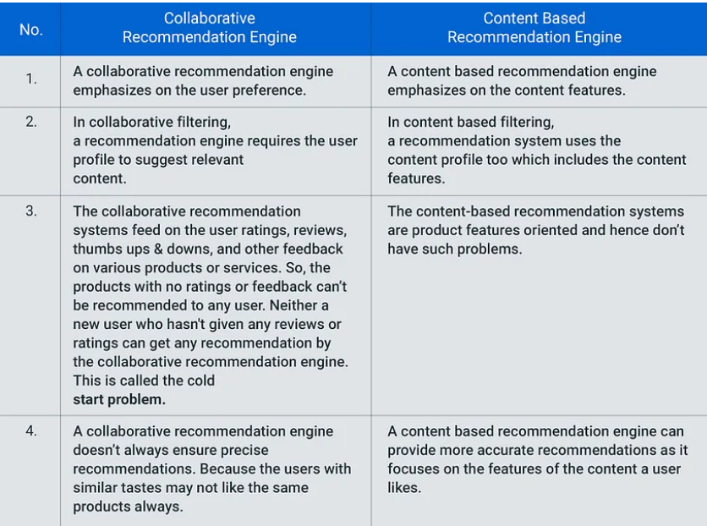

What is Feature Engineering
Feature engineering is a machine learning technique that leverages data to create new variables that aren’t in the training set. It can produce new features for both supervised and unsupervised learning, with the goal of simplifying and speeding up data transformations while also enhancing model accuracy. Feature engineering is required when working with machine learning models. Regardless of the data or architecture, a terrible feature will have a direct impact on your model.

Feature engineering is the process of selecting, manipulating, and transforming raw data into features that can be used in supervised learning. In order to make machine learning work well on new tasks, it might be necessary to design and train better features. As you may know, a “feature” is any measurable input that can be used in a predictive model — it could be the color of an object or the sound of someone’s voice. Feature engineering, in simple terms, is the act of converting raw observations into desired features using statistical or machine learning approaches.

Feature engineering consists of various process -
- Feature Creation: Creating features involves creating new variables which will be most helpful for our model. This can be adding or removing some features. As we saw above, the cost per sq. ft column was a feature creation.
- Transformations: Feature transformation is simply a function that transforms features from one representation to another. The goal here is to plot and visualise data, if something is not adding up with the new features we can reduce the number of features used, speed up training, or increase the accuracy of a certain model.
- Feature Extraction: Feature extraction is the process of extracting features from a data set to identify useful information. Without distorting the original relationships or significant information, this compresses the amount of data into manageable quantities for algorithms to process.
The most common linear methods for feature extraction are Principal Component Analysis (PCA) and Linear Discriminant Analysis (LDA). PCA uses an orthogonal transformation to convert data into a lower-dimensional space while maximizing the variance of the data. The variation reflects differences in data. The resulting features are an uncorrelated orthogonal basis set, called principal components. The feature vector corresponding to the largest eigenvalue contains the most massive amount of information. If a few eigenvalues of some features ​are small, it means that there is little information in these features. In practice, we usually discard these features to increase the density of samples and removing noise. The idea of LDA is quite simple. Given the training sample set, LDA tries to project the sample onto a straight line so that the projection points of interclass samples are as close as possible and the projection points of the intraclass samples are as far apart as possible. When classifying a new sample, we projected it onto the same line. The classification of this sample is determined based on the position of the projected point. Unlike PCA, which tries to maintain data information as much as possible, LDA is to make the data points more distinguishable after dimension reduction.
PCA maximizes the inherent information of the data after dimension reduction, and decide the importance of the direction by measuring the variance of the data in the projection direction. However, such projections may not be good enough to differentiate classes of data. Instead, they may make data points knead together and indistinguishable. PCA mainly finds better projection methods from the perspective of covariance of features.
- Exploratory Data Analysis : Exploratory data analysis (EDA) is a powerful and simple tool that can be used to improve your understanding of your data, by exploring its properties. The technique is often applied when the goal is to create new hypotheses or find patterns in the data. It’s often used on large amounts of qualitative or quantitative data that haven’t been analyzed before.
- Benchmark : A Benchmark Model is the most user-friendly, dependable, transparent, and interpretable model against which you can measure your own. It’s a good idea to run test datasets to see if your new machine learning model outperforms a recognised benchmark. These benchmarks are often used as measures for comparing the performance between different machine learning models like neural networks and support vector machines, linear and non-linear classifiers, or different approaches like bagging and boosting.

One Hot Encoding
One-hot encoding in machine learning is the conversion of categorical information into a format that may be fed into machine learning algorithms to improve prediction accuracy.
One-hot encoding is a common method for dealing with categorical data in machine learning.
The encoding can be inadequate at best for categorical variables with no ordinal relationship. Enabling the model for assumption of order among categories rather than forcing an ordinal relation through an ordinal encoding can lead to low performance or unexpected results.
Because there are three categories in this color variable, then three binary variables are required. The color is represented by a number 1 value in this binary variable, whereas the rest colors are represented by 0 values.
Since the categories are strings, they are sorted alphabetically first, and after that binary variables are generated for all categories individually. This means that blue is [1, 0, 0], the first variable being a 1, followed by orange, and finally purple.
If you don’t have a label list, the encoder will be fitted to the existing training data, which will almost certainly provide surely one example of all predicted labels for all variables. If new data already contains categories that aren’t present in the training set, the “handle unknown” option can be placed to ignore in order to avoid an error.
The numbers are replaced by 1s and 0s, depending on which column has what value. In our example, we’ll get four new columns, one for each country — India, Australia, Russia, and America.
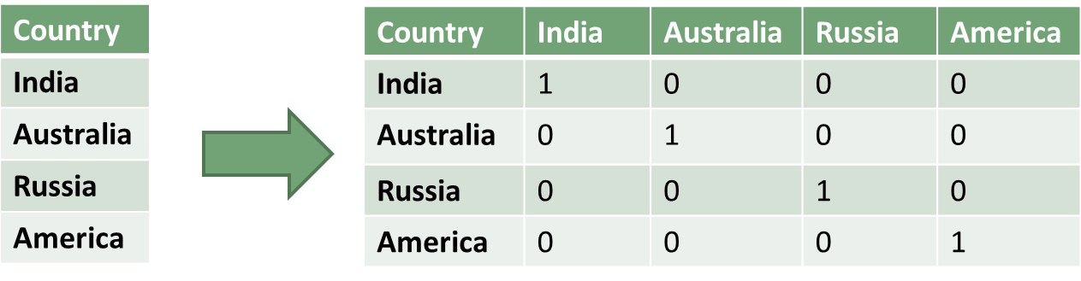

- It allows the use of categorical variables in models that require numerical input.
- It can improve model performance by providing more information to the model about the categorical variable.
- It can help to avoid the problem of ordinality, which can occur when a categorical variable has a natural ordering (e.g. “small”, “medium”, “large”).

Label Encoding
Label Encoding is a technique that is used to convert categorical columns into numerical ones so that they can be fitted by machine learning models which only take numerical data. It is an important pre-processing step in a machine-learning project.
This approach is very simple and it involves converting each value in a column into a number.
Consider a dataset having many more columns, to understand label-encoding, we will focus on one categorical column only i.e. State which is having below values.
Different labels are there in a State feature that is assigned different numeric values.
So for its implementation, all we have to do is:
- Import the LabelEncoder class from the sklearn library
- Fit and transform the first column of the data
- Replacing the existing text data with the new encoded data.
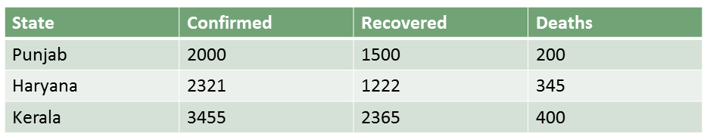
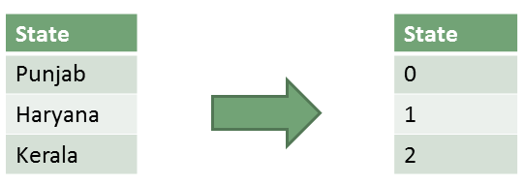

StandardScaler is used to resize the distribution of values ​​so that the mean of the observed values ​​is 0 and the standard deviation is 1. StandardScaler is an important technique that is mainly performed as a preprocessing step before many machine learning models, in order to standardize the range of functionality of the input dataset. StandardScaler comes into play when the characteristics of the input dataset differ greatly between their ranges, or simply when they are measured in different units of measure. StandardScaler removes the mean and scales the data to the unit variance. However, outliers have an influence when calculating the empirical mean and standard deviation, which narrows the range of characteristic values. The idea behind the StandardScaler is that variables that are measured at different scales do not contribute equally to the fit of the model and the learning function of the model and could end up creating a bias.

Parameters | Supervised machine learning | Unsupervised machine learning
Input Data | Algorithms are trained using labeled data. | Algorithms are used against data that is not labeled
Computational Complexity | Simpler method | Computationally complex
Accuracy | Highly accurate | Less accurate
No. of classes | No. of classes is known | No. of classes is not known
Data Analysis | Uses offline analysis | Uses real-time analysis of data
Algorithms used | Linear and Logistics regression, Random forest,  Support Vector Machine, Neural Network, etc. | K-Means clustering, Hierarchical clustering,  Apriori algorithm, etc.
Output | Desired output is given. | Desired output is not given.
Training data | Use training data to infer model. | No training data is used.
Complex model | It is not possible to learn larger and more complex models than with supervised learning. | It is possible to learn larger and more complex models with unsupervised learning.
Model | We can test our model. | We can not test our model.
Called as | Supervised learning is also called classification. | Unsupervised learning is also called clustering.
Example | Example: Optical character recognition. | Example: Find a face in an image.

Supervised learning types:
Types:-
- Regression
- Logistic Regression
- Classification
- Naive Bayes Classifiers
- K-NN (k nearest neighbors)
- Decision Trees
- Support Vector Machine

Unsupervised learning consists of Clustering, Association, Anomaly detection, and dimensionality reduction. Unsupervised learning applications are customer segmentation, market basket analysis, fraud detection, network security analysis, etc.

Clustering in Machine Learning

It is basically a type of unsupervised learning method. An unsupervised learning method is a method in which we draw references from datasets consisting of input data without labeled responses. Generally, it is used as a process to find meaningful structure, explanatory underlying processes, generative features, and groupings inherent in a set of examples.
Clustering is the task of dividing the population or data points into a number of groups such that data points in the same groups are more similar to other data points in the same group and dissimilar to the data points in other groups. It is basically a collection of objects on the basis of similarity and dissimilarity between them.

Clustering Methods:
- Density-Based Methods: These methods consider the clusters as the dense region having some similarities and differences from the lower dense region of the space. These methods have good accuracy and the ability to merge two clusters. Example DBSCAN (Density-Based Spatial Clustering of Applications with Noise), OPTICS (Ordering Points to Identify Clustering Structure), etc.
- Hierarchical Based Methods: The clusters formed in this method form a tree-type structure based on the hierarchy. New clusters are formed using the previously formed one. It is divided into two category
  - Agglomerative (bottom-up approach)
  - Divisive (top-down approach)

Support Vector Machine Algorithm
Support Vector Machine or SVM is one of the most popular Supervised Learning algorithms, which is used for Classification as well as Regression problems. However, primarily, it is used for Classification problems in Machine Learning.
The goal of the SVM algorithm is to create the best line or decision boundary that can segregate n-dimensional space into classes so that we can easily put the new data point in the correct category in the future. This best decision boundary is called a hyperplane.
SVM chooses the extreme points/vectors that help in creating the hyperplane. These extreme cases are called as support vectors, and hence algorithm is termed as Support Vector Machine

Types of SVM
SVM can be of two types:
- Linear SVM: Linear SVM is used for linearly separable data, which means if a dataset can be classified into two classes by using a single straight line, then such data is termed as linearly separable data, and classifier is used called as Linear SVM classifier.
- Non-linear SVM: Non-Linear SVM is used for non-linearly separated data, which means if a dataset cannot be classified by using a straight line, then such data is termed as non-linear data and classifier used is called as Non-linear SVM classifier.

Decision Tree Classification Algorithm
- Decision Tree is a Supervised learning technique that can be used for both classification and Regression problems, but mostly it is preferred for solving Classification problems. It is a tree-structured classifier, where internal nodes represent the features of a dataset, branches represent the decision rules and each leaf node represents the outcome.
- In a Decision tree, there are two nodes, which are the Decision Node and Leaf Node. Decision nodes are used to make any decision and have multiple branches, whereas Leaf nodes are the output of those decisions and do not contain any further branches.
- The decisions or the test are performed on the basis of features of the given dataset.
- It is a graphical representation for getting all the possible solutions to a problem/decision based on given conditions.
- It is called a decision tree because, similar to a tree, it starts with the root node, which expands on further branches and constructs a tree-like structure.
- In order to build a tree, we use the CART algorithm, which stands for Classification and Regression Tree algorithm.
- A decision tree simply asks a question, and based on the answer (Yes/No), it further split the tree into subtrees.
There are various algorithms in Machine learning, so choosing the best algorithm for the given dataset and problem is the main point to remember while creating a machine learning model. Below are the two reasons for using the Decision tree:
- Decision Trees usually mimic human thinking ability while making a decision, so it is easy to understand.
- The logic behind the decision tree can be easily understood because it shows a tree-like structure.

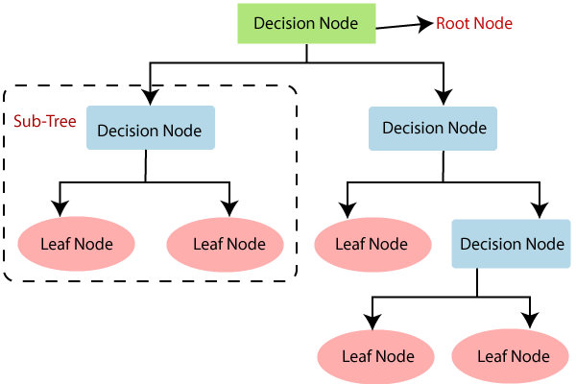

K-Means Clustering Algorithm
K-Means Clustering is an unsupervised learning algorithm that is used to solve the clustering problems in machine learning or data science. In this topic, we will learn what is K-means clustering algorithm, how the algorithm works, along with the Python implementation of k-means clustering.
It is a centroid-based algorithm, where each cluster is associated with a centroid. The main aim of this algorithm is to minimize the sum of distances between the data point and their corresponding clusters.
The algorithm takes the unlabeled dataset as input, divides the dataset into k-number of clusters, and repeats the process until it does not find the best clusters. The value of k should be predetermined in this algorithm.
The k-means clustering algorithm mainly performs two tasks:
- Determines the best value for K center points or centroids by an iterative process.
- Assigns each data point to its closest k-center. Those data points which are near to the particular k-center, create a cluster.
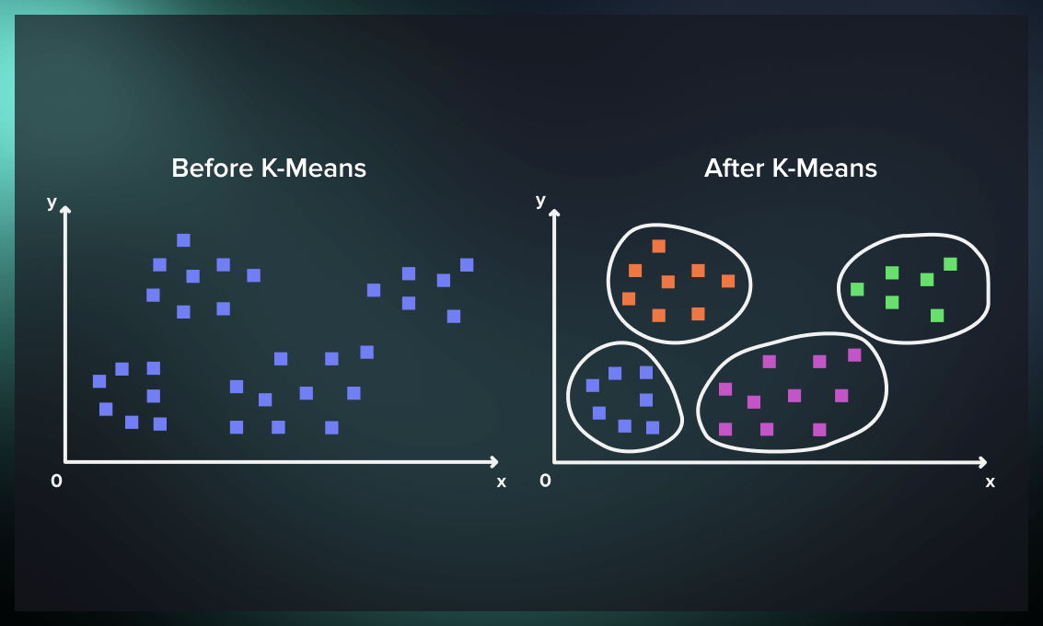
To sum up, the process consists of the following steps:
- Provide the number of clusters (k) the algorithm must generate.
- Randomly select k data points and assign each as a centroid of a cluster.
- Classify data based on these centroids.
- Compute the centroids of the resulting clusters.
- Repeat the steps 3 and 4 until you reach a stopping condition

K-Nearest Neighbor(KNN) Algorithm for Machine Learning
- K-Nearest Neighbour is one of the simplest Machine Learning algorithms based on Supervised Learning technique.
- K-NN algorithm assumes the similarity between the new case/data and available cases and put the new case into the category that is most similar to the available categories.
- K-NN algorithm stores all the available data and classifies a new data point based on the similarity. This means when new data appears then it can be easily classified into a well suite category by using K- NN algorithm.
- K-NN algorithm can be used for Regression as well as for Classification but mostly it is used for the Classification problems.
- K-NN is a non-parametric algorithm, which means it does not make any assumption on underlying data.
- It is also called a lazy learner algorithm because it does not learn from the training set immediately instead it stores the dataset and at the time of classification, it performs an action on the dataset.
- KNN algorithm at the training phase just stores the dataset and when it gets new data, then it classifies that data into a category that is much similar to the new data.

Why do we need a K-NN Algorithm?
Suppose there are two categories, i.e., Category A and Category B, and we have a new data point x1, so this data point will lie in which of these categories. To solve this type of problem, we need a K-NN algorithm. With the help of K-NN, we can easily identify the category or class of a particular dataset. Consider the below diagram:

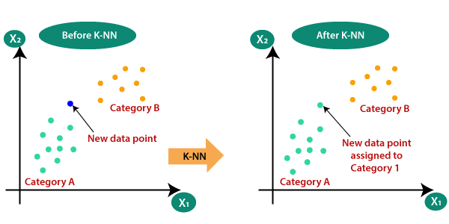

What is the difference between kNN and k-means?
Since both k-nearest neighbors (kNN) and k-means clustering use a hyperparameter called k, they can be mistaken for each other. Let’s look at the differences between these machine learning algorithms.
The main difference between the two algorithms is that k-means is a clustering algorithm, while k-nearest neighbors is a classification algorithm.
K-means is an unsupervised algorithm. It divides an unlabeled set of data into clusters based on the patterns that the data exhibits. The clusters are created by the algorithm and might not map to any “human” concepts.
In contrast, kNN is a supervised algorithm. It uses a distance function to find the closest labeled points to a given unlabeled point, the classes of which are then used to classify that point. This enables you to use a previously labeled data set to label new data points. The classes used for labeling are already predetermined: there is no way to create new ones.
The k value in k-means refers to the amount of clusters that will be created by the algorithm, while the k in kNN refers to the number of points (nearest neighbors) that will be used to classify any given point

Artificial Neural Network Tutorial
Artificial Neural Network Tutorial provides basic and advanced concepts of ANNs. Our Artificial Neural Network tutorial is developed for beginners as well as professions.
The term "Artificial neural network" refers to a biologically inspired sub-field of artificial intelligence modeled after the brain. An Artificial neural network is usually a computational network based on biological neural networks that construct the structure of the human brain. Similar to a human brain has neurons interconnected to each other, artificial neural networks also have neurons that are linked to each other in various layers of the networks. These neurons are known as nodes.
Artificial neural network tutorial covers all the aspects related to the artificial neural network. In this tutorial, we will discuss ANNs, Adaptive resonance theory, Kohonen self-organizing map, Building blocks, unsupervised learning, Genetic algorithm, etc.
The term "Artificial Neural Network" is derived from Biological neural networks that develop the structure of a human brain. Similar to the human brain that has neurons interconnected to one another, artificial neural networks also have neurons that are interconnected to one another in various layers of the networks. These neurons are known as nodes.
An Artificial Neural Network in the field of Artificial intelligence where it attempts to mimic the network of neurons makes up a human brain so that computers will have an option to understand things and make decisions in a human-like manner. The artificial neural network is designed by programming computers to behave simply like interconnected brain cells.
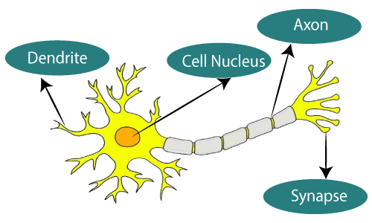
Biological Neural Network | Artificial Neural Network
Dendrites | Inputs
Cell nucleus | Nodes
Synapse | Weights
Axon | Output

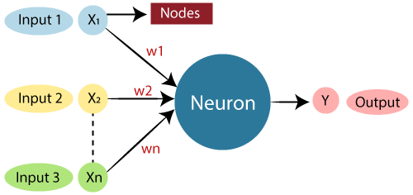

Logistic Regression in Machine Learning
- Logistic regression is one of the most popular Machine Learning algorithms, which comes under the Supervised Learning technique. It is used for predicting the categorical dependent variable using a given set of independent variables.
- Logistic regression predicts the output of a categorical dependent variable. Therefore the outcome must be a categorical or discrete value. It can be either Yes or No, 0 or 1, true or False, etc. but instead of giving the exact value as 0 and 1, it gives the probabilistic values which lie between 0 and 1.
- Logistic Regression is much similar to the Linear Regression except that how they are used. Linear Regression is used for solving Regression problems, whereas Logistic regression is used for solving the classification problems.
- In Logistic regression, instead of fitting a regression line, we fit an "S" shaped logistic function, which predicts two maximum values (0 or 1).
- The curve from the logistic function indicates the likelihood of something such as whether the cells are cancerous or not, a mouse is obese or not based on its weight, etc.
- Logistic Regression is a significant machine learning algorithm because it has the ability to provide probabilities and classify new data using continuous and discrete datasets.
- Logistic Regression can be used to classify the observations using different types of data and can easily determine the most effective variables used for the classification. The below image is showing the logistic function:
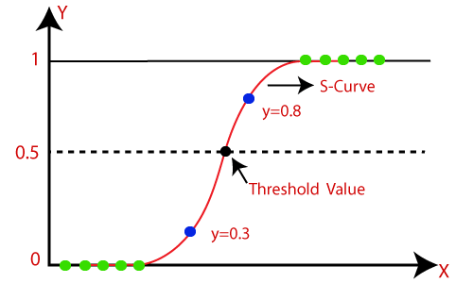
- The sigmoid function is a mathematical function used to map the predicted values to probabilities.
- It maps any real value into another value within a range of 0 and 1.
- The value of the logistic regression must be between 0 and 1, which cannot go beyond this limit, so it forms a curve like the "S" form. The S-form curve is called the Sigmoid function or the logistic function.
- In logistic regression, we use the concept of the threshold value, which defines the probability of either 0 or 1. Such as values above the threshold value tends to 1, and a value below the threshold values tends to 0.

