

| CIOBrain: Database Maintenance Functions  By **Group 7**  For Fellows Consulting Group, LLC.  **Date: Feb/3/2023**  **Team Members**  Naxel Santiago  John Whatley  Danny Bao  Steve Alvarado  Eyal Grinberg  Pranay Mantramurti |
| --- |

# Abstract

This document outlines the basic management plan for the CIOBrain: Database Maintenance project. Every section of this document can be found and navigated through the table of contents. The document consists of the methodology to be followed by the development team, and gives a proposed schedule to be used for the completion of the project. The aim of this document is to give all stakeholders and developers a guide as to how the project will be organized, how communications will be conducted and how file configuration will be kept up to version.

# 

# Table of Contents

*Abstract*

*Table of Contents*

*List of Figures*

*List of Tables*

*Introduction*

*Project Organization*

*Stakeholders*

*Development Team*

*Life Cycle Model Used*

*Risk Analysis*

*Risks*

*Severity*

*Hardware and Software Resource Requirements*

*Deliverables and Schedule*

*Monitoring, Reporting and Controlling Mechanisms*

*Professional Standards*

*Guideline*

*Configuration Management*

## 

## List of Figures

| Figure 1 - Risk Severity Matrix | 6 |
| --- | --- |
| Figure 2 - Asana | 11 |
| Figure 3 - Asana Tasks | 12 |

## List of Tables

| Table 1 - Stakeholder Table | 4 |
| --- | --- |
| Table 2 - Developer Team Table | 4 |
| Table 3 - Risk Table | 5 |
| Table 4 - Hardware Table | 6 |
| Table 4 - Schedule of Document Deliverables | 7 |

# Introduction

The project management plan described in this document will include everything from planning, to developing and testing a CIObrain database. The plan takes into consideration the schedule constraints (February-May 2023), and the amount of developers assigned to this project. CIObrain is a product that takes in databases, and creates dependency graphs out of them, to enable organizations easier understanding and visualization of their connections to other companies. As of now, the databases are all excel files format.

The CIObrain product has three app products: CIObrain trial, CIObrain development for win 10/11, and CIObrain azure deployment. Our team will focus on resolving existing bugs, and then creating a database system to make the apps work better.

The plan structure contains the information and components needed for this project: the organization, the lifecycle we chose, risk analysis, hardware and software in this project, deliverables, scheduling, and configuration.

# Project Organization

The project is organized into two different groups, the stakeholders and the development team. The stakeholders are made up of our sponsor and the end user who the application is made for, these would be the Chief Information Officers who will be analyzing all the data on the excel sheets through the use of the application. The development team is made up of UTD students who will be dividing the different work spaces accordingly. Through this we will have students who specialize in different areas and can dive deep into the specifics of each deliverable.

## Stakeholders

| **Role** | **Member Name** |
| --- | --- |
| Sponsor | Tom Hill |
| Customers | CIOs |

## Development Team

| **Role** | **Member Name** |
| --- | --- |
| Project Manager | Tom Hill |
| Project Lead | Naxel Santiago |
| Requirements Lead | Danny Bao |
| Development Lead | John Whatley |
| Testing Lead | Steve Alvarado |
| Deployment Lead | Eyal Grinberg |
| UI Lead | Pranay Mantramurti |

# 

# Life Cycle Model Used

The life cycle model used for the development of this will be an Agile methodology. An agile methodology allows for more flexibility while developing the software. Agile can produce a product faster when compared to the other life cycle models, thus it is ideal for our short term project. Models like waterfall are inherently weaker and produce products for a longer period of time. Agile also produces important metrics such as lead time, cycle time and throughput that allows for an increase in communication and a decrease in project risks.

# 

# Risk Analysis

## Risks

| **Risk ID** | **Risk Description** | **Likelihood** | **Impact** | **Exposure** |
| --- | --- | --- | --- | --- |
| A | Loss of key personnel | 40% | 0.6 | 0.2 |
| B | High requirements volatility | 90% | 0.5 | 0.5 |
| C | Setbacks due to dependency failures | 50% | 0.2 | 0.1 |
| D | Unrealistic commitments | 60% | 1.0 | 0.6 |

1. Loss of key personnel
   1. Reason: If team members fail to sufficiently continue to contribute to the project
   2. Mitigation: spreading responsibilities across multiple team members to mitigate risk; tracking velocity with story points to observe.
2. High requirements volatility
   1. Reason: If user needs are not clearly elicited or are uncovered to be drastically different during development
   2. Mitigation: attempt, as much as possible, to uncover requirements through interviews, emails, and user testing.
3. Setbacks due to dependency failures
   1. Reason: Problems that arise from physical machine failures and misrepresented features in dependencies used.
   2. Mitigation: work with “wide roots” first, testing basic features before fleshing features out; implement dependencies using interfaces such that they can be replaced with dependencies that fail to deliver.
4. Unrealistic commitments
   1. Reason: overcommitting available resources by over-estimating available resources relative to desired feature set quality and scope.
   2. Mitigation: target the features that give the most “bang for your buck” first; evaluate velocity at weekly meetings to inform project management goals; monitor requirements volatility.

## Severity

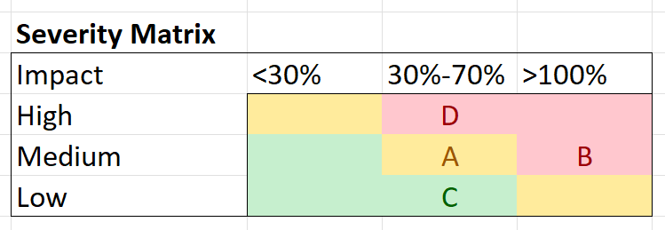

# Figure 1

# Hardware and Software Resource Requirements

| **Name** | **Description** | **Rationale** |
| --- | --- | --- |
| Windows 10/11 | Operating System | Compatibility issues such as line endings are less pervasive; OS available in UTD computer lab. |
| Azure | Hosting model | Provides flexible hosting models and in-depth logging; already in use from last semester. |
| Node.js | Web server | Already in use from last semester; switching would cause overhead. |
| React | Front-end UI web framework | Already in use from last semester; switching would cause overhead; provides flexible component-based web design model with dynamic data-binding. |
| Electron.js | Native client wrapper | Already in use from last semester; switching would cause overhead. |
| Microsoft Excel | Data format | Convenient to edit for existing users; already in use from last semester; switching would cause overhead. |
| Visual Studio Core | Integrated Development Environment | Easy to use, flexible (NOTE: not mandated). |

# Deliverables and Schedule

| **Assignment** | **Members** | **Due Date** |
| --- | --- | --- |
| Project Management Plan | All members | 2/3/2023 |
| Requirements Documentation | All members | 2/17/2023 |
| Architecture Documentation | All members | 3/3/2023 |
| Detailed Design Documentation | All members | 3/24/2023 |
| Testing Plan | All members | 4/14/2023 |
| Final Project Report | All members | 5/5/2023 |
| Final Project Demonstration | All members | 5/5/2023 |

# 

# Monitoring, Reporting and Controlling Mechanisms

Our team holds weekly sprints that begin every Monday and end on Friday. Additionally, weekly meetings are held with the sponsor every Friday at 2:00 PM CST to discuss the progress for the current sprint as well as the expectations and tasks to be completed for the next sprint. Progress will be reported through documentation deliverables that are to be completed on or before the assigned due dates listed in the table in the previous section. Our team will be tracking assignment deadlines using a project management application called **Asana**. All communications will be held through a **Discord** group chatin which all of the members are free to ask questions and collaborate.

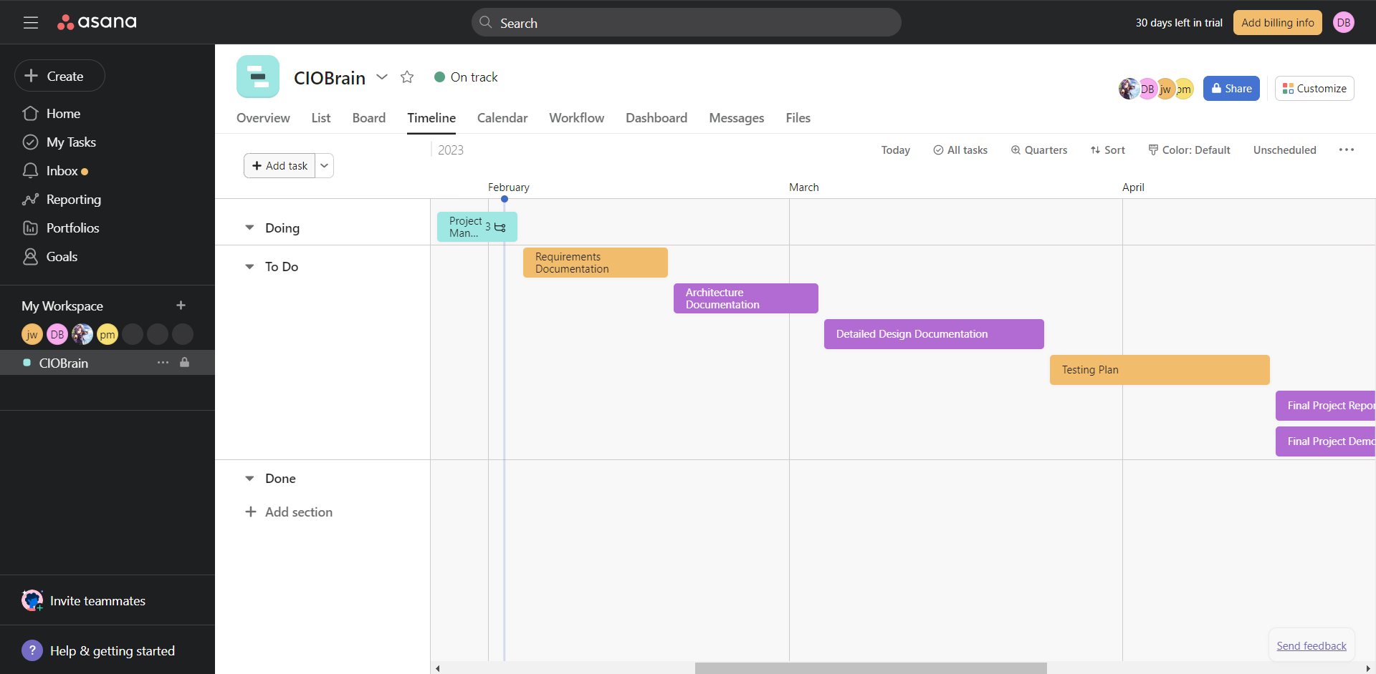

**Figure 2**

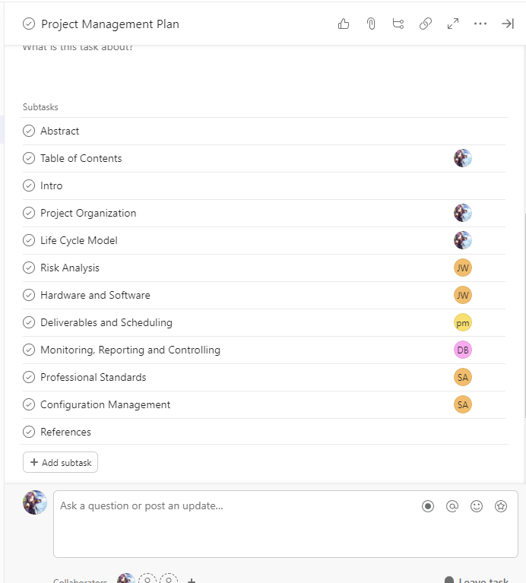

# Figure 3

# Professional Standards

“As a Comet, I pledge honesty, integrity, and service in all I do.”

- Comet Creed

* Team members are expected to meet every Friday at 2:00 pm to discuss progress of the project.
* Team members are expected to communicate any problems they encounter.
* Team members are expected to have completed their work on time.
* Team members are to conduct themselves in a respectful manner to one another.

## Guideline

“On the first occurrence of unacceptable behavior, determine the circumstances involved, resolve the problem, and document the event in the meeting minutes. On a second occurrence, notify the instructor of the problem. A meeting will be set up to evaluate the situation and resolve the problem. On a third occurrence, again notify the instructor of the problem. A meeting will be set up to evaluate the situation and resolve the problem. At this point, the team will have the *option* of removing the team member. If removed, then the team member receives a prorated grade based on the number of weeks they have participated in the group. Examples of unacceptable behavior may include not delivering on time, delivering poor quality work, missing team meetings, being unprepared for team meetings, disrespectful or rude behavior, etc. Reasons such as "too busy" or "I forgot", or "my dog ate my design model" are unacceptable. Valid reasons that must be considered include those listed for obtaining an incomplete standing in a course (illness, death in the family, travel for business or academic reasons, etc.)”

- Project Management Plan, Erick Wong

# Configuration Management

1. Document and Code can be found on Github