SUNYANI TECHNICAL UNIVERSITY (STU)
FACULTY OF APPLIED SCIENCE & TECHNOLOGY
DEPARTMENT OF COMPUTER SCIENCE

PROJECT TOPIC:
DESIGN AND IMPLEMENTATION OF A WEB-BASED
PRIVATE TUTOR FINDER
BY
KPETAA PATRICK 06201164
GAMOR KELVIN 06201139
HAMID MUFTAWU AYINGA 06201145
ASANTE DANTUO KENNETH 06201082

PROJECT SUBMITTED TO THE DEPARTMENT OF COMPUTER SCIENCE, FACULTY OF APPLIED SCIENCE AND TECHNOLOGY IN PARTIAL FULFILLMENT FOR THE REQUIREMENT OF THE AWARD OF NATIONAL HIGHER DIPLOMA IN COMPUTER SCIENCE DEPARTMENT

SEPTEMBER, 2023
DECLARATION
We hereby declare that, except for the reference to other people’s work, which has been duly acknowledged, this research work consists of our work produced from research undertaken under supervision and that no part nor full, has being published or presented for any DEGREE /HND elsewhere.

NAME OF STUDENT INDEX NUMBER SIGNATURE DATE
KPETAA PATRICK 06201164 ………………. …………..
GAMOR KELVIN 06201139 ………………. …………..
HAMID MUFTAWU AYINGA 06201145 ………………. ………….
ASANTE DANTUO KENNETH 06201082 ………………. ………….

CERTIFICATION
This is to certify that the project report titled “DESING AND IMPLEMENTATION OF A WEB-BASED PRIVATE TUTOR FINDER” is an authentic record and work done by Kpetaa Patrick, Gamor Kelvin, Hamid Muftawu Ayinga and Asante Dantuo Kenneth and submitted in partial fulfillment of requirement for the Higher National Diploma in Information and Communication Technology at Sunyani Technical University (STU).

MR. SLYVERSTER KWASI ADJEI-GYABBA DATE
(SUPERVISOR)

DR. BEN BEKLISI KWAME AYAWLI DATE
(HEAD OF DEPARTMENT)

DEDICATION
We will first of all dedicate this piece of work to the almighty God who has being with us right from the beginning of this journey to this far for his immersed blessings bestowed on us. We will also like to dedicate this work to our parents for the financial support rendered to us during this period in school. And we pray that God will grant them many years to reap the fruit of their labor. We also like to dedicate it to our able supervisor who out of his busy schedules still creates times to meet us to ensure that we are on truck. He has really contributed a lot to the success of this project. And finally, we will like to dedicate this work to all the lecturers in the computer science department who has impacted us with the required knowledge and skills throughout our three years stay in the university, without their selfless services rendered we couldn’t have come this far

ACKNOWLEGDEMENT
Our first and foremost gratitude goes to the almighty God who has given us retentive memory to be able to come out with this project based on what we are being taught. We will also like to thank all the lecturers in the computer science department for their guidance and the knowledge impacted unto us. We are really grateful for their selfless service rendered to us. Our special thanks also go to Mr. Kwao Dawson and Mr. Kusi for their constant advice to us on career building and how to find ourselves worthy in any society we find ourselves in. Finally, we will like to thank our project supervisor for his massive contribution to the success of this project.

TABLE OF CONTENT
DECLARATION.......................................................................................................................ii
CERTIFICATION.....................................................................................................................iii DEDICATION..........................................................................................................................iv ACKNOWLEDGEM................................................................................................................v ABSTRACT..............................................................................................................................vi
LIST OF FIGURES..................................................................................................................ix
CHAPTER ONE
1.1 Background of The Study…………………………………………………….……………1
1.2 Statement of The Problem…………………………………………………………………2
1.3 General Objective………………………………………………………………………….2
1.4 Specific Objectives…...…………………………………………………………………2-3
1.5 Significance of The Study…………………………………………………………………3
1.6 Limitation of the study…………………………………………………………….………3
1.7. Delimitations……………………………………………………………………..……….4
1.8 Organization of The Research…………………………………………….……………….5
CHAPTER TWO
Literature review
Introduction……………………………………………………………………………………6
2.1 Models…………………………………………………………………………………….6
2.2 Background……………………………………………………………………………...6-7
2.3 Fist Generation……………………………………………………………………………7.
2.4 Second Generation………………………………………………………………………..7
2.5 Third Generation………………………………………………………………………...8-9

CHAPTER THREE
3.1. System Analysis.……………..………………………………………………………….10
3.1.1 Tools Used for The System Analysis…..………………………………...…………11-18
3.1.2 Description of The Existing System……………………………………………….…...19
3.1.3 Problem Definition………………………………………………………………...…...20
3.1.4 Hardware Requirement Specification…...……………………………………….…….20
3.1.5 Software Requirement Specification……………..……………………………………20
3.1.6 Functional Requirements………………………………………………….……........21
3.1.7 Non-Functional Requirement………………………………………………………..22
3.1.8 Feasibility Analysis of The System………………………….………………………23
3.2. Database Design……………………………………………………….…….….....23-25
3.2.1 Data Element Dictionary…………………………………………………………26-28
CHAPTER FOUR
SYSTEM DEVELOPMENT, TESTING AND IMPLEMENTATION
4.1 System Development…………………………………………………………………29-38
4.2 System Testing……………………………………………………………………..…….39
4.3 System Implementation………………………………………………………………40-41
CHAPTER FIVE
SUMMARY, CONCLUSION AND RECOMMENDATIONS
5.1Summary……………………….………………………………………………….……...38
5.2 Conclusion…………………………………………………………………………….….38
5.3 Recommendations…………………………………………………………………….….39
REFERENCES……………………………………………………………………………….40
APPENDICES……………………………………………………………………………41-49
LIST OF FIGURES
Figure1: Use Case Diagram……………………………………………………….………...12
Figure2: Flowchart Diagram…...……………………………………………………….…..14
Figure3: Entity Relation Diagram……………………….…………………………….……15
Figure4: spiral model…………………………………………………….…………………18
Figure5: Admin Panel………………………………………………….………...…………32
Figure6: Student Panel………………………………………………….…………………..32
Figure7: Booking Section…………………………………………….…...…………….….33
Figure8: Home Page………………………………………………………………..…..…..33
Figure9: Course Section………………………………………………………….….….….34
Figure10: Profile Section……………………………………………………….………,…34
Figure11: Login Panel……………………………………………………….………….….35
Figure12: Registeration Section……………………………………………….……….…..35

ABSTRACT
The inclination of parents towards having their children to obtain best possible academic results as well as to secure scholarships for higher education are the common practices in Ghana. Some of these parents are willing to pay high price to secure the best tutors for home or private tuitions. This is because the teachers at schools are struggling to handle high numbers of students per class as well as incapacity of teachers to provide one-to-one coaching and mentoring due to high workloads. Hence, home or private tutoring is next practical solution that contributes in the building of the academic excellence of the children because of the one-on-one coaching and mentoring, small class, close monitoring on the learning, and continuous observation on the student’s performance. However, the parents are still facing impediments to decide the desirable home or private tutor for each specific subject at the reasonable rate. Therefore, this paper discusses on the issues faced by the parents in securing home/private tutor as well as a new developed web-based application to facilitate private-tutoring services. With the application web-based tutor finder, parents, teachers, tutors, and students have better opportunities to decide, earn, learn, and thrive successfully together.

CHAPTER ONE
INTRODUCTION
This chapter focuses on the objectives of the research, problems statements, and benefits of the system and an overview of the entire research organization. In an era defined by unprecedented access to information, the quest for knowledge has undergone a profound transformation. The traditional paradigms of education have evolved, and learners now have the world at their fingertips, ready to explore and conquer. In this rapidly changing landscape, the emergence of online private tutor finder platforms represents a pivotal step forward, bridging the gap between students hungry for knowledge and the expert guidance they seek.
  - Background Information
School is not the only place where students may learn. During secondary schooling, many students get additional support from private tutoring. In Germany, about half of the student population receives private tutoring at some point in their school career. Private tutoring refers to tutoring in academic subjects (e.g., languages, mathematics, or science) to improve academic achievement. It is provided by tutors for financial gain, and does not include extracurricular activities, such as sports, or remedial lessons in school. Students and their families invest a lot of time and money in private tutoring. The vast majority of them state that it improves the child’s academic achievement.
However, empirical findings on the effectiveness of private tutoring are rather contradictory. Among longitudinal studies that controlled for systematic differences between students with and without tutoring, some found a positive effect on achievement, but others found minimal effects or none at all. Therefore, it is not sufficient to ask whether private tutoring is effective in improving students’ achievement. Students’ prior knowledge and their motivation to learn, as well as the instructional quality of the tutoring lessons, are aspects that might influence its effectiveness. However, to the best of our knowledge, no studies have yet systemically investigated the instructional quality of private tutoring and its effect on students’ academic achievement. Therefore, the aim of this study was threefold: Drawing on data from the German National Educational Panel Study (NEPS; Blossfeld, Robbach, & von Maurice, 2011), we first analyzed whether students privately tutored in the subjects German or mathematics outperformed their non-tutored counterparts. Second, we analyzed whether the instructional quality of the tutoring lessons can be described with the three dimensions, structure, challenge, and support. Third, we analyzed the effects of the instructional quality on students' academic achievement. Similar to school instruction, private tutoring has multi-criteria goals. We, therefore, focused not only on achievement but also on the motivational effects of private tutoring. Computers and the internet are providing every information as a knowledge source. Even though everything is automated in the field of learning we prefer traditional methods.
In this busy world searching for tutors for any subject is a very difficult job. To make it simple herewith, we proposed an idea to find a subject expert tutor through web application. The proposed work has a common platform where the teacher and the student can access their respective available views. In this application users can register and view the availability of the subject expert based on the registered nearest location of the tutor. The process of finding a tutor is time-consuming.
The rise in educational standards has led to the need for additional coaching along with basic schooling. A web application for finding tutors can help a parent find tutors without consulting any third party. The application encourages parents to find tutors and tutors to find prospective students in their nearby vicinities. The tutor application also considers the fact that students need personal attention and guidance in studies. This system will be helpful for students and the parents who are considered as users to find the tutor in the nearby location. Teachers can also get a student just by logging onto the website and setting up the profile.
1.2 Statement of the Problem
Every parent desire to see their wards excel academically, some parents can go the extra mile to get tuition for their ward, unfortunately such parents encounter a lot of difficulties in getting the service of private tutors. Such difficulties include, getting a specialized tutor in various subjects, difficulties in finding qualified nearby tutors and also the cost involved in getting tutors. Hence the need to need to develop a tutor finding system to combat the challenges such parents or students faces in getting private tuition session.

1.3 General Objective
The main objective is to design and implement a web-based tutor finder system that will enable parents/students to get easy access to private tutors for extra tuition sessions.
1.4 Specific Objectives
- To develop a system to find the best private tutor which meet the demands of users indicating the status of booking and area of specialization.
- To send a notification to tutor and student on his booking appointment via email.
  - Significance of The Study
The Tutor Finder Project holds several significant advantages that aim to enhance the educational experience for all parties involved. The main objectives and significance are as follows:
- Complementing Teacher Efforts: The project aims to support and complement the efforts of teachers in integrating technology into the educational process. By providing a platform that connects parents, students, and tutors to the internet, the project creates an interactive and friendly environment for all users.
- Improving Academic Standards: One of the primary goals of the Tutor Finder Project is to ultimately improve the academic standard of pupils. By connecting students with qualified and experienced tutors, the project seeks to provide personalized guidance and support, leading to better academic performance.
- Easy Access to Tutors: The project ensures easy access to tutors for both students and parents, regardless of their geographical location. This accessibility eliminates the barriers of physical distance and enables students to find suitable tutors according to their needs.
- Flexible Mode of Instruction: The Tutor Finder Project offers flexibility in instructional methods by providing both virtual and face-to-face tutoring options. This adaptability allows students to choose the mode of learning that best suits their preferences and circumstances.

  - Limitation of the Study
Despite its potential benefits, the Tutor Finder Project does have some limitations that need to be acknowledged. These limitations include:
- Limited Awareness: Since the system is not known in the local environment, there might be challenges in promoting and disseminating information about the platform. Increasing awareness about its existence will be crucial for its success.
- Competition from Similar Apps: The presence of two apps with similar ideas in Europe might pose a challenge in gaining a competitive edge.
1.7 Delimitations
The benefits of implementing the Tutor Finder Project are multi-faceted and include:
- Enhanced Tutor Search: The proposed system will reduce difficulties in finding qualified and experienced private tutors by streamlining the search process and providing a database of vetted tutors.
- Transparent Decision-making: The ability to review tutors based on past students' and parents' experiences will promote transparency and help users make informed decisions when choosing a tutor.
- Improved Access to Education: Easy access to tutors regardless of location will expand educational opportunities for students who may have limited access to resources in their local area.
- Personalized Learning: By enabling students to select tutors based on their individual needs and preferences, the proposed system will facilitate personalized learning experiences.
- Building a Learning Community: The platform's interactive environment will foster collaboration and communication among parents, students, and tutors, creating a supportive learning community.
In conclusion, the Tutor Finder Project holds great promise in revolutionizing the way students find private tutors and enhancing the overall educational experience by utilizing technology, promoting accessibility, and fostering personalized learning opportunities.

1.8 Organization of the Research
This research work will be organized into five chapters. Chapter one is concerned with the introduction of the research study and it presents the preliminaries, theoretical background, statement of the problem, aim and objectives of the study, significance of the study, scope of the study, organization of the research and definition of terms.
Chapter two will focus on the literature review, the contributions of other scholars on the subject matter is discussed.
Chapter three will concern with the system analysis and design. It presents the research methodology used in the development of the system; it will analyze the present system to identify the problems and provides information on the advantages and disadvantages of the proposed system. The system design is also presented in this chapter.
Chapter four presents the system implementation and documentation, the choice of programming language, analysis of modules, choice of programming language and system requirements for implementation.
Chapter five focuses on the summary, constraints of the study, conclusion and recommendations are provided in this chapter based on the study carried out.

CHAPTER TWO
LITERATURE REVIEW
INTRODUCTION
This chapter looks at the existing literature relating to this study. Past existing literature has been reviewed extensively and weaknesses or gaps in those studies have been pointed out. This information was gotten from most research websites including google scholar and other platforms.
According to (Alkhatlan and Kalita, 2018), ITS’s are software capable of improving, adapting, and automating teaching. These systems offer the student interaction with the content adapted to their profile to improve the learning experience. An ITS (Online Tutoring System) usually has the Modules: Tutor, Student, Expert Knowledge, and User Interface. We consider these module names to standardize and facilitate understanding in this work.
2.1 MODELS
The Tutor Module is responsible for making pedagogical decisions and executing pedagogical instruction. This module needs algorithms to define the ITS intervention threshold in the study process, operationalize this intervention, and recommend content. The Student Module needs to capture, update and retrieve the student’s profile. The Expert Knowledge Module needs to represent and manipulate the learning content. The Student and Expert Knowledge Modules provide input for the Tutor Module to perform its tasks. The User Interface Module enables students to interact with the content and with the behavior of an ITS.
2.2 BACKGROUND
When talking about technological innovations, it is difficult to keep abreast of all the latest happenings since technological breakthroughs happen frequently. While ITS can benefit from these technological breakthroughs, they rely on advances not only in technology, but also fields like psychology and artificial intelligence. As such, ITS can be reviewed on a larger timescale than other technological innovations. One way they can be broken up is into generations (Nkambou et al., 2010). Nkambou et al. (2010) identified three generations of ITS. The first generational distinction made by Nkambou et al. (2010) described 20 years of research capped with seminal articles that related the state of the art. In similar fashion, the second generation is distinguished as 20 years of research, followed by the third generation which is ongoing.
2.3 FIRST GENERATION (1970-1990)
Nwana (1990) reviewed the first generation of artificial intelligence in education (AIED) and identified the steps that led to the realization of the first ITS. The precursor of ITS began with the development of computer assisted instruction (CAI) in the 1950s. Computer-assisted instruction programs followed a linear approach, moving students step-by-step to the learning goal or desired behavior. These initial attempts at CAI did not afford any individualization of the instruction. The same material was presented in the same sequence while ignoring student responses and providing no feedback (Nwana, 1990).
These machines advanced to branching programs in the 1960s. This new type of CAI took into consideration student responses and provided a unique learning tree for each student. As students successfully or unsuccessfully answered questions, the sequence of material changed to provide tailored instruction. Further functionality was added to CAI in the form of generative CAI in the late 1960s. The new CAI was able to create and solve its own material (Uhr, 1969). Woods & Hartley, 1971). This progression of CAI from linear programs to generative became the precursor for ITS.
2.4 SECOND GENERATION (1990-2010)
A majority of the ITS identified by the current review come from the second generation. As such, a review of the development of ITS will not be given here, but it is supplied in the findings section of this paper. Instead, this section addresses Self’s (1990) argument for the development of scientific foundations for AIED, including its own theories, techniques, and methods. Self also wanted theorizers to put into practice the ideas they had about ITS. In answer to Self’s call, biannual conferences and journals were created for the sole purpose of ITS development and research. Additionally, throughout the second generation, many ITS were built—another answer to Self’s call. However, these ITS rarely used the same architecture, which made it difficult to have a unified language. Regardless, common components could still be found between them. These components are: the domain, tutor, and student models as well as the interface used to interact with the tutoring system. Together, these components are called the four-component architecture (Wenger, 1987)

2.5 THIRD GENERATION (2010-present)
As ITS and other technologies become more commonplace in classrooms, Nye (2015) suggested that ITS will become less of comprehensive systems and more of an “ecosystem of reusable infrastructure and platforms”. This suggests that ITS will become a shell that draws from services provided by other sources. Nye provided an example where other online technologies operate under that philosophy: basic blog site uses authentication services from several different sources (e.g., Google, Facebook). This review corroborates this notion with the identification of some ITS that are domain independent. This means that these ITS are designed such that they are flexible enough to create an intelligent tutoring system based on the needs of whoever is creating content.
However, it is still too early to tell if ITS and AIED will make the shift to a service-based ecosystem even though Nye (2015) claimed it is an “existential necessity”. Even if ITS make the shift into a service-based ecosystem, thus obsoleting the need for a standardized architecture, much work has been done in the second and third generations that requires a consolidation of knowledge. By consolidating knowledge, gaps can be identified so that developers of ITS know which services ought to be provided and which are redundant. For example, the developers of Cognitive Tutor created a standalone Help Tutor which can provide metacognitive feedback to students and can be used in various systems (Roll, Aleven, McLaren, & Koedinger, 2011). Knowing that such a service already exists can help developers know that they should spend time on creating another service that fills a need like automatic affect detection.
Nowadays, 52% of parents in Malaysia facing difficulties providing academic guidance to their children at home (Romle A & Dalbir S 2011, pp. 1-6). This is because syllabus has changed frequently from time to time. This result generation gap that today syllabus unlike the syllabus learnt from their parents’ generation (Romle A & Dalbir S 2011, pp. 1-6). Therefore, most of the parents will opt to send their children take extra lessons after school hours or during holiday’s period. Today’s extra tutoring or private tutor is mostly obtained by referral among friends and family or direct contact via phone, website or email with tutors by hunting tutor website. Based on survey done by Amirul Azuani Romle and Dalbir Singh, they found that 23% parents cannot find suitable tutors for their children in Malaysia by using traditional ways obtain tutor via the referral among friends and family (Romle A & Dalbir S 2011, pp. 1-6). This is due to family members or friend facing similar issue on limitation of knowledge that only able obtain related information via flyer, advertisement locally.
Therefore, parents are beneficial if they can acquire suitable tutors via a central website that able to search for suitable tutor for their children at home without physically searching in the nearby residential area or referral from other that could give bias opinion or limited by the tutors. In present time, some websites do provide tutoring services already implement in Malaysia. First of all, feature compared such as “Handheld device mode” descript the website able to shrink the website layout to display in smaller smartphone screen for handheld devices ability. Then, for “Parents’ search functionalities”, it compares each website in term of the ability for parents directly contact wanted tutor by internal or external functionalities such as internal private message function or ability to get tutor’s contact information such as cell phone number, email address or etc. above and beyond.

CHAPTER THREE
SYSTEM ANALYSIS AND DESIGN
INTRODUCTION
This chapter is a discussion on requirement elicitation techniques such as interview and observation. Software development analysis such as spiral method, blueprint of the system in the form of flow chart, data flow diagram, use case diagrams, entity relationship (E.R) diagrams and database schema. Data gathering methodology for the proposed system is carried out using observation and interview method. According to (Kosso, Peter, 2011), observation is the active acquisition of information from a primary source. In living beings, observation employs the senses. Observations can be qualitative, that is, only the absence or presence of a property is noted, or quantitative if a numerical value is attached to the observed phenomenon by counting or measuring. But with this project the requirement we employed a participatory observation, which has been used in a variety of disciplines as a tool for collecting data about people, processes, and cultures in qualitative research. Interview is a very powerful method or tool for gathering data since it allows the person conducting\ the interview clarify a number of issues and also achieve detailed information. This provides the opportunity to get the in depth understanding of the users’ needs and requirements. Unstructured interview gives the chance to ask open- ended questions which helps identifies most of the system requirements. With interview, there is opportunity to ask most relevant questions customized for each respondent.
3.1 SYSTEM ANALYSIS
System analysis is a critical phase in the software development lifecycle (SDLC) and broader systems engineering processes. It is primarily concerned with understanding, defining, and documenting the requirements and constraints of a system that needs to be developed or improved.

3.1.1 TOOLS USE FOR THE SYSTEM ANALYSIS
During the system analysis phase of the online private tutor finder project, various tools and techniques were employed to understand the requirements and constraints of the system. The technique used in collecting data were, Interview, survey and brainstorming. Commonly used tools include:
Use Case Diagram
Use case diagram is valuable for visualizing the practical requirements for the system that will translate into design choices and development priorities. Use case diagrams are valuable UML diagram type and commonly used to analyses various systems. They enable you to imagine the difference types of roles in a system and how those roles cooperate with the system.
Figure1: Use case Diagram

Flowchart Diagram
A Flowchart is formalized clear representation of logic sequence, work or manufacturing process, organization chart or similar formalized structure. The purpose of flowchart is to provide with a common language or reference point when dealing with project or process. The flowchart below shows the application process, where any user can log in into the System, if the user has no account, then the admin can create account for the particular user. User can access privilege as shown in the below flowchart diagram.

Figure2: Flowchart Diagram

Entity Relationship Diagram
Entity relationship diagram is a kind of graph for presenting visually the entity set, attribute and the relationships between entities in a database

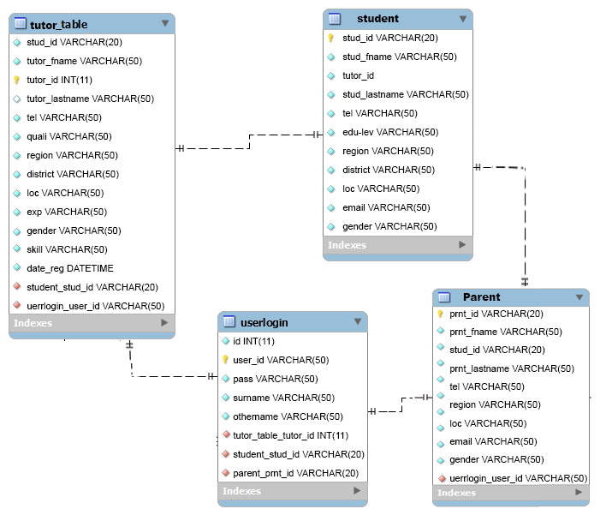
Figure3: Entity Relation Diagram

Spiral Development Model
The risk-driven sub setting of the spiral model steps allows the model to accommodate any appropriate mixture of a specification-oriented, prototype-oriented, simulation-oriented, and automatic transformation-oriented, or another approach to software development. The spiral model of the software process was originally proposed by Boehm (Boehm, 1988). Rather than represent the software process as a sequence of activities with some backtracking from one activity to another, the process is represented as a spiral. Each loop in the spiral represents a phase of the software process. Thus, the innermost loop might be concerned with system feasibility, the next loop with requirements definition, the next loop with system design, and so on. (Sommerville, 2006). The spiral model combines the iterative nature of prototyping with the controlled systematic aspects of the waterfall model.
Objective Identifications: Specific objectives for that phase of the project are defined. Constraints on the process and the product are identified and a detailed management plan is drawn up. Project risks are identified. Alternative strategies, depending on these risks, may be planned.
Alternate Evaluation: This involves Techniques use for discovering different methods or ways of accomplishing the work of the project. In this phase, it involves risk management and prototyping.
In risk management phase, a process will be undertaken to identify risks and alternate solutions. A prototype will then be produced at the end of the risk analysis phase. If any risk is found during the risk analysis, then alternate solutions are suggested and implemented.
Product development: In this phase, the software/system will be developed, along with
testing at the end of the phase. Hence in this phase, the development and testing are done.
Next phase planning: This phase allows the end-user, who is, in this case, a police officer to evaluate the output of the project to date before the project continues to the next spiral.
This way, the software will be developed in a series of evolutionary releases which might be paper models or prototypes. Each increment therefore will incorporate prototyping or
complete development of a part.
The first increment will produce a core product, addressing identified core needs. Each
the increment will be evaluated either by review or use after which a plan for the next increment will be drawn up. This methodology will work in tandem with test-driven development to guarantee the proper functioning of the system. The existing system, processes and procedures were observed closely and critically to gather data.

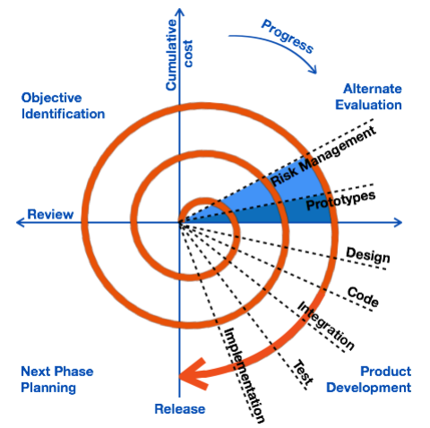

Figure:4 spiral model of the software development methodology

3.1.2 DESCRIPTION OF THE EXISTING SYSTEM
The existing system for finding private tutors operates primarily through traditional methods and fragmented online platforms. It lacks the centralized and user-friendly features that a modern online private tutor finder should ideally possess. Below are the key characteristics of the current system:
- Word-of-Mouth Referrals: Many students and parents rely on word-of-mouth referrals from friends, family, or acquaintances to find private tutors. This process is highly dependent on personal networks and lacks scalability.
- Tutoring Agencies: Some users resort to tutoring agencies or centers to find private tutors. However, these agencies often charge substantial fees, and the process of matching tutors with students can be slow and impersonal.
- Limited Subject Coverage: The current system offers limited subject coverage and specialization. It may not adequately cater to the diverse educational needs and preferences of students.
- Verification Challenges: Verifying the qualifications, credentials, and teaching experience of private tutors can be a cumbersome and uncertain process. This lack of transparency raises concerns about tutor quality and suitability.
- Inefficient Matchmaking: There is a lack of efficient matchmaking algorithms to connect students with suitable tutors. Matching is often done manually, leading to delays and potential mismatches.
- Inadequate User Profiles: Tutors and students have limited means to create comprehensive profiles, making it challenging to evaluate their compatibility. This lack of information hinders informed decision-making.
- Limited Communication Channels: Communication between students and tutors is primarily conducted through phone calls or emails. There's a lack of integrated communication features, such as messaging within the platform.
- Scheduling Issues: The scheduling tutoring sessions can be a manual and time-consuming task.

3.1.3 PROBLEM DEFINITION
The existing methods of finding private tutors are inefficient, lack transparency, and often do not meet the diverse educational needs of students and learners. These limitations create a pressing need for the development of an online private tutor finder platform to streamline the process of connecting students with qualified tutors.
3.1.4 HARDWARE REQUIREMENT SPECIFICATION
The technical feasibility carried out determined whether it is possible, in terms of software, hardware, personnel, and expertise, to handle the completion of the project. The system is technically feasible with development tools in terms of hardware and software. For the system to be implemented successfully some system requirements needs to be met. The hardware resources shall be as follows:
- Minimum of Pentium 4 processor with 1.4 GHZ speed
- Minimum of 512 MB of Ram
- A Hard disk of at least 40GB.
3.1.5 SOFTWARE REQUIREMENT SPECIFICATION
Then the software applications that are necessary for the implementation of this system are:
- Operating system: Window XP and above
- Environment work: Php/Mysql and Apache frame
- Browsers: Mozilla Firefox, Google Chrome, and UC Browser, and many others
- Back end: MYSQL and PHP
- Server: Xampp
- Sublime Text 3

Program Languages that are to be used:
- Graphic/Front End: Html, Css/ Bootstrap and JavaScript/Jquery
- Programming: PHP
- Database: MYSQL

3.1.6 FUNCTIONAL REQUIREMENT SPECIFICATION
Creating a functional requirement specification for an online private tutor finder system involves detailing the specific features and functionalities the system should have to meet user needs and solve identified problems. Here's a list of functional requirements for such a system:
User Registration and Profiles:
- User Registration: Users should be able to create accounts with unique usernames and passwords.
- Profile Creation: Users (both tutors and students) should be able to create and manage detailed profiles, including personal information, qualifications, subjects of interest, teaching experience (for tutors), and learning objectives (for students).
Communication and Scheduling:
- Scheduling: Allow users to book and manage tutoring sessions with a scheduling feature that considers both tutor and student availability.
- Notifications: Send email or in-app notifications for booking confirmations, session reminders, and other important updates.
User Account Management:
- Profile Editing: Allow users to edit and update their profiles, including personal information and profile pictures.
- Password Reset: Provide a password reset mechanism for users who forget their passwords.
- Account Deactivation: Allow users to deactivate or close their accounts if needed.
Admin Panel:
- Admin Dashboard: Provide administrators with a dashboard to monitor user activity, resolve disputes, and manage the platform.
- User Management: Allow administrators to manage user accounts, including suspending or banning users for policy violations.
3.1.7 NON-FUNCTIONAL REQUIREMENT SPECIFICATION
Non-functional requirements specify the qualities and characteristics that the online private tutor finder system should possess but are not directly related to its functionality. These requirements ensure that the system performs well, is reliable, secure, and user-friendly. Here's a list of non-functional requirements for such a system:
Performance Requirements:
- Response Time: The system should respond to user interactions within a maximum of 2 seconds to ensure a responsive user experience.
- Scalability: The system should be able to handle an increasing number of users and data without significant degradation in performance. It should be designed to scale horizontally as needed.
Security Requirements:
- Data Encryption: User data, including personal information and payment details, must be encrypted both in transit and at rest to protect against unauthorized access.
- Authentication: Implement secure authentication mechanisms, such as multi-factor authentication, to ensure that only authorized users can access the system.
- Authorization: Enforce strict access controls to limit what actions users can perform based on their roles (e.g., admin, tutor, student).
- Data Privacy: Comply with data privacy regulations and ensure that user data is handled and stored with the utmost privacy and consent.
Reliability and Availability:
- Uptime: The system should aim for at least 99.9% uptime, minimizing downtime for maintenance and updates.
- Redundancy: Implement redundancy measures, such as backup servers and databases, to ensure data integrity and availability in case of system failures.

Usability and User Experience:
- User-Friendly Interface: The user interface should be intuitive and user-friendly, catering to users of all levels of technical expertise.
- Accessibility: Ensure that the platform is accessible to individuals with disabilities, complying with accessibility standards.
- Cross-Browser Compatibility: The system should work seamlessly across various web browsers and devices, ensuring a consistent user experience. Compliance and Legal Requirements:
- Compliance with Laws: Ensure compliance with all relevant laws and regulations, including intellectual property, privacy, and education laws.
- Terms and Policies: Clearly communicate terms of service, privacy policies, and user agreements to users, and obtain their consent.
Backup and Disaster Recovery:
- Regular Backups: Implement regular automated backups of the system's database and critical data.
- Disaster Recovery Plan: Have a documented disaster recovery plan in place to recover the system in case of unforeseen events or data loss.
Cross-Platform Compatibility:
- Mobile Responsiveness: Ensure that the platform is mobile-responsive, allowing users to access and use it on smartphones and tablets.
User Support and Helpdesk:
- Helpdesk: Provide a support system for users to report issues, ask questions, and seek assistance with platform-related matters.
- Response Time for Support: Define response time expectations for support queries (e.g., within 24 hours for non-urgent inquiries).

3.1.8 FEASIBILITY ANALYSIS OF THE SYSTEM
- A high amount of risk analysis in this project is envisioned hence, avoidance of risk will be enhanced.
- Good for large and mission-critical projects – as it will be able to cope with changing
requirements as they can be introduced at any phase of the project.
- Project monitoring – can be done easily as reviews will be conducted regularly.
- Software is produced early in the software life cycle and hence system delivery will be fast.
- The model will be able to handle time and resources constraints.
3.2. DATABASE DESIGN
Designing the database for an online private tutor finder system involves defining the structure and relationships of the database tables to efficiently store and manage data related to users, tutors, students, sessions, reviews, and other relevant information. Below is a high-level overview of the database design for such a system:
Database Tables:
User Table:
  - Fields: UserID (Primary Key), Username, Email, Password (hashed), Role (Tutor or Student), Registration Date, Last Login, Status (Active, Inactive), etc.
Tutor Profile Table:
  - Fields: TutorProfileID (Primary Key), UserID (Foreign Key), Full Name, Profile Picture, Contact Information, Bio, Subjects Offered, Qualifications, Experience, Availability Schedule, Pricing, etc.
Student Profile Table:
  - Fields: StudentProfileID (Primary Key), UserID (Foreign Key), Full Name, Profile Picture, Contact Information, Educational Level, Learning Objectives, Subjects of Interest, etc.
Session Table:
  - Fields: SessionID (Primary Key), TutorID (Foreign Key), StudentID (Foreign Key), Date and Time, Duration, Location, Session Status (Scheduled, Completed, Canceled), Session Notes, Payment Status, etc.
Notification Table:
  - Fields: NotificationID (Primary Key), UserID (Foreign Key), Notification Type (e.g., Booking Confirmation).
Data Integrity:
- Enforce referential integrity constraints to ensure that data relationships between tables are maintained.
- Implement constraints, such as unique constraints on email addresses, to prevent duplicate data.

3.2.1 DATA ELEMENT DICTIONARY
A data element dictionary provides a detailed description of each data element used in a system. Here is a data element dictionary for an online private tutor finder system:
User Data:
User ID (Data Element): A unique identifier assigned to each user during registration.
  - Description: This data element uniquely identifies each user in the system.
  - Data Type: Integer
  - Constraints: Primary Key
Username (Data Element): The username chosen by the user for their account.
  - Description: The username is used for user identification and login.
  - Data Type: String (Alphanumeric)
  - Constraints: Unique, Not Null
Email Address (Data Element): The user's email address.
  - Description: Used for communication and account recovery.
  - Data Type: String (Email Format)
  - Constraints: Unique, Not Null
Password (Data Element): The hashed and salted password used for user authentication.
  - Description: Ensures secure access to the user's account.
  - Data Type: String (Hashed)
  - Constraints: Not Null
Registration Date (Data Element): The date and time when the user registered.
  - Description: Records when the user joined the platform.
  - Data Type: Datetime
  - Constraints: Not Null
Account Status (Data Element): Indicates whether the user's account is active or inactive.
  - Description: Determines if the user can access the platform.
  - Data Type: Enumeration (Active, Inactive)
  - Constraints: Not Null
Full Name (Data Element): The full name of the tutor.
  - Description: Displays the tutor's name on their profile.
  - Data Type: String
  - Constraints: Not Null
Contact Information (Data Element): The tutor's contact information (e.g., phone number, email).
  - Description: Allows users to contact the tutor.
  - Data Type: String (Phone, Email)
  - Constraints: Optional
Subjects Offered (Data Element): The subjects or topics the tutor can teach.
  - Description: Helps students find tutors based on their subject needs.
  - Data Type: Text (List of Subjects)
  - Constraints: Optional
Qualifications (Data Element): The tutor's educational qualifications and certifications.
  - Description: Showcases the tutor's academic achievements.
  - Data Type: Text
  - Constraints: Optional
Availability Schedule (Data Element): The tutor's available time slots for sessions.
  - Description: Helps students book sessions at convenient times.
  - Data Type: Datetime (Time Slots)
  - Constraints: Optional
Pricing Information (Data Element): The tutor's rates for tutoring services.
  - Description: Informs students about the tutor's pricing.
  - Data Type: Decimal (Currency)
  - Constraints: Optional
Student Profile Data:
Student Profile ID (Data Element): A unique identifier assigned to each student's profile.
  - Description: Uniquely identifies each student's profile.
  - Data Type: Integer
  - Constraints: Primary Key
User ID (Data Element): The user ID linked to the student's profile.
  - Description: Establishes a relationship between the user and their student profile.
  - Data Type: Integer (Foreign Key)
  - Constraints: Not Null
Full Name (Data Element): The full name of the student.
  - Description: Displays the student's name on their profile.
  - Data Type: String
  - Constraints: Not Null
Educational Level (Data Element): The student's current educational level.
  - Description: Provides information about the student's academic stage.
  - Data Type: String

CHAPTER FOUR

SYSTEM DEVELOPMENT TESTING AND IMPLEMENTATION

INTRODUCTION
This chapter describes the various tools and techniques used in the development of the Web-Based private tutor finder. The chapter also includes a description of the implementation, programming languages used, procedures adopted, testing and assessment as well as the various layers and also contains tasks performed by the system.
Implementation converts the concept presented in the design into an outcome. The latest available technologies had been used to implement the system. This chapter presents the implementation environment, implementation approach, and coding details. Our Software is structured well to work with a standard software development approach.

4.1 DEVELOPMENT TOOLS AND PLATFORM
This system was developed using the following architecture and tools
- Minimum of Pentium 4 processor with 1.4 GHZ speed
- Minimum of 512 MB of Ram
- A Hard disk of at least 40GB.
Then the software applications that are necessary for the implementation of this system are:
- Operating system: Window XP and above
- Environment work: Php/Mysql and Apache frame
- Browsers: Mozilla Firefox, Google Chrome, and UC Browser, and many others
- Back end: MYSQL and PHP
- Server: Xampp
- Sublime Text 3

Programming Languages that are used:
- Graphic/Front End: Html, Css/ Bootstrap and JavaScript/Jquery
- Programming: PHP

4.1.1 PHP

PHP is a server-side scripting language designed primarily for web development but is also used as a general-purpose programming language. Originally created by Rasmus Lerdorf in 1994, the PHP reference implementation is now produced by The PHP Group. PHP originally stood for Personal Home Page, but it now stands for the recursive acronym PHP: Hypertext Preprocessor. PHP code may be embedded into HTML code, or it can be used in combination with various web template systems, web content management systems, and web frameworks. PHP code is usually processed by a PHP interpreter implemented as a module in the web server or as a Common Gateway Interface (CGI) executable. The web server combines the results of the interpreted and executed PHP code, which may be any type of data, including images, with the generated web page. PHP code may also be executed with a command-line interface (CLI) and can be used to implement standalone graphical applications.
4.1.2 MYSQL
MYSQL is a relational database management system (RDMS) that runs as a server providing multi-user access to several databases. MySQL is a popular choice of database for use in web applications and is an open sources product. The official MySQL Workbench is a free integrated environment developed by MySQL AB that enables users to graphically administer MySQL databases and visually design database structures. MySQL Workbench replaces the previous package of software, MySQL GUI Tools. Similar to other third-party packages, but still considered the authoritative MySQL front end, MySQL Workbench lets users manage database design & modeling, SQL development (replacing MySQL Query Browser), and Database administration (replacing MySQL Administrator).
MySQL Workbench is available in two editions, the regular source Community Edition which may be downloaded from the MySQL website, and the proprietary Standard Edition which extends and improves the feature set of the Community Edition.
Third-party proprietary and free graphical administration applications (or "front ends") are available that integrate with MySQL and enable users to work with database structure and data visually.

4.1.3 XAMPP
XAMPP is a free and open-source cross-platform web server solution stack package developed by Apache Friends, consisting mainly of the Apache HTTP Server, MariaDB database, and interpreters for scripts written in the PHP and Perl programming languages. XAMPP stands for Cross-Platform (X), Apache (A), MariaDB (M), PHP (P), and Perl (P). It is a simple, lightweight Apache distribution that makes it extremely easy for developers to create a local web server for testing and deployment purposes. Everything needed to set up a web server – server application (Apache), database (MariaDB), and scripting language (PHP) – is included in an extractable file. XAMPP is also cross-platform, which means it works equally well on Linux, Mac, and Windows. Since most actual web server deployments use the same components as XAMPP, it makes transitioning from a local test server to a live server extremely easy as well.
4.1.4 SUBLIME TEXT 3
Sublime Text 3 Sublime Text is a proprietary cross-platform source code editor with a Python application programming interface (API). It natively supports many programming languages and mark-up languages, and functions can be added by users with plugins, typically community-built and maintained under free-software licenses. I used sublime text 3. Sublime text is chosen because of its features like;
- Multiple selections – this allows you to change texts on different line at once, with ease and also faster.
- Performance Cross platform – sublime text is available for Mac, Windows and Linux.

4.1.5 PROGRAM MODULES
Our web-based private tutor finder System has the following modules:
- The Admin Page: The admin page provides field options for the admin to log in with full privileges. The administrator page can do almost all privileges than any other user. The admin page has a very simple yet easy to work with interface with the ability to manipulate the system the way he wants it


Figure5: Admin Panel
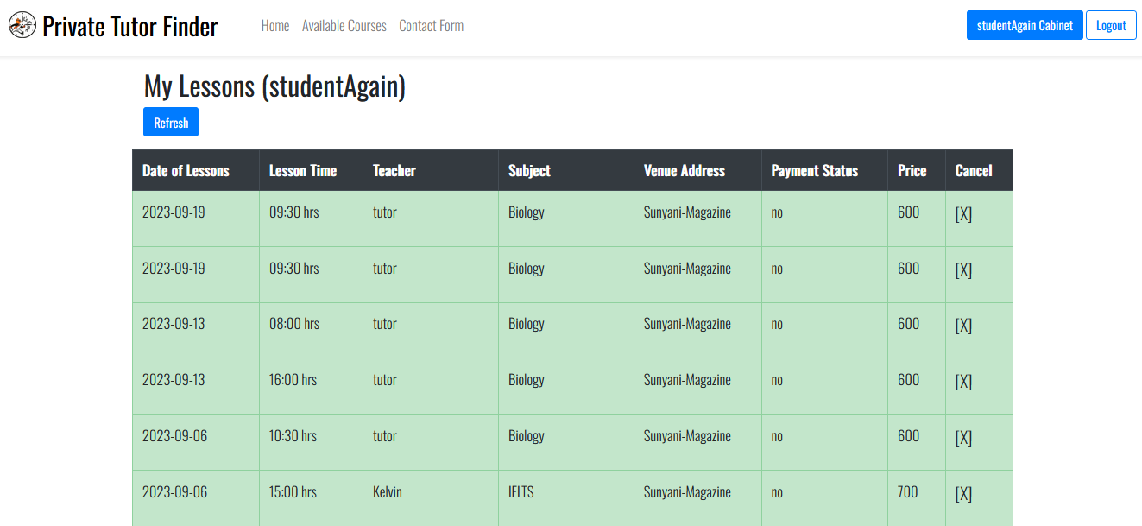
- Student Page: The student page provides field options for the students to log in to the system. The student page can allow the student to register and view content on the system.
Figure6: Student Panel
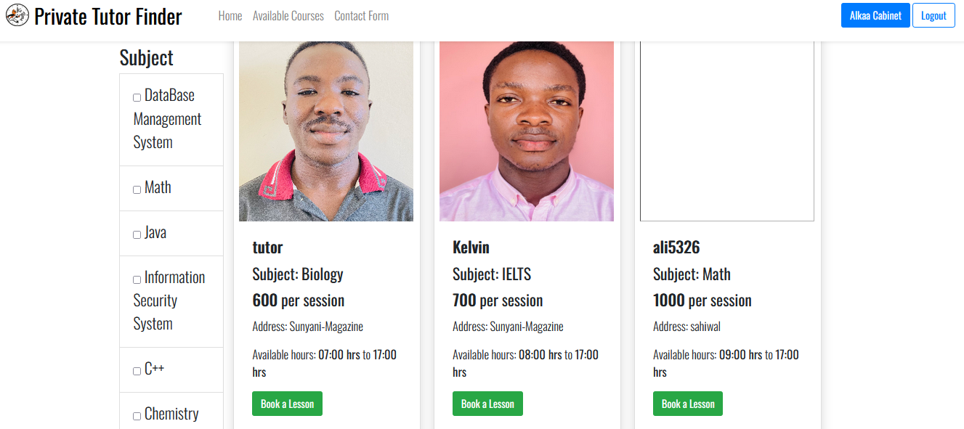
- Booking section: this where a student or parent who is registered on the system is able to book a tutor.

Figure7: Booking Section

Home page section: this is the user-friendly interface that enables parents, students and tutors to navigate through the system with ease.
Figure8: Home Page Section
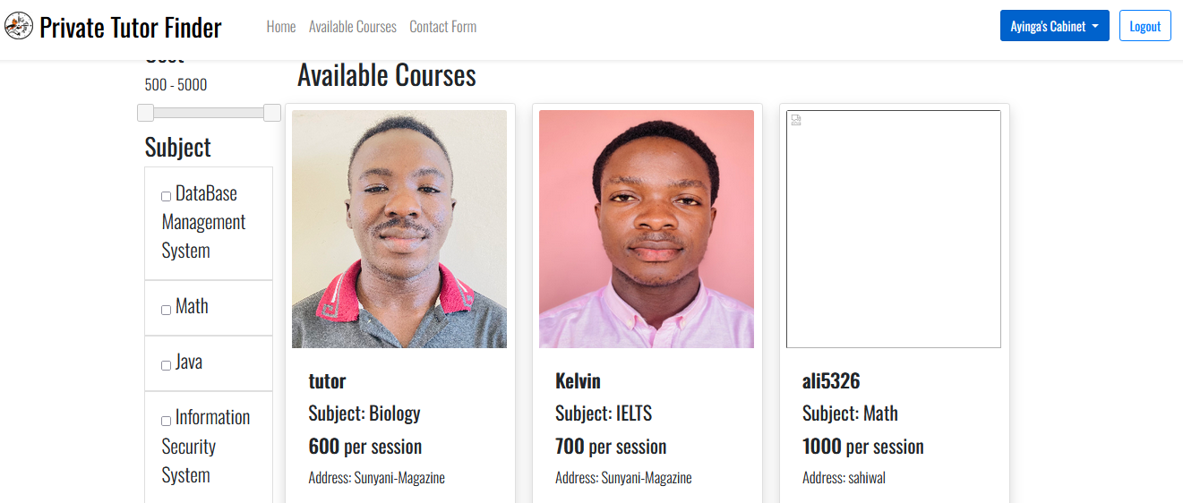
- Courses section: This page displays the list of courses various tutors on the system teaches. And therefore, parents or students are able to make their preference from the list of courses.
Figure9: Course Section

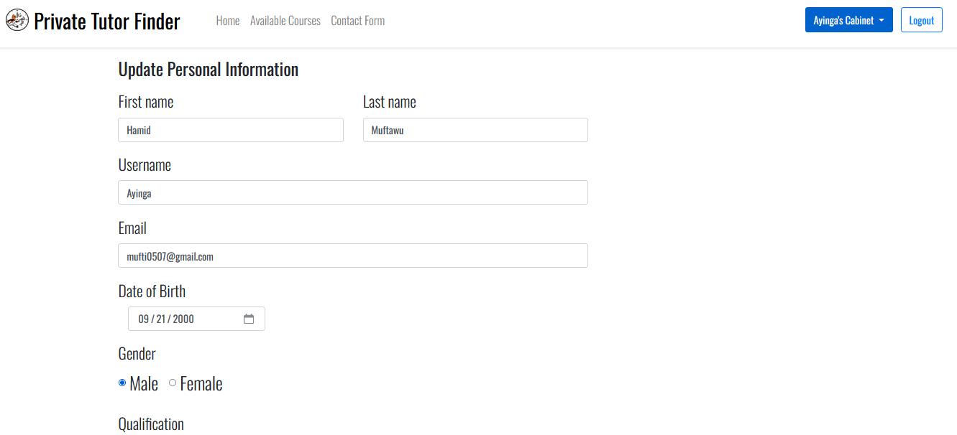
- Profile Section: This is where every user has the chance to update their profile or update their password.
Figure10: Profile Section
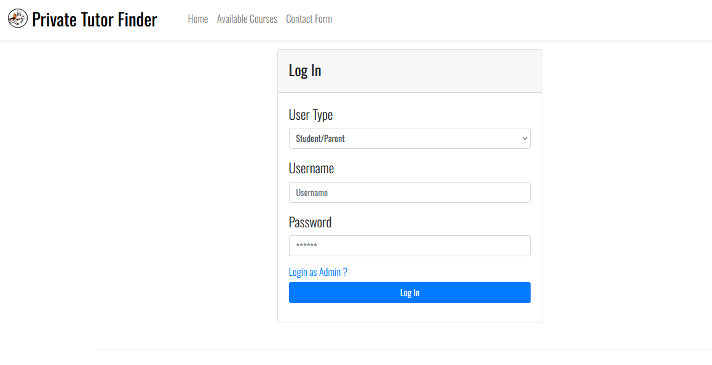
- Login Panel: This section allows the user to fill in the appropriate information required for accessing the platform
Figure11: Login panel
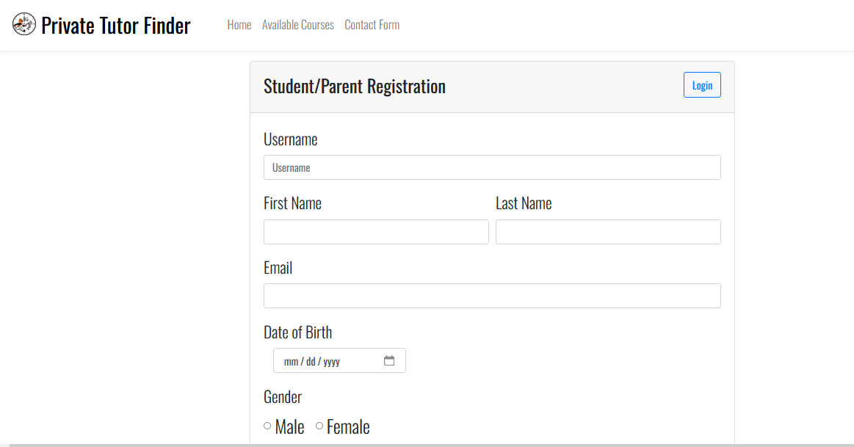
- Registration Section: Allow users to create accounts by providing their name, email, address, and a secure password.
Figure12: Registeration Section

4.2. TESTING
This section discusses the testing and evaluation of the developed web-based private tutor finder system. Here, the team tested the system against requirements to improve its efficiency and overall functionality. Testing was also conducted to find loopholes or oversight and bugs the system may have had and fix them.
Unit Testing
Unit testing places emphasis on the verification effort on the tiniest unit of the program design, the module. We used white box oriented and other modules which were conducted in parallel.

White Box Testing
This kind of testing sees to it that;
- Every independent path has been exercised at least once.
- All logical decisions have also been executed in both their true and false states.
- Loops are exercised within their operational bounds and boundaries.
- There is validity because all internal data have been exercised.
To adhere to the concept of white-box testing, we tested every feature that we created to ensure that the flow of data is correct. We checked the validity of all conditions and also exercised all loops on their boundaries.
Conditional Testing
In this section of testing, every condition was tested to both true and false sides. All the paths that could cause errors were traced to debug all possible bugs.
Data Flow Testing
This chooses the path of the program following the defined location and the variables used. We used this testing where we declared local variables.
Loop Testing
Every loop was tested to all its limits possible. The following strategies were used for the loops:
- Loops were tested above and below their limits and also skipped all the loops at once.

4.3 PROGRAM IMPLEMENTATION
This includes the implementation requirements of the system. It also details the implementation arrangement of the system.

System Implementation
The Web-Based private tutor finder System is implemented using Hypertext Pre-processor (PHP) programming language. The reason for using this programming language is that it has the benefits of easy development, flexibility, the tendency of giving the developer possible hints, and most importantly, it helps to create dynamic content that interacts with databases.

Operation Environment
The system is a web-based system and therefore requires tools needed to access or operate on the web. Such tools required by the system include:
- Internet Browser – the system is most efficient when accessed using Microsoft Edge, Google Chrome, Safari, Brave, Mozilla Firefox, and UC Browsers.
- Internet Connection – the system was developed with efficiency and flexibility in mind. The system is operational even on the lowest internet band available but will be slow in loading pages. The system can operate on 2G bands, 3G bands, 4G bands, or higher.

Deployment Plan
The implementation plan we have devised is to run a pilot study of the newly built system and run it on the computer science department administrator’s system. The next steps to be taken by the project team will be based on the feedback the team gets from the users of the system after we host it.
Training Of Users
There is no need to train users for the system because it's user-friendly and its mode of operation is simple. However, we included the user guide on the homepage to enable users understand the various navigation paths on the system. The whole software is modelled to be user-friendly for ease of use by all operators.

CHAPTER FIVE

SUMMARY, CONCLUSION, AND RECOMMENDATIONS

5.1 SUMMARY
The focal point of this project work is to develop a system that will efficiently, accurately, and severely help parents and students to easily access tutors based on their needs. And also serve the purpose of generating extra income for qualified and experienced tutors as well graduate teachers who has not yet being engaged by the government. The system will proactively link students, parents and tutors together on an environment based on technology. The work embodies the various problems associated with students or parents finding it difficult to get tutors for their wards to have extra tuition session aside the normal classroom teachings to aid better understanding and excel well in academics, outlining the objectives of the new system developed, explaining the individual specifications, and then how the program is implemented.
The program was successfully designed and developed using PHP, a programming language that is easily understood by both novice and advanced programmers whereas the spiral model was also used in the system design methodology since it allows the revisiting of each phase of the design process until the entire project is complete. The whole system was tested and all the shortfalls were improved upon. This yielded a result of having a well-enhanced web-based private tutor finder that aids in giving the best private tuition session. We cannot say this project work is perfect; however, the benefits of the project cannot be overlooked.

5.2 CONCLUSION
It is important to keep up with the latest technologies and avoid the traditional way of doing things because it provides competitive business advantages and increase the process in assisting the parent or students in finding a private -tutor and matches the private tutor with the potential clients. our web-based private tutor finder System is not commonly found in so many countries and specifically our country is not an exception hence our decision in coming out with such project at the computer science department and if being approved and given the go ahead we will further host it on the web, it is going to be a great tool to have. It allows a quick, clear, and detailed overview of the tutor student relations. It has a user-friendly interface, fewer functions, and easy access. Without the necessity of heavy training, it proves to be one of the systems which will hit the market. This system offers a much larger number of advantages when compared to its disadvantages.

5.3 RECOMMENDATIONS
The web-based private tutor system has successfully solved some of the problems concerning students and parents having difficulties in finding the best tutors. Although the aims and objectives of the system are met, there is still room for further improvement.
With the recent technological advancements, we recommend that in any future work features such as personalization, GPS integration, SMS integration, client and user chat, and the development of the Android/iOS version of this system should be taken into consideration to enhance the efficiency and effectiveness of the system.

References
Alkhatlan, A. &. (2018). A comprehensive historical survey with recent development. Intelligent Tutoring systems.
Blossfeld, H. P. (2011). Education as a lifelong process. NEPS.
Boehm, B. W. (1988, May). A spiral model of software development and enhancement. computer, 61-72.
Kosso, P. (2011). Science and Common Sense (Vol. 1). Northern Arizona, USA: Springer Science and Business Media B.V.). doi:https://doi.org/10.1007/978-94-007-1614-8_1
Nkambou, R. a. (2010). Advances in Intelligent Tutoring Systems (Vol. 308). Berlin/Heidelberg, Germany: Springer. doi:10.1007/978-3-642-14363-2
Nwana, H. (1990). Intelligent Tutoring system. Artificial Intellingence Review, 251-277.
Nye, B. (2015, 01). AIED is splitting up (into services) and the next generation will be all right. AIED workshops, 1432, 62-71.
Roll, I. A. (2011). Improving students help-seeking skills using metacognitige feedback in an intelligent tutoring system. Iearning and Instruction, 267-280.
Romle, A. &. (2011). Integrated parent information system (SMIB) to increase parental involvement in children's learning process in Malaysian primary school’ in . 17-19 July, (pp. 1-6). Selangor: Electrical Engineering and Informatics (ICEEI).
Self, J. (1990). Theoretical Foundations for Intelligent Tutoring Systems. Journal Of Artificial Intelligence in Education, 3-14.
Sommerville, I. (2006). Software Engineering. Harlow, England: Addison-Wesly.
Uhr, L. (1969). Teaching Machine Programs That generate problems as a foundation of interaction with student. 1969 24th National Conference (pp. 125-134). New York: NY:ACM.
Wenger, M. (1987). Artificial intelligence and tutoring system: Computational and cognitive approaches to the communication of knowledge. Los Atlos: CA: Morgan Kaufmann.
Woods, P. &. (1971). some learning models for arithmetic tasks and their use in computer base learning . British Journal of education psychology, 38-48.

APPENDICES
Email.php
<?php
use PHPMailer\PHPMailer\PHPMailer;
use PHPMailer\PHPMailer\Exception;
use PHPMailer\PHPMailer\SMTP;
require_once "phpmailer/src/PHPMailer.php";
require_once "phpmailer/src/SMTP.php";
require_once "phpmailer/src/Exception.php";
//PHPMailer Object
function sendMail($email,$message){
$mail = new PHPMailer(true); //Argument true in constructor enables exceptions
try {
//Server settings
$mail->isSMTP(); //Send using SMTP
$mail->Host = "smtp.gmail.com"; //Set the SMTP server to send through
$mail->SMTPAuth = true;
$mail->SMTPSecure = PHPMailer::ENCRYPTION_STARTTLS; //Enable implicit TLS encryption
$mail->Port = 587; //Enable SMTP authentication
$mail->Username = "mufti0507@gmail.com";
$mail->Password = "ehuyppubtyckwqvv";

//Recipients
$mail->setFrom($email, 'Tutor Booking');
$mail->addAddress($email, ''); //Add a recipient
$mail->addReplyTo($email, 'noreply');
// $mail->addCC('cc@example.com');
// $mail->addBCC('bcc@example.com');

//Attachments
// $mail->addAttachment('/var/tmp/file.tar.gz'); //Add attachments
// $mail->addAttachment('/tmp/image.jpg', 'new.jpg'); //Optional name

//Content
$mail->isHTML(true); //Set email format to HTML
$mail->Subject = 'Tutor Booking';
$mail->Body = $message;
$mail->AltBody = 'Auto Generated Email';
$mail->send();
} catch (Exception $e) {
echo "Message could not be sent. Mailer Error: {$mail->ErrorInfo}<br>";
}
}

All_bookings.php
<?php
session_start();
$er = 0;
require("config.php");
include("db_connect.php");
if ($_SESSION['SESS_USERTYPE'] == 'admin') {

$query = "SELECT * FROM bookings, all_time_slots, logins WHERE bookings.booking_time = all_time_slots.slot_id and bookings.dr_id=logins.id and bookings.dr_id=all_time_slots.dr_id group by bookings.booking_id order By bookings.booking_date desc";
$statement = $connect->prepare($query);
$statement->execute();
$result = $statement->fetchAll();
$total_row = $statement->rowCount();

} else {
header("Location: login.php");
}

require("header.php");
?>
<div class="container">
<h1>All Bookings</h1>
<table class="table display table-bordered" id="bookings-table">
<thead class="thead-dark">
<tr>
<th onclick="sortTable(0)" scope="col">Booking Date</th>
<th onclick="sortTable(1)" scope="col">Booking Time</th>
<th onclick="sortTable(0)" scope="col" style="width: 150px;">Student</th>
<th onclick="sortTable(0)" scope="col" style="width: 150px;">Teacher</th>
<th onclick="sortTable(0)" scope="col" style="width: 150px;">Subject</th>
<th onclick="sortTable(0)" scope="col">Location</th>
<th onclick="sortTable(0)" scope="col">Status</th>
<th scope="col">Price</th>
<th scope="col">Cancel</th>
</tr>
</thead>
<tbody>
<?php
if ($total_row > 0) {
foreach ($result as $row) {
echo "<tr class='table-danger'>";
echo "<td>".$row['booking_date']."</td>";
echo "<td>".$row['slot_time']." hrs</td>";
echo "<td>".$row['username']."</td>";
echo "<td>".$row['specialization']."</td>";
echo "<td>".$row['address']."</td>";
echo "<td>".$row['bookings_status']."</td>";
echo "<td>".$row['price']."</td>";
echo "</tr>";
}
} else {
echo "<tr class='table-success'>";
echo "<td>".$row['booking_date']."</td>";
echo "<td>".$row['slot_time']." hrs</td>";
echo "<td>".$row['username']."</td>";
echo "<td>".$row['specialization']."</td>";
echo "<td>".$row['address']."</td>";
echo "<td>".$row['bookings_status']."</td>";
echo "<td>".$row['price']."</td>";
echo "<td><p id='delete' onclick='ensure(".$row["booking_id"].")'>[X]</p></td>";
echo "</tr>";
}
?>
</tbody>
</table>
</div>
</div>

Login.php
<?php
require("header.php");
require("config.php");
// error_reporting(E_ALL);
// ini_set('display_errors', 1);
// Redirect to the homepage if already logged in
if(isset($_SESSION['SESS_LOGGEDIN'])) {
header("Location: index.php");
}

if(isset($_POST['submit'])) {
$loginsql = "SELECT * FROM logins WHERE username = '" . $_POST['userBox']. "' AND password = '" . sha1($_POST['passBox']) . "' AND user_type = '" . $_POST['userOption']. "' AND status = 'approved'";
$loginres = mysqli_query($conn, $loginsql);
$numrows = mysqli_num_rows($loginres);

if($numrows == 1) {
$loginrow = mysqli_fetch_assoc($loginres);

$_SESSION['SESS_LOGGEDIN'] = 1;
$_SESSION['SESS_USERNAME'] = $loginrow['username'];
$_SESSION['SESS_USERID'] = $loginrow['id'];
$_SESSION['SESS_USERTYPE'] = $loginrow['user_type'];
echo "<script>window.location.replace('index.php');</script>";
} else {
echo "<script>window.location.replace('login.php?error=1');</script>";
}
} else {

?>
<?php
if(isset($_GET['error']) && $_GET['error'] == '5') {
echo "<strong> Registered Successfully.. you may <a href='login.php' style='color:#3F51B5'>login Now!</a></strong>";
}
?>

<div class="row justify-content-center">
<div class="col-md-4">
<div class="card">
<header class="card-header">
<h4 class="card-title mt-2">Log In</h4>
<?php if(isset($_GET['error']) && $_GET['error']==1) {
echo "<strong>Invalid password or username or ask admin to approve your account!</strong>";
} ?>
</header>
<article class="card-body">

<form method="POST" action="<?php $_SERVER['SCRIPT_NAME']; ?>">
<!-- <?php include('errors.php'); ?> -->
<div class="form-group">
<label>User Type</label>
<select name="userOption" class="form-control">
<option value="student">Student/Parent</option>
<option value="tutor">Tutor</option>
</select>
</div>

<div class="form-group">
<label>Username</label>
<input name="userBox" class="form-control" placeholder="Username" type="textbox">
</div>
<div class="form-group">
<label>Password</label>
<input class="form-control" name="passBox" placeholder="******" type="password">
</div>
<div class="form-group">
<div class="checkbox">
</div>
</div>
<div class="form-group">
<h6> <a href="login_admin.php">Login as Admin ?</a></h6>
<button type="submit" class="btn btn-primary btn-block" name="submit" value="Log in">Log In</button>
</div>
</form>
</article>
</div>
</div>
</div>

</div>

<?php
}
require("footer.php");
?>

