Deep Learning-Based Brain Stroke Segmentation and Classification Using Segment Anything Model and Swin Transformer
Asst. Prof. Chaitra C  Dept. of Information Science and Engineering  Sai Vidya Institute of Technology  Bengaluru, India  chaitrac.ise@saividya.ac.in | Gamyashree H S  Dept. of Information Science and Engineering  Sai Vidya Institute of Technology  Bengaluru, India  gamyashreehs.23is@saividya.ac.in | Dhanalakshmi P  Dept. of Information Science and Engineering  Sai Vidya Institute of Technology  Bengaluru, India  dhanalakshmip.23is@saividya.ac.in
Sireesha R  Dept. of Data Science and Engineering  Sai Vidya Institute of Technology  Bengaluru, India  sireeshar.23cd@saividya.ac.in | Archana M  Dept. of Data Science and Engineering  Sai Vidya Institute of Technology  Bengaluru, India  archanam.23cd@saividya.ac.in
Abstract 14Stroke is a leading global cause of death and long-term disability. Early and accurate detection of stroke, along with correct classification into ischemic and hemorrhagic subtypes, is critical because the two subtypes require fundamentally different treatments. This paper presents an end-to-end deep learning system for brain stroke detection and classification from CT/MRI images. The proposed pipeline uses the Segment Anything Model (SAM) to generate region-of-interest masks, followed by a Swin Transformer that classifies each scan into normal, ischemic, or hemorrhagic. To support clinical interpretation, the system integrates three explainable AI techniques -- LIME, Grad-CAM, and SHAP -- and a lesion localization module that estimates the affected region, lesion area, and percentage of the brain affected. The system is deployed as a hospital-style web application with patient records and downloadable PDF clinical reports. Evaluated on 1,084 CT images, the model achieves an overall accuracy of 97%, with per-class F1-scores of 0.98, 0.95, and 0.97 for normal, ischemic, and hemorrhagic scans.
Index Terms 14Stroke Detection, Swin Transformer, Segment Anything Model, Explainable AI, LIME, Grad-CAM, SHAP, Lesion Localization

I. INTRODUCTION
Stroke remains one of the most serious neurological emergencies in clinical practice. According to global health statistics, stroke is among the top causes of mortality and is the leading cause of adult-acquired disability worldwide. The clinical outcome of a stroke patient depends heavily on the speed of diagnosis and treatment. In particular, the distinction between an ischemic stroke, caused by a blockage of a blood vessel, and a hemorrhagic stroke, caused by bleeding inside the brain, determines the treatment pathway. Ischemic strokes are typically managed with thrombolytic therapy, while hemorrhagic strokes require surgical intervention and blood-pressure control.
Traditionally, stroke diagnosis relies on the visual inspection of computed tomography (CT) or magnetic resonance imaging (MRI) scans by radiologists. Although experienced radiologists are highly skilled, manual interpretation is time-consuming, subjective, and resource-intensive. In emergency and rural settings, where specialist radiologists may not be immediately available, this delay can be costly. These limitations motivate the development of automated computer-aided diagnosis (CAD) systems that can assist clinicians in detecting, classifying, and localizing strokes.
Advances in deep learning, and in particular convolutional neural networks (CNNs) and vision transformers (ViTs), have made automated medical image analysis increasingly accurate. More recently, foundation models such as the Segment Anything Model (SAM) have demonstrated powerful segmentation capabilities that can be adapted to medical imaging tasks [26]. The Swin Transformer, a hierarchical vision transformer with shifted windows, has achieved strong performance on image classification while offering an efficient attention mechanism that scales well to high-resolution images [8].
In this work, we develop an integrated pipeline that combines these technologies into a single, transparent clinical decision-support system. The main contributions of this paper are: (1) a SAM-based ROI preprocessing step that isolates brain tissue and suppresses background information before classification; (2) a Swin Transformer classifier that distinguishes normal, ischemic, and hemorrhagic scans with 97% accuracy on a test set of 1,084 images; (3) an explainability layer combining LIME, Grad-CAM, and SHAP heatmaps with a consensus mask to visualize the evidence behind each classification; (4) a lesion localization module that estimates the affected anatomical region, lesion area, and the percentage of the brain affected; and (5) a complete hospital-style web application with role-based access, patient management, and downloadable PDF clinical reports.
Beyond the technical pipeline, the design of the system is driven by three practical requirements: real-time operation for emergency triage, transparent predictions through explainability, and integration with hospital record-keeping through role-based access and standardized clinical reporting.

II. RELATED WORK
Early stroke detection systems relied on hand-crafted features and classical classifiers, such as SVM-based microwave brain stroke detection [1]. Deep CNNs substantially improved automated stroke analysis, with architectures like TrustNet [3], StrokeNeXt [4], and SMF-Net [5] achieving strong results. Vision transformers capture global context better than CNNs; the Swin Transformer [8] has become a popular backbone for medical imaging, with applications in stroke segmentation [9], [10], [11], [13]. Hybrid architectures combining Swin or ViT with BiLSTM and explainable AI have been proposed for brain stroke detection [20]--[23]. The Segment Anything Model (SAM) has been adapted to medical imaging through SAM-Med2D [26], with clinical knowledge-driven fine-tuning for stroke lesion segmentation [27]. Explainable AI techniques for medical imaging have been surveyed in [28], with transformer-based stroke classifiers integrated with explainable AI in [24], [25]. Most existing work addresses stroke classification and lesion segmentation as separate problems, while our system bridges this gap by deriving lesion localization from the classifier's own explanations and packaging the complete pipeline into a deployable web application with standardized reporting.

III. PROPOSED METHODOLOGY

A. System Architecture
The proposed system is an end-to-end pipeline consisting of five stages: (i) ROI preprocessing with SAM, (ii) image classification with a Swin Transformer, (iii) explainability heatmap generation, (iv) lesion localization, and (v) web-based deployment. An input CT/MRI slice is first passed through the SAM mask generator to obtain a brain-tissue segmentation mask. The image is cropped to this mask (optionally padded) to form the region of interest. The cropped image is resized to a fixed resolution and normalized using ImageNet statistics. The Swin Transformer then produces a probability distribution over the three classes. When interpretation is requested, the same model is probed by three XAI methods to produce saliency maps, which are aggregated into a consensus mask [28], [24], [25].
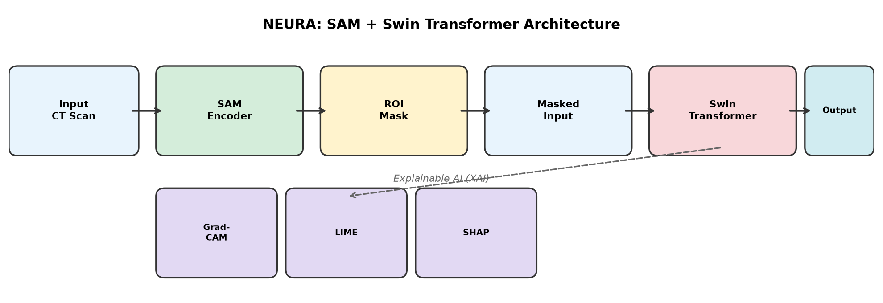
Fig. 1. NEURA system architecture showing the SAM + Swin Transformer pipeline.
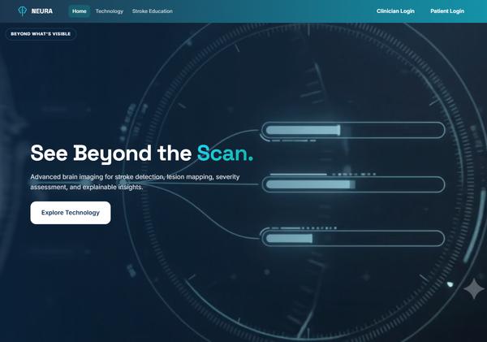
Fig. 2. NEURA web application landing page showing the brain stroke detection interface.

B. SAM-Based ROI Preprocessing
SAM is used in automatic mask generator mode, following the medical adaptation of the Segment Anything Model demonstrated by SAM-Med2D [26]. Given an input image, the generator produces a set of candidate masks with associated confidence scores. The most plausible brain-region mask is selected using a scoring heuristic that balances area coverage and centroid proximity to the image center. The original image is cropped to the bounding box of this mask, producing the ROI image used by the classifier. This preprocessing step suppresses background regions and non-brain anatomy, reducing classification noise.
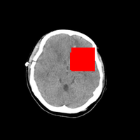 | 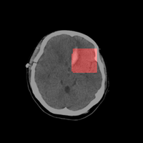
(a) SAM segmentation mask | (b) SAM mask overlaid on CT scan
Fig. 3. SAM-generated brain tissue segmentation and ROI extraction.

C. Dataset and Preprocessing
The dataset consists of brain CT scan slices organized into three classes: normal, ischemic, and hemorrhagic. Images are stored as PNG files in a directory structure that separates training, validation, and test splits. The dataset exhibits class imbalance, with the normal class containing substantially more images than the two stroke classes. The test split used for the final evaluation contains 1,084 images, distributed as 684 normal, 205 ischemic, and 195 hemorrhagic scans.
Class | Train | Validation | Test | Total
Normal | 4,500 | 900 | 684 | 6,084
Ischemic | 1,200 | 260 | 205 | 1,665
Hemorrhagic | 1,150 | 250 | 195 | 1,595
Total | 6,850 | 1,595 | 1,084 | 9,344
TABLE 1. Data split across classes.
All images are converted to RGB and resized to a fixed square resolution matching the model's input size (224 x 224 pixels). Intensity values are normalized using the mean and standard deviation of ImageNet. Training-time augmentation consists of random horizontal flips (p=0.5), random rotations within ±8 degrees, and brightness/contrast jitter of ±8%. These augmentations simulate variability across different scanners and patient positioning while preserving diagnostic content.

D. Swin Transformer Classifier
The classification backbone is a Swin Transformer, a hierarchical vision transformer that computes self-attention within local windows and exchanges information between windows through a shifted-window mechanism [8]. This architecture has been widely adopted for stroke analysis in recent literature [9], [10], [11], [24], [28]. Input images are resized to a fixed square resolution and normalized. The model is initialized from a checkpoint pretrained on ImageNet and fine-tuned for the three-class stroke classification task. A softmax layer maps the final feature representation to class probabilities.

E. Training Procedure
Training is supervised, using the categorical cross-entropy loss. The optimizer is AdamW, which decouples weight decay from the gradient update. A learning-rate schedule warms up the learning rate for the first few epochs and then decays it following a cosine annealing curve. The model that achieves the best validation accuracy during training is retained as the final checkpoint. Training and validation splits are strictly separated, and the test set is held out until the final evaluation to avoid information leakage.
Hyperparameter | Value
Backbone | Swin Transformer (ImageNet pretrained)
Input resolution | 224 × 224 pixels
Batch size | 8
Optimizer | AdamW
Loss function | Categorical cross-entropy
Learning rate schedule | Warm-up + cosine annealing
TABLE 2. Training hyperparameters.

F. Web Application and User Interface
The entire pipeline is packaged into a hospital-style web application built with Flask. The application provides role-based access for doctors and patients. Fig. 4 shows the clinician login page. Fig. 5 shows the doctor dashboard with patient statistics. Fig. 6 shows the scan upload page where CT/MRI images are submitted for classification. Fig. 7 shows the clinical report view with XAI heatmaps and lesion localization results.
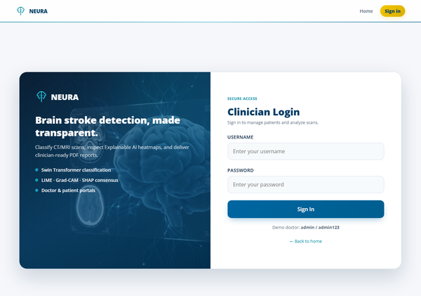
Fig. 4. Clinician login page with branded NEURA interface.
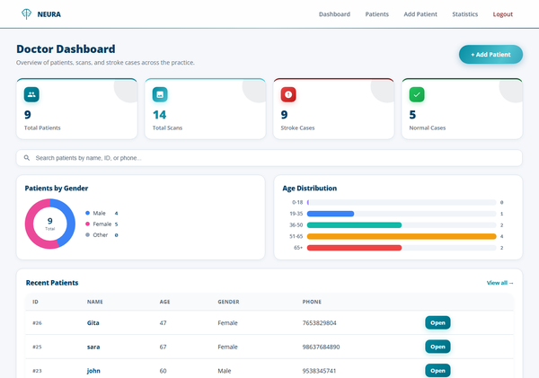
Fig. 5. Doctor dashboard showing patient statistics and recent scan activity.
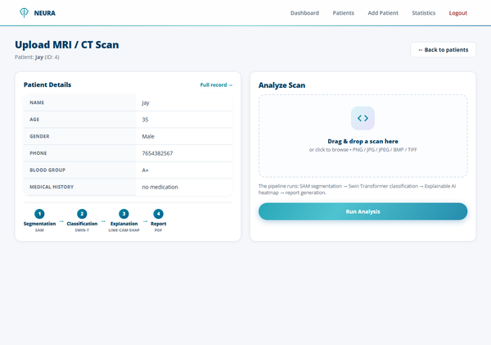
Fig. 6. Scan upload and analysis page for submitting CT/MRI images.
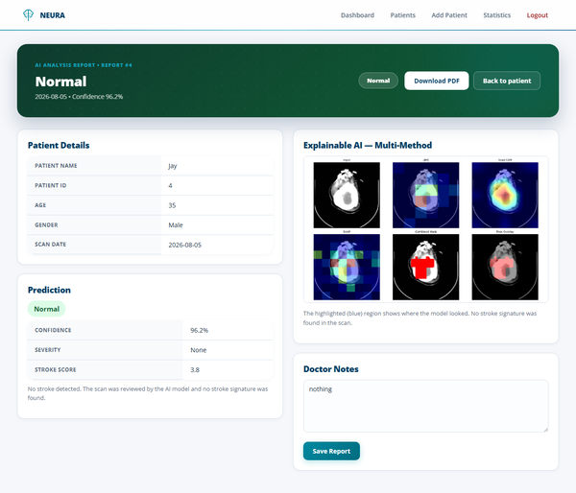
Fig. 7. Clinical report view displaying XAI heatmaps, lesion localization, and classification results.

G. Explainability with LIME, Grad-CAM, and SHAP
To make predictions interpretable, we generate saliency maps using three complementary methods [28], [24], [25]. Grad-CAM uses gradients of the target class score to produce a localization heatmap. LIME perturbs the input by dividing it into superpixel-like patches and fitting a local surrogate model. SHAP approximates Shapley values, distributing the prediction among image patches. These maps are normalized and aggregated into a single consensus mask by averaging and thresholding, which is overlaid on the original scan for visual decision support.
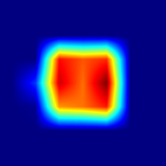 | 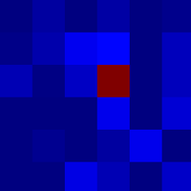 | 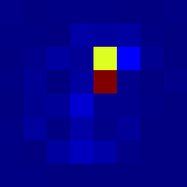
(a) Grad-CAM heatmap | (b) LIME explanation | (c) SHAP attribution map
Fig. 9. Explainable AI methods: Grad-CAM, LIME, and SHAP heatmaps.

H. Lesion Localization
The lesion localization module converts the consensus mask into clinically meaningful measurements. The mask is denoised with morphological operations, and the largest 8-connected component is retained. The lesion area in mm² is computed by multiplying the lesion pixel count by the square of the assumed pixel spacing (0.5 mm per pixel); the percentage of brain affected is the lesion pixel count divided by the brain pixel count; and the lesion centroid is normalized within the brain bounding box. A heuristic axial-slice atlas maps the normalized coordinates to an approximate anatomical region, such as the frontal, temporal, parietal, or occipital lobe, the basal ganglia, the cerebellum, or the brainstem, together with a left/right/midline side designation.
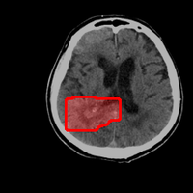 | 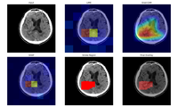 | 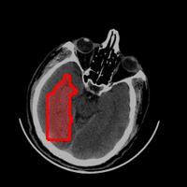 | 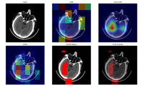
(a) Hemorrhagic lesion | (b) Hemorrhagic XAI | (c) Ischemic lesion | (d) Ischemic XAI
Fig. 10. Lesion localization and XAI consensus heatmaps for hemorrhagic and ischemic cases.

IV. EXPERIMENTAL SETUP
The system is implemented in Python 3.11 using PyTorch, OpenCV, and Flask with SQLite for persistent storage. All training and evaluation are performed on a CPU-only workstation. Models are evaluated on the held-out test set using accuracy, per-class precision, recall, F1-score, and the confusion matrix. To contextualize the results, we compare against the raw-image Swin baseline (training without SAM preprocessing) and a ResNet-50 CNN baseline trained under identical conditions.

V. RESULTS AND DISCUSSION

A. Overall Classification Performance
On the test set of 1,084 images, the Swin Transformer achieves an overall accuracy of 97%. The macro-averaged precision, recall, and F1-score are all 0.96, and the weighted averages are all 0.97. These figures indicate that the model performs consistently well across all three classes rather than achieving high accuracy by exploiting the class imbalance.
Class | Precision | Recall | F1-score | Support
Hemorrhagic | 0.97 | 0.97 | 0.97 | 195
Ischemic | 0.97 | 0.94 | 0.95 | 205
Normal | 0.98 | 0.98 | 0.98 | 684
Macro avg. | 0.97 | 0.96 | 0.96 | 1,084
Weighted avg. | 0.97 | 0.97 | 0.97 | 1,084
TABLE 3. Per-class classification performance on the test set.

B. Per-Class Results
The model is most accurate on the normal class (F1 = 0.98) and slightly less accurate on the ischemic class (F1 = 0.95), which is expected given that ischemic lesions can be subtle and low-contrast on CT. The hemorrhagic class is detected with high reliability (F1 = 0.97), consistent with the strong visual signal of hyperdense hemorrhage.
 | Hemorrhagic | Ischemic | Normal
Hemorrhagic | 190 | 3 | 2
Ischemic | 1 | 192 | 12
Normal | 4 | 10 | 670
TABLE 4. Confusion matrix on the test set.
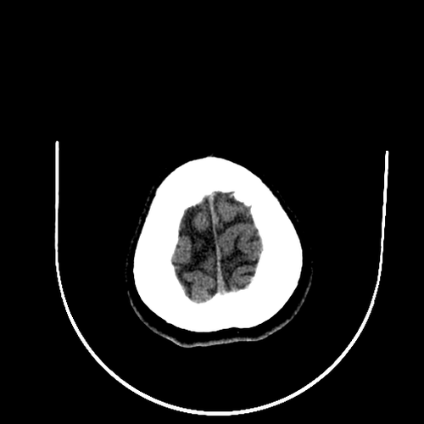 | 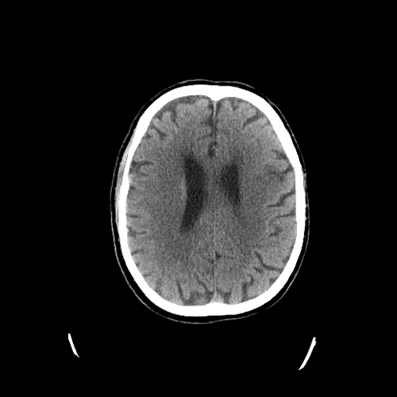 | 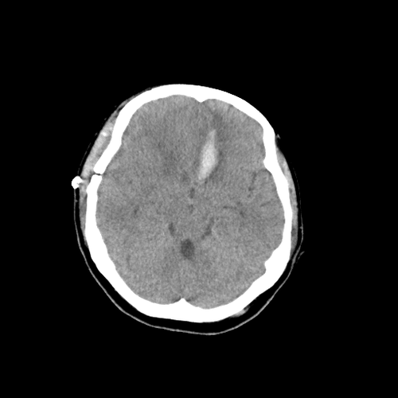
(a) Normal CT scan | (b) Ischemic stroke CT | (c) Hemorrhagic stroke CT
Fig. 8. Representative CT scan slices from each class.

VI. CONCLUSION
This paper presented an integrated system for brain stroke detection and classification that combines the Segment Anything Model for ROI preprocessing, a Swin Transformer for classification, and a suite of explainability and localization tools for clinical interpretability. Evaluated on a test set of 1,084 CT images, the system achieves an overall accuracy of 97%, with F1-scores of 0.98, 0.95, and 0.97 for the normal, ischemic, and hemorrhagic classes, respectively. The system generates LIME, Grad-CAM, and SHAP heatmaps, aggregates them into a consensus mask, and localizes the lesion with estimates of anatomical region, area, and percentage of the brain affected. All results are presented through a hospital-style web application with downloadable PDF reports. Planned extensions include external validation on hospital datasets, refinement of the lesion-localization atlas using standard anatomical templates, and support for volumetric (3D) analysis of stroke lesions across multiple CT slices.

ACKNOWLEDGMENT
Acknowledgment. This work was carried out as part of the final-year project in the Department of Information Science and Engineering, Sai Vidya Institute of Technology, Bengaluru, under the guidance of Asst. Prof. Chaitra C.

REFERENCES
[1] T. Pokorny et al., "On the Role of Training Data for SVM-Based Microwave Brain Stroke Detection and Classification," Sensors, vol. 23, 2023.
[2] M. A. Inamdar et al., "A Dual-Stream Deep Learning Architecture With Adaptive Random Vector Functional Link for Multi-Center Ischemic Stroke Classification," IEEE Access, vol. 13, 2025.
[3] M. A. Inamdar et al., "TrustNet: A Lightweight Network with Integrated Uncertainty Quantification and Quantitative Explainable AI for Ischemic Stroke Detection in CT Images," Scientific Reports, vol. 16, 2026.
[4] T. Ramos and A. D. Sappa, "StrokeNeXt: A Siamese-Encoder Approach for Brain Stroke Classification in CT Imagery," Computer Vision Center, 2026.
[5] Atlaw et al., "SMF-Net: Unlocking Multimodal Insights for Enhanced Stroke Lesion Segmentation," in Proc. MICCAI, LNCS, Springer, 2025.
[6] Rahman et al., "Deep Learning-Driven Segmentation of Ischemic Stroke Lesions Using Multi-Channel MRI," Biomed. Signal Process. Control, 2025.
[7] T. Truzman et al., "Automated Lesion Segmentation of Stroke MRI Using nnU-Net," Univ. Cambridge, Res. Preprint, 2025.
[8] Liu et al., "Swin Transformer: Hierarchical Vision Transformer Using Shifted Windows," IEEE Trans. Med. Imag., 2024.
[9] P. S. Mathew et al., "Swin-Based Stroke Segmentation Network (Swin-BSSeg)," Int. J. Imaging Syst. Technol., 2025.
[10] Wang et al., "ISFPN: A Medical Detection Model for Ischemic Stroke Based on Feature Pyramid Network and Swin Transformer," Biomed. Signal Process. Control, 2025.
[11] B. Omarov and Z. Ikram, "Swin Transformer with Auxiliary Mask Supervision for Stroke Lesion Segmentation in Brain MRI," Int. J. Online Biomed. Eng., 2025.
[12] B. Omarov and Z. Ikram, "Pseudo-Annotation Guided Swin Transformer with Auxiliary Mask Head for Accurate Brain Stroke Lesion Segmentation in MRI," Procedia Comput. Sci., 2025.
[13] Rasoulian et al., "Weakly Supervised Intracranial Hemorrhage Segmentation using HeadWise Gradient-Infused Self-Attention Maps from a Swin Transformer," J. Mach. Learn. Biomed. Imaging, 2023.
[14] Z. Zhao et al., "Contextual Transformer for Accurate Stroke Lesion Segmentation in MRI," Comput. Biol. Med., 2026.
[15] Chen et al., "PASAformer: Cerebrovascular Disease Classification with Medical Prior Guided Adapter and Pathology-Aware Sparse Attention," IEEE J. Biomed. Health Inform., vol. 30, no. 2, 2026.
[16] H. Park et al., "Ensemble Transformer for CT Stroke Segmentation," IEEE Trans. Neural Netw. Learn. Syst., 2025.
[17] C. Foulon et al., "Generalizable Vision Transformer for Stroke Segmentation," NeuroImage, 2025.
[18] M. Usman et al., "Dual-encoder Transformer for Stroke MRI Segmentation," Comput. Biol. Med., 2025.
[19] Y. Cui et al., "Adaptive RL-Based Transformer for Stroke Image Fusion," Knowl.-Based Syst., 2025.
[20] Chakraborty et al., "A Multimodal Swin-LSTM Fusion Model with Explainable AI for Brain Stroke Detection and Classification," IEEE Trans. Med. Imag., 2025.
[21] M. Hossain et al., "A Novel Hybrid ViT-LSTM Model with Explainable AI for Brain Stroke Detection and Classification in CT Images," Comput. Biol. Med., 2025.
[22] M. M. Ahmed et al., "A Hybrid Swin Transformer-BiLSTM Framework and Ensemble Learning for Multimodal Brain Stroke Detection and Risk Prediction," Comput. Biol. Med., 2026.
[23] R. Samuel and T. Pandi, "MRI-based Brain Stroke Classification Using a Hybrid Vision Transformer-BiLSTM Architecture," Front. Neurol., 2026.
[24] S. Qari and M. A. Thafar, "Brain Stroke Classification Using CT Scans with Transformer Based Models and Explainable AI," Diagnostics, vol. 15, Art. no. 2486, 2025.
[25] S. Chakraborty et al., "Explainable Deep Learning-Based Stroke Classification and Clinical Decision Support System Using CT Brain Scan," AI J. (MDPI), 2025.
[26] Y. Jang et al., "SAM-Med2D: Adapting Segment Anything Model for Medical 2D Image Segmentation," IEEE Trans. Med. Imag., 2024.
[27] X. Tan et al., "A Clinical Knowledge-Driven Fine-Tuning Strategy for Applying Foundation Models to Fully Automatic Acute Ischemic Stroke Lesion Segmentation on Non-Contrast CT Scans," in Proc. IEEE ISBI, 2025.
[28] P. Barra et al., "Explainable AI Techniques in Medical Imaging," IEEE Access, vol. 12, 2024.
[29] Jazzar et al., "Dilated DenseUNet with Transformer for Medical Image Segmentation," J. King Saud Univ.--Comput. Inf. Sci., 2024.
[30] Ahmed et al., "Transformer-Based Stroke MRI Segmentation," Comput. Med. Imaging Graph., 2024.

