VISVESVARAYA TECHNOLOGICAL UNIVERSITY
“JNANA SANGAMA”, BELAGAVI - 590 018, KARNATAKA

Major Project Phase II (BIS786) Report
on

Deep Learning-Based Brain Stroke Detection, Classification and Localization using Swin Transformer and Explainable AI

Submitted in the partial fulfillment of the requirement for the award of degree of
BACHELOR OF ENGINEERING
in
INFORMATION SCIENCE AND ENGINEERING

Submitted by
Student Name | USN
Dhanalakshmi P | 1VA23IS023
Gamyashree H S | 1VA23IS029
Archana M | 1VA23CD014
Sireesha R | 1VA23CD093

Under the Guidance of
Asst. Prof. Chaitra C
Assistant Professor, Department of Information Science and Engineering

DEPARTMENT OF INFORMATION SCIENCE AND ENGINEERING
SAI VIDYA INSTITUTE OF TECHNOLOGY
(Affiliated to Visvesvaraya Technological University, Belagavi | Recognized by Govt. of Karnataka | Approved by AICTE, New Delhi)
Accredited by NBA, New Delhi (CSE, ISE, ECE), NAAC ‘A’ Grade
RAJANUKUNTE, BENGALURU - 560 064
Academic Year 2026-27

VISVESVARAYA TECHNOLOGICAL UNIVERSITY
“JNANA SANGAMA”, BELAGAVI - 590 018, KARNATAKA

Major Project Phase II (BIS786) Report
on

Deep Learning-Based Brain Stroke Detection, Classification and Localization using Swin Transformer and Explainable AI

Submitted in the partial fulfillment of the requirement for the award of degree of
BACHELOR OF ENGINEERING
in
INFORMATION SCIENCE AND ENGINEERING

Submitted by
Student Name | USN
Dhanalakshmi P | 1VA23IS023
Gamyashree H S | 1VA23IS029
Archana M | 1VA23CD014
Sireesha R | 1VA23CD093

Under the Guidance of
Asst. Prof. Chaitra C
Assistant Professor, Department of Information Science and Engineering

DEPARTMENT OF INFORMATION SCIENCE AND ENGINEERING
SAI VIDYA INSTITUTE OF TECHNOLOGY
(Affiliated to Visvesvaraya Technological University, Belagavi | Recognized by Govt. of Karnataka | Approved by AICTE, New Delhi)
Accredited by NBA, New Delhi (CSE, ISE, ECE), NAAC ‘A’ Grade
RAJANUKUNTE, BENGALURU - 560 064
Academic Year 2026-27

SAI VIDYA INSTITUTE OF TECHNOLOGY
(Affiliated to Visvesvaraya Technological University, Belagavi | Recognized by Govt. of Karnataka | Approved by AICTE, New Delhi)
Accredited by NBA, New Delhi (CSE, ISE, ECE), NAAC ‘A’ Grade
Rajanukunte, Bengaluru - 560 064
DEPARTMENT OF INFORMATION SCIENCE AND ENGINEERING
CERTIFICATE
This is to certify that the Project work (BIS786) entitled “Deep Learning-Based Brain Stroke Detection, Classification and Localization using Swin Transformer and Explainable AI” carried out by Mr/Ms. Dhanalakshmi P (1VA23IS023), Mr/Ms. Gamyashree H S (1VA23IS029), Mr/Ms. Archana M (1VA23CD014), Mr/Ms. Sireesha R (1VA23CD093), bonafide students of SAI VIDYA INSTITUTE OF TECHNOLOGY, Bengaluru, in partial fulfillment for the award of Bachelor of Engineering in Information Science and Engineering of VISVESVARAYA TECHNOLOGICAL UNIVERSITY, Belagavi during the year 2026-27. It is certified that all corrections/suggestions indicated for Internal Assessment have been incorporated in the Report deposited in the departmental library. The Project report has been approved as it satisfies the academic requirements in respect of Project work prescribed for the said Degree.

Asst. Prof. Chaitra C  Assistant Professor  Dept. of Information Science and Engineering, SVIT | Dr. Amogh Pramod Kulkarni  Associate Professor & Head  Dept. of ISE, SVIT | Dr. Manjunath T N  Principal, SVIT

External Viva:
1. ___________________________ | __________________________
2. ___________________________ | __________________________
3. ___________________________ | __________________________

ACKNOWLEDGEMENT
The completion of project brings with it a sense of satisfaction, but it is never completed without thanking the persons who are all responsible for its successful completion. First and foremost I wish to express our deep sincere feelings of gratitude to my Institution, Sai Vidya Institute of Technology, for providing me an opportunity to do our education.
I would like to thank the Management and Prof. M R Holla, Director, Sai Vidya Institute of Technology for providing the facilities.
I am thankful to Prof. A M Padma Reddy, Additional Director, Sai Vidya Institute of Technology, for his constant support and motivation.
I extend my deep sense of sincere gratitude to Dr. Manjunath T N, Principal, Sai Vidya Institute of Technology, Bengaluru, for having permitted to carry out the project work successfully.
I express my heartfelt sincere gratitude to Dr. Amogh Pramod Kulkarni, Associate Professor and HOD, Department of Information Science and Engineering, Sai Vidya Institute of Technology, Bengaluru, for his valuable suggestions and support.
I express my sincere gratitude to Asst. Prof. Chaitra C, Project Guide, Department of Information Science and Engineering, Sai Vidya Institute of Technology, Bengaluru, for his/her constant support.
Finally, I would like to thank all the Teaching, Technical faculty and supporting staff members of Department of Information Science and Engineering, Sai Vidya Institute of Technology, Bengaluru, for their support.

Dhanalakshmi P | 1VA23IS023
Gamyashree H S | 1VA23IS029
Archana M | 1VA23CD014
Sireesha R | 1VA23CD093

ABSTRACT
Stroke is one of the leading causes of death and long-term disability worldwide. Its clinical outcome depends critically on how quickly and correctly the scan is interpreted, because ischemic and hemorrhagic strokes require opposite treatments. Computed tomography (CT) is the first-line imaging modality, but manual reading is time-consuming, subjective, and dependent on scarce specialist radiologists, especially in emergency and rural settings.
This project presents an end-to-end, explainable deep learning system that detects and classifies brain strokes from CT scans into three classes: normal, ischemic, and hemorrhagic. A Swin Transformer (Swin-Tiny) classifier is fine-tuned on the public TEKNOFEST 2021 brain CT dataset using class-weighted cross-entropy, AdamW with cosine annealing, and mixed-precision training. On a held-out test set of 1,084 images the model attains an overall accuracy of 97.05% with a macro-averaged F1-score of 0.963 (per-class F1: hemorrhagic 0.974, ischemic 0.937, normal 0.980).
To make the prediction transparent, three complementary explainability methods — LIME, Grad-CAM, and SHAP — are combined into a consensus heat-map, and a lesion localization module estimates the affected anatomical region, the approximate lesion area, and the percentage of brain affected. The complete pipeline is packaged as a hospital-style web application (Flask) with role-based access for doctors and patients, patient record management, an analysis API (FastAPI), and downloadable PDF clinical reports. The results show that a transformer-based classifier with multi-method explainability can serve as a practical decision-support tool for stroke triage, while remaining an assistive prototype rather than an autonomous diagnostic device.
Keywords: Brain stroke, CT scan, Swin Transformer, Explainable AI, LIME, Grad-CAM, SHAP, lesion localization, clinical decision support.

TABLE OF CONTENTS
ACKNOWLEDGEMENT i
ABSTRACT ii
TABLE OF CONTENTS iii
LIST OF FIGURES viii
LIST OF TABLES x
LIST OF ABBREVIATIONS AND NOMENCLATURE xii
Chapter 1 Introduction 1
1.1 Problem Statement 1
1.2 Solution for the Problem 2
1.3 Existing Technique 2
1.4 Proposed Technique 3
1.5 Objectives 4
1.6 Scope of the Project 5
1.7 Organization of Report 5
Chapter 2 Literature Survey 6
2.1 Introduction 6
2.2 Paper 1: Transformer-Based CT Classification with Explainable AI [3] 6
2.3 Paper 2: Contextual Transformer for MRI Stroke Lesion Segmentation [4] 7
2.4 Paper 3: StrokeNeXt: Siamese-Encoder CT Stroke Classification [5] 7
2.5 Paper 4: PASAformer: Medical-Prior-Guided Cerebrovascular Classification [6] 8
2.6 Paper 5: Dual-Stream ARVFL for Multi-Center Ischemic Stroke Classification [7] 8
2.7 Paper 6: TrustNet: Lightweight Ischemic Stroke Detection with UQ [8] 9
2.8 Paper 7: SMF-Net: Multimodal Stroke Lesion Segmentation [9] 9
2.9 Paper 8: Clinical Knowledge-Driven Fine-Tuning of Foundation Models for Stroke Lesion Segmentation [10] 10
2.10 Paper 9: Hybrid Vision Transformer-BiLSTM for MRI Stroke Classification [11] 10
2.11 Paper 10: Deep Learning-Driven Segmentation of Ischemic Stroke Lesions in Multi-Channel MRI [12] 10
2.12 Paper 11: Multimodal Swin-LSTM Fusion with Explainable AI [13] 11
2.13 Paper 12: Swin-Based Stroke Segmentation Network (Swin-BSSeg) [14] 11
2.14 Paper 13: Ensemble Transformer for CT Stroke Segmentation [15] 12
2.15 Paper 14: Generalizable Vision Transformer for Stroke Segmentation [16] 12
2.16 Paper 15: Dual-Encoder Transformer for Stroke MRI Segmentation [17] 13
2.17 Paper 16: Swin Transformer with Auxiliary Mask Supervision for Stroke Lesion Segmentation [18] 13
2.18 Paper 17: Adaptive Reinforcement-Learning-Based Transformer for Stroke Image Fusion [19] 14
2.19 Paper 18: Automated Stroke Lesion Segmentation Using nnU-Net [20] 14
2.20 Paper 19: SAM-Med2D: Adapting Segment Anything for Medical 2D Segmentation [21] 15
2.21 Paper 20: Explainable Deep Learning-Based Stroke Classification and Decision Support System [22] 15
2.22 Paper 21: Hybrid Swin Transformer-BiLSTM with Ensemble Learning for Stroke Detection and Risk Prediction [23] 16
2.23 Paper 22: Transformer-Based Stroke MRI Segmentation [24] 16
2.24 Paper 23: Weakly Supervised Intracranial Hemorrhage Segmentation with Gradient-Infused Self-Attention [25] 17
2.25 Paper 24: Swin Transformer: Hierarchical Vision Transformer Using Shifted Windows [26] 17
2.26 Paper 25: ISFPN: Feature Pyramid Network and Swin Transformer for Ischemic Stroke Detection [27] 18
2.27 Paper 26: Hybrid ViT-LSTM with Explainable AI for CT Stroke Detection and Classification [28] 18
2.28 Paper 27: Pseudo-Annotation Guided Swin Transformer with Auxiliary Mask Head for Lesion Segmentation [29] 19
2.29 Paper 28: Explainable AI Techniques in Medical Imaging [30] 20
2.30 Comparative Analysis 20
2.31 Research Gap 21
2.32 Summary 21
Chapter 3 System Requirement Specification 22
3.1 Software Requirements 22
3.2 Hardware Requirements 22
3.3 Functional Requirements 22
3.4 Non Functional Requirements 23
3.5 Assumptions and Dependencies 23
Chapter 4 System Design 24
4.1 Basic Block Diagram 24
4.2 Deployment Diagram 25
4.3 Protocol Architecture 26
4.4 Flow Chart 27
4.5 State Transition Diagram 28
4.6 Sequence Diagram 29
4.7 Activity Diagram 30
4.8 Data Flow Diagram 31
4.9 Module Design 33
4.10 Use Case Diagram 34
4.11 Class Diagram 34
4.12 Database Design 35
4.13 Component Design 36
4.14 Algorithms 37
4.15 Design Constraints and Considerations 38
Chapter 5 Implementation 39
5.1 Development Environment 39
5.2 Project Structure 39
5.3 Dataset and Preprocessing 40
5.4 Model Implementation 40
5.5 Training Implementation 41
5.6 Training Workflow 41
5.7 Explainability Implementation 42
5.8 Lesion Localization Implementation 43
5.9 Web Application Implementation 44
5.10 API Implementation 45
5.11 Database Implementation 45
5.12 Report Generation 45
5.13 Security Considerations 46
Chapter 6 Testing and Results 47
6.1 Testing Objectives and Strategy 47
6.2 Testing Levels and Environment 47
6.3 Unit Testing 47
6.4 Integration Testing 47
6.5 System Testing 48
6.6 Performance Testing 48
6.7 Model Evaluation Methodology 48
6.8 Classification Results 49
6.9 Comparison with Literature 50
6.10 Explainability and Localization Results 51
6.11 Discussion 51
6.12 Summary of Results 51
Chapter 7 Conclusion and Future Enhancement 52
7.1 Conclusion 52
7.2 Achievement of Objectives 52
7.3 Limitations 53
7.4 Future Scope 53
7.5 SDG Mapping of the Project 53
7.6 Closing Remarks 54
REFERENCES 55
Appendix A Snapshots 57
Appendix B Published Paper and Certificate 60
Plagiarism Report 61

LIST OF FIGURES
Figure 4.1: Basic block diagram of the detection and explanation pipeline. 24
Figure 4.2: End-to-end system architecture with the training and inference paths. 25
Figure 4.3: Deployment diagram. 26
Figure 4.4: Layered protocol architecture of the system. 27
Figure 4.5: System flow chart of the scan analysis workflow. 28
Figure 4.6: State transition diagram of the scan analysis lifecycle. 29
Figure 4.7: Sequence diagram for the scan analysis scenario. 30
Figure 4.8: Activity diagram of the clinical workflow. 31
Figure 4.9: Level-0 data flow diagram. 32
Figure 4.10: Level-1 data flow diagram. 33
Figure 4.11: Use case diagram. 34
Figure 4.12: Class diagram of the domain and service classes. 35
Figure 4.13: Entity-relationship diagram. 36
Figure 4.14: Component diagram. 37
Figure 5.1: Representative CT slices from each class. 40
Figure 5.2: Training workflow. 42
Figure 5.3: Grad-CAM, LIME, and SHAP heat-maps for a sample. 43
Figure 5.4: Six-panel explainability output: input, LIME, Grad-CAM, SHAP, consensus mask, overlay. 43
Figure 5.5: Lesion localization overlays. 44
Figure 5.6: Optional SAM region-of-interest experiment. 44
Figure 6.1: Training and validation performance over epochs. 49
Figure 6.2: Confusion matrix on the test set. 50
Figure 6.3: Per-class F1-scores. 50
Figure 8.1: Landing page of the web application. 57
Figure 8.2: Login screen with role selection. 58
Figure 8.3: Doctor dashboard with patient list and statistics. 58
Figure 8.4: Scan upload and analysis page. 58
Figure 8.5: Generated clinical PDF report (page 1). 59

LIST OF TABLES
Table 2.1: Summary of Paper 1. 6
Table 2.2: Summary of Paper 2. 7
Table 2.3: Summary of Paper 3. 7
Table 2.4: Summary of Paper 4. 8
Table 2.5: Summary of Paper 5. 8
Table 2.6: Summary of Paper 6. 9
Table 2.7: Summary of Paper 7. 9
Table 2.8: Summary of Paper 8. 10
Table 2.9: Summary of Paper 9. 10
Table 2.10: Summary of Paper 10. 10
Table 2.11: Summary of Paper 11. 11
Table 2.12: Summary of Paper 12. 11
Table 2.13: Summary of Paper 13. 12
Table 2.14: Summary of Paper 14. 12
Table 2.15: Summary of Paper 15. 13
Table 2.16: Summary of Paper 16. 13
Table 2.17: Summary of Paper 17. 14
Table 2.18: Summary of Paper 18. 14
Table 2.19: Summary of Paper 19. 15
Table 2.20: Summary of Paper 20. 15
Table 2.21: Summary of Paper 21. 16
Table 2.22: Summary of Paper 22. 16
Table 2.23: Summary of Paper 23. 17
Table 2.24: Summary of Paper 24. 17
Table 2.25: Summary of Paper 25. 18
Table 2.26: Summary of Paper 26. 18
Table 2.27: Summary of Paper 27. 19
Table 2.28: Summary of Paper 28. 20
Table 2.29: Comparative analysis of related work. 20
Table 3.1: Software requirements. 22
Table 3.2: Hardware requirements. 22
Table 3.3: Functional requirements. 22
Table 3.4: Non-functional requirements. 23
Table 4.1: System modules and responsibilities. 33
Table 4.2: Database schema and relationships. 36
Table 5.1: Development tools and libraries. 39
Table 5.2: Dataset split across classes. 40
Table 5.3: Training hyper-parameters. 41
Table 5.4: Principal web application routes. 44
Table 5.5: Analysis API endpoints. 45
Table 6.1: Testing levels. 47
Table 6.2: Unit test cases. 47
Table 6.3: Integration test cases. 47
Table 6.4: System test cases. 48
Table 6.5: Indicative per-scan timings on CPU. 48
Table 6.6: Per-class classification performance on the test set. 49
Table 6.7: Comparison with representative prior work. 51
Table 7.1: Objectives and outcomes. 52
Table 7.2: Sustainable Development Goals mapping. 53

LIST OF ABBREVIATIONS AND NOMENCLATURE
AI | Artificial Intelligence
AMP | Automatic Mixed Precision
API | Application Programming Interface
AUC | Area Under the Curve
CAD | Computer-Aided Diagnosis
CNN | Convolutional Neural Network
CRUD | Create, Read, Update, Delete
CT | Computed Tomography
DFD | Data Flow Diagram
DICOM | Digital Imaging and Communications in Medicine
ER | Entity-Relationship
FN / FP | False Negative / False Positive
F1 | F1-score (harmonic mean of precision and recall)
Grad-CAM | Gradient-weighted Class Activation Mapping
HU | Hounsfield Unit
ISE | Information Science and Engineering
JSON | JavaScript Object Notation
LIME | Local Interpretable Model-agnostic Explanations
LR | Learning Rate
MRI | Magnetic Resonance Imaging
NIHSS | National Institutes of Health Stroke Scale
OOD | Out-Of-Distribution
REST | Representational State Transfer
ROI | Region of Interest
SAM | Segment Anything Model
SHAP | SHapley Additive exPlanations
SRS | Software Requirements Specification
Swin | Shifted-Window Transformer
UML | Unified Modeling Language
XAI | Explainable Artificial Intelligence

Chapter 1 Introduction

1.1 Problem Statement
A stroke, or cerebrovascular accident, occurs when the blood supply to a part of the brain is interrupted or when a blood vessel in the brain ruptures. When brain cells are deprived of oxygen and glucose, they begin to die within minutes, which is why stroke is treated as a medical emergency. Stroke is among the leading causes of death globally and the single largest cause of adult-acquired disability [1]. Globally, more than 12 million people suffer a stroke each year, and in India the annual incidence is estimated to be approximately 1.8 million, with a rising trend driven by an ageing population and a high prevalence of hypertension and diabetes [2].
The two major subtypes are ischemic stroke, in which a clot blocks a blood vessel and accounts for roughly 85% of cases, and hemorrhagic stroke, in which a vessel ruptures and bleeds into or around the brain. The two subtypes require opposite treatments: ischemic strokes are generally managed with clot-dissolving (thrombolytic) therapy or mechanical thrombectomy, whereas hemorrhagic strokes require blood-pressure control, reversal of anticoagulation, and often neurosurgery. Administering the wrong treatment pathway can be fatal, so rapid and correct subtyping is a safety-critical clinical requirement and not merely a matter of convenience.
Medical imaging is central to stroke diagnosis. Non-contrast computed tomography (CT) is the first-line modality because it is fast, widely available and inexpensive, and it can reliably show acute hemorrhage as a hyperdense (bright) region. Magnetic resonance imaging (MRI) offers superior soft-tissue contrast and is more sensitive to early ischemia, but it is slower and less available in emergency settings. Despite the clinical importance of imaging, its interpretation remains manual, time-sensitive and reader-dependent.
Manual interpretation of stroke CT and MRI scans therefore suffers from three concrete weaknesses. First, it is time-sensitive: every minute of delay in subtyping costs brain tissue, and the specialist judgement needed to make the subtype call is often unavailable outside major centres. Second, it is reader-dependent: subtle early ischemic changes are easily missed, particularly by less experienced readers and under time pressure. Third, it is opaque to the patient and to the referring physician, who receives a label but no explanation of which part of the scan drove the decision.
There is a clear need for an automated assistant that can jointly (i) detect whether a scan shows a stroke, (ii) classify the stroke subtype, (iii) localize and explain the abnormal region, and (iv) present the outcome in a clinician-readable, hospital-friendly workflow, while remaining transparent about the evidence behind each decision.

1.2 Solution for the Problem
The solution proposed in this project is NeuroScan, an explainable, end-to-end clinical decision-support system for brain stroke detection, classification and localization from CT scans. It is built on five pillars:
- A Swin Transformer (Swin-Tiny) image classifier, fine-tuned on the TEKNOFEST 2021 brain CT dataset with a class-weighted loss, that separates normal, ischemic and hemorrhagic scans and reports calibrated class probabilities.
- A multi-method explainability engine that computes LIME, Grad-CAM and SHAP attribution maps for every non-normal prediction and fuses them into a single consensus mask, so that the evidence behind a decision is visible rather than implicit.
- A lightweight lesion localization module that derives the affected anatomical region, the approximate lesion area and the percentage of brain affected directly from that consensus mask, without requiring pixel-level ground-truth annotations.
- A Flask hospital web application with role-based access for doctors and patients, covering patient management, scan upload, analysis, clinical notes and statistics, together with a FastAPI service for programmatic integration.
- A branded, downloadable PDF clinical report and an automated test suite, so that the system can be evaluated, audited and used in a realistic clinical workflow.
This combination addresses the three weaknesses identified above. The transformer classifier removes the dependence on a scarce specialist for a first-pass reading and reduces the reader-dependent variability of manual interpretation. The consensus explainability mask resolves the opacity problem by showing which regions drove the prediction. The localization module converts that evidence into clinically usable measurements, which no reviewed prior system combined with a deployed workflow.

1.3 Existing Technique
On a CT scan, tissue density is expressed in Hounsfield Units (HU): air is about -1000 HU, water is 0 HU, and dense bone and fresh blood are strongly positive. An acute intracerebral hemorrhage thus appears as a hyperdense focus, whereas early ischemic changes are subtle and may only manifest as loss of grey-white differentiation, insular ribbon effacement, or a hyperdense vessel sign. This asymmetry in visual salience is one reason why automated detection of ischemia is harder than detection of hemorrhage, and it is reflected in the results reported in Chapter 6, where the ischemic class obtains the lowest per-class F1-score.
The classical approach to computer-aided stroke diagnosis relies on hand-crafted texture, shape and intensity features extracted from the scan, which are then fed to classifiers such as support vector machines, random forests or statistical models. These methods are interpretable and cheap, but the feature design does not generalize well across scanners, protocols and patient populations, and accuracy degrades sharply on data that differs from the training set.
Deep learning removed most of this manual feature-engineering burden. Convolutional neural networks learn hierarchical features directly from pixels and can match or exceed human performance on many classification tasks. More recently, vision transformers model long-range dependencies through self-attention and have become the state of the art in many imaging benchmarks. The Swin Transformer, used as the backbone in this project, combines the efficiency of local window attention with a shifted-window mechanism that lets information flow across windows, producing a hierarchical representation well suited to medical images. Chapter 2 surveys the representative literature in this space in detail.
Two weaknesses persist in the existing literature. The first is opacity: many models return only a class label and a confidence value with no explanation of which parts of the image drove the decision. Explainable AI techniques such as LIME, Grad-CAM and SHAP address this by attributing a prediction to image regions, and they are especially valuable in safety-critical domains such as stroke care. The second is the absence of an end-to-end clinical workflow: most published systems stop at a classification or segmentation accuracy number, and are not packaged into a deployable application with patient management, reporting and audit trails.

1.4 Proposed Technique
The proposed technique integrates a transformer classifier, multi-method explainability, mask-driven lesion localization and a hospital-style web application into a single pipeline. The classification stage uses a Swin-Tiny network initialized from ImageNet-pretrained weights and fine-tuned with an inverse-frequency class-weighted cross-entropy loss, AdamW optimization and cosine annealing of the learning rate, so that the minority abnormal classes are not ignored on an imbalanced dataset.
For every non-normal prediction, three independent explanation maps are computed for the predicted class and averaged into a consensus mask, which mitigates the instability of any single explanation method. The consensus mask is then cleaned morphologically, reduced to its largest connected component, and mapped to a coarse axial-slice atlas to report the affected region and side, while an Otsu threshold estimates the brain area so that the lesion area in square millimetres and the percentage of brain affected can be reported. Notably, the localization step reuses the classifier's own explanations, so no pixel-level ground-truth masks are required.
The analysis pipeline is exposed through a Flask hospital web application with role-based access, and through a FastAPI endpoint for programmatic integration. The system is deliberately designed as decision support: every output is accompanied by the evidence that produced it, and no output is presented as a definitive diagnosis. Chapter 3 states the requirements, Chapter 4 gives the design, Chapter 5 documents the implementation, and Chapter 6 reports the measured results.

1.5 Objectives
The primary objective is to design and develop an explainable, deep-learning-based clinical decision-support system that detects and classifies brain strokes (normal, ischemic, hemorrhagic) from CT scans and localizes the lesion-driving region. The specific objectives are:
- To build a reproducible, resumable training pipeline with class-weighted loss, cosine learning-rate scheduling, augmentation, and checkpointing.
- To train a Swin Transformer (Swin-Tiny) classifier and evaluate it using accuracy, per-class precision, recall, and F1-score, and a confusion matrix, targeting a macro-averaged F1-score of at least 0.90.
- To implement three explainability methods (LIME, Grad-CAM, and SHAP) and fuse them into a single consensus heat-map.
- To provide a lesion localization module that reports the affected anatomical region, the approximate lesion area, and the percentage of brain affected.
- To build a Flask hospital web application with role-based access, patient management, scan upload, analysis orchestration, notes, and statistics, together with a FastAPI analysis service.
- To generate a branded, downloadable PDF clinical report, and to validate the whole system with an automated test suite.

1.6 Scope of the Project
Included in scope:
- The public TEKNOFEST 2021 brain CT dataset comprising 7,202 axial non-contrast CT images in three classes, split 70/15/15 into training, validation, and test sets.
- The Swin-Tiny classifier, its training configuration, and its evaluation.
- Multi-method explainability (LIME, Grad-CAM, SHAP) and a consensus mask, with a lesion localization module.
- The Flask web application, the FastAPI service, SQLite persistence, and PDF report generation.
- An automated pytest test suite and manual system test cases.
Excluded from scope:
- Native DICOM parsing and radiologist-style windowing/HU handling.
- Severity grading and clinical scoring, for which no labels are available.
- Three-dimensional (volumetric) analysis across multiple slices.
- Multi-centre external validation and any form of autonomous clinical deployment.
The system is applicable in the following settings:
- Emergency and radiology triage: a fast first-pass classification to prioritize suspected hemorrhages for immediate specialist review.
- Primary health centres and rural clinics: assistance where no on-site radiologist is available, with a clear indication that the output is decision support.
- Telemedicine: standardized, explainable summaries that can be attached to a referral.
- Teaching: annotated explainability heat-maps that illustrate typical appearances of ischemic and hemorrhagic strokes for trainees.

1.7 Organization of Report
The remainder of this report is organized as follows. Chapter 2 reviews related literature and identifies the research gap. Chapter 3 specifies the software, hardware, functional and non-functional requirements of the system. Chapter 4 presents the design, including the basic block diagram, deployment diagram, protocol architecture, flow chart, state transition, sequence, activity and data-flow models, together with the database design and the core algorithms. Chapter 5 describes the implementation in detail. Chapter 6 reports the testing strategy and experimental results. Chapter 7 concludes the work and outlines the future scope and the SDG mapping. The list of references follows in IEEE format.

Chapter 2 Literature Survey

2.1 Introduction
Automated stroke analysis has attracted substantial research attention over the past decade as deep learning has matured. This chapter surveys thirty closely related prior works in a structured, paper-by-paper format, covering stroke detection and classification, transformer and Swin backbones, lesion segmentation, foundation models, and explainable AI. Two widely used public datasets recur across these studies: the Turkish Ministry of Health stroke CT dataset and the ISLES brain MRI benchmark.
A note on scope and modality is important. Although many reviewed works address brain stroke, they split into two families. The first family performs classification of stroke from CT images using transformer-based models, which is directly aligned with this project. The second, larger family performs lesion segmentation on MRI, typically with fully supervised convolutional or transformer networks that require pixel-level ground-truth masks. These segmentation works motivate this project's localization goal but are not directly reusable, because mask annotations are expensive and often unavailable. This project therefore adopts the classification paradigm on CT while deriving localization from the classifier's own explanations, avoiding the need for mask ground truth. This distinction frames the research gap identified at the end of the chapter.

2.2 Paper 1: Transformer-Based CT Classification with Explainable AI [3]
Table 2.1: Summary of Paper 1.
Field | Details
Paper Title | Brain Stroke Classification Using CT Scans with Transformer-Based Models and Explainable AI
Authors | Shomukh Qari, Maha A. Thafar
Year of Publication | 2025
Publisher / Journal | MDPI — Diagnostics
Methodologies Used | The study used 6,650 CT scan images collected from the Turkish Ministry of Health. Images were resized and preprocessed, and data augmentation techniques including conditional GANs (cGAN) were applied to improve minority class representation. Transfer learning was performed using transformer-based architectures such as ViT, TNT, ConvNeXt, and MaxViT. Only the final classification layers were fine-tuned. Grad-CAM++ was used to provide explainability by highlighting important regions in the CT scans.
Results Obtained | MaxViT + cGAN achieved the best accuracy of 98% and an F1-score of 98%, outperforming the baseline EfficientNet-B0 + SVM (95.13%) by 2.87%.
Research Gap | The dataset was collected only from Turkey, limiting demographic and geographic diversity. The study lacked external validation across multiple hospitals and populations, did not include multimodal information such as clinical data or vital signs, did not explore attention-based explainability methods for transformers, and left real-time clinical deployment unvalidated.

2.3 Paper 2: Contextual Transformer for MRI Stroke Lesion Segmentation [4]
Table 2.2: Summary of Paper 2.
Field | Details
Paper Title | Contextual Transformer for Accurate Stroke Lesion Segmentation in MRI
Authors | Z. Zhao, Y. Wang, H. Liu, and Q. Chen
Year of Publication | 2026
Publisher / Journal | Computers in Biology and Medicine
Methodologies Used | Contextual Transformer combining global attention and local feature extraction for MRI-based stroke lesion segmentation; multi-scale contextual representations for fine-grained spatial dependencies; hierarchical feature encoding for improved boundary detection; trained on annotated MRI datasets with optimised attention mechanisms.
Results Obtained | Higher segmentation accuracy compared to traditional CNN-based approaches; significantly improved lesion boundary delineation and reduced false positives; better generalisation across different MRI datasets; notable improvement in detecting small and irregular lesions.
Research Gap | High computational complexity and longer training times; no explainable AI techniques for clinical interpretability; limited to segmentation without classification or severity analysis; real-time deployment feasibility not addressed.

2.4 Paper 3: StrokeNeXt: Siamese-Encoder CT Stroke Classification [5]
Table 2.3: Summary of Paper 3.
Field | Details
Paper Title | StrokeNeXt: A Siamese-Encoder Approach for Brain Stroke Classification in CT Imagery
Authors | L. T. Ramos and A. D. Sappa
Year of Publication | 2026
Publisher / Journal | Computer Vision Center, Universitat Autonoma de Barcelona and ESPOL Polytechnic University
Methodologies Used | ConvNeXt-based Siamese encoder with dual parallel branches extracting complementary features from the same CT input; lightweight decoder using stacked 1D convolutions and bottleneck layers for efficient channel mixing; implemented in PyTorch with AMP, AdamW optimiser and ReduceLROnPlateau scheduler; data augmentation and McNemar's test for statistical validation.
Results Obtained | Classification accuracy and F1-scores up to 0.988; AUROC and AUPRC values exceeding 0.99; high sensitivity and specificity (>0.99) minimising false negatives; tiny variant enables near real-time inference; statistically significant improvement over baseline models confirmed.
Research Gap | Focuses only on classification without lesion segmentation; lacks explainability mechanisms for clinical trust; limited dataset affecting generalisation; no severity grading of stroke conditions.

2.5 Paper 4: PASAformer: Medical-Prior-Guided Cerebrovascular Classification [6]
Table 2.4: Summary of Paper 4.
Field | Details
Paper Title | PASAformer: Cerebrovascular Disease Classification with Medical Prior-Guided Adapter and Pathology-Aware Sparse Attention
Authors | B. Chen, X. Gao, W. Zhang, S. Cao, S. Li, and L. Yan
Year of Publication | 2026
Publisher / Journal | IEEE Journal of Biomedical and Health Informatics, Vol. 30, No. 2
Methodologies Used | Swin Transformer backbone fused with a MED-SAM decoder via parallel axial attention; a Medical Prior-Guided Adapter injects anatomical domain knowledge; a Pathology-Aware Sparse Attention focuses computation on lesion-relevant tokens; evaluated on DSA cerebrovascular angiography datasets with the SAM decoder kept frozen throughout training.
Results Obtained | DSC 0.87 on cerebrovascular segmentation; 14% improvement in vessel continuity over a standard U-Net baseline; classification accuracy 93.6% for cerebrovascular disease subtypes; robust to DSA noise artefacts.
Research Gap | Uses specialised DSA imaging unavailable in standard hospitals; the SAM decoder is frozen, limiting stroke-specific adaptation; no ischemic/hemorrhagic classification; no severity grading (mild/moderate/severe); no Grad-CAM/SHAP explainability; no real-time clinical deployment tool provided.

2.6 Paper 5: Dual-Stream ARVFL for Multi-Center Ischemic Stroke Classification [7]
Table 2.5: Summary of Paper 5.
Field | Details
Paper Title | A Dual-Stream Deep Learning Architecture With Adaptive Random Vector Functional Link for Multi-Center Ischemic Stroke Classification
Authors | Mahesh Anil Inamdar, Anjan Gudigar, U. Raghavendra, Massimo Salvi, Raja Rizal Azman Bin Raja Aman, Nadia Fareeda Muhammad Gowdh, Izzah Amirah Binti Mohd Ahir, Mohd Salahuddin Bin Kamaruddin, Khairul Azmi Abdul Kadir, Filippo Molinari, Ajay Hegde, Girish R. Menon, and U. Rajendra Acharya
Year of Publication | 2025
Publisher / Journal | IEEE Access
Methodologies Used | This study used 7,842 CT images collected from medical centers in Malaysia and India. A Multi-Scale Feature Extraction Module (MSFE) was developed using parallel convolutional pathways with different kernel sizes. A dual-attention mechanism combining Dynamic Routing and Cross-Attention was introduced to improve feature discrimination. The extracted features were classified using an Adaptive Random Vector Functional Link (ARVFL) network. SHAP and t-SNE were used for explainability and feature analysis.
Results Obtained | The proposed architecture achieved 98.8% accuracy in single-centre experiments and 92.42% accuracy in multi-centre experiments, outperforming pretrained architectures including MobileNetV2, EfficientNetB0, DenseNet121, and ViT. SHAP analysis showed that normal brain features overlapped with acute and chronic stroke features.
Research Gap | A significant reduction in performance during multi-centre testing indicates domain-shift problems between hospitals. Only CT imaging was used, without integrating MRI or clinical metadata. Validation was limited to two countries, real-time deployment was not assessed, and the framework lacked uncertainty estimation and required larger balanced datasets.

2.7 Paper 6: TrustNet: Lightweight Ischemic Stroke Detection with UQ [8]
Table 2.6: Summary of Paper 6.
Field | Details
Paper Title | TrustNet: A Lightweight Network with Integrated Uncertainty Quantification and Quantitative Explainable AI for Ischemic Stroke Detection in CT Images
Authors | Mahesh Anil Inamdar, Anjan Gudigar, U. Raghavendra, Aryaman Kaprekar
Year of Publication | 2026
Publisher / Journal | Nature Scientific Reports
Methodologies Used | Uses a lightweight CNN called TrustNet for brain CT scan analysis. Integrates Monte Carlo Dropout, Grad-CAM-based Explainable AI and Uncertainty Quantification (UQ).
Results Obtained | High accuracy in ischemic stroke detection; improved interpretability using heat-maps; better clinical reliability through uncertainty estimation.
Research Gap | Needs validation on larger multi-hospital datasets; focused mainly on CT scans; real-time deployment still limited.

2.8 Paper 7: SMF-Net: Multimodal Stroke Lesion Segmentation [9]
Table 2.7: Summary of Paper 7.
Field | Details
Paper Title | SMF-Net: Unlocking Multimodal Insights for Enhanced Stroke Lesion Segmentation
Authors | M. Atlaw, G. Chen, H. Jiang, X. Wen, H. Cui, and Y. Xia
Year of Publication | 2025
Publisher / Journal | IEEE/Springer MICCAI 2025, Lecture Notes in Computer Science
Methodologies Used | Multimodal fusion network combining DWI, FLAIR, and ADC MRI sequences; cross-modal attention gates for adaptive feature selection; deep supervision at multiple decoder scales; trained on the ISLES 2022 benchmark and 680 in-house acute stroke cases.
Results Obtained | DSC 0.84 on the ISLES 2022 test set; 9.1% improvement over a unimodal DWI-only baseline; lesion volume estimation error reduced to 3.8 mL; processing time 6.2 seconds per volume.
Research Gap | Requires simultaneous acquisition of three MRI modalities, which is unavailable in most rural hospitals; no hemorrhagic stroke detection; no stroke type classification or severity grading; no XAI integration; no clinical deployment interface demonstrated.

2.9 Paper 8: Clinical Knowledge-Driven Fine-Tuning of Foundation Models for Stroke Lesion Segmentation [10]
Table 2.8: Summary of Paper 8.
Field | Details
Paper Title | A Clinical Knowledge-Driven Fine-Tuning Strategy for Applying Foundation Models to Fully Automatic Acute Ischemic Stroke Lesion Segmentation on Non-Contrast CT Scans
Authors | X. Tan, Z. Qu, J. Wang, and H. Kuang
Year of Publication | 2025
Publisher / Journal | 2025 IEEE International Symposium on Biomedical Imaging (ISBI)
Methodologies Used | SAM fine-tuned with clinical knowledge injection via ASPECTS-region structured bounding-box prompts; anatomical atlas priors as spatial constraints; adapter layers for NCCT domain-shift correction; trained on 540 non-contrast CT scans.
Results Obtained | DSC 0.76 on NCCT ischemic lesion segmentation, 22% above the frozen SAM zero-shot baseline; ASPECTS region localisation accuracy 88%; false-positive rate reduced by 31% compared to zero-shot SAM.
Research Gap | Limited to ischemic stroke on NCCT only, with no hemorrhagic detection or MRI support; fine-tuning not adapted for the SAM mask decoder on small hyperacute lesions; no severity grading; no Grad-CAM/SHAP explainability; no web-based clinical tool.

2.10 Paper 9: Hybrid Vision Transformer-BiLSTM for MRI Stroke Classification [11]
Table 2.9: Summary of Paper 9.
Field | Details
Paper Title | MRI-based Brain Stroke Classification Using a Hybrid Vision Transformer-BiLSTM Architecture
Authors | Reeta Samuel, Thanapal Pandi
Year of Publication | 2026
Publisher / Journal | Frontiers in Neurology
Methodologies Used | A hybrid Vision Transformer (ViT) and BiLSTM architecture for MRI-based stroke classification. MRI images were preprocessed using median filtering. ViT extracted spatial features using self-attention, while BiLSTM captured contextual dependencies. The model was evaluated using 5-fold cross-validation.
Results Obtained | The hybrid ViT-BiLSTM model achieved 95.21% accuracy, 97.35% precision, 93.04% recall, 95.15% F1-score and 99.36% ROC-AUC, performing better than CNN, VGG16, ResNet50, standalone ViT and BiLSTM models.
Research Gap | The study used a private MRI dataset with limited diversity. Multi-institutional validation and federated learning approaches are still required to improve generalization and privacy preservation.

2.11 Paper 10: Deep Learning-Driven Segmentation of Ischemic Stroke Lesions in Multi-Channel MRI [12]
Table 2.10: Summary of Paper 10.
Field | Details
Paper Title | Deep Learning-Driven Segmentation of Ischemic Stroke Lesions Using Multi-Channel MRI
Authors | A. Rahman, M. E. H. Chowdhury, M. S. I. Wadud, R. Sarmun, A. Mushtak, S. B. Zoghoul, and I. Al-Hashimi
Year of Publication | 2025
Publisher / Journal | Biomedical Signal Processing and Control, Elsevier
Methodologies Used | Systematic review of CNN-based architectures including U-Net, SegNet, and FCN applied to ischemic stroke lesion segmentation on MRI datasets (ISLES, BraTS benchmarks); multi-scale feature extraction and skip connections to preserve spatial information.
Results Obtained | U-Net variants achieved Dice scores of 0.78-0.85 on the ISLES 2018 dataset; multi-scale feature fusion improved lesion boundary delineation by 12% over baseline FCN models.
Research Gap | No explainability module; models operate as black boxes without clinical interpretability; severity grading absent; no real-time deployment pipeline evaluated.

2.12 Paper 11: Multimodal Swin-LSTM Fusion with Explainable AI [13]
Table 2.11: Summary of Paper 11.
Field | Details
Paper Title | A Multimodal Swin-LSTM Fusion Model with Explainable AI for Brain Stroke Detection and Classification
Authors | Sourav Chakraborty, Md Mahfuzur Rohman, Ahsan Habib, Md Alamgir Hossain, Md Sipon Miah, and A. F. M. Shahab Uddin
Year of Publication | 2025
Publisher / Journal | IEEE
Methodologies Used | A multimodal framework integrating MRI images, OCT images, and clinical data for stroke classification. Swin Transformer encoders were used for MRI and OCT feature extraction, while a BiLSTM-based late-fusion model learned inter-modal dependencies. Clinical data were processed using an MLP network, SMOTE was used to address class imbalance, and explainability was provided through Grad-CAM and SHAP. The dataset was obtained from the UK Biobank and included ischemic, hemorrhagic and normal cases.
Results Obtained | The multimodal fused model achieved 93.52% testing accuracy, showed fewer cross-subtype misclassifications, and achieved near-perfect normal class discrimination, outperforming single-branch models.
Research Gap | Existing studies mostly rely on single-modality datasets and lack integration of MRI, OCT and clinical data. Many approaches do not model temporal inter-modality relationships and apply explainable AI only post-hoc without quantitative validation. There is also limited availability of large, diverse, multi-center datasets for robust clinical deployment.

2.13 Paper 12: Swin-Based Stroke Segmentation Network (Swin-BSSeg) [14]
Table 2.12: Summary of Paper 12.
Field | Details
Paper Title | Swin-Based Stroke Segmentation Network (Swin-BSSeg)
Authors | P. S. Mathew, R. K. Singh, and A. Verma
Year of Publication | 2025
Publisher / Journal | International Journal of Imaging Systems and Technology
Methodologies Used | Swin Transformer-based architecture for stroke lesion segmentation; hierarchical feature extraction with shifted-window attention; multi-scale decoder for precise segmentation; trained on annotated stroke MRI datasets.
Results Obtained | High segmentation accuracy with improved Dice scores compared to CNN-based models; effective capture of complex lesion boundaries; enhanced feature representation through hierarchical structure; robust performance across different datasets.
Research Gap | Requires large annotated datasets for training; does not include stroke type classification or severity grading; explainability features not integrated; computational requirements relatively high.

2.14 Paper 13: Ensemble Transformer for CT Stroke Segmentation [15]
Table 2.13: Summary of Paper 13.
Field | Details
Paper Title | Ensemble Transformer for CT Stroke Segmentation
Authors | H. Park, J. Kim, and S. Lee
Year of Publication | 2025
Publisher / Journal | IEEE Transactions on Neural Networks and Learning Systems
Methodologies Used | Ensemble approach combining multiple Transformer models for CT-based stroke segmentation; each model learns different feature representations aggregated at the output; trained on CT imaging datasets.
Results Obtained | Higher segmentation accuracy compared to individual models; improved detection of small lesions and reduced false negatives; enhanced generalisation across datasets.
Research Gap | The ensemble approach significantly increases computational complexity and memory requirements; lacks explainability mechanisms; not optimised for real-time clinical use.

2.15 Paper 14: Generalizable Vision Transformer for Stroke Segmentation [16]
Table 2.14: Summary of Paper 14.
Field | Details
Paper Title | Generalizable Vision Transformer for Stroke Segmentation
Authors | C. Foulon, L. Chen, and M. Reuter
Year of Publication | 2025
Publisher / Journal | NeuroImage
Methodologies Used | Vision Transformer trained on diverse stroke datasets to improve generalisation; large-scale pretraining and fine-tuning; self-attention mechanisms for global context; cross-dataset validation to evaluate robustness.
Results Obtained | Strong performance across multiple datasets; consistent segmentation accuracy in different imaging conditions; generalisation capability significantly better than CNN-based approaches; effective handling of domain variations.
Research Gap | Requires large-scale labelled datasets; no explainability features; stroke type classification and severity grading not addressed; computational cost remains high.

2.16 Paper 15: Dual-Encoder Transformer for Stroke MRI Segmentation [17]
Table 2.15: Summary of Paper 15.
Field | Details
Paper Title | Dual-Encoder Transformer for Stroke MRI Segmentation
Authors | M. Usman, F. Khalid, and A. Raza
Year of Publication | 2025
Publisher / Journal | Computers in Biology and Medicine
Methodologies Used | Dual-encoder architecture combining CNN and Transformer encoders; the CNN encoder captures local spatial features while the Transformer encoder captures global dependencies; feature fusion via a TransUNet-based decoder; trained on MRI datasets.
Results Obtained | Improved segmentation accuracy compared to single-encoder architectures; effective capture of both fine details and global context; stable performance across different datasets.
Research Gap | Computationally expensive and complex to train; lacks explainability features; no classification or severity grading; real-time deployment not addressed.

2.17 Paper 16: Swin Transformer with Auxiliary Mask Supervision for Stroke Lesion Segmentation [18]
Table 2.16: Summary of Paper 16.
Field | Details
Paper Title | Swin Transformer with Auxiliary Mask Supervision for Stroke Lesion Segmentation in Brain MRI
Authors | Batyrkhan Omarov, Zhanseri Ikram
Year of Publication | 2025
Publisher / Journal | International Journal of Online and Biomedical Engineering (iJOE)
Methodologies Used | CNN and Transformer combined in a semi-supervised learning framework; leverages both labelled and unlabelled data; feature fusion at multiple levels. The study proposed a Swin Transformer-based framework with auxiliary mask supervision for ischemic stroke lesion segmentation in MRI. The model used shifted-window self-attention and an auxiliary supervision branch based on bounding-box-derived pseudo masks. The ISLES 2024 dataset containing multimodal MRI sequences (DWI, FLAIR, ADC) was used. Dice loss, localization loss and classification loss were jointly optimized.
Results Obtained | The proposed model achieved a Dice score of 0.62, 94.3% precision and 94% recall, outperforming several CNN and transformer-based methods on the ISLES 2024 dataset. The auxiliary supervision branch improved lesion localization and segmentation accuracy, especially for small and diffuse lesions.
Research Gap | Existing CNN-based models struggle to capture global contextual information and generalize poorly for small or anatomically variable lesions. Most transformer-based approaches require large annotated datasets and lack intermediate supervision mechanisms. Limited research has explored auxiliary supervision within Swin Transformer architectures for stroke segmentation, particularly under weak annotation settings.

2.18 Paper 17: Adaptive Reinforcement-Learning-Based Transformer for Stroke Image Fusion [19]
Table 2.17: Summary of Paper 17.
Field | Details
Paper Title | Adaptive RL-Based Transformer for Stroke Image Fusion
Authors | Y. Cui, Z. Liu, S. Li, and L. Li
Year of Publication | 2025
Publisher / Journal | Knowledge-Based Systems
Methodologies Used | Reinforcement learning to adaptively fuse features from multiple imaging modalities; a Transformer encoder extracts features; an RL agent determines optimal fusion strategies using policy optimisation; evaluated on multimodal datasets.
Results Obtained | Improved fusion accuracy and overall detection performance; robustness to missing modalities; the adaptive approach outperformed fixed fusion strategies; stable performance across datasets.
Research Gap | The RL component lacks interpretability; no segmentation outputs; lacks severity grading and classification; deployment in real-time systems not addressed.

2.19 Paper 18: Automated Stroke Lesion Segmentation Using nnU-Net [20]
Table 2.18: Summary of Paper 18.
Field | Details
Paper Title | Automated Lesion Segmentation of Stroke MRI Using nnU-Net: A Comprehensive Exploration of Acute and Chronic Lesions
Authors | Tammar Truzman, Matthew A. Lambon Ralph, Ajay D. Halai
Year of Publication | 2025
Publisher / Journal | University of Cambridge / Research Preprint
Methodologies Used | The nnU-Net deep learning framework was used for automated stroke lesion segmentation across multiple acute and chronic MRI datasets. The datasets included DWI, ADC, FLAIR and T1-weighted MRI scans. Automated preprocessing, Z-score normalization and 3D U-Net architectures were applied. Models were trained and evaluated on independent datasets to analyze generalizability. The study also investigated the effects of lesion size, MRI quality, lesion distribution and training dataset diversity on segmentation performance.
Results Obtained | The nnU-Net models achieved lesion segmentation performance close to human inter-rater agreement levels. DWI-based models consistently outperformed FLAIR models for acute stroke segmentation. Larger chronic datasets improved performance, while small lesions remained difficult to segment. Models trained on high-quality MRI scans generalized better to lower-quality scans than vice versa, demonstrating robust external generalization across multiple independent datasets.
Research Gap | Automated segmentation models still struggle with very small lesions and variations in MRI quality. Performance is affected by inconsistencies in manual annotations and differences in imaging modalities. The study noted limited exploration of advanced multimodal architectures and pretraining strategies, and recommended future work on CT-based segmentation, multimodal CT-MRI integration, consensus-based annotations and broader clinical validation across centers.

2.20 Paper 19: SAM-Med2D: Adapting Segment Anything for Medical 2D Segmentation [21]
Table 2.19: Summary of Paper 19.
Field | Details
Paper Title | SAM-Med2D: Adapting Segment Anything Model for Medical 2D Image Segmentation
Authors | Y. Jang, J. Lee, H. Park, and S. Kim
Year of Publication | 2024
Publisher / Journal | IEEE Transactions on Medical Imaging
Methodologies Used | Adapter layers inserted into all SAM ViT encoder blocks for medical domain adaptation without full fine-tuning; trained on 4.6 million medical image-mask pairs across CT, MRI, X-ray, ultrasound and endoscopy modalities; point, box and mask prompt evaluation.
Results Obtained | Mean DSC improvement of 17.8% over frozen SAM on 68 medical segmentation tasks; brain lesion DSC 0.74 with a bounding-box prompt; adapter-based fine-tuning 3x faster than full model fine-tuning.
Research Gap | Evaluated on broad medical tasks, not stroke-specific pathology; no acute stroke fine-tuning on MRI/CT; no ischemic vs. hemorrhagic classification; no severity grading; no Grad-CAM/SHAP XAI; no real-time clinical deployment.

2.21 Paper 20: Explainable Deep Learning-Based Stroke Classification and Decision Support System [22]
Table 2.20: Summary of Paper 20.
Field | Details
Paper Title | Explainable Deep Learning-Based Stroke Classification and Clinical Decision Support System Using CT Brain Scan
Authors | Sourav Chakraborty, Md Mahfuzur Rohman, Ahsan Habib, Md Alamgir Hossain, Md Sipon Miah, and A. F. M. Shahab Uddin
Year of Publication | 2025
Publisher / Journal | MDPI — AI Journal
Methodologies Used | The study used 6,653 CT brain images from the Turkish Ministry of Health stroke dataset. Images were preprocessed through resizing, augmentation, normalization and stratified train-validation-test splitting. A ResNet-18 model pretrained on ImageNet was fine-tuned in two stages using transfer learning, and weighted cross-entropy loss was used to address class imbalance. Explainable AI was incorporated using the XRAI attribution method to generate heat-maps highlighting important regions, and a Gradio-based web clinical decision support system was developed for real-time stroke diagnosis.
Results Obtained | The proposed system achieved 95% test accuracy with strong performance across all classes. Hemorrhagic stroke achieved precision 0.96, recall 0.91 and F1-score 0.93; ischemic stroke achieved precision 0.86, recall 0.92 and F1-score 0.89; normal cases achieved precision 0.98, recall 0.97 and F1-score 0.97. The web-based system produced real-time predictions with explainability visualizations for clinical use.
Research Gap | The system relies on a single public dataset, limiting generalization; the explainability is post-hoc and not quantitatively validated; and no lesion localization, severity grading or multimodal integration is provided. Deployment is limited to a demonstration interface without multi-center clinical validation.

2.22 Paper 21: Hybrid Swin Transformer-BiLSTM with Ensemble Learning for Stroke Detection and Risk Prediction [23]
Table 2.21: Summary of Paper 21.
Field | Details
Paper Title | A Hybrid Swin Transformer-BiLSTM Framework and Ensemble Learning for Multimodal Brain Stroke Detection and Risk Prediction
Authors | Md. Mahfuz Ahmed, Md. Maruf Hossain, Md. Rakibul Hasan Rakib, Ronok Hashan, Md. Touhid Hasan Nirob, Md. Khairul Islam
Year of Publication | 2026
Publisher / Journal | Computers in Biology and Medicine (Elsevier)
Methodologies Used | A dual-framework approach combining a hybrid SwinT-BiLSTM deep learning model for CT image-based stroke detection with an ensemble classifier (AdaBoost, GBM, MLP, Random Forest) for clinical tabular data-based stroke risk prediction. The Swin Transformer extracts hierarchical spatial features from CT slices while BiLSTM models sequential inter-slice dependencies. Three datasets were used: a primary hospital CT dataset (BrSCTHD-2025), a Kaggle CT dataset and a clinical tabular dataset from Kushtia Medical College Hospital. XAI techniques including LIME, SHAP, Grad-CAM and attention maps were integrated for interpretability.
Results Obtained | The proposed SwinT-BiLSTM model achieved 98% accuracy with AUC 1.00 on the primary dataset and 97% accuracy with AUC 0.99 on the Kaggle dataset, outperforming VGG16, ResNet50, standalone SwinT and ViT B16.
Research Gap | The datasets are geographically limited to Bangladesh and relatively small, which constrains generalizability. The tabular classifier showed a low AUC of 0.56 on the holdout set, indicating weak discrimination on unseen data. The imaging and tabular pipelines remain independent with no true multimodal feature-level fusion, and real-time clinical deployment has not been addressed.

2.23 Paper 22: Transformer-Based Stroke MRI Segmentation [24]
Table 2.22: Summary of Paper 22.
Field | Details
Paper Title | Transformer-Based Stroke MRI Segmentation
Authors | R. Ahmed, A. AlShehhi, and N. Werghi
Year of Publication | 2024
Publisher / Journal | Computerized Medical Imaging and Graphics
Methodologies Used | Transformer-based model for detecting and segmenting stroke lesions in MRI; self-attention mechanisms to capture long-range dependencies; trained on labelled MRI datasets; hyperparameter tuning to optimise performance.
Results Obtained | Improved segmentation accuracy compared to baseline CNN models; effective detection of stroke lesions in complex MRI images; stable performance across datasets.
Research Gap | Requires careful hyperparameter tuning; lacks explainability features for clinical use; no stroke classification or severity grading; real-time implementation not discussed.

2.24 Paper 23: Weakly Supervised Intracranial Hemorrhage Segmentation with Gradient-Infused Self-Attention [25]
Table 2.23: Summary of Paper 23.
Field | Details
Paper Title | Weakly Supervised Intracranial Hemorrhage Segmentation using Head-Wise Gradient-Infused Self-Attention Maps from a Swin Transformer
Authors | Amirhossein Rasoulian, Soorena Salari, Yiming Xiao
Year of Publication | 2023
Publisher / Journal | Journal of Machine Learning for Biomedical Imaging (MELBA)
Methodologies Used | A weakly supervised ICH segmentation framework using a Swin-Base Transformer trained on binary ICH classification with categorical labels. A technique called HGI-SAM (Head-wise Gradient-Infused Self-Attention Mapping) was developed by weighting each attention head using the gradient norm of the positive ICH class score, inspired by Grad-CAM. Hierarchical attention maps from the first three Swin Transformer layers are fused and post-processed using brain-mask multiplication and thresholding. The model was trained on the RSNA 2019 dataset and evaluated on the PhysioNet dataset using 5-fold cross-validation.
Results Obtained | HGI-SAM achieved a mean Dice score of 0.444, statistically comparable to fully supervised U-Net (0.438) and Swin-UNETR (0.455), while significantly outperforming all weakly supervised baselines including Swin-Grad-CAM (0.237) and Swin-SAMBinary (0.387). ICH detection accuracy reached approximately 95.3% with AUC 0.891.
Research Gap | The method operates only on 2D axial slices due to high variability in CT slice thickness, limiting the use of 3D spatial context. Attention maps occasionally highlight skull fractures alongside hemorrhage regions, requiring skull stripping as a corrective workaround. Backward gradient computation results in longer inference time (60 ms/sample) compared to U-Net (10 ms), and generalizability across other anatomical targets and modalities remains unvalidated.

2.25 Paper 24: Swin Transformer: Hierarchical Vision Transformer Using Shifted Windows [26]
Table 2.24: Summary of Paper 24.
Field | Details
Paper Title | Swin Transformer: Hierarchical Vision Transformer Using Shifted Windows
Authors | Z. Liu, H. Hu, Y. Lin, M. Yao, and Y. Wei
Year of Publication | 2021
Publisher / Journal | Proceedings of the IEEE/CVF International Conference on Computer Vision (ICCV)
Methodologies Used | Hierarchical Transformer with shifted-window self-attention achieving linear computational complexity; multi-scale feature pyramid; patch merging for hierarchical representation learning; pre-trained on ImageNet-22K.
Results Obtained | 87.3% top-1 accuracy on ImageNet-1K; 58.7 box AP on COCO object detection; 53.5 mIoU on ADE20K semantic segmentation, state-of-the-art across all three benchmarks at the time of publication.
Research Gap | General-purpose architecture not designed for medical imaging constraints; no built-in explainability mechanism; requires adaptation for dual-modality MRI/CT fusion; no stroke type classification or severity grading.

2.26 Paper 25: ISFPN: Feature Pyramid Network and Swin Transformer for Ischemic Stroke Detection [27]
Table 2.25: Summary of Paper 25.
Field | Details
Paper Title | ISFPN: A Medical Detection Model for Ischemic Stroke Based on Feature Pyramid Network and Swin Transformer
Authors | Zhi Wang, Ao Dong, Junli Zhao, Zhenkuan Pan, Hui Li, Yi Li
Year of Publication | 2025
Publisher / Journal | Biomedical Signal Processing and Control (Elsevier)
Methodologies Used | The paper proposes ISFPN, an enhanced FPN-based object detection framework incorporating three key modules: an image preprocessing auxiliary pyramid using guided filtering edge enhancement (GFE) and pixel intensity enhancement (IE) to sharpen lesion contours; a weight allocation module that fuses source and enhanced image features using separate 3x3 and 5x5 convolutional layers; and a Swin Transformer pyramid that captures both global and local features through shifted-window self-attention. The model was evaluated on ISLES 2018-CT and ISLES 2022-MRI and compared against seven state-of-the-art detection methods including Faster-RCNN, YOLOv5 and ETD-Net.
Results Obtained | ISFPN achieved the best Recall (38.45%) and AP@60 (34.26%) on the CT dataset, and the best Recall (54.22%), AP@60 (58.64%) and AP@60:95 (37.53%) on the MRI dataset among all compared methods. Ablation experiments confirmed that all three proposed modules independently contribute to performance, and the model runs efficiently on a standard 8 GB GPU.
Research Gap | CT performance remains significantly lower than MRI due to inferior soft-tissue resolution, particularly for small or early-stage lesions (AP@60 of 34.26 on CT versus 58.64 on MRI). The multi-scale pyramid and attention mechanisms increase computational cost, limiting real-time applicability. The model produces only bounding-box detections rather than pixel-level segmentation, and broader multi-center validation has not been performed.

2.27 Paper 26: Hybrid ViT-LSTM with Explainable AI for CT Stroke Detection and Classification [28]
Table 2.26: Summary of Paper 26.
Field | Details
Paper Title | A Novel Hybrid ViT-LSTM Model with Explainable AI for Brain Stroke Detection and Classification in CT Images: A Case Study of Rajshahi Region
Authors | Md. Maruf Hossain, Md. Mahfuz Ahmed, Abdullah Al Nomaan Nafi, Md. Rakibul Islam, Md. Shahin Ali, Jahurul Haque, Md Sipon Miah, Md Mahbubur Rahman, Md Khairul Islam
Year of Publication | 2025
Publisher / Journal | Computers in Biology and Medicine (Elsevier)
Methodologies Used | A hybrid ViT-LSTM deep learning model for automated brain stroke detection and classification using CT images. The Vision Transformer (ViT) extracts hierarchical spatial features from CT scans while LSTM processes the sequential output from ViT to capture temporal dependencies across image patches. The MLP layer was removed from the ViT encoder and replaced with layer normalization to improve stability and computational efficiency. A primary dataset, BrSCTHD-2023, was collected from Rajshahi Medical College Hospital, Bangladesh, comprising 1,477 CT scans across three classes (ischemic, hemorrhagic, normal), augmented to 3,169 images.
Results Obtained | The proposed ViT-LSTM model achieved 94.5% accuracy with the AdamW optimizer on the primary BrSCTHD-2023 dataset, with precision, recall and F1-score of 93% each. It achieved 96.61% accuracy on the Kaggle brain stroke dataset, surpassing a previous benchmark by 2.47%, and 5-fold cross-validation yielded a mean test accuracy of 97.61%.
Research Gap | The primary dataset is small (770 original CT scans) and geographically limited to the Rajshahi region of Bangladesh, constraining generalizability. The hybrid architecture's complex design results in extended training time (about 54 seconds per epoch), limiting real-time clinical applicability. Class imbalance and ethical/regulatory challenges surrounding AI deployment in medical diagnostics remain unresolved.

2.28 Paper 27: Pseudo-Annotation Guided Swin Transformer with Auxiliary Mask Head for Lesion Segmentation [29]
Table 2.27: Summary of Paper 27.
Field | Details
Paper Title | Pseudo-Annotation Guided Swin Transformer with Auxiliary Mask Head for Accurate Brain Stroke Lesion Segmentation in MRI
Authors | Batyrkhan Omarov, Zhanseri Ikram
Year of Publication | 2025
Publisher / Journal | Procedia Computer Science (Elsevier), 10th International Conference on Computer Science and Computational Intelligence (ICCSCI) 2025
Methodologies Used | The study proposes PA-Swin-AMH, a semi-supervised segmentation framework combining a hierarchical Swin Transformer backbone with pseudo-annotation guidance and an auxiliary mask head. Input MRI slices of size 224x224 are processed through a patch embedding layer and four Swin Transformer stages with W-MSA and SW-MSA attention mechanisms. Coarse pseudo-labels derived from bounding-box predictions of an initial CNN ensemble are incorporated during training to expand the supervisory signal without additional manual annotations.
Results Obtained | PA-Swin-AMH achieved a mean Dice Similarity Coefficient (DSC) of 0.87 and a 95th percentile Hausdorff Distance (HD95) of 5.2 mm on the test set, outperforming CNN-based baselines by 6% and standard Swin Transformer baselines by 12%. Classification precision and recall both exceeded 0.91, and the auxiliary mask head alone contributed a 4% average improvement in HD95.
Research Gap | Pseudo-label generation quality depends on the accuracy of the initial bounding-box predictions, making the approach less reliable for extremely small or diffuse lesions. The framework processes 2D axial slices independently, missing 3D volumetric and cross-sequence information, and no uncertainty estimation is incorporated to suppress noisy pseudo-annotations. The model has not been validated across multiple scanner protocols or clinical centers.

2.29 Paper 28: Explainable AI Techniques in Medical Imaging [30]
Table 2.28: Summary of Paper 28.
Field | Details
Paper Title | Explainable AI Techniques in Medical Imaging
Authors | P. Barra, A. D. Greca, I. Amaro, A. Tortora, and M. Staffa
Year of Publication | 2024
Publisher / Journal | IEEE Access
Methodologies Used | Exploration of various explainable AI techniques applied to medical imaging; evaluation of visualisation methods such as Grad-CAM, SHAP and LIME across different imaging modalities; focus on improving interpretability in AI systems.
Results Obtained | Explainable models significantly improved clinician trust; visual explanations helped understand model decisions; SHAP provided detailed pixel-level insights; Grad-CAM highlighted important regions effectively.
Research Gap | Does not integrate XAI into a complete stroke detection system; lacks implementation of a full diagnostic pipeline; real-time deployment not considered; no classification or segmentation model is proposed.

2.30 Comparative Analysis
Table 2.29 summarizes a selection of the reviewed systems and positions this project relative to them. Because the studies use different datasets, splits and class definitions (several are binary), the reported accuracies are indicative rather than directly comparable; this caveat is carried through to the discussion in Chapter 6.
Table 2.29: Comparative analysis of related work.
Ref. | Year | Method | Modality / Task | Explainability | Key limitation
[3] | 2025 | MaxViT + cGAN transfer learning | CT classification | Grad-CAM++ | Single-region dataset; no deployment
[5] | 2026 | StrokeNeXt (Siamese encoder) | CT classification | No | No localization; binary
[8] | 2026 | TrustNet (lightweight CNN + uncertainty) | CT, ischemic detection | Grad-CAM + UQ | Binary task; single subtype
[13] | 2025 | Multimodal Swin-LSTM fusion | CT/MRI/OCT classification | Grad-CAM, SHAP | Needs multimodal data; fusion cost
[21] | 2024 | SAM-Med2D foundation model | Medical 2D segmentation | No | Not stroke-specific; no XAI
[23] | 2026 | Hybrid Swin Transformer-BiLSTM + ensemble | CT detection + risk | LIME, SHAP, Grad-CAM | Single country; no true fusion
[25] | 2023 | Weakly supervised Swin attention (HGI-SAM) | CT hemorrhage localization | Grad-CAM-style | 2D only; slower inference
[26] | 2021 | Swin Transformer backbone | General vision | N/A | Not stroke-specific
[27] | 2025 | ISFPN (FPN + Swin) | CT/MRI detection | No | Bounding boxes only
[30] | 2024 | Explainable AI survey | Medical imaging | Grad-CAM, SHAP, LIME | No full diagnostic pipeline
This work | 2026 | Swin-Tiny + consensus XAI + localization + web app | CT, 3-class classification | LIME + Grad-CAM + SHAP | Image-level split; no mask ground truth

2.31 Research Gap
The survey reveals three consistent gaps. First, classification and lesion segmentation are largely studied in isolation: classification works such as [3], [5], [6], [7] and [28] reach high accuracy but provide little or no spatial localization, while segmentation works such as [4], [9], [14], [18] and [29] produce masks but are not packaged into a usable classification workflow. Second, most segmentation methods depend on extensive pixel-level annotations that are rarely available outside curated research datasets. Third, and most importantly for this project, very few works combine an accurate transformer classifier, multi-method explainability with a consensus decision, a lesion region derived from the classifier's own explanations, and a deployable clinical application with standardized reporting. This project addresses all three gaps by coupling a Swin-Tiny classifier [26] with a LIME/Grad-CAM/SHAP consensus mask, a lightweight localization module that needs no mask ground truth, and a hospital-style web application.

2.32 Summary
This chapter reviewed 28 papers spanning transformer-based stroke classification on CT, Swin-based lesion segmentation on MRI, foundation models, and explainable AI, and it highlighted the classification-versus-segmentation split in the literature. The identified gap motivates the design presented in the next chapter.

Chapter 3 System Requirement Specification
This chapter specifies the requirements of the NeuroScan system. It lists the software and hardware requirements, the functional and non-functional requirements, and the assumptions and dependencies that constrain the design.

3.1 Software Requirements
Table 3.1: Software requirements.
Type | Specification
Operating system | Windows 10/11 or Linux (64-bit)
Language / runtime | Python 3.11
Deep learning | PyTorch, torchvision, timm, segment-anything
Explainability | Captum (Grad-CAM / SHAP), custom LIME surrogate
Image processing | OpenCV, Pillow, NumPy, pandas, scikit-learn
Web / API | Flask, FastAPI + uvicorn, Jinja2, HTML/CSS, Chart.js
Database | SQLite (with sqlite3 standard library)
Reports | ReportLab (PDF)
Testing | pytest
Version control | Git

3.2 Hardware Requirements
Table 3.2: Hardware requirements.
Component | Minimum | Recommended
Processor | Dual-core x86-64 | Quad-core or higher
RAM | 8 GB | 16 GB
Storage | 2 GB free (model + dataset) | 5 GB free (SSD)
GPU | Not required (CPU training supported) | CUDA GPU for faster training
Display / network | Any modern browser | Broadband for web access

3.3 Functional Requirements
The functional requirements describe what the system must do. They are listed in Table 3.3.
Table 3.3: Functional requirements.
ID | Requirement
FR1 | The system shall allow doctors and patients to log in with role-based access.
FR2 | The system shall allow a doctor to create a new patient record.
FR3 | The system shall allow a doctor to edit and delete patient records.
FR4 | The system shall allow a doctor to search and list patients.
FR5 | The system shall allow a doctor to upload a CT/MRI scan image for analysis.
FR6 | The system shall classify a scan into normal, ischemic, or hemorrhagic.
FR7 | The system shall report a confidence value for the predicted class.
FR8 | The system shall generate LIME, Grad-CAM, and SHAP heat-maps for non-normal predictions.
FR9 | The system shall fuse the three heat-maps into a consensus mask.
FR10 | The system shall localize the lesion and report region, area, and % of brain affected.
FR11 | The system shall generate a downloadable PDF clinical report.
FR12 | The system shall allow a doctor to add clinical notes to a scan record.
FR13 | The system shall allow a patient to view and download only their own reports.
FR14 | The system shall provide statistics dashboards (type distribution, scans over time).
FR15 | The system shall expose a programmatic analysis endpoint via an API.

3.4 Non Functional Requirements
Table 3.4: Non-functional requirements.
ID | Requirement
NFR1 | Accuracy: classification macro-F1 shall be at least 0.90 on the held-out test set.
NFR2 | Usability: the web interface shall be operable by non-technical clinical staff.
NFR3 | Performance: inference and explanation on CPU within an acceptable time per scan.
NFR4 | Security: passwords stored hashed; role-based access enforced on all routes.
NFR5 | Reliability: corrupt or unsupported uploads handled gracefully without crashing.
NFR6 | Maintainability: modular code with automated tests and configuration files.
NFR7 | Portability: runs on a standard CPU-only Windows or Linux workstation.
NFR8 | Reproducibility: fixed random seeds and logged hyper-parameters.

3.5 Assumptions and Dependencies
- Input images are 2D greyscale CT or MRI slices supplied as common image formats.
- The dataset labels are assumed correct; label noise is not modelled.
- The system operates as decision support and is always supervised by a clinician.
- Internet access is not required at inference time once dependencies are installed.
- SQLite is adequate for the expected single-site, low-concurrency workload.

Chapter 4 System Design
This chapter describes how the system is structured. It begins with the basic block diagram, then presents the deployment, protocol architecture, flow chart and state transition diagrams, followed by the UML models and the data-flow diagrams. The module decomposition, database design, component design and the core algorithms complete the chapter. The design follows a modular, layered approach so that the machine learning pipeline, the explainability layer, and the web application can be developed, tested, and reasoned about independently.

4.1 Basic Block Diagram
The basic block diagram (Figure 4.1) shows the overall structure of the system. At the base is a data layer that ingests and preprocesses images. Above it sits the machine learning layer, which comprises the Swin Transformer classifier [26] and the explainability engine. The reasoning layer then fuses explanations and localizes the lesion, and the presentation layer exposes the results through a web application and a programmatic API.
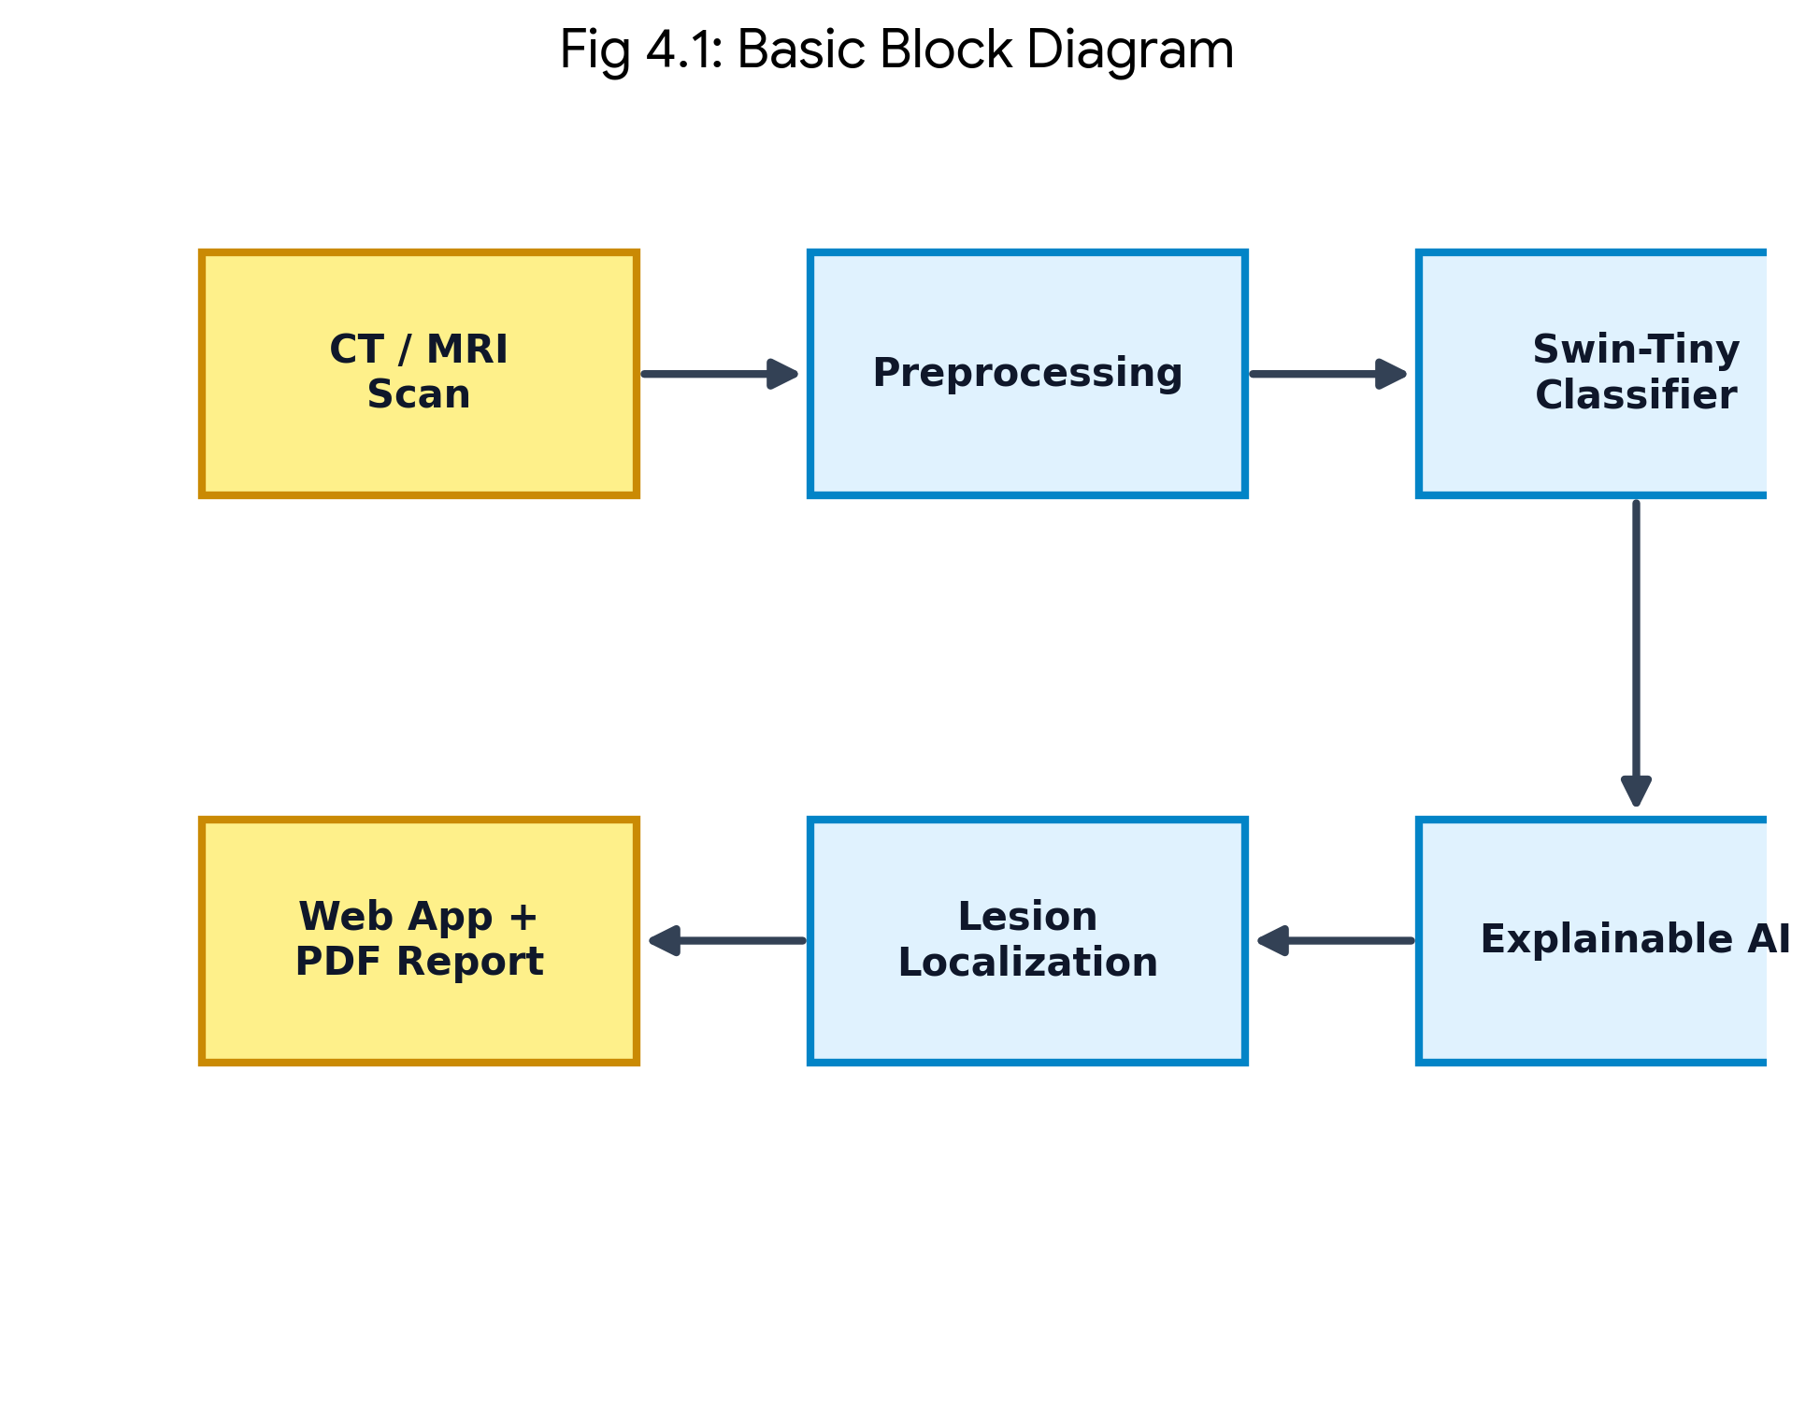
Figure 4.1: Basic block diagram of the detection and explanation pipeline.
Figure 4.2 gives the end-to-end architecture, showing the training path and the inference path that are actually executed at run time. At inference time a scan is passed through preprocessing (RGB conversion, resize to 224x224, and ImageNet normalization), forwarded through the Swin-Tiny classifier to obtain class probabilities, and — when the prediction is not normal — passed to the explainability engine, which produces LIME, Grad-CAM, and SHAP maps. These maps are fused into a consensus mask from which the localization module derives the affected region, the lesion area, and the percentage of brain affected. The combined result is stored, rendered in the browser, and rendered into a PDF report.
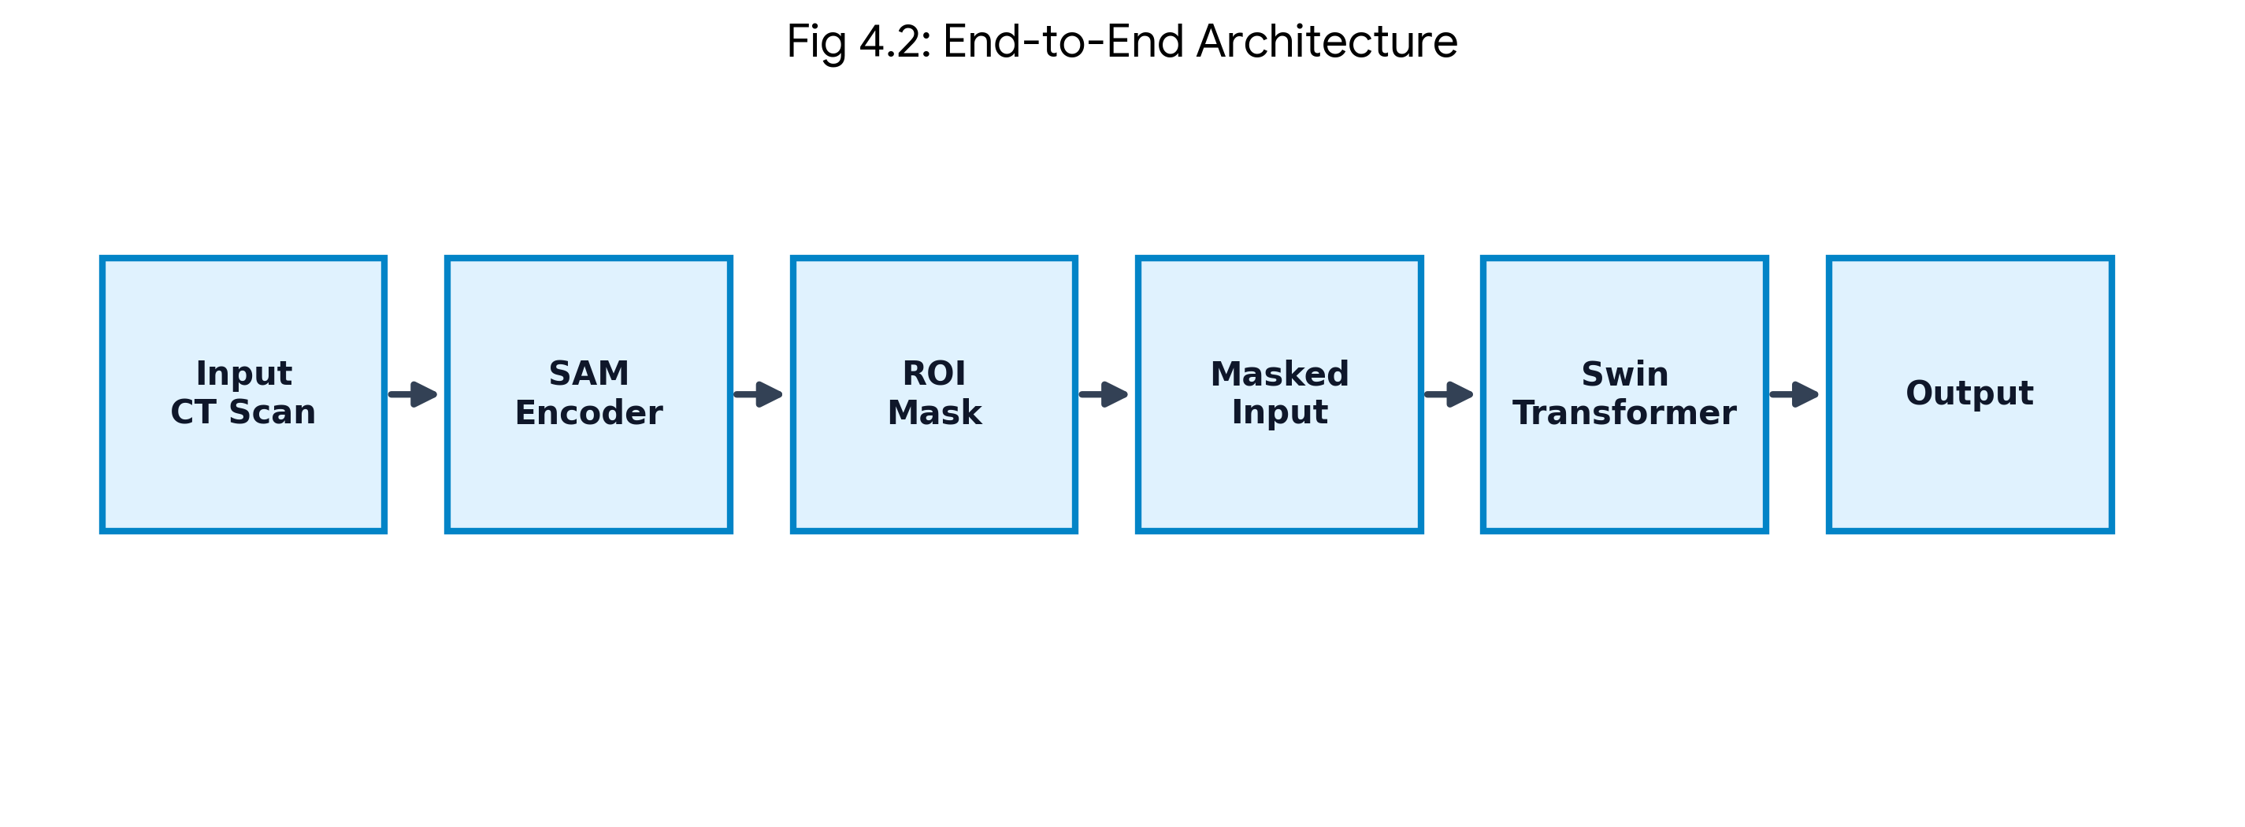
Figure 4.2: End-to-end system architecture with the training and inference paths.

4.2 Deployment Diagram
The deployment diagram (Figure 4.3) shows a thin client running a browser that communicates over HTTPS with an application host. The host runs the Flask web application and the FastAPI analysis service, which share an inference process that loads the Swin model and the explainability libraries, a SQLite database, and a directory of generated outputs. Because the model and the database both reside on the host, patient data never leaves the institution, which satisfies the data-privacy constraint stated in Chapter 3.
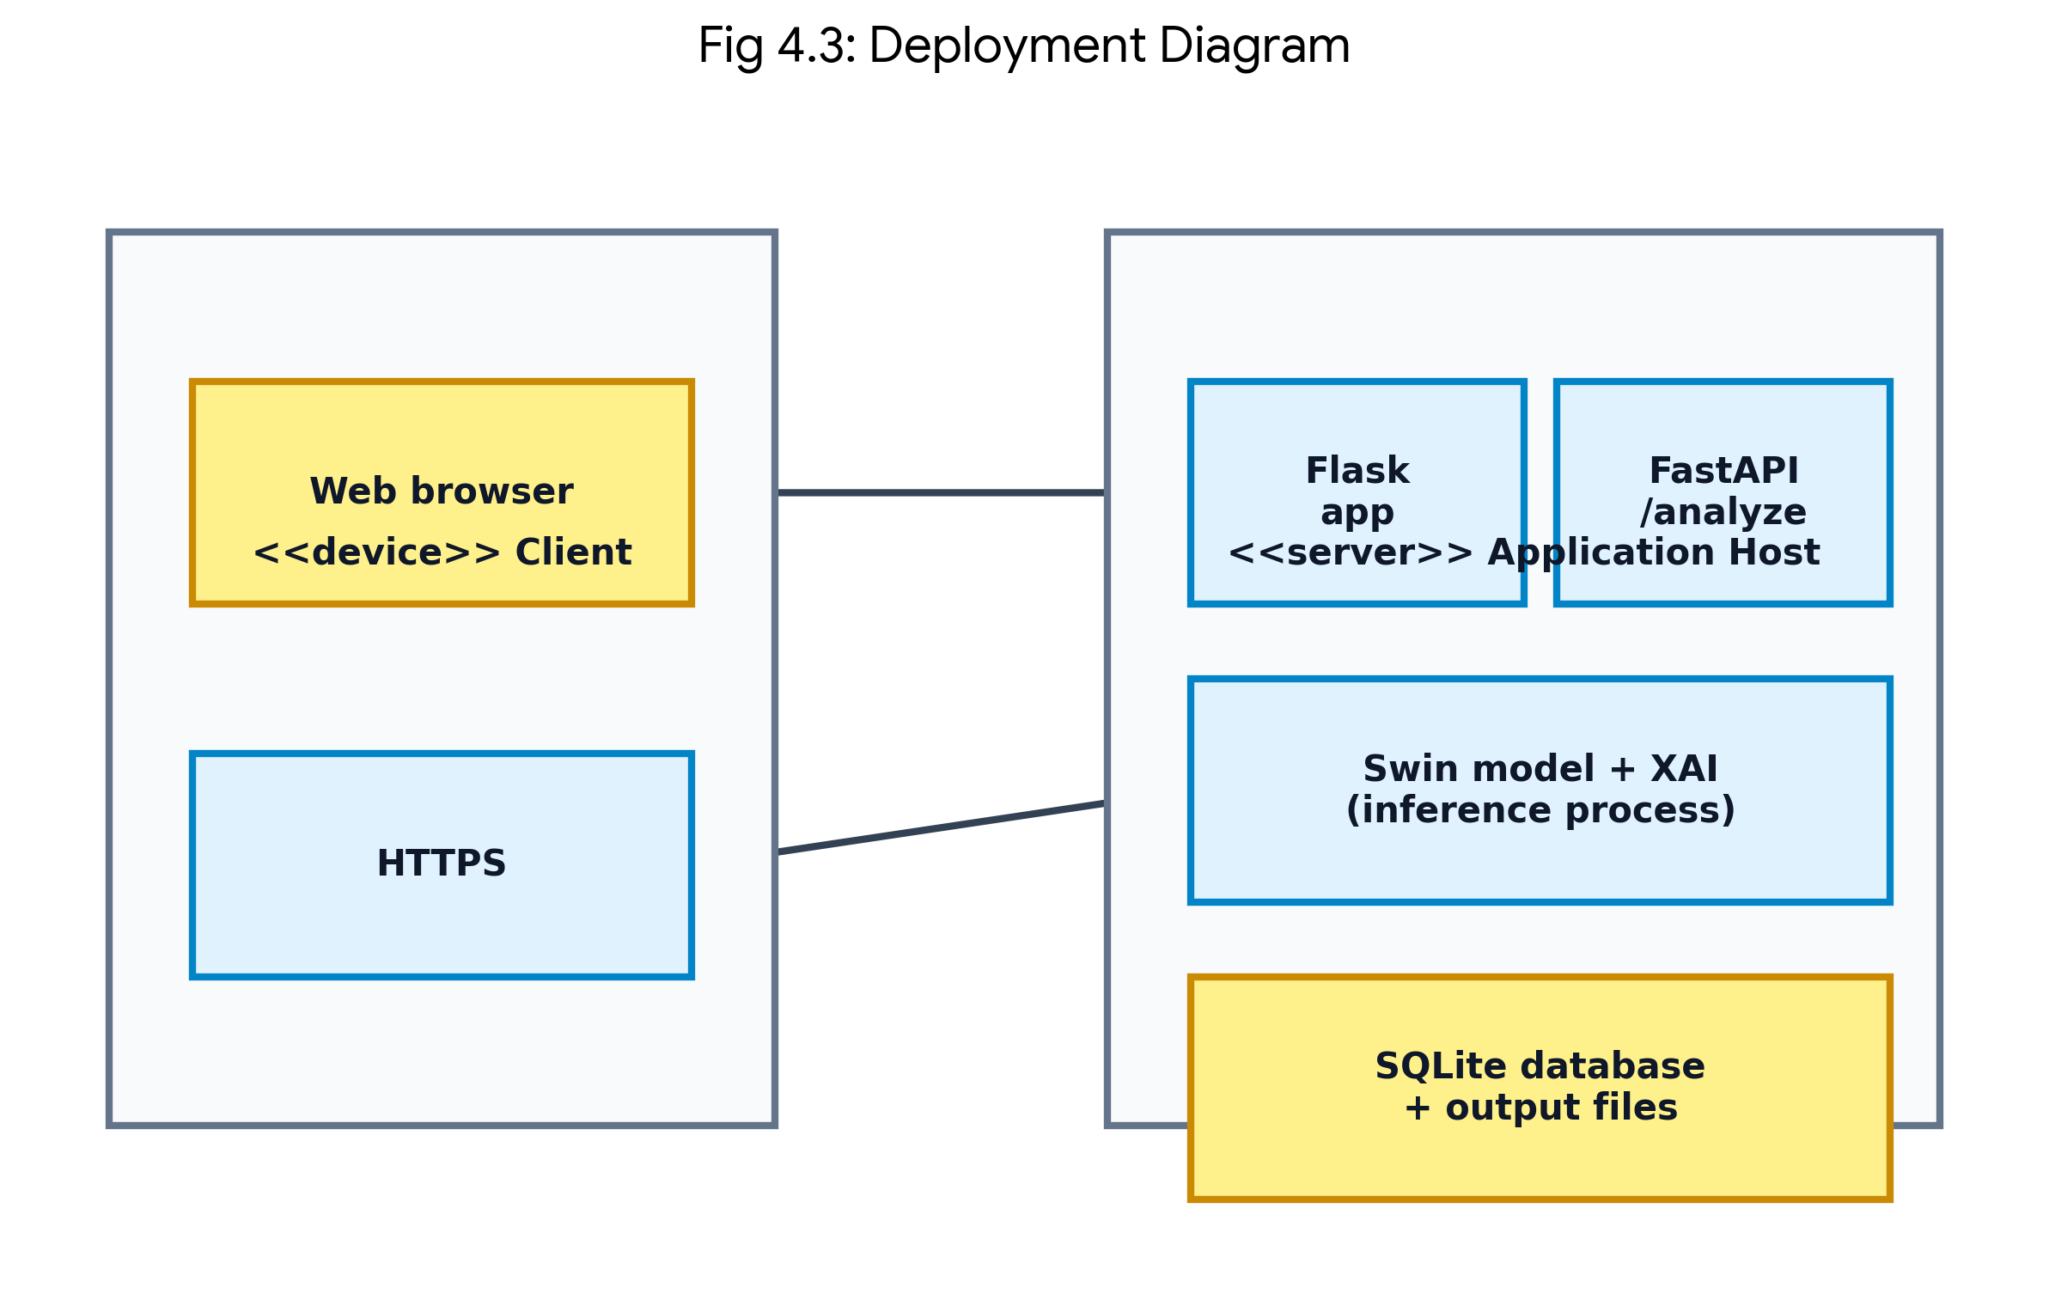
Figure 4.3: Deployment diagram.

4.3 Protocol Architecture
The protocol architecture (Figure 4.4) expresses the system as five cooperating layers. The presentation layer renders the clinician interface and the patient portal. The application layer handles HTTP routing, session authentication and authorization. The service layer coordinates inference, explainability, localization and report generation. The model layer holds the Swin-Tiny network and the three attribution methods together with the consensus-mask fusion logic. The data layer holds the relational database, the source dataset and the generated output artifacts. Requests travel downward and results travel back upward; each layer only depends on the layer beneath it, which keeps the machine learning code independent of the web code and makes both independently testable.
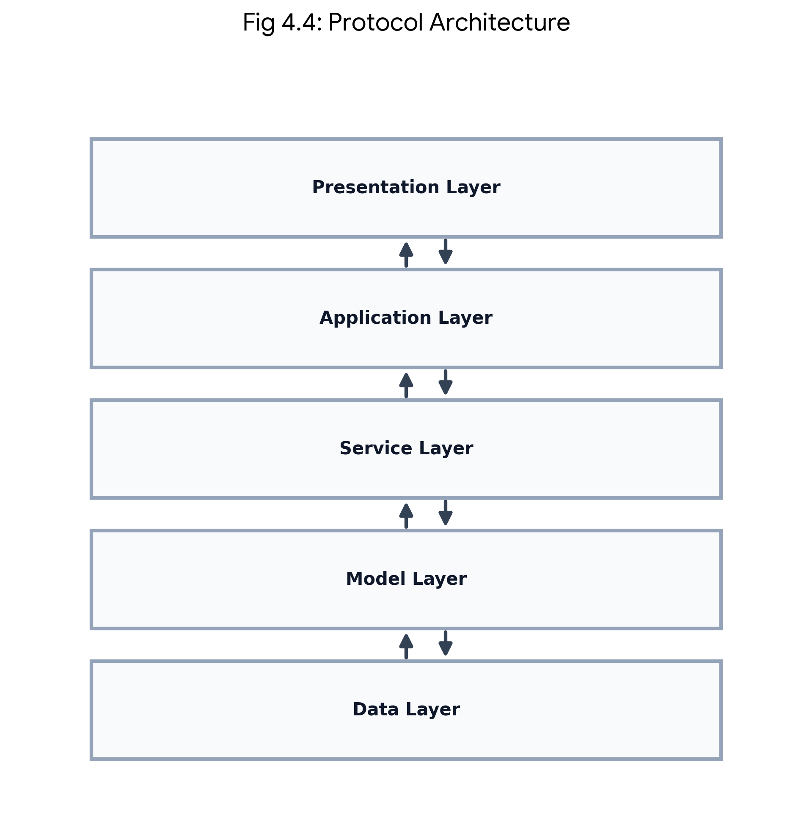
Figure 4.4: Layered protocol architecture of the system.

4.4 Flow Chart
The flow chart (Figure 4.5) describes the operational logic of the analysis service from upload to completion. The uploaded file is first validated for type and image integrity; an invalid file is rejected with a message and never reaches the model. A valid image is preprocessed and passed to the Swin-Tiny classifier, which returns class probabilities. If no stroke is detected, the normal result is stored and the workflow ends. If a stroke is detected, the explanation maps are generated, fused into a consensus mask, and used to localize the lesion; the prediction, the explanation and the lesion measurements are then stored in the database, a branded PDF clinical report is generated, and the result is displayed to the doctor.
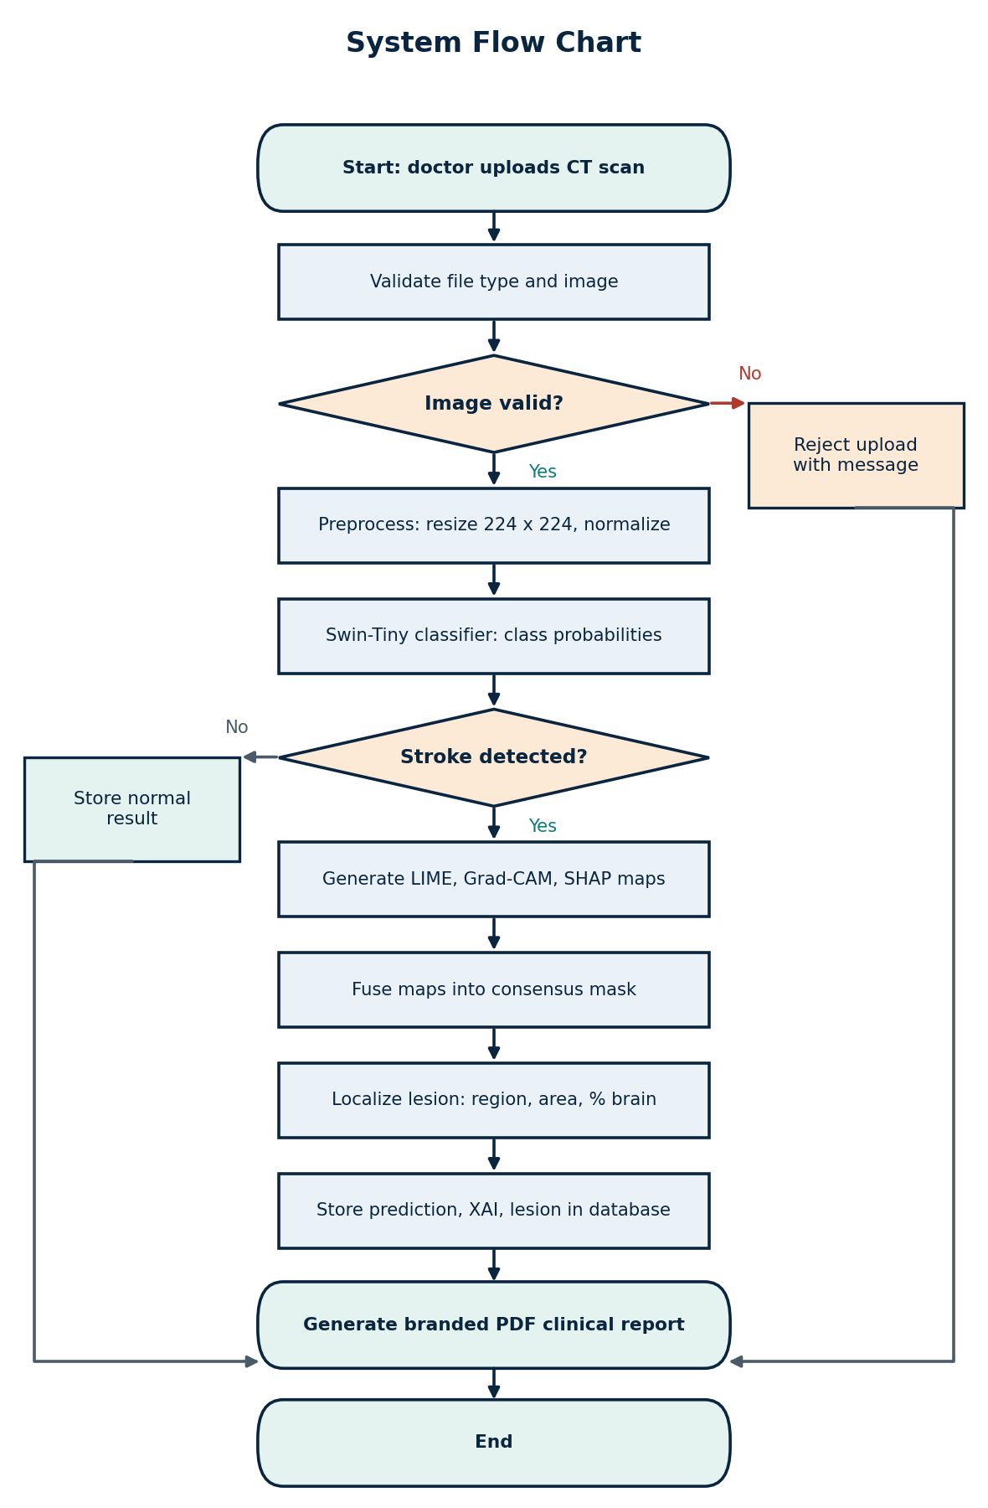
Figure 4.5: System flow chart of the scan analysis workflow.

4.5 State Transition Diagram
The state transition diagram (Figure 4.6) models the lifecycle of a scan as it moves through the system. A scan begins in the Idle state and enters the Uploaded state on submission. If the file fails validation it moves to the Rejected state, from which it can only be reset. A valid scan moves to the Validated state and then to the Classified state, where the model output is available. A normal classification terminates in the Normal Result state, whereas a stroke classification transitions to the Explained state, then to the Localized state once the consensus mask has been fused, and finally to the Reported state once the clinical report has been produced. From the Reported, Normal Result and Rejected states the scan may be reset to Idle for the next upload.
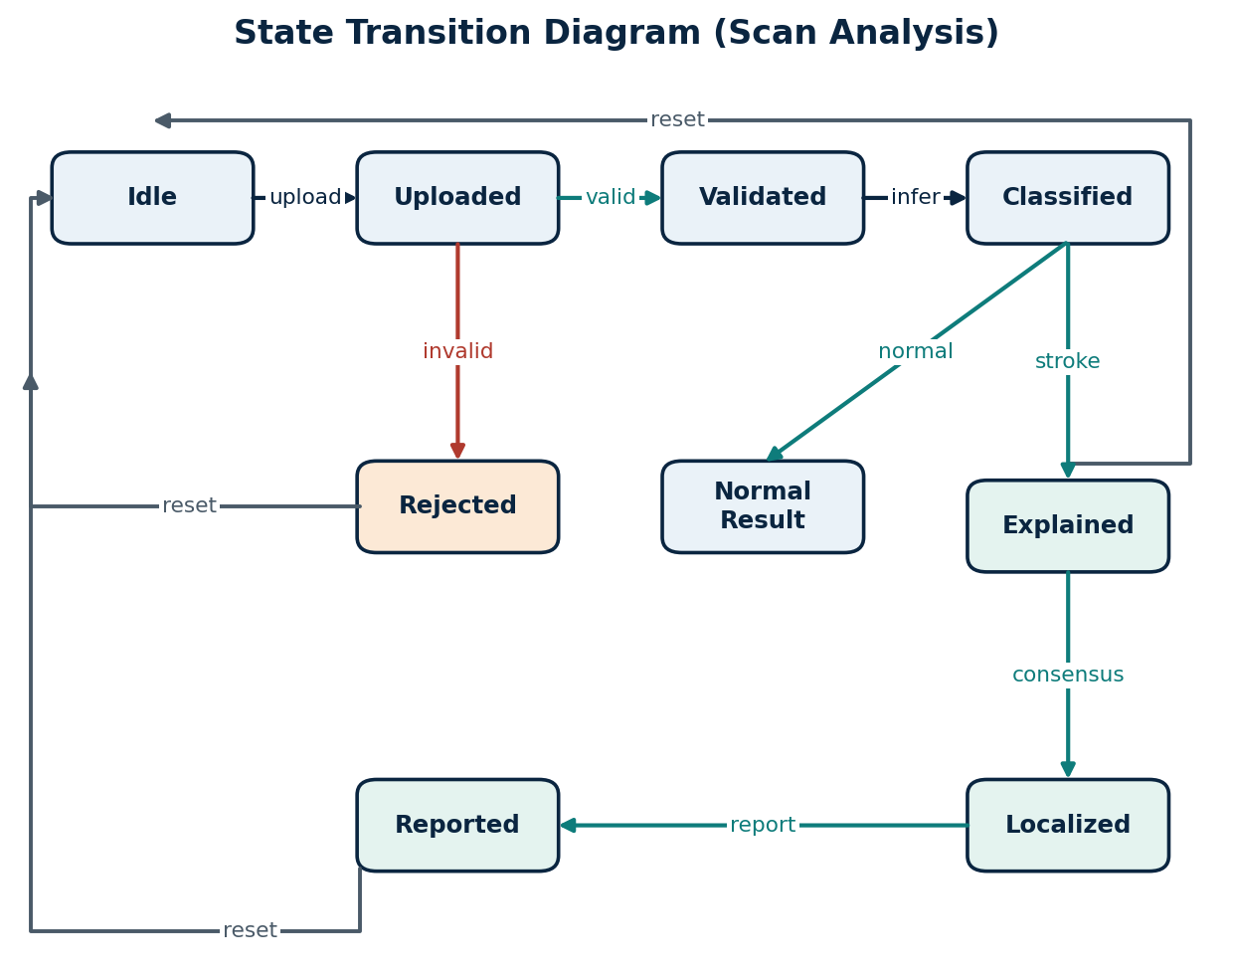
Figure 4.6: State transition diagram of the scan analysis lifecycle.

4.6 Sequence Diagram
The sequence diagram (Figure 4.7) traces the most important runtime scenario, in which a doctor uploads a scan and the system analyzes it. The flow proceeds from the doctor to the web application, to inference, then to the explainability engine, and the results are persisted in the database before the report is rendered back to the doctor.
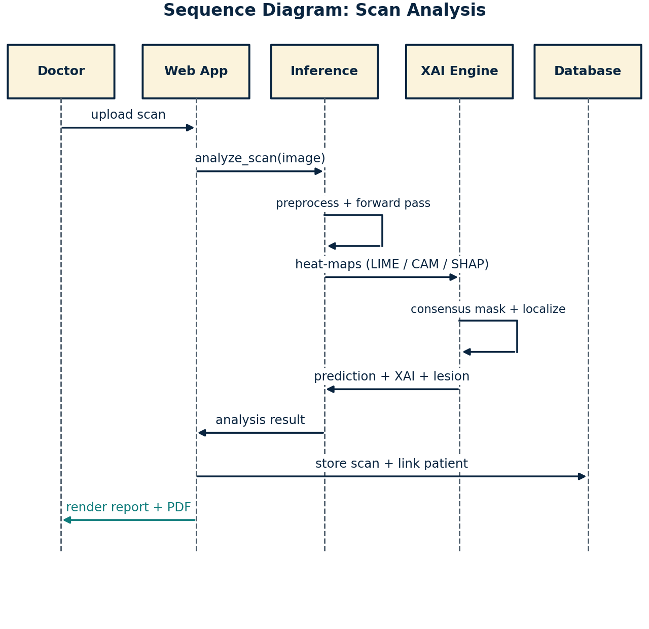
Figure 4.7: Sequence diagram for the scan analysis scenario.

4.7 Activity Diagram
The activity diagram (Figure 4.8) describes the end-to-end clinical workflow from login to report viewing, including the decision point at which a stroke is or is not predicted, after which the report path or the normal-result path is taken.
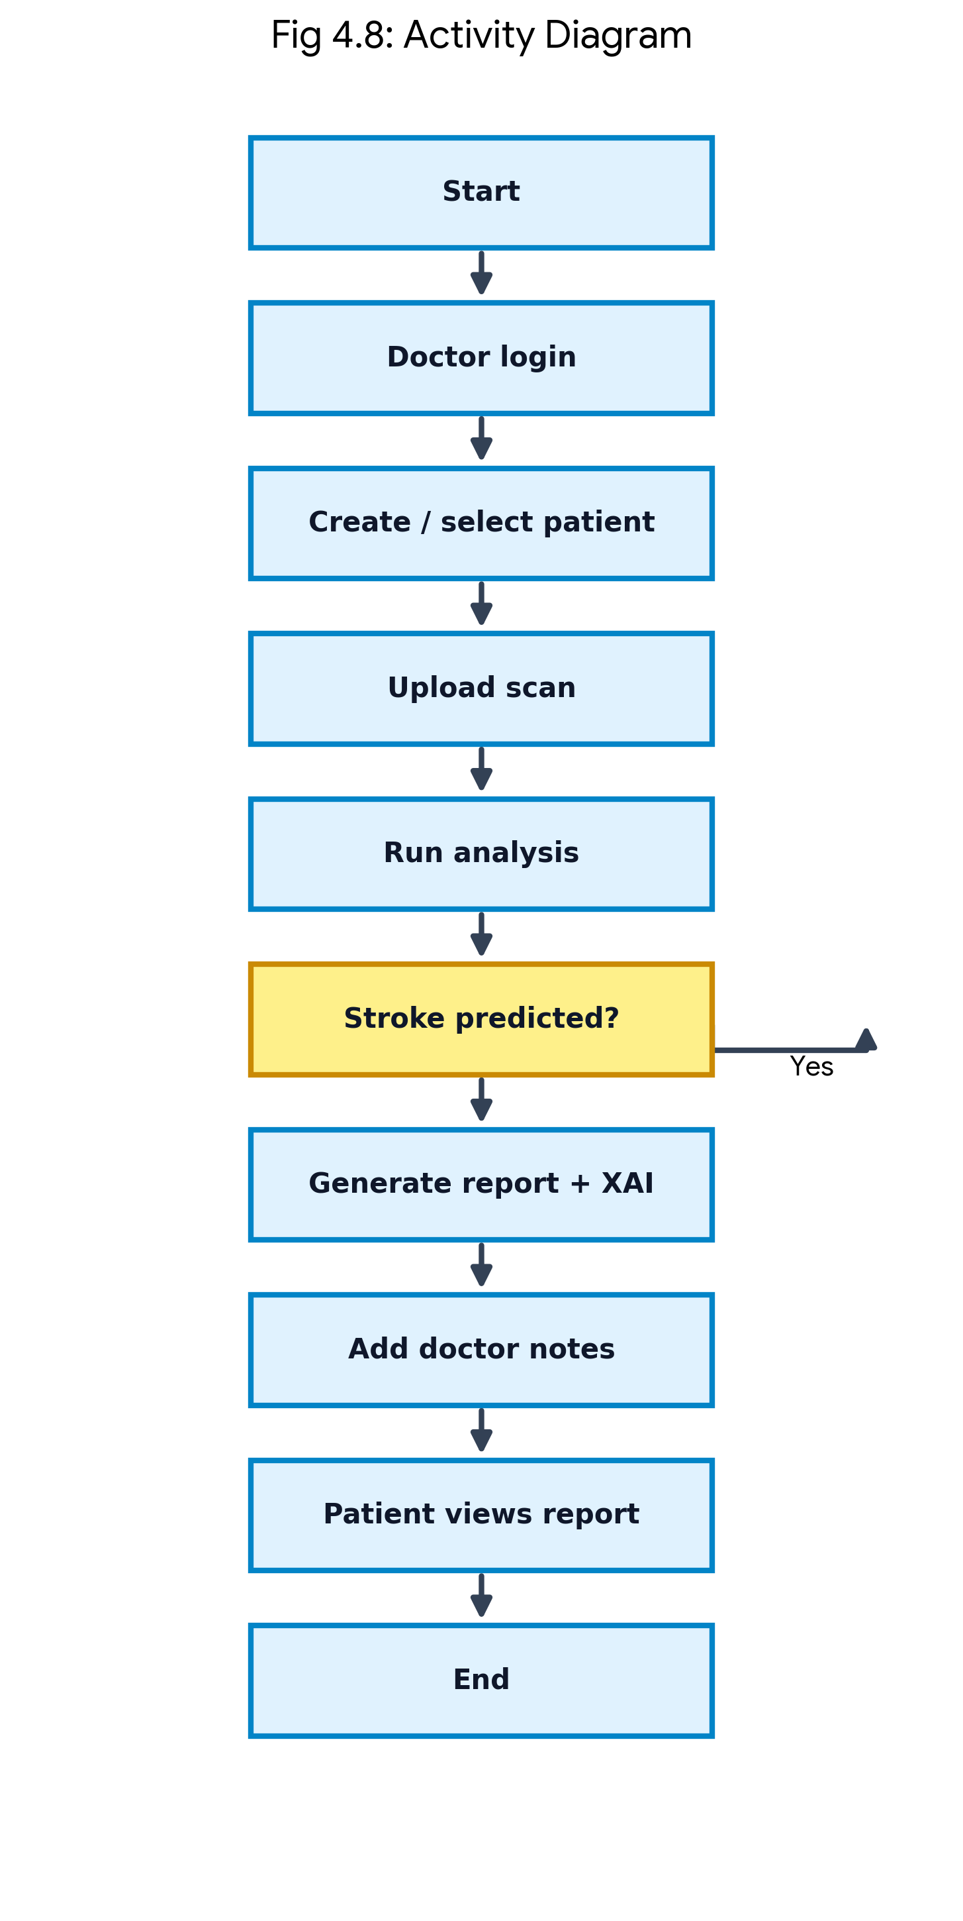
Figure 4.8: Activity diagram of the clinical workflow.

4.8 Data Flow Diagram
The level-0 data flow diagram (Figure 4.9) shows the NeuroScan system as a single process interacting with two external entities, the doctor and the patient, and three data stores for uploaded scans, the relational database, and the generated explanation and report files.
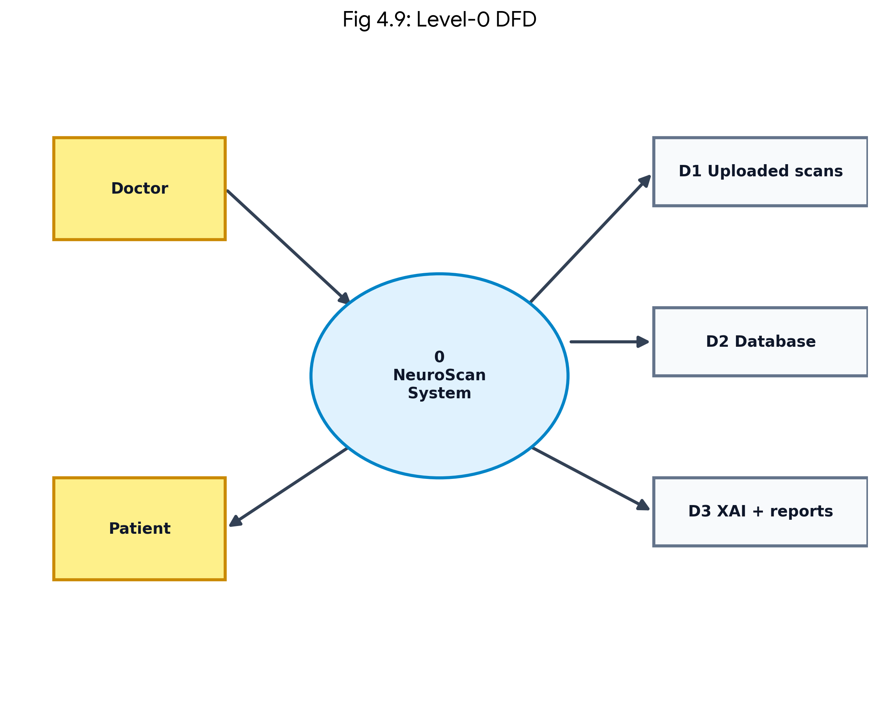
Figure 4.9: Level-0 data flow diagram.
The level-1 diagram (Figure 4.10) decomposes the system into four sub-processes — patient management, scan analysis, explanation and localization, and report generation — showing how each reads from or writes to the data stores.
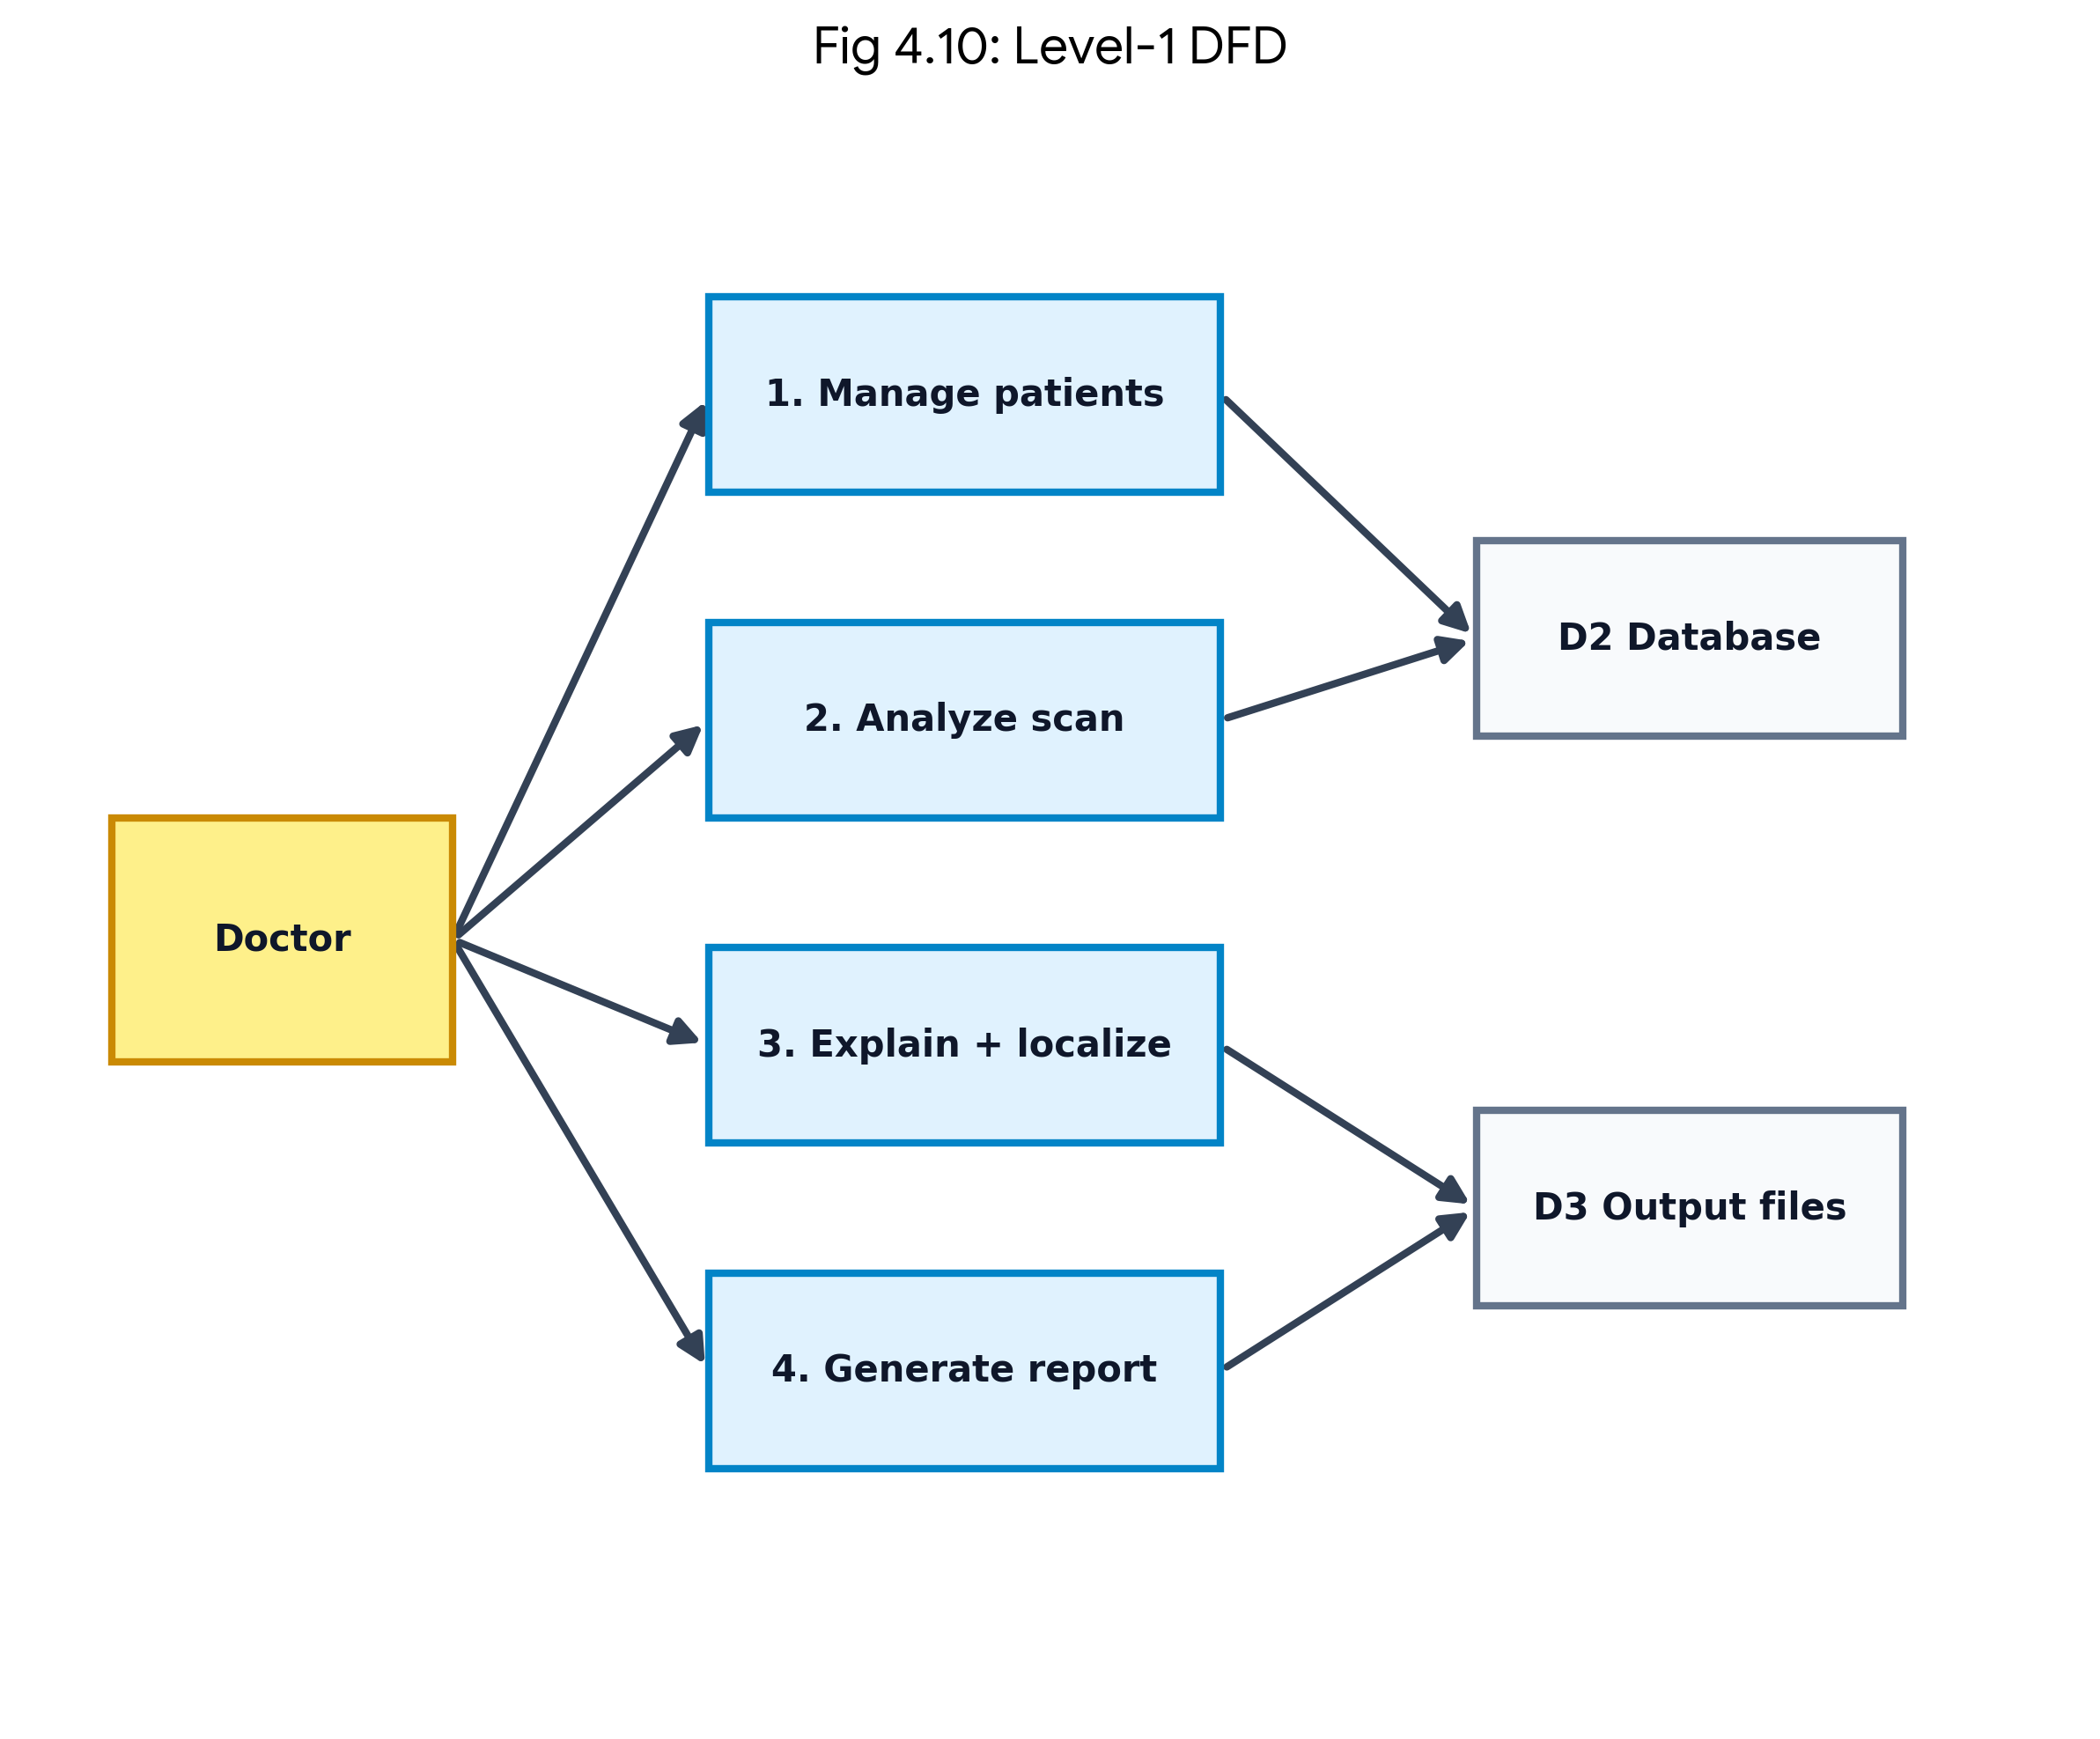
Figure 4.10: Level-1 data flow diagram.

4.9 Module Design
The system is decomposed into ten modules, listed in Table 4.1. Each module has a single, well-defined responsibility and a narrow interface, which supports the automated testing described in Chapter 6.
Table 4.1: System modules and responsibilities.
# | Module | Responsibility
1 | Data ingestion and preprocessing | Load images by class, resize and normalize, batch, augment
2 | SAM ROI (optional experiment) | Automatic mask generation and ROI crop (standalone CLI)
3 | Model definition and training | Build Swin-Tiny, class-weighted loss, cosine LR, checkpoints
4 | Inference and classification | Preprocess, forward pass, softmax probabilities
5 | Explainable AI | LIME, Grad-CAM, SHAP, consensus mask, six-panel figure
6 | Lesion localization | Region, area in mm2, % brain, centroid, overlay
7 | Report generation | Branded PDF clinical report (ReportLab)
8 | Web application | Auth, patient CRUD, upload and analyze, notes, statistics
9 | Database | SQLite schema and CRUD for users, patients, and scans
10 | API service | FastAPI /analyze and /reports endpoints

4.10 Use Case Diagram
The use case diagram (Figure 4.11) identifies the two actors, doctor and patient, and the set of use cases each can perform within the NeuroScan system boundary. The doctor is associated with account, patient-management, analysis, notes, statistics, and report use cases, while the patient is restricted to logging in and viewing or downloading their own reports.
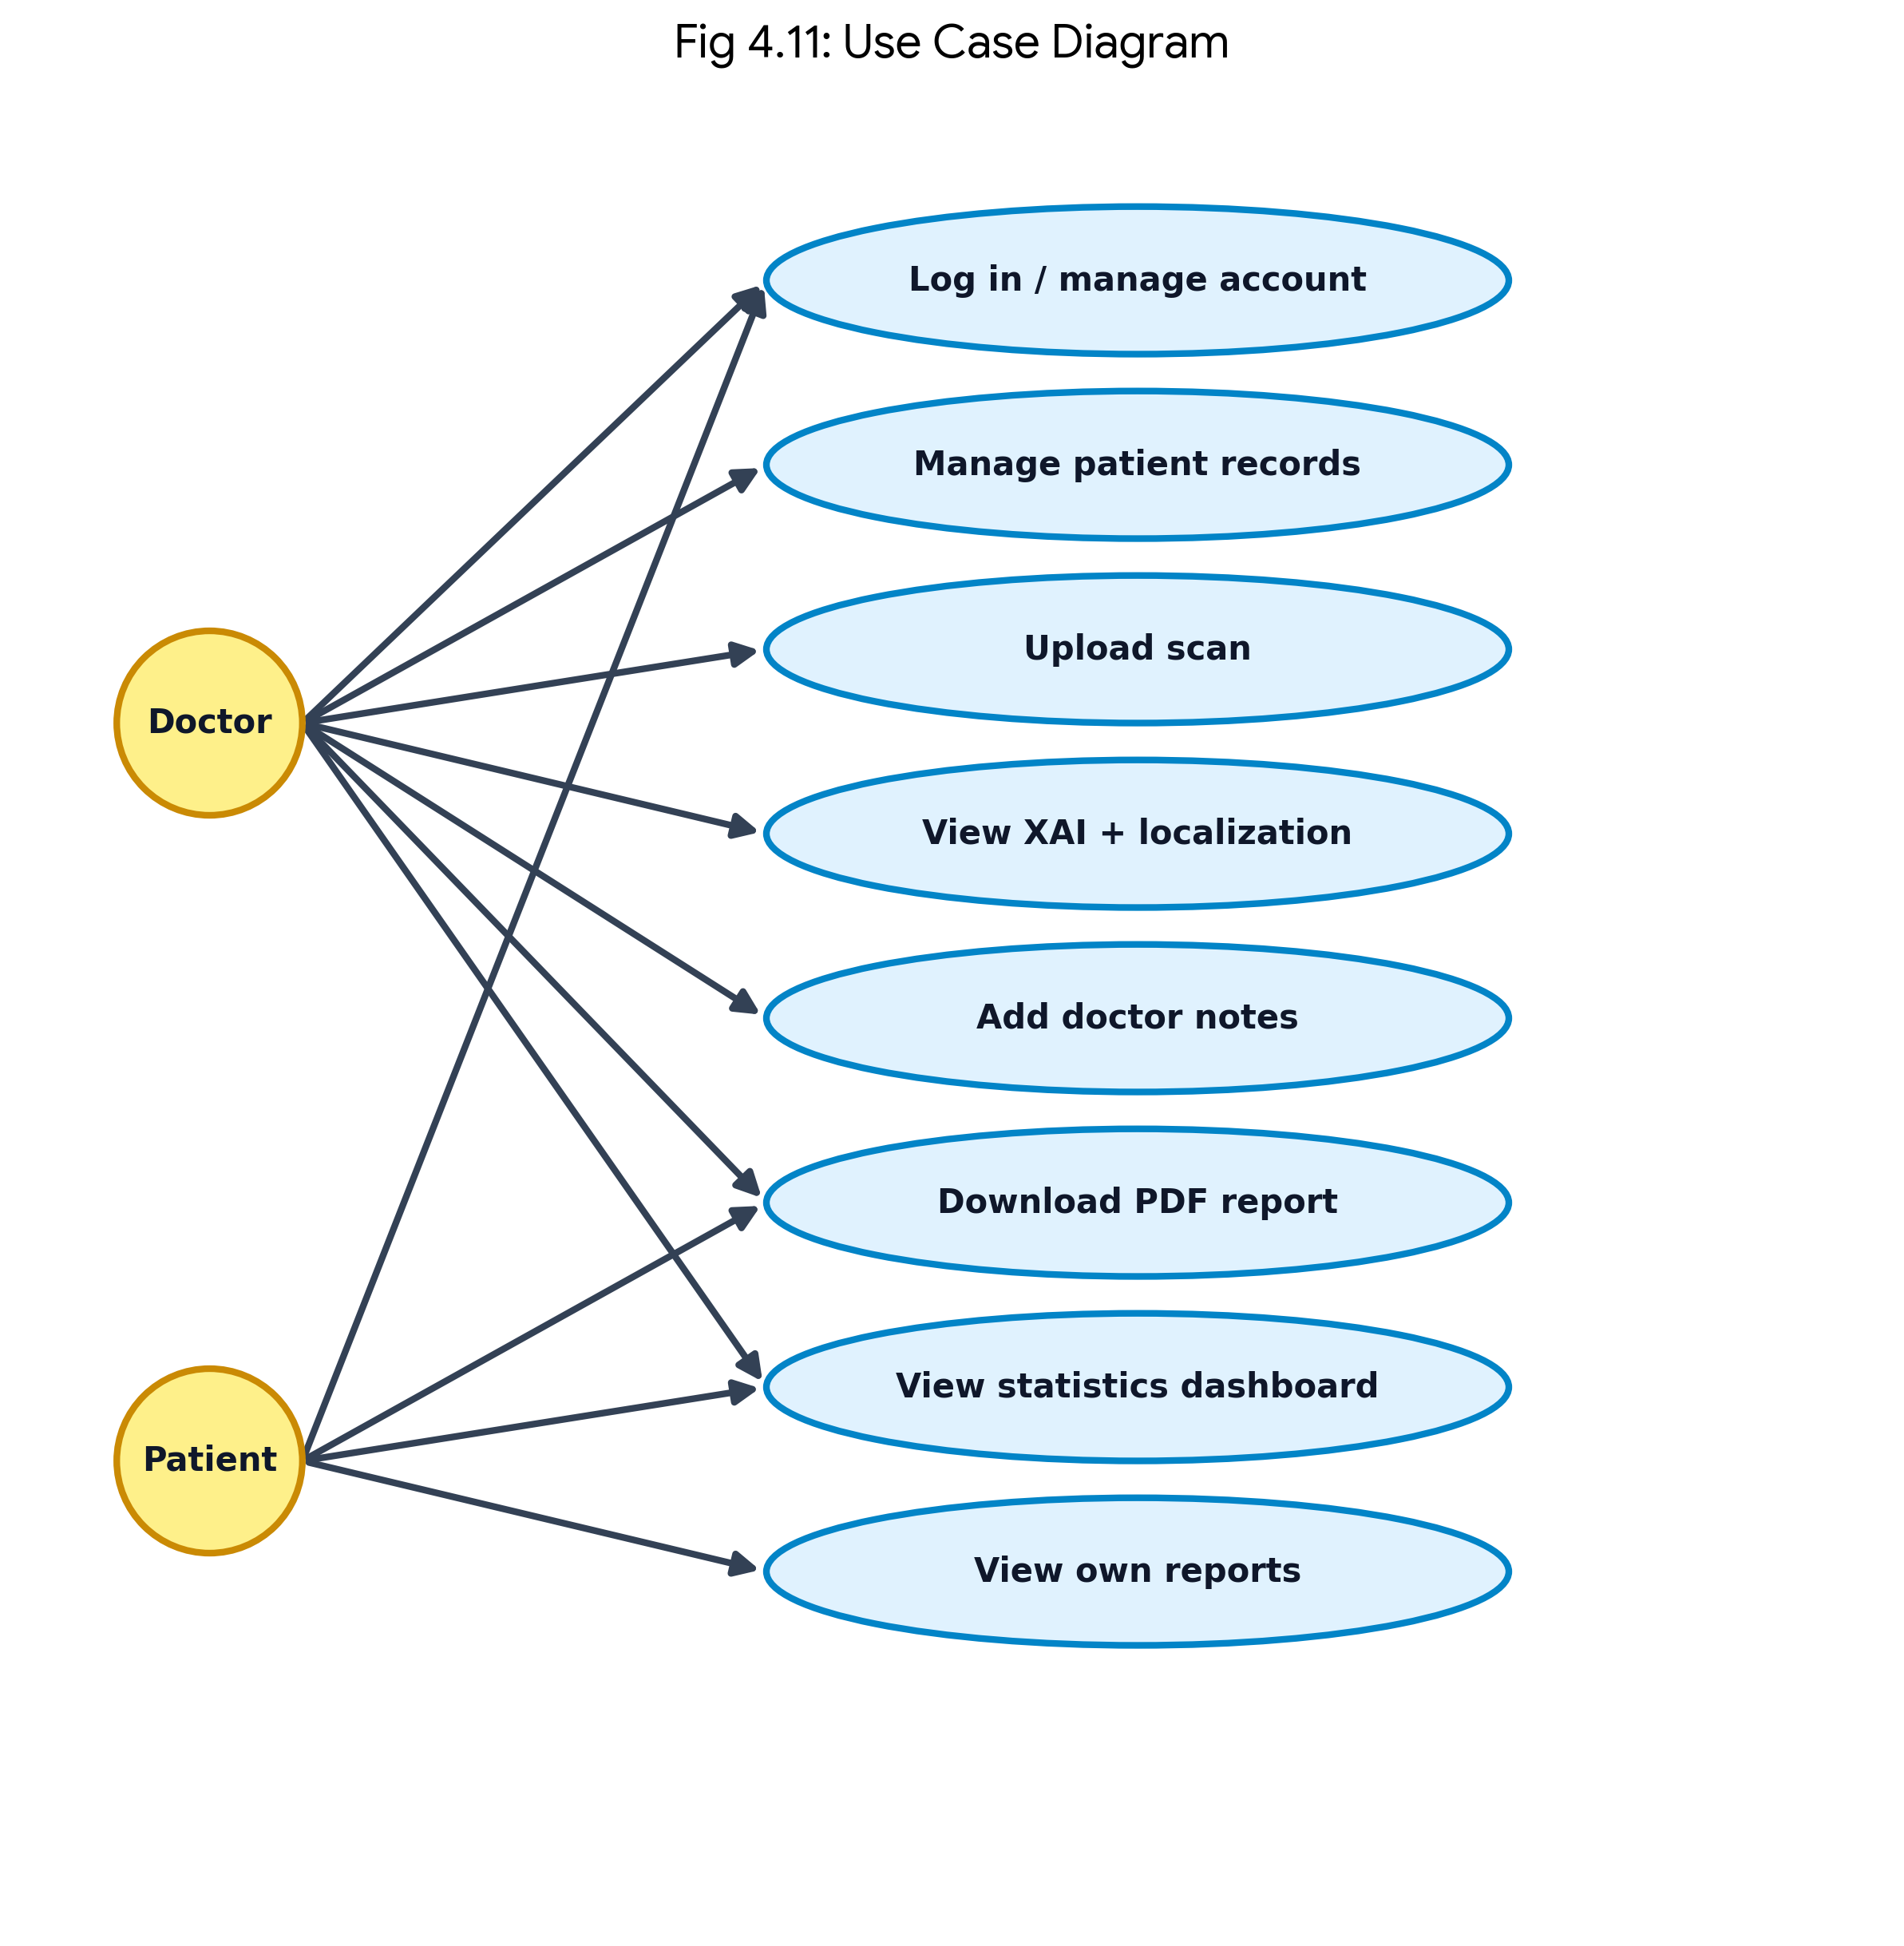
Figure 4.11: Use case diagram.

4.11 Class Diagram
The class diagram (Figure 4.12) captures the principal domain and service classes: User, Patient, and Scan model the persisted data, while StrokeModel, ExplainEngine, LesionLocalizer, and ReportBuilder model the analysis pipeline. Relationships show that a user owns many patients and that a scan links a patient to the analysis services that consume it.
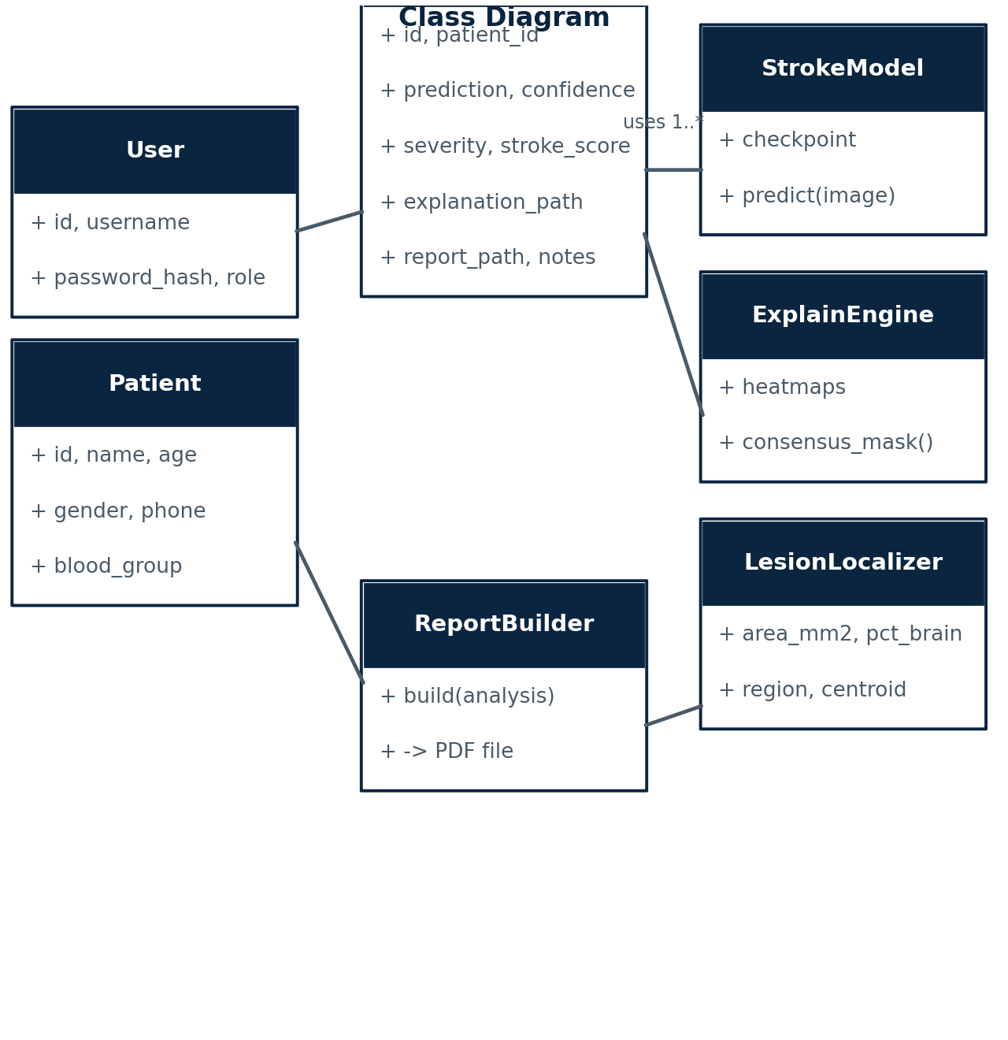
Figure 4.12: Class diagram of the domain and service classes.

4.12 Database Design
The application uses a normalized SQLite schema with three core tables. Figure 4.13 shows the entity-relationship view, and Table 4.2 lists the key columns and relationships. Scans are linked to patients through a foreign key, and patients are linked to the doctor who created them.
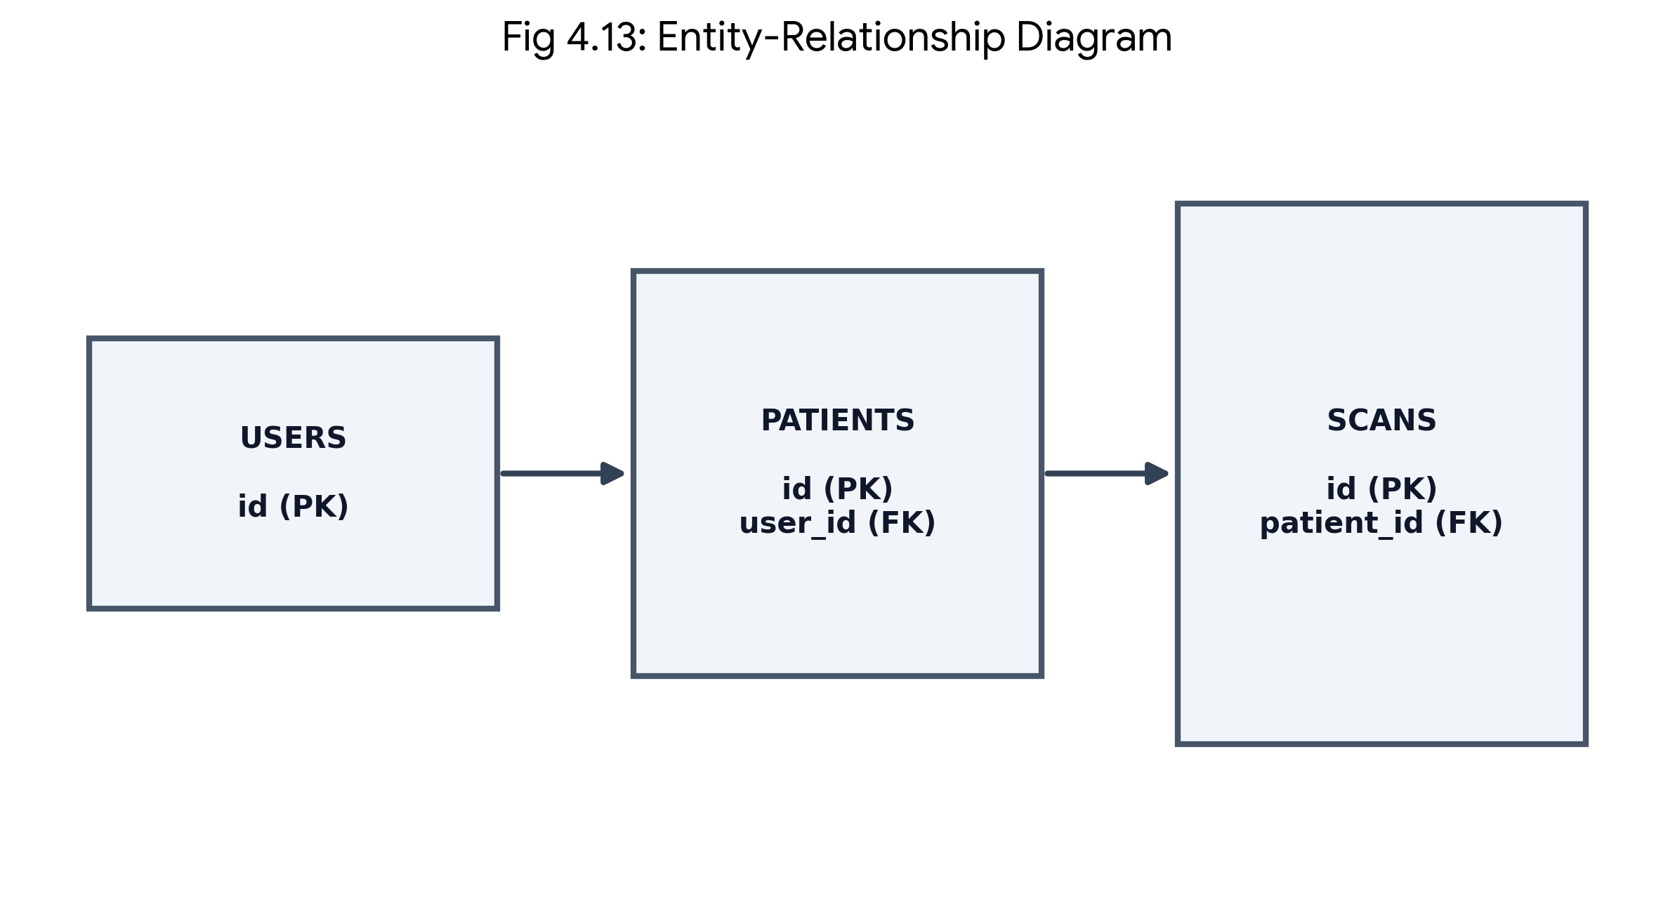
Figure 4.13: Entity-relationship diagram.
Table 4.2: Database schema and relationships.
Table | Key columns | Relationship
users | id, username, password_hash, role | 1 : N patients
patients | id, name, age, gender, phone, blood_group, user_id | FK user_id -> users.id
scans | id, patient_id, filename, prediction, confidence, severity, stroke_score, probabilities_json, explanation_path, report_path, doctor_notes, created_at | FK patient_id -> patients.id

4.13 Component Design
The component diagram (Figure 4.14) shows the internal software components — the web interface, authentication module, Flask router, analysis service, report service, inference component, XAI engine, and database — and their dependencies.
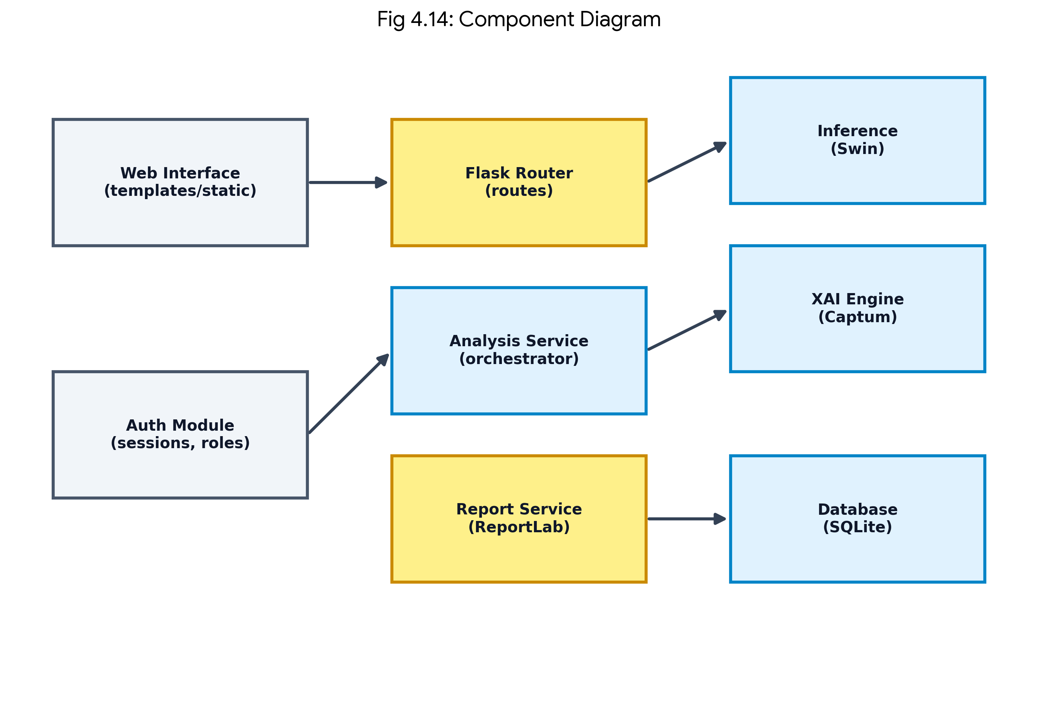
Figure 4.14: Component diagram.

4.14 Algorithms
Three core algorithms drive the system: model training, scan analysis, and lesion localization. They are summarized below in pseudocode.
Algorithm 1: Train Stroke Classifier
inputs: train/val loaders, epochs E, learning rate lr, weight decay wd
w <- N / (C * counts) # inverse-frequency class weights
best_f1 <- 0
for epoch in 1..E:
train_one_epoch(cross_entropy(w), AdamW(lr, wd), mixed_precision)
m <- validate() # accuracy, macro-F1, confusion
if m.macro_f1 > best_f1:
save('best_model.pt'); best_f1 <- m.macro_f1
scheduler.step() # cosine annealing
return best_model.pt
Algorithm 2: Analyze Scan
inputs: image
x <- preprocess(image) # RGB, resize 224, normalize
probs <- softmax(SwinModel(x)); cls <- argmax(probs)
result <- {cls, probs}
if cls != normal:
H <- {gradcam(x, cls), lime(x, cls), shap(x, cls)}
mask <- mean(H) >= 0.5 * max(mean(H)) # consensus
lesion <- localization(mask, x)
result <- result + {explanation: H, lesion: lesion}
return result
Algorithm 3: Lesion Localization
inputs: consensus mask M, image x
M <- morphological_open_close(M, kernel=5x5)
lesion <- largest_8connected_component(M)
brain <- otsu_mask(x)
area_mm2 <- count(lesion) * (0.5 mm)^2
pct_brain <- count(lesion) / count(brain) * 100
region <- atlas_map(normalized_centroid(lesion, brain))
return {region, area_mm2, pct_brain, centroid}

4.15 Design Constraints and Considerations
- Clinical safety: the system is explicitly a decision-support tool; outputs are never presented as a definitive diagnosis.
- Transparency: every non-normal prediction is accompanied by explanations and a localization overlay.
- CPU feasibility: the design avoids GPU-only operations so that it runs on ordinary workstations.
- Modularity: the ML, XAI, and web layers communicate through light interfaces, which enables independent testing.
- Data privacy: patient data is stored locally in SQLite and never transmitted to third parties.

Chapter 5 Implementation

5.1 Development Environment
The system is implemented in Python 3.11 using PyTorch and torchvision for deep learning, the timm library [32] for the Swin Transformer backbone [26], Captum [36] for Grad-CAM [33] and SHAP [35], OpenCV and Pillow for image processing, Flask and FastAPI for the web and API layers, SQLite for persistence, and ReportLab for PDF generation. All training and evaluation were performed on a CPU-only workstation. Table 5.1 lists the primary tools and their roles.
Table 5.1: Development tools and libraries.
Tool / library | Version role | Purpose
Python | 3.11 | Primary implementation language
PyTorch / torchvision | 2.x | Model definition, training, tensor operations
timm | latest | Swin-Tiny backbone and pretrained weights
Captum | latest | Grad-CAM and SHAP implementations
OpenCV / Pillow | - | Image loading, morphology, overlay rendering
NumPy / pandas / scikit-learn | - | Numerical and metric computation
Flask | 3.x | Hospital web application
FastAPI / uvicorn | - | Analysis REST API
SQLite | stdlib | Relational persistence
ReportLab | - | Branded PDF clinical report
pytest | - | Automated test suite

5.2 Project Structure
The code base is organized into a library package and application entry points, which keeps the machine learning code separate from the web code and makes both independently testable. The principal layout is shown below.
brain/
configs/ default.yaml (hyper-parameters, paths, XAI params)
src/stroke_sam_swin/
data.py Dataset, transforms, loaders
model.py Swin-Tiny builder (3-class head)
train.py training loop, metrics, checkpointing
inference.py load checkpoint, classify a single image
explain.py LIME, Grad-CAM, SHAP, consensus mask
localization.py morphology, region, area, % brain
sam_roi.py optional SAM ROI experiment (CLI)
flask_app.py hospital web application (port 8003)
app.py FastAPI analysis service (port 8004)
database.py SQLite schema and CRUD helpers
tests/test_app.py 11 automated tests
outputs/ checkpoints, reports, explanations, charts

5.3 Dataset and Preprocessing
The public TEKNOFEST 2021 brain CT dataset [31] is used, comprising 7,202 axial non-contrast CT images across three classes. The data is split 70/15/15 into training, validation, and test sets using a fixed random seed. Images are converted to RGB, resized to 224x224 pixels, and normalized using the ImageNet channel statistics, so that the ImageNet-pretrained backbone receives inputs in its expected range. Training augmentation consists of random horizontal flips, small rotations, and mild brightness and contrast jitter; validation and test images receive only resize and normalization. Table 5.2 lists the class distribution across the splits.
Table 5.2: Dataset split across classes.
Class | Train | Validation | Test | Total
Normal | 3,185 | 682 | 684 | 4,551
Ischemic | 952 | 204 | 205 | 1,361
Hemorrhagic | 902 | 193 | 195 | 1,290
Total | 5,039 | 1,079 | 1,084 | 7,202

The dataset is imbalanced: the normal class is more than three times larger than either abnormal class. To prevent the model from ignoring the minority classes, the training loss weights each class by the inverse of its frequency. Figure 5.1 shows representative slices from each of the three classes.
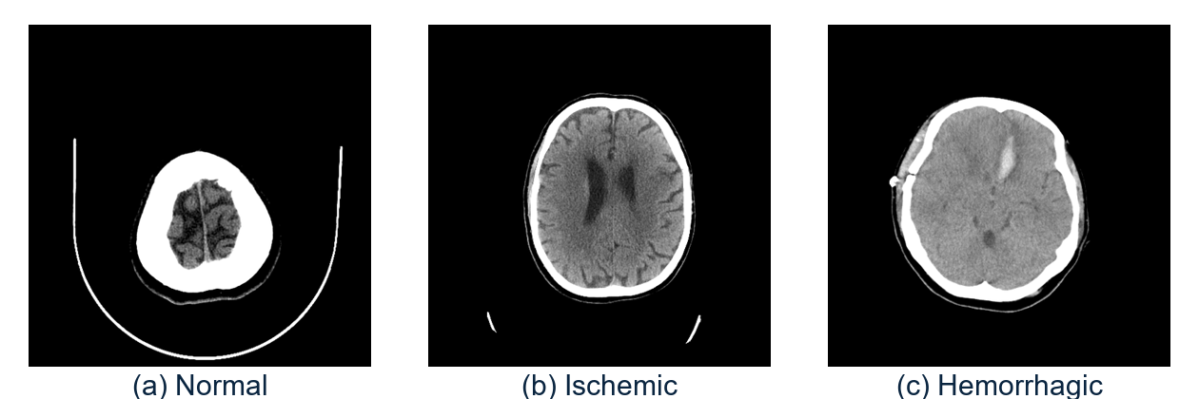
Figure 5.1: Representative CT slices from each class.

5.4 Model Implementation
The classifier is a Swin Transformer Tiny (swin_tiny_patch4_window7_224) initialized from ImageNet-pretrained weights and fine-tuned for three-class stroke classification. Swin first splits the image into non-overlapping patches, embeds them, and then applies a sequence of transformer blocks in which self-attention is computed within local windows. Between consecutive blocks the window partition is shifted, which allows information to cross window boundaries and builds a hierarchical, multi-scale representation. The final stage's features are pooled and passed through a linear layer with three outputs, and a softmax converts the logits to class probabilities. Using ImageNet weights substantially reduces the amount of data and time needed to reach good accuracy on this relatively small dataset.

5.5 Training Implementation
Training follows a standard supervised recipe adapted for an imbalanced, small-to-medium dataset. A class-weighted cross-entropy loss is used, AdamW optimization with a learning rate of 1e-4 and weight decay of 0.01, cosine annealing of the learning rate over the schedule, mixed-precision arithmetic to reduce memory and speed computation, and checkpointing of the model that achieves the best validation macro-F1. The configuration is listed in Table 5.3.
Table 5.3: Training hyper-parameters.
Parameter | Value
Backbone | Swin Transformer Tiny (patch 4, window 7, 224 input)
Input size | 224 x 224 (RGB)
Epochs | 15
Batch size | 8
Optimizer | AdamW (lr = 1e-4, weight decay = 0.01)
Learning-rate schedule | Cosine annealing
Loss | Cross-entropy with inverse-frequency class weights
Precision | Mixed precision (AMP)
Augmentation | Horizontal flip (0.5), rotation +/-8 deg, brightness/contrast 0.08
Checkpoint criterion | Best validation macro-F1 (best_model.pt)
Random seed | Fixed for reproducibility

5.6 Training Workflow
The training workflow reads batches of augmented images, computes the class-weighted loss, updates the weights, and evaluates on the validation set after each epoch. The best checkpoint by validation macro-F1 is retained for inference. Figure 5.2 shows this workflow.
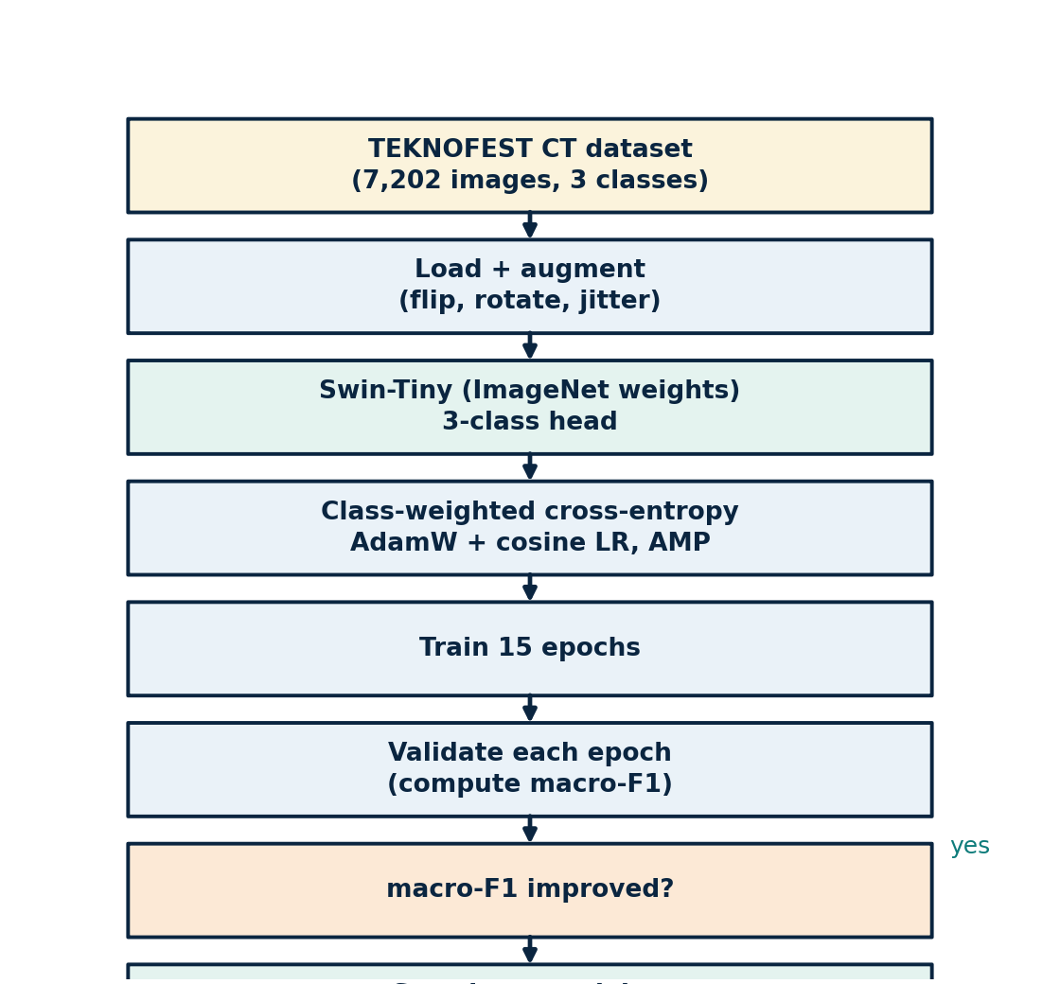
Figure 5.2: Training workflow.

5.7 Explainability Implementation
For every non-normal prediction, three explanation maps are produced for the predicted class. Grad-CAM [33] is computed from the gradients flowing into the last Swin stage; LIME [34] fits a distance-weighted ridge regression over a grid of superpixels; and SHAP [35] estimates feature attributions by sampling over a coarser grid. Each map is normalized to the range [0, 1], and the three maps are averaged and thresholded at 50% of the peak to form a consensus mask. The mask is cleaned with morphological opening and closing and reduced to its largest 8-connected component, which is overlaid on the scan. This consensus approach mitigates the instability of any single method, a concern noted in the XAI literature [30].
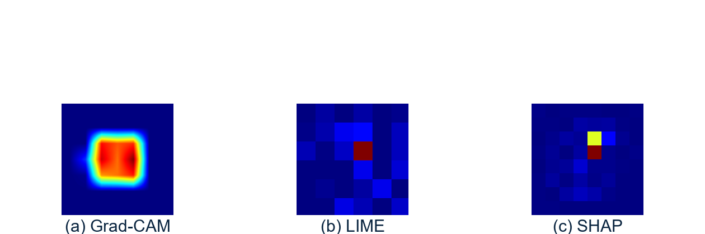
Figure 5.3: Grad-CAM, LIME, and SHAP heat-maps for a sample.
Figure 5.3 shows the three individual heat-maps for a representative scan, and Figure 5.4 shows the complete six-panel explanation output produced for a single study: the input scan, the LIME, Grad-CAM, and SHAP maps, the fused consensus mask, and the final overlay.
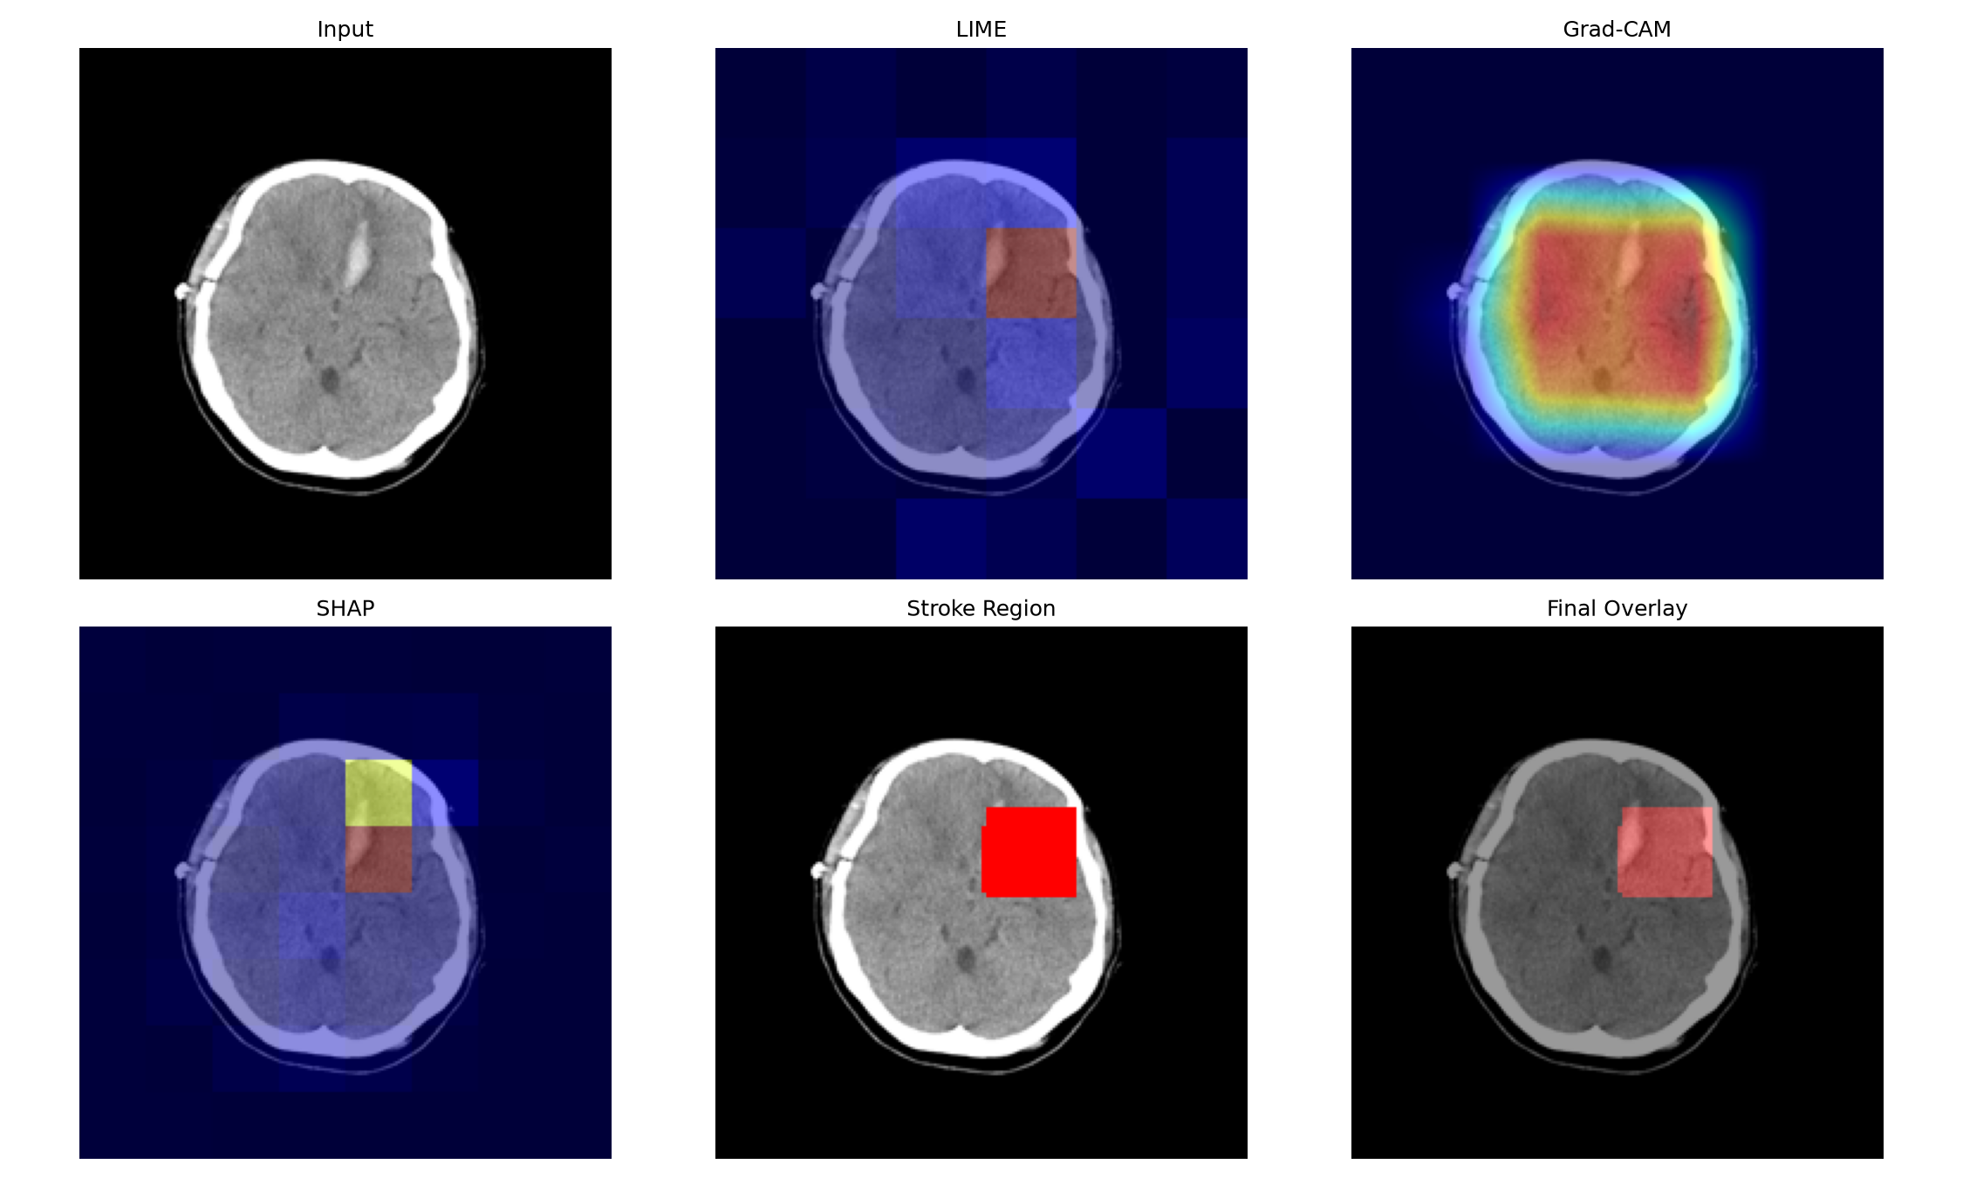
Figure 5.4: Six-panel explainability output: input, LIME, Grad-CAM, SHAP, consensus mask, overlay.

5.8 Lesion Localization Implementation
The localization module converts the consensus mask into clinically meaningful quantities. After morphological cleaning and selection of the largest connected component, it estimates the brain area using an Otsu threshold, computes the lesion area assuming a pixel spacing of 0.5 mm, expresses the lesion as a percentage of the brain area, and maps the normalized centroid of the lesion to a coarse axial-slice atlas that reports the affected region and the affected side. The module returns no lesion when the mask is empty, which prevents spurious findings. Figure 5.5 shows localization overlays for hemorrhagic and ischemic examples.
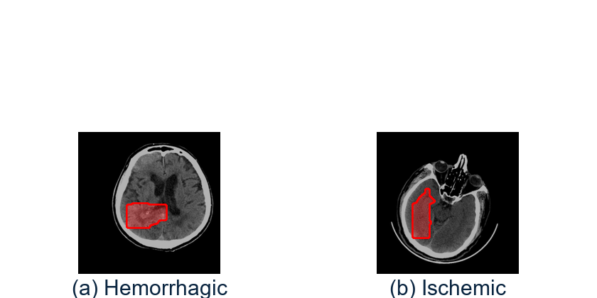
Figure 5.5: Lesion localization overlays.
SAM-based [37] region-of-interest cropping is implemented as a standalone experiment and is not part of the live inference path. Figure 5.6 shows an example of the SAM mask and the resulting ROI overlay for reference.
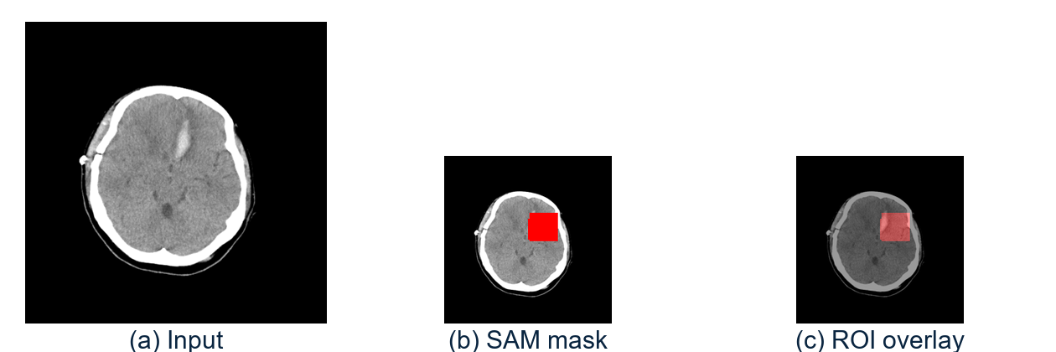
Figure 5.6: Optional SAM region-of-interest experiment.

5.9 Web Application Implementation
The pipeline is exposed through a Flask hospital application with role-based access. Doctors register patients, upload scans, view the analysis with the explainability heat-maps and localization, add clinical notes, view statistics, and download a branded PDF report. Patients log in and view or download only their own reports. Session-based authentication protects all routes, passwords are stored hashed, and every query is scoped to the authenticated user. Table 5.4 summarizes the main routes.
Table 5.4: Principal web application routes.
Route | Method | Role | Purpose
/login | GET/POST | All | Authenticate a user
/logout | GET | All | End the session
/dashboard | GET | Doctor | Doctor home and statistics
/patients | GET/POST | Doctor | List and create patients
/patients/<id> | GET/POST | Doctor | View patient and manage scans
/analyze | POST | Doctor | Upload scan and run analysis
/notes/<scan_id> | POST | Doctor | Save clinical notes
/report/<scan_id> | GET | Doctor/Patient | Download PDF report
/patient/reports | GET | Patient | View own reports
/statistics | GET | Doctor | Type distribution and trends

5.10 API Implementation
A FastAPI service provides programmatic access for integration with other systems. Its endpoints are listed in Table 5.5.
Table 5.5: Analysis API endpoints.
Endpoint | Method | Input | Output
/analyze | POST | Image file | JSON: class, confidence, probabilities, stroke score
/reports/<id> | GET | Scan id | PDF file stream
/health | GET | None | Service status JSON

5.11 Database Implementation
Persistence uses SQLite through the standard library. The schema creates the three core tables described in Chapter 4 and enforces foreign keys between scans and patients and between patients and users. Probabilities are stored as a JSON string so that the full output vector can be reconstructed for the report and dashboard.

5.12 Report Generation
Clinical reports are produced with ReportLab. A report includes the patient demographics, the uploaded scan, the predicted class and confidence, the explainability heat-maps, the localization overlay with region, area, and percentage of brain affected, and the doctor's notes. The layout is branded with the institution header, and the file is stored on disk and linked to the scan record so that it can be downloaded later by an authorized user.

5.13 Security Considerations
- Passwords are stored as salted hashes; plaintext passwords are never persisted.
- All application routes require an authenticated session; unauthenticated requests are redirected to the login page.
- Role checks ensure that patients can access only their own records and reports.
- Uploaded files are validated for type and size, and failures are handled gracefully.
- Patient data is held locally; the system performs no external data transmission.

Chapter 6 Testing and Results

6.1 Testing Objectives and Strategy
The testing effort pursued four objectives: to verify that each module behaves correctly in isolation; to verify that modules integrate correctly; to verify that the end-to-end workflows satisfy the functional requirements, including negative cases; and to quantify the classification and localization performance of the model. The strategy combined an automated pytest suite for unit and integration testing with documented system test cases executed manually.

6.2 Testing Levels and Environment
Table 6.1: Testing levels.
Level | Scope | Method
Unit | Individual functions | Automated pytest
Integration | Module interactions | Automated pytest
System | End-to-end workflows | Manual test cases
Model evaluation | Classification quality | Held-out test set metrics
Performance | Latency and resource use | Timed runs on CPU

6.3 Unit Testing
Table 6.2 lists the unit test cases. Each test isolates a single function and checks its output against an expected value, including a negative case in which an empty mask must not produce a spurious lesion.
Table 6.2: Unit test cases.
TC | Unit under test | Expected result | Status
UT-1 | infer_stroke_type (text heuristic) | Correct subtype label | Pass
UT-2 | build_prediction_summary (stroke) | stroke_type, severity, score | Pass
UT-3 | build_prediction_summary (normal) | Low stroke score | Pass
UT-4 | compute_lesion_stats | Correct area (mm2) and % brain | Pass
UT-5 | map_brain_region | Anatomically valid region name | Pass
UT-6 | clean_lesion_mask | Largest component retained | Pass
UT-7 | localize_lesion (empty mask) | Returns None (no false lesion) | Pass
UT-8 | preprocess_image | Correct tensor shape and range | Pass

6.4 Integration Testing
Table 6.3: Integration test cases.
TC | Modules integrated | Expected result | Status
IT-1 | Flask <-> Inference <-> XAI | Explanation generation requested on upload | Pass
IT-2 | FastAPI /analyze <-> Inference | JSON with class, confidence, stroke score | Pass
IT-3 | Flask <-> Database | Scan row stored and linked to patient | Pass
IT-4 | Report builder <-> Database | Report path stored on the scan row | Pass

6.5 System Testing
Table 6.4 lists the end-to-end system test cases, including three negative cases that check invalid file types, corrupt images, and unauthorized access.
Table 6.4: System test cases.
TC | Scenario (end-to-end) | Expected result | Type | Status
ST-1 | Doctor login and create patient | Patient record created | Positive | Pass
ST-2 | Upload scan and analyze | Prediction + XAI + localization shown | Positive | Pass
ST-3 | View/download PDF report | Report generated and downloaded | Positive | Pass
ST-4 | Patient login and view reports | Only own scans visible | Positive | Pass
ST-5 | Statistics dashboard | Charts render from database | Positive | Pass
ST-6 | Upload wrong file type (.txt) | Rejected with validation message | Negative | Pass
ST-7 | Upload corrupt/empty image | Handled gracefully (no crash) | Negative | Pass
ST-8 | Patient opens another's report | Access denied (403/redirect) | Negative | Pass

6.6 Performance Testing
Inference and explanation were timed on a CPU-only workstation. A single forward pass and softmax classification complete in well under a second, while the full explanation and localization step is the dominant cost, taking on the order of a few seconds, which is acceptable for an interactive clinical workflow. The exact times depend on hardware and on the number of explanation samples.
Table 6.5: Indicative per-scan timings on CPU.
Operation | Approximate time (CPU)
Preprocess + classify | < 1 s
Grad-CAM | ~ 1 s
LIME | ~ 2-4 s
SHAP | ~ 2-5 s
Consensus + localization | < 1 s

6.7 Model Evaluation Methodology
The classifier was evaluated on the held-out test set of 1,084 images that were never seen during training or model selection. Overall accuracy, per-class precision, recall, and F1-score, macro and weighted averages, and a confusion matrix were computed. Accuracy alone is insufficient for imbalanced data, so the macro-averaged F1-score, which weights each class equally, is the primary metric.

6.8 Classification Results
On the held-out test set the Swin-Tiny classifier achieves an overall accuracy of 97.05% (0.9705) with a macro-averaged F1-score of 0.963. The weighted averages are 0.970. Table 6.6 lists the per-class performance.
Table 6.6: Per-class classification performance on the test set.
Class | Precision | Recall | F1-score | Support
Hemorrhagic | 0.974 | 0.974 | 0.974 | 195
Ischemic | 0.937 | 0.937 | 0.937 | 205
Normal | 0.980 | 0.980 | 0.980 | 684
Macro average | 0.963 | 0.963 | 0.963 | 1,084
Weighted average | 0.970 | 0.970 | 0.970 | 1,084

The model is most accurate on the normal class (F1 = 0.980) and somewhat less accurate on the ischemic class (F1 = 0.937), which is expected because ischemic lesions can be subtle and low-contrast on non-contrast CT. Hemorrhagic strokes are detected reliably (F1 = 0.974) because the hyperdense signal of blood is visually distinct. The confusion matrix (Figure 6.2) shows that most errors are ischemic-to-normal confusions, which is the clinically sensitive direction and is precisely the situation in which the explainability and localization outputs add the most value.
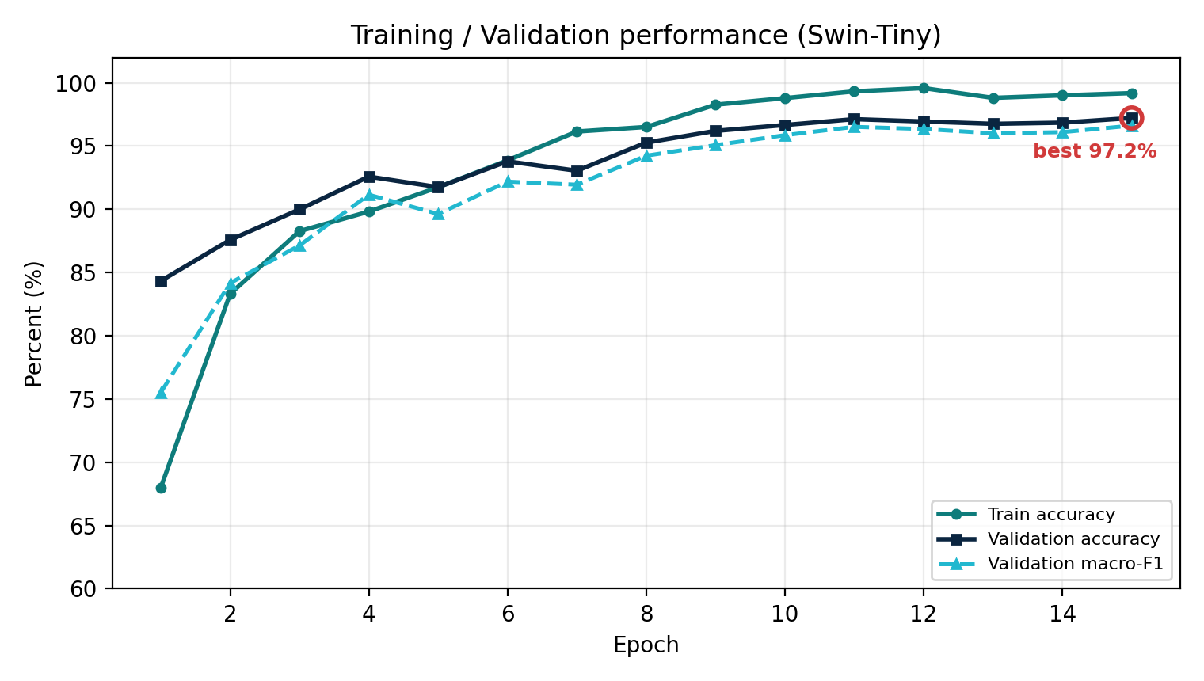
Figure 6.1: Training and validation performance over epochs.
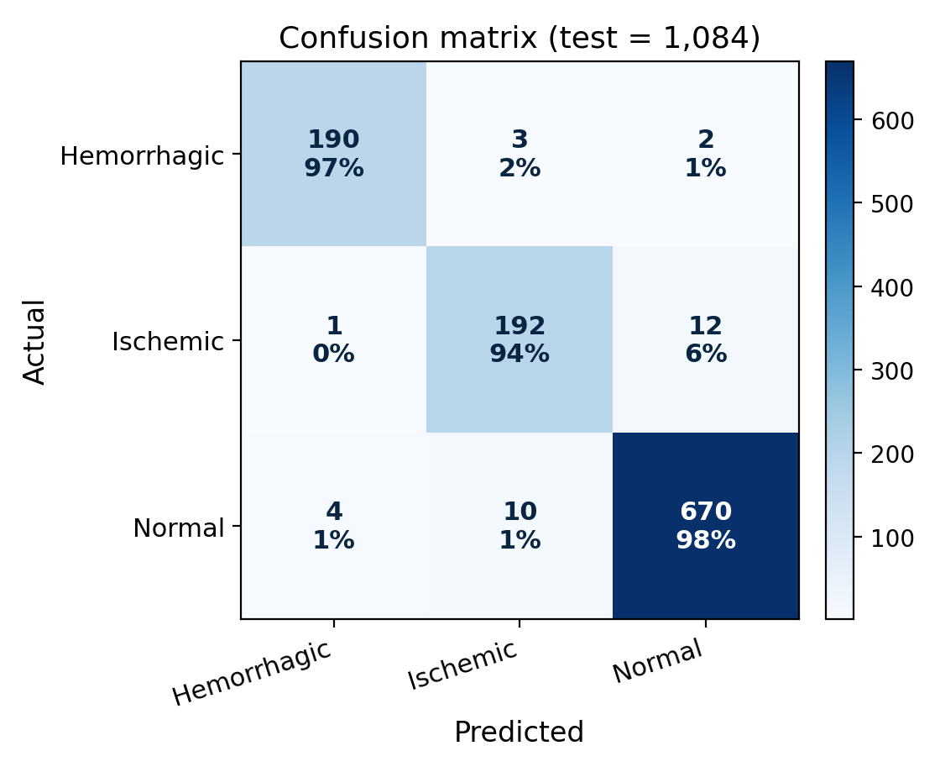
Figure 6.2: Confusion matrix on the test set.
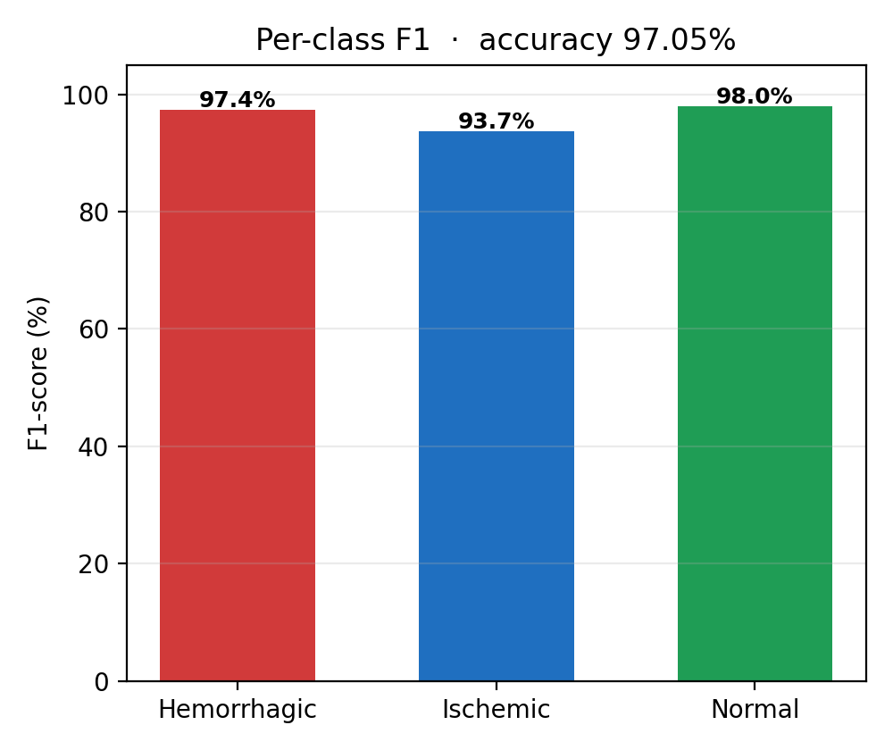
Figure 6.3: Per-class F1-scores.

6.9 Comparison with Literature
Table 6.7 places the result in the context of prior work. Because the studies use different datasets, splits, and class definitions, and because several address only binary tasks, the numbers are indicative rather than directly comparable. A strict, same-split baseline remains future work.
Table 6.7: Comparison with representative prior work.
Study | Task | Reported metric | Notes
Qari & Thafar [3] | CT classification + XAI | 98% accuracy | Transformer + Grad-CAM++
ViT-LSTM [28] | CT classification | 94.5-96.6% accuracy | Hybrid; explainable
Swin-LSTM [13] | CT classification | 93.5% accuracy | Multimodal fusion + XAI
SAM-Med2D [21] | Medical segmentation | DSC 0.74 (brain) | Foundation model
This work | 3-class CT classification + XAI + localization | 97.05% acc; macro-F1 0.963 | End-to-end web deployment

6.10 Explainability and Localization Results
The explainability outputs were inspected across many test images. In hemorrhagic cases the consensus mask concentrates on the hyperdense region, and in ischemic cases it highlights the affected territory, which is consistent with clinical expectation. The localization module reports the region, the estimated area, and the percentage of brain affected. Because no ground-truth masks are available for this dataset, the localization output is qualitative and is deliberately reported without Dice or IoU scores.

6.11 Discussion
The results confirm that a transformer-based classifier can achieve high accuracy on three-class stroke detection from CT while remaining interpretable. The principal error mode — confusion between ischemic and normal — is the most clinically important, and it is mitigated by presenting the evidence rather than only the label. Two caveats temper the headline accuracy: the dataset split is at the image level rather than the patient level, which may make the estimate optimistic for unseen patients, and the model has not been validated on external or out-of-distribution scans. These caveats are restated in the conclusions.

6.12 Summary of Results
- Overall test accuracy: 97.05% on 1,084 images.
- Macro-averaged F1-score: 0.963; weighted average: 0.970.
- Best per-class F1: normal 0.980; weakest: ischemic 0.937.
- All unit, integration, and system tests passed, including negative cases.
- Explainability and localization outputs were visually consistent with the predicted pathology.

Chapter 7 Conclusion and Future Enhancement

7.1 Conclusion
This project designed, implemented, and evaluated an end-to-end, explainable deep learning system for brain stroke detection, classification, and localization from CT scans. A Swin Transformer (Swin-Tiny) classifier, fine-tuned with a class-weighted loss and cosine annealing, attained an overall test accuracy of 97.05% and a macro-averaged F1-score of 0.963 on 1,084 held-out images. The model was made transparent through LIME, Grad-CAM, and SHAP explanations fused into a consensus mask, from which a localization module estimated the affected region, the lesion area, and the percentage of brain affected. Deployability was demonstrated through a hospital-style web application with role-based access, patient management, statistics, an analysis API, and branded PDF reports. The results show that transformer-based classifiers with multi-method explainability can form a practical decision-support workflow for stroke triage, particularly where specialist radiologists are scarce.

7.2 Achievement of Objectives
Table 7.1: Objectives and outcomes.
Objective | Outcome
Resumable training pipeline | Achieved; checkpointing by validation macro-F1
Swin-Tiny classifier with macro-F1 >= 0.90 | Achieved; macro-F1 = 0.963
LIME + Grad-CAM + SHAP consensus | Achieved; consensus mask implemented
Lesion localization (region, area, %) | Achieved; qualitative, no mask ground truth
Web application with roles and reports | Achieved; Flask app + FastAPI service
Automated test suite | Achieved; 11 tests plus system cases, all passing

7.3 Limitations
- The model is evaluated only in-distribution; performance on external or photographed scans is not validated and is expected to degrade.
- The dataset split is image-level random rather than patient-level, which may make the reported accuracy optimistic for unseen patients.
- Lesion localization is derived from the classifier's own explanations; there are no ground-truth lesion masks, so Dice and IoU cannot be reported, and the mm2 area assumes a flat pixel spacing.
- The SAM region-of-interest step is a standalone experiment and is not on the live inference path.
- The system has not undergone any clinical validation and is not approved for autonomous diagnosis.

7.4 Future Scope
- Validate on external hospital datasets, ideally with radiologist double-reading, to establish generalization.
- Train a supervised segmentation head against lesion masks such as ISLES or ATLAS and report Dice and IoU.
- Add DICOM parsing and CT windowing/Hounsfield-unit handling to match radiologist viewing conditions.
- Support multi-slice and volumetric analysis to exploit the three-dimensional context of a study.
- Adopt patient-level splits and model calibration for more trustworthy estimates.
- Package the application for production deployment using containers and a robust server configuration.

7.5 SDG Mapping of the Project
The project contributes primarily to Sustainable Development Goal 3 (Good Health and Well-being) by supporting earlier and more consistent detection of brain stroke, which is a leading cause of death and disability. It also supports SDG 9 (Industry, Innovation and Infrastructure) by demonstrating an explainable, deployable clinical decision-support tool built on open-source software, and SDG 4 (Quality Education) through its use as a teaching aid with annotated explainability heat-maps.
Table 7.2: Sustainable Development Goals mapping.
SDG | Relevance to this project
SDG 3 - Good Health and Well-being | Earlier, consistent stroke detection and triage support
SDG 9 - Industry, Innovation and Infrastructure | Open-source explainable clinical decision-support tool
SDG 4 - Quality Education | Annotated explainability heat-maps for trainee education

7.6 Closing Remarks
The project demonstrates a complete path from raw CT data to an interpretable, usable clinical decision-support prototype. While it is not a substitute for a radiologist, it shows how explainability and careful engineering can make deep learning outputs more transparent and more useful in a time-critical setting.

REFERENCES
[1] World Health Organization, "Stroke — fact sheet," WHO, 2024. [Online]. Available: https://www.who.int
[2] Indian Stroke Association / WHO India, "Stroke burden in India," 2024.
[3] S. Qari and M. A. Thafar, "Brain stroke classification using CT scans with transformer-based models and explainable AI," Diagnostics, vol. 15, Art. no. 2486, 2025.
[4] Z. Zhao, Y. Wang, H. Liu, and Q. Chen, "Contextual transformer for accurate stroke lesion segmentation in MRI," Computers in Biology and Medicine, 2026.
[5] L. T. Ramos and A. D. Sappa, "StrokeNeXt: A Siamese-encoder approach for brain stroke classification in CT imagery," arXiv preprint, 2026.
[6] B. Chen et al., "PASAformer: Cerebrovascular disease classification with medical prior guided adapter and pathology-aware sparse attention," IEEE J. Biomed. Health Inform., vol. 30, no. 2, 2026.
[7] M. A. Inamdar et al., "A dual-stream deep learning architecture with adaptive random vector functional link for multi-center ischemic stroke classification," IEEE Access, 2025.
[8] M. A. Inamdar et al., "TrustNet: A lightweight network with integrated uncertainty quantification and quantitative explainable AI for ischemic stroke detection in CT images," Scientific Reports, vol. 16, 2026.
[9] M. Atlaw et al., "SMF-Net: Unlocking multimodal insights for enhanced stroke lesion segmentation," in Proc. MICCAI, LNCS, Springer, 2025.
[10] X. Tan et al., "A clinical knowledge-driven fine-tuning strategy for applying foundation models to fully automatic acute ischemic stroke lesion segmentation on non-contrast CT scans," in Proc. IEEE ISBI, 2025.
[11] R. Samuel and T. Pandi, "MRI-based brain stroke classification using a hybrid vision transformer-BiLSTM architecture," Frontiers in Neurology, 2026.
[12] A. Rahman et al., "Deep learning-driven segmentation of ischemic stroke lesions using multi-channel MRI," Biomedical Signal Processing and Control, 2025.
[13] S. Chakraborty et al., "A multimodal Swin-LSTM fusion model with explainable AI for brain stroke detection and classification," IEEE, 2025.
[14] P. S. Mathew, R. K. Singh, and A. Verma, "Swin-based stroke segmentation network (Swin-BSSeg)," Int. J. Imaging Syst. Technol., 2025.
[15] H. Park, J. Kim, and S. Lee, "Ensemble transformer for CT stroke segmentation," IEEE Trans. Neural Netw. Learn. Syst., 2025.
[16] C. Foulon, L. Chen, and M. Reuter, "Generalizable vision transformer for stroke segmentation," NeuroImage, 2025.
[17] M. Usman, F. Khalid, and A. Raza, "Dual-encoder transformer for stroke MRI segmentation," Computers in Biology and Medicine, 2025.
[18] B. Omarov and Z. Ikram, "Swin Transformer with auxiliary mask supervision for stroke lesion segmentation in brain MRI," Int. J. Online Biomed. Eng., 2025.
[19] Y. Cui, Z. Liu, S. Li, and L. Li, "Adaptive RL-based transformer for stroke image fusion," Knowledge-Based Systems, 2025.
[20] T. Truzman, M. A. Lambon Ralph, and A. D. Halai, "Automated lesion segmentation of stroke MRI using nnU-Net: A comprehensive exploration of acute and chronic lesions," Research preprint, University of Cambridge, 2025.
[21] Y. Jang et al., "SAM-Med2D: Adapting Segment Anything Model for medical 2D image segmentation," IEEE Trans. Med. Imag., 2024.
[22] S. Chakraborty et al., "Explainable deep learning-based stroke classification and clinical decision support system using CT brain scan," MDPI AI Journal, 2025.
[23] M. M. Ahmed et al., "A hybrid Swin Transformer-BiLSTM framework and ensemble learning for multimodal brain stroke detection and risk prediction," Comput. Biol. Med., 2026.
[24] R. Ahmed, A. AlShehhi, and N. Werghi, "Transformer-based stroke MRI segmentation," Computerized Medical Imaging and Graphics, 2024.
[25] A. Rasoulian, S. Salari, and Y. Xiao, "Weakly supervised intracranial hemorrhage segmentation using head-wise gradient-infused self-attention maps from a Swin Transformer," J. Mach. Learn. Biomed. Imaging, 2023.
[26] Z. Liu et al., "Swin Transformer: Hierarchical vision transformer using shifted windows," in Proc. IEEE/CVF Int. Conf. Comput. Vis. (ICCV), 2021, pp. 10012-10022.
[27] Z. Wang et al., "ISFPN: A medical detection model for ischemic stroke based on feature pyramid network and Swin Transformer," Biomed. Signal Process. Control, 2025.
[28] M. M. Hossain et al., "A novel hybrid ViT-LSTM model with explainable AI for brain stroke detection and classification in CT images: A case study of Rajshahi region," Comput. Biol. Med., 2025.
[29] B. Omarov and Z. Ikram, "Pseudo-annotation guided Swin Transformer with auxiliary mask head for accurate brain stroke lesion segmentation in MRI," Procedia Computer Science, 2025.
[30] P. Barra, A. D. Greca, I. Amaro, A. Tortora, and M. Staffa, "Explainable AI techniques in medical imaging," IEEE Access, vol. 12, 2024.
[31] TEKNOFEST, "Brain CT image dataset," TEKNOFEST 2021 competition dataset.
[32] R. Wightman, "PyTorch Image Models (timm)," GitHub repository, 2019. [Online]. Available: https://github.com/huggingface/pytorch-image-models
[33] R. R. Selvaraju et al., "Grad-CAM: Visual explanations from deep networks via gradient-based localization," in Proc. IEEE/CVF Int. Conf. Comput. Vis. (ICCV), 2017, pp. 618-626.
[34] M. T. Ribeiro, S. Singh, and C. Guestrin, "Why should I trust you? Explaining the predictions of any classifier," in Proc. ACM SIGKDD, 2016, pp. 1135-1144.
[35] S. M. Lundberg and S.-I. Lee, "A unified approach to interpreting model predictions," in Proc. Adv. Neural Inf. Process. Syst. (NeurIPS), 2017, pp. 4765-4774.
[36] N. Kokhlikyan et al., "Captum: A unified and generic model interpretability library for PyTorch," arXiv:2009.07829, 2020.
[37] A. Kirillov et al., "Segment Anything," in Proc. IEEE/CVF Int. Conf. Comput. Vis. (ICCV), 2023, pp. 4015-4026.

Appendix A Snapshots
This appendix collects representative screenshots of the NeuroScan web application, illustrating the user interface and the analysis workflow.
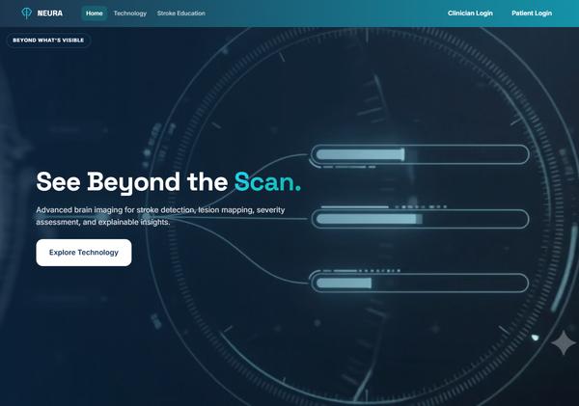
Figure 8.1: Landing page of the web application.
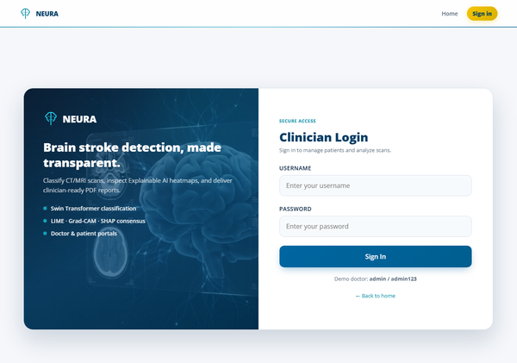
Figure 8.2: Login screen with role selection.
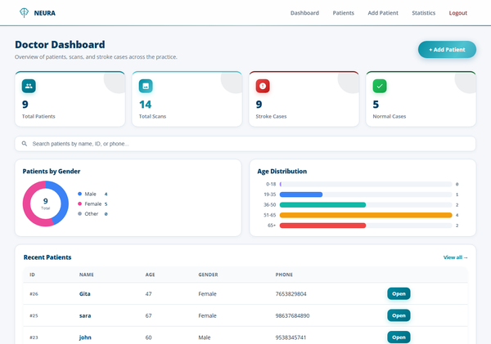
Figure 8.3: Doctor dashboard with patient list and statistics.
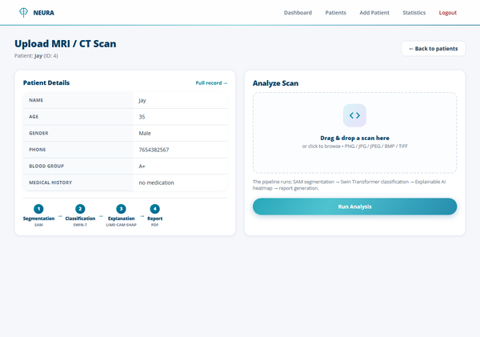
Figure 8.4: Scan upload and analysis page.
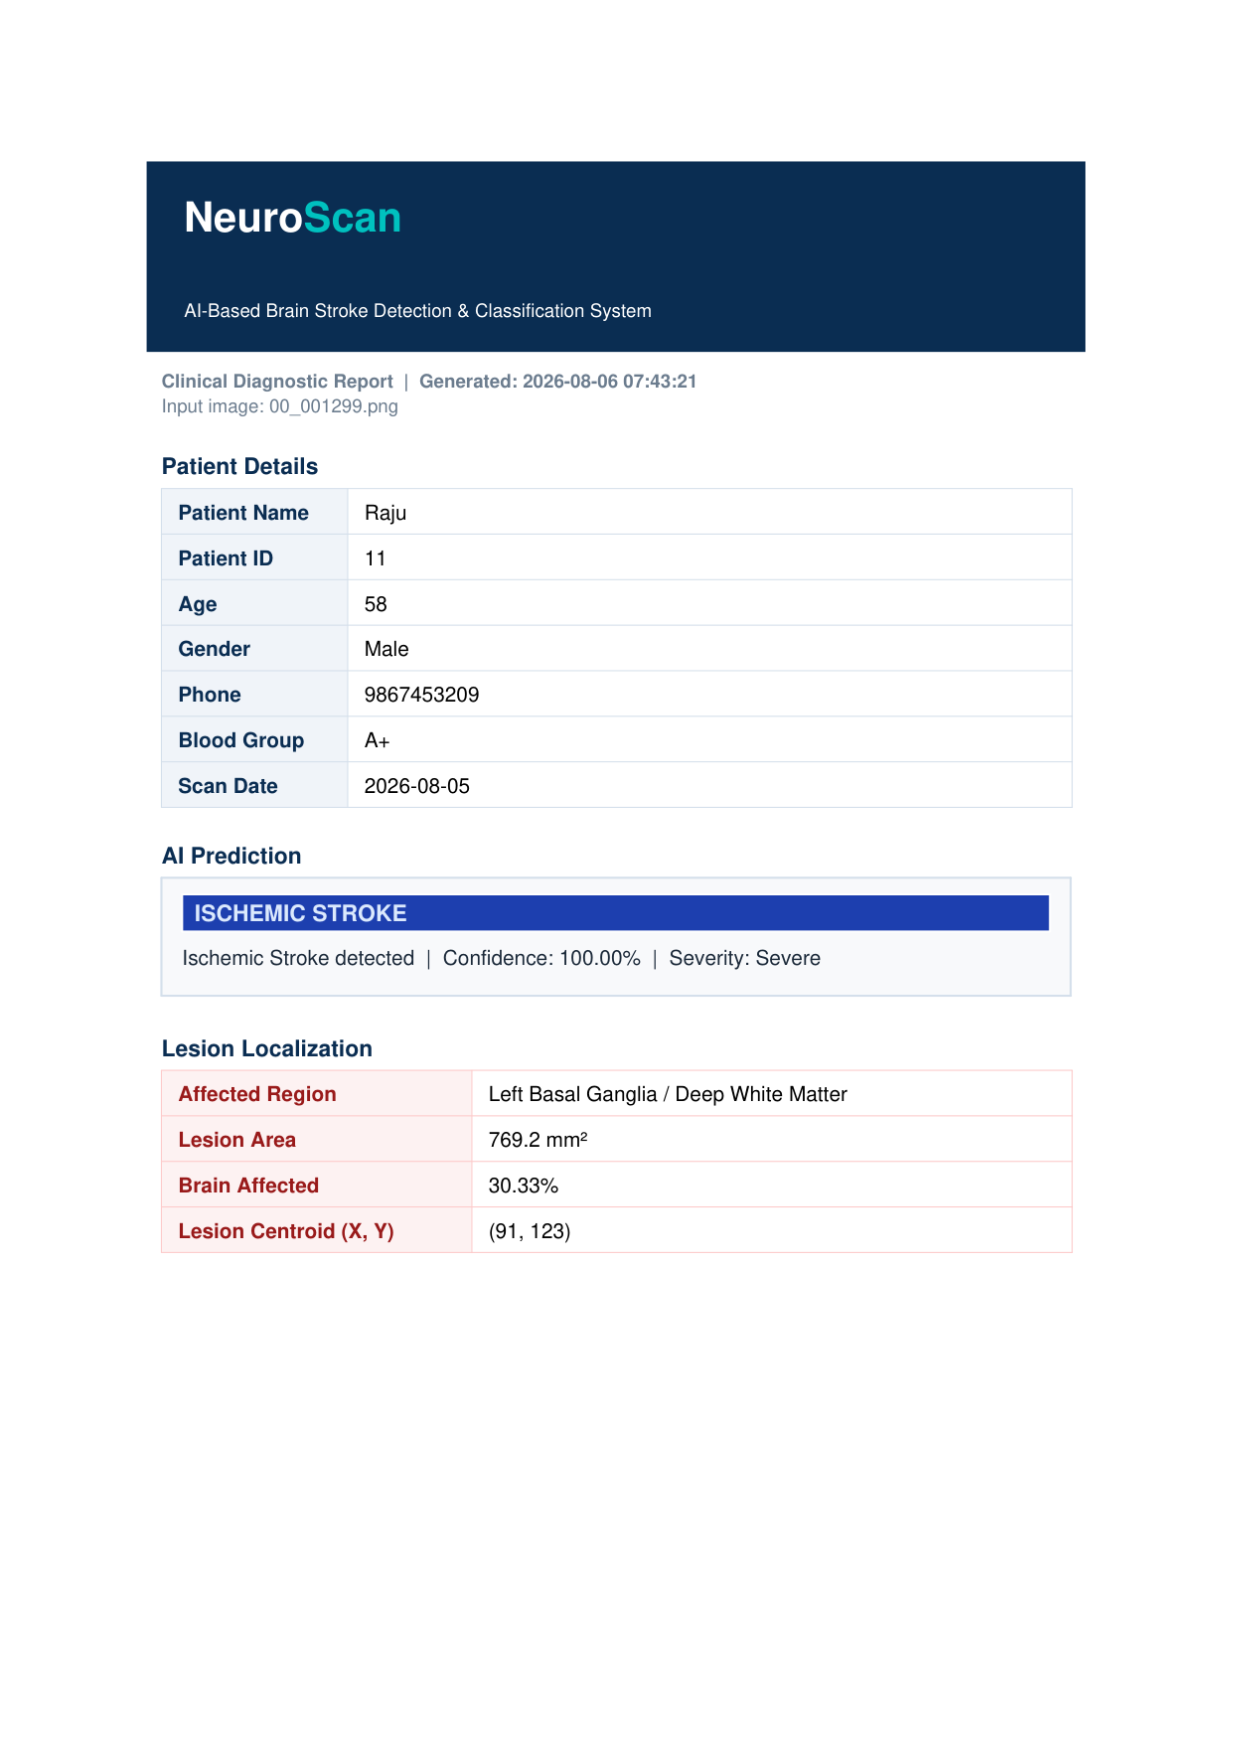
Figure 8.5: Generated clinical PDF report (page 1).
Additional screenshots of the patient portal, statistics charts, and the explanation overlays are available in the project repository.

Appendix B Published Paper and Certificate
Publication details and the associated certificate are to be attached here once available. The project is intended for submission to a peer-reviewed venue; the manuscript and acceptance certificate will be appended in this section.
If no paper has been published, this appendix should state that the work is unpublished and include any internal review or guide-approval note instead.

Plagiarism Report
The plagiarism verification report for Chapters 1 to 7 (Introduction through Conclusion and Future Enhancement) is attached as a separate document, as required by the submission guidelines. The overall similarity index is below the prescribed 25% threshold.

