**İZELTAŞ** :

KATALOG sayfa 71

<https://urun.n11.com/lokma-takimlari/lokma-derin-alti-kose-16-mm-12-anahtar-izeltas-P415160066> 42.59 lira ücretsiz kargo

<https://www.gittigidiyor.com/yapi-market-tamirat/izeltas-1-2-alti-kose-derin-lokma-anahtari-16-mm-140-gr_pdp_521674423> 44.9 lira kargo ücretsiz

<https://www.canlarteknik.com/DERIN-LOKMA-ALTI-KOSE-16-MM-12,PR-7293.html> 48 lira

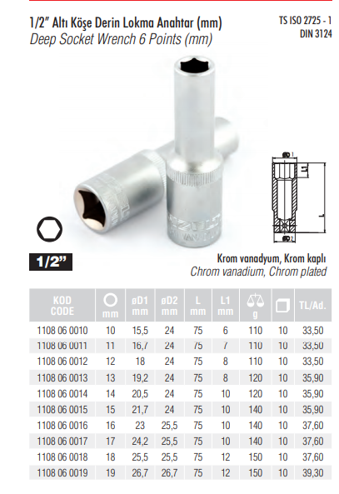

**CETA FORM :**

**KATALOG sayfa 77**

<https://www.akakce.com/lokma-takimi/en-ucuz-c24-h16-1-2-6-kose-16-mm-derin-lokma-anahtar-fiyati,357392570.html> 49.91 lira ücretsiz kargo

<https://www.gittigidiyor.com/yapi-market-tamirat/ceta-form-c24-h16-16-mm-1-2-6-kose-derin-lokma-anahtar_pdp_516964110>

<https://www.hepsiburada.com/ceta-form-c24-h16-16-mm-1-2-6-kose-derin-lokma-anahtar-pm-HB000000J017> 48.8 lira

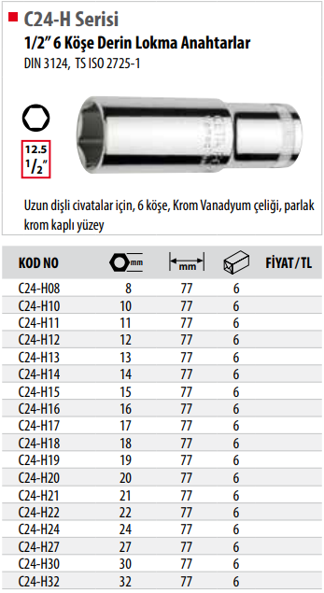

**RICO :**

**Katalog sayfa 23**

Koçtaş satış linki :

<https://www.koctas.com.tr/rico-derin-lokma-1-2/p/1000069656> 39.99 lira

<https://www.gittigidiyor.com/yapi-market-tamirat/rico-1-2-6-kose-derin-uzun-lokma-16-mm_pdp_593199412> 47.99 ücretsiz kargo

