Paper Title* (use style: paper title)
*Note: Sub-titles are not captured in Xplore and should not be used

line 1: 1st Given Name Surname
line 2: dept. name of organization
(of Affiliation)
line 3: name of organization
(of Affiliation)
line 4: City, Country
line 5: email address or ORCID
line 1: 4th Given Name Surname
line 2: dept. name of organization
(of Affiliation)
line 3: name of organization
(of Affiliation)
line 4: City, Country
line 5: email address or ORCID
line 1: 2nd Given Name Surname
line 2: dept. name of organization
(of Affiliation)
line 3: name of organization
(of Affiliation)
line 4: City, Country
line 5: email address or ORCID
line 1: 5th Given Name Surname
line 2: dept. name of organization
(of Affiliation)
line 3: name of organization
(of Affiliation)
line 4: City, Country
line 5: email address or ORCID
line 1: 3rd Given Name Surname
line 2: dept. name of organization
(of Affiliation)
line 3: name of organization
(of Affiliation)
line 4: City, Country
line 5: email address or ORCID
line 1: 6th Given Name Surname
line 2: dept. name of organization
(of Affiliation)
line 3: name of organization
(of Affiliation)
line 4: City, Country
line 5: email address or ORCID

Abstract—This electronic document is a “live” template and already defines the components of your paper [title, text, heads, etc.] in its style sheet. *CRITICAL: Do Not Use Symbols, Special Characters, Footnotes, or Math in Paper Title or Abstract. (Abstract)
Keywords—component, formatting, style, styling, insert (key words)

Introduction (Heading 1)
This template, modified in MS Word 2007 and saved as a “Word 97-2003 Document” for the PC, provides authors with most of the formatting specifications needed for preparing electronic versions of their papers. All standard paper components have been specified for three reasons: (1) ease of use when formatting individual papers, (2) automatic compliance to electronic requirements that facilitate the concurrent or later production of electronic products, and (3) conformity of style throughout a conference proceedings. Margins, column widths, line spacing, and type styles are built-in; examples of the type styles are provided throughout this document and are identified in italic type, within parentheses, following the example. Some components, such as multi-leveled equations, graphics, and tables are not prescribed, although the various table text styles are provided. The formatter will need to create these components, incorporating the applicable criteria that follow.

related work
In modern cybersecurity, key management is the foundation of secure communication. The Diffie–Hellman (D–H) key exchange protocol and the RSA public-key encryption algorithm are two fundamental pillars of modern cryptography, offering essential solutions to the problems of key distribution and digital identity verification.

Diffie–Hellman Key Exchange Protocol
The Diffie–Hellman (D–H) protocol, proposed in 1976, enables two communicating parties to establish a shared secret key over an insecure channel without directly transmitting it [1]. The security of the protocol relies on the computational hardness of the discrete logarithm problem, meaning that deriving private keys from public information is computationally infeasible (Maurer & Wolf, 2000).
In practice, both parties generate private keys and corresponding public keys based on a shared modulus and generator. After exchanging public keys, each side can independently compute the same shared secret key.
However, the D–H protocol does not inherently provide authentication, making it vulnerable to Man-in-the-Middle (MITM) attacks[2]. As a result, it is commonly combined with digital signatures or certificates in protocols such as TLS to ensure both confidentiality and authenticity.

RSA Public-Key Cryptosystem
The RSA algorithm, introduced by Rivest, Shamir, and Adleman in 1978, was the first practical public-key cryptosystem that supports both encryption and digital signatures[3]. RSA’s security is based on the mathematical difficulty of prime factorization of large integers—specifically, decomposing a modulus$n=p×q$ into its two large prime factors[4].
RSA uses a pair of keys: the public key is used for encryption or signature verification, while the private key is used for decryption or signing. Because the private key cannot be feasibly derived from the public key, RSA provides robust asymmetric encryption and authentication.
Due to its versatility and proven reliability, RSA is widely deployed in systems such as PGP for secure email, TLS/SSL for web protocols, SSH, digital certificates, and two-factor authentication systems like RSA SecurID[4]. Despite the emergence of newer algorithms, RSA remains one of the most trusted cryptographic standards in modern cybersecurity infrastructure.

Methods
To better understand the security boundaries of these algorithms, we examine two representative and implementable attack techniques: the Man-in-the-Middle (MITM) attack against the D–H key exchange protocol, and the factorization attack on RSA using Pollard’s rho algorithm.
These examples demonstrate how weaknesses in protocol design and computational limits can be exploited, as well as the countermeasures that can mitigate such risks.

Man-in-the-Middle Attack on Diffie–Hellman Protocol

Attack Principle: The D–H protocol performs key agreement without authenticating the communicating parties, leaving it inherently vulnerable to MITM attacks[2]. An attacker can intercept public key exchanges and impersonate each party to the other, establishing independent shared keys with both sides. This allows the attacker to decrypt, modify, and re-encrypt communications invisibly.

Attack Procedure: The MITM attack typically follows these steps[2]:

Interception and Impersonation: When Alice and Bob exchange their D–H public keys, the attacker (Mallory) intercepts both messages.

Session Substitution: Mallory generates her own private and public keys. She sends her public key to Alice pretending to be Bob, and to Bob pretending to be Alice.

Key Derivation: Alice computes a shared key with Mallory’s public key, assuming it came from Bob. Bob does the same, computing a shared key with Mallory. Mallory now holds two distinct keys—one shared with Alice and another with Bob.

Traffic Manipulation: Mallory can decrypt any message sent by Alice, read or alter its content, and re-encrypt it using the second shared key before forwarding it to Bob (and vice versa). Both legitimate users remain unaware of the breach.

Implementation and Defense: The implementation of a MitM attack necessitates the interception and alteration of communication channels, typically achieved through techniques such as ARP spoofing or DNS hijacking. This exploit is feasible because the foundational Diffie-Hellman (D–H) key exchange protocol lacks a native authentication mechanism, allowing an adversary to impersonate both parties. Consequently, robust defensive strategies are required to mitigate this threat. A pivotal method involves the use of Digital Certificates and Public Key Infrastructure (PKI), which bind public keys to verified identities through a trusted Certificate Authority (CA), as universally implemented in the TLS/SSL protocols. Alternatively, the use of Static D–H Keys with Out-of-Band Verification can preclude impersonation. In this scheme, entities maintain long-term key pairs and authenticate each other by comparing the fingerprints of their public keys via a pre-established, secure secondary channel.

Factorization Attack on RSA Using Pollard’s Rho Algorithm

Attack Principle: RSA security depends entirely on the infeasibility of factoring a large composite number $n=pq$. If an attacker successfully factors $n$, they can derive the private key $d$ from the public parameters $(e,n)$, completely breaking the system[3]. Among various factorization methods, Pollard’s rho algorithm is an efficient probabilistic algorithm that performs well for medium to large integers. It leverages the birthday paradox to detect a nontrivial factor of nby finding collisions in a pseudorandom sequence[5].

Attack Procedure: Pollard’s rho algorithm proceeds as follows:

Initialization: Choose initial values$x=2,y=2$, and set $d=1$.

Iterative Compuatation: Use a pseudo-random function such as$f(x)=(x^2+1)mod" " n$:
Update $x=f(x)$,
Update $y=f(f(y))$(thus $y$ advances twice as fast as $x$),
Compute $d=gcd(∣x-y∣,n)$.

Result Checking:
If $d=1$, continue the process.
If $1<d<n$, $d$ is a nontrivial factor of $n$(i.e., $p$ or $q$), and the factorization succeeds.
If $d=n$, restart with different initial parameters.
This cycle-detection approach is efficient because it exploits Floyd’s cycle-finding algorithm, which allows fast collision detection with minimal memory.

Implementation and Defense: The efficiency of Pollard's rho algorithm is contingent upon the rapid detection of cycles within its pseudo-random sequence in the modular arithmetic space. Research indicates that the algorithm's running time is probabilistic and correlates with the number of iterations required to find a non-trivial factor, increasing in a sub-exponential manner with the size of the modulus $n$[5]. To mitigate factorization attacks such as Pollard's rho, several key practices are recommended. First, RSA keys should be generated using large, random, and unpredictable prime numbers $p$ and $q$. Second, the modulus length must be sufficient, with a minimum of 2048 bits for contemporary applications, as smaller key sizes are vulnerable to efficient factorization. Finally, it is critical to employ well-vetted and verified cryptographic libraries to avoid implementation flaws that could undermine security. When these measures are correctly implemented with sufficiently large key sizes, the RSA cryptosystem remains secure against Pollard's rho and other known classical cryptographic attacks[6].

Pre-Shared Key Authentication Against MITM Attacks on Diffie-Hellman
Research has demonstrated that the traditional Diffie-Hellman protocol, due to its lack of an authentication mechanism, allows attackers to easily forge public keys and perform man-in-the-middle interception[7]. To effectively counter the man-in-the-middle attack threats faced by the Diffie-Hellman key exchange protocol while ensuring the scheme exhibits good engineering feasibility and demonstration effectiveness, this study adopts a pre-shared key based authentication mechanism as the core defense scheme. This scheme fundamentally resolves the issue of authenticating communicating parties' identities by integrating a lightweight identity verification mechanism, while fully preserving the original key agreement functionality of the DH protocol.

Technical Principle: At the technical implementation level, the core of this defense mechanism lies in integrating message authentication functionality into the standard DH key exchange process. Before initiating key exchange, the two communicating parties must first securely pre-share an authentication key via a secure channel. This key operates independently of the key agreement process and is specifically used to authenticate the exchanged public key data. In concrete implementation, when transmitting its DH public key, the sending party uses the pre-shared key to generate a corresponding message authentication code (MAC) via an HMAC algorithm. Upon receiving the data, the receiving party employs the same key and algorithm to verify the public key. If the MAC verification fails, it indicates that a malicious attacker may be attempting to tamper with or forge the public key within the communication channel, prompting the receiver to immediately terminate the session establishment process.

Implementation Procedure: The implementation of this defense mechanism encompasses the following key steps:

Initialization: The communicating parties (e.g., Alice and Bob) mutually agree upon a pre-shared key through a secure out-of-band channel prior to establishing communication. This key is typically a string possessing a certain level of complexity.

Key Exchange and Authentication: Alice generates her DH public key A and computes the authentication code HMAC(PSK, A), where PSK is the pre-shared key. Subsequently, she transmits the combination of the public key and the authentication code (A, HMAC(PSK, A)) to Bob.
Upon receiving the data, Bob recalculates the HMAC value using his locally stored PSK and the received public key A'. If the computed result matches the received authentication code, the public key is deemed authentic and originating from Alice; otherwise, a man-in-the-middle attack is assumed present in the channel, and the session is terminated immediately.
Bob employs the same mechanism to send his DH public key B and the corresponding authentication code to Alice, who performs an analogous verification operation. This mutual authentication mechanism aligns with the identity verification concepts proposed in recent improved Diffie-Hellman schemes[8].

Secure Session Establishment: A subsequent secure communication channel, utilizing the shared key negotiated via the DH protocol, is established only after both parties successfully complete the aforementioned PSK authentication. Authentication failure by either party results in connection termination, thereby preventing any unverified entity from participating in the key agreement.

Scheme Advantage Analysis: From a practical application perspective, this defense scheme offers multiple significant advantages. Regarding implementation complexity, it requires only the integration of an HMAC computation module into the existing protocol stack, eliminating the need for deploying complex Public Key Infrastructure (PKI) and substantially reducing engineering complexity and deployment costs. In terms of demonstration value, the binary nature of the authentication outcome makes the attack detection process intuitively visible, rendering it highly suitable for teaching and demonstration environments. Architecturally, the scheme is fully self-contained, operating independently of external authentication services, making it particularly apt for temporary or closed communication scenarios. This self-contained characteristic has proven its practical utility in certain wireless communication contexts [9]. Security-wise, provided the pre-shared key remains confidential, the scheme can effectively identify and block various types of identity forgery attacks, thereby providing reliable identity authentication assurance for the key exchange process.

Defense Against Factorization Attacks on RSA

Principle of Defense: The most effective defense against factorization attacks such as Pollard’s rho is to ensure secure RSA key generation. As Dan Boneh (1999) highlighted in his seminal review, the security of the RSA algorithm fundamentally depends on the computational difficulty of factoring the modulus$n = p × q$[10]. Among all known attacks, factorization remains the most direct and powerful threat. If the modulus n is too small, or if the prime numbers $p$ and $q$ are poorly chosen, theoretical attacks can easily become practical.
Therefore, the cornerstone of RSA security lies not in the encryption or decryption process itself, but in the generation of strong cryptographic keys. The main defense principle is to carefully select primes p and q so that their product n can resist all known efficient factorization algorithms.
In practice, the defense strategy focuses on two main objectives:
Increase computational complexity: Ensure that the modulus n is large enough so that any factorization algorithm (including Pollard’s rho and the Number Field Sieve) would require an impractical amount of time and computing power.
Eliminate structural weaknesses: Make sure that the primes $p$ and $q$ have no special mathematical structure that could be exploited by specific algorithms such as Pollard’s $p-1$ method.

Detailed Defense Methods:

Using a Sufficiently Large Modulus: Choosing a sufficiently large modulus n is the most straightforward and effective way to resist factorization attacks. The length of the RSA key directly determines the level of computational effort required to break it. As Nisha and Farik point out, a 2048-bit RSA key is currently recognized as the minimum secure standard and is widely used in modern systems such as TLS/SSL[4]. For applications that require long-term security or protection against nation-state adversaries, 3072-bit or 4096-bit keys are strongly recommended.
The security rationale is based on the time complexity of factorization algorithms. For example, the time complexity of Pollard’s rho algorithm is approximately $O(\sqrt{p})$, where p is the smaller prime factor of n. Therefore, doubling the key length does not simply double the difficulty—it increases it exponentially, making real-world attacks computationally infeasible. By increasing the key size, organizations effectively raise the cost of attack to a point beyond realistic limits, forming a solid defensive barrier against factorization attempts

Generating Strong Primes: In the RSA cryptosystem, a strong prime is not only a large random prime number but one that satisfies specific mathematical conditions to resist specialized factorization methods. A strong prime p should meet the following requirements:
- $p$ itself is a large prime number;
- $p-1$ contains a large prime factor $r$, which makes Pollard’s $p-1$ attack inefficient;
- ideally, $p+1$ also has a large prime factor to resist algorithms such as Williams’ $p+1$ method;
- $r-1$ itself contains a large prime factor for deeper protection.
To achieve this, the RSA key generation process should include several key steps:
- Use a cryptographically secure pseudorandom number generator (CSPRNG) to produce candidate numbers with sufficient entropy, ensuring they cannot be predicted.
- Apply rigorous probabilistic primality tests, such as the Miller-Rabin test, to ensure that both $p$ and $q$ are very likely to be prime.
- For modern key sizes (≥2048 bits), strong primes occur naturally with high probability. However, verifying strong-prime conditions remains a best practice to further prevent potential structural weaknesses and resist side-channel attacks.
By following these measures, the RSA cryptosystem can maintain a strong level of security even in the face of advanced factorization algorithms.

Results

Diffie–Hellman MITM experiment

Experiment goals and setup
The purpose of the experiment was to (1) demonstrate a practical Man-in-the-Middle (MITM) attack against an unauthenticated Diffie–Hellman (D-H) key exchange and (2) evaluate the effectiveness of a simple protocol-level defense: pre-shared key (PSK) + HMAC verification. The experiment used a small pedagogical D-H parameter set to make the attack clear and reproducible: $p=23p=23$, $g=5g=5$. All trials logged public keys, computed shared secrets and verification results; logged outputs are available in the attack and defense logs.
Implementation notes: the attack and defense demos were implemented in Python. The basic MITM follows the classic pattern where an attacker (Eve) intercepts and replaces the public values exchanged between Alice and Bob, establishing independent shared secrets with each party. The defended version appends an HMAC (computed using a PSK) to the D-H public value so receivers verify authenticity before accepting a public value.

Quantitative results
Summary table (attack vs defended case) — results are aggregated from multiple trials and the summary file.
- attack vs defended case
Experiment | Trials | MITM success rate | Outcome (example)
Baseline — Basic D-H (no auth) | 3 | 100.0% | Attacker established two shared secrets (e.g., client=17, server=18). See attack log.
Defended — D-H + PSK/HMAC | N/A (same trials) | 0.0% | Bob detected MAC mismatch and aborted the session; no shared secret established. See defense log.
Summary table (attack vs defended case)
A bar chart (Figure 1) visually compares the two experiments: the baseline shows 100% MITM success while the PSK/HMAC defended case shows 0% success.
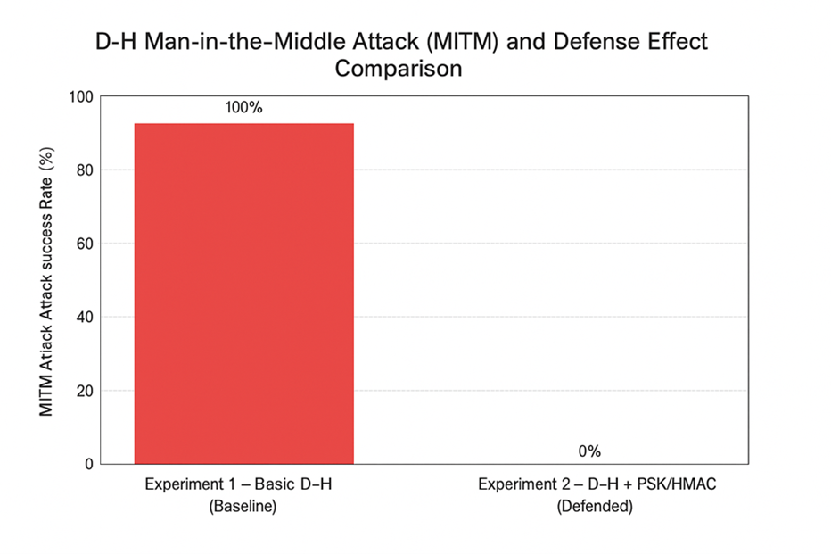

Comparison of MITM Success Rate — Baseline vs PSK-HMAC Defended Diffie–Hellman

Observations from the logs
Baseline (no authentication): In every trial the attacker successfully replaced public values and derived shared secrets with both Alice and Bob. The logs record matching attacker-client and attacker-server secrets and non-matching client-server secrets (e.g., Trial 1: client=17, server=18). Summary: Total trials = 3; Successful attacks = 3; Success rate = 100%.
Defended (PSK + HMAC): On attempted MITM, the receiver verified HMAC attached to the incoming public value and obtained verify_mac() == False. The receiver aborted the session immediately; no session key was established and the attack failed. Logs show the detection message: MITM ATTACK DETECTED! (Bob verification failed).

Short evaluation conclusion
The required visualizations (bar chart and tables) are provided and clearly convey differences in success rate (satisfies visualization rubric items).
The experimental evidence supports the claim that unauthenticated D-H is trivially vulnerable to MITM, while PSK+HMAC blocks the attack in this demonstrator environment.

Discussion

Strengths and weaknesses of the MITM attack (the attack method):
Strengths:
Low computational cost. The MITM attack does not require heavy number-theoretic computation; it only requires active control of the message path. As the logs show, replacement of public values is sufficient to succeed (100% success in our trials).
Practical under realistic network conditions. If an attacker can intercept or route traffic (e.g., compromised router, ARP spoofing, malicious Wi-Fi hotspot), MITM is straightforward and immediately effective.
Weaknesses:
Requires network positioning or an oracle. The attacker must be able to intercept or modify traffic between the two endpoints; without network access the attack is infeasible.
Detectable if authentication exists. Adding any form of entity authentication (certificates, PSK+HMAC, signatures) causes simple replacement to fail, as our defended experiment demonstrates.
No long-term cryptanalytic gain. MITM breaks confidentiality of a session but does not compromise the mathematical hardness underlying D-H; it must be executed live during the handshake.

Strengths and weaknesses of PSK+HMAC defense:
Strengths:
Highly effective against MITM in practice. Our experiments show the defense prevented all attempted attacks (0% success) by ensuring that modified public values fail MAC verification.
Lightweight and practical. PSK+HMAC is computationally inexpensive and suitable for constrained environments (IoT, ad-hoc networks) where full PKI may be undesirable or unavailable. This makes it attractive where fast, local authentication is needed.
Weaknesses:
Key management overhead. PSKs must be distributed securely, stored, and rotated. If PSKs are leaked, the defense fails; thus lifecycle management is critical.
Scalability and trust model. PSK schemes are less scalable than PKI because they require pairwise or group key provisioning. For large open systems (public-internet), PKI + signatures are generally preferable.
Specific protocol caveats. Poor PSK usage (reused keys, weak key derivation) or incorrect HMAC binding can leave gaps (e.g., replay or binder mis-use). Implementation care is necessary.

Practical implications & recommendations: For private / closed deployments (e.g., device fleets, sensor networks): PSK+HMAC is a fast, effective defense against MITM and is recommended when secure PSK provisioning is feasible. Our logs show immediate detection of tampering and safe session termination.
For broad public deployments (e.g., web servers): Use authenticated (E)DHE with certificates (SIGMA/PKI) or PSK modes properly integrated by protocol standards (as in TLS 1.3) rather than ad-hoc PSK. Literature reviews such as Mitra et al. (2021) emphasize that large-scale public systems should adopt certificate-based or signature-based authentication mechanisms rather than relying solely on pre-shared keys[17].
Implementation hygiene: Ensure HMAC binds the public value to session/context and use secure PRFs; log and alert on verification failures so administrators can respond to repeated MITM attempts.

Closing remark: Compared with RSA key-targeted attacks (which require heavy computation or weak keys), MITM is an opportunistic protocol attack that can be devastating if the protocol lacks authentication. In other words, protocol-layer defenses protect session establishment, while mathematical-layer defenses (RSA key hardening) protect long-term credentials. A layered approach — authentication at handshake and robust key generation for long-term keys — is the recommended defense-in-depth.

RSA experiment
The Pollard’s rho attack experiments were conducted on RSA moduli of various bit lengths (64–512 bits) under two configurations: balanced primes ($p ≈ q$) and imbalanced primes ($p ≪ q$).
Each test generated multiple random key pairs. The metrics recorded were Attack Success Rate (ASR), average attack time, and security assessment.
The experimental results are summarized using both tabular and graphical visualizations.

Quantitative Results Overview
Table II presents the numerical outcomes for all tested RSA key sizes, showing the relationship between bit length, attack success rate, and average runtime.
Bit Length | ASR (%) | Success/Total | Avg Time (sec) | Relative to 64-bit | Security Assessment
64 | 100.0 | 10/10 | 0.027 | 1× | Highly Insecure
80 | 100.0 | 10/10 | 0.458 | 17× | Highly insecure
96 | 100.0 | 8/8 | 22.52 | 834× | Highly insecure
112 | 80.0 | 4/5 | 617 | 22870× | Partial Risk
128 | 0.0 | 0/3 | 2503 | 92703× | Secure
256 | 0.0 | 0/5 | 4656 | 172449× | Secure
512 | 0.0 | 0/3 | 9539 | 353304× | Secure
256 lmbalanced | 100.0 | 10/10 | 4.85 | 179× | Highly Insecure
- RSA Pollard's rho Attack Experiment Results Summary
The data show that all keys below 112 bits are easily factorized, while keys of 128 bits and above show no successful attacks within the given computational limit.
The imbalanced 256-bit configuration (p≈40 bits, q≈216 bits) was completely broken in 4.85 seconds, confirming that prime imbalance severely compromises security.

Visual Presentation of Attack Results
To better illustrate the numerical findings, six charts (Figures 2–7) visualize the attack behavior across bit lengths and configurations.
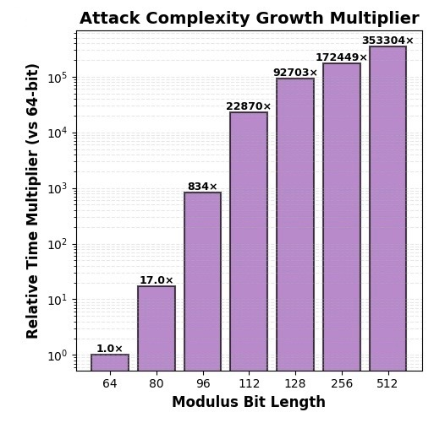
- Average Attack Time vs. RSA Bit Length
This plot shows the exponential growth of average runtime as bit length increases. Runtime remains under one second for ≤80-bit keys but rises sharply beyond 96 bits, reaching several thousand seconds at 128 bits and above.
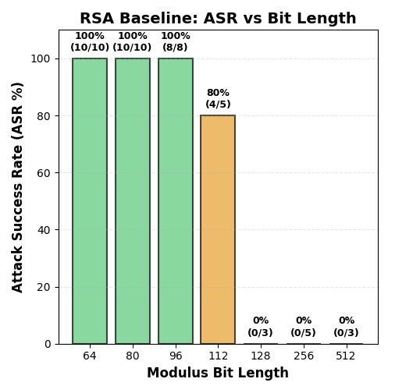
- Attack Success Rate (ASR) vs. RSA Bit Length
ASR drops abruptly between 112-bit (80%) and 128-bit (0%), forming a clear security boundary. This transition reflects the square-root complexity limit of Pollard’s rho.
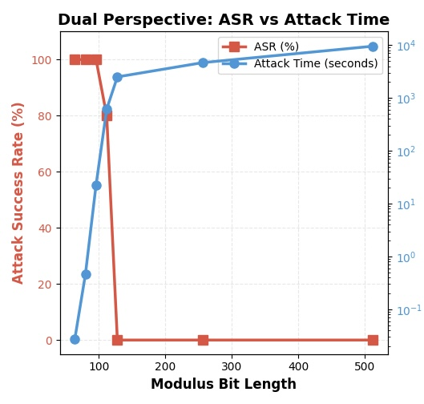
- Balanced vs. Imbalanced 256-bit Keys
This figure overlays ASR and runtime, emphasizing the trade-off between success probability and computational cost. The curve flattens as key size increases, showing Pollard’s rho’s inefficiency for large moduli.
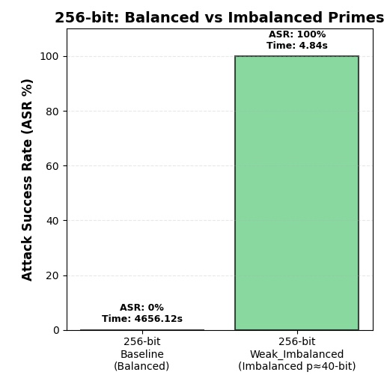
- Balanced vs. Imbalanced 256-bit Keys
This comparison clearly demonstrates that even a large modulus becomes weak if one prime is small. The imbalanced key (p≈40 bits) was fully compromised, while the balanced 256-bit key resisted all attacks.
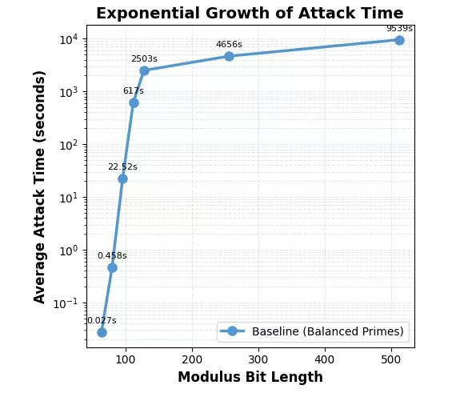
- Runtime under Different Configurations
This figure visualizes the effect of defense strategies. Increasing modulus size or ensuring balanced primes causes the attack time to increase exponentially, confirming both as effective defenses.
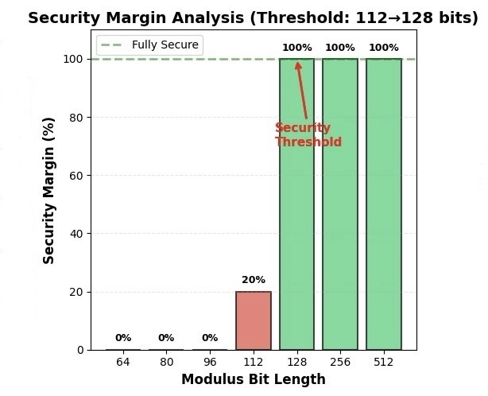
- Security Level Classification by Key Size
Keys under 96 bits fall into the “Highly Insecure” zone, 112-bit is “Partial Risk,” while ≥128-bit are categorized as “Secure.” This visualization summarizes the overall resistance pattern observed in the study.

Consolidated Findings

Attack observations: Small keys (64–96 bits) were fully compromised within seconds (ASR=100%). 112-bit keys showed partial success (ASR=80%, average runtime ≈617 s). No successful attacks occurred beyond 128 bits within runtime limits. The imbalanced 256-bit configuration was completely broken despite large modulus size.

Defense observations: Increasing modulus size exponentially increases attack cost and lowers success probability. Balanced prime selection is critical; unbalanced primes destroy security. Both strategies combined (large, balanced primes) provide practical resistance to Pollard’s rho.

Visualization and clarity: The six figures collectively demonstrate RSA’s resistance curve, defense efficiency, and prime-balance effect. Table II consolidates all numerical data for quantitative reference. The combination of line charts, bar charts, and comparative visuals satisfies the visualization and summary criteria.

discussion

In-Depth Comparison of Attack Mechanisms: Protocol Exploit vs. Mathematical Exploit
This section presents a comparative analysis of two fundamentally distinct attack mechanisms in cryptographic systems: the Man-in-the-Middle (MITM) attack on the Diffie–Hellman (D–H) key exchange and the factorization-based attack on RSA using Pollard’s rho algorithm. While both undermine secure communication, they operate at separate layers—one exploits protocol-level weaknesses, whereas the other targets the mathematical underpinnings of public-key cryptography. A clear understanding of their differences elucidates the multifaceted nature of cryptographic vulnerabilities and aids in prioritizing defensive strategies.

Core Logic: Session-Level Protocol Manipulation vs. Computational-Level Key Compromise: The MITM attack on Diffie–Hellman constitutes a protocol-layer intrusion. It does not attempt to solve the underlying discrete logarithm problem but instead capitalizes on the lack of entity authentication during the key exchange. By intercepting and relaying messages, the attacker establishes two independent key exchanges—one with each legitimate party—thereby positioning itself as an undetected intermediary capable of decrypting, altering, and re-encrypting all communications. The vulnerability stems not from the mathematical robustness of D–H, but from the unverified identity flow within the protocol. It has been proposed to augment D–H with a cryptographically secured Cyclic Redundancy Check (CRC) to authenticate messages and verify entity legitimacy[11]. Such a measure effectively mitigates the MITM threat through external validation, without altering the core mathematical construct.
In contrast, the Pollard’s rho attack on RSA exemplifies a mathematical-layer cryptanalytic strategy. Its goal is to factor the RSA modulus $N=pq$ in order to derive the private key. This attack employs probabilistic integer factorization techniques that exploit number-theoretic properties rather than procedural flaws. Research indicates that Pollard’s rho, along with Fermat factorization and related algorithms, presents tangible risks to RSA when the modulus length is insufficient or the prime structure is weak; nevertheless, their efficacy is constrained by computational resources and integer characteristics[12]. The practical security of RSA thus fundamentally relies on the infeasibility of large integer factorization, implying that any significant advancement in algorithmic efficiency or computational power could directly undermine RSA’s security guarantees[13].

Technical Paradigm: Instantaneous Session Hijack vs. Resource-Intensive Mathematical Search: The technical paradigms of these attacks further underscore their operational and resource disparities.
The MITM attack functions as a real-time, network-level manipulation. It is feasible whenever an adversary can interpose itself between two unauthenticated communicating endpoints. This attack requires no exceptional computational capability but exploits procedural openness and precise timing. Defensive measures accordingly focus on protocol reinforcement through authentication mechanisms, such as integrating symmetric verification—for instance, HMAC or pre-shared keys—into the D–H handshake[11]. These enhancements offer lightweight yet effective security, particularly suitable for ad-hoc or resource-constrained environments. However, they also transfer part of the security burden to key management, necessitating secure distribution and periodic updating of shared credentials.
Conversely, the Pollard’s rho attack is a long-term, computation-intensive mathematical exploit. Its success is heavily dependent on algorithmic refinements and hardware scalability. Parallelization, for example, can markedly accelerate factorization by optimizing polynomial selection and cycle detection across distributed systems[14]. Such advancements extend the practical reach of attacks against RSA moduli, thereby challenging conventional key-length recommendations. This attack paradigm is not opportunistic but resource-bound, demanding substantial processing capability, parallel computational architecture, and time—attributes that render it less accessible, yet potentially catastrophic when deployed at scale.

Systemic Role and Consequenc Ephemeral Session Breach vs. Persistent Key Compromise: The systemic implications and consequences of these attacks further highlight their divergent impacts.
In the context of Diffie–Hellman, the MITM attack constitutes a session-specific “identity breach.” Its execution compromises the confidentiality and integrity of a single communication instance, permitting message tampering or impersonation without breaking the underlying cryptographic problem. Mitigation strategies involve embedding authenticated verification—such as digital signatures, pre-shared keys, or cryptographically secure CRCs—into the key exchange process[11]. These mechanisms ensure mutual entity authentication before a session key is established and trusted.
For RSA, Pollard’s rho represents a “foundational compromise.” Successful factorization grants the attacker persistent access to the private key, enabling decryption and forgery across all the sessions dependent on that key. Countermeasures are thus oriented toward mathematical strengthening: employing sufficiently large modulus sizes, generating strong primes, and guaranteeing high entropy during key generation. The reliability of RSA hinges on adherence to contemporary cryptographic standards (e.g., ≥2048-bit keys) and continuous assessment of algorithmic and computational progress[13]. Moreover, the proliferation of multicore and distributed computing environments must be incorporated into security assessments, as parallel attacks recalibrate practical hardness assumptions[14].
In summary, MITM and Pollard’s rho attacks embody two orthogonal threat models—the former exploiting communication flow at the protocol layer, and the latter compromising cryptographic primitives at the mathematical layer. Their comparison yields a critical engineering insight: the security of modern systems necessitates defense in depth, where procedural authentication (“identity defense”) works in concert with mathematical robustness (“computational defense”). Diffie–Hellman requires assured identity verification, whereas RSA demands computational intractability. Only through the integration of both dimensions can long-term cryptographic assurance be maintained within an evolving technological landscape.

In-Depth Comparison of Defense Mechanisms: Protocol Empowerment vs. Mathematical Fortification
The two core mechanisms to be discussed next – Pre-Shared Key (PSK) authenticated Diffie-Hellman and enhanced key generation for RSA – are vivid manifestations of this concept. Although both fall within the defensive domain, they differ fundamentally in their core principles, technical paradigms, and systemic roles. A comparative analysis helps deepen the understanding of layered defenses in cryptographic systems.

Core Philosophy: External Empowerment of Protocol Flow vs. Internal Fortification of Cryptographic Primitives: The core logic of these two defense mechanisms operates at different security layers. PSK-D-H authentication is essentially a "protocol-layer defense". It does not challenge the security of the discrete logarithm problem upon which the D-H key exchange itself relies, but rather provides an "external reinforcement" targeting the lack of identity authentication in its interactive process. This mechanism guarantees the authenticity of communicating entities by introducing a symmetric trust anchor (the PSK) independent of the key exchange process itself. Its defensive approach is to empower the process, i.e., to superimpose an identity verification layer on top of the existing mathematical protocol to ensure the trustworthiness of the participating parties.
In contrast, the RSA key enhancement strategy is a "mathematical-layer defense". It directly addresses the security foundation of the RSA cryptosystem – the computational intractability of the large integer factorization problem. Its defensive logic is not to modify the protocol flow, but to fortify the foundation from within, by meticulously constructing the mathematical properties of the key itself (such as using a sufficiently large modulus length and prime factors that meet "strong prime" criteria) to systematically increase the computational complexity for an attacker attempting mathematical cryptanalysis. It focuses on the intrinsic strength of the cryptographic primitive, not on how it is used in a session.

Technical Paradigm: Agility of Hybrid Architecture vs. Standardization of Pure Paradigm: The difference in philosophy directly leads to a divergence in technical paradigms. Diffie–Hellman remains a fundamental component of many modern cryptographic protocols; however, in its original unauthenticated form, it is vulnerable to MITM attacks, necessitating additional defensive mechanisms[15]. The PSK-D-H scheme embodies such a mechanism through a "hybrid architecture" philosophy. Building on Khader and Lai, authentication mechanisms can be integrated into the standard D-H process to mitigate MITM risks. Their study proposed an enhanced D-H exchange where each party’s public key is verified through a pre-shared authentication token, effectively preventing unauthorized intermediaries from altering key values. This aligns with the proposed PSK-D-H model adopted in this paper, where pre-shared credentials add a lightweight yet strong identity verification step[16]. In practice, this is achieved by flexibly using lightweight symmetric cryptographic tools (HMAC) to resolve the identity trust crisis in public-key cryptographic protocols. The advantage of this paradigm lies in its agility and self-containment. It implements the "pre-shared keys" approach noted by Ahmed et al., avoiding the need for a complex Public Key Infrastructure (PKI), and thereby achieving immediate, closed-loop security assurance, which is particularly suitable for resource-constrained or ad-hoc communication scenarios. However, the cost is shifting part of the security burden to the lifecycle management of the PSK, where key distribution, storage, and rotation become new security challenges. In contrast, RSA key enhancement is the self-perfection of the "pure public-key paradigm". Its security is entirely built upon number theory principles and standardized processes, achieving maximum strength through computationally intensive key generation (e.g., using secure random number generation and multiple primality tests). This paradigm is the cornerstone for building large-scale, open trust systems (like the Web PKI). However, its security strongly depends on strict adherence to established standards (like NIST guidelines) and continuous resistance against advancements in computing technology; it appears particularly vulnerable facing paradigm-shifting threats like quantum computing.

Systemic Role: Dynamic Session's "Identity Sentinel" vs. Static Trust's "Strength Cornerstone": Ultimately, these two mechanisms play distinctly different roles within the system security architecture. PSK-based D-H authentication acts like a dynamic "identity sentinel". It is active during the session establishment phase, performing a one-time identity verification task specific to the entities in this communication. Its core value lies in establishing a trusted starting point for an ephemeral or temporary secure channel.
The strengthened RSA key, however, resembles a static "strength cornerstone". It is typically embedded within long-term digital certificates, serving as a persistent trust credential that endorses entity identity and provides long-term confidentiality and integrity guarantees for key exchange or digital signatures. Its value lies in providing a widely verifiable, consistently stable security foundation.
In conclusion, the comparison between PSK-D-H authentication and RSA key enhancement profoundly reveals a set of core trade-offs in cryptographic engineering: at the protocol layer, it's the trade-off between the "agility of external empowerment" and the "complexity of key management"; at the mathematical layer, it's the trade-off between the "standardization of intrinsic fortification" and the "vulnerability to paradigm shifts". This understanding is crucial for guiding future system design: in complex security ecosystems, the two are not substitutive but complementary. A robust system often requires "sentinels" to guard the integrity of the process and "cornerstones" to anchor the system's long-term trust, working together to build a defense-in-depth.

Conclusion and Future Work

Authors’ Contribution

References
- W. Diffie and M. Hellman, “New directions in cryptography,” IEEE Trans. Inf. Theory, vol. 22, no. 6, pp. 644–654, Nov. 1976, doi: 10.1109/TIT.1976.1055638.
- K. M. Jain, M. V. Jain, and J. L. Borade, “A survey on Man in the Middle Attack,” Int. J. Sci. Res. (IJSR), 2016.
- X. Zhou and X. Tang, “Research and implementation of RSA algorithm for encryption and decryption,” in Proc. 6th Int. Forum Strategic Technol. (IFOST), 2011.
- S. Nisha and M. Farik, “RSA Public Key Cryptography Algorithm: A Review,” Int. J. Sci. Res. Publ., 2017..
- M. A. Budiman and D. Rachmawati, “On factoring RSA modulus using random-restart hill-climbing algorithm and Pollard's rho algorithm,” J. Phys.: Conf. Ser., 2017.
- M. Mumtaz and L. Ping, “Forty years of attacks on the RSA cryptosystem: A brief survey,” J. Discrete Math. Sci. Crypt., 2019.
- A. S. Khader and D. Lai, “Preventing man-in-the-middle attack in Diffie-Hellman key exchange protocol,” in Proc. 22nd Int. Conf. Telecommun. (ICT), Apr. 2015, pp. 204–208.
- T. S. Galu, A. A. Adeyelu, and S. U. Otor, “An Improved Deffie Hellman Scheme for Mitigating an Eavesdropping Attack on a Network,” Int. J. Innov. Sci. Res. Technol., vol. 9, no. 4, pp. 3101–3108, Apr. 2024, doi: 10.38124/ijisrt/IJISRT24APR2479.
- W. Shen, Y. Cheng, B. Yin, J. Du, and X. Cao, “Diffie-Hellman in the air: A link layer approach for in-band wireless pairing,” IEEE Trans. Veh. Technol., vol. 70, no. 11, pp. 11894–11907, Nov. 2021.
- D. Boneh, “Twenty years of attacks on the RSA cryptosystem,” Not. Amer. Math. Soc., vol. 46, no. 2, pp. 203–213, Feb. 1999.
- N. Naher, M. M. Haque, and M. Asaduzzaman, “Authentication of Diffie–Hellman protocol against man-in-the-middle attack using cryptographically secure CRC,” in Proc. Int. Conf. Ethical Hacking, 2018, pp. 123–132, doi: 10.1007/978-981-13-1544-2_12.
- A. S. Shatnawi, M. M. Almazari, Z. AlShara, E. Taqieddin, and D. Mustafa, “RSA cryptanalysis—Fermat factorization exact bound and the role of integer sequences in the factorization problem,” J. Inf. Secur. Appl., vol. 78, p. 103614, Sep. 2023, doi: 10.1016/j.jisa.2023.103614.
- D. R. L. Brown, “Breaking RSA may be as difficult as factoring,” J. Cryptol., vol. 29, no. 1, pp. 220–241, Jan. 2016, doi: 10.1007/s00145-014-9192-y.
- R. P. Brent, “Some parallel algorithms for integer factorisation,” in *Proc. Euro-Par ’99 Parallel Process.*, 1999, pp. 1–21, doi: 10.1007/3-540-48311-X_1.
- M. Ahmed, B. Sanjabi, D. Aldiaz, A. Rezaei, and H. Omotunde, “Diffie-Hellman and its application in security protocols,” Int. J. Eng. Sci. Innovative Technol., vol. 1, pp. 69–73, 2012.
- A. S. Khader and D. Lai, “Preventing man-in-the-middle attack in Diffie-Hellman key exchange protocol,” in Proc. 22nd Int. Conf. Telecommun. (ICT), Apr. 2015, pp. 204–208.
- S. Mitra, S. Das, and M. Kule, “Prevention of the man-in-the-middle attack on Diffie-Hellman key exchange algorithm: A review,” in Proc. Int. Conf. Frontiers Comput. Syst. (FCAS), 2021, pp. 579–590, doi: 10.1007/978-981-15-7834-2_58.

